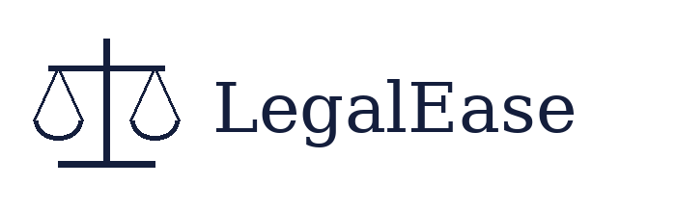
PROJECT PRESENTATION
LegalEase
AI-Powered Legal Document Generator
Team Members
Name | Role
N. Harini | Team Leader
S. Praveena | Team Member
S. Nandhini | Team Member
N. Mariyammal | Team Member

1. Introduction
LegalEase is a website that makes legal documents using Artificial Intelligence. The user types a few details, and the AI writes a full legal document in a few seconds. The user can read it, change it, and download it as a TXT, Word, or PDF file.

2. Problem
- Legal documents are hard to write for people without legal knowledge.
- Hiring a lawyer for every small agreement is costly and slow.
- Free templates from the internet are often not complete or not correct for the user.

3. Our Solution
LegalEase asks for only four simple details: the document type, the people involved, the terms and conditions, and the effective date. Using these, the Gemini AI model writes a clear document with numbered sections, legal clauses, and a signature place.

4. Main Features
- Makes contracts, NDAs, lease agreements, offer letters, and more.
- Shows a preview of the document on the screen.
- Lets the user edit the text before downloading.
- Downloads in three formats: TXT, DOCX, and PDF.
- Adds the logo, a terms table, and a footer to the files.
- Keeps the API key safe in a secret .env file.

5. Technologies Used
Part | Technology | Use
Frontend | Streamlit | Input form, preview, edit, download buttons
Backend | FastAPI | Receives the request and sends the answer
AI Model | Google Gemini | Writes the legal document
Files | python-docx, fpdf2 | Creates Word and PDF files
Language | Python | Used for the whole project
Deployment | Render | Puts the project online

6. How It Works
- Step 1: The user fills in the form on the Streamlit page.
- Step 2: The page sends the details to the FastAPI backend.
- Step 3: The backend makes a clear prompt and asks Gemini to write the document.
- Step 4: Gemini sends back the text, and it is shown as a preview.
- Step 5: The user edits it if needed and downloads the file.

7. Example
Input | Example
Document Type | Freelance Work Contract
Parties | Jane Doe (Service Provider), TechNova Inc. (Client)
Terms | Work delivered by May 15, 2025; Payment within 7 days; Client owns the rights
Effective Date | April 15, 2025

Output: a full contract with sections such as Services, Payment, Confidentiality, Termination, Governing Law, and a signature block.

8. Advantages
- Saves time and money.
- Easy to use for anyone, with no legal background.
- The user can change the document before using it.
- Looks professional with logo and footer.

9. Limitations
- AI documents are drafts and are not legal advice. A lawyer should check them before signing.
- Needs an internet connection and a Gemini API key.

10. Future Scope
- Support for more languages, such as Tamil and Hindi.
- Ready-made templates for more document types.
- Login system and saving old documents.
- Plain-language summary of each clause.

11. Conclusion
LegalEase makes legal drafting simple, fast, and easy for everyone. By using Streamlit, FastAPI, and Gemini AI together, our team built a working tool that creates, previews, edits, and downloads legal documents. Thank you.

