Account controller tests

Account service tests

Transaction controller tests

Transaction service tests

Fundtransfer controller tests

Fundtransfer service tests

Account controller tests

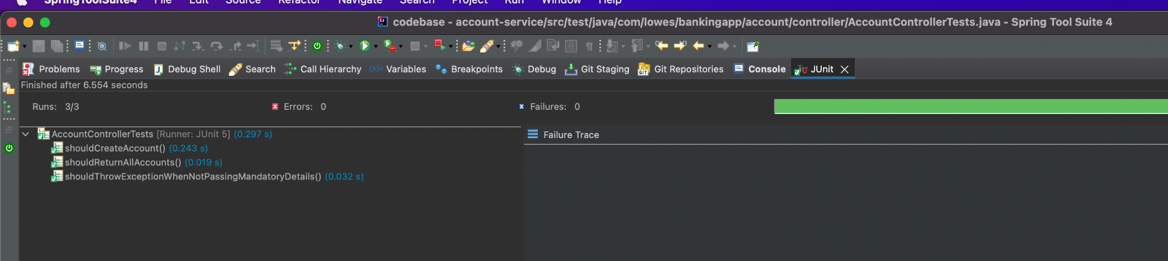

Account service tests

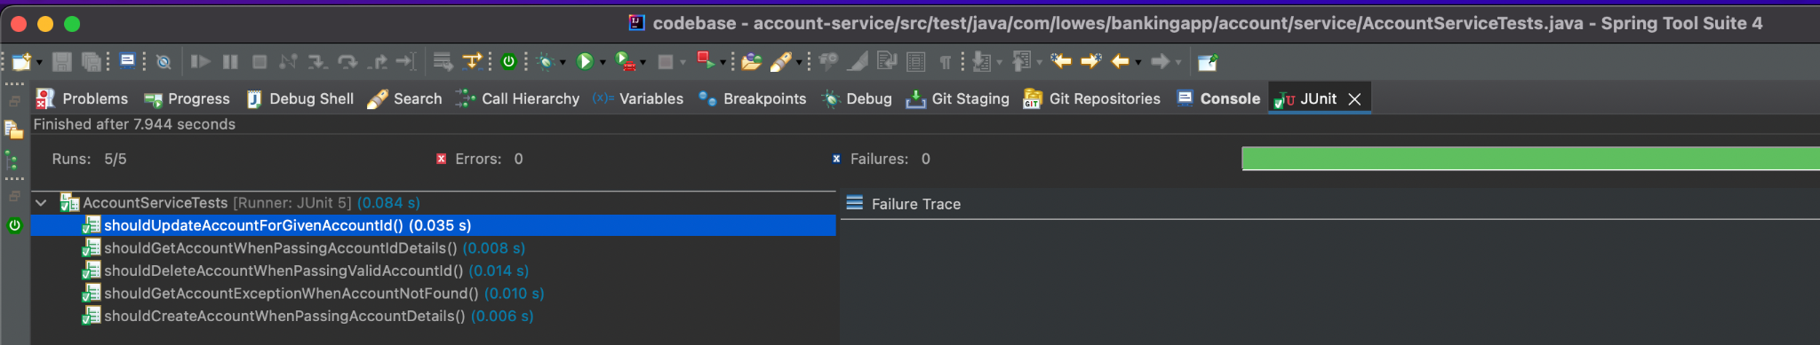

Transaction controller tests

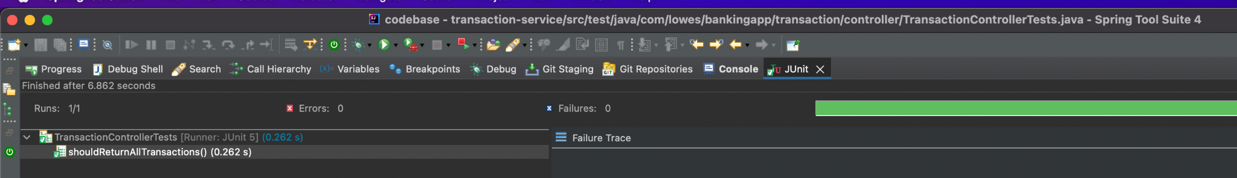

Transaction service tests

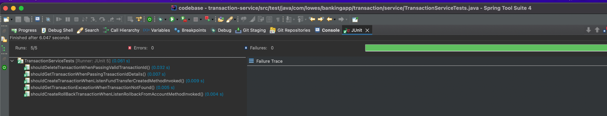

Fundtransfer controller tests

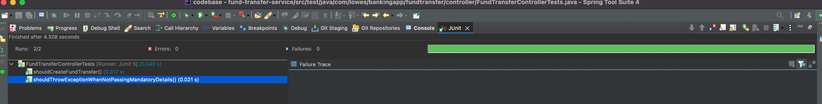

Fundtransfer service tests

