1. Add Account via gateway
2. Validation on Create and Update Request data
3. View account
   1. Exceptional Handling View Emp
4. Update account
5. Exceptional Handling Upd emp
6. Delete account
7. Exceptional Handling Del emp
8. View all accounts
9. ExceptionalHandling if no account in the table
10. Database Exception

Add account via gateway

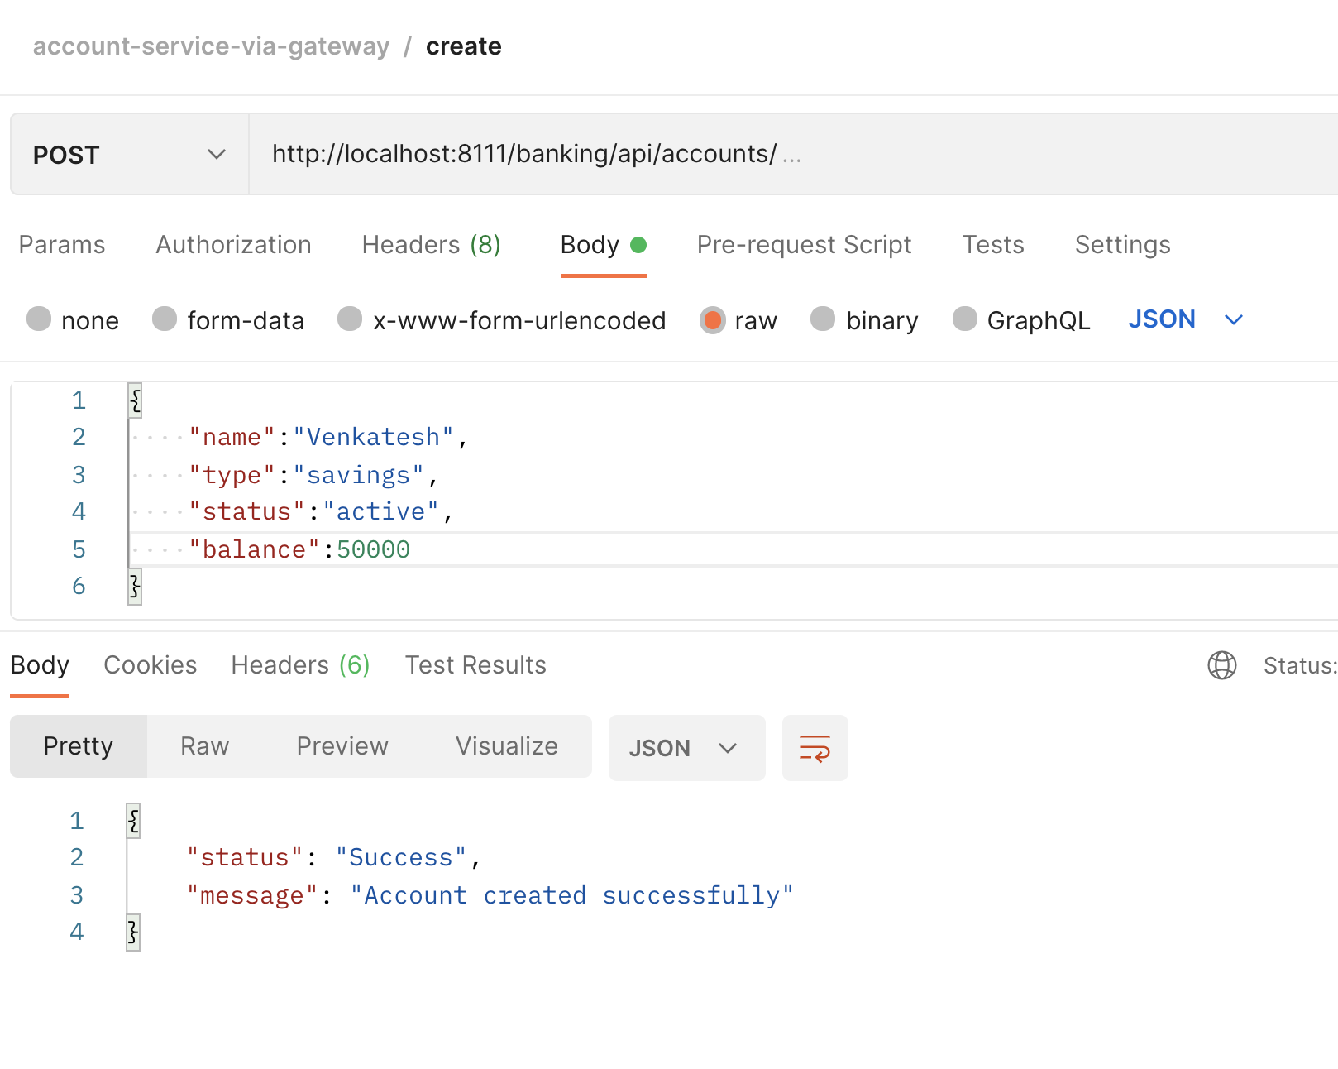

Validation on Create and Update Request data

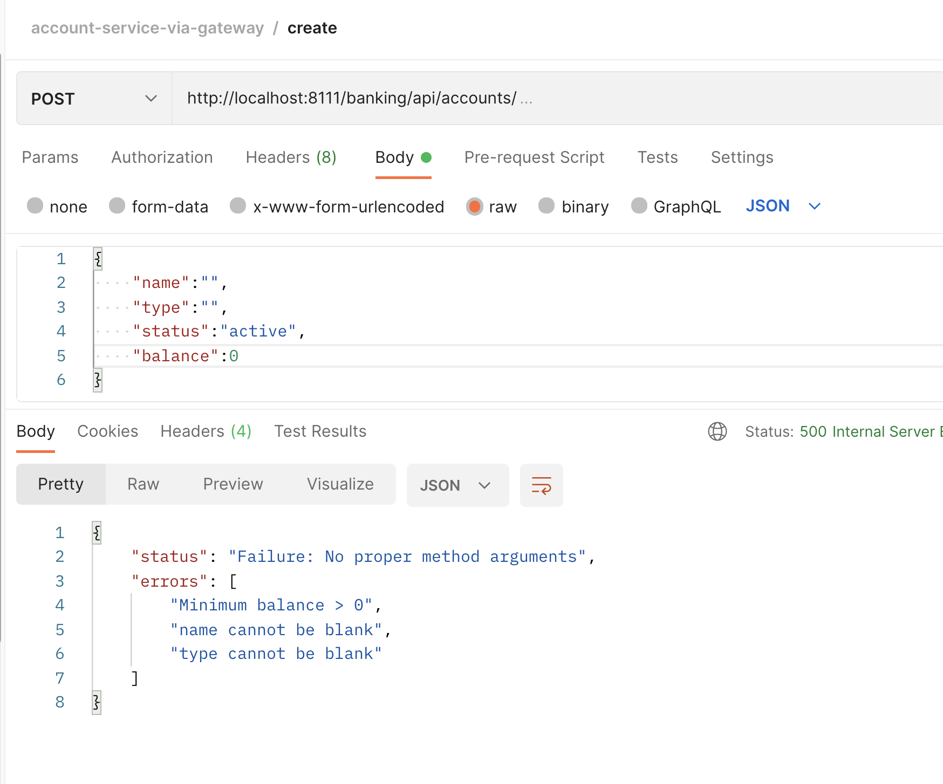

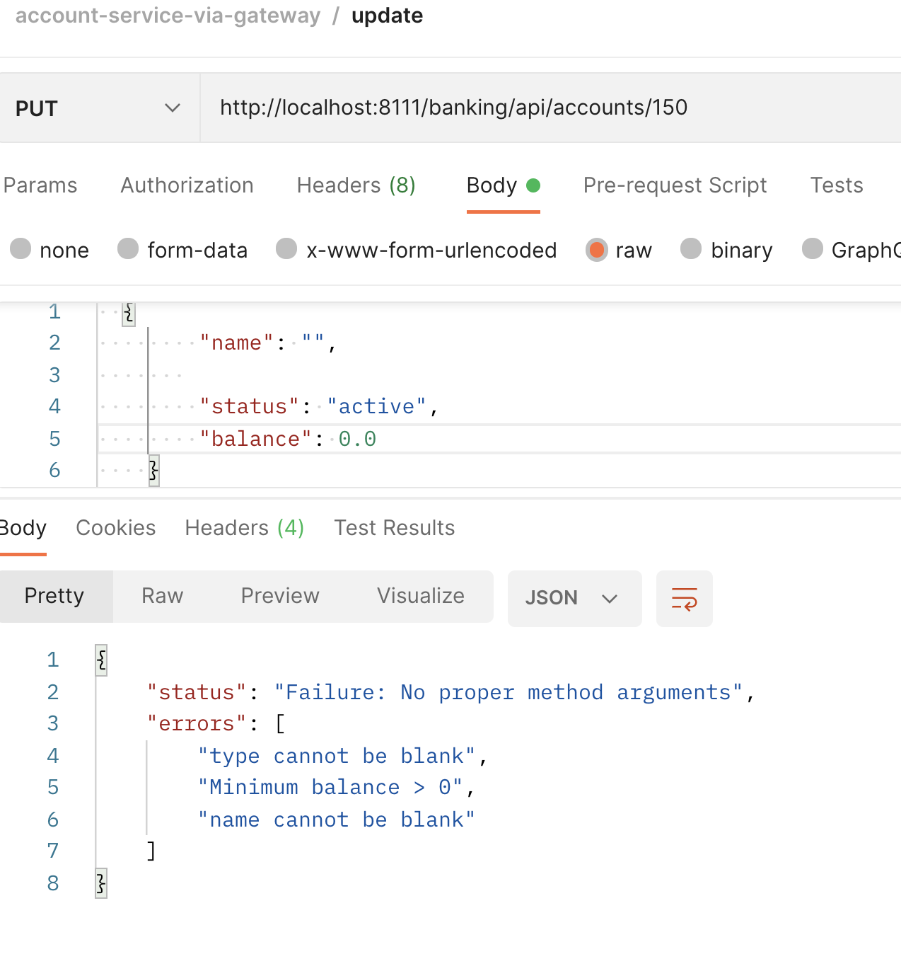

View account

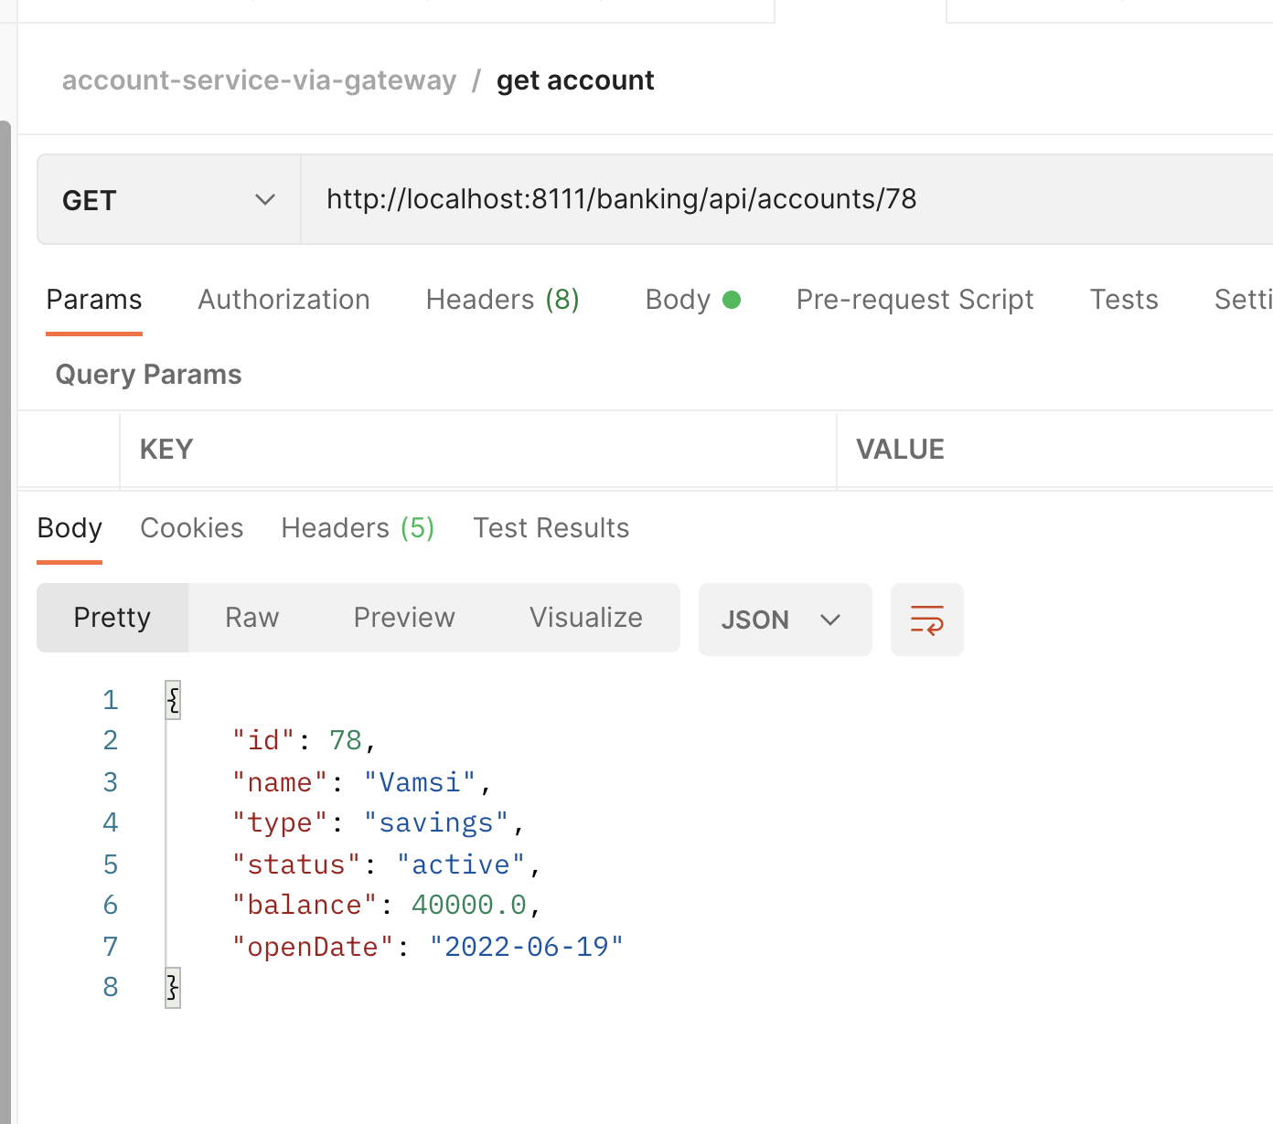

Exceptional Handling View Emp

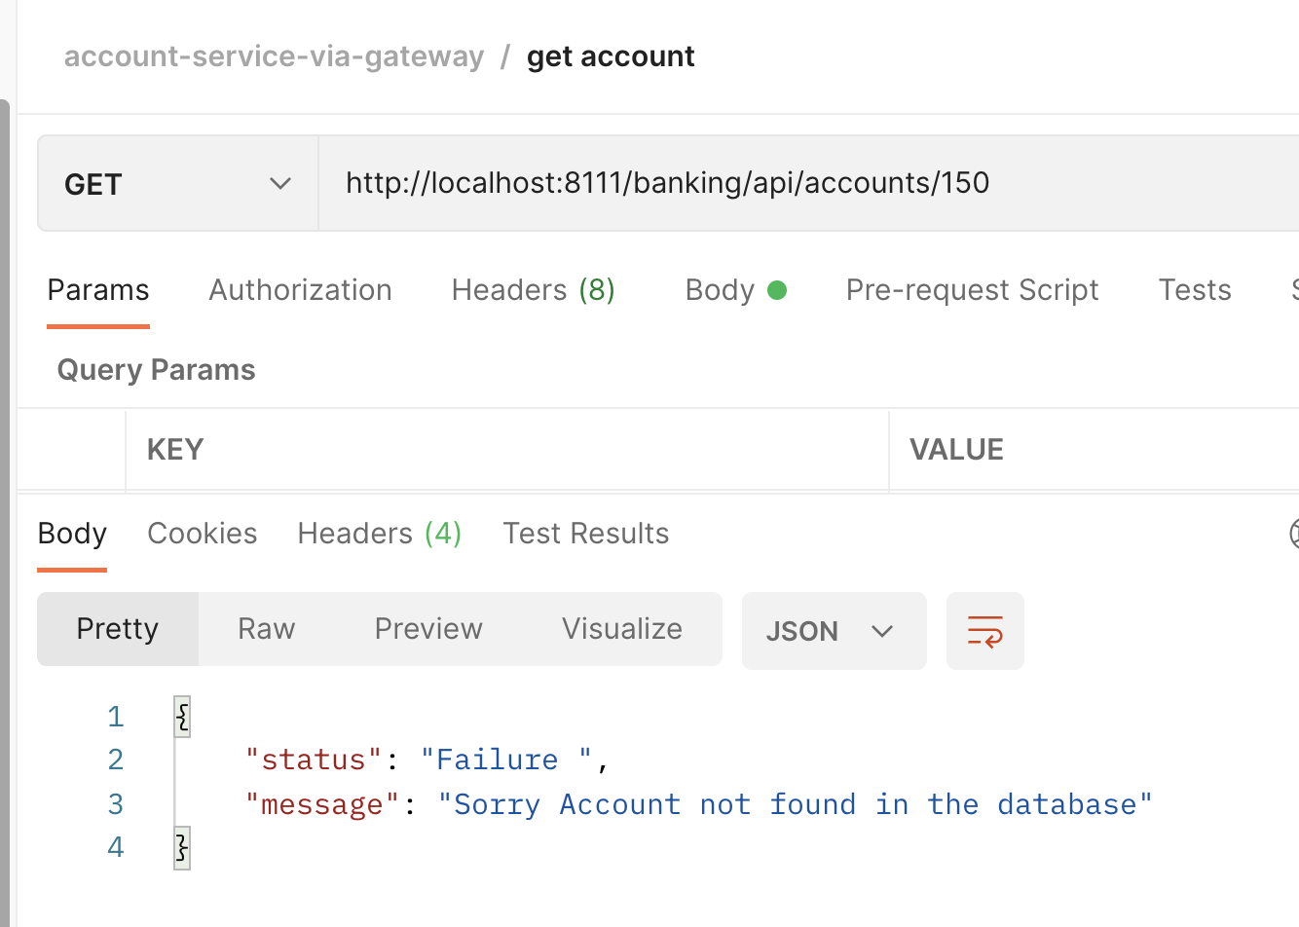

Update account

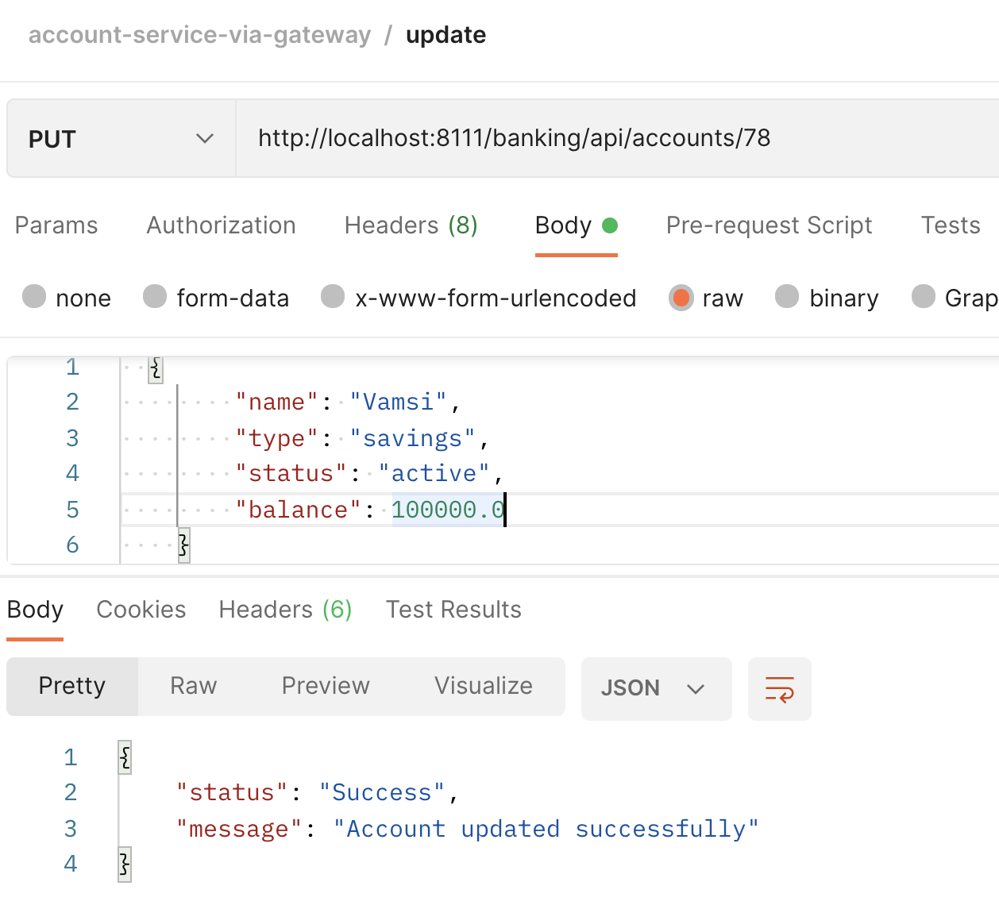

Exceptional Handling Upd emp

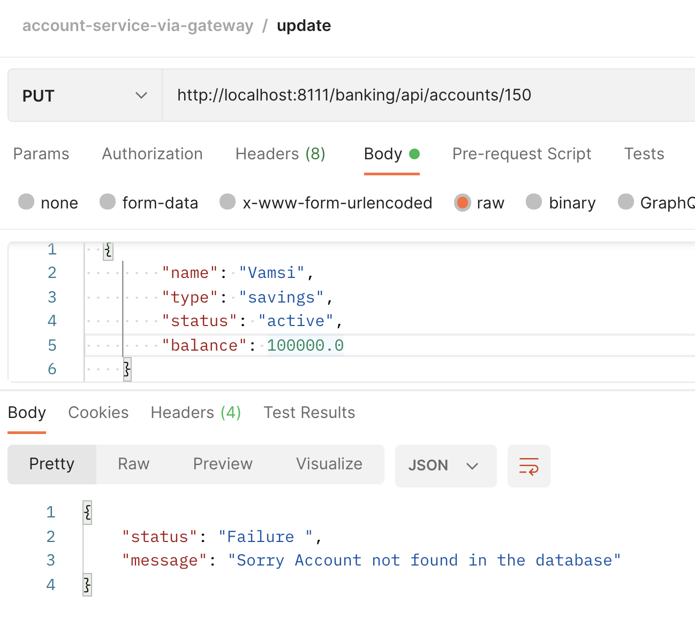

Delete account

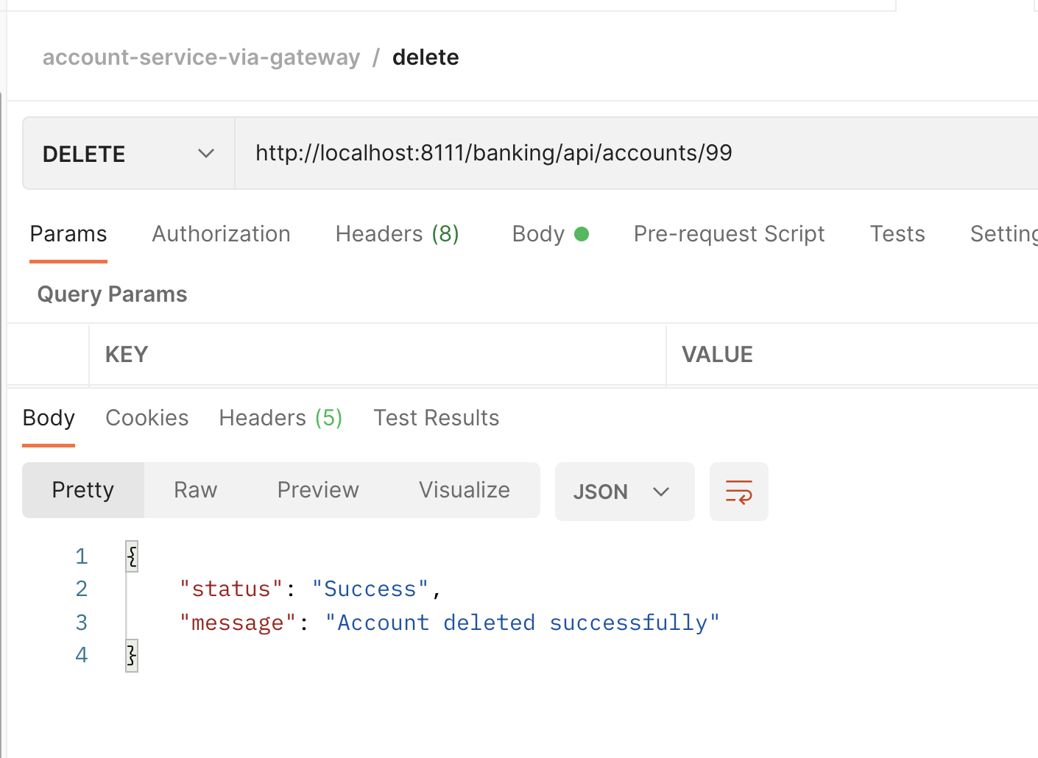

Exceptional Handling Del emp

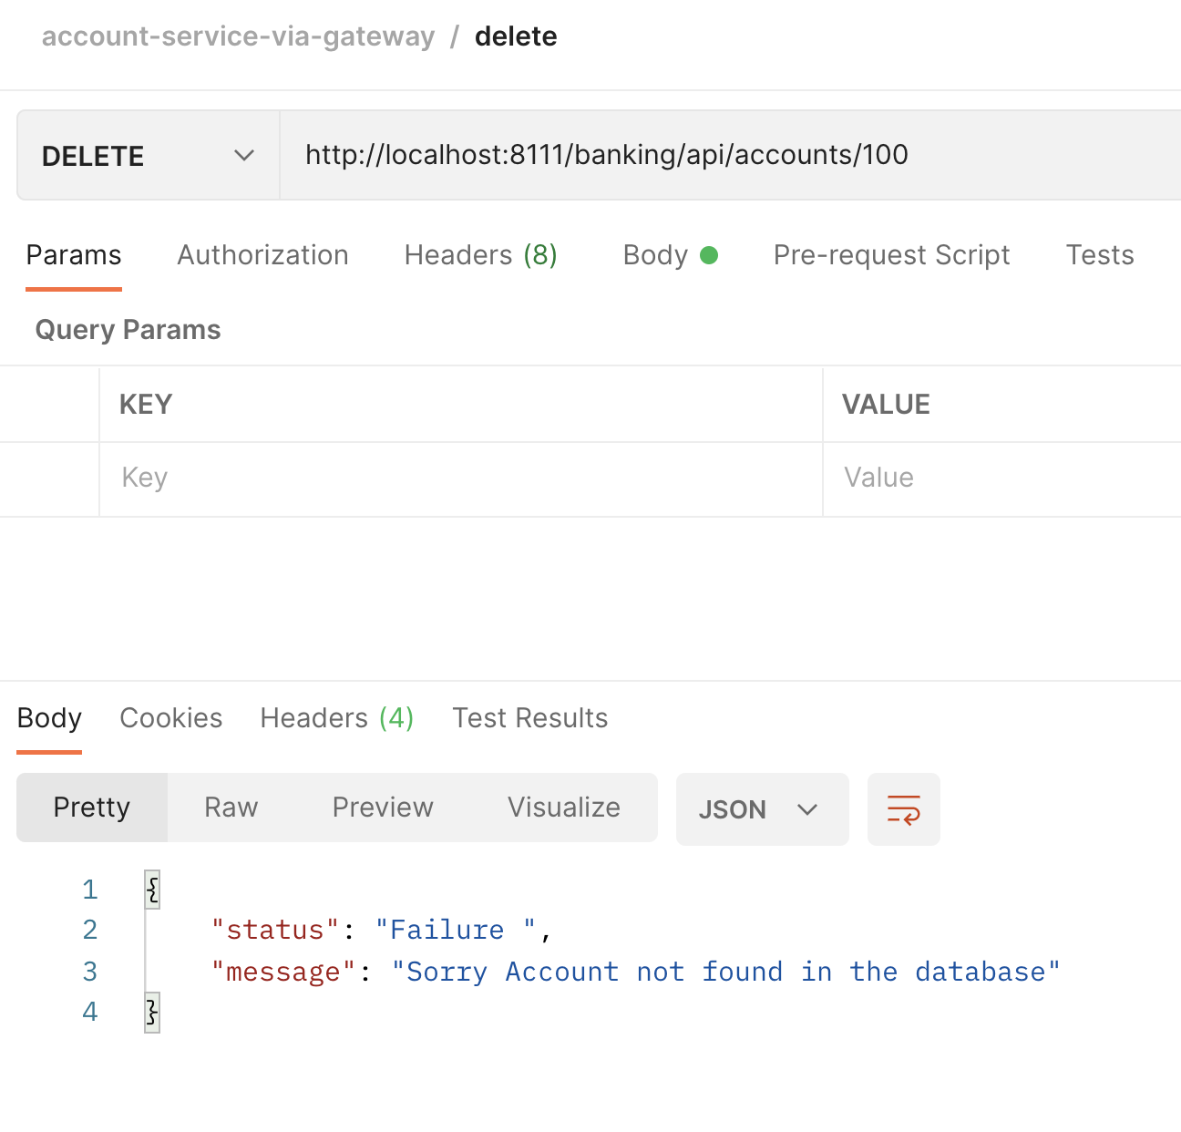

View all accounts

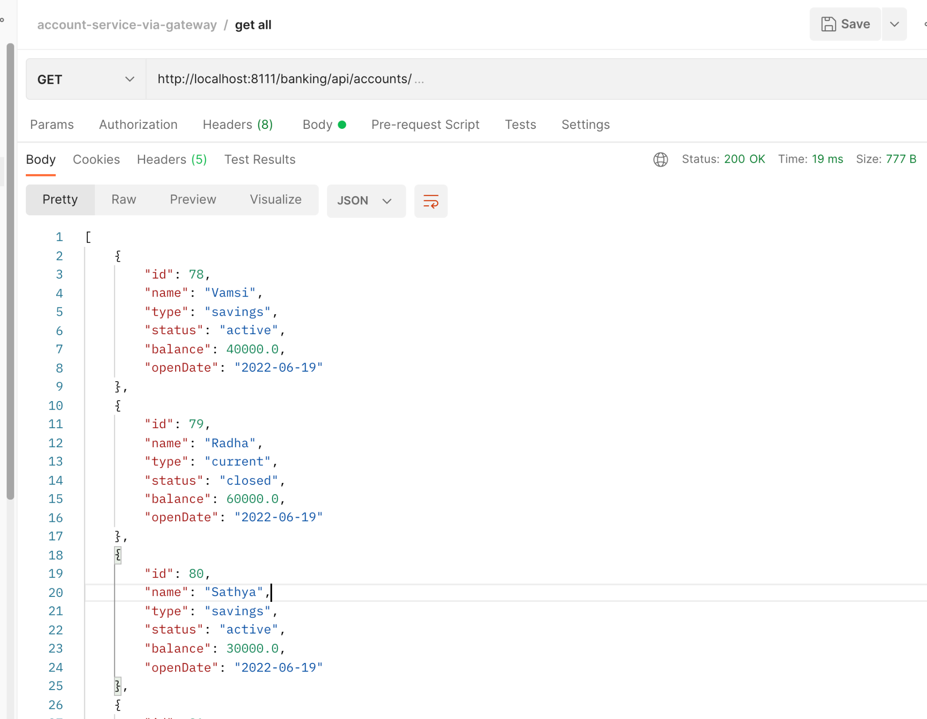

ExceptionalHandling if no account in the table

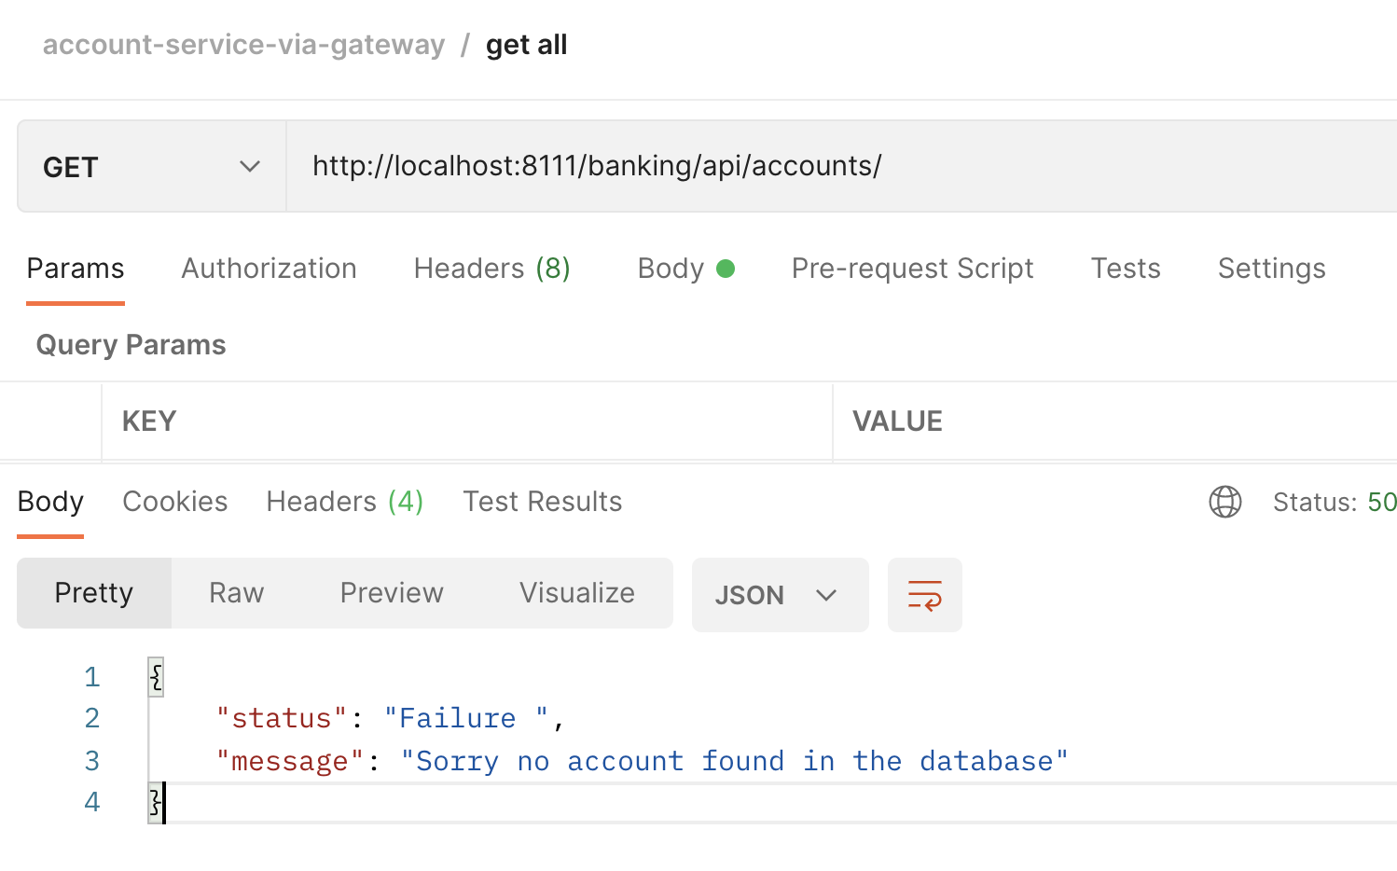

Database Exception

