EurekaRegistryWithAllServices-beforeDockerizing

EurekaRegisterServerWithAllServices-afterDockerizing

dockerizedContainers-all services

Docker-hub-images

dockerContainersInDockerDesktop

KubernetesWithDockerImages

CMAK-KafkaManager

AdminService-withServicesList

AdminService-wallboard

AdminService-AccountServiceMetrics

AdminService-AccountDetails

EurekaRegistryWithAllServices-beforeDockerizing

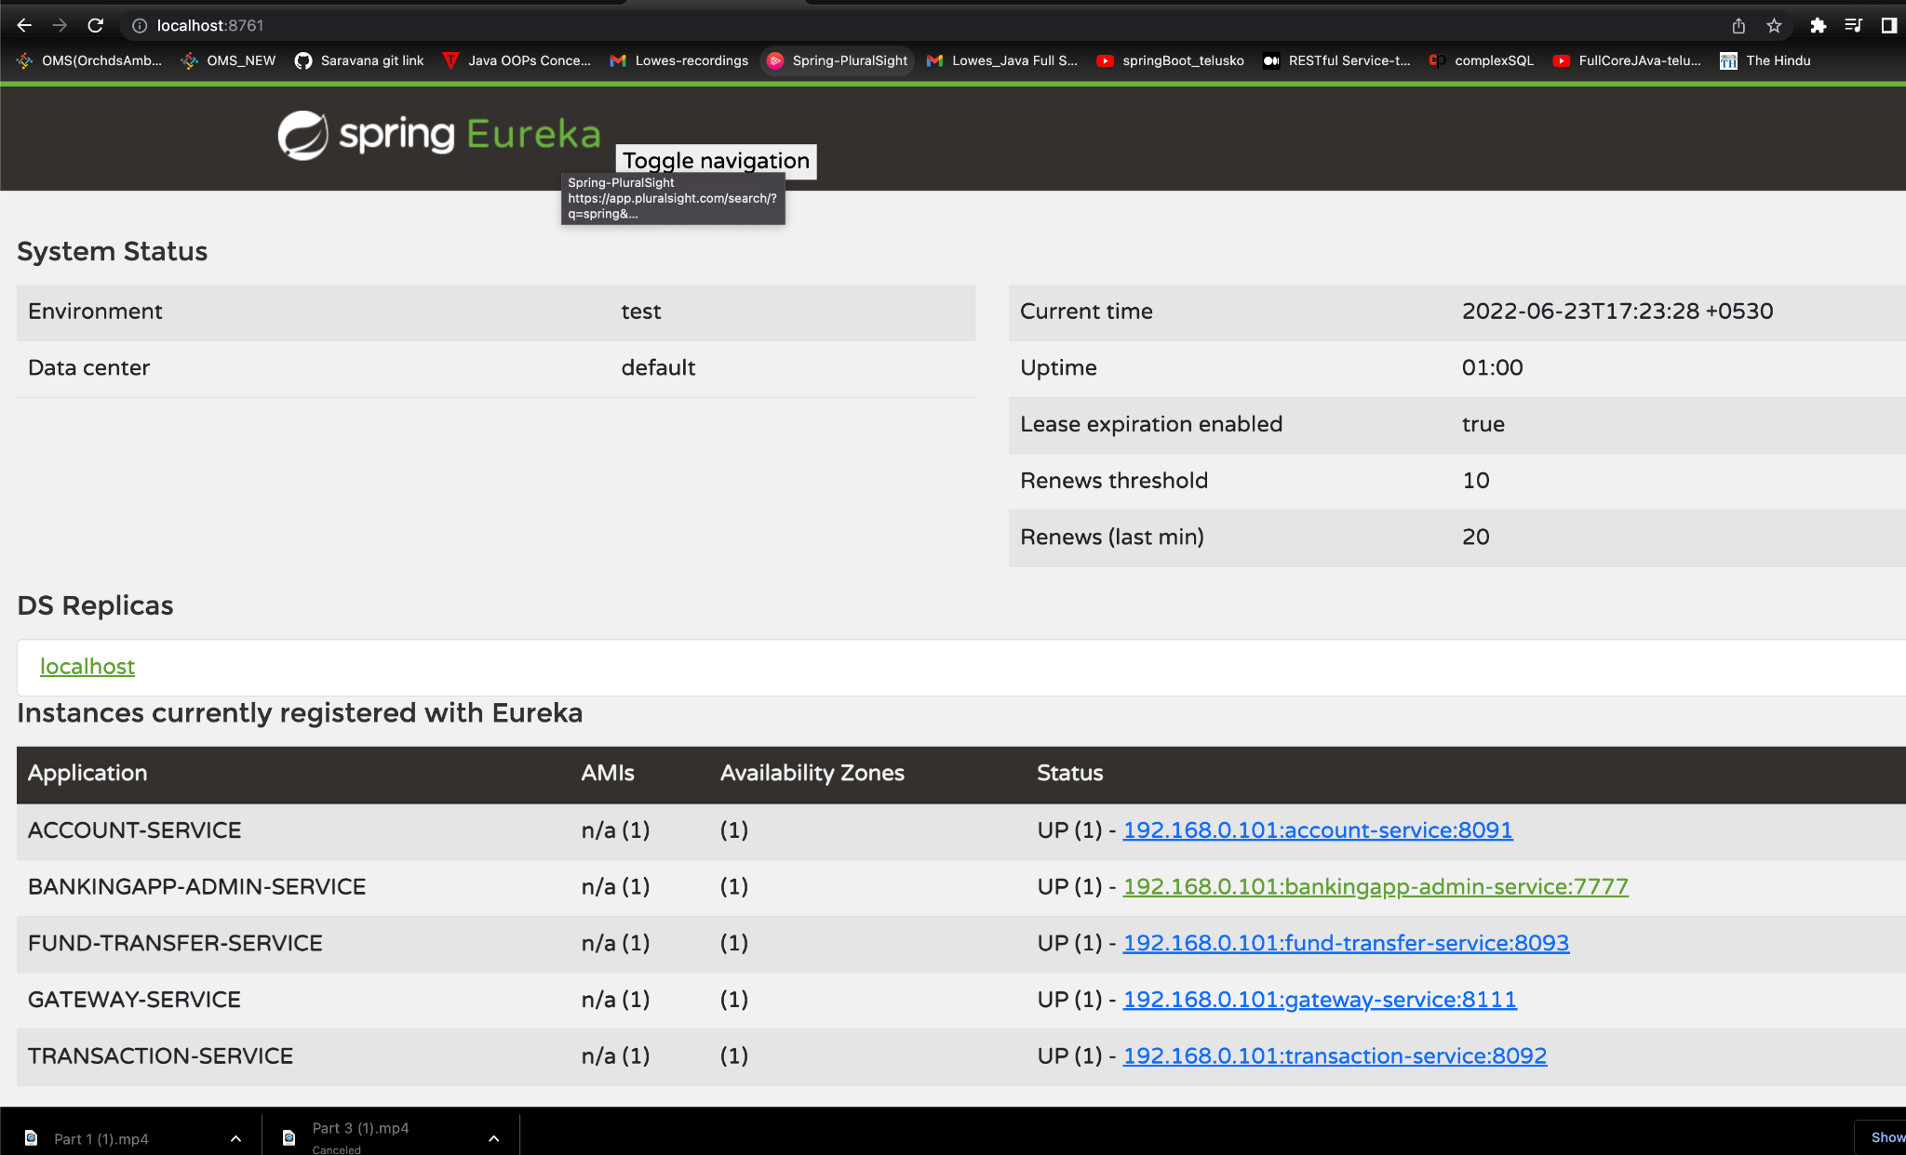

EurekaRegisterServerWithAllServices-afterDockerizing

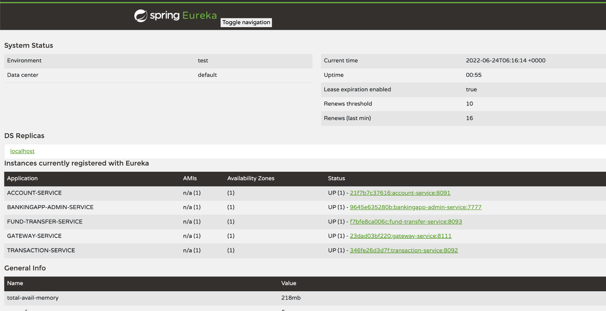

dockerizedContainers-all services

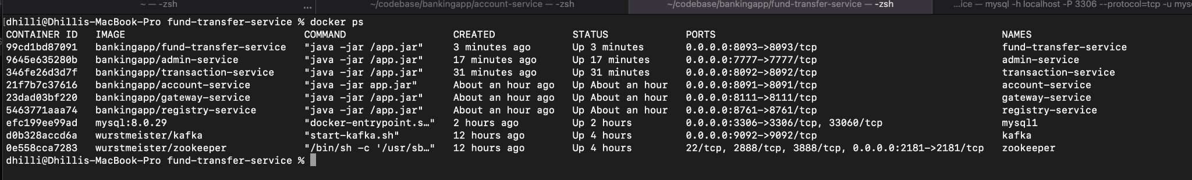

Docker-hub-images

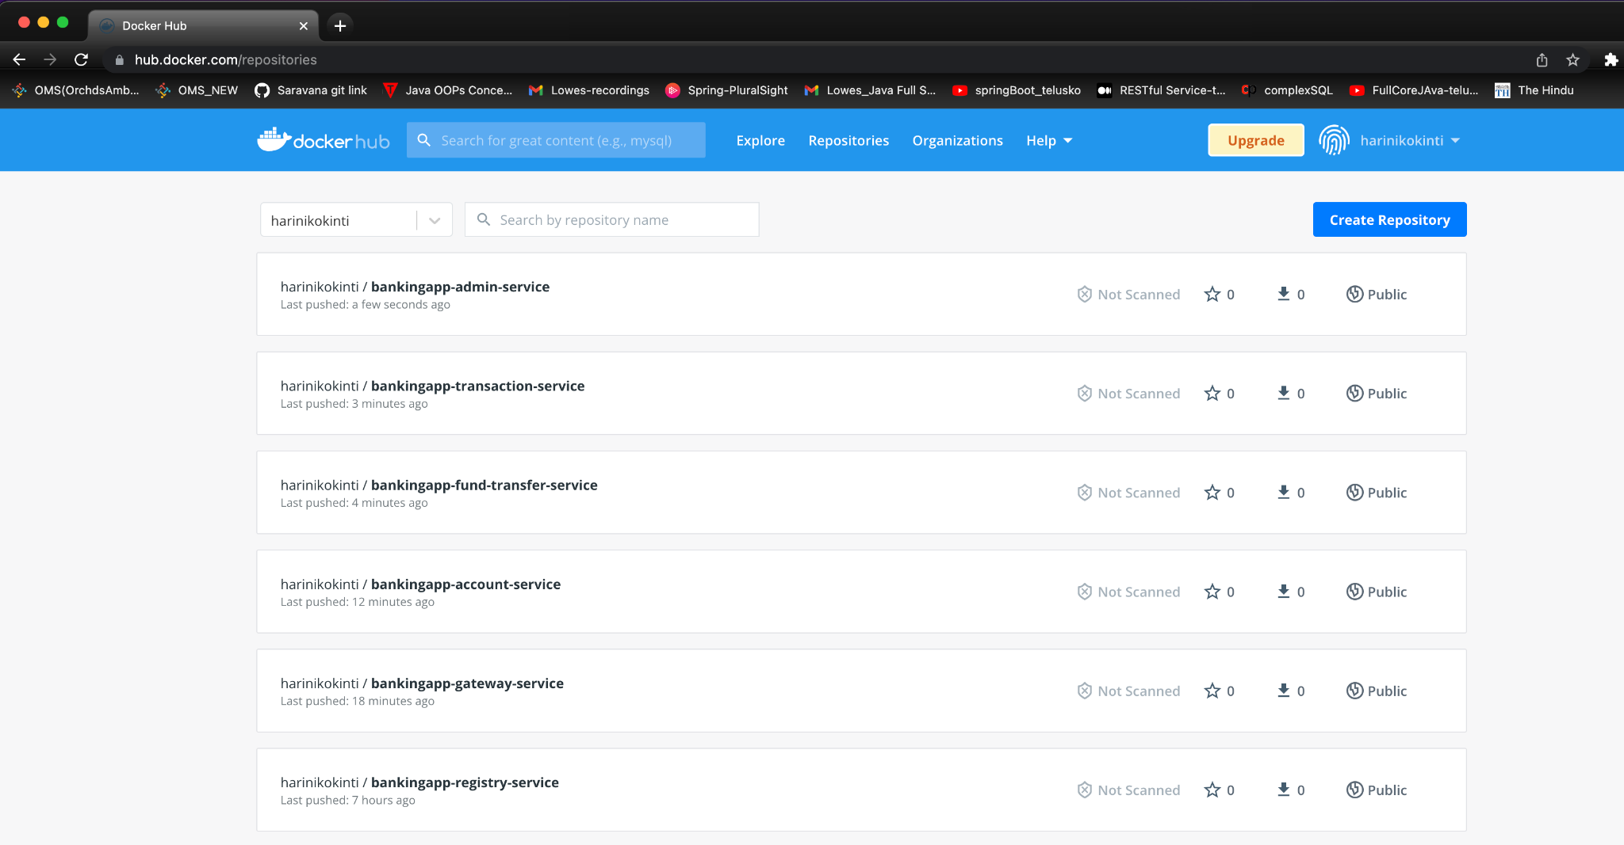

dockerContainersInDockerDesktop

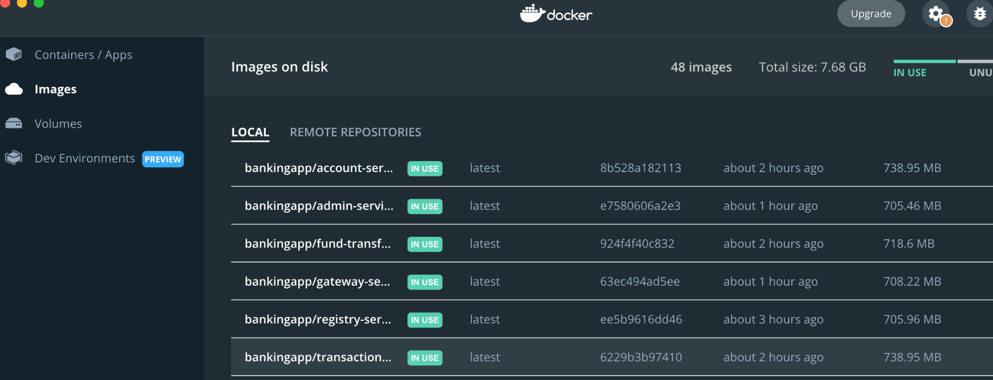

KubernetesWithDockerImages

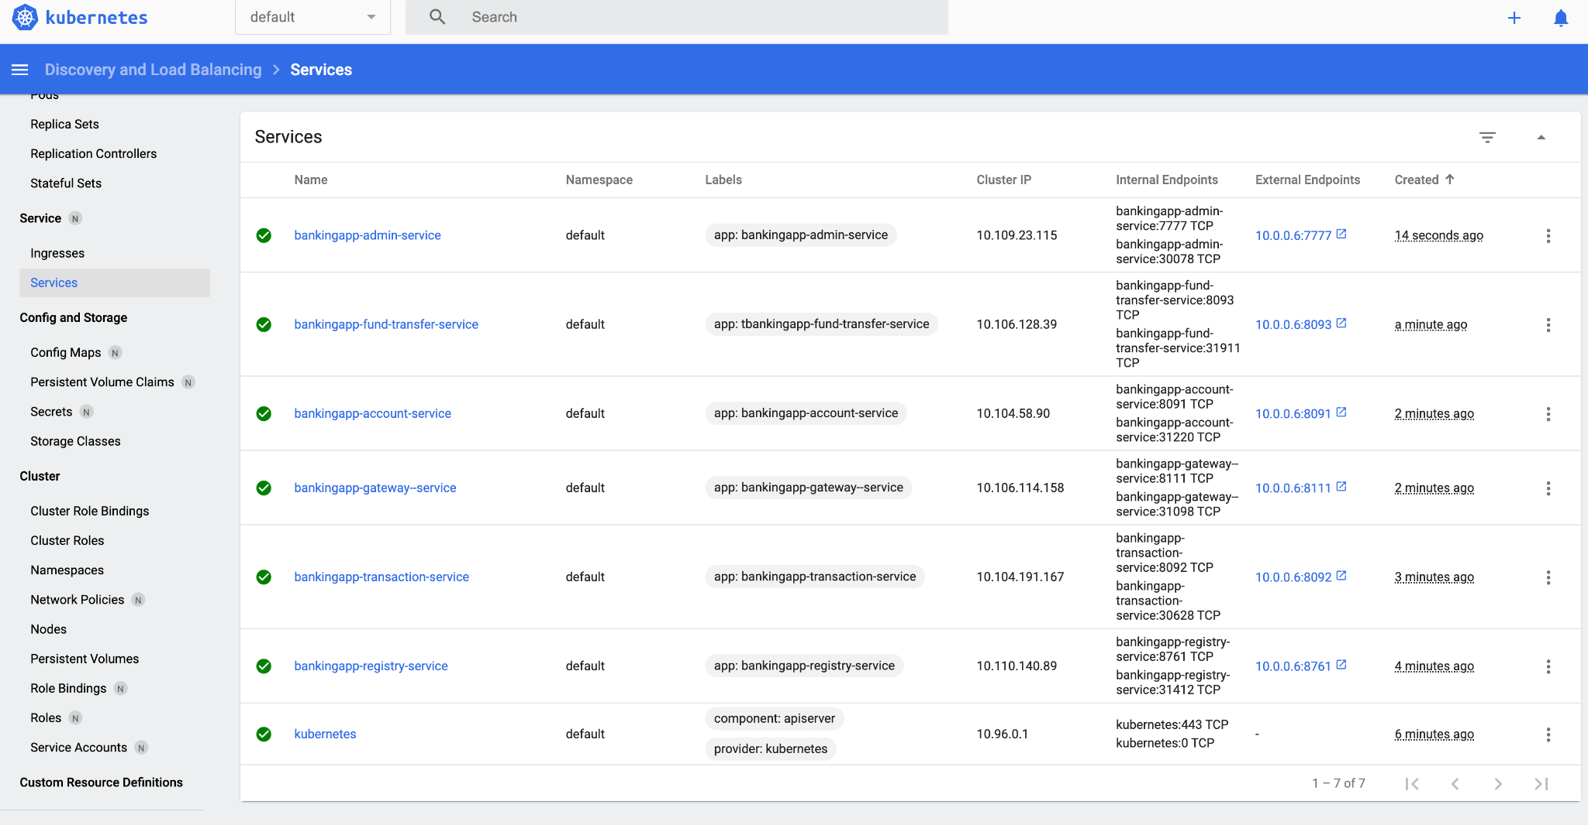

<https://ea6173b347e048728c0052f786df2900-167772166-30000-frugo01.environments.katacoda.com/#/service?namespace=default>

CMAK-KafkaManager

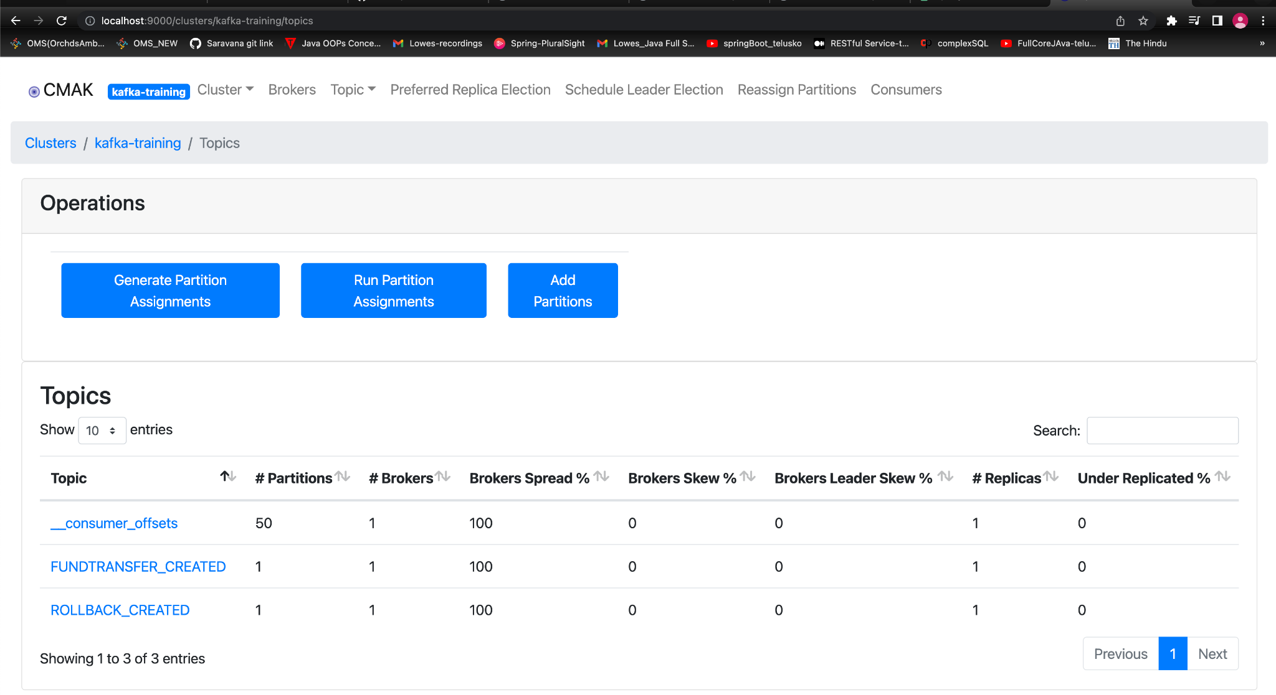

AdminService-withServicesList

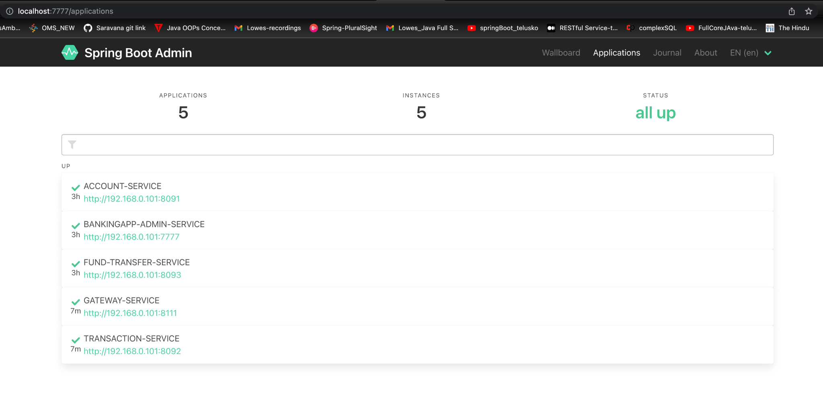

AdminService-wallboard

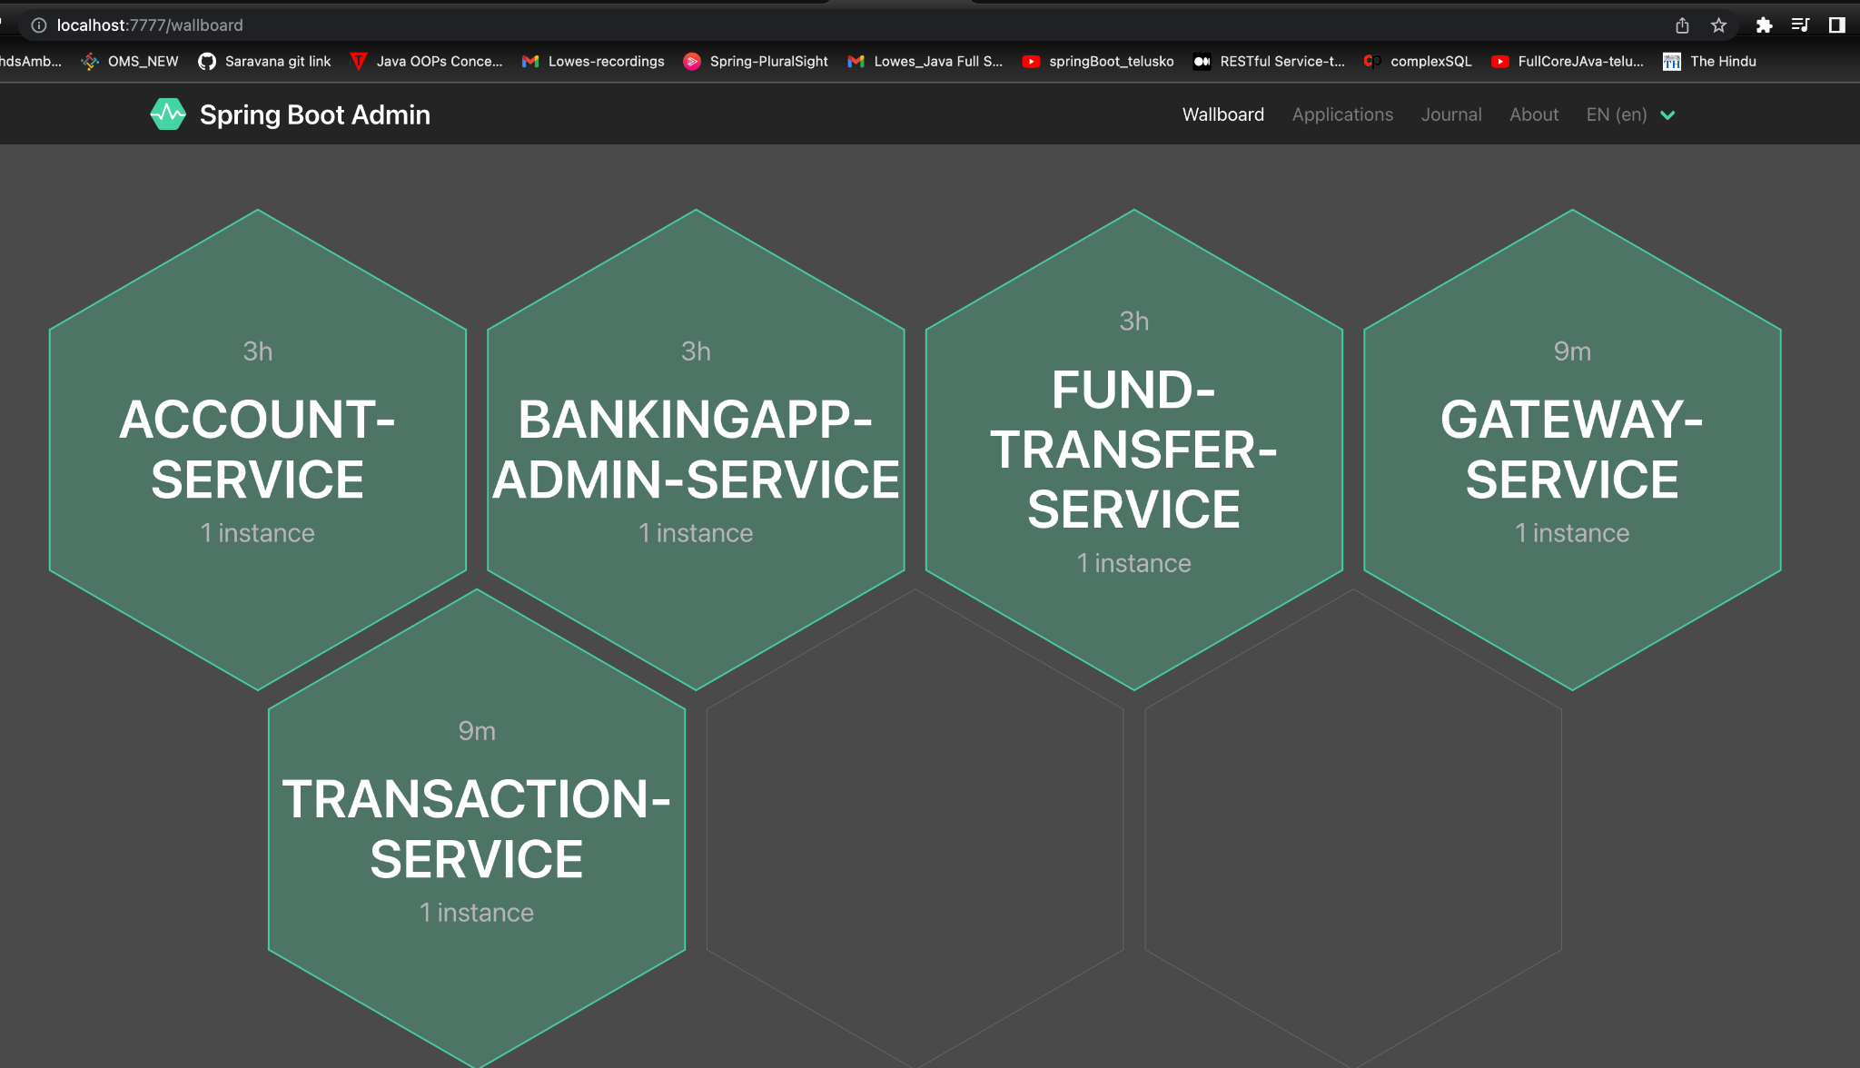

AdminService-AccountServiceMetrics

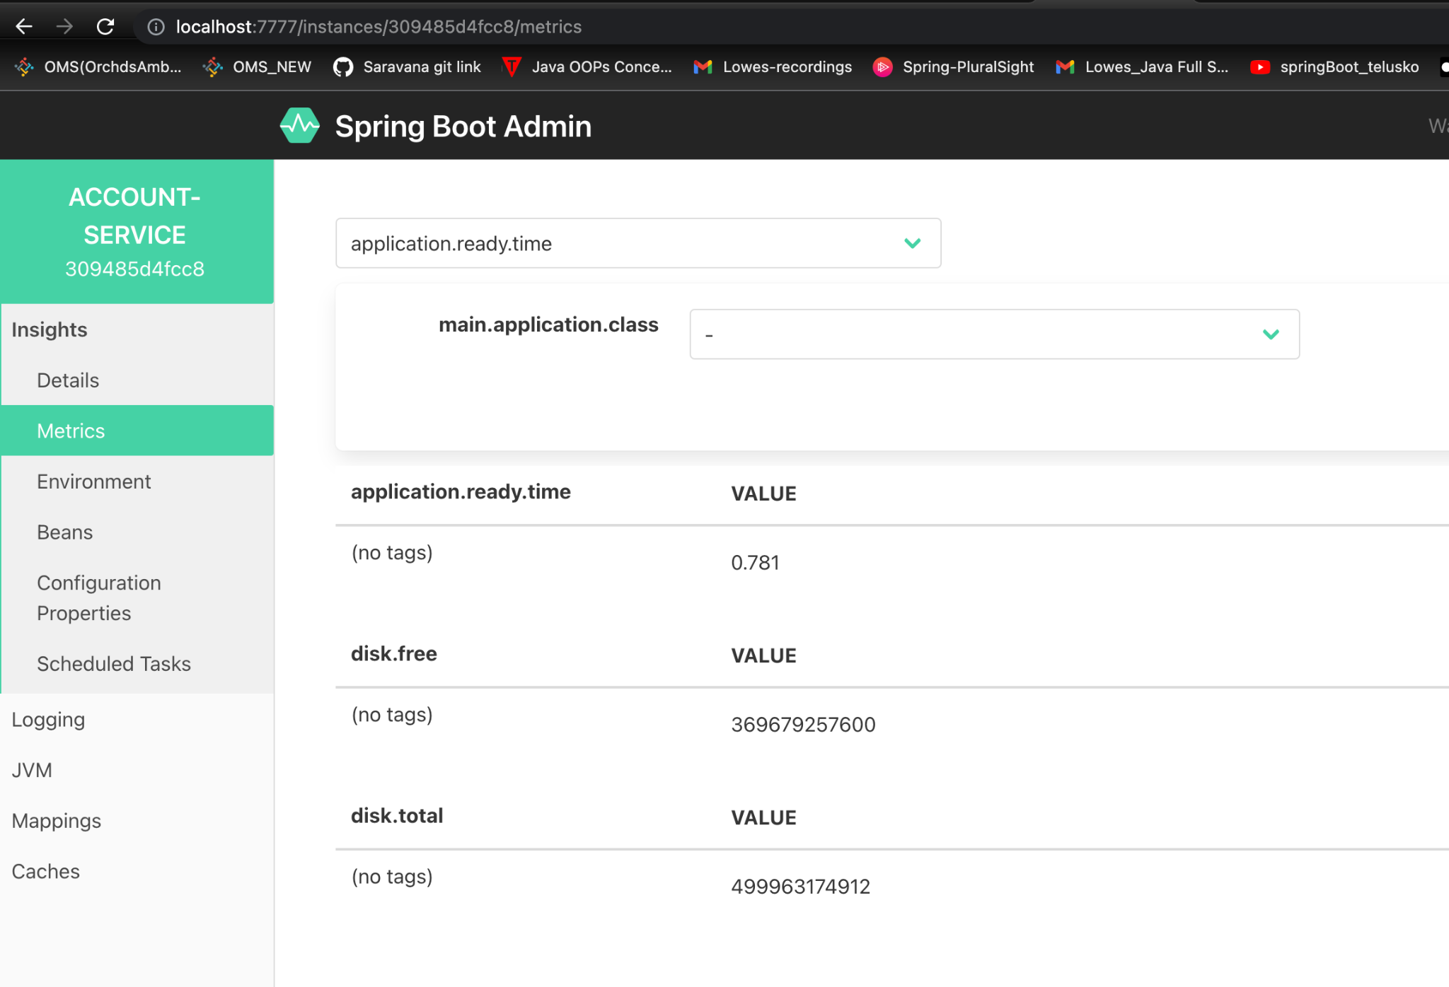

AdminService-AccountDetails

