1. Fund Transfer Success
   1. accountTableBeforeFundTransfer-success
   2. fundtransferInitiated-success
   3. transactionTableAfterFundTransfer-success
   4. accountTableAfterFundTransfer-success
2. Fund Transfer Rollback
   1. accountTableBeforeFundTransfer-rollback
   2. fundtransferInitiated-rollback
   3. transactionTableAfterFundTransfer-rollback
   4. accountTableAfterFundTransfer-rollback
3. Validation
4. ExceptionalHandling

Fund Transfer Success:

accountTableBeforeFundTransfer-success

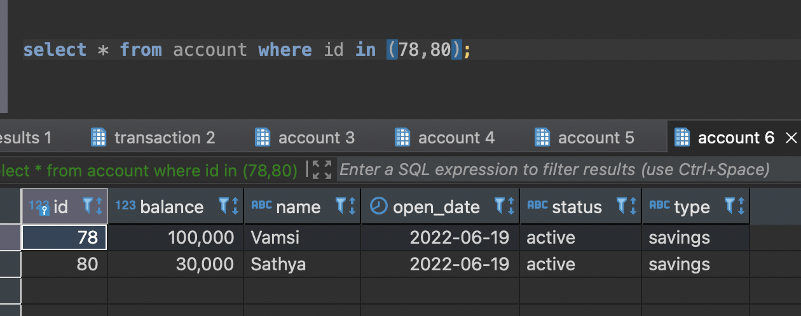

fundtransferInitiated-success

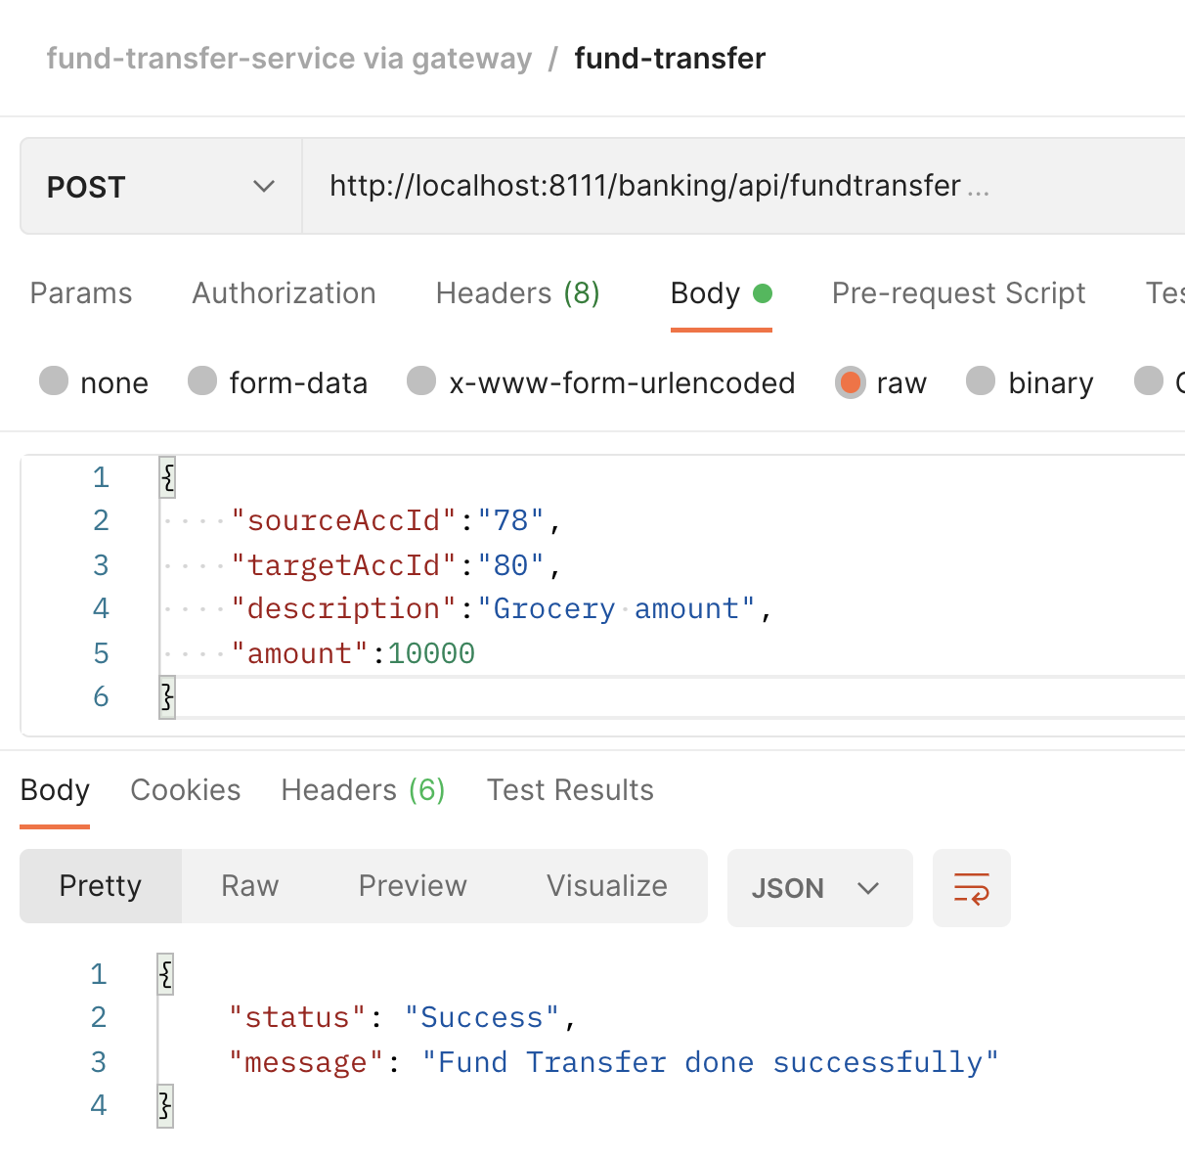

transactionTableAfterFundTransfer-success

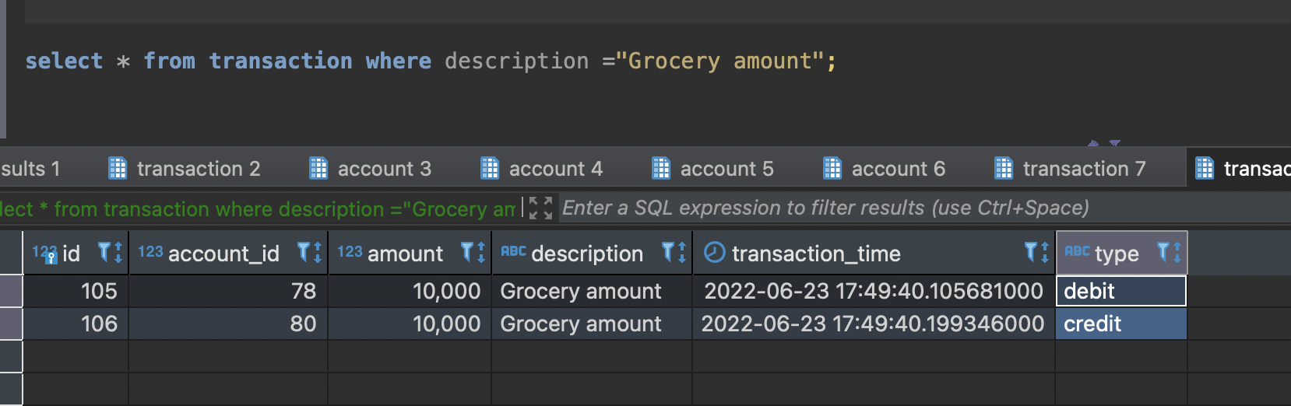

accountTableAfterFundTransfer-success

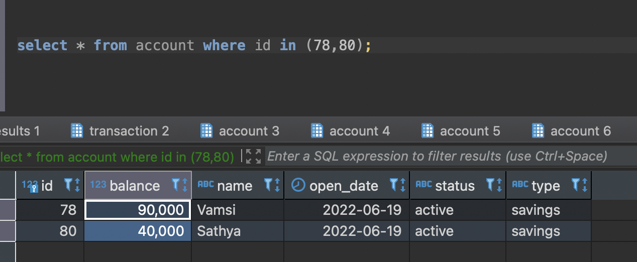

Fund Transfer Rollback:

accountTableBeforeFundTransfer-rollback

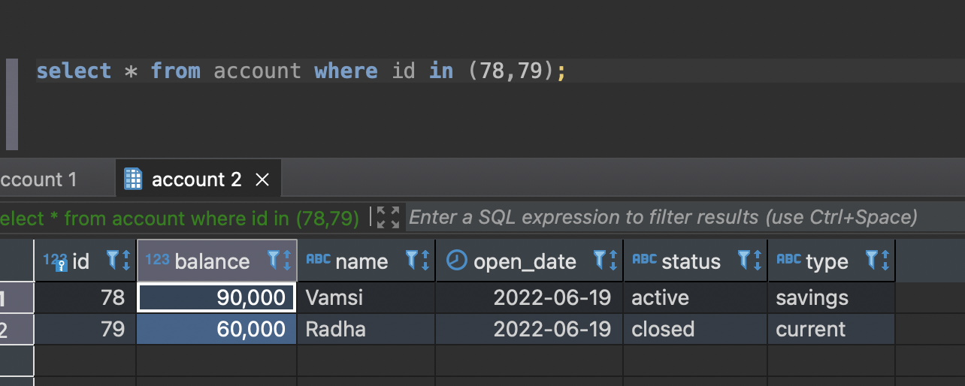

fundtransferInitiated-rollback

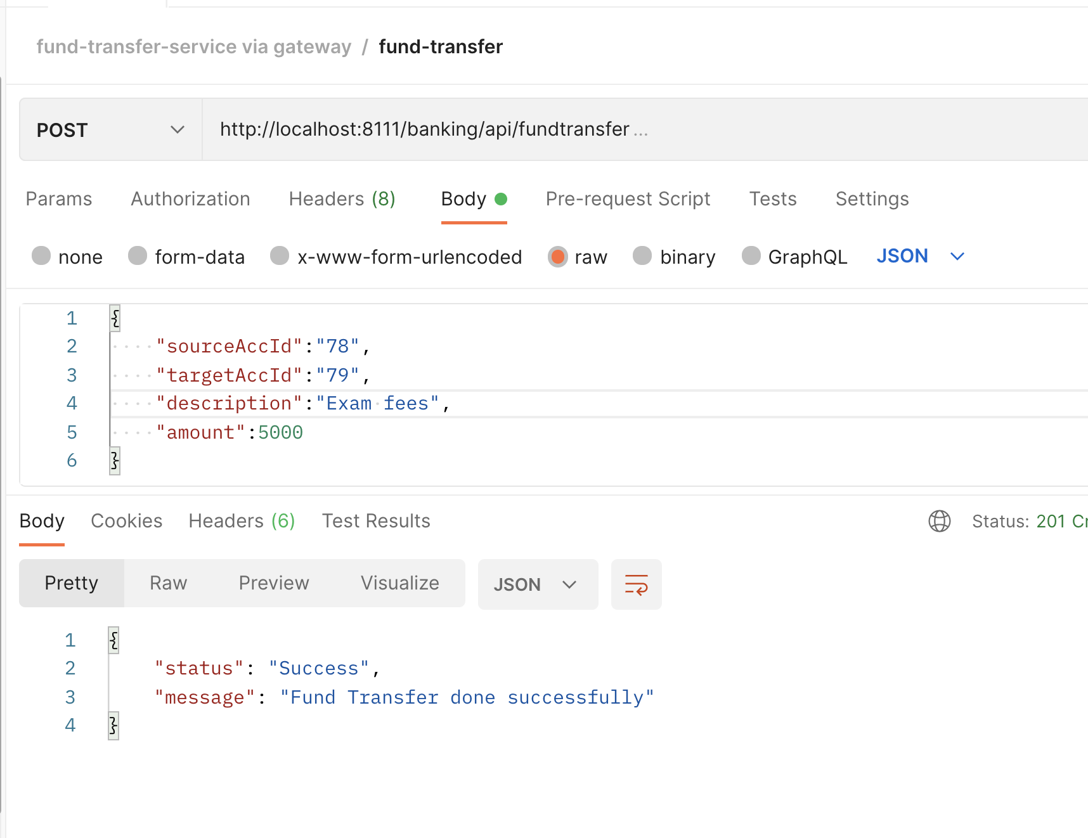

transactionTableAfterFundTransfer-rollback

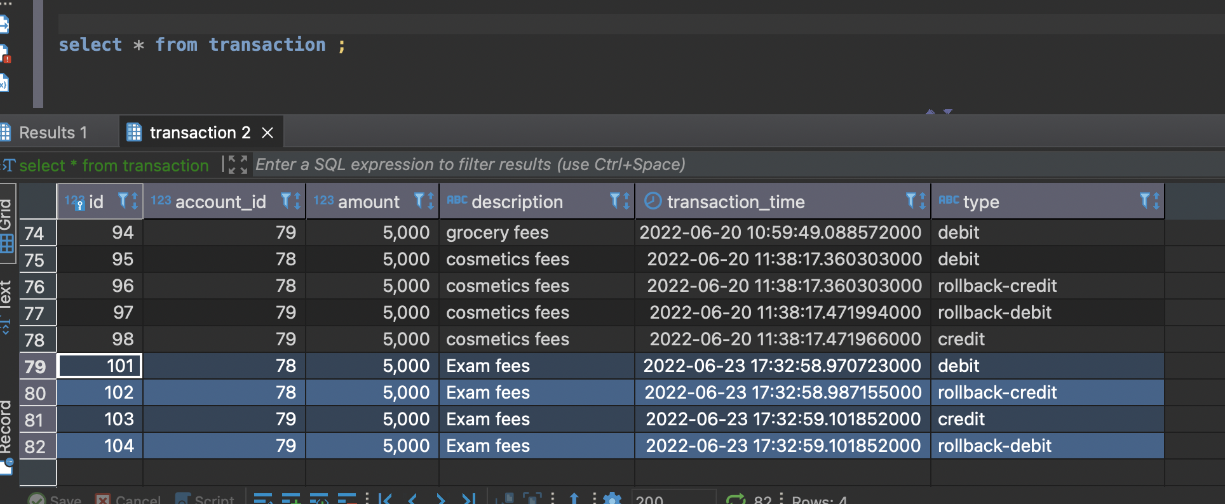

accountTableAfterFundTransfer-rollback

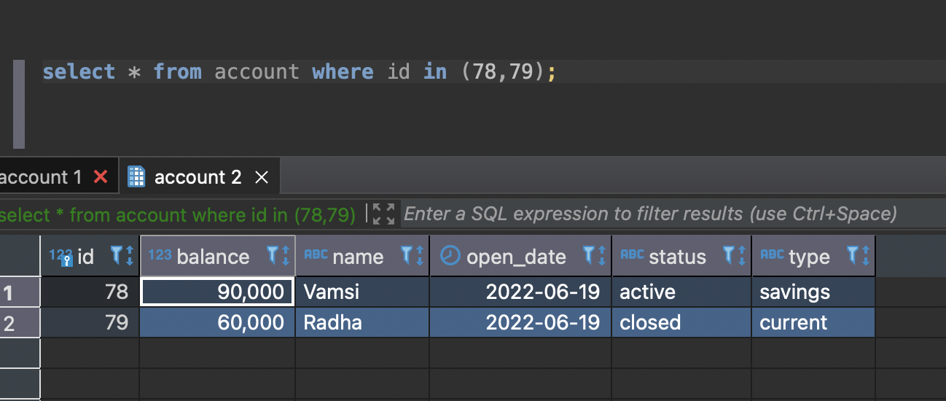

Validation

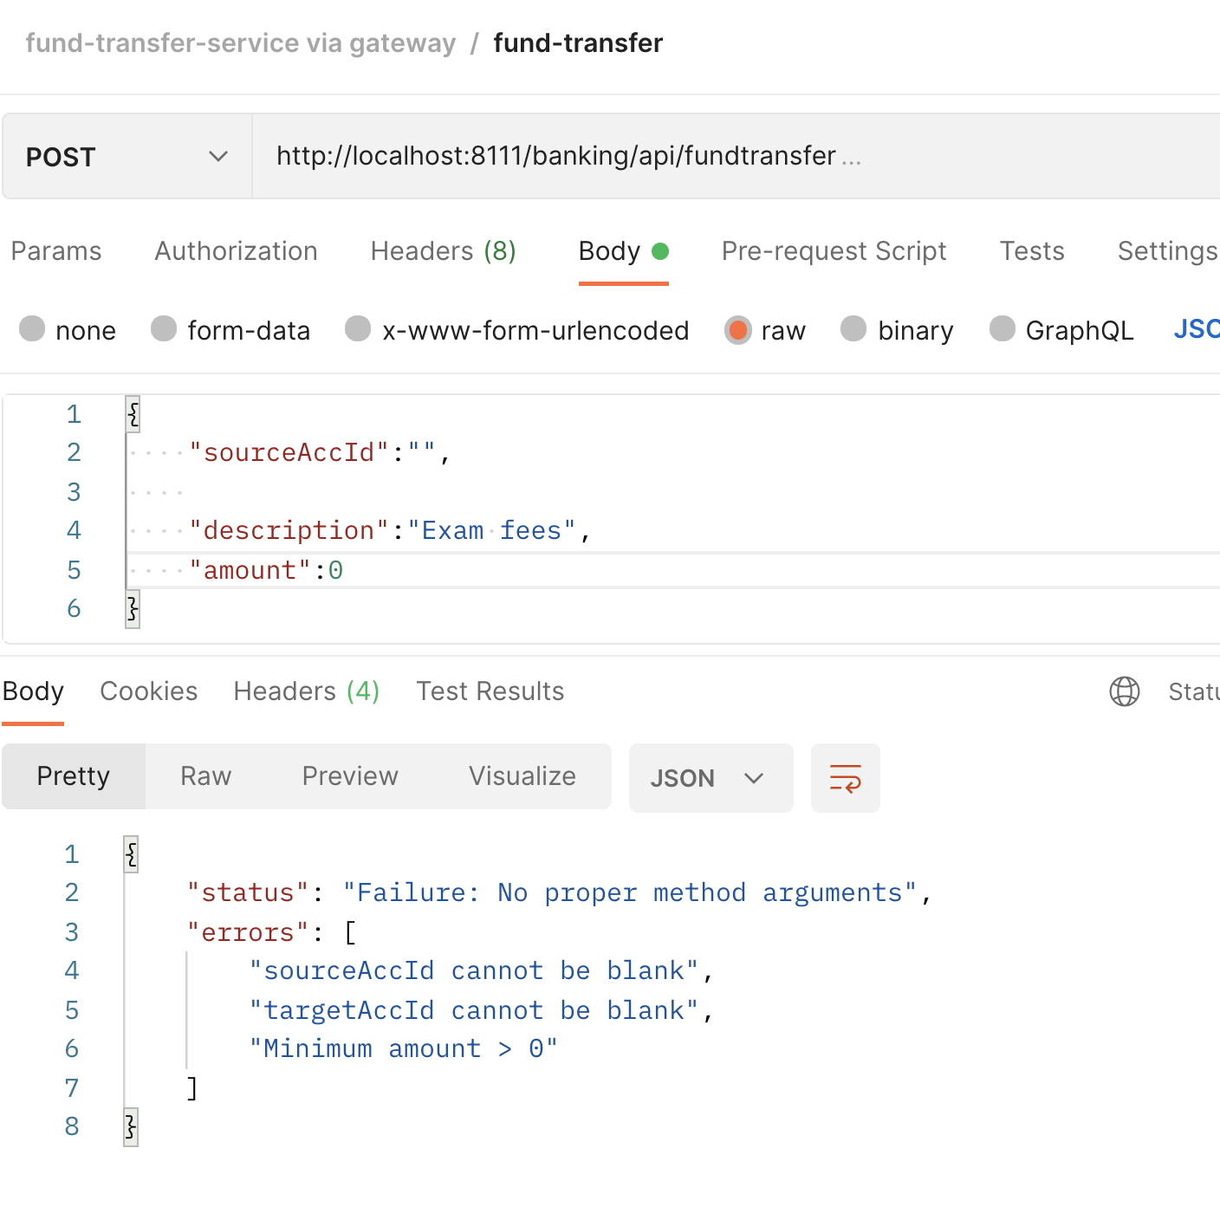

Exceptionalhandling

sourceAccountWithZeroBalance

