1. Validation on Update Request data
2. View transaction
   1. Exceptional Handling View transaction
3. Update transaction
4. Exceptional Handling Upd transaction
5. Delete transaction
6. Exceptional Handling Del transaction
7. View all transactions
8. ExceptionalHandling if no transaction in the table

Validation on Update Request data

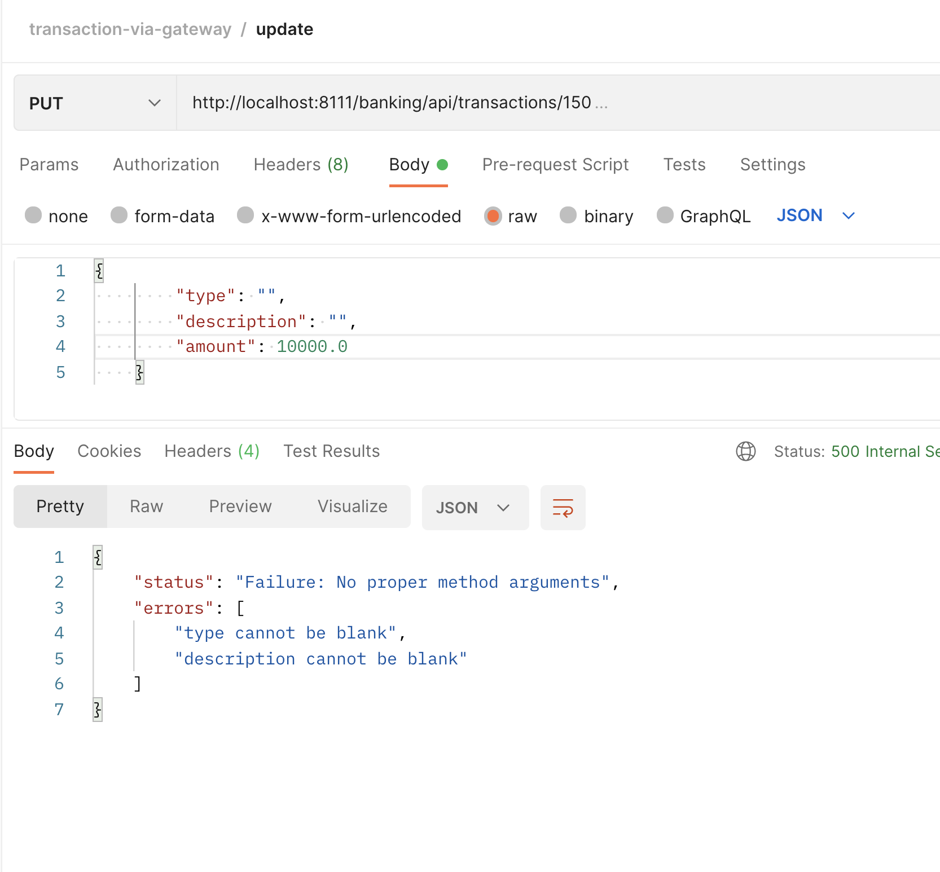

View transaction

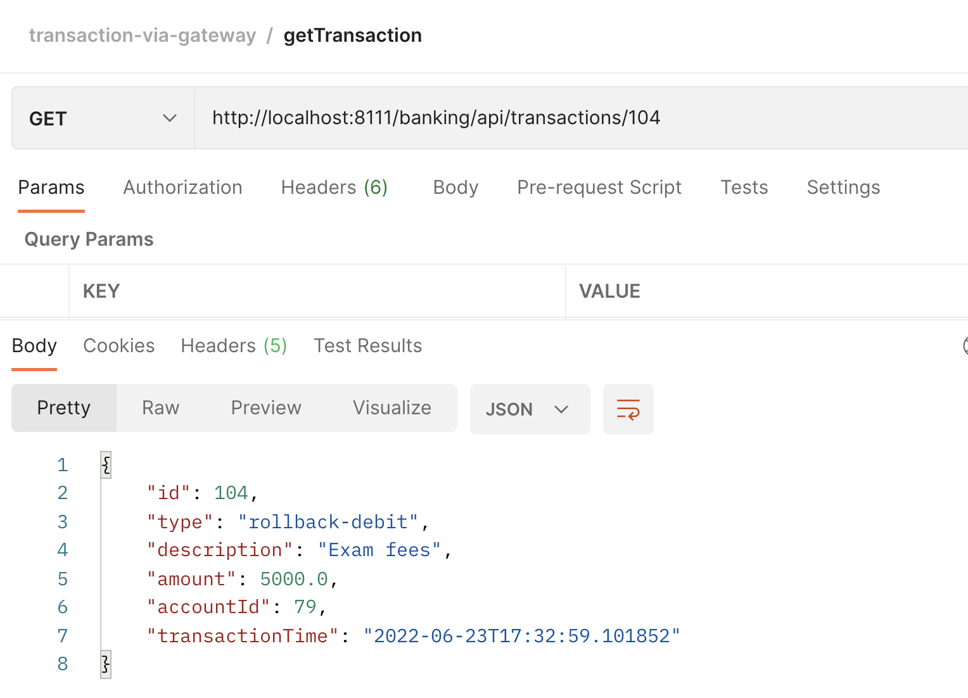

Exceptional Handling View transaction

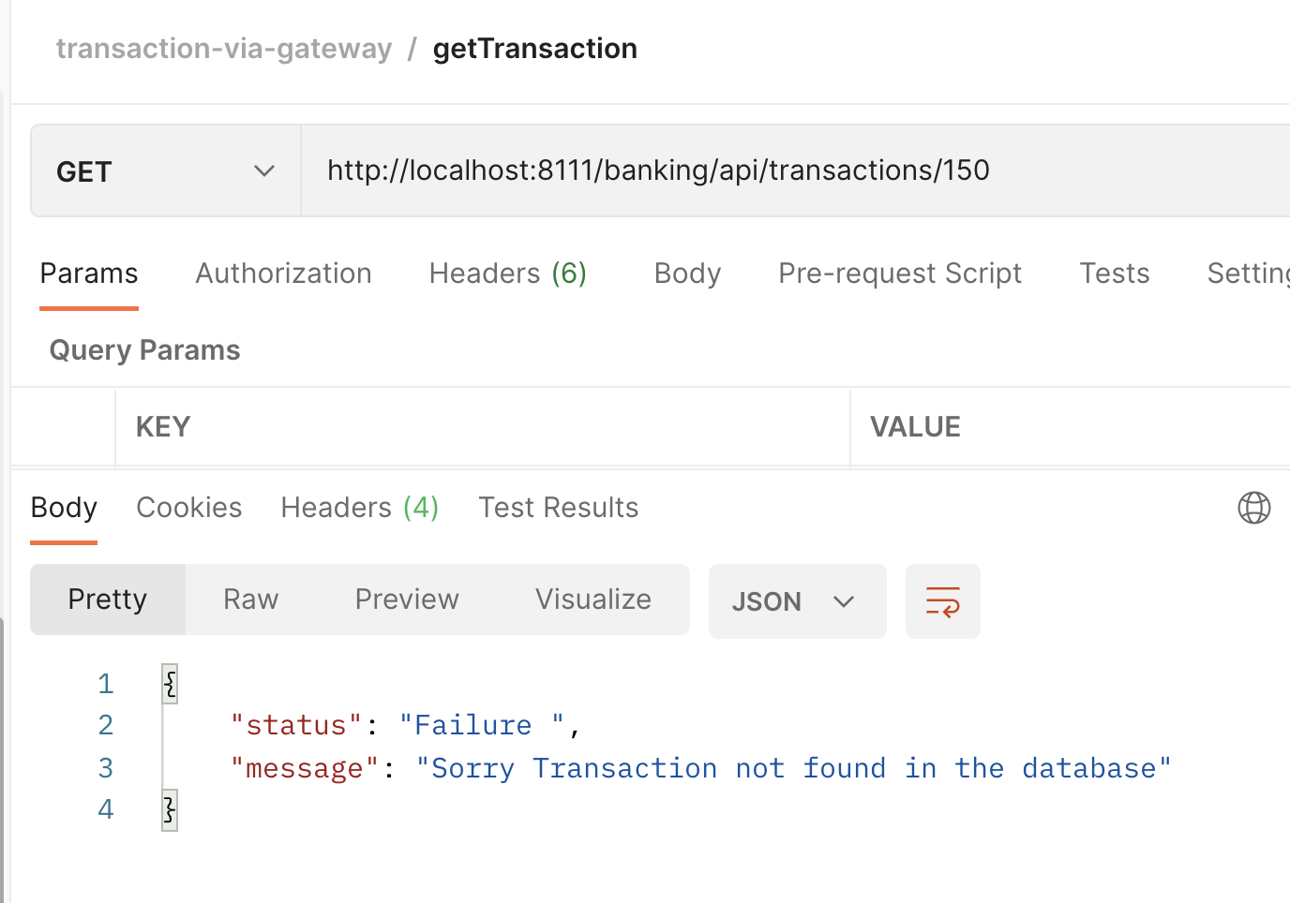

Update transaction

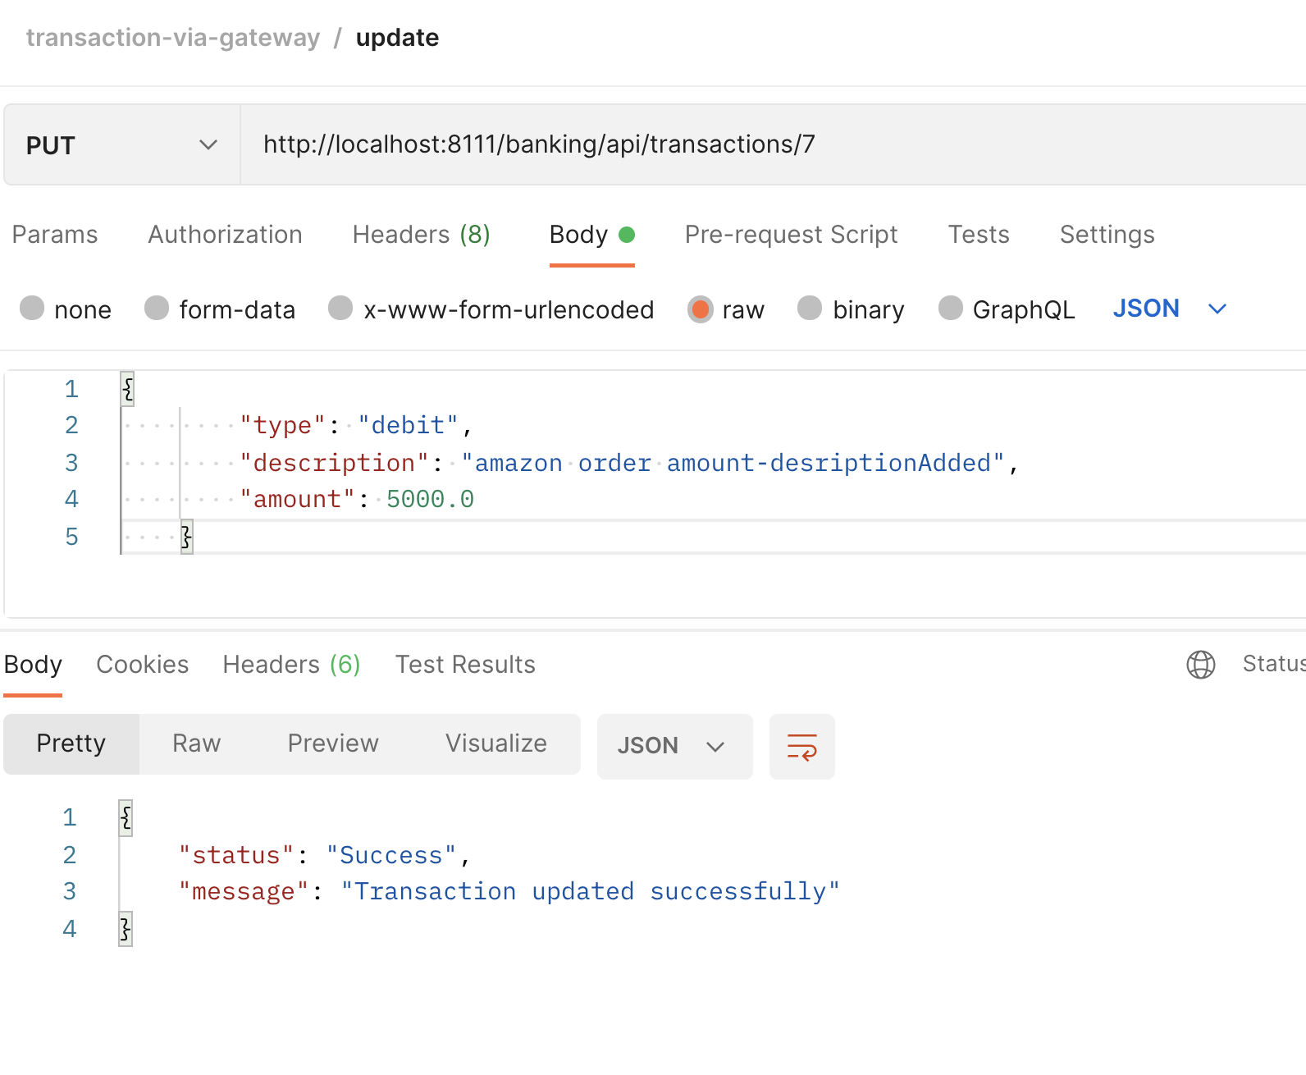

Exceptional Handling Upd transaction

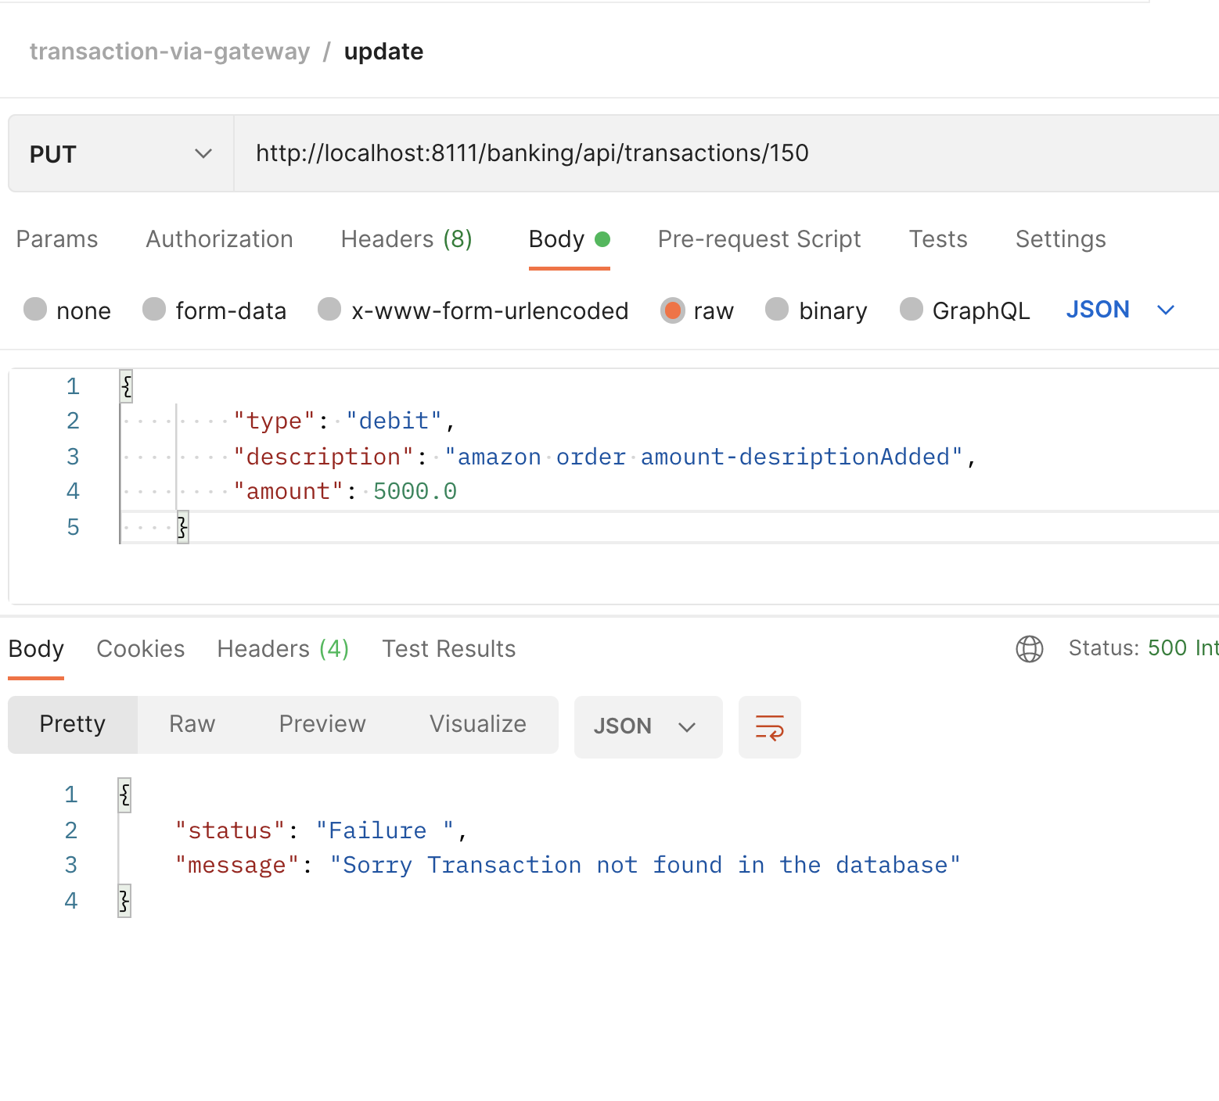

Delete transaction

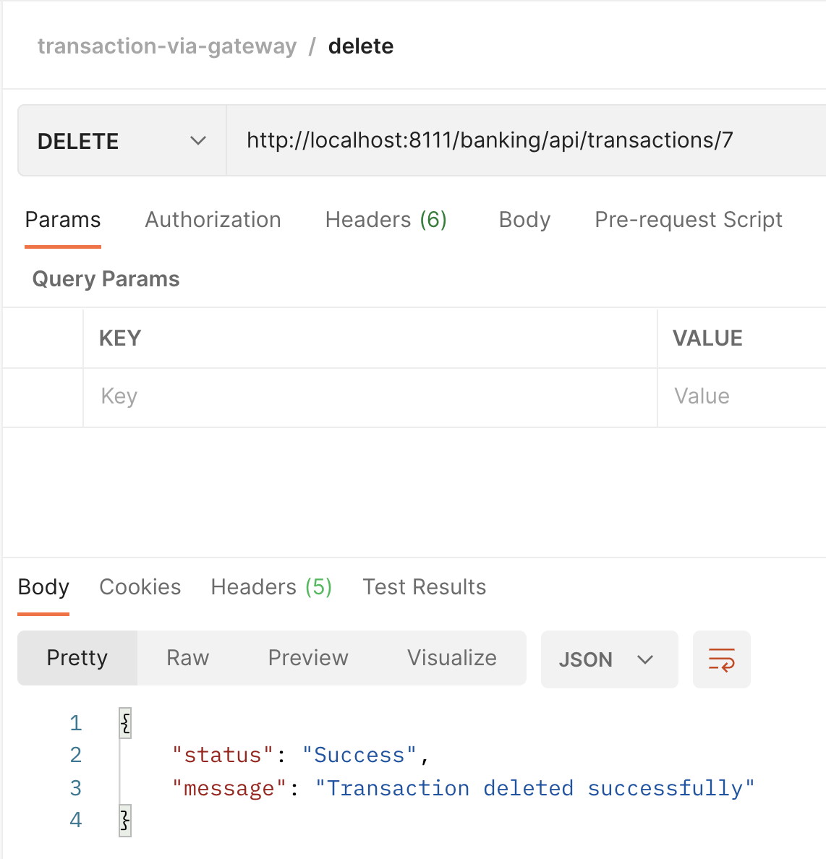

Exceptional Handling Del transaction

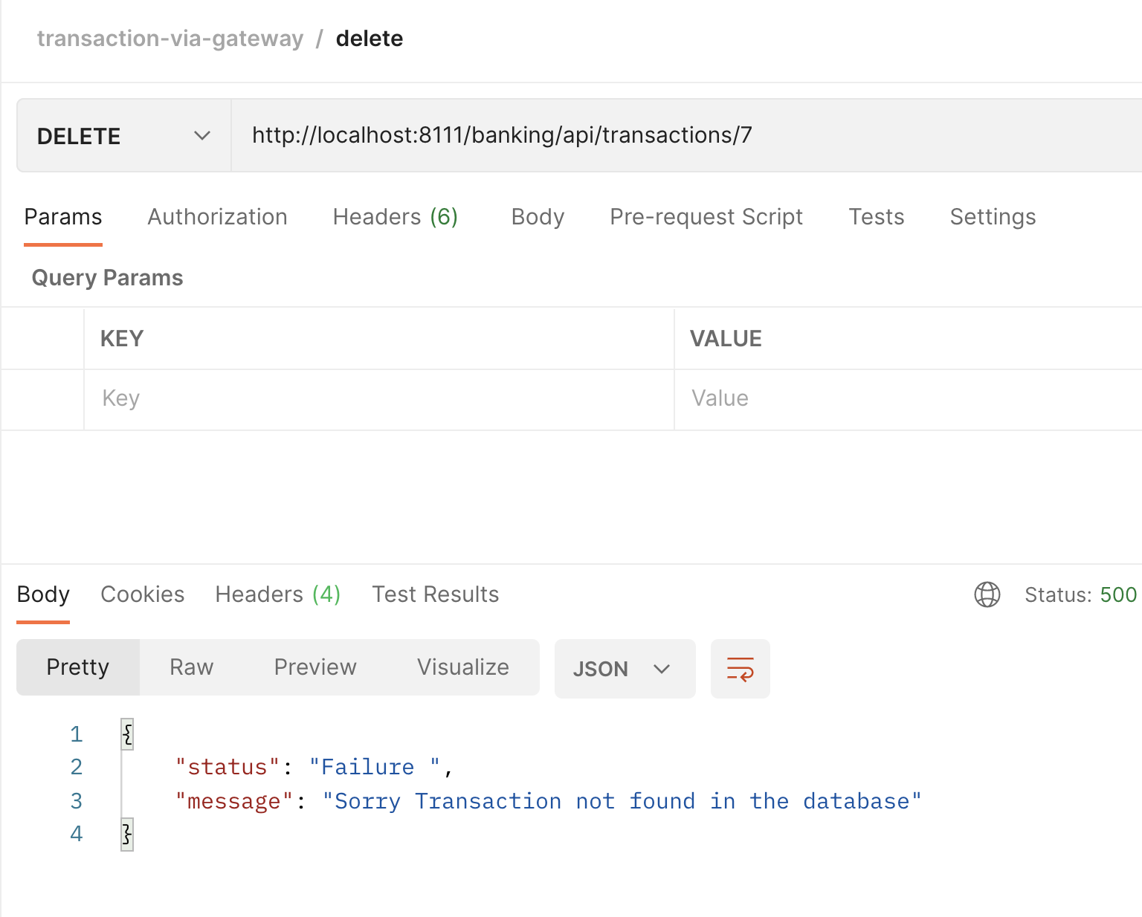

View all transactions

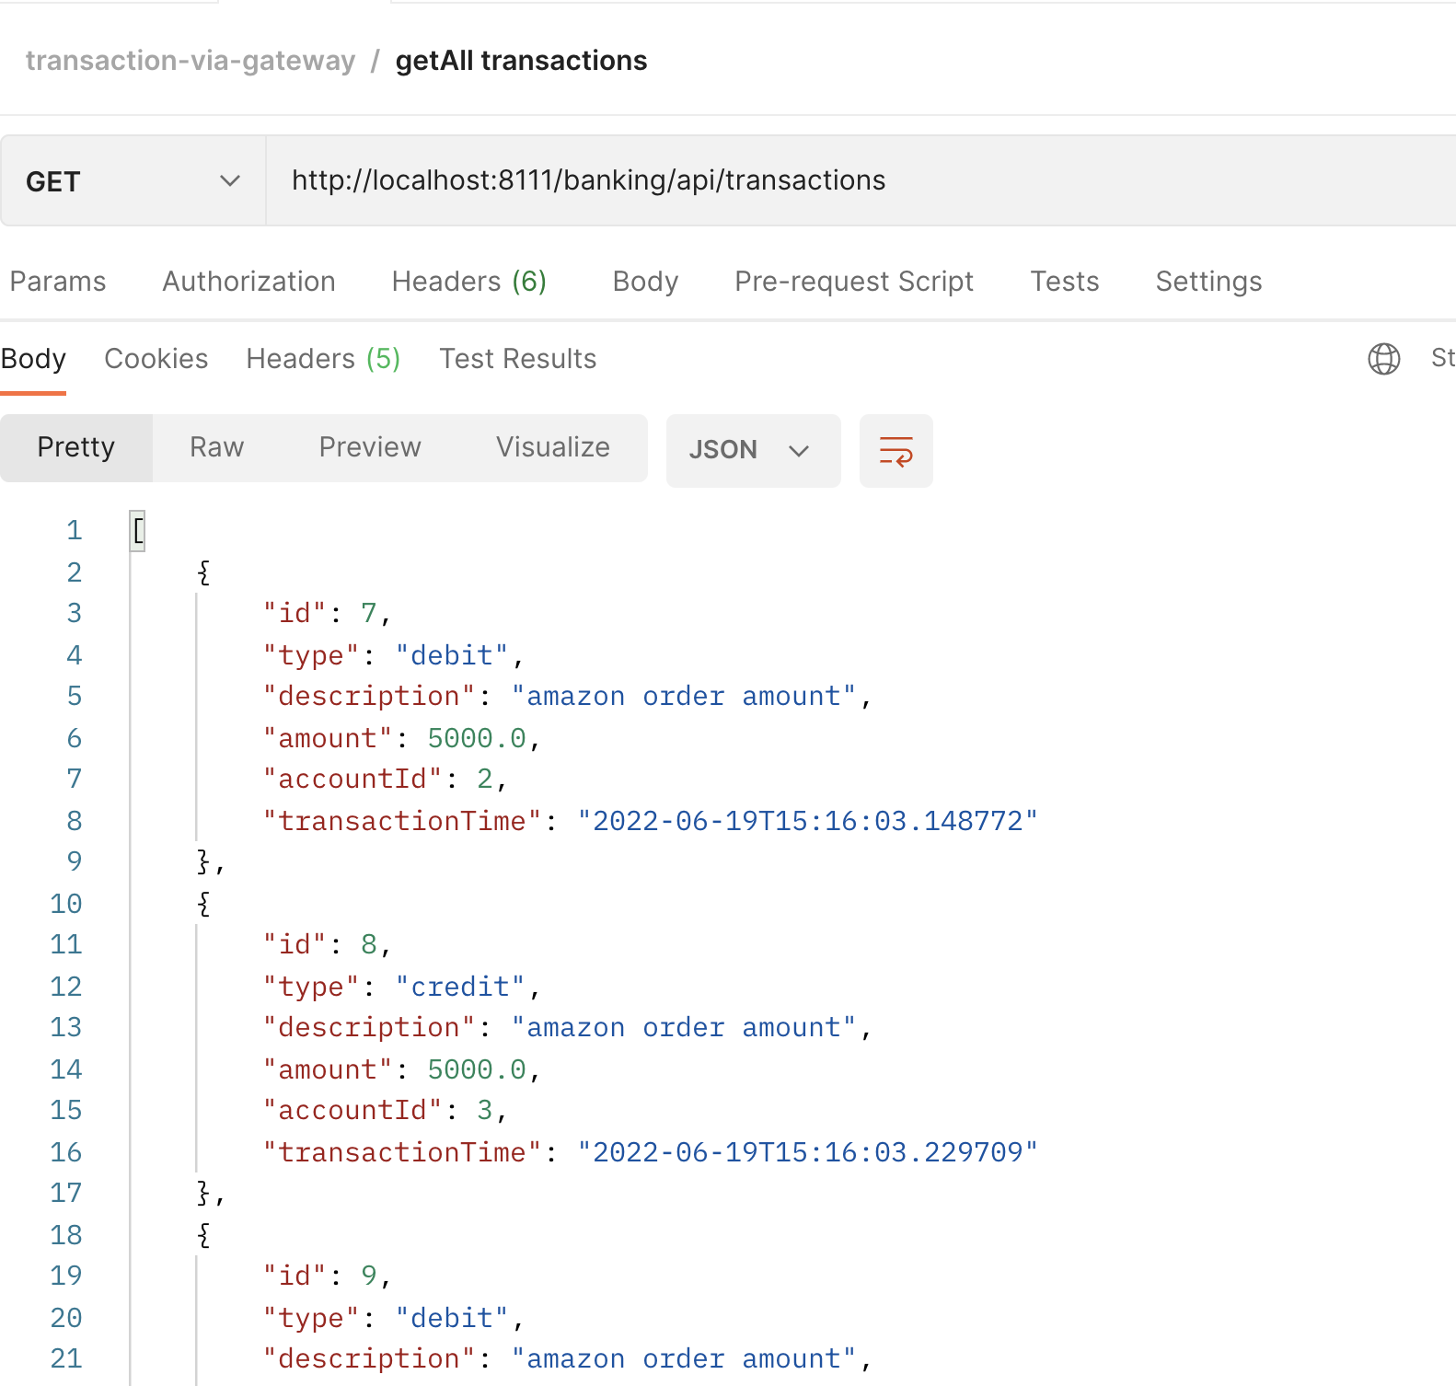

ExceptionalHandling if no transaction in the table

