**Employee-mgmt-with-arrays**

1. **Add Employee**

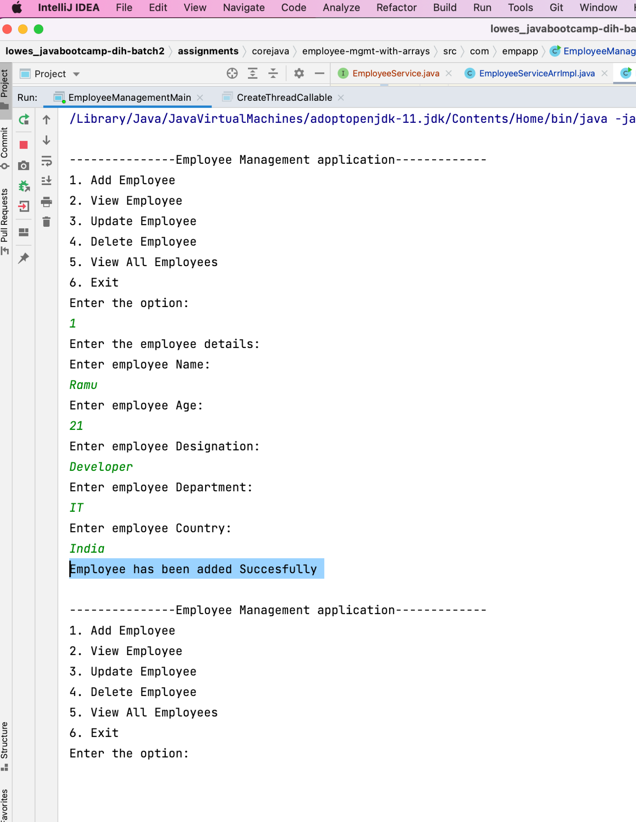

1. **View an Employee**

Handles InputMismatchException of empId and Employee not found Exception.

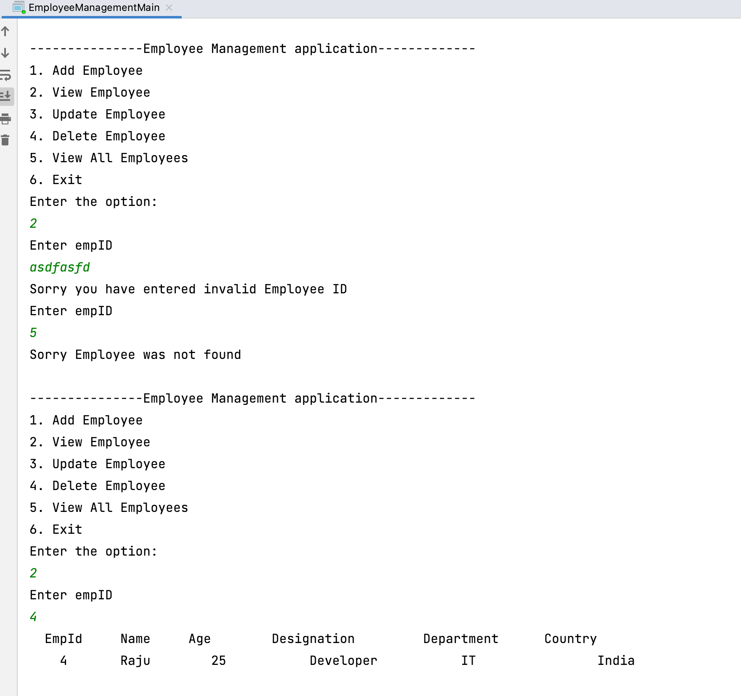

1. **Update an Employee**

Handles InputMismatchException of empId and Employee not found Exception.

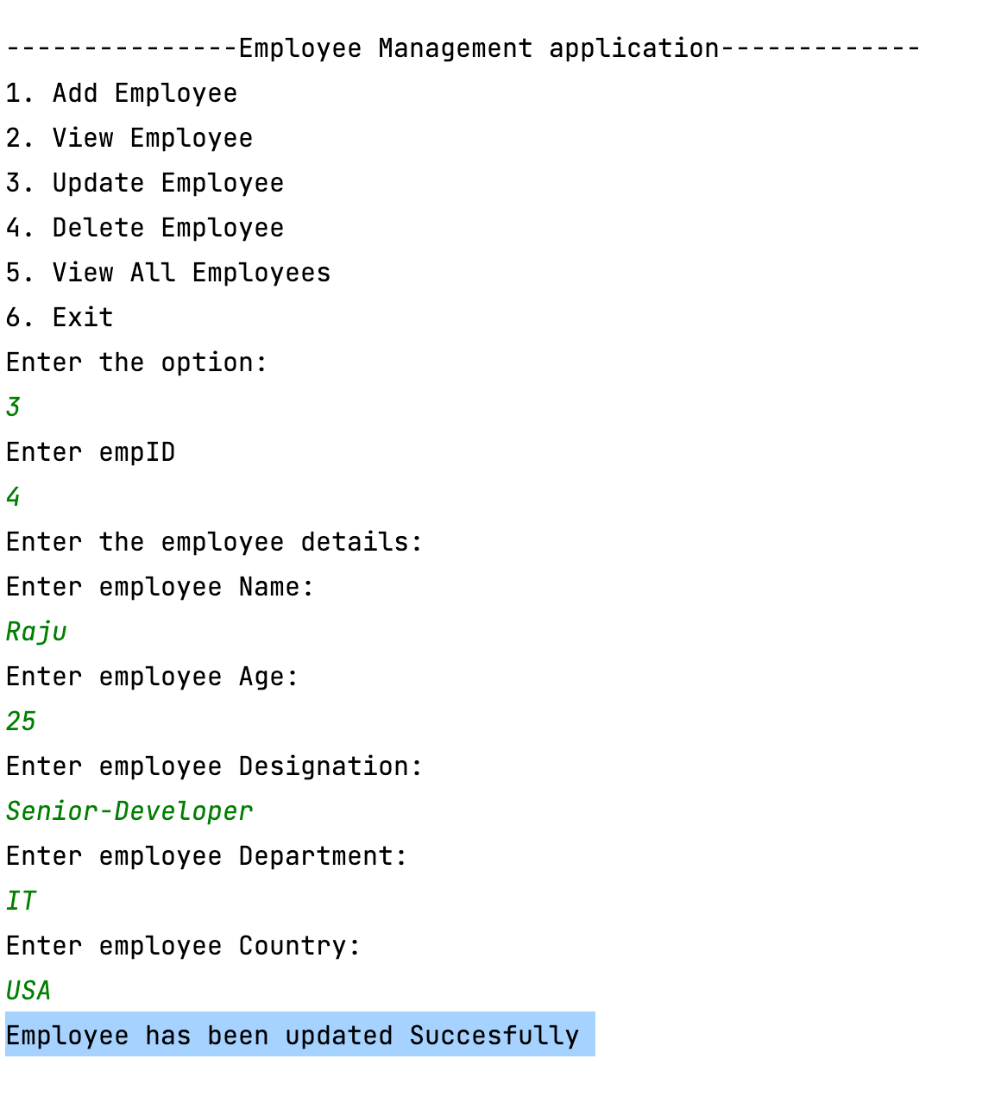

1. **Delete an Employee**

Handles InputMismatchException of empId and Employee not found Exception.

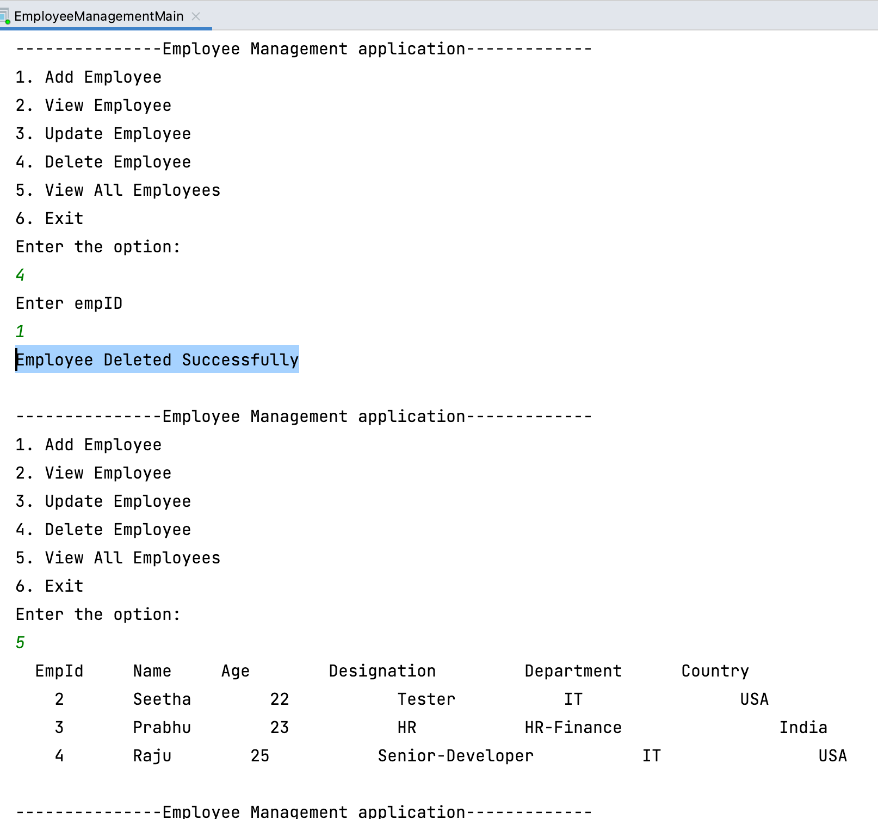

1. **View all Employees** 