1. Add Employee
2. Validation on Age, Salary, DOJ
3. View Employee
   1. Exceptional Handling View Emp
4. Update employee
5. Exceptional Handling Upd emp
6. Delete employee
7. Exceptional Handling Del emp
8. View all employees
9. Print Statistics
10. BulkImport
11. BulkExport

Add employee

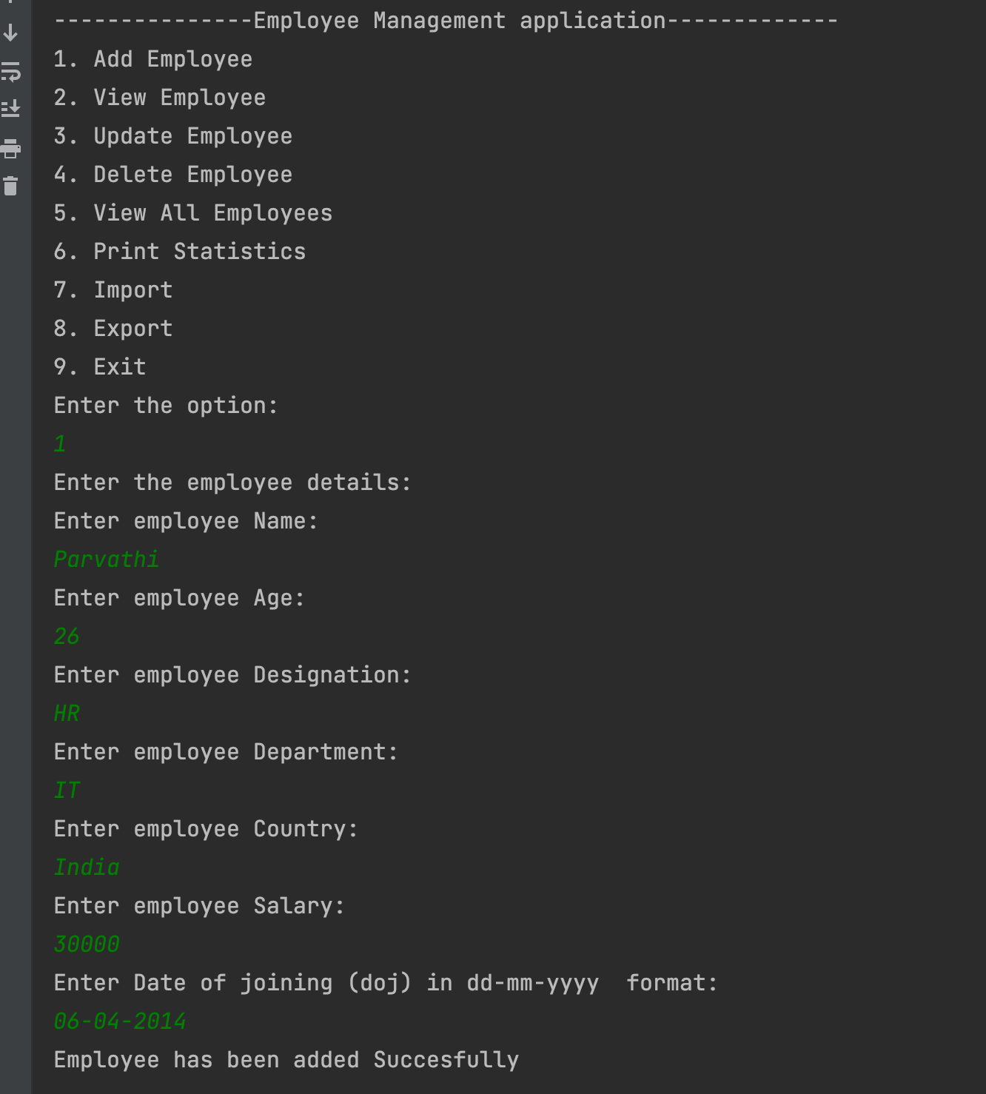

Validation on Age, Salary, DOJ

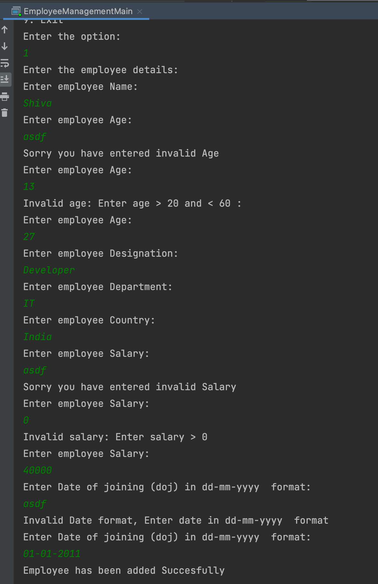

View Employee

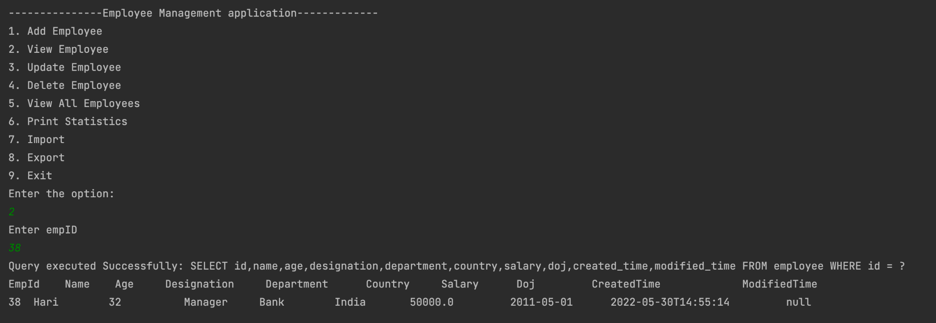

Exceptional Handling View Emp

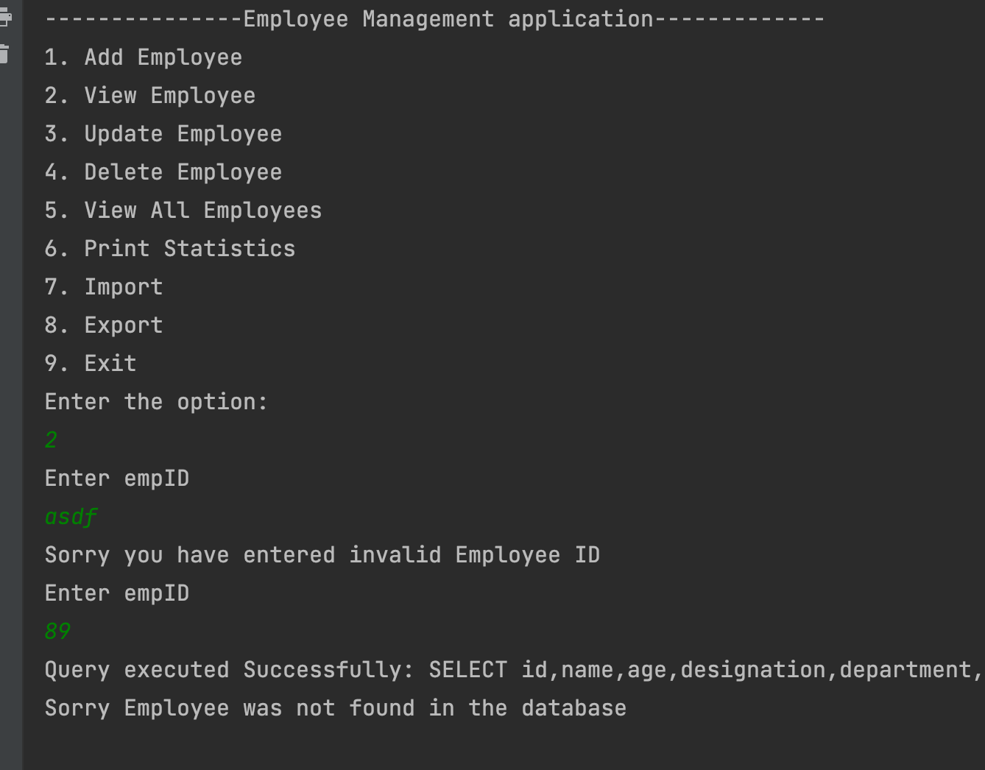

Update employee

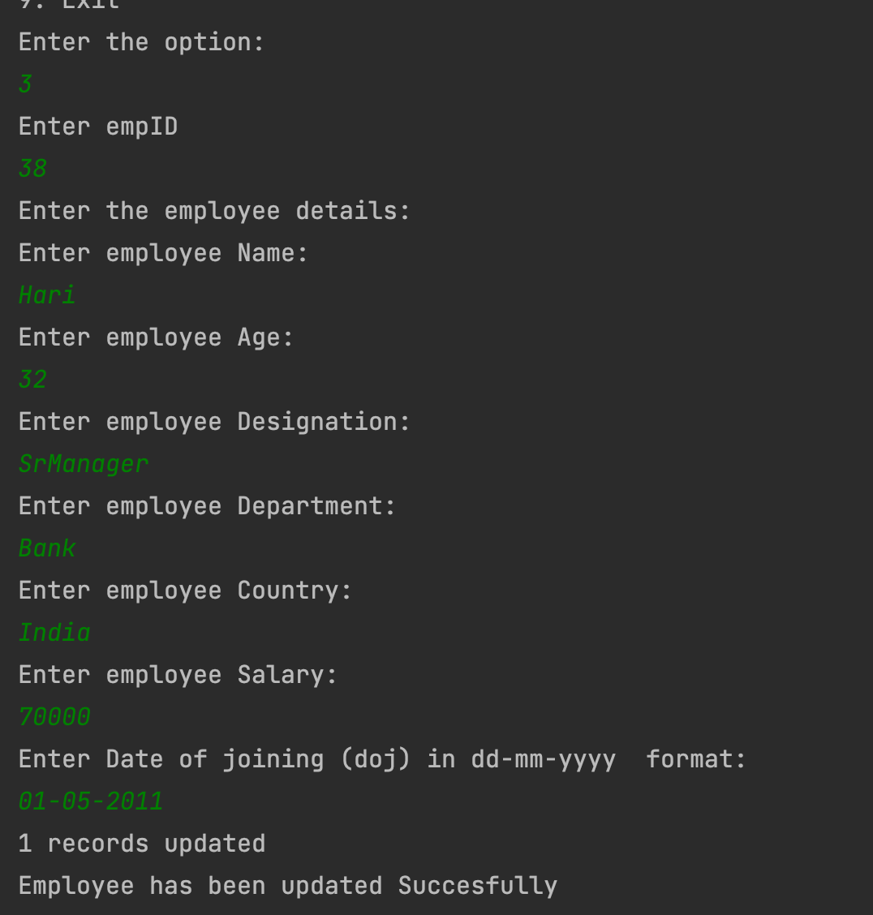

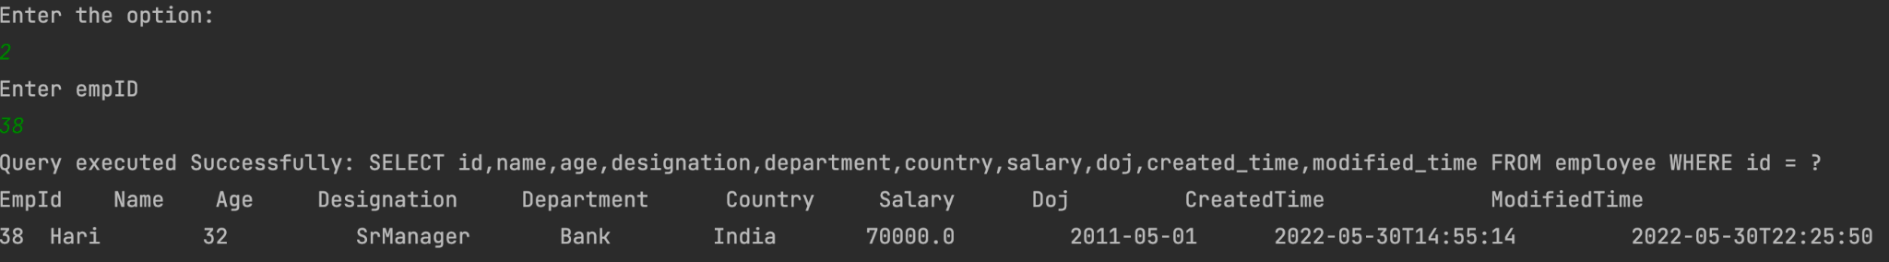

Exceptional Handling Upd emp

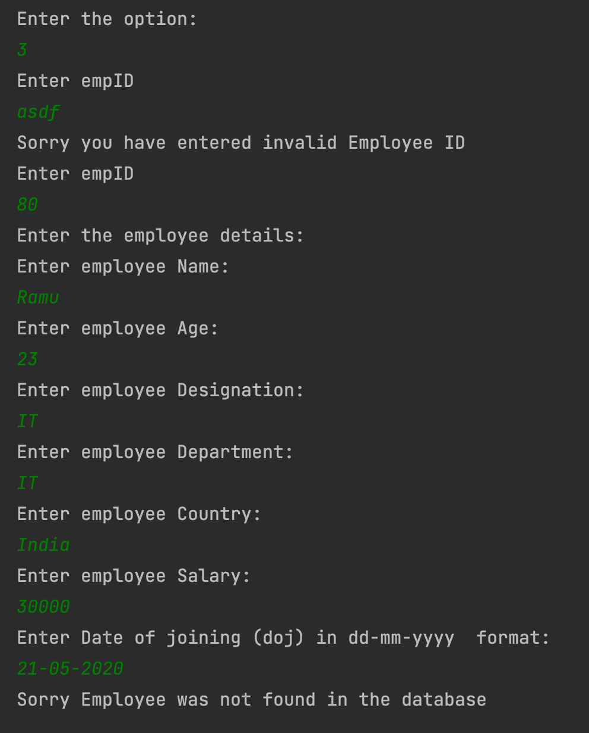

Delete employee

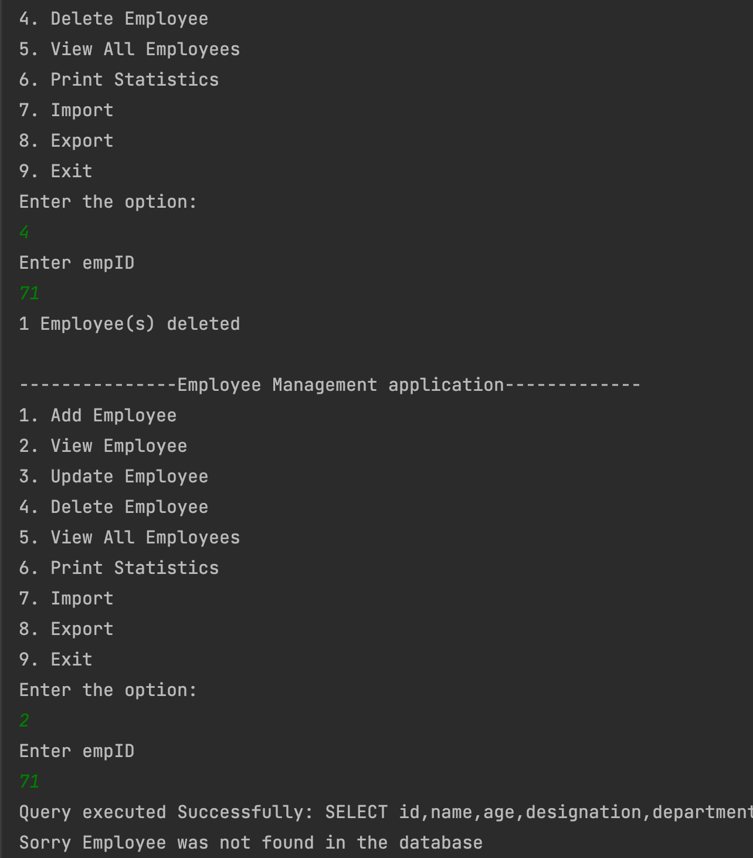

Exceptional Handling Del emp

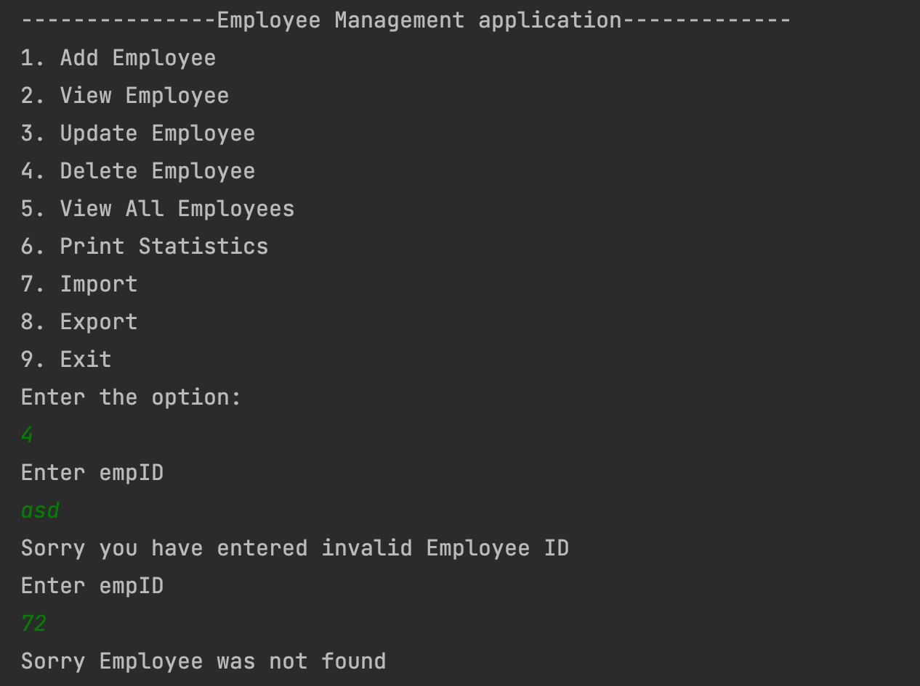

View all employees

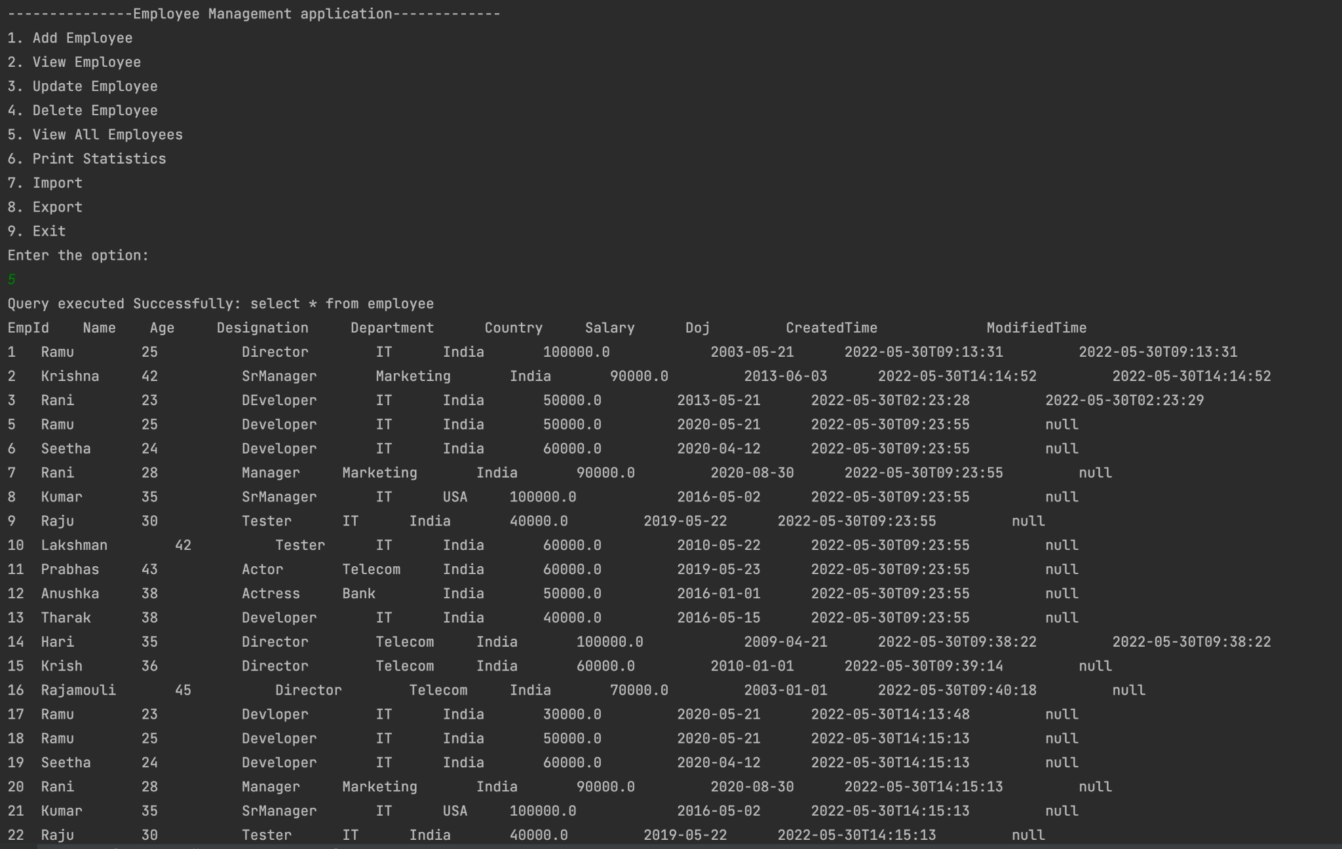

Print Statistics

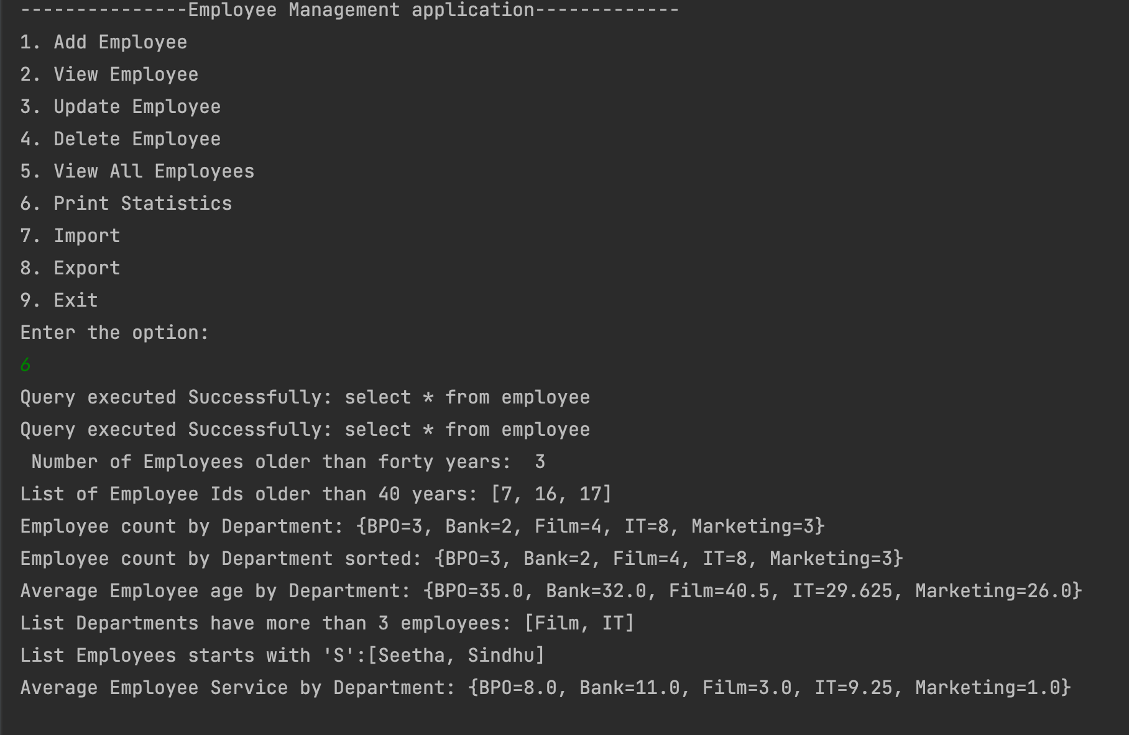

Bulk Import

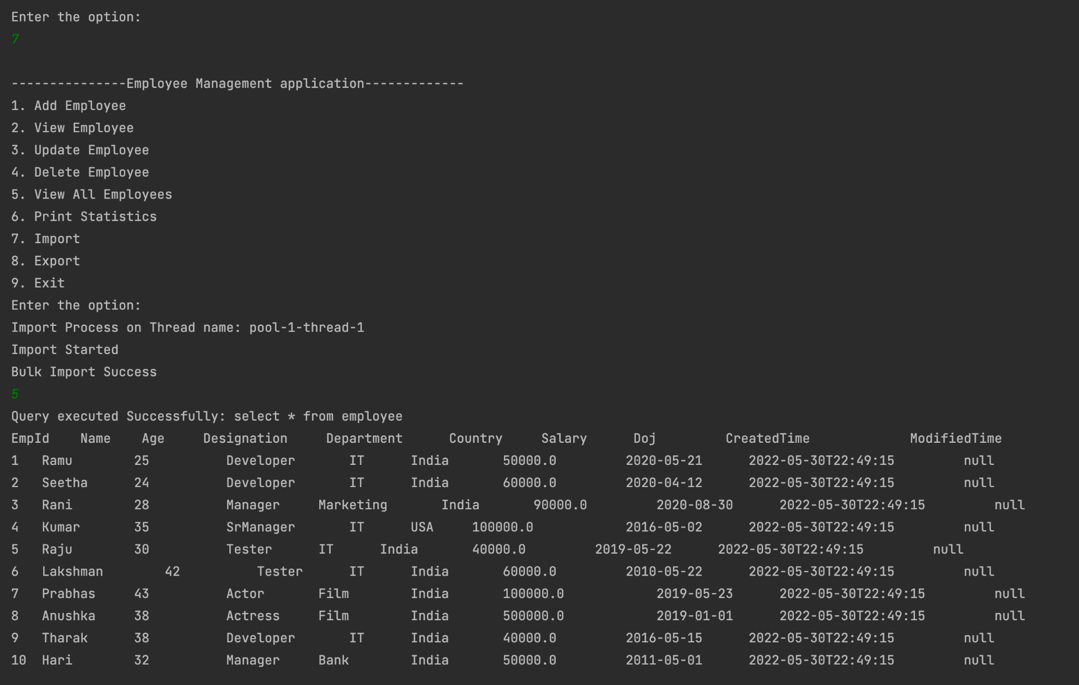

Bulk Export

