1. Home Page
2. User-registration-page
   1. user-register-success
   2. user-addedToTable
3. userLogin-success
4. add employee
5. addedEmployeeInTable
6. List employees
7. Delete employee
8. deletedRecord-intable
9. UpdateEmp
10. updatedEmp-page
11. updatedEmp-in table

Home Page 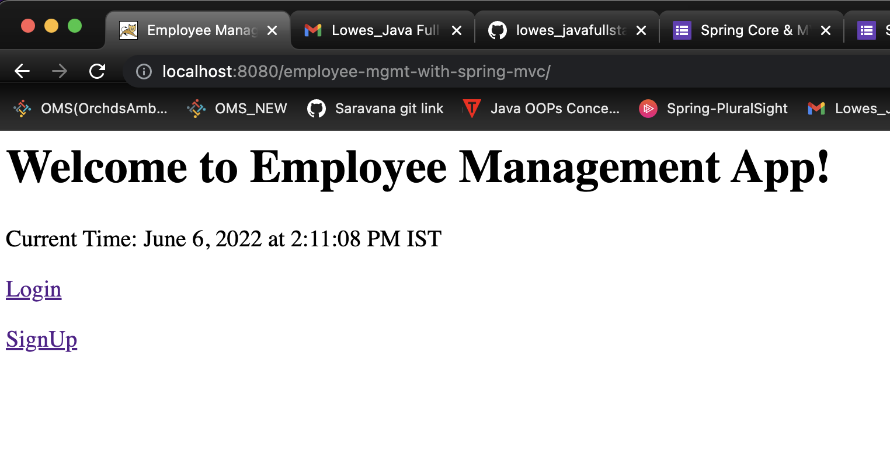

User-registration page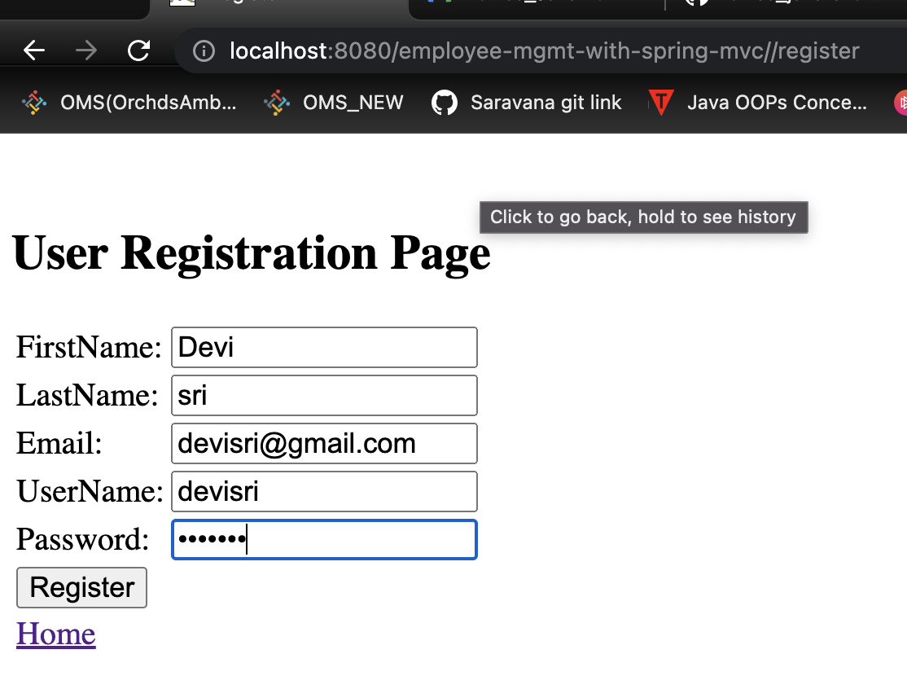

User-register-success 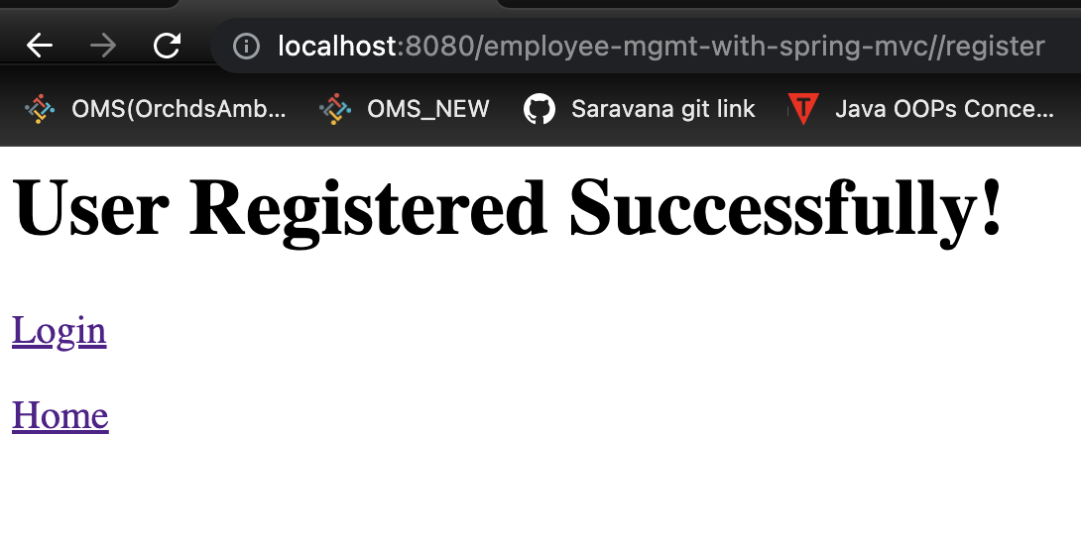

user-addedToTable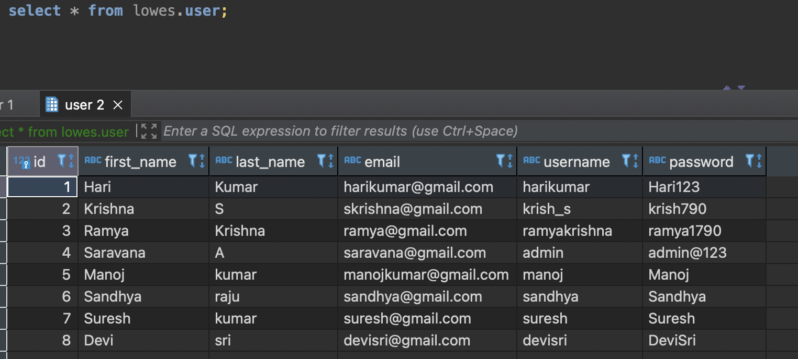

userLogin-success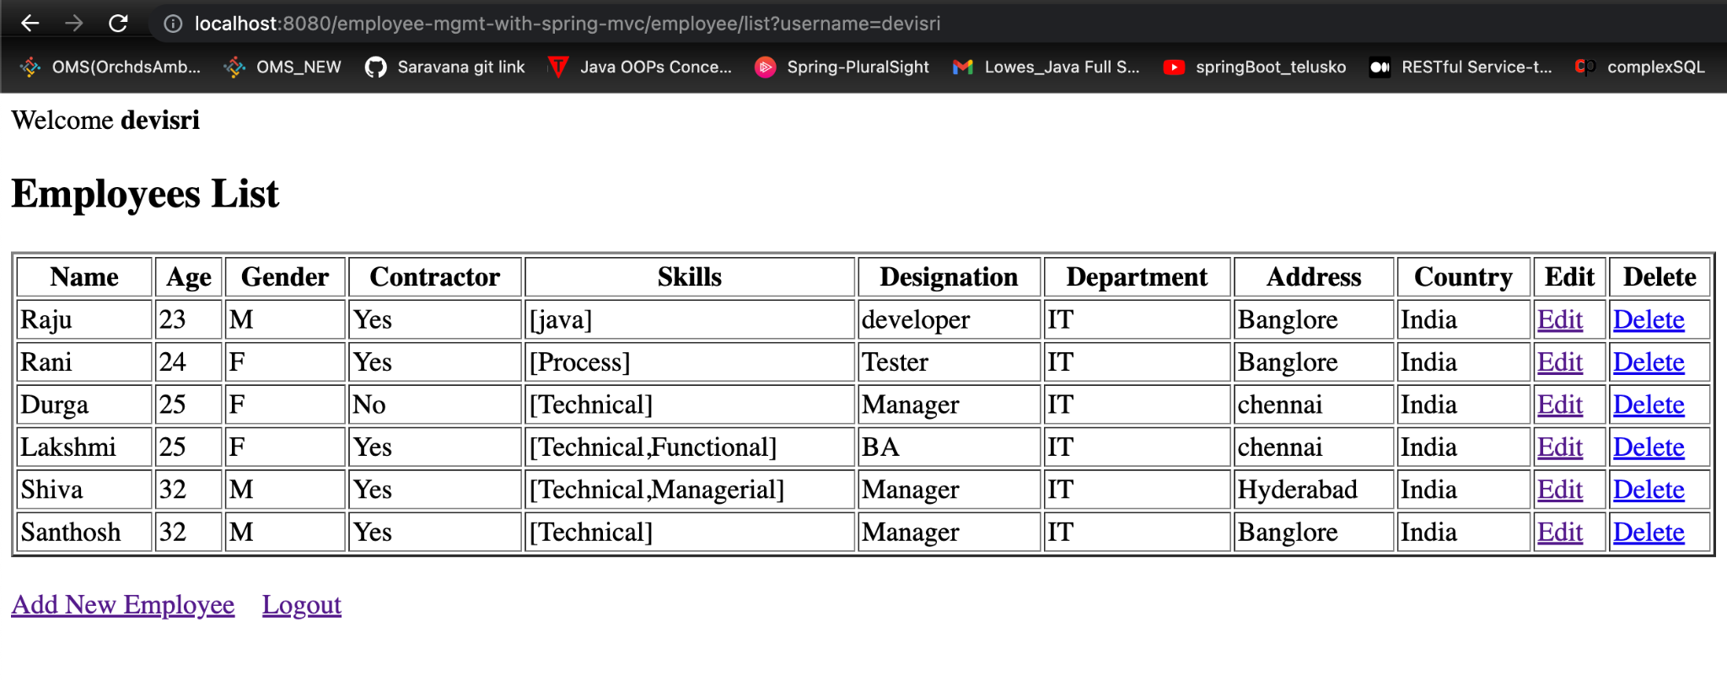

Add Employee 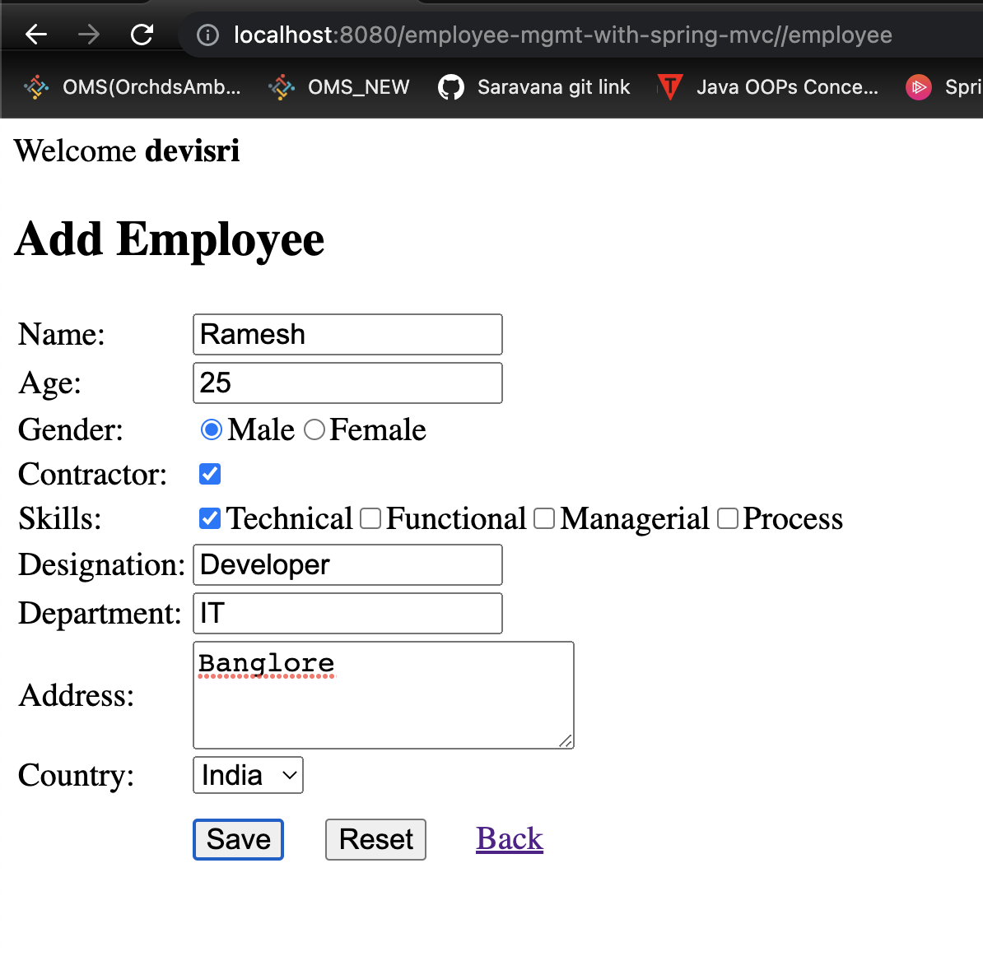

addedEmployeeInTable 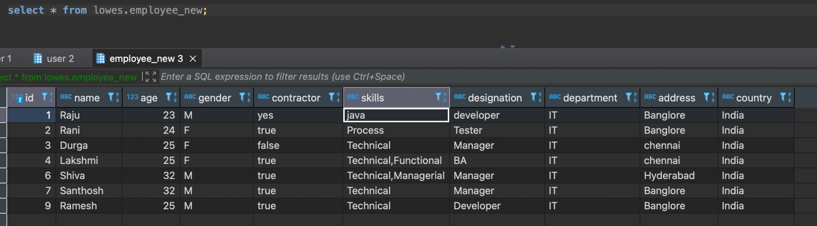

List employees

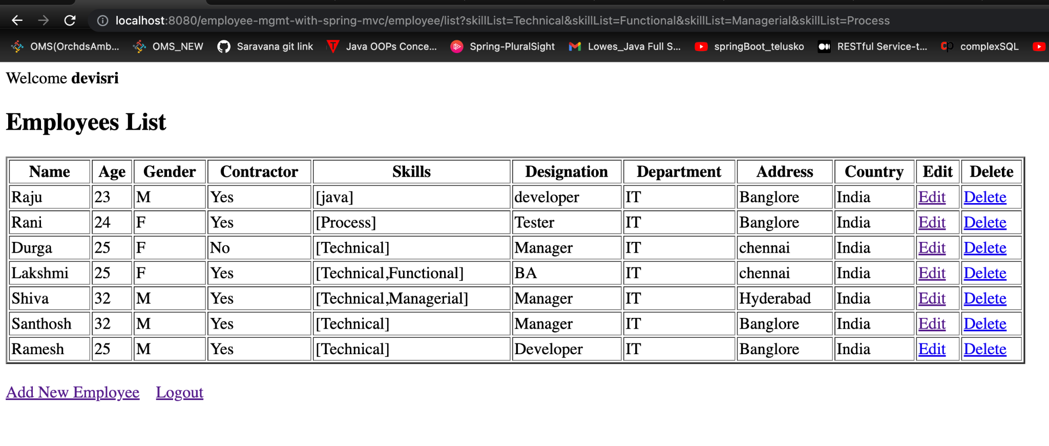

Delete employee 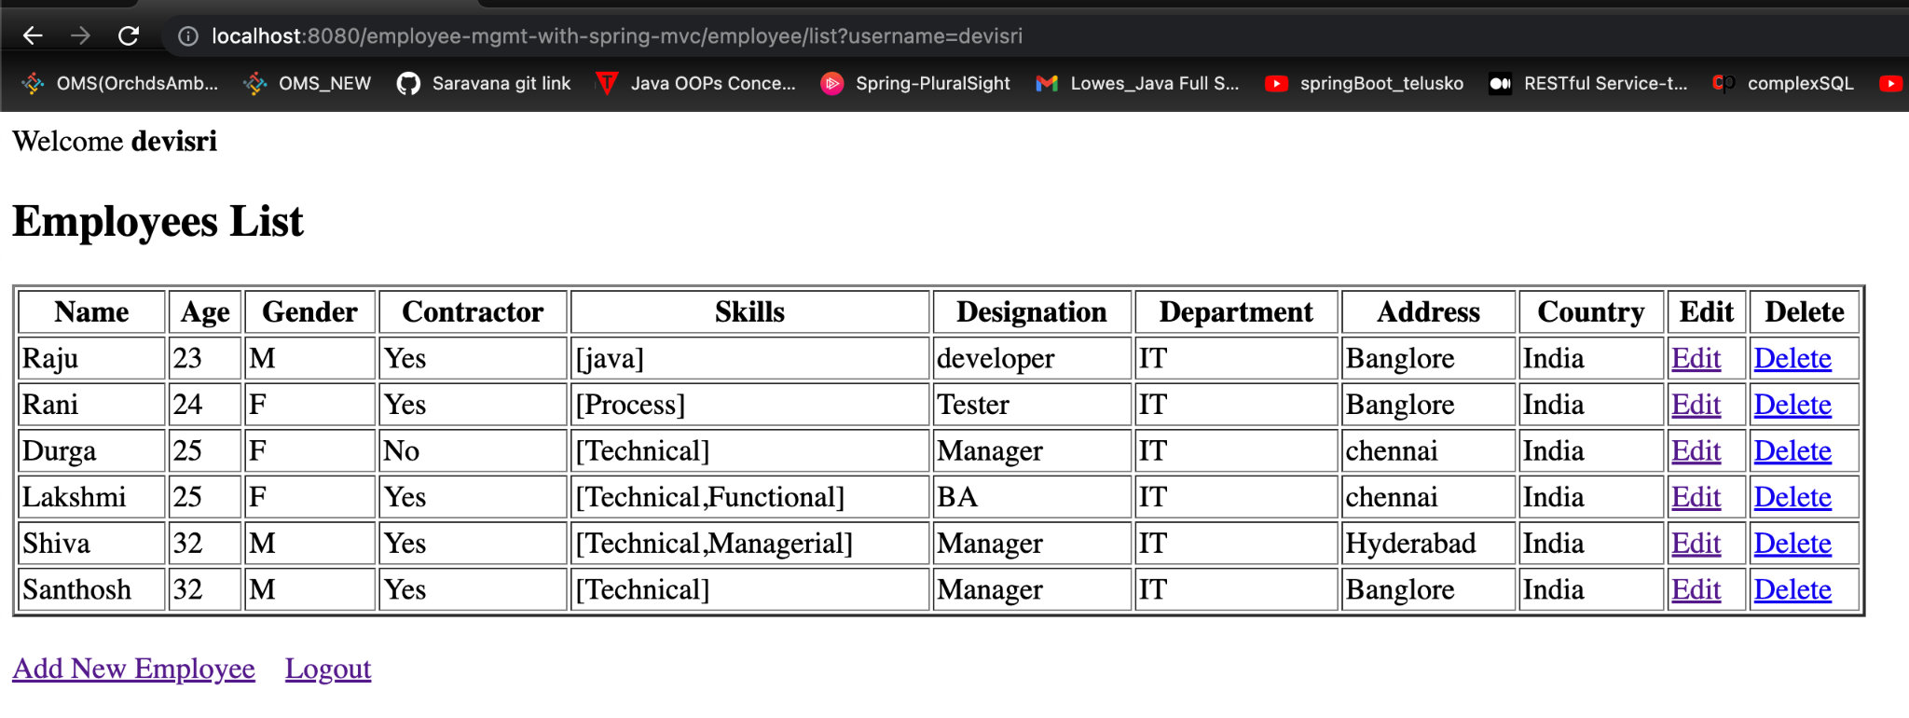

deletedRecord-intable 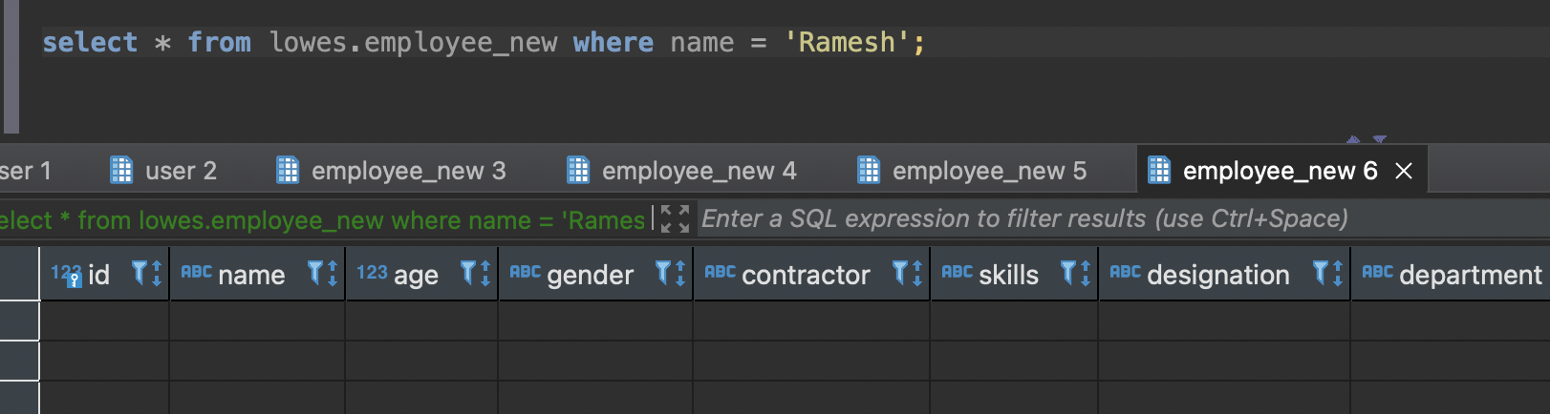

UpdateEmp 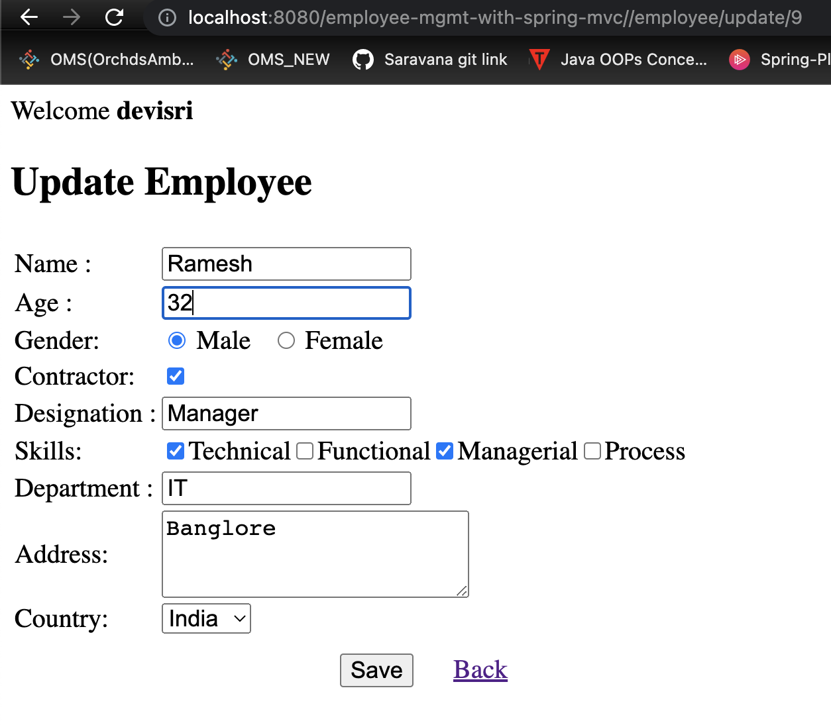

updatedEmp-page 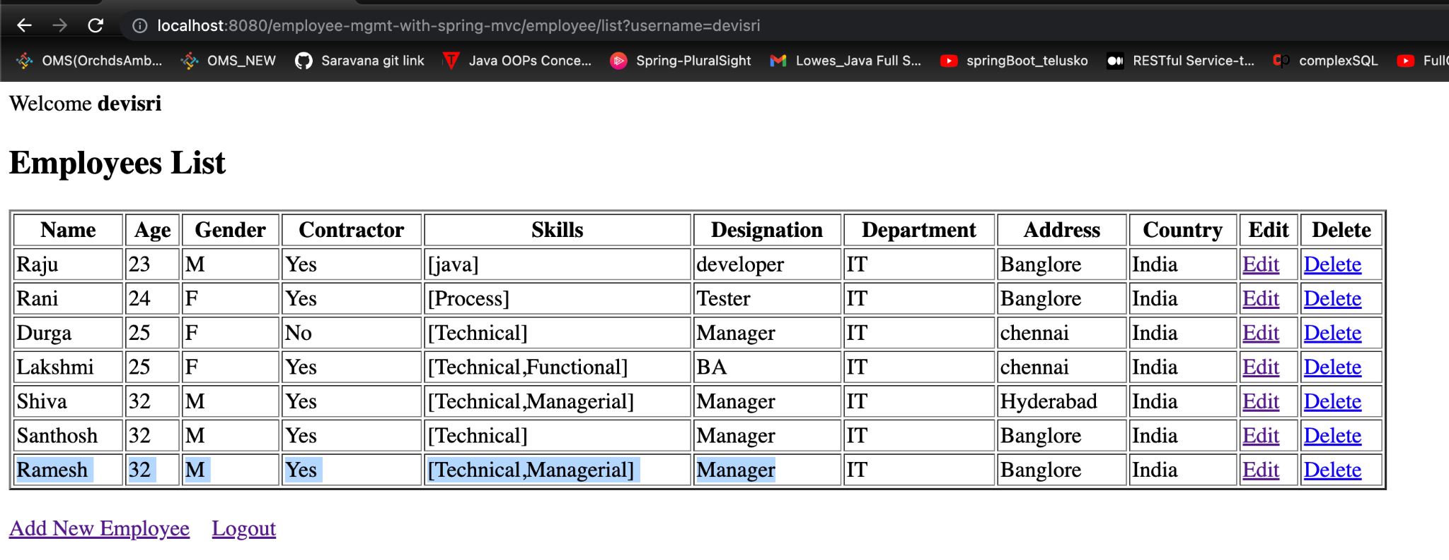

updatedEmp-in table 