1. Add Employee
2. View Employee
   1. Exceptional Handling View Emp
3. Update employee
4. Exceptional Handling Upd emp
5. Delete employee
6. Exceptional Handling Del emp
7. View all employees

Add employee

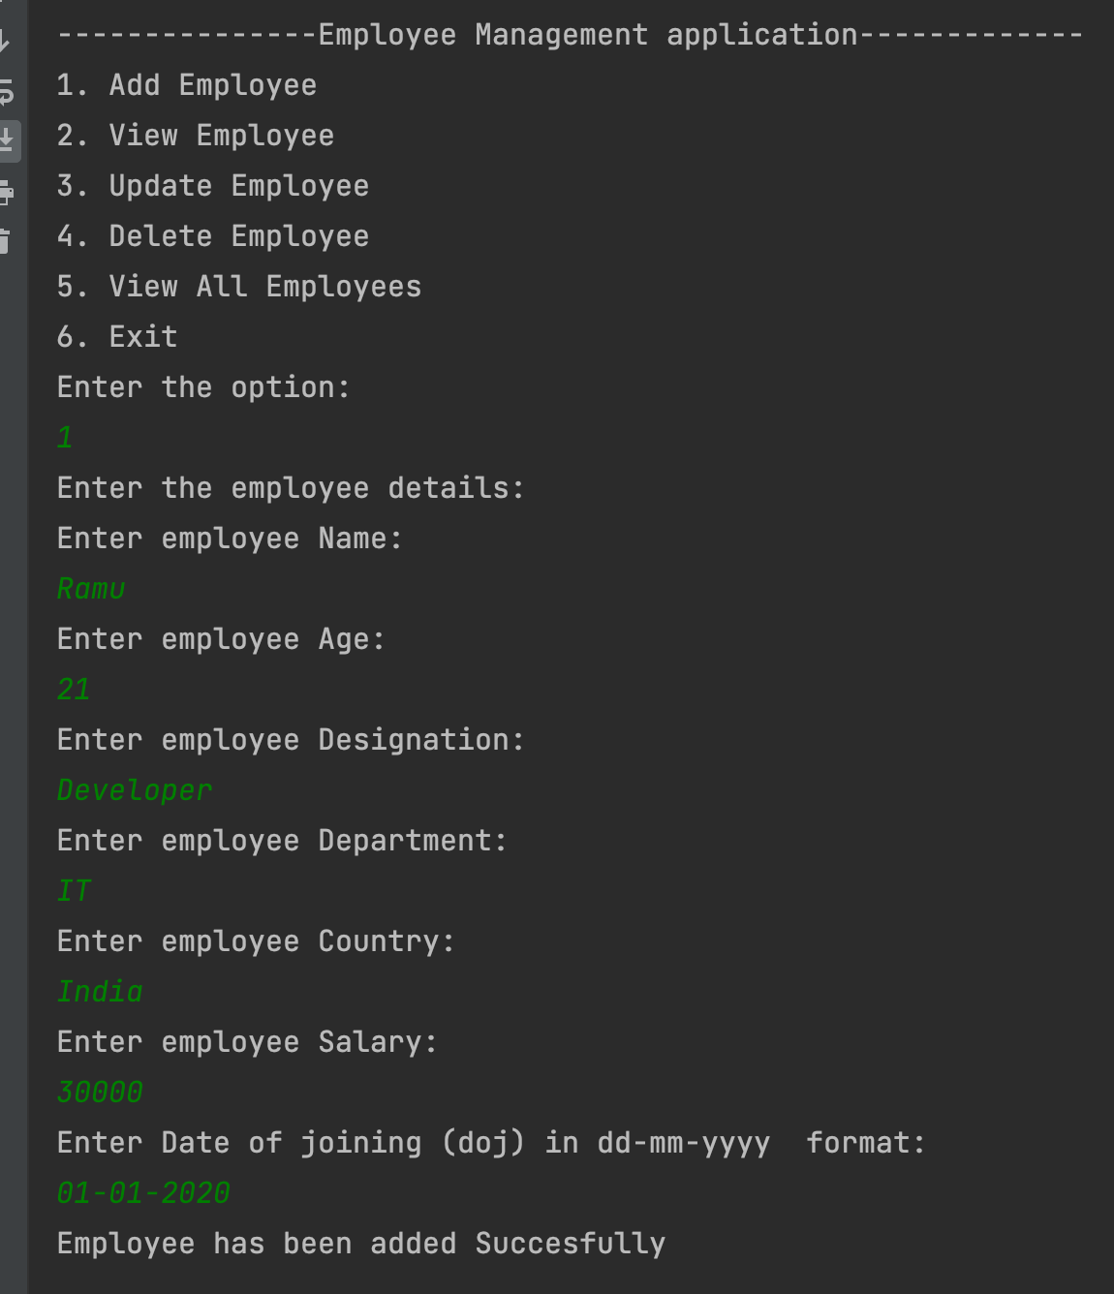

View Employee

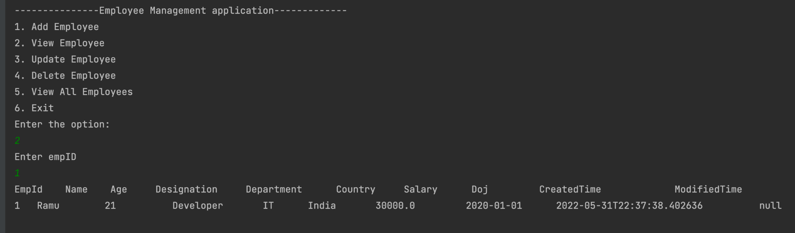

Exceptional Handling View Emp

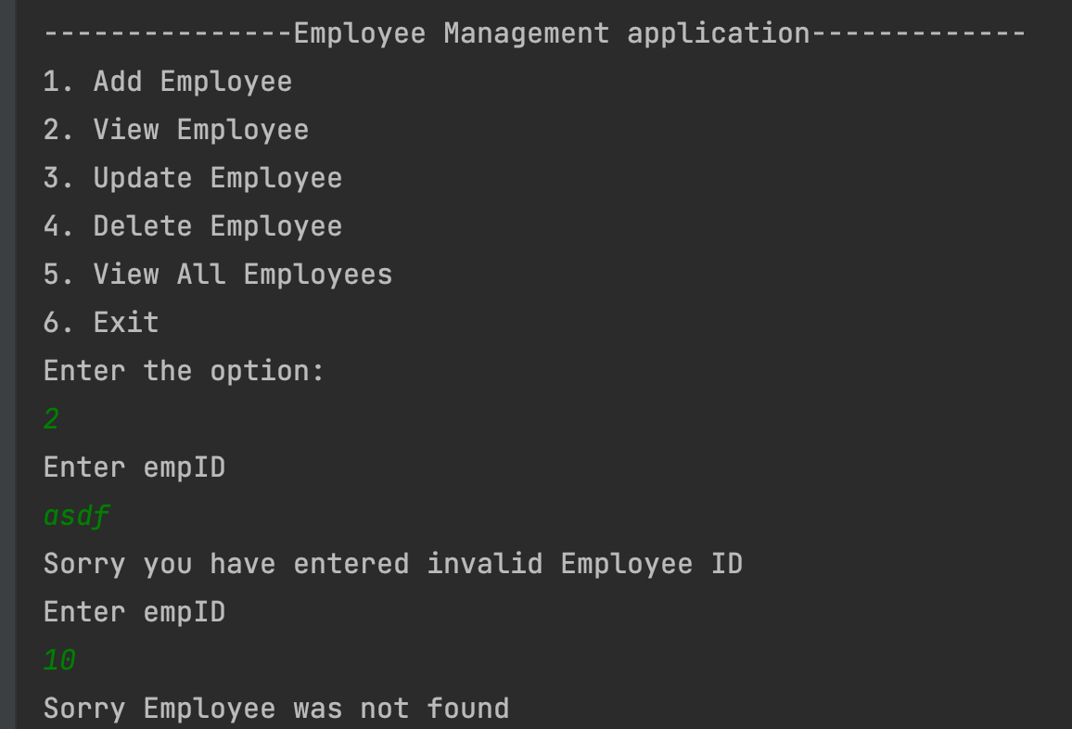

Update employee

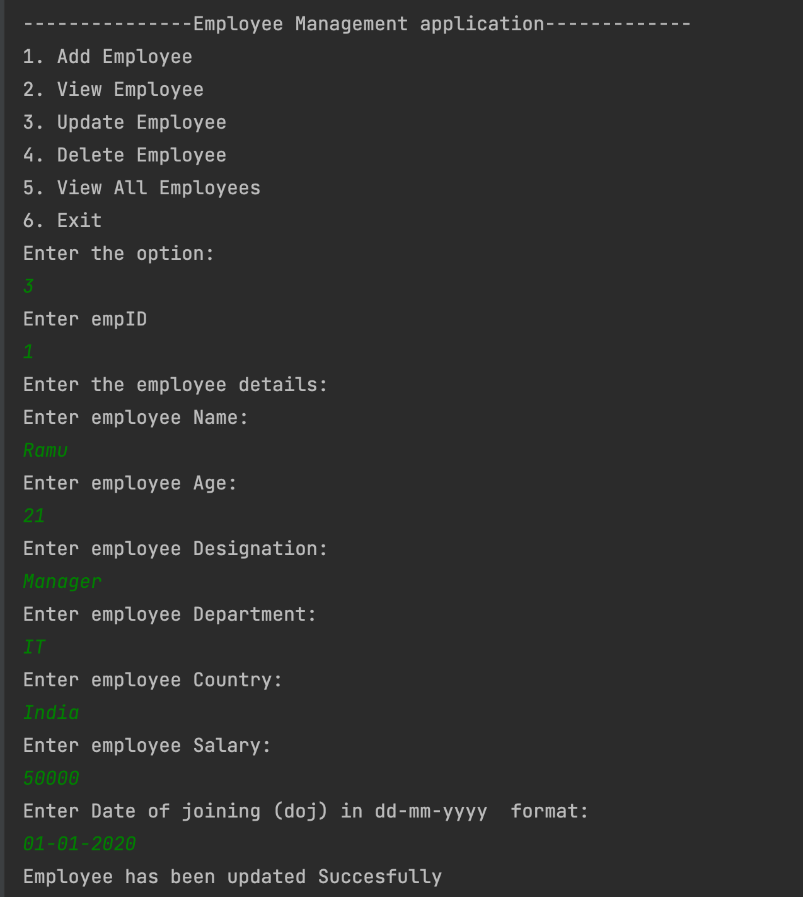



Exceptional Handling Upd emp

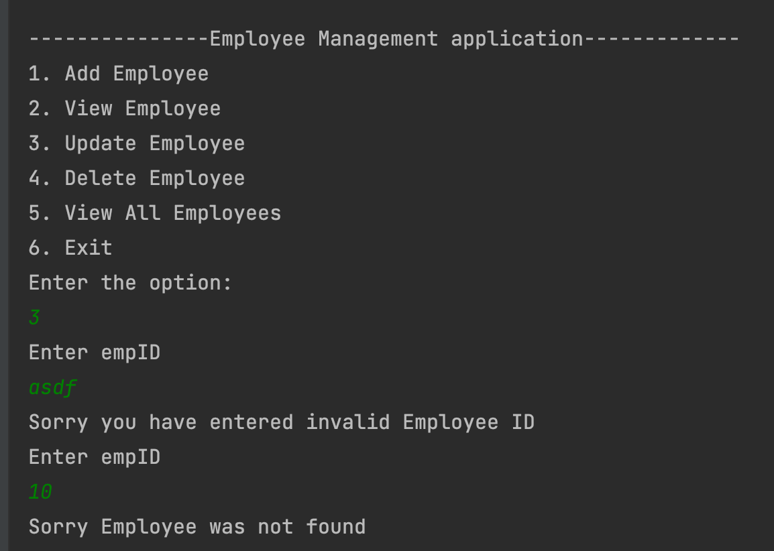

Delete employee

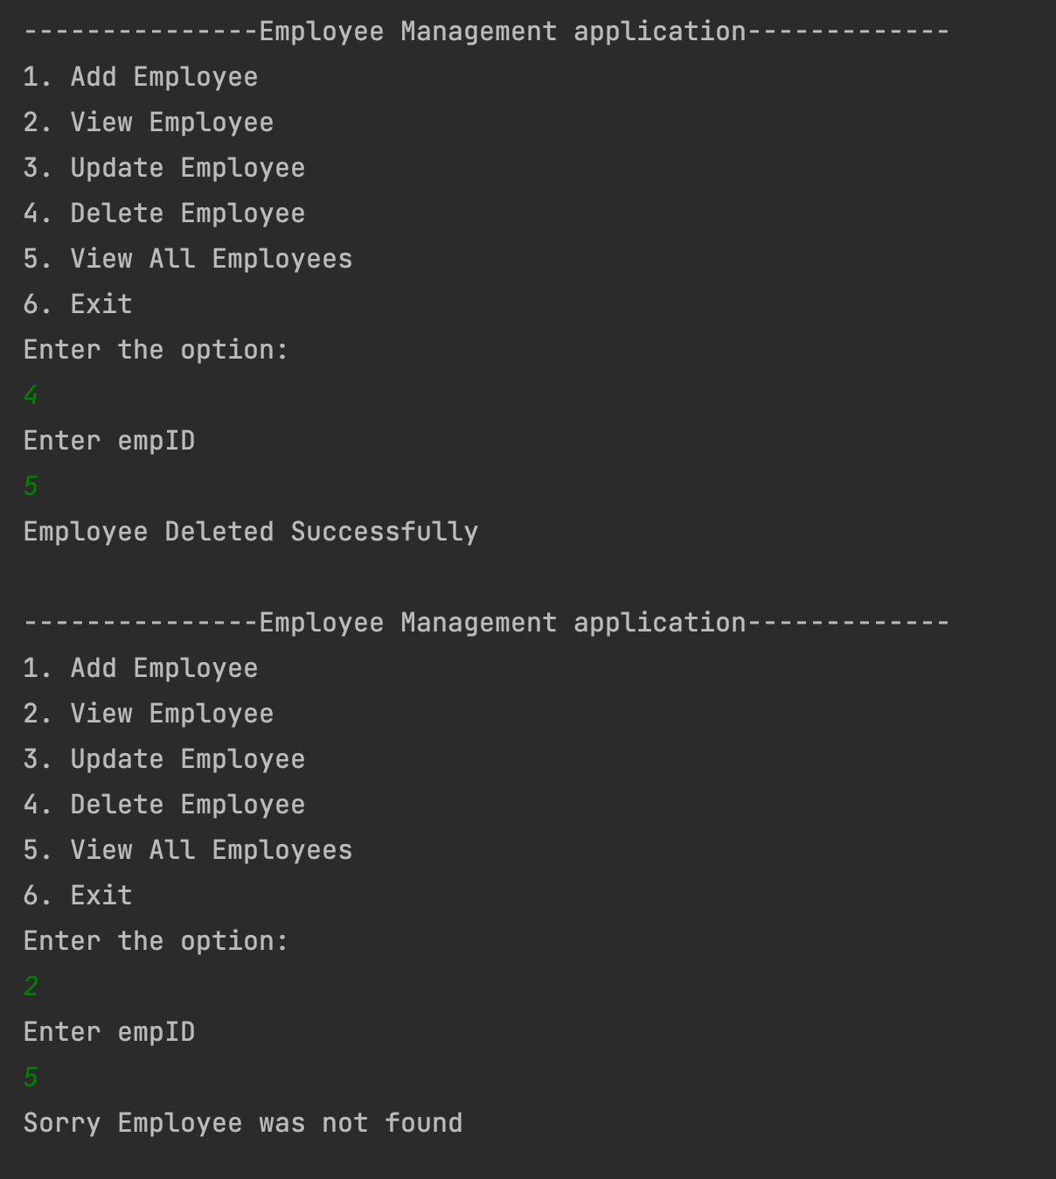

Exceptional Handling Del emp

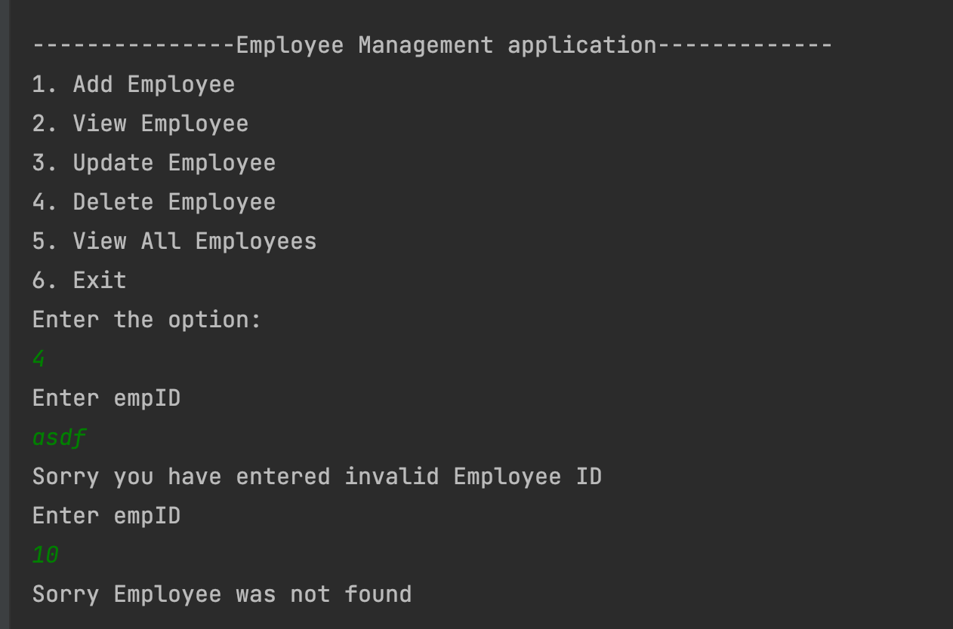

View all employees

