1. Add Employee
2. Validation on Create and Update Request data
3. View Employee
   1. Exceptional Handling View Emp
4. Update employee
5. Exceptional Handling Upd emp
6. Delete employee
7. Exceptional Handling Del emp
8. View all employees
9. ExceptionalHandling if no Emp in the table
10. Database Exception
11. Content - Negotiation
12. Logging

Add employee

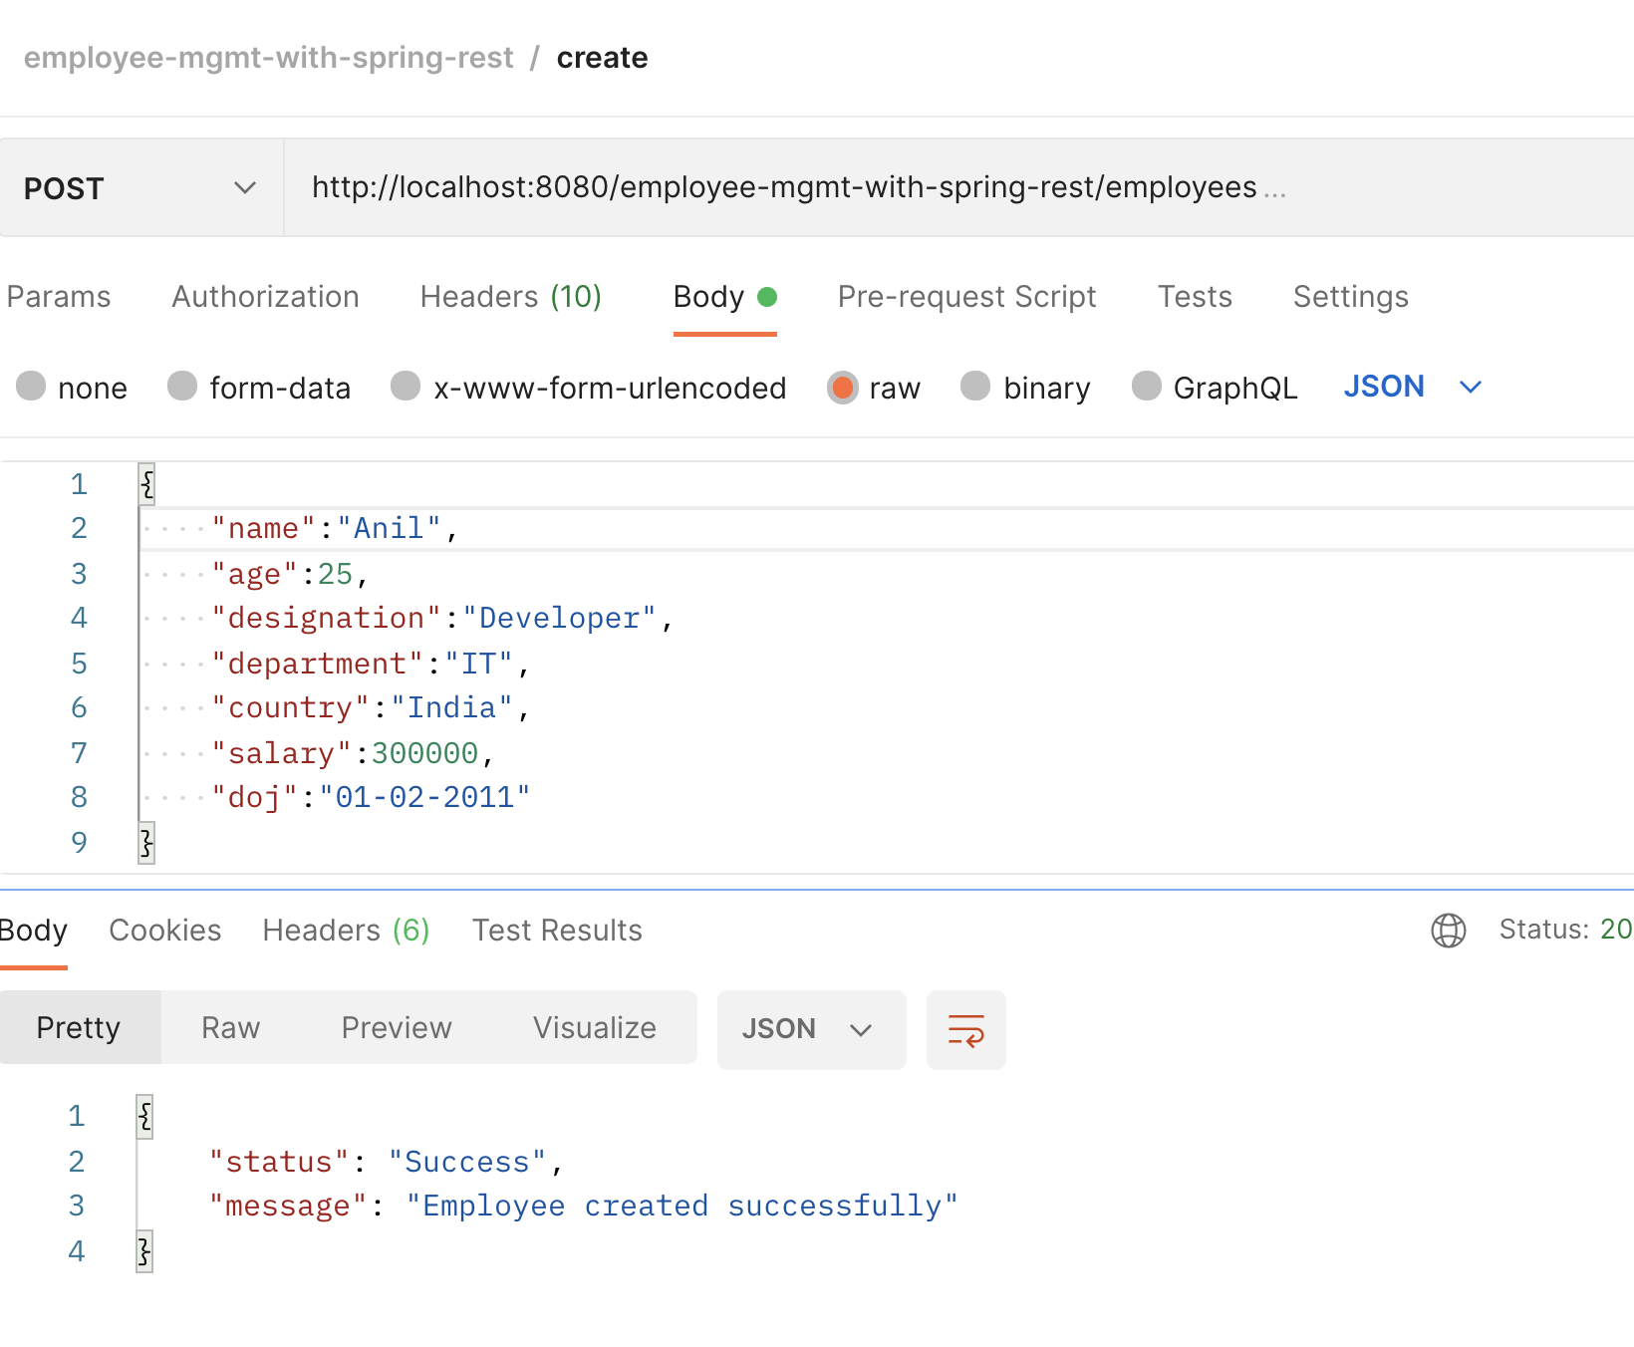

Validation on Create and Update Request data

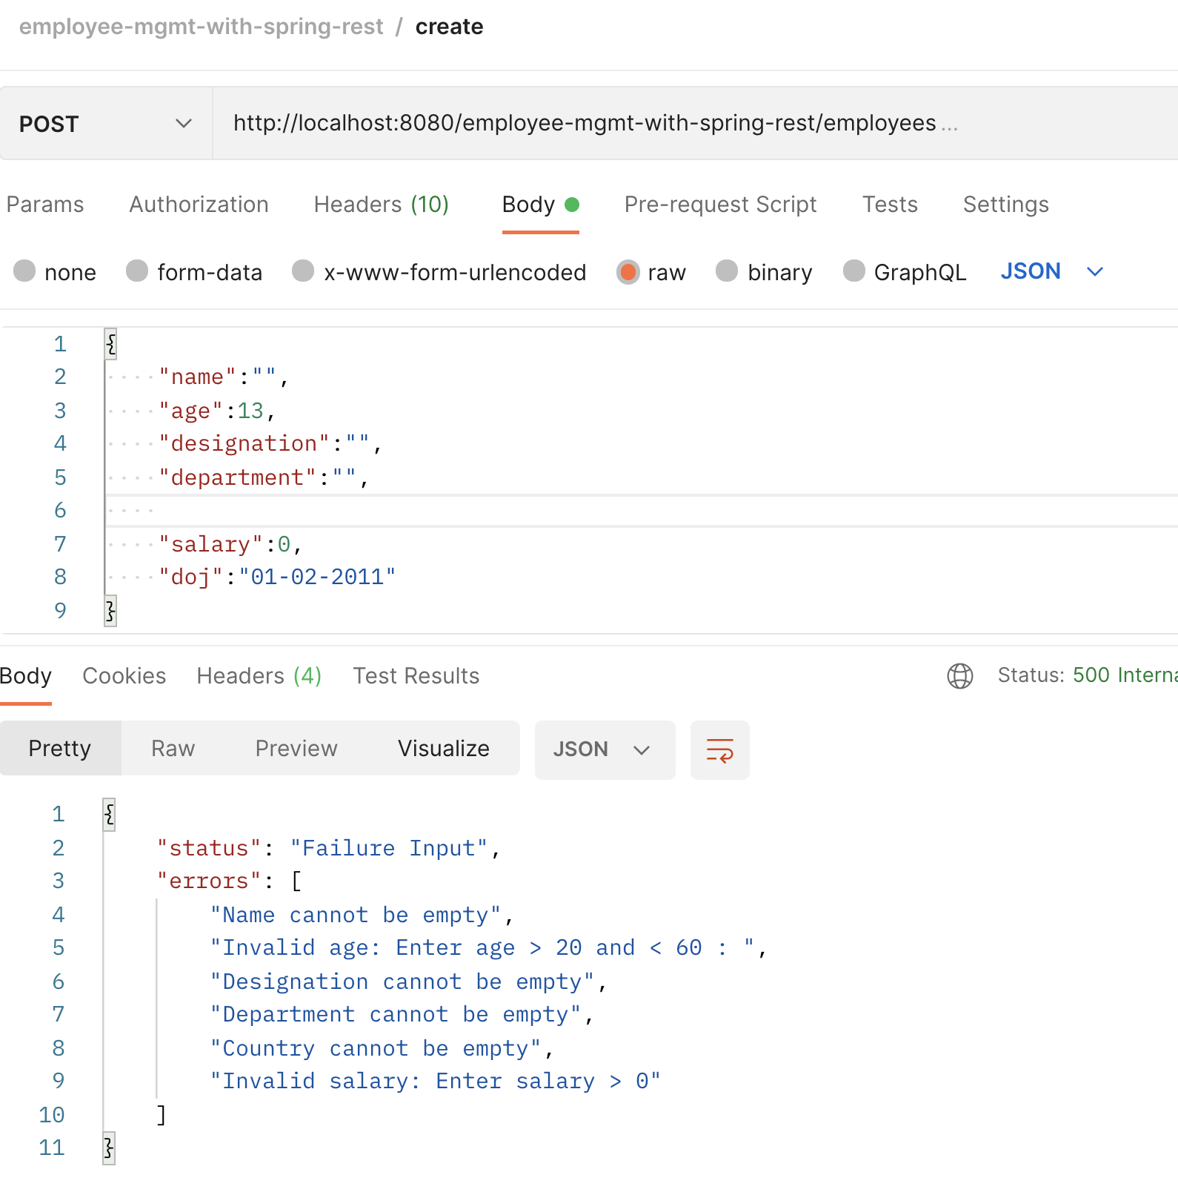

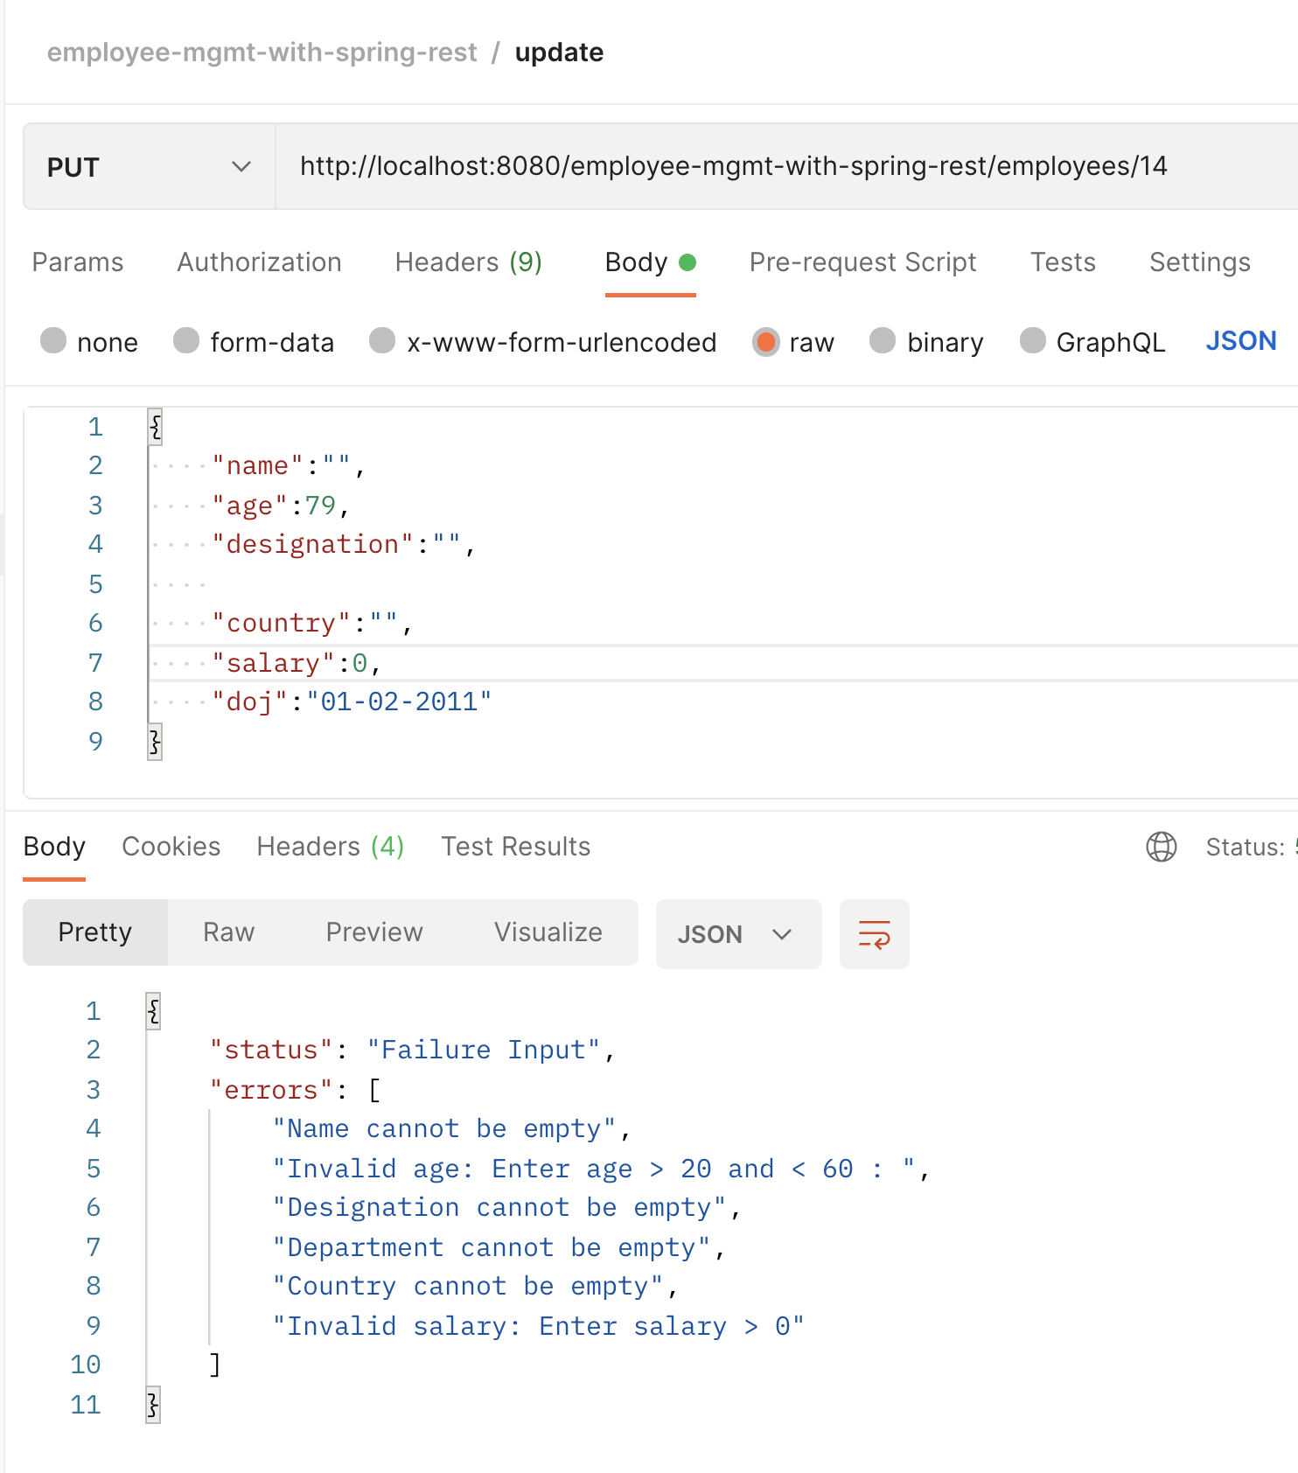

View Employee

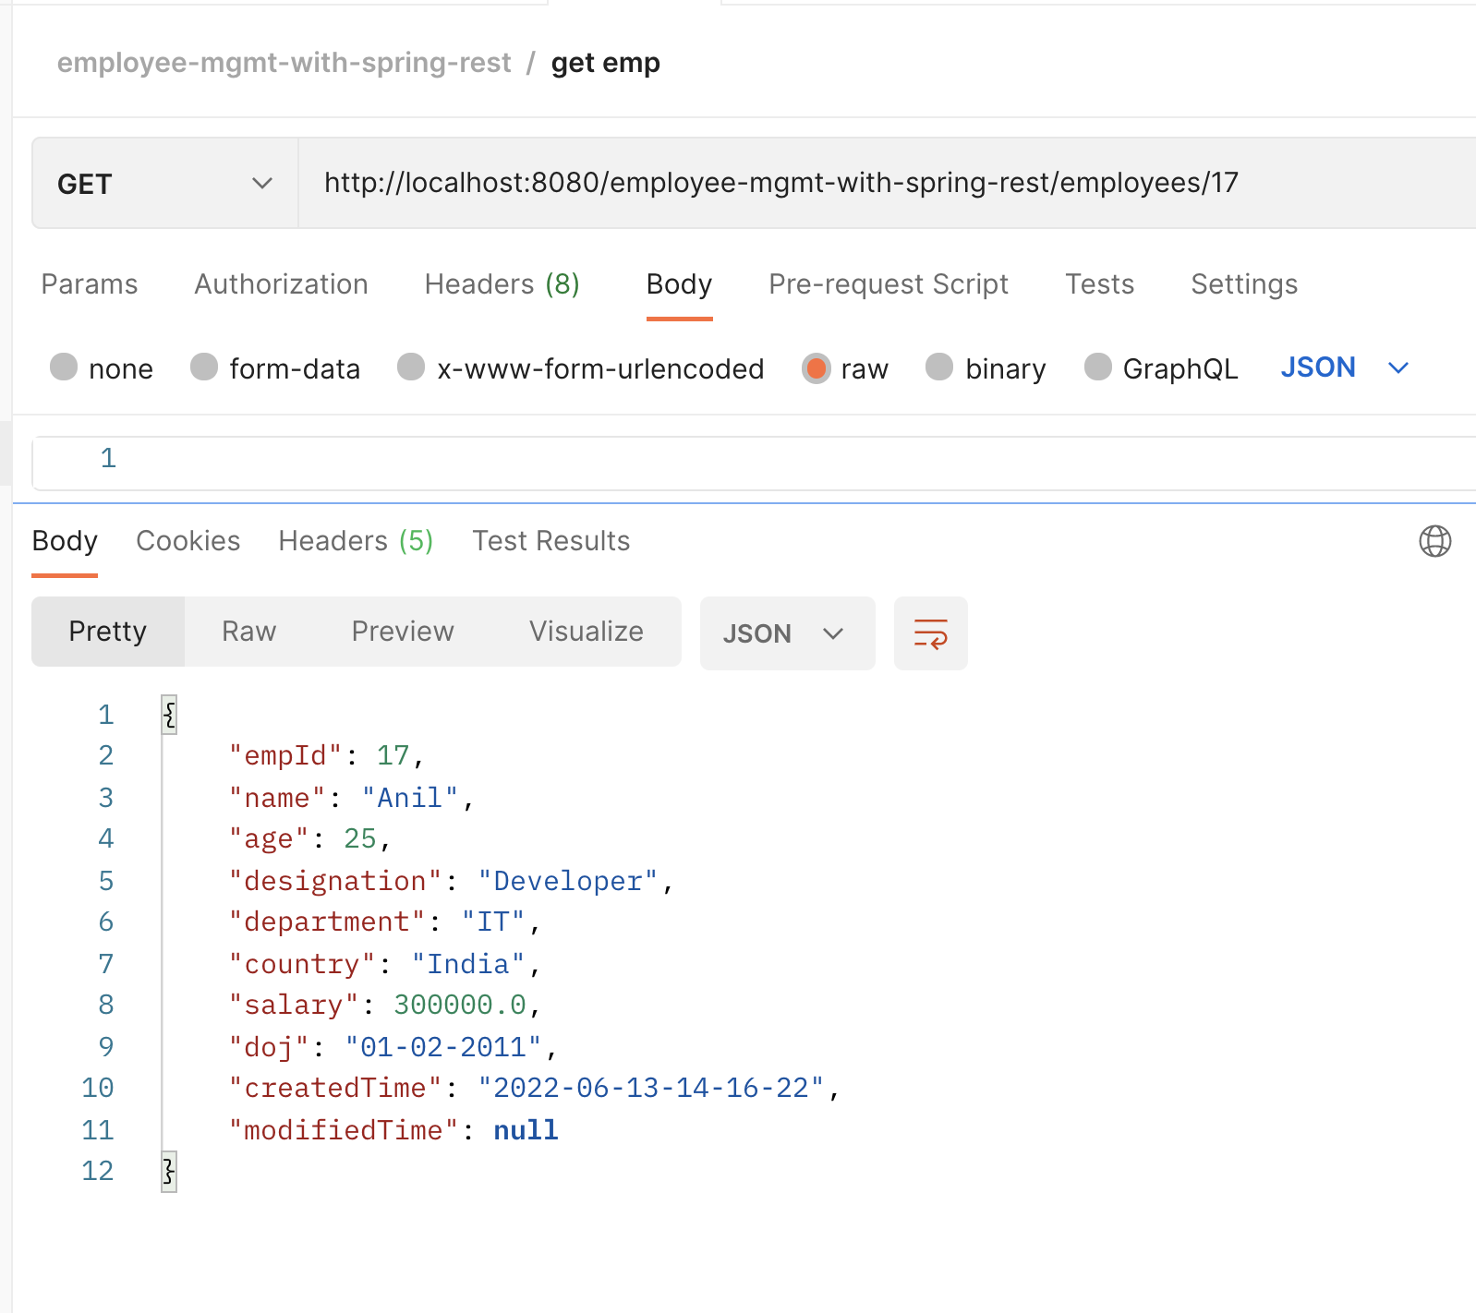

Exceptional Handling View Emp

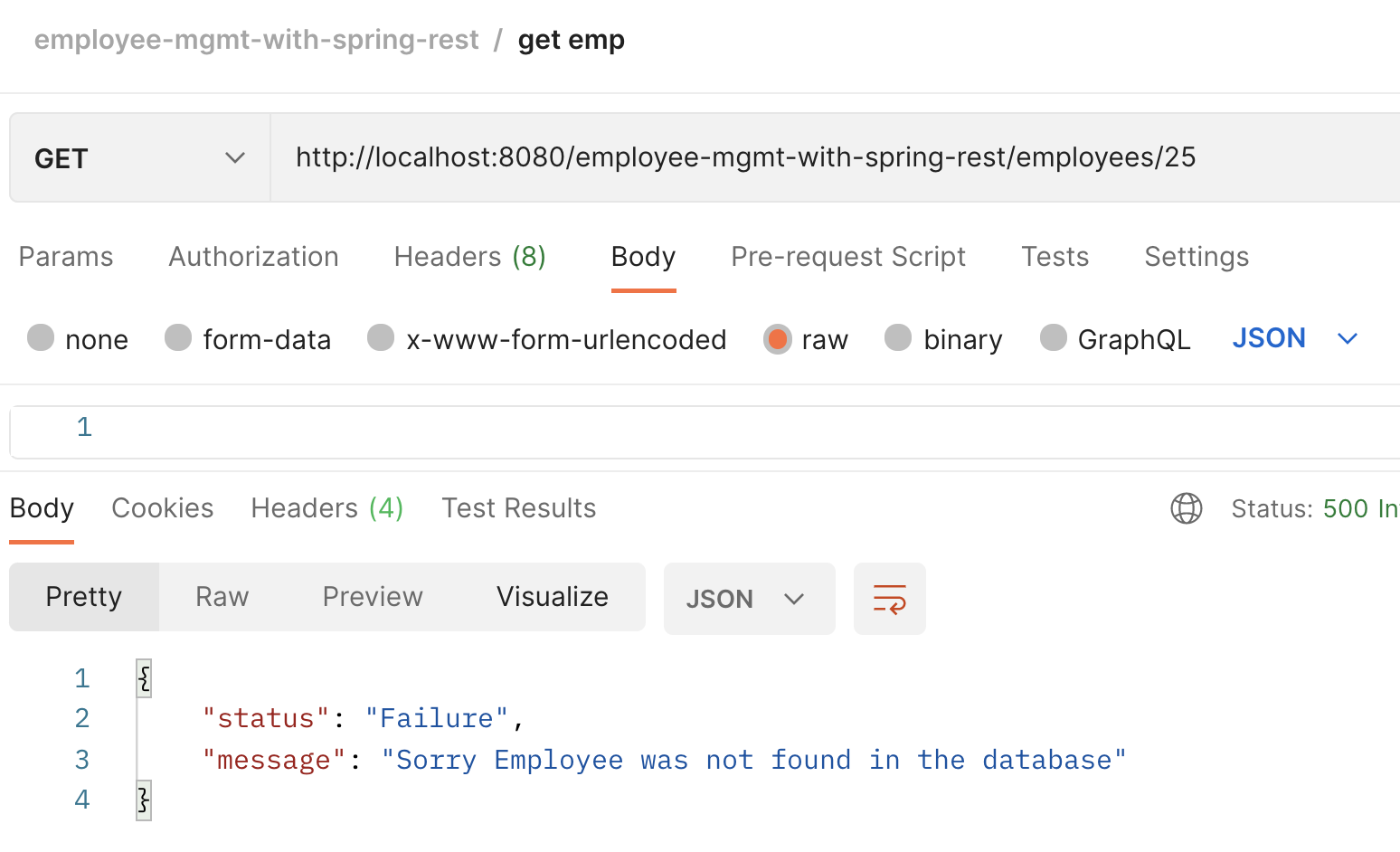

Update employee

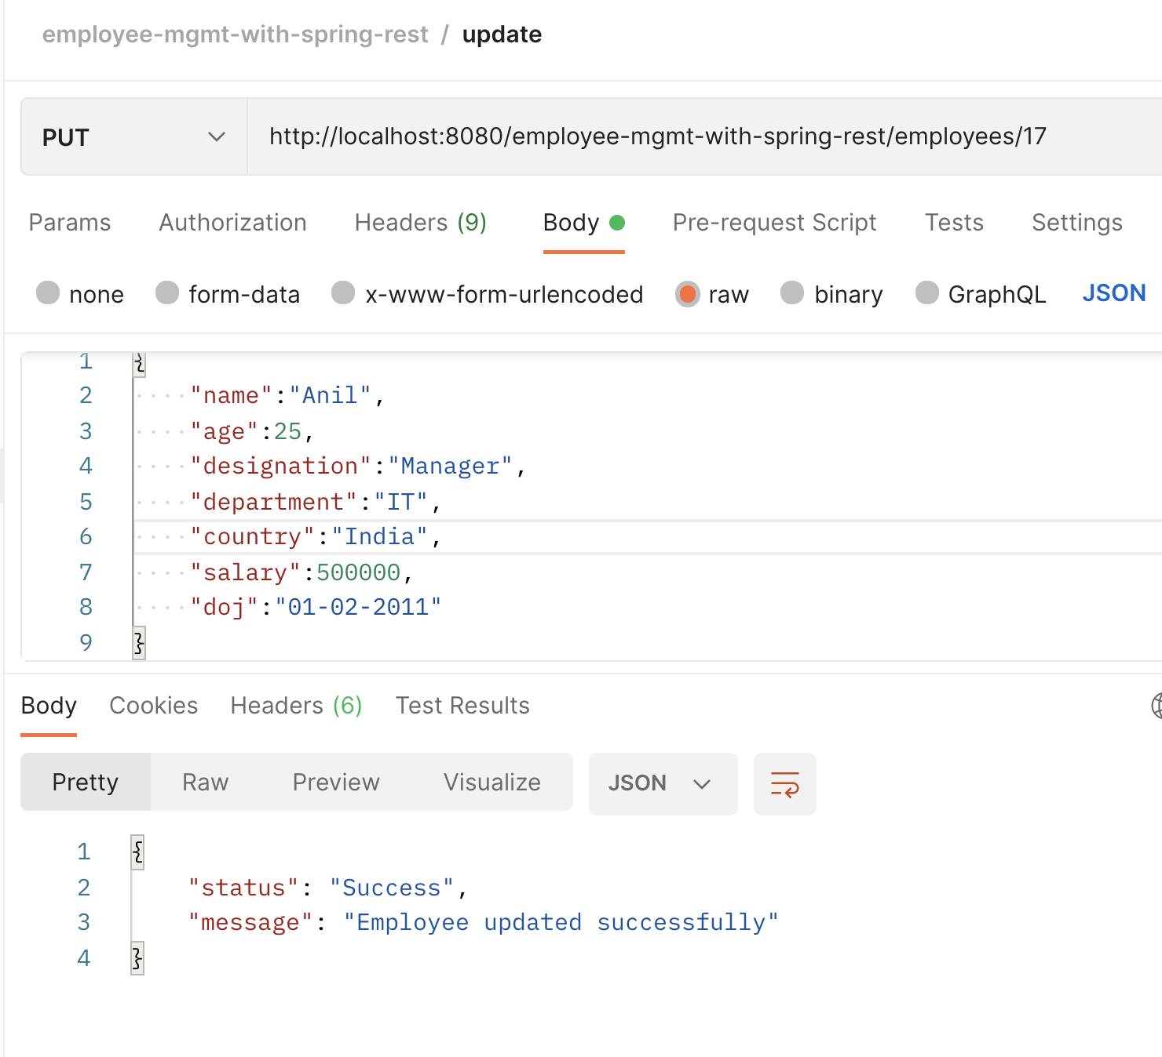

Exceptional Handling Upd emp

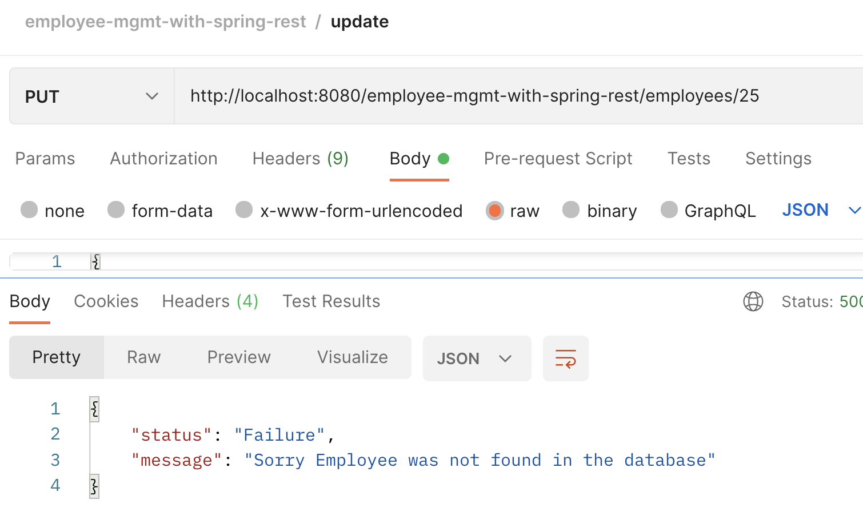

Delete employee

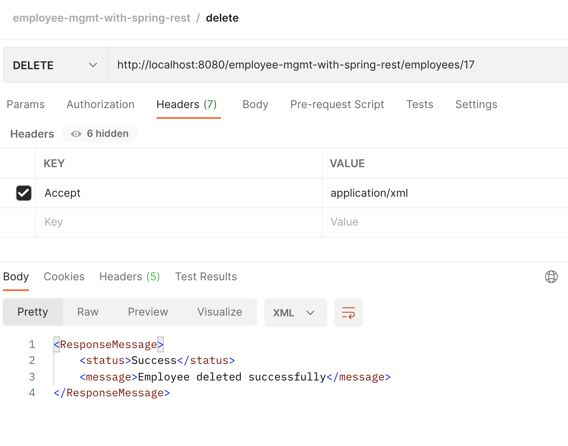

Exceptional Handling Del emp

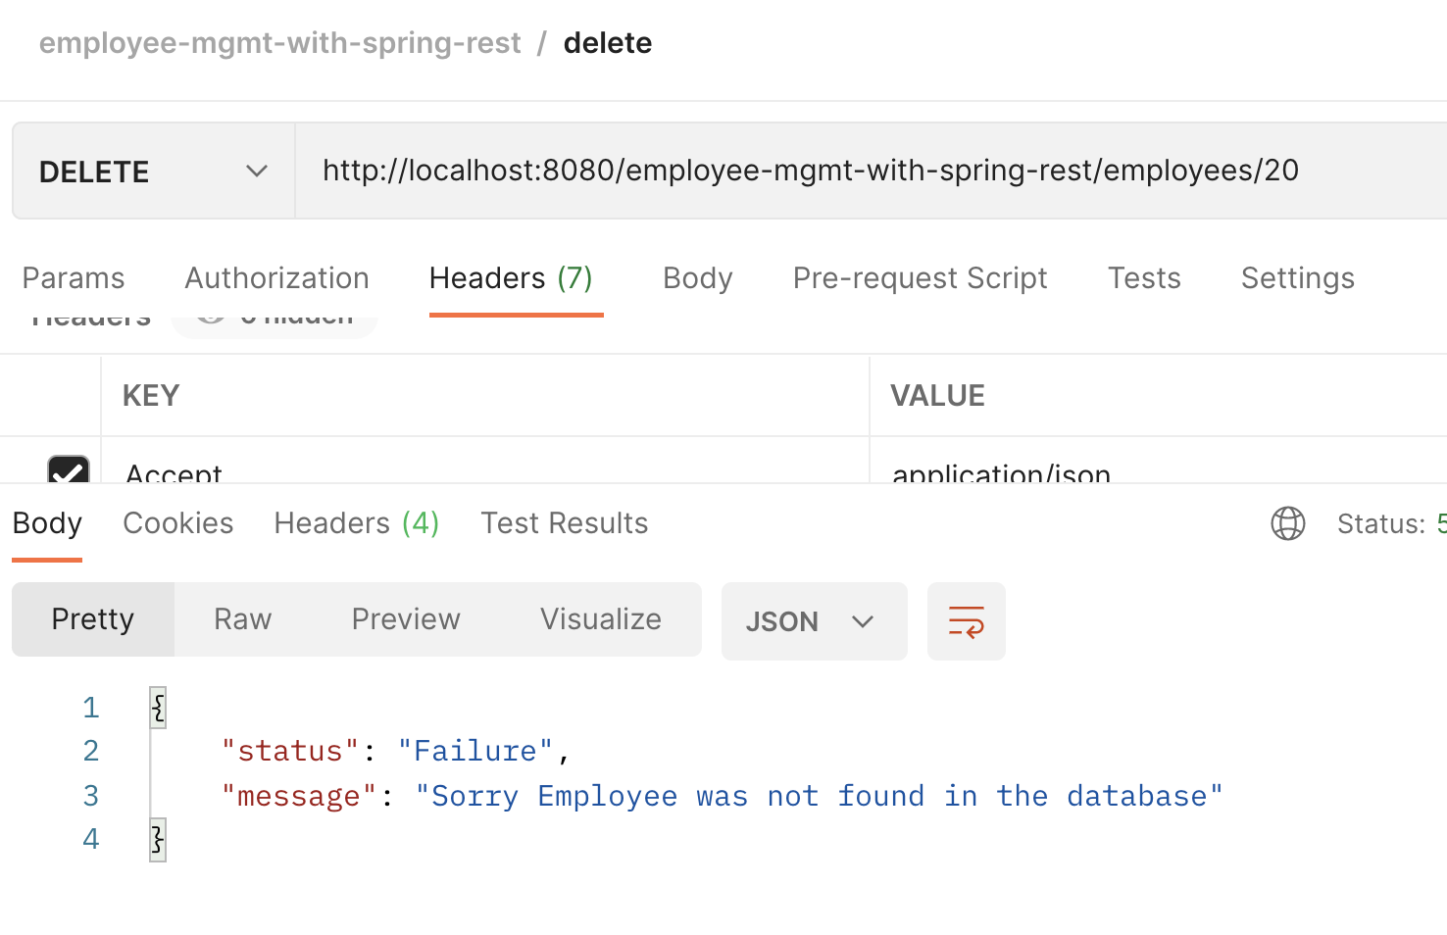

View all employees

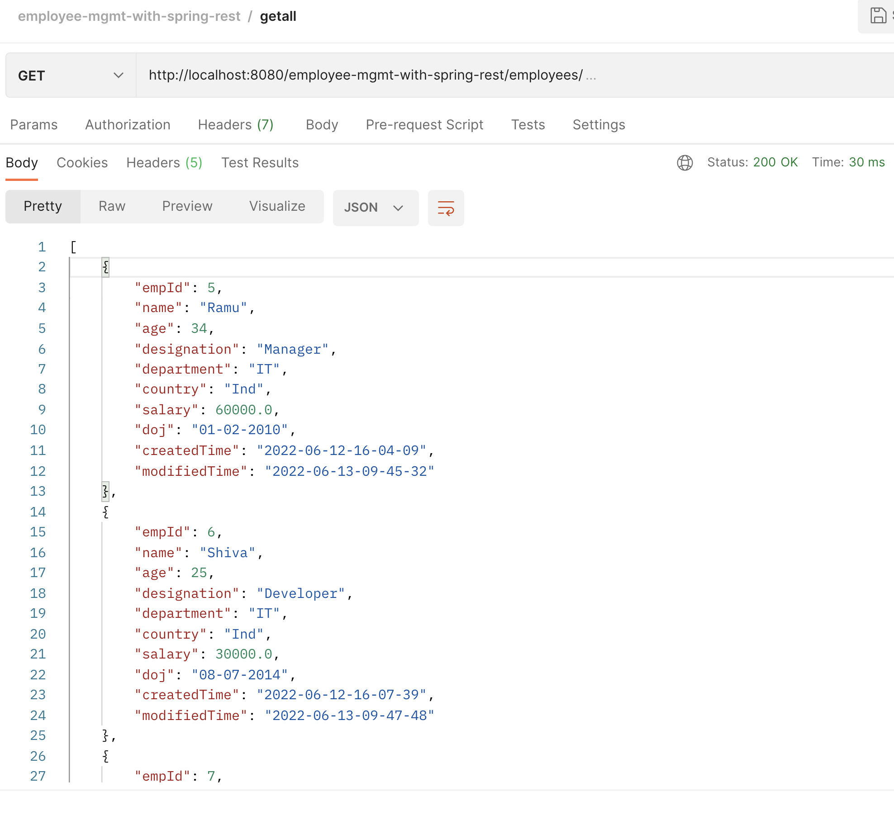

ExceptionalHandling if no Emp in the table

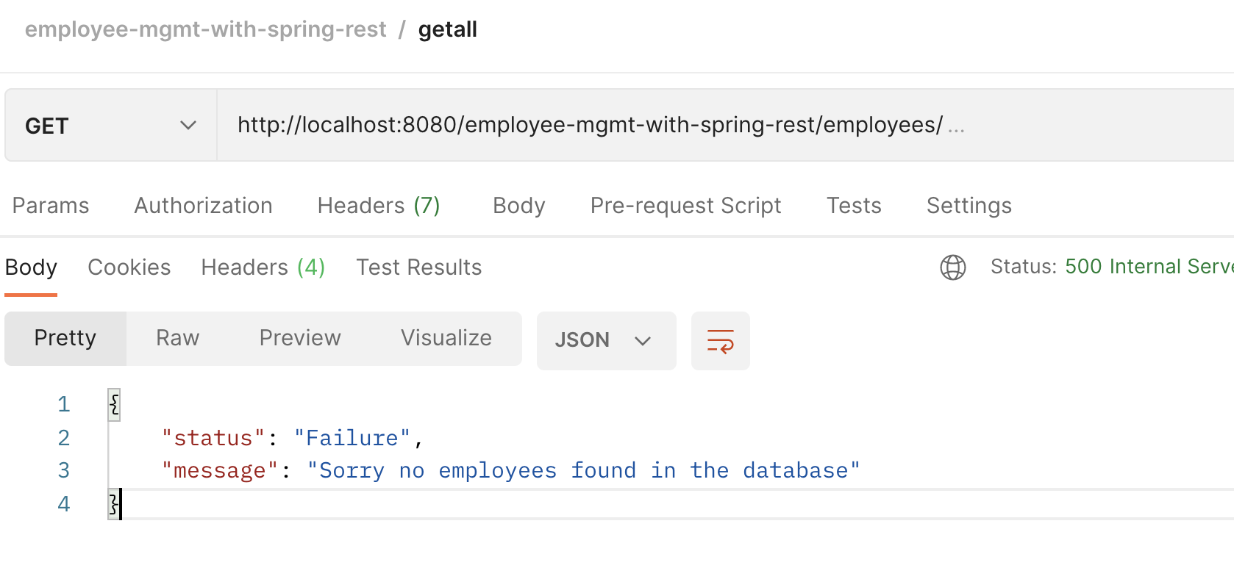

Database Exception

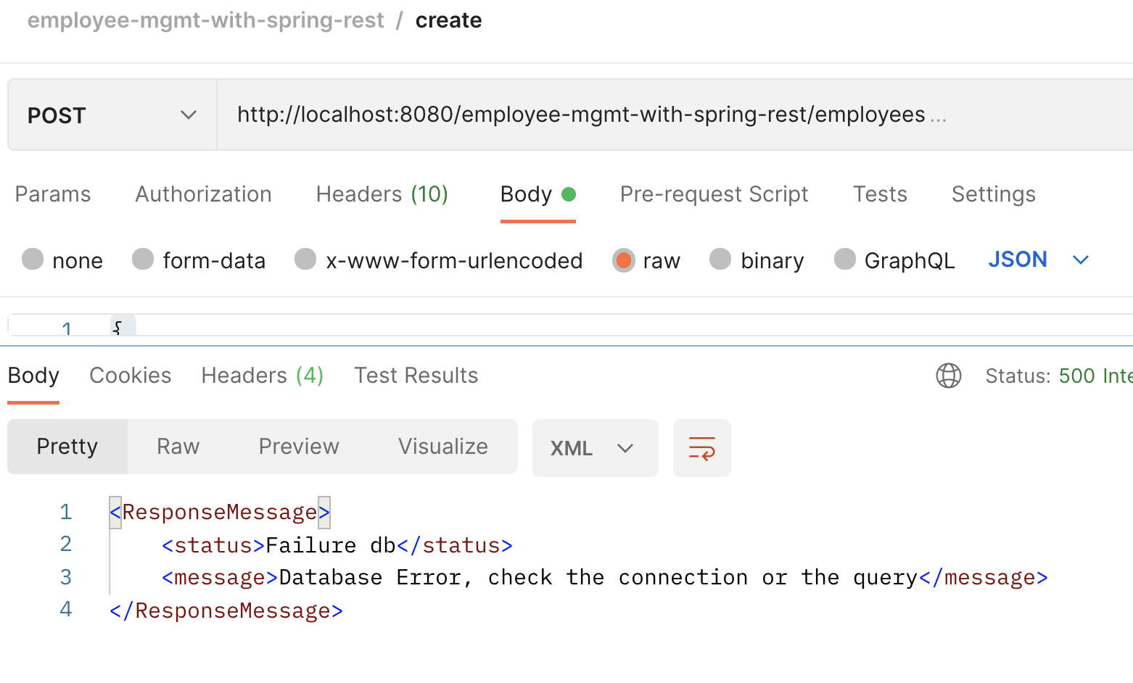

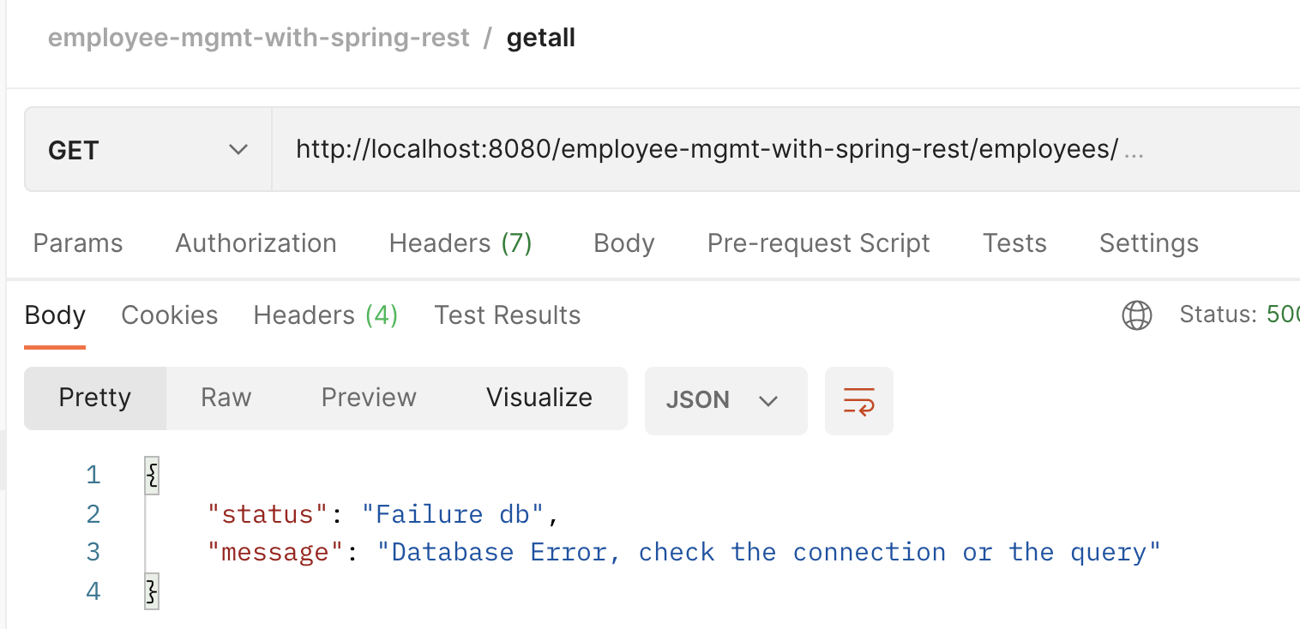

Content-Negotiation

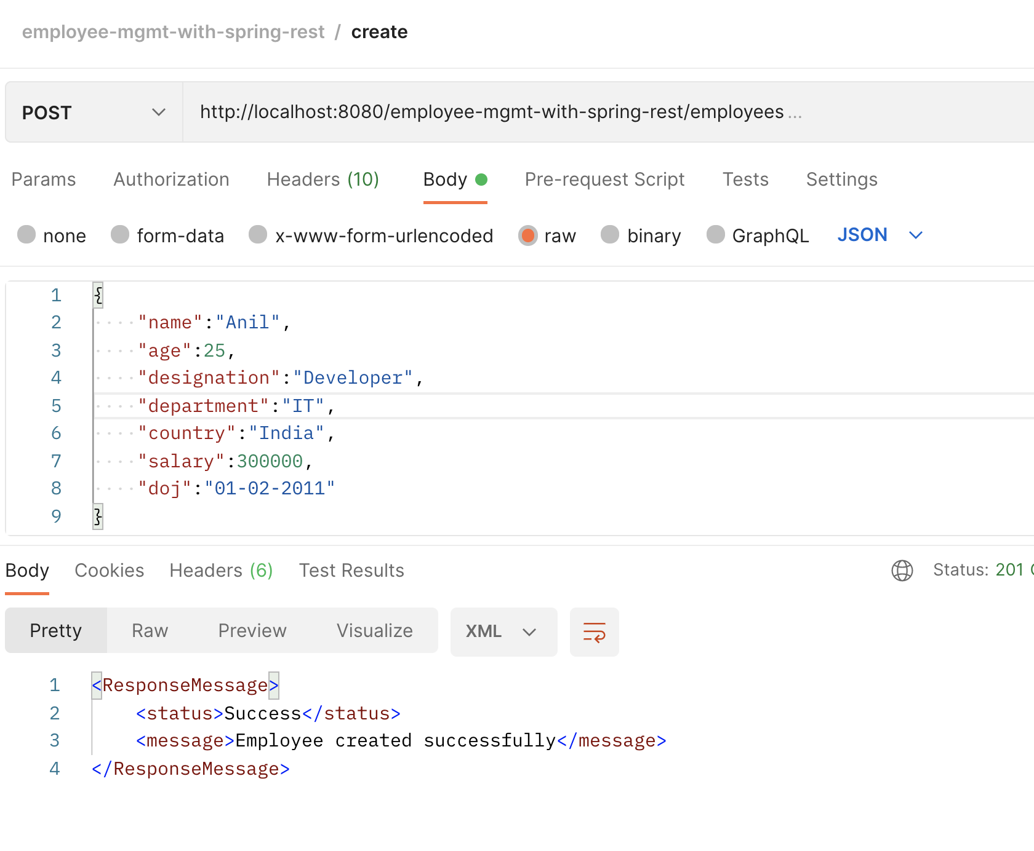

Logging

