“InterviewAI: Design and Development of an AI-Powered Mock Interview Platform with Real-Time Voice Transcription and Granular Scorecards”
A Project Report Submitted in the partial fulfillment of the requirements for the award of the degree of

BACHELOR OF TECHNOLOGY
In

DEPARTMENT OF COMPUTER SCIENCE ENGINEERING
&
DEPARTMENT OF COMPUTER SCIENCE AND INFORMATION TECHNOLOGY
By

M. YASHWANT RAJ 2520030181
KRISH SUREJA 2520030134
HARINI KUCHIPUDI 2520030399

Under the Esteemed Guidance of

Dr Yerragudipadu Subbarayudu Assistant Professor
Department of Computer Science and Engineering




K L (Deemed to be) University DEPARTMENT OF COMPUTER SCIENCE ENGINEERING
&

DEPARTMENT OF COMPUTER SCIENCE AND INFORMATION TECHNOL

Declaration

The Project Report entitled “InterviewAI: Design and Development of an AI-Powered Mock Interview Platform with Real-Time Voice Transcription and Granular Scorecards” is a record of Bonafide work of M. YASHWANT RAJ - 2520030181, KRISH SUREJA - 2520030134, HARINI KUCHIPUDI - 2520030389 submitted in
partial fulfillment for the award of B. Tech in Computer Science and Engineering (or) Computer Science and Information Technology to the K L University. The results embodied in this report have not been copied from any other departments/University/Institute.

M. YASHWANT RAJ – 2520030181 KRISH SUREJA – 2520030134 HARINI KUCHIPUDI – 2520030389

K L (Deemed to be) University

DEPARTMENT OF COMPUTER SCIENCE ENGINEERING

&

DEPARTMENT OF COMPUTER SCIENCE AND INFORMATION TECHNOLOGY

CERTIFICATE

This is certify that the mini project based report entitled“InterviewAI: Design and Development of an AI-Powered Mock Interview Platform with Real-Time Voice Transcription and Granular Scorecards” is a bonafide work done and submitted by M. YASHWANT RAJ - 2520030181, KRISH SUREJA - 2520030134, HARINI KUCHIPUDI - 2520030389
in partial fulfillment of the requirements for the award of the degree of BACHELOR OF TECHNOLOGY in Department of Computer Science Engineering, K L (Deemed to be University), during the academic year 2025-2026.

Signature of the Guide

Signature of the Course Coordinator Signature of the HOD

ACKNOWLEDGEMENT
The success in this project would not have been possible but for the timely help and guidance rendered by many people. Our wish to express my sincere thanks to all those who has assisted us in one way or the other for the completion of my project.

Our greatest appreciation to my Course Coordinator Dr Yerragudipadu Subbarayudu, and my guide Dr Yerragudipadu Subbarayudu, Department of Computer Science which cannot be expressed in words for his/her tremendous support, encouragement and guidance for this project.

We express our gratitude to Dr. P Venkateshwara Roa (CSE)/Dr. Kaja Shareef (CSIT), Head of the Department for Computer Science Engineering/ Department for Computer Science and Information Technology for providing us with adequate facilities, ways and means by which we are able to complete this project-based Lab.

We thank all the members of teaching and non-teaching staff members, and also who have assisted me directly or indirectly for successful completion of this project. Finally, I sincerely thank my parents, friends and classmates for their kind help and cooperation during my work.

M. YASHWANT RAJ – 2520030181 KRISH SUREJA – 2520030134 HARINI KUCHIPUDI – 2520030389

Abstract

Preparing for job interviews is one of the biggest challenges faced by students and early-career professionals. Traditional preparation methods such as reading question banks, watching tutorials or practising with friends are passive, inconsistent and rarely provide objective feedback. To address this, our project focuses on the Design and Development of InterviewAI: an AI-Powered Mock Interview Platform with Real-Time Voice Transcription and Granular Scorecards. Our core aim was to build a single, easy-to-use web application in which any candidate can rehearse a realistic interview at any time and receive detailed feedback immediately afterwards.

InterviewAI is a dark-themed, single-page React web application that simulates AI-powered mock job interviews across more than ten role tracks. Users select a role, configure the session by choosing the experience level, interview type, difficulty and number of questions, and then take part in a live interview in which spoken answers are transcribed in real time. Questions are generated dynamically by a Large Language Model and adapt to the candidate's previous answers, so that each session feels like a genuine conversation rather than a fixed quiz.

On completion, the platform generates a granular scorecard in which every answer is evaluated against a six-dimension rubric reflecting top-tier hiring standards, covering technical accuracy, depth of knowledge, problem solving, structure and clarity, relevance and delivery. The scorecard presents an overall score, strengths, gaps and a hiring-bar verdict, and all sessions are stored on a personal candidate dashboard that tracks progress over time. The system is built with React, Node.js, Express and MongoDB, uses the browser Web Speech API for transcription, and is deployed on cloud platforms. In summary, this project delivers a complete, secure and user-friendly solution that makes realistic, measurable interview practice available to every candidate.

Index

S.  No. | Chapters | Topics | Page.no
 |  | Acknowledgement
 |  | Abstract
1 | Introduction | - Background of the project  - Problem statement  - Scope of the project  - Objective(s)  - Importance of the application  - Target users/audience | 5-8
2 | System Requirements | - Hardware requirements  - Software requirements  - Development tools and frameworks | 9-10
3 | Technology Stack | - Front-end design (React, Vite, Tailwind CSS)  - Back-end design (Node.js, Express)  - Database design (MongoDB, Mongoose)  - Version control (Git, GitHub)  - APIs and external services (LLM API, Web Speech API) | 11-12
4 | System Architecture | - High-level architecture diagram  - Description of each layer (frontend, backend, database)  - Deployment architecture (cloud, CI/CD pipeline) | 13-14
5 | Design | Interview flow design  ER diagram / database schema | 15-16
6 | Implementation | - Module-wise implementation  - Front-end logic (UI rendering, state management)  - API integration  - Authentication & Authorization | 17-19
7 | Features | - List of main features  - How each feature works (user perspective + technical description) | 20-21
8 | Testing | - Postman testing (frontend/backend)  - Integration testing  - Tools used for testing  - Test cases and results | 22-23
9 | Deployment | - Steps to deploy  - Environment configuration  - Hosting of frontend and backend | 24
10 | Challenges & Limitations | - Issues faced during development  - Solutions applied  - Current limitations or known bugs | 25-26
11 | Future Enhancements | - Planned features  - Possible integrations or optimizations | 27
12 | Conclusion | - Summary of the project  - What was achieved  - Skills learned during development | 28
13 | References | Books, documentation and learning resources | 29

14 | Appendices | - Screenshots of the app  - Sample code snippets  - Installation/setup instructions  - User manual or guide  -Geo Tag photos with guide  -Review forms with guide signatures | 30-32

CHAPTER 1 – INTRODUCTION

1.1 Background of the Project
Landing a job in today's competitive market depends on far more than a good résumé. Whether the target role is a software engineer, a data analyst or a product manager, candidates are expected to think aloud, structure their answers clearly, defend technical decisions and remain composed under time pressure. Most students and early-career professionals, however, get very little realistic practice before their first real interview. Campus placement training is usually limited to a few group sessions, and one-to-one mock interviews with experienced mentors are expensive, hard to schedule and impossible to repeat as often as a candidate would like.
Recent advances in Large Language Models (LLMs) and in browser-based speech recognition have made it possible to close this gap with software. An LLM can generate role-specific questions, react to what a candidate has just said, and evaluate an answer against a written rubric in a matter of seconds. The Web Speech API now allows modern browsers to convert spoken audio into text in real time without any additional installation. Combined with a responsive single-page application, these technologies can recreate the pressure and flow of a real interview at any time of day.
InterviewAI is a dark-themed, single-page React web application that simulates AI-powered mock job interviews across more than ten role tracks. A user selects a role, configures the session (experience level, interview type, difficulty and number of questions), and then takes part in a live interview in which questions are presented one at a time and answers are captured through real-time voice transcription. Because the next question can depend on the quality and content of the previous answer, the interview feels dynamic rather than scripted. When the session ends, the platform generates a granular scorecard in which each answer is evaluated against the standards that top-tier employers apply when making hiring decisions. Every completed session is stored and tracked on a personal candidate dashboard, so that a user can see how their performance changes over time.
The project draws on several core areas of computer science and software engineering:
- Web Technology: a component-based React front end with client-side routing, a dark theme and a responsive layout.
- Artificial Intelligence: prompt engineering for question generation and structured, rubric-based answer evaluation using an LLM.
- Speech Processing: real-time speech-to-text using the browser's built-in speech recognition capabilities.
- Database Management: persistent storage of user profiles, interview sessions, answers and scorecards.
- Software Engineering Principles: modular design, REST API design, secure authentication and systematic testing.

The background of the project therefore rests on three observations: candidates need frequent, realistic and low-cost interview practice; the technology required to deliver it is now mature and accessible; and the feedback a candidate receives must be specific and measurable if it is to lead to real improvement.

1.2 Problem Statement
Interview preparation today is fragmented and, for many candidates, ineffective. Question lists and video tutorials are passive: they tell a candidate what might be asked but never test how the candidate actually responds when speaking out loud. Peer mock interviews are better, but friends rarely have the domain expertise to judge technical depth, tend to be lenient, and are not always available. Professional coaching is accurate but costly, which excludes a large section of students.
Existing online practice tools suffer from further shortcomings. Many offer only a static bank of questions with no evaluation. Others provide a generic chat-based assistant that does not enforce interview conditions such as time limits, spoken answers or a fixed number of questions. Where feedback is offered, it is often a single overall score or a few lines of general advice, with no breakdown by skill and no comparison against the level expected by leading employers. Finally, most tools do not keep a history, so a candidate cannot tell whether practice is actually paying off.
The core problem addressed by this project is the absence of a single platform that combines role-specific question generation, a realistic voice-driven interview experience, objective multi-dimensional evaluation and long-term progress tracking. The project aims to solve this problem by:
- Providing realistic interview simulations for more than ten role tracks, configurable by experience level, interview type and difficulty.
- Capturing spoken answers with real-time transcription so that candidates practise speaking, not just typing.
- Generating adaptive follow-up questions so that every session is different and responds to the candidate.
- Producing a granular scorecard with per-dimension scores, strengths, gaps and improvement tips benchmarked against top-tier hiring standards.
- Tracking all sessions on a personal dashboard so that progress is visible and measurable.

1.3 Scope of the Project
The scope of InterviewAI covers the design, development, testing and deployment of a web-based mock interview platform. The functional scope includes user registration and login; a role catalogue with at least ten tracks; a session-configuration screen; a live interview room with question display, countdown timer, microphone control and live transcript; an evaluation engine that scores each answer; a scorecard page; and a candidate dashboard with history and analytics.
The technical scope includes a React single-page front end with a dark theme and responsive design, a Node.js and Express REST API, a MongoDB database, integration with an LLM provider through a server-side proxy so that API keys are never exposed to the browser, and use of the browser Web Speech API for transcription. The interview can also be completed by typing, which serves as a fallback for browsers or devices without speech-recognition support.
The following items are intentionally outside the scope of the present version: video recording and facial-expression analysis, live human interviewers, resume parsing, company-specific question sets, native mobile applications and multi-language interviews. These are discussed as future enhancements in Chapter 11.
In summary, the scope of the project is:
- A single-page, dark-themed React application delivering end-to-end mock interviews.
- More than ten role tracks, each with configurable level, type, difficulty and length.
- Real-time voice transcription with a typed-answer fallback.
- LLM-driven dynamic questioning and rubric-based evaluation.
- A granular scorecard and a personal dashboard with persistent history.
- Secure authentication, REST APIs and cloud deployment.

1.4 Objectives of the Project
The main objective of this project is to design and develop a platform that lets any candidate rehearse for a job interview in realistic conditions and receive detailed, objective feedback immediately afterwards. The specific objectives are:
- To design and build a responsive, dark-themed single-page application using React that guides the user from role selection to final scorecard without page reloads.
- To support more than ten role tracks and allow the user to configure the experience level, interview type, difficulty and number of questions.
- To integrate real-time speech-to-text so that spoken answers appear on screen as the candidate speaks.
- To generate questions dynamically using an LLM, adapting follow-up questions to the candidate's previous answers.
- To evaluate each answer against a structured rubric covering technical accuracy, depth, communication, structure, relevance and delivery.
- To generate a granular scorecard that presents an overall score, per-dimension scores, strengths, gaps and a hiring-bar verdict.
- To provide a personal candidate dashboard that stores every session and visualises progress over time.
- To secure user data through hashed passwords, token-based authentication and server-side handling of third-party API keys.
- To apply modern software engineering practices including version control, API testing, automated component tests and continuous deployment.

Beyond building a working product, the project also aims to demonstrate how generative AI can be used responsibly in an educational setting: with structured prompts, validated JSON outputs, clear scoring rubrics and transparent feedback rather than opaque scores.

1.5 Importance of the Application
Interview performance is one of the strongest determinants of career outcomes, yet it is a skill that is rarely practised systematically. InterviewAI is important because it makes high-quality practice available to every candidate, at any time, at negligible cost. A student in a small town with no access to experienced mentors can rehearse the same style of questions as a student at a top institution.
The application is also important for the quality of its feedback. Instead of a vague impression such as "you did well", the candidate sees exactly which dimensions were strong and which were weak, what a stronger answer would contain, and how the latest session compares with earlier ones. Because every answer is scored against the same rubric, the numbers are comparable across sessions, which turns practice into a measurable process.
Speaking out loud is a skill in its own right. Candidates who prepare only by reading often find that their answers become disorganised or filled with hesitation words once they must speak. By capturing answers by voice and transcribing them live, the platform trains this skill directly, and the transcript allows the evaluation engine to comment on clarity, structure and filler words.
From an educational perspective, the project is a practical case study in full-stack development, prompt engineering, API design and data visualisation. From an institutional perspective, universities and training centres can use the platform to supplement placement-training programmes without increasing mentor workload. In summary, the application:
- Provides realistic, repeatable interview practice for more than ten roles.
- Delivers objective, multi-dimensional feedback benchmarked against top-tier hiring standards.
- Builds spoken-communication confidence through voice-first interaction.
- Makes progress visible through a personal dashboard.
- Reduces dependence on costly coaching and mentor availability.

1.6 Target Users / Audience
The primary users of InterviewAI are final-year and pre-final-year students preparing for campus placements and internships. They typically have strong theoretical knowledge but limited experience articulating it under interview conditions.
The secondary users are early-career professionals and career switchers who are applying for roles in a new domain, for example from support to software development or from software development to data science. They benefit from the platform's ability to generate questions for a role they have not previously interviewed for.
Further groups who may benefit include training and placement cells, bootcamps and coaching institutes, which can recommend the platform to learners as a self-service practice tool, and experienced professionals who want to refresh their interview skills before a job change.

CHAPTER 2 – SYSTEM REQUIREMENTS

2.1 Hardware Requirements
InterviewAI is a browser-based application, so the hardware requirements for end users are modest. The developer machine needs somewhat more capacity to run the front-end build tooling, the Node.js server and a local database instance. A working microphone is required for voice answers; a webcam is not required in the current version.
Component | Minimum (User) | Recommended (Developer)
Processor | Dual-core 1.6 GHz | Quad-core 2.5 GHz or higher (Intel i5 / Ryzen 5 class)
RAM | 4 GB | 8 GB or more
Storage | Not applicable (browser based) | 256 GB SSD with at least 10 GB free
Display | 1280 x 720 resolution | 1920 x 1080 resolution
Audio input | Built-in or headset microphone | Noise-cancelling headset microphone
Network | 2 Mbps broadband | 10 Mbps or faster, stable connection

2.2 Software Requirements
The application runs in any modern web browser. For the best voice-transcription experience, a Chromium-based browser such as Google Chrome or Microsoft Edge is recommended, because these browsers provide the most complete implementation of the Web Speech API.
Category | Requirement
Operating system | Windows 10/11, macOS 12 or later, or a current Linux distribution
Browser (user) | Google Chrome 100+ or Microsoft Edge 100+ (recommended); Safari 15+ with limited speech support; Firefox supported in typed-answer mode
Runtime (developer) | Node.js 18 LTS or later with npm 9+
Database | MongoDB 6+ (local instance) or MongoDB Atlas (cloud)
Version control | Git 2.40+ with a GitHub account
API testing | Postman (desktop or web)
Code editor | Visual Studio Code with ESLint and Prettier extensions

2.3 Development Tools and Frameworks
The following tools and frameworks were used during the development of the project.
Tool / Framework | Purpose
React 18 | Component-based user interface library for the single-page application
Vite | Fast development server and production bundler for the front end
React Router | Client-side routing between landing, setup, interview, scorecard and dashboard views
Tailwind CSS | Utility-first styling used to implement the dark theme and responsive layout
Recharts | Charts for the scorecard (radar, bar) and the dashboard (progress trend)
Node.js and Express | Back-end runtime and REST API framework
Mongoose | Object-document mapper for MongoDB schemas and queries
JSON Web Tokens and bcrypt | Stateless authentication and password hashing
Vitest and React Testing Library | Unit and component testing
Postman | Manual and collection-based API testing
Git and GitHub | Source control, collaboration and continuous integration

CHAPTER 3 – TECHNOLOGY STACK
InterviewAI follows a three-tier architecture consisting of a React single-page front end, a Node.js and Express application layer, and a MongoDB data layer, supported by two external capabilities: an LLM provider for question generation and evaluation, and the browser's Web Speech API for transcription. This chapter explains the technologies chosen for each tier and the reasons behind those choices.

3.1 Front-End Design
The front end is built with React 18 and bundled with Vite. React's component model suits the application well because the interface is composed of reusable pieces such as role cards, question panels, transcript boxes, score meters and chart widgets. React Router provides client-side navigation so that the user moves between screens without full page reloads, which is essential during a live interview where a reload would lose the session.
The visual design is dark-themed. Tailwind CSS utility classes define a palette of deep slate backgrounds, subtle borders and a small number of accent colours used for calls to action and score indicators. A dark interface reduces eye strain during longer practice sessions and gives the application a focused, professional feel. The layout is fully responsive so that the same interface works on laptops, tablets and phones.
Application state is managed through React hooks and a lightweight global store. Transient interface state, such as whether the microphone is listening, stays local to a component, while shared state, such as the active session, the current question index and the user profile, is kept in the store. Recharts renders the radar chart on the scorecard and the progress line chart on the dashboard.

3.2 Back-End Design
The back end is a Node.js application that uses Express to expose a REST API. Node.js was chosen because it lets the team use JavaScript across the whole stack, which shortens the learning curve and allows validation logic and data shapes to be shared between the client and the server. The API is organised into routers for authentication, roles, sessions, answers and analytics.
The back end also acts as a secure proxy to the LLM provider. The browser never receives the provider's API key. Instead, the front end calls the project's own endpoints; the server builds the prompt, calls the LLM, validates that the response is well-formed JSON, and returns only the fields the client needs. This design also makes it possible to change the LLM provider or model without modifying the front end.

3.3 Database Design
MongoDB was selected as the database because interview data is naturally document-shaped. A scorecard, for example, contains nested per-dimension scores, lists of strengths and gaps and per-question feedback, all of which can be stored in a single document and retrieved in a single query. Mongoose defines schemas for User, Session, Answer, Scorecard and RoleTrack, adds validation and indexes, and provides a clean query interface. MongoDB Atlas hosts the production database.

3.4 Version Control
Git is used for version control and GitHub for hosting the repository. The team followed a simple branching model in which the main branch always holds deployable code, and new features such as the speech module or the dashboard were developed in separate feature branches and merged through pull requests after review. GitHub Actions runs linting and the automated test suite on every pull request.

3.5 APIs and External Services
Service | Purpose in InterviewAI
LLM API (server-side) | Generates role-specific and follow-up questions; evaluates answers against the scoring rubric and returns structured JSON
Web Speech API (browser) | Converts spoken audio into text in real time, including interim results that appear while the candidate is still speaking
MongoDB Atlas | Cloud-hosted database for users, sessions, answers and scorecards
Vercel | Hosting and global CDN for the React front end
Render | Hosting for the Node.js and Express API

Using the browser's own speech recognition keeps audio on the client side, avoids the cost and latency of streaming audio to a separate transcription service, and simplifies the privacy story: the platform stores the text transcript, not the audio recording.

CHAPTER 4 – SYSTEM ARCHITECTURE

4.1 High-Level Architecture Diagram
Figure 4.1 shows the high-level architecture of InterviewAI. The system is organised into three layers. The presentation layer runs entirely in the user's browser; the application layer runs on the server; and the data and external services layer holds the persistent database and the LLM provider. Speech-to-text is performed inside the browser by the Web Speech API, so only the final transcript travels to the server.
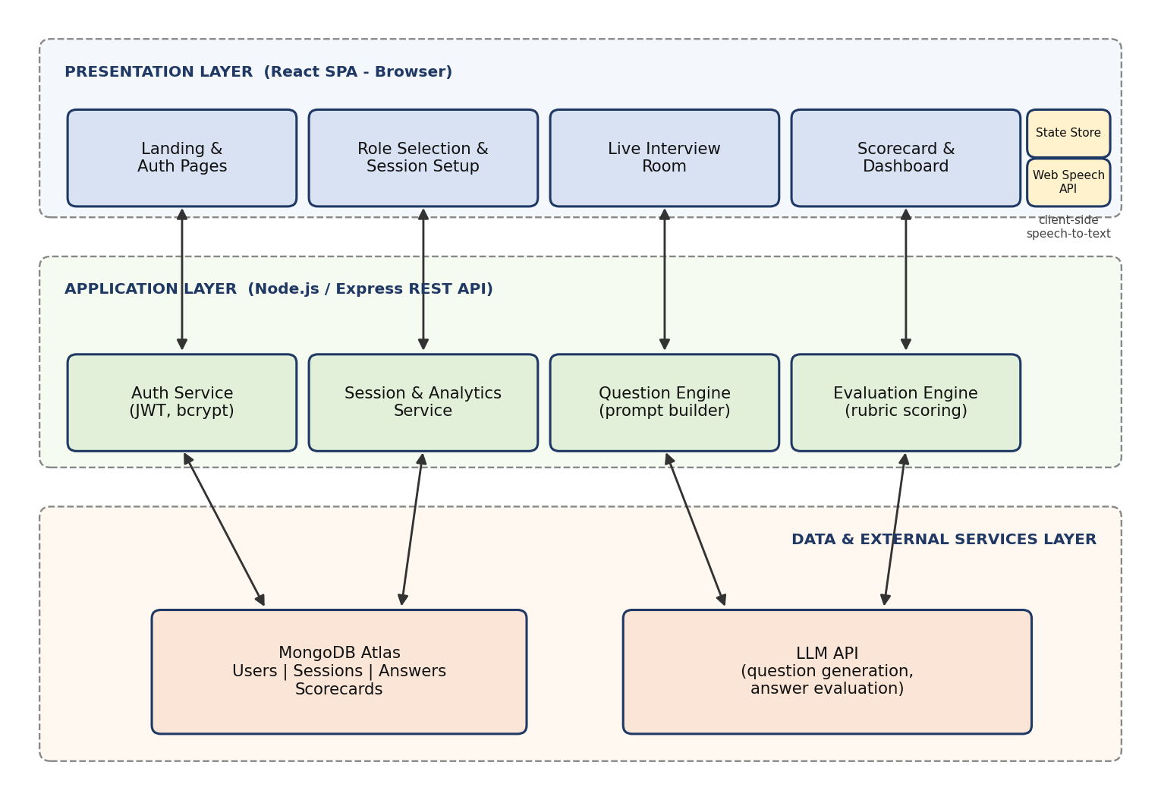
Figure 4.1: High-level architecture of InterviewAI

4.2 Description of Each Layer
Presentation layer (React front end)
The presentation layer contains the landing and authentication pages, the role-selection and session-setup screens, the live interview room, the scorecard page and the candidate dashboard. A global store holds the active session, and a speech module wraps the Web Speech API behind a small hook so that the rest of the interface does not depend on browser-specific details. All communication with the server uses HTTPS requests carrying a JWT in the Authorization header.
Application layer (Node.js and Express)
The application layer exposes REST endpoints and contains four main services. The Auth Service registers users, verifies credentials and issues tokens. The Session and Analytics Service creates sessions, stores answers and computes dashboard statistics. The Question Engine assembles a prompt from the selected role, level, interview type, difficulty and the conversation so far, calls the LLM and returns the next question. The Evaluation Engine sends each answer, together with the rubric, to the LLM and returns validated JSON containing scores and feedback.
Data and external services layer
MongoDB stores five collections: users, role tracks, sessions, answers and scorecards. The LLM provider is accessed only from the server. Keeping the LLM behind the application layer protects the API key, allows rate limiting per user, and provides a single place to log, retry and validate model output.

4.3 Deployment Architecture
The production deployment separates the front end and the back end. The React build is served as static files from Vercel's global content delivery network, which gives fast load times for users in any region. The Express API runs as a web service on Render and connects to a MongoDB Atlas cluster over a TLS-encrypted connection. Secrets such as the database URI, the JWT signing secret and the LLM API key are stored as environment variables on the hosting platforms and never committed to the repository.
A continuous-integration pipeline built with GitHub Actions runs on every push and pull request. It installs dependencies, runs ESLint, executes the Vitest test suite and verifies that the production build succeeds. When changes are merged into the main branch, Vercel and Render automatically build and deploy the new version, so that a tested change reaches users without manual steps.

CHAPTER 5 – DESIGN

5.1 Interview Flow Design
The overall user journey is designed as a linear flow with one loop. After authenticating, the user chooses a role track and configures the session. The interview then repeats a cycle of asking a question, capturing a spoken answer with a live transcript and recording it, until the chosen number of questions has been answered. Evaluation then runs against the rubric, and the resulting scorecard is saved and shown on the dashboard. Figure 5.1 summarises this flow.
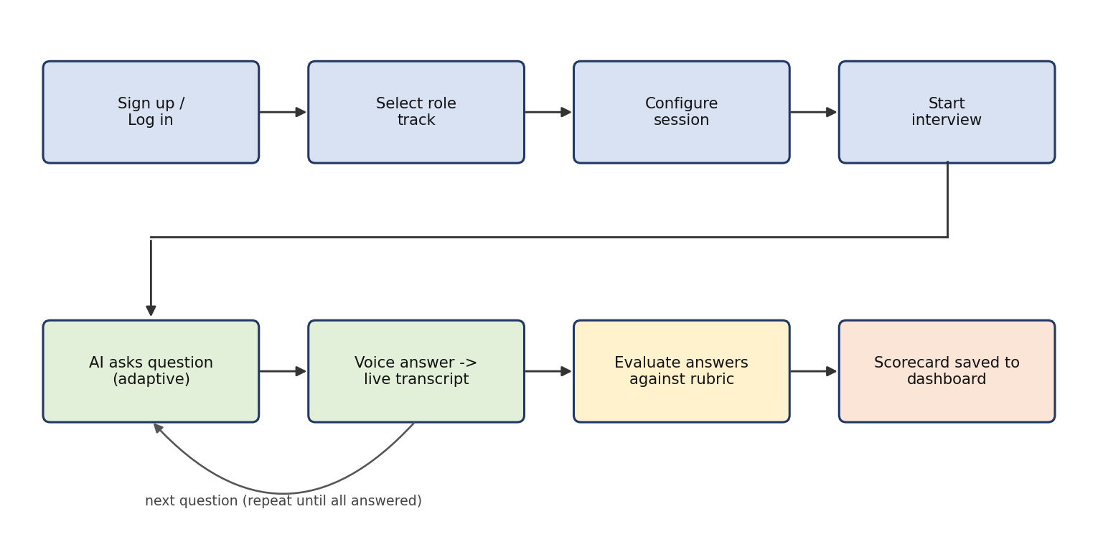
Figure 5.1: End-to-end interview session flow

5.2 ER Diagram / Database Schema
Figure 5.2 shows the entity-relationship diagram. A User can have many Sessions. Each Session belongs to one RoleTrack, contains many Answers and produces exactly one Scorecard. Dimension scores and feedback are stored as nested objects inside the Answer and Scorecard documents, which avoids joins and makes the scorecard page fast to load.
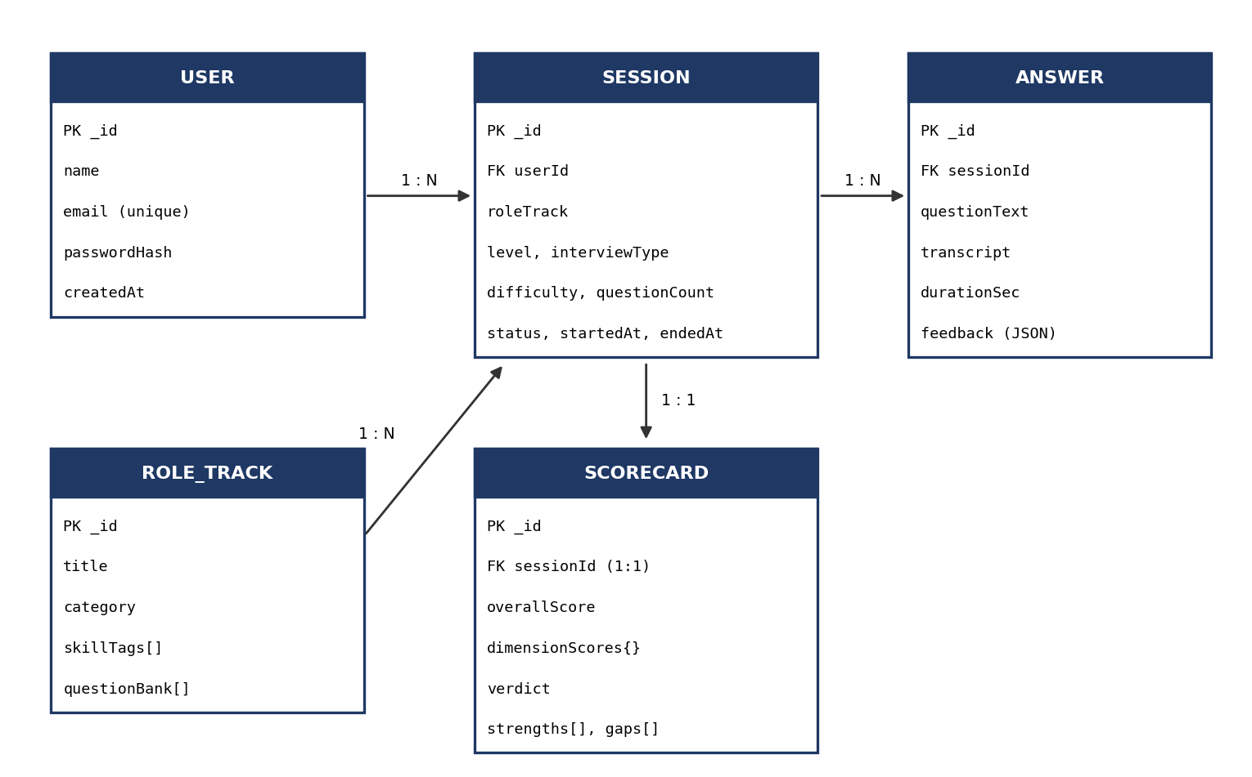
Figure 5.2: Entity-relationship diagram of InterviewAI
Collection | Key fields | Description
users | name, email, passwordHash, createdAt | Registered candidates; email is unique and indexed
roletracks | title, category, skillTags[], questionBank[] | Catalogue of 12 role tracks with seed topics used to guide question generation
sessions | userId, roleTrack, level, interviewType, difficulty, questionCount, status, startedAt, endedAt | One document per interview attempt
answers | sessionId, questionText, transcript, durationSec, feedback | One document per question answered, with per-answer evaluation
scorecards | sessionId, overallScore, dimensionScores, verdict, strengths[], gaps[] | Aggregated result of a session, used by the scorecard page and the dashboard

CHAPTER 6 – IMPLEMENTATION

6.1 Module-Wise Implementation
Module 1: Authentication and profile
Users register with a name, email and password. The server validates the input, hashes the password with bcrypt and stores the user. On login, the server compares the password hash and returns a signed JSON Web Token that the client stores and attaches to subsequent requests. Protected routes in the React application redirect unauthenticated visitors to the login page.
Module 2: Role selection and session setup
The role-selection screen presents the available tracks as cards. The following twelve tracks are included: Frontend Developer, Backend Developer, Full-Stack Developer, Data Analyst, Data Scientist, Machine Learning Engineer, DevOps and Cloud Engineer, Cybersecurity Analyst, Product Manager, UI/UX Designer, Business Analyst and HR / Behavioural. After choosing a track the user configures the session by selecting the experience level (fresher, junior, mid or senior), the interview type (technical, behavioural or mixed), the difficulty (easy, medium or hard), the number of questions (five, eight or ten) and the answer mode (voice or typed).
Module 3: Live interview room
The interview room shows the current question, a countdown timer, a microphone button and a live transcript panel. When the user starts speaking, interim speech results are displayed immediately and are replaced by final results as the recogniser becomes confident. The user can pause, re-record or edit the transcript before submitting. On submission, the answer is saved and the Question Engine is asked for the next question.
Module 4: Question Engine
The Question Engine builds a prompt that contains the role, level, interview type, difficulty, the skill tags for the role, the questions already asked and a short summary of the candidate's previous answer. The prompt instructs the model to ask exactly one question, to avoid repeating topics, and, where the previous answer was vague or incomplete, to ask a probing follow-up instead of moving to a new topic. This is what makes the interview dynamic.
Module 5: Evaluation Engine
After the final question, the Evaluation Engine scores each answer against a rubric that mirrors the criteria used by top-tier employers. The rubric has six dimensions, each scored from 0 to 10 with written justification. The model is required to return JSON only; the server validates the structure and the score ranges and retries once if validation fails.
Dimension | What is assessed | Weight
Technical accuracy | Correctness of facts, concepts and solutions | 25%
Depth of knowledge | Understanding of trade-offs, edge cases and the 'why' | 20%
Problem solving | Logical approach, decomposition and reasoning aloud | 20%
Structure and clarity | Organised delivery; use of STAR format for behavioural questions | 15%
Relevance | Directly answers the question that was asked | 10%
Delivery | Pace, filler words and conciseness measured from the transcript | 10%

Module 6: Scorecard and dashboard
The scorecard page displays the overall score out of 100, a radar chart of the six dimensions, a list of strengths and gaps, and per-question feedback with a suggested stronger answer outline. A verdict (Strong Hire, Hire, Borderline or Not Yet Ready) shows how the overall score compares with the hiring bar for the chosen level. The dashboard lists all earlier sessions, plots the score trend, highlights the strongest and weakest dimensions and shows how many sessions have been completed for each role.

6.2 Front-End Logic (UI Rendering and State Management)
The application is a single page; routes are rendered by React Router without reloading the document. The route structure is: the landing page, login and register pages, the role-selection page, the session-setup page, the interview room, the scorecard page and the dashboard. Pages that need an authenticated user are wrapped in a protected-route component.
State is divided by lifetime. Short-lived interface state, such as the open or closed state of a dialog, is held in component state. The active interview, including the configuration, the list of questions and answers and the current index, is held in a global store so that it survives navigation between components. The store also persists a draft of the current session to the browser's session storage so that an accidental refresh does not discard the user's progress.
Speech capture is encapsulated in a custom hook that wraps the browser's SpeechRecognition interface. The hook exposes the interim and final transcript, a listening flag and start and stop functions. If the browser does not support speech recognition, the hook reports that fact and the interface automatically switches to the typed-answer mode.

6.3 API Integration
The front end communicates with the back end through a small API client that adds the base URL and the Authorization header and handles errors in one place. The principal endpoints are listed below.
Method | Endpoint | Description
POST | /api/auth/register | Create a new user account
POST | /api/auth/login | Authenticate and return a JWT
GET | /api/roles | List the available role tracks
POST | /api/sessions | Create a new interview session with the chosen configuration
POST | /api/sessions/:id/question | Generate the next question using previous answers as context
POST | /api/sessions/:id/answer | Save an answer transcript for the current question
POST | /api/sessions/:id/finish | Evaluate all answers and generate the scorecard
GET | /api/sessions/:id/scorecard | Retrieve the scorecard for a session
GET | /api/me/dashboard | Return history and aggregated analytics for the logged-in user

Calls that involve the LLM are the slowest part of the system. The interface therefore shows a loading state while the next question is being prepared, and the final evaluation shows a progress indicator so that the user understands that the scorecard is being generated.

6.4 Authentication and Authorisation
Passwords are never stored in plain text; they are hashed with bcrypt using a per-user salt. After a successful login the server issues a JWT signed with a secret held in an environment variable and set to expire after a fixed period. An authentication middleware verifies the token on every protected route and attaches the user identity to the request.
Authorisation follows a simple ownership rule: a user may read and modify only their own sessions, answers and scorecards. Every query that touches these collections includes the authenticated user's identifier, so that one candidate can never access another candidate's data by guessing an identifier. Additional protections include input validation on all request bodies, rate limiting on the login and LLM-backed endpoints, and a restrictive CORS policy that allows only the deployed front-end origin.

CHAPTER 7 – FEATURES

7.1 List of Main Features
- Dark-themed single-page interface that is fully responsive.
- More than ten role tracks, from frontend development to product management and HR.
- Configurable sessions: level, interview type, difficulty, number of questions and answer mode.
- Live interview room with countdown timer and microphone control.
- Real-time voice transcription with interim results and an editable transcript.
- Dynamic, adaptive questions that follow up on the candidate's previous answer.
- Rubric-based evaluation across six dimensions.
- Granular scorecard with radar chart, strengths, gaps, model-answer outline and hiring-bar verdict.
- Personal candidate dashboard with history, trends and role-wise statistics.
- Secure registration and login with token-based authentication.

7.2 How Each Feature Works
Role tracks and session configuration
User perspective: the user browses role cards, picks one and answers a short set of configuration questions. Technical description: role data is fetched from the roles endpoint; the selected options are posted to the sessions endpoint, which creates a session document in the 'in progress' state and returns its identifier. The identifier and configuration are stored in the global store.
Live interview and real-time transcription
User perspective: the question appears, the timer starts, and the user presses the microphone button and speaks. Words appear in the transcript panel as they are spoken. Technical description: the speech hook starts a continuous SpeechRecognition session with interim results enabled. Interim results are rendered in a lighter colour; when the recogniser marks a result as final, it is appended to the committed transcript. When the user submits, the transcript and the elapsed time are sent to the answer endpoint.
Adaptive questioning
User perspective: the interviewer sometimes asks a follow-up that clearly relates to what the user just said, for example asking for a concrete example after a general answer. Technical description: the question endpoint sends the LLM the configuration, the list of previous questions and a trimmed version of the latest transcript. The prompt asks the model to choose between a deeper follow-up and a new topic based on completeness of the previous answer, and the response is limited to a single question.
Evaluation and scorecard
User perspective: at the end of the interview the user sees a scorecard within a few seconds. Technical description: the finish endpoint gathers all answers, builds an evaluation prompt that includes the rubric and the level-specific expectations, and calls the LLM with an instruction to return JSON. The server validates the JSON, computes the weighted overall score from the dimension scores, derives the verdict from level-specific thresholds, stores the scorecard and returns it.
The overall score is calculated as the weighted average of the dimension scores scaled to 100:
overall = round( 10 * ( 0.25*technical + 0.20*depth + 0.20*problemSolving
+ 0.15*structure + 0.10*relevance + 0.10*delivery ) )

Candidate dashboard
User perspective: the dashboard shows past sessions, a line chart of overall scores, the weakest and strongest dimensions and the number of sessions per role. Technical description: the dashboard endpoint runs an aggregation over the user's scorecards, returning the data in a shape that Recharts can render directly. Selecting a session opens its stored scorecard so that earlier feedback can be reviewed at any time.

CHAPTER 8 – TESTING

8.1 Postman Testing (Frontend/Backend)
Every REST endpoint was tested in Postman before it was connected to the front end. A Postman collection was created with folders for authentication, roles, sessions and analytics, and an environment variable stores the base URL and the JWT so that requests can be chained. Each request contains test scripts that assert the HTTP status code, the response structure and, for protected routes, that a request without a token is rejected.
Endpoint | Scenario | Expected result
POST /api/auth/register | Valid new user | 201 Created and user id returned
POST /api/auth/register | Duplicate email | 409 Conflict with error message
POST /api/auth/login | Wrong password | 401 Unauthorized
GET /api/roles | Authenticated request | 200 OK with list of 12 roles
POST /api/sessions | Missing required field | 400 Bad Request with validation message
GET /api/sessions/:id/scorecard | Another user's session | 403 Forbidden
GET /api/me/dashboard | No token supplied | 401 Unauthorized

8.2 Integration Testing
Integration testing verified that the front end, the back end, the database, the LLM and the speech module work together. The main end-to-end scenario was exercised repeatedly: register, log in, choose a role, configure a session, answer all questions by voice, receive the scorecard and find the session on the dashboard. Further integration scenarios covered the typed-answer fallback, refreshing the page during an interview, an expired token during a session, and a malformed LLM response.
Special attention was paid to the LLM integration. Responses that were not valid JSON, that omitted a dimension or that contained a score outside the range 0 to 10 were deliberately simulated; in each case the server retried once and then returned a clear error that the interface displayed with a retry button, rather than crashing or saving incomplete data.

8.3 Tools Used for Testing
Tool | Use
Postman | API functional tests and collection runs
Vitest | Unit tests for scoring functions and utility code
React Testing Library | Component tests for forms, role cards and the interview room
Browser DevTools | Network inspection, responsive-layout checks and performance review
Lighthouse | Performance, accessibility and best-practice audits
GitHub Actions | Automatic execution of lint and test suites on every pull request

8.4 Test Cases and Results
ID | Test case | Expected result | Status
TC-01 | Register with valid details | Account created; user redirected to role selection | Pass
TC-02 | Login with incorrect password | Error message shown; no token issued | Pass
TC-03 | Access dashboard without login | Redirected to login page | Pass
TC-04 | Select each of the 12 role tracks | Setup screen opens for the chosen role | Pass
TC-05 | Start session with default configuration | First question displayed with timer running | Pass
TC-06 | Speak an answer in Chrome | Live transcript appears while speaking | Pass
TC-07 | Open interview in an unsupported browser | Typed-answer mode enabled with a notice | Pass
TC-08 | Submit an answer | Answer saved; next question generated | Pass
TC-09 | Give a vague answer | Follow-up question probes the same topic | Pass
TC-10 | Let the timer expire | Answer auto-submitted; interview continues | Pass
TC-11 | Complete all questions | Scorecard generated with all six dimensions | Pass
TC-12 | Simulated invalid LLM output | Retry occurs; error shown if it fails again | Pass
TC-13 | Refresh the page mid-interview | Session restored from saved draft | Pass
TC-14 | View an older scorecard from the dashboard | Stored scorecard displayed correctly | Pass
TC-15 | Use the application on a 375 px wide screen | Layout adapts; no horizontal scrolling | Pass

CHAPTER 9 – DEPLOYMENT

9.1 Steps to Deploy
- Push the latest tested code to the main branch of the GitHub repository.
- Create a MongoDB Atlas cluster, create a database user and add the hosting platform's IP range to the network access list.
- Create a web service on Render, connect it to the repository's server folder, and set the build command to 'npm install' and the start command to 'node server.js'.
- Add the required environment variables to the Render service.
- Create a project on Vercel, connect the repository's client folder and set the build command to 'npm run build' with 'dist' as the output directory.
- Set the API base URL environment variable on Vercel to the deployed Render URL.
- Trigger a deployment, open the public URL and run the smoke-test scenario of registering, running a short interview and viewing the scorecard.

9.2 Environment Configuration
Variable | Location | Purpose
MONGODB_URI | Back end | Connection string for the MongoDB Atlas database
JWT_SECRET | Back end | Secret used to sign and verify authentication tokens
JWT_EXPIRES_IN | Back end | Token lifetime, for example 7d
LLM_API_KEY | Back end | Credential for the LLM provider; never exposed to the browser
LLM_MODEL | Back end | Name of the model used for questions and evaluation
CLIENT_ORIGIN | Back end | Allowed front-end origin for the CORS policy
VITE_API_URL | Front end | Base URL of the deployed API

Local development uses a .env file that is excluded from version control through .gitignore. A sample file, .env.example, lists the required names without values so that new contributors can set up the project quickly.

9.3 Hosting of Frontend and Backend
The front end is hosted on Vercel, which serves the static build from a global CDN and provides automatic HTTPS and preview deployments for pull requests. The back end is hosted on Render as a Node.js web service with automatic deployments from the main branch and HTTPS enabled by default. The database is hosted on MongoDB Atlas, which provides managed backups and monitoring. Because the three components are independently hosted, each can be scaled or replaced without affecting the others.

CHAPTER 10 – CHALLENGES & LIMITATIONS

10.1 Issues Faced During Development
- Inconsistent LLM output: the model occasionally returned text around the JSON, missed a field or produced an out-of-range score.
- Speech-recognition behaviour: transcripts sometimes duplicated phrases, the recogniser stopped after a period of silence, and browser support was uneven.
- Latency: generating the next question or the final scorecard could take several seconds, which felt slow in a live interview.
- Scoring consistency: the same answer could receive slightly different scores on different runs.
- State loss: an accidental page refresh during an interview erased the session.
- Dark-theme accessibility: some accent colours did not provide enough contrast on dark backgrounds.

10.2 Solutions Applied
- Structured prompts with a strict JSON schema, server-side validation of every field and range, and a single automatic retry.
- A custom speech hook that deduplicates final results, restarts the recogniser when it ends unexpectedly and falls back to typed answers when speech recognition is unavailable.
- Loading indicators, short prompts with trimmed context, and preparing the next question while the user is still reviewing the transcript to hide part of the delay.
- Low-temperature model settings, a fixed rubric with explicit score anchors and weighted aggregation on the server rather than by the model.
- Saving a draft of the active session to session storage after every answer and restoring it on load.
- Adjusting the palette to meet WCAG contrast ratios and checking each screen with Lighthouse.

10.3 Current Limitations or Known Bugs
- Voice transcription works best in Chromium-based browsers; Firefox users must type their answers.
- Transcription accuracy depends on microphone quality, accent and background noise, and technical terms are occasionally misrecognised.
- The platform evaluates the content and delivery of the transcript but does not analyse tone of voice, eye contact or body language.
- Scores are an AI-based estimate and may differ from the judgement of a human interviewer; they should be used as guidance rather than as a guarantee of outcome.
- The platform requires an internet connection and depends on the availability of the LLM provider.
- Interviews are currently available in English only.

CHAPTER 11 – FUTURE ENHANCEMENTS

11.1 Planned Features
- Video mode with webcam recording and analysis of eye contact, posture and facial expressions.
- Resume-aware interviews in which questions are generated from the user's uploaded résumé and the job description.
- Company-specific tracks that reflect the interview patterns of well-known employers.
- Coding-round mode with an embedded editor and automated test execution.
- Multi-language support so that candidates can practise in their preferred language.
- Streaks, badges and goals on the dashboard to encourage regular practice.
- Shareable scorecards and mentor review, so that a teacher can add comments to a student's session.

11.2 Possible Integrations or Optimisations
- Streaming LLM responses so that questions appear word by word and perceived latency falls.
- Text-to-speech so that the AI interviewer can ask each question in a natural voice.
- A server-side speech-to-text option to improve accuracy and to support browsers without native speech recognition.
- Caching of role metadata and aggregated analytics to reduce database load.
- Progressive Web App support for installation on phones and limited offline browsing of past scorecards.
- Integration with LinkedIn and job portals to recommend practice tracks for roles a user is applying to.
- Analytics for institutions so that training and placement cells can view anonymised cohort-level progress.

CHAPTER 12 – CONCLUSION

12.1 Summary of the Project
InterviewAI is a dark-themed, single-page React web application that simulates AI-powered mock job interviews across more than ten role tracks. The user selects a role, configures the session and takes part in a live interview with real-time voice transcription and dynamic questions. At the end of the session the platform produces a granular scorecard, evaluated against top-tier hiring standards, and stores it on a personal candidate dashboard where progress can be tracked over time.
The project follows a clear three-tier architecture, with a React front end, a Node.js and Express API that securely mediates access to the LLM, and a MongoDB database. It has been tested at the API, component and end-to-end levels and deployed to the cloud using a continuous-integration and continuous-deployment pipeline.

12.2 What Was Achieved
- A working end-to-end mock interview experience from login to scorecard.
- Twelve role tracks with configurable level, type, difficulty and length.
- Real-time voice transcription with a typed-answer fallback.
- Adaptive question generation that responds to the candidate's earlier answers.
- A six-dimension rubric and a weighted scoring model producing an overall score and a hiring-bar verdict.
- A personal dashboard that makes improvement visible across sessions.
- Secure authentication, per-user data isolation and protection of third-party API keys.
- A documented and tested system that is deployed and accessible through a public URL.

12.3 Skills Learned During Development
The project gave the team practical experience across the full stack. On the front end, the team learned to design component hierarchies in React, manage shared state, build accessible dark interfaces and visualise data with charts. On the back end, the team learned REST API design, JWT authentication, schema design in MongoDB and secure handling of secrets.
The team also learned how to work with generative AI as an engineering component: writing structured prompts, constraining model output to a schema, validating it, handling failures gracefully and reducing variability in scoring. Beyond technical skills, the project strengthened teamwork, Git-based collaboration, time management, systematic testing and technical documentation.

CHAPTER 13 – REFERENCES

Books
- McDowell, G. L., Cracking the Coding Interview, CareerCup.
- Banks, A. and Porcello, E., Learning React, O'Reilly Media.
- Haverbeke, M., Eloquent JavaScript, No Starch Press.
- Martin, R. C., Clean Code: A Handbook of Agile Software Craftsmanship, Prentice Hall.

Documentation and Learning Resources
- React documentation – https://react.dev
- Vite documentation – https://vitejs.dev
- React Router documentation – https://reactrouter.com
- Tailwind CSS documentation – https://tailwindcss.com/docs
- Recharts documentation – https://recharts.org
- MDN Web Docs, Web Speech API – https://developer.mozilla.org/docs/Web/API/Web_Speech_API
- Node.js documentation – https://nodejs.org/docs
- Express documentation – https://expressjs.com
- MongoDB and Mongoose documentation – https://www.mongodb.com/docs and https://mongoosejs.com
- JSON Web Tokens introduction – https://jwt.io/introduction
- OWASP Top Ten – https://owasp.org/www-project-top-ten
- Postman Learning Center – https://learning.postman.com
- Vercel and Render documentation – https://vercel.com/docs and https://render.com/docs

CHAPTER 14 – APPENDICES

14.1 Screenshots of the App
The following figures show the main screens of InterviewAI. Replace each frame with the corresponding screenshot of the running application.
[ Insert screenshot ]  Figure A.1: Landing page | [ Insert screenshot ]  Figure A.2: Login / register
[ Insert screenshot ]  Figure A.3: Role selection (12 tracks) | [ Insert screenshot ]  Figure A.4: Session setup
[ Insert screenshot ]  Figure A.5: Live interview room with transcript | [ Insert screenshot ]  Figure A.6: Scorecard with radar chart
[ Insert screenshot ]  Figure A.7: Candidate dashboard | [ Insert screenshot ]  Figure A.8: Past session review

14.2 Sample Code Snippets
A. Speech-recognition hook (src/hooks/useSpeech.js)
import { useEffect, useRef, useState } from "react";

export default function useSpeech() {
const Rec = window.SpeechRecognition || window.webkitSpeechRecognition;
const supported = Boolean(Rec);
const recRef = useRef(null);
const [listening, setListening] = useState(false);
const [finalText, setFinalText] = useState("");
const [interim, setInterim] = useState("");

useEffect(() => {
if (!supported) return;
const rec = new Rec();
rec.continuous = true;
rec.interimResults = true;
rec.lang = "en-US";
rec.onresult = (e) => {
let tmp = "";
for (let i = e.resultIndex; i < e.results.length; i++) {
const t = e.results[i][0].transcript;
if (e.results[i].isFinal) setFinalText((p) => (p + " " + t).trim());
else tmp += t;
}
setInterim(tmp);
};
rec.onend = () => setListening(false);
recRef.current = rec;
return () => rec.abort();
}, []);

const start = () => { recRef.current?.start(); setListening(true); };
const stop = () => recRef.current?.stop();
const reset = () => { setFinalText(""); setInterim(""); };
return { supported, listening, finalText, interim, start, stop, reset };
}

B. Weighted score calculation (server/utils/score.js)
const WEIGHTS = {
technical: 0.25, depth: 0.20, problemSolving: 0.20,
structure: 0.15, relevance: 0.10, delivery: 0.10,
};

function overallScore(dims) {
const sum = Object.entries(WEIGHTS)
.reduce((acc, [k, w]) => acc + w * Number(dims[k]), 0);
return Math.round(sum * 10); // scale 0-10 to 0-100
}

function isValidDims(dims) {
return Object.keys(WEIGHTS).every(
(k) => Number.isFinite(dims[k]) && dims[k] >= 0 && dims[k] <= 10
);
}

module.exports = { overallScore, isValidDims };

14.3 Installation / Setup Instructions
- Install Node.js 18 or later and Git, and create a free MongoDB Atlas cluster (or start a local MongoDB).
- Clone the repository: git clone <repository-url> and open the project folder.
- In the server folder, copy .env.example to .env and fill in MONGODB_URI, JWT_SECRET, LLM_API_KEY, LLM_MODEL and CLIENT_ORIGIN.
- In the server folder run npm install and then npm run seed to load the 12 role tracks, followed by npm run dev.
- In the client folder copy .env.example to .env, set VITE_API_URL to the server address, run npm install and then npm run dev.
- Open http://localhost:5173 in Google Chrome or Microsoft Edge and allow microphone access when prompted.

14.4 User Manual or Guide
- Create an account on the Register page and log in.
- On the role-selection page, choose the role you want to practise for.
- On the setup page, select your experience level, interview type, difficulty, number of questions and answer mode (voice or typed), then press Start Interview.
- Read the question, press the microphone button and answer aloud. Check the live transcript, edit it if required and press Submit.
- Repeat for each question. Follow-up questions may depend on your previous answer.
- After the last question, wait a few seconds for the scorecard. Review the overall score, the radar chart, strengths, gaps and suggested improvements.
- Open the Dashboard at any time to review past sessions and track how your scores change.

14.5 Geo-Tagged Photos with Guide
[ Attach geo-tagged photographs of the project work sessions here, with the guide present. ]

14.6 Review Forms with Guide Signatures
[ Attach scanned review forms signed by the project guide here. ]

