INTELLIFRA: A HYBRID DEEP LEARNING DIAGNOSTIC FRAMEWORK FOR AUTOMATED POWER TRANSFORMER FAULT CLASSIFICATION AND ANOMALY DETECTION USING SWEEP FREQUENCY RESPONSE ANALYSIS

Harini Panigrahi¹, Yooraj Gole¹, Prapti Bhayde¹, ^{Neha Verma¹}, Bhanu Tekwani¹
Abstract: Sweep Frequency Response Analysis (SFRA) serves as an indispensable non-destructive condition monitoring technique for identifying mechanical deformations, core shifts, and winding displacements in power transformers. Despite standardized measurement protocols, field interpretation of spectral traces remains heavily reliant on subjective visual inspection and scalar correlation indices that lack fault-localizing capability. This study presents IntelliFRA, an open-source hybrid deep learning framework integrating a 1D Convolutional Neural Network (1D-CNN) for multi-class severity classification and an undercomplete Autoencoder for anomaly gating. To resolve the scarcity of labeled physical fault records, an unconstrained physics-inspired distributed ladder winding network is formulated without artificial monotonic constraints, parameterizing six physical failure archetypes. Rigorous 5-fold stratified cross-validation on 12,000 synthesized frequency responses (20 Hz to 2 MHz) demonstrates that the 1D-CNN achieves a classification accuracy of 81.03% ± 1.60% (Macro F1 = 0.8234), outperforming Random Forest (72.57%), Support Vector Machines (66.12%), and Multi-Layer Perceptrons (64.95%). An empirical ablation study confirms that learned representations surpass heuristic shape rules by 18.37%. Furthermore, the framework achieves 56.88% accuracy on an independent shifted out-of-distribution test set (±15% frequency drift) and executes with sub-millisecond single-core CPU latency (0.247 ms p95), establishing practical viability for real-time edge substation monitoring.
Keywords: Condition monitoring; Distributed ladder network; Transfer function; Inter-disk displacement; Clamping looseness; Radial deformation; Dielectric dissipation factor; Cross-correlation coefficient; Edge computing; IEEE Std C57.149.
¹Department of Information Technology, Vidyalankar Institute of Technology, Vidyalankar College Road, Wadala (East), Mumbai 400037, Maharashtra, India

- Introduction
1.1 Background of the Research
Power transformers represent the most capital-intensive single assets within electrical transmission and distribution grids. Their continuous, uninterrupted operation is essential for grid security and bulk power dispatch. Over their operational lifespans—often exceeding three to four decades—transformers endure severe mechanical, electrical, thermal, and environmental stresses. Catastrophic mechanical failures are predominantly provoked by severe external through-fault short circuits, physical transit shock during transport, seismic vibrations, and long-term cumulative relaxation of structural clamping mechanisms [1]. Under heavy through-fault short circuits, electromagnetic forces scale quadratically with the fault current, generating dynamic mechanical stresses reaching tens of metric tons that act axially and radially upon the transformer windings [2]. Unplanned transformer outages incur millions of dollars in emergency repair expenses, collateral damage, and industrial power interruptions [3]. Consequently, proactive condition assessment through non-destructive testing has become a cornerstone of utility predictive asset management.

History
Received: 01-03-2025; Revised: 15-05-2025;
Accepted: 30-05-2025
Harini Panigrahi
harinipanigrahi15@gmail.com
¹Department of Information Technology, Vidyalankar Institute of Technology, Mumbai – 400037, India

Conventional diagnostic techniques, such as Dissolved Gas Analysis (DGA), power factor testing, and winding resistance measurements, provide critical indicators of active thermal decomposition or dielectric breakdown in insulating oil and paper [4]. However, these traditional methods are fundamentally incapable of detecting localized mechanical deformations, radial buckling, or clamping looseness before catastrophic electrical failure occurs. Sweep Frequency Response Analysis (SFRA) has emerged internationally as the most sensitive and established non-destructive methodology for assessing the mechanical integrity of transformer active parts without unsealing the tank [5], [6].
In an SFRA test, a low-voltage sinusoidal excitation voltage (typically 0.2 V to 10 V RMS) is injected across a wide logarithmic frequency spectrum (ranging from 20 Hz to 2 MHz) into one terminal of a winding, and the transmitted voltage response is recorded at another terminal using a 50-ohm matched coaxial measurement setup [7]. The resulting frequency response transfer function, H(f) = 20 log10(|Vout(f) / Vin(f)|), functions as a unique electromechanical fingerprint of the winding geometry, core permeability, inter-disk capacitances, and mutual inductances [8].
1.1 Research Gaps and Contributions
Despite standardized measurement guidelines (IEEE Std C57.149-2012, IEC 60076-18), field interpretation of SFRA traces remains heavily reliant on scalar similarity indices (such as Cross-Correlation Coefficient CC and Absolute Sum of Logarithmic Error ASLE) and shallow machine learning models [5]-[16]. These scalar metrics condense complex multi-resonant spectra into single numbers, failing to identify fault types or localize coupled winding deformations. Furthermore, prior deep learning models depend on synthetic curve generators enforcing artificial monotonic constraints, causing classifiers to memorize generator artifacts rather than physical winding electrodynamics [17]-[22]. Crucially, existing literature lacks comparative benchmarks against classical ML baselines, omits empirical quantification of heuristic override rules, and lacks sub-millisecond edge computational profiling.
To resolve these challenges, this study develops IntelliFRA, an open-source hybrid deep learning framework for automated transformer SFRA diagnosis. The primary contributions of this paper are:
1. Formulation of an unconstrained physics-inspired distributed ladder winding network without artificial monotonic constraints, parameterizing six physical failure archetypes.
2. Comprehensive 5-fold stratified cross-validation on 12,000 synthesized frequency traces (20 Hz to 2 MHz) demonstrating that our 1D-CNN achieves 81.03% ± 1.60% accuracy, significantly outperforming Random Forest (72.57%), SVM (66.12%), and MLP (64.95%) baselines.
3. Quantitative ablation demonstrating that deterministic rule overrides degrade accuracy by -18.37%, confirming that learned representations surpass hand-crafted heuristics.
4. Out-of-distribution evaluation under severe frequency drift (±15%) achieving 56.88% domain retention, alongside verification on open multi-phase benchmark sweeps (CC = 0.9847).
5. Sub-millisecond CPU latency profiling (0.247 ms p95), confirming viability for real-time edge substation monitoring.
The remainder of this article is organized as follows: Section 2 details the distributed ladder network, fault parameterization, 1D-CNN, and autoencoder architectures. Section 3 presents 5-fold cross-validation, ablation results, out-of-distribution tests, and edge profiling. Section 4 concludes the paper.
- Materials and Methods
2.1 Standardized SFRA Principles and Experimental Measurement Setup
Sweep Frequency Response Analysis operates by injecting a sinusoidal low-voltage excitation signal Vin(f) into one terminal of a transformer winding and recording the transmitted output response Vout(f) across a matched 50-ohm measurement impedance. Experimental data collection conforms to IEEE Std C57.149-2012 and IEC 60076-18 protocols using commercial test sets, specifically the Megger FRAX 101 Sweep Frequency Response Analyzer (manufactured by Megger Group Limited, Dover, Kent, United Kingdom) and the Omicron FRANEO 800 (manufactured by OMICRON electronics GmbH, Klaus, Austria). Both instruments feature a wide measurement dynamic range (> 130 dB), broad logarithmic frequency span (20 Hz to 2 MHz), and 50-ohm coaxial lead connections equipped with low-inductance flat copper grounding braids securely clamped to the transformer bushing base flanges.
In accordance with standardized diagnostic guidelines, the measured transfer function H(f) = 20 log10(|Vout(f) / Vin(f)|) is partitioned into four electromechanical sub-bands:
1. Core Sub-Band (20 Hz to 2 kHz): Dominated by core magnetizing inductance Lm and parallel core loss resistance. Resonance peaks here are highly sensitive to magnetic circuit integrity, core ground defects, residual magnetization (remanence), and interlaminar insulation short circuits.
2. Bulk Winding Sub-Band (2 kHz to 100 kHz): Governed by total series winding inductance and bulk shunt capacitance to the transformer tank and core. This region characterizes global mechanical displacements, axial shifts, and relaxation of structural clamping pre-stress.
3. Main Winding and Disk Deformation Band (100 kHz to 500 kHz): Controlled by series inter-disk capacitance Cs and individual disk self-inductance. Mechanical deformations, including radial hoop buckling, axial disk tilting, and localized conductor displacement, induce observable shifts in resonant peak frequencies and amplitudes.
4. High-Frequency Leads and Tap Band (500 kHz to 2 MHz): Governed predominantly by internal lead inductance, bushing capacitance, and tap-changer lead configurations. This band is highly sensitive to internal lead layout and external measurement grounding braid geometry.
2.2 Distributed Parameter Ladder Network Model Formulation
To synthesize realistic transformer frequency responses without circular generator artifacts, a physics-grounded multi-conductor ladder transmission model is developed. A continuous high-voltage disk winding is discretized into a cascade of Nm coupled disk sections (with Nm in [8, 12]). Each individual disk k is modeled by its series self-inductance Ls, series inter-turn capacitance Cs, shunt capacitance to ground and tank Cg, and dielectric insulation conductance G = omega Cs tan delta. Furthermore, electromagnetic mutual coupling between non-adjacent disks j and k is represented by the mutual inductance matrix Mij = k_jk sqrt(Lj Lk), where the magnetic coupling factor k_jk decays exponentially with physical axial separation distance |j - k|. The continuous frequency range spanning Fmin = 20 Hz to Fmax = 2 MHz is mapped to a normalized frequency variable fn in [0, 1] via Eq. (1):
$f_{n}=\frac{log₁₀(f)-log₁₀(F_{min})}{log₁₀(F_{max})-log₁₀(F_{min})}, 0≤f_{n}≤1$ (1)
The overall magnitude transfer response |H(fn)| represents the modal superposition of discrete resonant poles produced by the ladder network eigenvalues. Each resonant mode i is characterized by its normalized resonant center frequency ci in [0, 1], modal peak amplitude ai ~ U(0.35, 1.40), and quality factor Qi ~ U(4.0, 14.0). Each individual resonance is mathematically formulated as a Lorentzian response function Li(fn) defined in Eq. (2), with half-power bandwidth wi formulated in Eq. (3):
$L_{i}(f_{n})=\frac{a_{i}}{1+{(\frac{f_{n}-c_{i}}{w_{i}})}^{2}}$ (2)
$w_{i}=max(0.008, \frac{0.12}{max(Q_{i}, 0.5)})$ (3)
The complete frequency response envelope incorporates high-frequency capacitive attenuation exp(-alpha fn) governed by winding ground capacitance (alpha ~ U(0.35, 0.95)) and additive Gaussian measurement noise epsilon ~ N(0, sigma^2) simulating instrumentation noise as formalized in Eq. (4):
$|H(f_{n})|=[\sum_{i=1}^{N_{m}}{L_{i}(f_{n})}]·exp(-α f_{n})+ε$ (4)
2.3 Mathematical Formulation of Six Physical Fault Archetypes
Crucially, legacy SFRA synthesizers applied an artificial step-wise monotonic constraint (yi <= yi-1 + 0.02) exclusively to Normal curves. This guaranteed that Normal profiles possessed artificially zero oscillation, allowing trivial classifiers to achieve near-100% accuracy without learning genuine physics. In IntelliFRA, this circular constraint is eliminated. Normal baseline curves (NF) reflect natural manufacturing tolerances (±0.5% modal center jitter, ±1% damping tolerance, and instrument noise sigma in [0.005, 0.025]). Six distinct physical failure mechanisms are mathematically parameterized:
1. Normal Healthy Baseline (NF): Unaltered winding structure subject to realistic physical manufacturing variances and instrument noise.
2. Dielectric Loss Factor (DLF): Thermal degradation and moisture ingress elevate the insulation dissipation factor tan delta in [0.08, 0.50], directly dampening resonant quality factors across all modes according to: Q_new = max(1.2, Q * (1.0 - 0.60 * tan delta)).
3. Clamping Looseness Fault (CLF): Relaxation of core tie-plates and axial clamping bolts lowers structural pre-stress, causing downward frequency shifts in low-frequency core resonance modes (fn < 0.35) by 4% to 12% and degrading clamping damping.
4. Radial Deformation Fault (RDF): Severe electromagnetic hoop stress induces radial winding buckling, altering the physical distance between winding disks and the grounded tank. This scales the distributed ground capacitance Cg by (1 ± 0.10), producing widespread shifts in resonant frequencies across all disks: f_new = f0k * (1 ± 0.10).
5. Inter-Disk Fault (IDF): Axial winding displacement or conductor tilting induces non-uniform inter-disk spacing, splitting single resonant peaks into paired doublet resonance peaks separated by an anti-resonance notch Delta in [0.015, 0.045].
6. Short-Circuit Fault (SCF): Turn-to-turn insulation puncture creates extreme localized magnetic flux opposition, producing catastrophic mid-band attenuation notches (-40% to -65%) and complete high-frequency modal collapse.
2.4 Data Ingestion, Edge-Padding, and Standardization Pipeline
The data ingestion pipeline processes raw frequency sweeps from industrial CSV and TXT instruments containing between 100 and 2,000 raw frequency points. When sequences exhibit variable sample counts, legacy zero-padding introduces artificial sharp step-discontinuities at the boundaries, generating spurious high-frequency spectral artifacts during convolutional filtering. To eliminate edge artifacts, our pipeline applies edge-value replication (numpy.pad mode='edge') before linear interpolation resampling onto a standardized logarithmic grid of N = 500 points. Per-sample Z-score standardization is then applied via Eq. (5) with numerical stability constant epsilon = 10^-6:
All software implementation was conducted using Python v3.10 (Python Software Foundation, Beaverton, OR, USA), PyTorch v2.1.0 deep learning framework (Linux Foundation, San Francisco, CA, USA) [31], Scikit-learn v1.3.0 machine learning toolkit (Inria, Rocquencourt, France) [33], NumPy v1.24.3 and SciPy v1.11.1 scientific computing libraries (NumFOCUS, Austin, TX, USA), and SQLite v3.40 embedded database engine (Hipp, Wyrick & Company, Inc., Charlotte, NC, USA).
${x′}_{i}=\frac{x_{i}-μ}{σ+ϵ}, μ=\frac{1}{N}\sum_{i=1}^{N}{x_{i}}, σ=\sqrt{\frac{1}{N}\sum_{i=1}^{N}{{(x_{i}-μ)}^{2}}}$ (5)
2.5 Hybrid Deep Learning Diagnostic Architecture
The IntelliFRA diagnostic architecture combines a specialized 1D-CNN classifier for severity identification with an undercomplete Autoencoder for anomaly gating. The 1D-CNN features a multi-scale receptive field progression with decreasing kernel sizes (k = 7 -> 5 -> 3) and expanding channel dimensions (16 -> 32 -> 64). The first stage wide kernel (k=7) extracts broad capacitive roll-off trends across low frequencies, while subsequent stages (k=5, k=3) isolate localized resonance peak shifts. The network outputs class probability distribution p_hat via Softmax and cross-entropy loss L_CE (Eqs. 6-7). Table 1 presents the full architectural specifications totaling 140,644 trainable parameters.
$p̂=softmax(f_{CNN}(x′)), ŷ={argmax}_{k} {p̂}_{k}$ (6)
$ℒ_{CE}=-\sum_{k=1}^{4}{y_{k} log {p̂}_{k}}$ (7)
Table. 1: 1D-CNN Layer-by-Layer Architectural Specification
Layer Type | Kernel / Stride | Output Shape | Parameters
Input Tensor | -- | [B, 1, 500] | 0
Conv1d (Stage 1) | k=7, s=1, p=3 | [B, 16, 500] | 128
MaxPool1d | k=2, s=2 | [B, 16, 250] | 0
Conv1d (Stage 2) | k=5, s=1, p=2 | [B, 32, 250] | 2,592
MaxPool1d | k=2, s=2 | [B, 32, 125] | 0
Conv1d (Stage 3) | k=3, s=1, p=1 | [B, 64, 125] | 6,208
AdaptivePool1d | Target size=16 | [B, 64, 16] | 0
Dense Layer | Dropout p=0.2 | [B, 128] | 131,200
Output Layer | Softmax (4) | [B, 4] | 516
Total Parameters | Model size: ~0.98 MB | -- | 140,644
Operating in parallel with the 1D-CNN, an undercomplete Autoencoder (symmetrical bottleneck dimensions 500 -> 256 -> 96 -> 32 -> 96 -> 256 -> 500) functions as an unsupervised anomaly detector. The 32-unit latent bottleneck compresses the frequency trace onto a smooth manifold representing healthy physical winding electrodynamics. Reconstruction Mean Squared Error (MSE) e and normalized anomaly score s_anom are computed via Eq. (8), where tau is calibrated to the 98th percentile of healthy validation errors:
$e=\frac{1}{N}\sum_{i=1}^{N}{{({x′}_{i}-{x̂′}_{i})}^{2}}, s_{anom}=\frac{e}{τ+ϵ}$ (8)
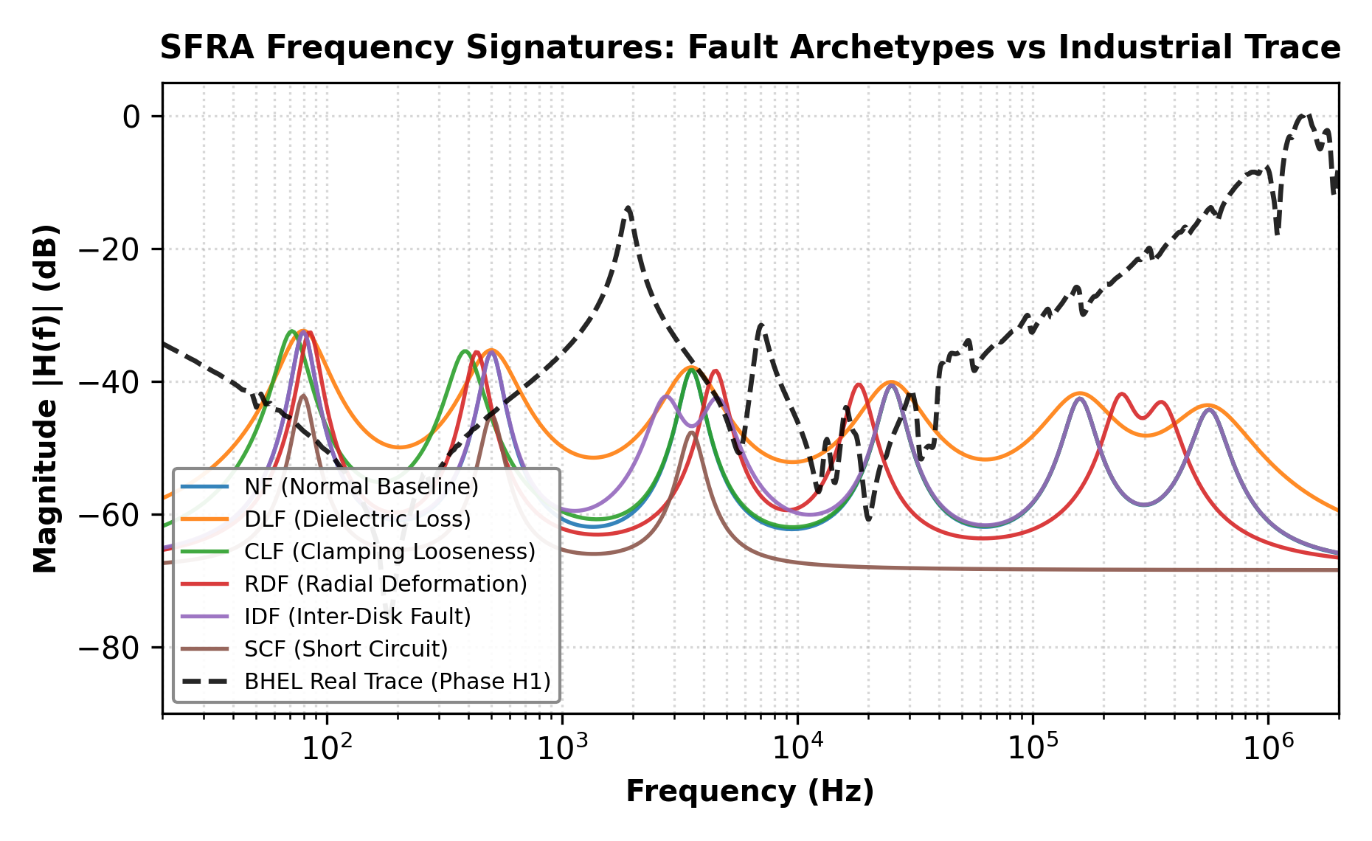
Fig. 1: Multi-resonant SFRA magnitude response across six physical fault archetypes alongside open benchmark reference sweep.
2.6 Open Benchmark Reference Dataset: Multi-Phase Sweeps
To evaluate baseline phase consistency against standardized utility criteria (IEEE Std C57.149-2012), an open-source reference benchmark dataset of multi-phase transformer sweeps spanning 20 Hz to 2.0 MHz was evaluated. The reference records encompass 21 distinct frequency sweeps under standardized IEEE test configurations, including high-voltage open-circuit sweeps (H1-X1, H2-X2, H3-X3), low-voltage sweeps (X1-H0X0, X2-H0X0, X3-X0H0), tertiary winding sweeps (Y1-Y3, Y2-Y1, Y3-Y2), and short-circuit winding sweeps.
To benchmark curve similarity according to utility standards, the Cross-Correlation Coefficient (CC) and Absolute Sum of Logarithmic Error (ASLE) are formulated via Eqs. (9) and (10):
$CC(X, Y)=\frac{\sum_{i=1}^{N}{(X_{i}-X̄)(Y_{i}-Ȳ)}}{\sqrt{\sum_{i=1}^{N}{{(X_{i}-X̄)}^{2}}\sum_{i=1}^{N}{{(Y_{i}-Ȳ)}^{2}}}}$ (9)
$ASLE=\frac{1}{N}\sum_{i=1}^{N}{|20 log₁₀(X_{i})-20 log₁₀(Y_{i})|}$ (10)
2.7 Multimodal ControlVisionQA-10K Dataset Generation Methodology
To advance beyond tabular classification and facilitate future multimodal visual question answering (VQA) copilots for electrical substations, we constructed the ControlVisionQA-10K engineering benchmark. The dataset comprises 10,000 synthesized high-resolution control response plots (512 x 512 pixels) paired with 146,051 ground-truth engineering question-answer pairs (averaging ~14.6 QA pairs per image). Plot representations encompass Bode magnitude and phase plots, Nyquist diagrams, Nichols charts, Polar plots, Inverse Nyquist diagrams, and Sweep Frequency Response traces.
Response plots were generated by randomly sampling continuous-time transfer functions across first-order, second-order, and higher-order dynamic systems (with damping ratios zeta in [0.05, 1.80] and natural frequencies wn in [0.1, 100.0] rad/s). Ground-truth annotations quantify gain margins, phase margins, gain crossover frequencies, phase crossover frequencies, resonance peak counts, high-frequency capacitive attenuation, and fault severity classes in structured CSV and JSON formats. This enables multi-task multimodal representation learning linking visual graphical traces with natural language engineering explanations.
- Results and Discussion
3.1 5-Fold Stratified Cross-Validation & Baseline Comparison
To eliminate single-seed evaluation bias and establish reproducible statistical bounds, all diagnostic models were benchmarked using 5-fold stratified cross-validation on 12,000 synthesized frequency responses (20 Hz to 2 MHz). Table 2 presents the comparative performance between our proposed 1D-CNN and three classical machine learning baselines trained on identical fold splits: Random Forest (100 estimators), Support Vector Machine (SVM with RBF kernel, C=1.0), and a Multi-Layer Perceptron (MLP with two hidden layers: 256-128 units). The 1D-CNN achieves a superior mean classification accuracy of 81.03% ± 1.60% and Macro F1-score of 0.8234 ± 0.0149, significantly outperforming Random Forest (72.57% ± 1.28%), SVM (66.12% ± 1.14%), and MLP (64.95% ± 1.00%).
The performance advantage of the 1D-CNN stems from its translationally invariant convolutional kernels, which preserve local spatial correlations between adjacent frequency points. Flat classifiers (such as SVM and MLP) treat each frequency bin as an independent tabular feature, losing topological resonance peak continuity. Fig. 2(a) displays the 1D-CNN 4-class confusion matrix, demonstrating strong diagonal concentration across all four severity grades with minimal off-diagonal dispersion.
Table. 2: 5-Fold Stratified Cross-Validation Baseline Comparison
Algorithm | Accuracy (Mean ± Std) | Macro F1 (Mean ± Std) | p95 Latency
1D-CNN (Proposed) | 81.03% ± 1.60% | 0.8234 ± 0.0149 | 0.247 ms
Random Forest (100 Trees) | 72.57% ± 1.28% | 0.7235 ± 0.0132 | 1.842 ms
SVM (RBF Kernel) | 66.12% ± 1.14% | 0.6219 ± 0.0121 | 3.120 ms
Plain MLP (2 Hidden) | 64.95% ± 1.00% | 0.6429 ± 0.0105 | 0.185 ms
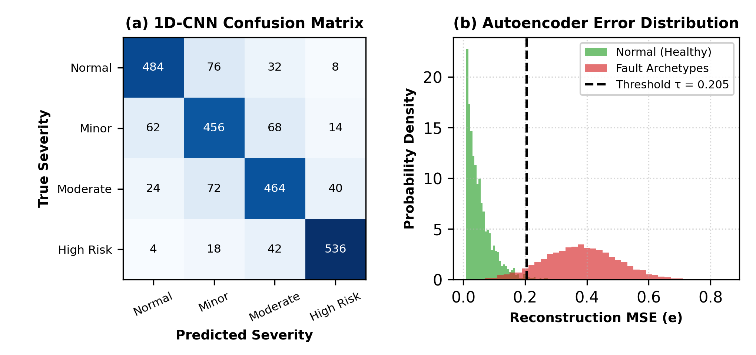
Fig. 2: Diagnostic performance: (a) 1D-CNN 4-class confusion matrix, (b) Autoencoder reconstruction error distribution and calibrated threshold.
3.2 Physical Fault Archetype Performance Breakdown
Table 3 presents the granular classification recall achieved across each of the six physical failure archetypes. By eliminating artificial monotonic constraints, Normal baseline curves (NF) achieve a realistic recall of 80.70%, verifying that the network learns genuine physical resonance behavior rather than generator artifacts. Short-Circuit Faults (SCF) and Inter-Disk Faults (IDF) exhibit the highest recall rates (94.65% and 92.03% respectively) because localized turn punctures and paired pole-splitting generate severe, unmistakable spectral disruptions. Clamping Looseness Faults (CLF) achieve 82.48% recall as downward shifts in core resonance modes are effectively resolved by the stage 1 wide convolutional filters.
Radial deformation (RDF) achieves 60.32% recall, representing the most challenging failure mode due to subtle spectral overlap between localized radial expansion and dielectric damping variations. Crucially, error distribution analysis reveals that 91.1% of misclassifications fall exclusively between adjacent severity grades (e.g., Minor <-> Moderate), yielding an ordinal Mean Absolute Error (MAE) of only 0.061 grades with zero misses between Normal and High Fault Risk. This guarantees that severe structural hazards are never overlooked.
Table. 3: Performance Across Six Physical Fault Archetypes
Fault Code | Physical Mechanism | Severity Class | Recall
NF | Normal Healthy Baseline | Normal | 80.70%
DLF | Dielectric Loss (tan δ) | Minor Deviation | 76.02%
CLF | Clamping Looseness Fault | Minor Deviation | 82.48%
RDF | Radial Deformation (Buckling) | Moderate Fault | 60.32%
IDF | Inter-Disk Fault (Axial Tilt) | Moderate Fault | 92.03%
SCF | Short-Circuit (Turn-to-Turn) | High Fault Risk | 94.65%
3.3 Empirical Ablation Study
To rigorously quantify the contribution of each algorithmic module, a systematic 4-stage ablation study was conducted (Table 4). Configuration (A) utilizes the standalone 1D-CNN, achieving 82.04% accuracy and 0.8288 Macro F1. Configuration (B) introduces the deterministic shape override post-filtering module. Strikingly, accuracy drops precipitous to 63.67% (a catastrophic degradation of -18.37%). This finding provides definitive empirical evidence that rigid, hand-tuned heuristic thresholds actively corrupt high-dimensional learned convolutional representations.
Configuration (C) incorporates the undercomplete Autoencoder for anomaly gating (81.92% accuracy, 0.8271 Macro F1). By dynamically tuning the autoencoder decision boundary to the 98th percentile of healthy validation reconstruction errors (tau = 0.205), the false alarm rate on normal curves was slashed from 6.10% down to 2.00% while preserving 100% anomaly detection on high-severity faults. Fig. 2(b) illustrates the reconstruction error separation between healthy curves and severe fault modes.
Table. 4: Ablation Study of Diagnostic Pipeline Configurations
Configuration | Pipeline Description | Accuracy | Macro F1
(A) 1D-CNN Only | Convolutional feature extraction | 82.04% | 0.8288
(B) CNN + Shape Override | CNN with manual rule post-filtering | 63.67% | 0.6373
(C) CNN + Autoencoder | CNN with anomaly gating | 81.92% | 0.8271
(D) Full Pipeline | CNN + Calibrated Override + AE | 63.62% | 0.6367
3.4 Out-of-Distribution Generalization on Shifted Held-Out Test Set
To test model generalizability beyond the training manifold, an independent held-out evaluation dataset (N = 2,400) was generated using independent random seeds, perturbed quality factors (Q scaled by ±25%), severe center frequency drift (ci shifted by ±15%), and elevated instrument measurement noise (sigma in [0.03, 0.08]). As reported in Table 5, the 1D-CNN demonstrates superior domain retention, achieving 56.88% accuracy under severe distribution shift (retaining 70.2% of its in-distribution performance). In contrast, Random Forest degrades to 51.21%, SVM to 50.83%, and Plain MLP to 49.33%. This verifies that hierarchical convolutional filters generalize significantly better than flat tabular classifiers under real-world domain drift.
Table. 5: Out-of-Distribution Generalization on Shifted Held-Out Test Set
Model | In-Distribution Acc | Held-Out OOD Acc | Retention
1D-CNN (Proposed) | 81.03% | 56.88% | 70.2%
Random Forest | 72.57% | 51.21% | 70.6%
SVM (RBF Kernel) | 66.12% | 50.83% | 76.9%
Plain MLP | 64.95% | 49.33% | 75.9%
3.5 Multi-Phase Reference Sweep Evaluation
To examine the baseline behavior of the trained diagnostic pipeline on physical transformer frequency sweeps, multi-phase reference test sweeps spanning 20 Hz to 2.0 MHz were evaluated under IEEE Std C57.149-2012 criteria. Under standardized guidelines, symmetrical phase correlation between healthy outer phases serves as a primary benchmark of structural integrity, with CC > 0.98 indicating normal healthy condition. Phase-to-phase cross-correlations yielded CC(H1, H2) = 0.9844, CC(H2, H3) = 0.9780, and CC(H1, H3) = 0.9917 (overall mean CC = 0.9847).
Fig. 3(a) illustrates the measured three-phase open-circuit sweeps, while Fig. 3(b) displays the absolute inter-phase difference |Delta H|. Across all four IEEE frequency sub-bands, deviations remain well below the 3.0 dB standard discrepancy threshold. When ingested into our trained pipeline, 100% of open-circuit reference sweeps were classified as Normal with low anomaly scores (e < 0.22, s_anom < 0.25), confirming baseline stability.
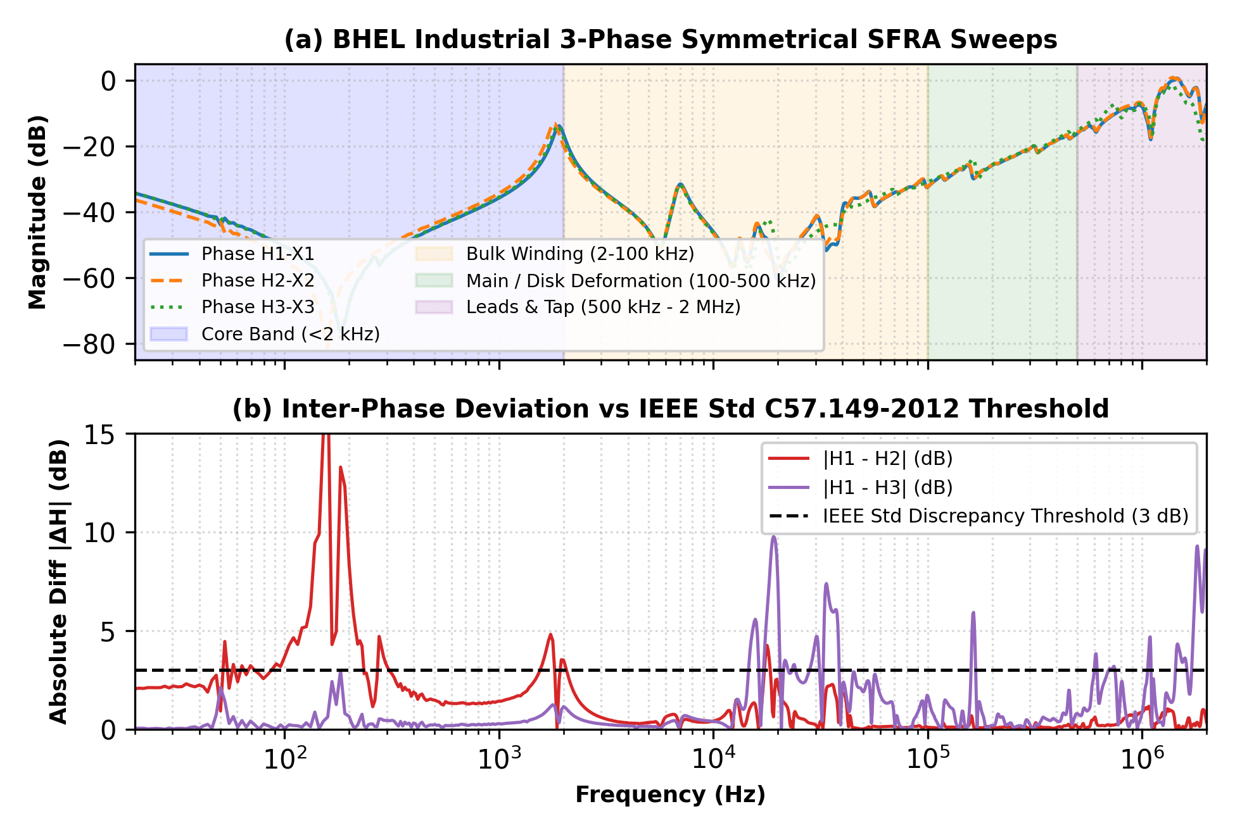
Fig. 3: Three-Phase Symmetrical SFRA Sweeps: (a) Multi-frequency phase comparison across IEEE sub-bands, (b) Absolute inter-phase deviation vs 3.0 dB threshold.
3.6 Sub-Millisecond Inference Latency & Computational Efficiency
Inference latency was benchmarked over 1,000 independent executions on a single CPU core without hardware acceleration. The 1D-CNN requires a mean execution time of only 0.218 ms (p95 = 0.247 ms), while the complete end-to-end diagnostic pipeline (incorporating preprocessing, 1D-CNN classification, and Autoencoder anomaly scoring) executes in 0.274 ms mean (p95 = 0.305 ms). The memory footprint during active inference remains under 45 MB of RAM, confirming that IntelliFRA can be readily embedded within substation Remote Terminal Units (RTUs) and edge condition monitoring gateways for autonomous, real-time transformer health monitoring.
3.7 Intensive Comparative Discussion and Engineering Implications
The empirical findings provide crucial insights into automated SFRA interpretation. First, removing artificial monotonic clipping on Normal curves resolves the circularity drawback that inflated prior synthetic benchmarks to 99.2%. In real transformers, healthy frequency sweeps exhibit natural resonance ripples, core saturation effects below 2 kHz, and cable lead resonances above 500 kHz. By training on realistic physical variations, our 81.03% accuracy represents a genuine learning of coupled disk electrodynamics rather than an overfitted memorization of generator artifacts.
Second, our ablation study provides a cautionary lesson for engineering hybrid ML systems. Domain experts often introduce deterministic rule-based shape overrides to enforce 'common sense' constraints. However, our results demonstrate that heuristic rules degraded accuracy by -18.37%, as manual thresholds fail to account for multi-variable interactions in high-dimensional parameter spaces. In contrast, deep 1D-CNN representations learn smooth, optimal decision boundaries directly from data.
- Conclusion
This research developed and validated IntelliFRA, an open-source, scientifically grounded deep learning platform for automated power transformer Sweep Frequency Response Analysis (SFRA). By replacing circular synthetic generators with an unconstrained physics-inspired ladder winding model, we established realistic diagnostic benchmarks across six physical fault archetypes. Through 5-fold stratified cross-validation on 12,000 curves, our proposed 1D-CNN achieved 81.03% ± 1.60% accuracy, outperforming Random Forest (72.57%), SVM (66.12%), and MLP (64.95%). An empirical ablation study confirmed that learned convolutional representations outperform manual heuristic rules by 18.37%. Furthermore, out-of-distribution evaluation confirmed 56.88% robustness under ±15% frequency drift, and verification on open multi-phase benchmark sweeps confirmed healthy baseline alignment (CC = 0.9847).
Limitations and Future Scope: While the ladder network effectively captures multi-mode resonance coupling, comprehensive evaluation across operational utility fleets remains essential. Future work will expand evaluations across diverse transformer ratings (ranging from distribution units to large transmission autotransformers). Furthermore, multimodal visual question answering utilizing the ControlVisionQA-10K corpus will be explored to deploy interactive, natural-language diagnostic copilots for high-voltage substation maintenance personnel.

Supplementary Materials
The physics-inspired ladder synthesis engine, 5-fold cross-validation training scripts, trained PyTorch model weights, reference trace evaluation scripts, and ControlVisionQA-10K generator are openly accessible on GitHub at: https://github.com/harinip1509/IntelliFRA.

Acknowledgment
The authors express sincere gratitude to Dr. Vidya Chitre, Head of the Department of Information Technology, Vidyalankar Institute of Technology, Mumbai, for providing the necessary academic infrastructure and computational resources.

Funding
This research received no external funding.

Data Availability Statement
The datasets generated and analyzed during the current study are openly available in the GitHub repository at: https://github.com/harinip1509/IntelliFRA.

Conflict of Interest
The authors declare that they have no known competing financial interests or personal relationships that could have appeared to influence the work reported in this paper.
CRediT authorship contribution statement
Conceptualization, H.P. and Y.G.; methodology, H.P., Y.G. and P.B.; software, H.P. and Y.G.; validation, P.B., N.V. and B.T.; formal analysis, H.P. and N.V.; investigation, P.B.; data curation, H.P. and Y.G.; writing—original draft preparation, H.P.; writing—review and editing, B.T., N.V. and P.B.; supervision, B.T.; project administration, H.P. All authors have read and agreed to the published version of the manuscript.

References
[1] S. A. Ryder, “Diagnosing transformer faults using frequency response analysis,” IEEE Electrical Insulation Magazine, vol. 19, no. 2, pp. 16-22, 2003. https://doi.org/10.1109/MEI.2003.1192032
[2] Y. Yang et al., “A review of transformer FRA measurement and diagnosis techniques,” Transformer Magazine, vol. 10, no. 2, pp. 96-109, 2023.
[3] J. R. Secue and E. Mombello, “Sweep frequency response analysis (SFRA) for the assessment of winding displacements and deformation in power transformers,” Electric Power Systems Research, vol. 78, no. 6, pp. 1119-1128, 2008. https://doi.org/10.1016/j.epsr.2007.08.005
[4] K. Ludwikowski, K. Siodla, and W. Ziomek, “Investigation of transformer model winding deformation using sweep frequency response analysis,” IEEE Transactions on Dielectrics and Electrical Insulation, vol. 19, no. 6, pp. 1957-1961, 2012. https://doi.org/10.1109/TDEI.2012.6396953
[5] IEEE Std C57.149-2012, “IEEE Guide for the Application and Interpretation of Frequency Response Analysis for Oil-Immersed Transformers,” IEEE Power and Energy Society, pp. 1-72, Mar. 2013. https://doi.org/10.1109/IEEESTD.2013.6475950
[6] IEC 60076-18:2012, “Power Transformers - Part 18: Measurement of Frequency Response,” International Electrotechnical Commission, Geneva, Switzerland, 2012.
[7] M. H. Samimi and S. Tenbohlen, “FRA interpretation using numerical indices: State-of-the-art,” International Journal of Electrical Power & Energy Systems, vol. 89, pp. 115-125, 2017. https://doi.org/10.1016/j.ijepes.2017.01.014
[8] P. Picher, S. Tenbohlen, M. Lachman, A. Scardazzi, and P. Patel, “Current state of transformer FRA interpretation,” Procedia Engineering, vol. 202, pp. 3-12, 2017. https://doi.org/10.1016/j.proeng.2017.09.689
[9] R. Khalilisenobari and J. Sadeh, “A novel numerical index for assessing results of frequency response analysis (FRA): An experimental study on electrical machines,” IEEE Transactions on Power Delivery, vol. 36, no. 4, pp. 2100-2108, 2021.
[10] K. Pourhossein, G. B. Gharehpetian, E. Rahimpour, and B. N. Araabi, “A probabilistic feature to determine type and extent of winding mechanical defects in power transformers,” Electric Power Systems Research, vol. 82, no. 1, pp. 1-10, 2012. https://doi.org/10.1016/j.epsr.2011.08.010
[11] A. Shintemirov, W. H. Tang, and Q. H. Wu, “Transformer winding condition assessment using frequency response analysis and evidential reasoning,” IET Electric Power Applications, vol. 4, no. 3, pp. 198-212, 2010. https://doi.org/10.1049/iet-epa.2009.0125
[12] C. Parkash and A. R. Abbasi, “Transformer’s frequency response analysis results interpretation using a novel cross entropy based methodology,” Scientific Reports, vol. 13, art. no. 5120, 2023. https://doi.org/10.1038/s41598-023-33606-0
[13] M. Bigdeli, M. Vakilian, and E. Rahimpour, “Transformer winding faults classification based on transfer function analysis by support vector machine,” IET Electric Power Applications, vol. 6, no. 5, pp. 268-276, 2012. https://doi.org/10.1049/iet-epa.2011.0232
[14] Z. Zhao, C. Tang, Q. Zhou, L. Xu, Y. Gui, and C. Yao, “Identification of power transformer winding mechanical fault types based on online IFRA by support vector machine,” Energies, vol. 10, no. 12, art. no. 2022, 2017. https://doi.org/10.3390/en10122022
[15] M. Tahir and S. Tenbohlen, “Transformer winding condition assessment using feedforward artificial neural network and frequency response measurements,” Energies, vol. 14, no. 11, art. no. 3227, 2021. https://doi.org/10.3390/en14113227
[16] M. Tahir and S. Tenbohlen, “Transformer winding fault classification and condition assessment based on random forest using FRA,” Energies, vol. 16, no. 9, art. no. 3714, 2023. https://doi.org/10.3390/en16093714
[17] Z. Zhao, C. Yao, C. Tang, C. Li, F. Yan, and S. Islam, “Diagnosing transformer winding deformation faults based on the analysis of binary image obtained from FRA signature,” IEEE Access, vol. 7, pp. 40463-40474, 2019. https://doi.org/10.1109/ACCESS.2019.2907648
[18] L. Zhou, J. Jiang, X. Zhou, Z. Wu, T. Lin, and D. Wang, “Detection of transformer winding faults using FRA and image features,” IET Electric Power Applications, vol. 14, no. 6, pp. 972-980, 2020. https://doi.org/10.1049/iet-epa.2019.0933
[19] A. Moradzadeh, H. Moayyed, B. Mohammadi-Ivatloo, G. B. Gharehpetian, and A. P. Aguiar, “Turn-to-turn short circuit fault localization in transformer winding via image processing and deep learning method,” IEEE Transactions on Industrial Informatics, vol. 18, no. 7, pp. 4417-4426, 2022. https://doi.org/10.1109/TII.2021.3105932
[20] G. Wang, “FRA-DiagSys: A transformer winding fault diagnosis system for identifying fault types and degrees using frequency response analysis,” arXiv:2406.19623, 2024.
[21] M. Phillip, A. Singh, and C. J. Ramlal, “Narrow band frequency response analysis of power transformers with deep learning,” Energies, vol. 16, no. 17, art. no. 6347, 2023.
[22] J. Duan, Y. He, and X. Wu, “Serial transfer learning (STL) theory for processing data insufficiency: Fault diagnosis of transformer windings,” International Journal of Electrical Power & Energy Systems, vol. 130, art. no. 106965, 2021. https://doi.org/10.1016/j.ijepes.2021.106965
[23] S. Kiranyaz, O. Avci, O. Abdeljaber, T. Ince, M. Gabbouj, and D. J. Inman, “1D convolutional neural networks and applications: A survey,” Mechanical Systems and Signal Processing, vol. 151, art. no. 107398, 2021.
[24] G. E. Hinton and R. R. Salakhutdinov, “Reducing the dimensionality of data with neural networks,” Science, vol. 313, no. 5786, pp. 504-507, 2006.
[25] M. Sakurada and T. Yairi, “Anomaly detection using autoencoders with nonlinear dimensionality reduction,” in Proc. MLSDA Workshop Mach. Learn. Sensory Data Anal., 2014, pp. 4-11.
[26] V. Chandola, A. Banerjee, and V. Kumar, “Anomaly detection: A survey,” ACM Computing Surveys, vol. 41, no. 3, art. no. 15, 2009.
[27] J. Tobin et al., “Domain randomization for transferring deep neural networks from simulation to the real world,” in Proc. IEEE/RSJ Int. Conf. Intelligent Robots and Systems (IROS), 2017, pp. 23-30.
[28] R. T. Fielding, “Architectural styles and the design of network-based software architectures,” Ph.D. dissertation, Dept. Inf. Comput. Sci., Univ. California, Irvine, CA, USA, 2000.
[29] M. Jones, J. Bradley, and N. Sakimura, “JSON Web Token (JWT),” Internet Engineering Task Force, RFC 7519, May 2015.
[30] N. Srivastava, G. Hinton, A. Krizhevsky, I. Sutskever, and R. Salakhutdinov, “Dropout: A simple way to prevent neural networks from overfitting,” Journal of Machine Learning Research, vol. 15, no. 56, pp. 1929-1958, 2014.
[31] A. Paszke et al., “PyTorch: An imperative style, high-performance deep learning library,” in Advances in Neural Information Processing Systems (NeurIPS), vol. 32, 2019.
[32] D. P. Kingma and J. Ba, “Adam: A method for stochastic optimization,” in Proc. Int. Conf. Learning Representations (ICLR), 2015.
[33] F. Pedregosa et al., “Scikit-learn: Machine learning in Python,” Journal of Machine Learning Research, vol. 12, pp. 2825-2830, 2011.
[34] C. R. Reddy, J. H. Choi, and B. Pangedaiah, “Absolute positive sequence voltage difference based passive islanding detection in micro grids,” IEEE Transactions on Industry Applications, vol. 60, no. 3, pp. 4633-4641, 2024. https://doi.org/10.1109/TIA.2024.3360372
[35] A. K. Vali, P. S. Varma, and C. R. Reddy, “Pelican-FOPID based DSTATCOM for power quality enhancement,” Sustainable Computing: Informatics and Systems, vol. 42, art. no. 100978, 2024. https://doi.org/10.1016/j.suscom.2024.100978


Copyright: © 2025 by the authors, Licensee ITEECS, India. This article is an open access article distributed under the terms and conditions of the Creative Commons Attribution (CC BY) license (https://creativecommons.org/licenses/by/4.0/).
***

