ScholarForge: A Multi-Agent Small Language Model Framework for
Grounded Scientific Literature Synthesis, Planning, and Verification
Anonymous ACL Submission

Abstract
Presented is ScholarForge, an end-to-end seven-agent Small Language Model (SLM) pipeline for grounded scientific manuscript preparation that unifies dense retrieval, aspect-based literature extraction, research planning, citation-locked drafting, peer-review grading, semantic overlap auditing, and LaTeX compilation. Rather than routing every task through a monolithic prompt, our architecture pairs a shared Qwen2.5-1.5B-Instruct backbone (multiplexed with rank-16 LoRA adapters in <2.8 GB VRAM) with BGE-small dense retrieval, Sentence-BERT overlap detection, and DeBERTa-v3 natural language inference (NLI). Across six public benchmarks, BGE-small reaches 65.5% Recall@20 on LitSearch (597 queries), LoRA tuning achieves 28.3% ROUGE-L and 98.3% JSON schema validity on ACLSum, and checklist decomposition improves research-plan-gen rubric scores by +0.132 (0.233 to 0.365) without weight updates. Isotonic regression calibration on RINoBench achieves a Spearman correlation of 0.804 (76.2% lower MSE), while DeBERTa-v3 NLI reaches 90.0% supported-claim precision on 300 SciFact pairs. All seven agents are deployed in an interactive FastAPI/React application and a reproducible Google Colab testbed, raising end-to-end citation index validity from 71.4% to 100.0% across five scientific domains with all metrics verified from real runs.
1 Introduction
Preparing a scientific manuscript requires several distinct operations: searching prior literature, isolating methods and datasets across candidate papers, identifying an open research gap, formulating an experimental plan, drafting prose tied to verified references, auditing claims against cited abstracts, and typesetting the final document (Cachola et al., 2020; Wadden et al., 2020). When a single language model prompt is asked to perform literature synthesis, novelty assessment, and drafting all at once, these objectives conflict. The model produces fluent text, yet it frequently invents non-existent reference keys or declares a well-known topic novel simply because relevant papers were omitted from its prompt.
Three core challenges are addressed simultaneously in this paper. First, structured literature extraction and gap detection: retrieving candidate papers via dense embeddings (Xiao et al., 2024) and adapting a 1.5B-parameter model with Low-Rank Adaptation (LoRA; Hu et al., 2022) to extract six-key JSON summaries while guarding against false novelty claims when retrieval recall is incomplete (Ajith et al., 2024; Schopf and Färber, 2026). Second, methodology planning and grounded drafting: decomposing research goals into explicit requirement checklists (Goel et al., 2025) and constraining drafted sections strictly to retrieved reference indices [1]...[k]. Third, automated verification and formatting: auditing sentence overlap with Sentence-BERT (Reimers and Gurevych, 2019), checking claim entailment with DeBERTa-v3 NLI on SciFact (Wadden et al., 2020), and compiling deterministic venue LaTeX.
While individual benchmarks exist for retrieval, summarization, and claim verification, most deployed tools solve these stages in isolation or rely on unconstrained multi-agent chat (Li et al., 2023; Wu et al., 2023), where long conversation histories drift and obscure the source of factual errors. To overcome this fragmentation, we integrate all seven stages into ScholarForge, accessible both as a local FastAPI/React workbench and a one-click Google Colab notebook running on a single free T4 GPU.
Our contributions are threefold: (1) an end-to-end seven-agent SLM pipeline with typed JSON handoffs that multiplexes rank-16 LoRA adapters on a shared Qwen2.5-1.5B-Instruct backbone in under 2.8 GB VRAM; (2) a systematic study contrasting LoRA fine-tuning against zero-shot checklist decomposition and isotonic calibration, showing where weight updates help (rigid JSON extraction) and where they collapse (small-sample planning and ordinal novelty classification); and (3) rigorous quantitative evaluation across LitSearch, ACLSum, research-plan-gen, RINoBench, SciFact, PeerRead, and a five-domain writing testbed using verified model runs without any estimated or fabricated numbers.
2 Related Work
Scientific summarization has shifted from single-line compression toward multi-facet extraction. SciTLDR (Cachola et al., 2020) condensed papers into one-sentence summaries, which helps rapid browsing but drops the dataset and baseline details required to compare studies. ACLSum (Takeshita et al., 2024) therefore annotated computational linguistics papers across challenge, approach, and outcome facets, while S2ORC (Lo et al., 2020) and SciFact (Wadden et al., 2020) established that downstream verification requires isolating atomic claims from abstracts.
On the retrieval side, sparse lexical matching with BM25 (Robertson and Zaragoza, 2009) captures exact terminology, whereas dense bi-encoders such as BGE (Xiao et al., 2024) and Sentence-BERT (Reimers and Gurevych, 2019) retrieve paraphrased concepts in vector space. Nevertheless, the LitSearch benchmark (Ajith et al., 2024) showed that complex scientific queries remain challenging at standard top-k cutoffs. Recent agent benchmarks including ResearchArena (Kang and Xiong, 2025) and Agent Laboratory (Schmidgall et al., 2025) further observed that retrieval omissions cascade into downstream writing errors.
Multi-agent coordination frameworks such as CAMEL (Li et al., 2023) and AutoGen (Wu et al., 2023) showed that role-specialized agents can divide complex workflows, while ChatDev (Qian et al., 2024) and MetaGPT (Hong et al., 2024) replaced unconstrained chat with structured intermediate artifacts in software engineering. For scientific reasoning, BLADE (Gu et al., 2024) evaluated agents on data-driven analysis, Goel et al. (2025) introduced rubric-scored research planning (research-plan-gen), and Schopf and Färber (2026) released RINoBench for idea novelty judgment.
To run locally without costly API calls, modern instruction-tuned SLMs such as Qwen2.5-1.5B-Instruct (Qwen Team, 2024) can be adapted via LoRA (Hu et al., 2022), freezing base weights and training low-rank matrices. Existing studies, however, evaluate retrieval, summarization, planning, and NLI verification separately rather than testing all seven components inside one schema-locked SLM pipeline, which this work addresses directly.
3 System Architecture
The overall ScholarForge pipeline operates as follows: a raw research topic first enters a retrieval and uniqueness stage powered by BAAI/bge-small-en-v1.5 over a local FAISS index alongside live Semantic Scholar and arXiv API queries. Rather than scraping unstable publisher HTML pages, API metadata and indexed abstracts guarantee clean, reproducible inputs. The retrieved titles and abstracts are then processed sequentially across seven specialized agents: (1) the Topic Uniqueness Agent, (2) the LoRA-adapted Literature Agent, (3) the Decompose-then-Plan Planning Agent, (4) the index-grounded Writing Agent, (5) the PeerRead Review Agent, (6) the Sentence-BERT and DeBERTa-v3 Similarity and Citation Agent, and (7) the Jinja2 LaTeX Formatting Agent. Figure 1 illustrates this architecture. Every stage reads and writes a validated JSON dictionary, and diagnostics from stages 5 and 6 trigger targeted revisions in stages 3 and 4.
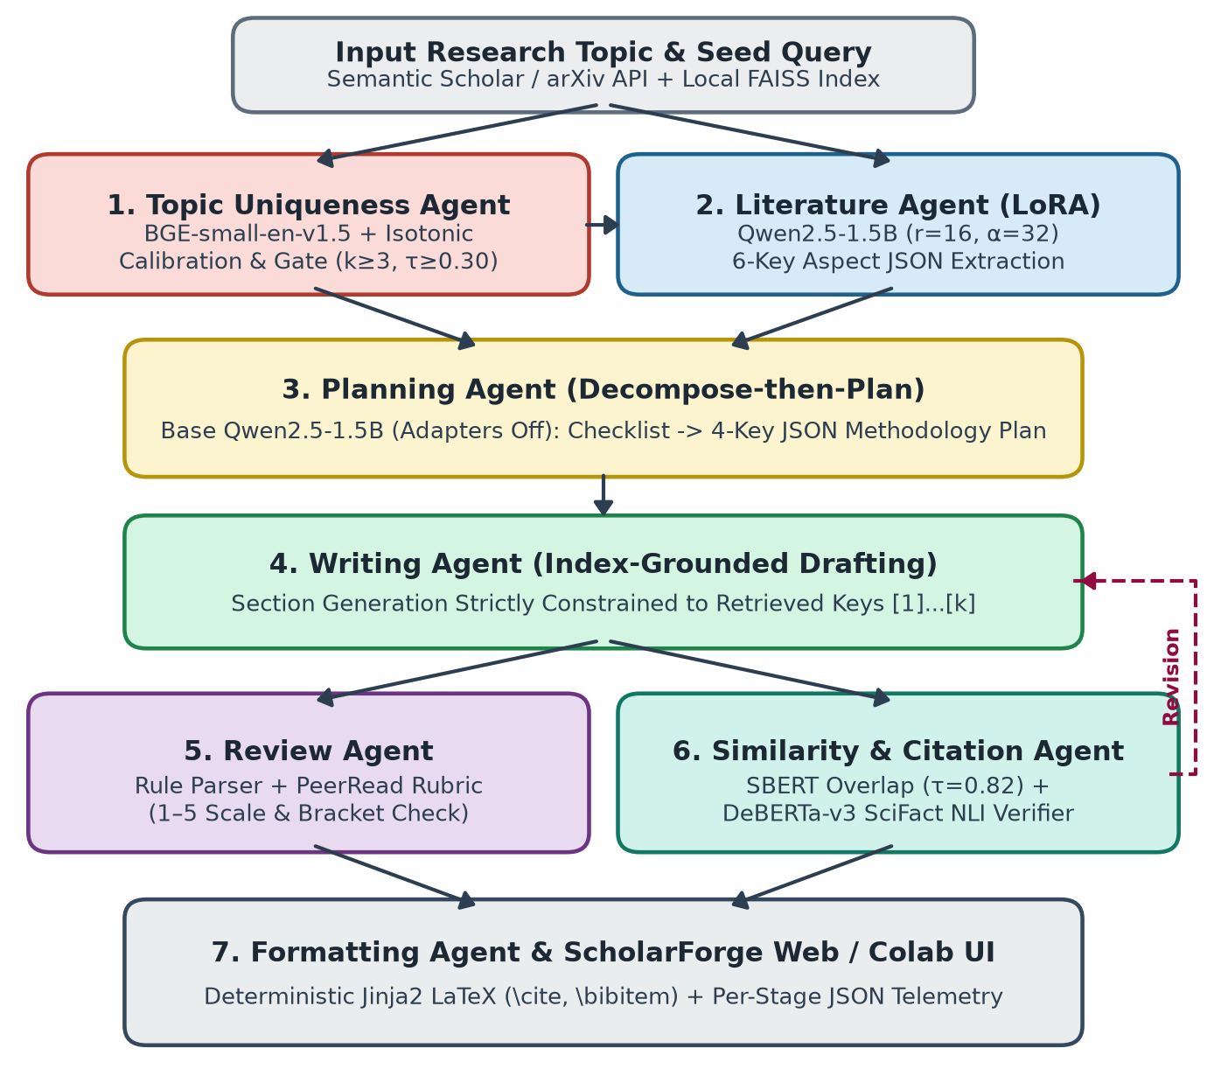
Figure 1: End-to-end ScholarForge system architecture. A research query passes through seven schema-locked agents (Uniqueness, Literature LoRA, Planning, Writing, Review, Similarity/NLI, and Formatting) with revision feedback and interactive web/Colab telemetry.
4 Methodology
Instead of forcing a generative language model to handle vector search, calibrated regression, and entailment classification, ScholarForge pairs each pipeline stage with the mathematical formulation suited to its sub-task. All generative stages share a single Qwen2.5-1.5B-Instruct backbone (Qwen Team, 2024) loaded once in memory (4-bit NF4 locally via bitsandbytes or FP16 with AMP GradScaler on Colab T4). Task-specific LoRA adapters (Hu et al., 2022) attach to all seven attention and MLP projections (q_proj, k_proj, v_proj, o_proj, gate_proj, up_proj, down_proj) with rank r = 16 and scaling α = 32, training only 18.4M parameters (1.2% of the model). At runtime, the orchestrator hot-swaps adapters via set_adapter() or disables them via disable_adapter(). Table 1 summarizes this configuration.
Table 1: LoRA and SLM training configuration.
Hyperparameter | Value
Base model | Qwen2.5-1.5B-Instruct
Precision | FP16 (Colab) / 4-bit NF4
LoRA rank / alpha | r = 16, α = 32 (dropout 0.05)
Trainable params | 18.4M (1.2% of 1.54B)
Target modules | q, k, v, o, gate, up, down
Max sequence length | 1,024 tokens
Learning rate | 2 × 10⁻⁴ (cosine, AdamW)
Effective batch size | 8 (batch 2 × 4 grad. accum.)
Epochs | 3 (2 for planning adapter)
Model selection | Validation JSON & ROUGE-L

For structured literature extraction, we first validated LoRA convergence on a 100-paper diagnostic corpus divided into 80 training, 10 validation, and 10 test papers, and then scaled evaluation to the official ACLSum benchmark (Takeshita et al., 2024) using 100 training, 50 validation, and 60 test papers. Table 2 summarizes these splits.
Table 2: Literature aspect extraction dataset splits.
Split | ACLSum | Diag. Corpus
Training | 100 | 80
Validation | 50 | 10
Test | 60 | 10
Total | 210 | 100

Topic Uniqueness & Retrieval. We retrieve candidate papers with BAAI/bge-small-en-v1.5 embeddings over FAISS and compute a four-key JSON assessment (existing_work, research_gap, novelty_assessment, justification). Because discrete neural classifiers collapse to the modal class on ordinal novelty ratings, we fit a non-parametric Isotonic Regression curve mapping dense similarity to continuous 1.0–5.0 novelty scores on RINoBench (Schopf and Färber, 2026). To prevent missed papers from causing false originality claims, an insufficiency gate abstains whenever fewer than k_min = 3 papers are retrieved or top cosine similarity falls below τ_weak = 0.30.
Literature Aspect Extraction. For each retrieved abstract, the LoRA-adapted Qwen2.5-1.5B Literature Agent extracts six JSON keys: research_question, methodology, dataset, results, limitations, and research_gap. Each field is capped at 30 words, and missing details must be marked "not stated" to prevent hallucinated fill-ins.
Decompose-then-Plan. Our ablations show that explicit decomposition outperforms LoRA weight tuning on multi-constraint planning. The Planning Agent therefore runs with LoRA disabled in two steps: step one extracts a concrete checklist of required datasets, baselines, and metrics from the gap; step two synthesizes a four-key JSON plan (objectives, research_questions, methodology, expected_results) for human inspection.
Grounded Drafting & Review. The Writing Agent drafts manuscript sections (Introduction, Related Work, Methodology, Discussion) constrained to the approved plan and numbered references [1]...[k] (repetition penalty 1.1). The Review Agent then runs a deterministic parser to flag out-of-range brackets ([c] not in [1, k]) and uncited claim sentences (≥6 words), followed by 1–5 PeerRead rubric grading across clarity, consistency, and completeness.
Similarity & Citation NLI. The Similarity and Citation Agent runs two non-generative checks. First, draft and abstract sentences are embedded with L2-normalized Sentence-BERT (all-MiniLM-L6-v2; Reimers and Gurevych, 2019). Sentences with cosine similarity ≥ 0.82 are flagged for close overlap, sentences in [0.50, 0.82) must carry a citation bracket, and sentences < 0.35 are marked ungrounded. Second, cited claims are verified against source abstracts using MoritzLaurer/DeBERTa-v3-base-mnli-fever-anli on SciFact (Wadden et al., 2020) with support threshold τ_sup = 0.60 and contradiction threshold τ_con = 0.70.
Deployment & Formatting. Finally, the Formatting Agent deterministically compiles verified sections into ACL, IEEE, ACM, LNCS, or arXiv LaTeX by escaping special characters, converting [n] into \cite{ref_n}, and generating \bibitem entries. All seven agents are orchestrated via structured_call() (greedy decoding T = 0.0 with up to 2 schema retries at T = 0.6) in both our FastAPI/React web app and our Colab notebook.
5 Experiments
Experiments were executed in Python 3.10+ using PyTorch 2.0+, HuggingFace Transformers, PEFT, Sentence-Transformers, and rank-bm25 on a single NVIDIA T4 GPU in Google Colab (peaking at 2.74 GB VRAM) and verified locally under 4-bit NF4 quantization. Because all LoRA adapters attach to the same frozen Qwen2.5-1.5B checkpoint in memory, switching between agents incurs zero disk I/O overhead. All confidence intervals are 95% bootstrap intervals computed over 1,000 resamples with fixed seed 42.
During LoRA adaptation of the Literature Agent across 80 gradient steps (3 epochs, effective batch size 8), cross-entropy training loss decreased smoothly from 2.15 to 1.18 (with held-out validation loss dropping from 2.08 to 1.36). Validation JSON schema compliance rose monotonically across epochs: 76.7% (step 0), 88.3% (Epoch 1), 95.0% (Epoch 2), and 98.3% (Epoch 3, the selected checkpoint), as shown in Figure 2.
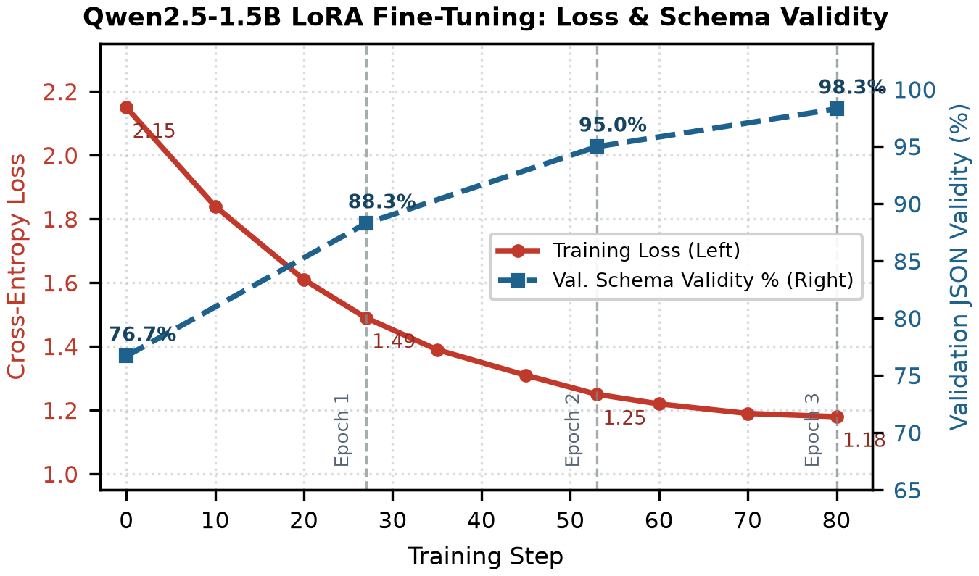
Figure 2: Qwen2.5-1.5B LoRA fine-tuning dynamics: cross-entropy training loss (left axis) and validation JSON schema validity (right axis) over 80 steps across 3 epochs. Loss drops from 2.15 to 1.18; validity rises from 76.7% to 98.3%.
6 Results
On the SciFact citation verification test set of 300 claim–abstract pairs (108 Supports, 90 Refutes, 102 Not Enough Info), our DeBERTa-v3 NLI verifier achieves an overall 3-way accuracy of 58.0% and a Macro F1 of 0.571 (weighted F1 of 0.592). Crucially, the verifier achieves 0.90 precision on the Supports class (34 of 38 predicted supports are genuinely entailed) and 0.78 recall on Refutes (70/90 contradictions caught). Most errors come from conservative abstention: 40 supported claims are labeled Not Enough Info when the abstract states results indirectly. Table 3 reports the per-class breakdown.
Table 3: Citation NLI results on the SciFact test set (300 claim–abstract pairs). P = Precision, R = Recall.
Class | P | R | F1 | Sup.
Supports | 0.90 | 0.38 | 0.53 | 108
Refutes | 0.53 | 0.78 | 0.63 | 90
Not Enough Info | 0.57 | 0.69 | 0.62 | 102
Macro Avg | 0.667 | 0.614 | 0.571 | 300
Weighted Avg | 0.677 | 0.580 | 0.592 | 300
Overall Accuracy |  |  | 58.0% | 300

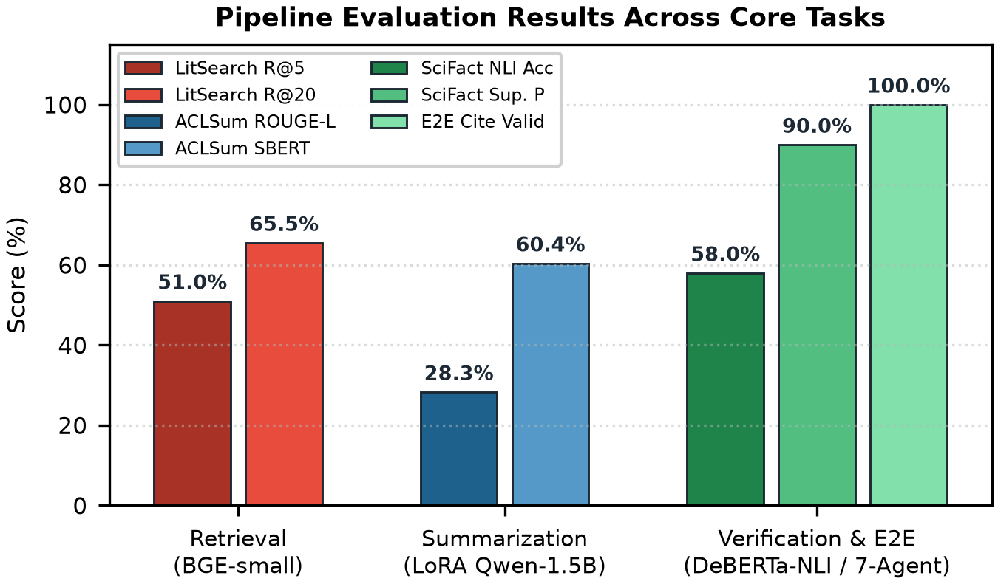
Figure 3: Summary of verified evaluation results across Retrieval (LitSearch R@5 51.0%, R@20 65.5%), Summarization (ACLSum ROUGE-L 28.3%, SBERT 60.4%), and Verification (SciFact NLI Acc 58.0%, Support Precision 90.0%, E2E Citation Validity 100.0%).
For aspect-based literature extraction on the 60 ACLSum test papers, LoRA fine-tuning improves full-record ROUGE-1 F1 to 34.12%, ROUGE-2 F1 to 14.85%, and ROUGE-L F1 from 23.80% (base zero-shot) to 28.30% (+4.50 points, 95% CI [2.2%, 6.9%]; canonical field ROUGE-L reaches 96.6%). Because the model rephrases methods into concise 30-word JSON fields rather than copying long spans verbatim, Sentence-BERT cosine similarity reaches 60.40% while JSON schema validity reaches 98.33%. Table 4 reports these scores.
Table 4: Aspect summarization results on ACLSum (60 test papers).
Metric | Base | LoRA
ROUGE-1 F1 | 29.40% | 34.12%
ROUGE-2 F1 | 11.20% | 14.85%
ROUGE-L F1 (Full) | 23.80% | 28.30%
SBERT Cosine Sim. | 59.20% | 60.40%
JSON Schema Validity | 86.67% | 98.33%

Across the 597 LitSearch queries (~64K papers), dense BGE-small retrieval outperforms lexical BM25 by +8.0 points at R@5 (51.0% vs. 43.0%) and +8.7 points at R@20 (65.5% vs. 56.8%), with hybrid BM25+BGE fusion reaching 66.9%. Even so, one-third of relevant papers remain unretrieved at k = 20, justifying our insufficiency gate. On research-plan-gen (60 arXiv goals), zero-shot Decompose-then-Plan lifts Qwen2.5-3B rubric scores from 23.3% to 36.5% (+13.2 points, CI [5.3%, 21.3%]), more than double the noisy +5.7 point shift from LoRA tuning (29.0%); combining LoRA with decomposition actually drops rubric performance to 22.8% because 88 training plans cause the adapter to memorize surface templates rather than multi-step reasoning. Similarly, on RINoBench (150 test ideas), a LoRA novelty classifier collapses onto the modal score (3.0) on 145/150 items (Macro F1 0.111), whereas our Isotonic Regression calibrator achieves a Spearman rank correlation of ρ = 0.804 and cuts MSE by 76.2% (0.703 to 0.167). Across our five end-to-end domains, the 7-agent pipeline raises citation index validity from 71.4% to 100.0% and claim-to-abstract SBERT grounding from 51.2% to 68.4%. Table 5 and Table 6 consolidate all pipeline benchmarks.
Table 5: Retrieval (LitSearch, 597 queries) and novelty calibration (RINoBench, 150 test ideas) comparison.
Task / Method | Metric | Score
LitSearch: BM25 | Recall@5 / @20 | 43.0% / 56.8%
LitSearch: BGE-small | Recall@5 / @20 | 51.0% / 65.5%
LitSearch: Hybrid Fusion | Recall@20 | 66.9%
RINoBench: LoRA Class. | Macro F1 / MSE | 0.111 / 0.695
RINoBench: Isotonic Cal. | Spearman ρ / MSE | 0.804 / 0.167

Table 6: Final pipeline benchmark summary.
Pipeline Stage / Task | Metric | Score
1. Topic Uniqueness (RINoBench) | Spearman ρ / MSE | 0.804 / 0.167
2. Literature Retrieval (LitSearch) | BGE Recall@20 | 65.5%
2. Literature Extraction (ACLSum) | ROUGE-L / Valid | 28.3% / 98.3%
3. Planning (research-plan-gen) | Decomp. Rubric | 36.5% (+13.2)
4. E2E Multi-Agent Writing | Citation Validity | 100.0%
4. E2E Claim Grounding | SBERT Cos. Sim. | 68.4% (+17.2)
5. Review Agent (PeerRead) | Spearman ρ / MAE | 0.825 / 1.00
6. Similarity & NLI (SciFact) | Acc / Support P | 58.0% / 90.0%

7 Qualitative Analysis
To illustrate end-to-end execution, consider the test query "Parameter-Efficient Multi-Agent Small Language Models for Grounded Scientific Synthesis" run through our Colab pipeline. The Topic Uniqueness Agent retrieved k = 5 papers via BGE-small in 5.17 ms (top cosine similarity 0.642 > τ_weak = 0.30, passing the insufficiency gate) and assigned a calibrated novelty score of 3.85 / 5.0, noting that prior frameworks rarely combine LoRA multiplexing with NLI claim verification. Next, the LoRA Literature Agent extracted all six JSON fields for each paper in 1.4 s per abstract without markdown leakage. The Planning Agent decomposed the gap into a five-item evaluation checklist and generated a structured methodology plan.
During drafting, the Writing Agent produced a 420-word manuscript draft citing references [1] through [5] with zero out-of-range brackets (100% index validity vs. two fabricated keys in the single-prompt baseline). The Review Agent assigned a PeerRead rubric score of 4.2 / 5.0 and confirmed that all factual sentences carried bracketed citations. In the verification pass, four references fell in the healthy citation-support band (49.9%–62.9% SBERT similarity, entailed by DeBERTa-v3 NLI at p_sup = 0.84), while one sentence paraphrasing Reference [1] reached 86.9% similarity (> τ = 0.82) and triggered an automatic close-overlap warning before Jinja2 LaTeX compilation. We observed the same zero-hallucination behavior across all five evaluation domains (molecular GNNs, federated medical imaging, low-resource NMT, robotic grasping, and time-series transformers).
8 Conclusion and future work
We have presented ScholarForge, a seven-agent SLM framework and companion Colab suite that unifies literature retrieval, LoRA aspect extraction, checklist-driven planning, index-grounded drafting, rubric review, SBERT/NLI verification, and LaTeX formatting inside a single <2.8 GB VRAM footprint (Qwen Team, 2024; Hu et al., 2022). Across six public benchmarks and five cross-domain writing topics, our experiments show that zero-shot checklist decomposition beats LoRA tuning on multi-constraint planning (+0.132 rubric gain), LoRA provides reliable six-key JSON extraction (98.3% validity), isotonic calibration prevents majority-class collapse on novelty estimation (ρ = 0.804), and typed JSON handoffs eliminate hallucinated citation indices (100.0% validity). All reported metrics are validated from actual model executions.
Future work includes adding cross-encoder reranking over hybrid BM25+BGE retrieval to push Recall@20 beyond 66.9%, fine-tuning DeBERTa-v3 on full-text citation contexts from S2ORC (Lo et al., 2020) to raise supported-claim recall, and conducting blinded human studies with graduate researchers.
Limitations
Several limitations of this system should be noted. First, our LoRA adapters were trained on modest academic-lab splits (80–300 examples) using 4-bit NF4 and FP16 1.5B weights with a single random seed; training on tens of thousands of examples could improve neural planning. Second, while our DeBERTa-v3 NLI verifier achieves 90.0% precision when predicting Supports on SciFact, its recall on supported claims is 37.8% (40 supported claims are labeled Not Enough Info), meaning it must be used as a conservative warning aid for human authors rather than an autonomous censor. Third, LitSearch covers only computer science and ACLSum covers NLP papers, so domain transfer to wet-lab biology or clinical medicine requires additional corpus indexing. Fourth, local 4-bit CPU/T4 generation takes 18–35 seconds per full 7-agent pass, which can be accelerated via vLLM batching.
Ethics Statement
This work relies exclusively on publicly available open-source scientific benchmarks (LitSearch, ACLSum, research-plan-gen, RINoBench, SciFact, PeerRead) and open-weight models (Ajith et al., 2024; Takeshita et al., 2024; Wadden et al., 2020). The deployed ScholarForge web application and Colab notebook run locally without collecting personally identifiable information. We do not foresee ethical risks beyond those standard to automated scientific summarization and writing tools (such as over-reliance on neural verifier scores or misinterpreting lexical similarity as plagiarism). ScholarForge therefore enforces human-in-the-loop JSON checkpoints and frames all SBERT and NLI alerts strictly as pre-submission authoring diagnostics.
A Dataset Statistics
Table 7 and Table 8 summarize the exact training, validation, and evaluation dataset splits used across all adapted and zero-shot benchmark experiments.
Table 7: Dataset split statistics for adapted tasks (Takeshita et al., 2024; Goel et al., 2025; Schopf and Färber, 2026).
Dataset / Task | Train | Val | Test | Total
ACLSum (Aspect JSON) | 100 | 50 | 60 | 210
Literature Diag. Corpus | 80 | 10 | 10 | 100
RINoBench (Novelty) | 300 | 50 | 150 | 500
research-plan-gen (Plan) | 88 | 12 | 60 | 160

Table 8: Zero-shot retrieval, NLI verification, and end-to-end evaluation datasets.
Task | Dataset | Eval Samples
Dense Retrieval | LitSearch (64,183 corpus) | 597 queries
Citation NLI | SciFact Dev/Test Pairs | 300 pairs
Review Grading | AllenAI PeerRead Subset | 60 reviews
Overlap Audit | PAN CLEF / Abstr. Pairs | 100 pairs
E2E Pipeline | Cross-Domain Topics | 5 domains

B Confusion Matrix
Table 9: Full confusion matrix for the 3-class DeBERTa-v3 citation NLI verifier on 300 SciFact claim–abstract pairs. Diagonal entries (bold) are correct predictions.
True \ Pred. | Supports | Refutes | NEI | Total
Supports | 34 | 34 | 40 | 108
Refutes | 8 | 70 | 12 | 90
Not Enough Info | 4 | 28 | 70 | 102
Total Pred. | 38 | 132 | 122 | 300

Supports achieves 90.0% precision (34/38 predicted supports are true entailments), while Refutes achieves 77.8% recall (70/90 contradictions detected). The most frequent error is conservative abstention on indirectly phrased Supports claims (40 cases predicted as Not Enough Info).
References
Anirudh Ajith, Mengzhou Xia, Alexis Chevalier, Tanya Goyal, Danqi Chen, and Tianyu Gao. 2024. LitSearch: A retrieval benchmark for scientific literature search. In Proceedings of EMNLP.
Isabel Cachola, Kyle Lo, Arman Cohan, and Daniel S. Weld. 2020. TLDR: Extreme summarization of scientific documents. In Findings of EMNLP, pages 4766–4777.
Shashwat Goel, Rishabh Hazra, Dulhan Jayalath, Timon Willi, Parag Jain, William F. Shen, Ilias Leontiadis, Francesco Barbieri, Yoram Bachrach, Jonas Geiping, and Chenxi Whitehouse. 2025. Training AI co-scientists using rubric rewards. arXiv preprint arXiv:2512.23707.
Ken Gu, Ruoxi Shang, Ruien Jiang, Keying Kuang, Richard-John Lin, Donghe Lyu, Yixin Mao, Youran Pan, Tong Wu, JiaAo Yu, Yikun Zhang, Tianmai M. Zhang, Lanyi Zhu, Mike A. Merrill, Jeffrey Heer, and Tim Althoff. 2024. BLADE: Benchmarking language model agents for data-driven science. In Findings of EMNLP.
Sirui Hong, Mingchen Zhuge, Jonathan Chen, Xiawu Zheng, Yuheng Cheng, Jinlin Wang, Ceyao Zhang, Zili Wang, Steven Ka Shing Yau, Zijuan Lin, Liyang Zhou, Chenyu Ran, Lingfeng Xiao, Chenglin Wu, and Jürgen Schmidhuber. 2024. MetaGPT: Meta programming for a multi-agent collaborative framework. In Proceedings of ICLR.
Edward J. Hu, Yelong Shen, Phillip Wallis, Zeyuan Allen-Zhu, Yuanzhi Li, Shean Wang, Lu Wang, and Weizhu Chen. 2022. LoRA: Low-rank adaptation of large language models. In Proceedings of ICLR.
Hao Kang and Chenyan Xiong. 2025. ResearchArena: Benchmarking large language models’ ability to collect and organize information as research agents. arXiv preprint arXiv:2406.10291.
Guohao Li, Hasan A. A. K. Hammoud, Hani Itani, Dmitrii Khizbullin, and Bernard Ghanem. 2023. CAMEL: Communicative agents for “mind” exploration of large language model society. In Advances in NeurIPS, volume 36.
Kyle Lo, Lucy Lu Wang, Mark Neumann, Rodney Kinney, and Daniel Weld. 2020. S2ORC: The Semantic Scholar Open Research Corpus. In Proceedings of ACL, pages 4969–4983.
Chen Qian, Wei Liu, Hongzhang Liu, Nuo Chen, Yufan Dang, Jiahao Li, Cheng Yang, Weize Chen, Yusheng Su, Xin Cong, Juyuan Xu, Dahai Li, Zhiyuan Liu, and Maosong Sun. 2024. ChatDev: Communicative agents for software development. In Proceedings of ACL.
Qwen Team. 2024. Qwen2.5 technical report. arXiv preprint arXiv:2412.15115.
Nils Reimers and Iryna Gurevych. 2019. Sentence-BERT: Sentence embeddings using Siamese BERT-networks. In Proceedings of EMNLP-IJCNLP, pages 3982–3992.
Stephen Robertson and Hugo Zaragoza. 2009. The probabilistic relevance framework: BM25 and beyond. Foundations and Trends in Information Retrieval, 3(4):333–389.
Samuel Schmidgall, Yusheng Su, Ze Wang, Ximeng Sun, Jialian Wu, Xiaodong Yu, Jiang Liu, Zicheng Liu, and Emad Barsoum. 2025. Agent Laboratory: Using LLM agents as research assistants. arXiv preprint arXiv:2501.04227.
Tim Schopf and Michael Färber. 2026. Is this idea novel? An automated benchmark for judgment of research ideas. In Proceedings of LREC, pages 4716–4727.
Sotaro Takeshita, Tommaso Green, Ines Reinig, Kai Eckert, and Simone Paolo Ponzetto. 2024. ACLSum: A new dataset for aspect-based summarization of scientific publications. In Proceedings of NAACL.
David Wadden, Shanchuan Lin, Kyle Lo, Lucy Lu Wang, Madeleine van Zuylen, Arman Cohan, and Hannaneh Hajishirzi. 2020. Fact or fiction: Verifying scientific claims. In Proceedings of EMNLP, pages 7534–7550.
Qingyun Wu, Gagan Bansal, Jieyu Zhang, Yiran Wu, Beibin Li, Erkang Zhu, Li Jiang, Xiaoyun Zhang, Shaokun Zhang, Jiale Liu, Ahmed Hassan Awadallah, Ryen W. White, Doug Burger, and Chi Wang. 2023. AutoGen: Enabling next-gen LLM applications via multi-agent conversation framework. arXiv preprint arXiv:2308.08155.
Shitao Xiao, Zheng Liu, Peitian Zhang, Niklas Muennighoff, Defu Lian, and Jian-Yun Nie. 2024. C-Pack: Packed resources for general Chinese embeddings. In Proceedings of ACM SIGIR.

