LEGALEASE: AI-POWERED LEGAL DOCUMENT GENERATOR
Academic Year: 2026-2027
ARULMIGU KAPALEESWARAR ARTS AND SCIENCE COLLEGE
KOLATHUR,CHENNAI-99.
Team ID: 6ab74b9602319e850fcdfcbf
Team Size: 5 MEMBERS
Team Leader: Sindhi Sowjanya A
Team Member: Harini T
Team Member: Thilagavathy P
Team Member: Deepthika P
Team Member: Hemalatha E

S.No. CONTENTS
- Introduction
- Problem Statement
- Objectives
- Scope of the Project
- Existing System
- Proposed System
- Technologies Used
- System Requirements
- System Architecture
- System Workflow
- Module Description
- Database Design
- Screenshot
- Advantages
- Limitations
- Future Enhancement
- Conclusion

1. INTRODUCTION
LegalEase: AI-Powered Legal Document Generator is an innovative application developed to democratize access to legal documentation. It leverages the power of Generative Artificial Intelligence to create customized, professionally structured legal documents such as Non-Disclosure Agreements (NDAs), freelance contracts, and lease agreements.
Users simply input basic details—such as the parties involved, the effective date, and specific terms—and the system generates a comprehensive legal document in seconds. The application eliminates the need for expensive legal consultations for routine documents, providing a fast, free, and user-friendly solution for freelancers, small business owners, and individuals.
2. PROBLEM STATEMENT
Accessing legal documentation is a significant challenge for many individuals and small businesses. Hiring a lawyer to draft a simple contract or NDA can cost anywhere between Rs. 5,000 to Rs. 25,000, which is prohibitive for micro-entrepreneurs and freelancers.
While free templates exist online, they are often rigid, generic, and cannot be customized to specific project needs. Furthermore, users often lack the legal knowledge to adapt these templates correctly, leading to anxiety about signing legally insufficient documents.
LegalEase addresses this gap by providing an AI-driven solution that generates customized, legally structured documents instantly. It bridges the gap between expensive professional legal services and inadequate free templates.
3. OBJECTIVES
The main objective of LegalEase is to provide a free, intelligent, and instant solution for generating legal documents. The key objectives include:
- To provide a user-friendly interface for inputting legal document requirements.
- To utilize Generative AI to create customized legal documents (NDAs, Contracts, etc.).
- To ensure all generated documents contain proper legal structures, numbered sections, and signature blocks.
- To provide multi-format export options (TXT, DOCX, PDF) for ease of use.
- To eliminate the high cost and long turnaround time associated with traditional legal drafting.
- To empower freelancers and small businesses to protect their interests affordably.
4. SCOPE OF THE PROJECT
The scope of LegalEase is to provide a robust, web-based platform for generating personalized legal documents. The system accepts user inputs (Document Type, Parties, Terms, Dates) and uses an advanced Large Language Model (LLM) to construct a formal document.
The project covers the generation of common legal documents including Freelance Contracts, Non-Disclosure Agreements (NDAs), and Residential Lease Agreements. The generated document can be previewed, edited inline by the user, and downloaded in three formats (PDF, Word, and Plain Text). Future scope includes multi-language support, digital signatures, and cloud deployment.
5. EXISTING SYSTEM
In the existing system, individuals manage legal documentation through two primary methods:
- Hiring Legal Professionals: While accurate, this method is extremely expensive and time-consuming (taking days or weeks).
- Downloading Static Templates: Users download generic Word documents from the internet. These templates are rigid, often contain irrelevant clauses, and require manual editing which can introduce legal errors.
The existing systems lack personalization, real-time generation, and multi-format export capabilities. They do not provide an intelligent, automated solution for everyday legal needs.
6. PROPOSED SYSTEM
The proposed system, LegalEase, is designed to provide an intelligent and instant solution for personal legal documentation.
The system features a clean Streamlit-based frontend where users input their specific requirements. This data is sent via HTTP to a FastAPI backend, which securely constructs a prompt and communicates with Google's Gemini AI model. The AI generates a complete, formal legal document.
The system reduces the need for manual legal drafting and provides important documentation in an easy-to-understand format. By combining AI with document generation libraries, LegalEase ensures that users receive a properly formatted, downloadable document in under 30 seconds.
7. TECHNOLOGIES USED
The LegalEase project utilizes a modern, cutting-edge technology stack:
- Frontend: Streamlit (Python-based web framework for rapid UI development).
- Backend: FastAPI (High-performance REST API framework), Uvicorn (ASGI server).
- Artificial Intelligence: Google Gemini API (gemini-3.8-flash model) for natural language generation.
- Document Processing: python-docx (DOCX generation), fpdf2 (PDF generation).
- Data Validation: Pydantic.
- Environment Management: python-dotenv for secure API key handling.
- Programming Language: Python 3.10+.
8. SYSTEM REQUIREMENTS
Hardware Requirements
- Processor: Intel Core i3 or above
- RAM: Minimum 4 GB (8 GB recommended)
- Storage: Minimum 10 GB free space
- Display: Standard HD Monitor
- Internet: Stable Internet Connection (Required for Gemini API)
Software Requirements
- Operating System: Windows 10/11, macOS, or Linux
- Development Environment: Visual Studio Code
- Browser: Google Chrome, Microsoft Edge, or Mozilla Firefox
- Python Version: 3.10 or higher
9. SYSTEM ARCHITECTURE
The LegalEase system follows a modern three-tier architecture:
- Presentation Layer (Streamlit): Handles user input, displays the generated document preview, and provides download buttons.
- Application Layer (FastAPI): Receives HTTP POST requests from the frontend, validates data using Pydantic, and orchestrates the AI generation logic.
- AI & Integration Layer (Gemini API): The GeminiDocumentGenerator class constructs the prompt and fetches the legal text from Google's servers.
Overall Flow:
User → Streamlit Frontend → FastAPI Backend → Gemini API → FastAPI Backend → Streamlit Frontend → User
(Insert a simple block diagram here showing this flow)
10. SYSTEM WORKFLOW
- User Input: The user opens the Streamlit web app and fills out the form (Document Type, Parties, Terms, Effective Date).
- Request Handling: Clicking "Generate Document" sends a JSON payload to the FastAPI backend endpoint (/generate).
- AI Prompt Construction: The backend constructs a carefully engineered prompt for the Gemini API.
- AI Generation: Gemini processes the prompt and returns a comprehensive legal document.
- Sanitization & Preview: The backend returns the text. Streamlit sanitizes markdown symbols and displays the document in a dark-themed preview box.
- Inline Editing: The user can optionally click "Edit Document" to modify the generated text.
- Export: The user downloads the final document as a TXT, DOCX, or PDF file.
11. MODULE DESCRIPTION
The LegalEase system is divided into the following core modules:
1. User Interface Module (Frontend)
Built with Streamlit, this module provides a clean form for data entry and a dark-themed preview box. It handles session state to preserve the document across edits and manages the download buttons.
2. API & Routing Module (Backend)
Built with FastAPI, this module defines the /generate endpoint. It uses Pydantic models to validate incoming user data (e.g., ensuring required fields are not empty) before processing.
3. AI Generation Module (AI Core)
This module contains the GeminiDocumentGenerator class. It securely loads the API key from the .env file, constructs the legal prompt, and communicates with the Google Gemini API to generate the document text.
4. Document Formatting Module
This module contains utility functions (format_docx, format_pdf, sanitize_text) that take the raw AI text and convert it into professionally formatted, downloadable files.
12. DATABASE DESIGN
LegalEase is intentionally designed as a stateless application to prioritize user privacy. No user data, generated documents, or personal information is stored on any server or database.
However, the application uses a transient "Session State" managed by Streamlit to hold the generated document during the user's active session.
Session Variable | Data Type | Purpose
generated_text | String | Stores the AI-generated legal text so it persists during editing.
doc_type | String | Stores the document type (e.g., "NDA") for file naming.
show_edit | Boolean | Controls the visibility of the inline text editor.
This privacy-first design ensures that sensitive legal data never leaves the user's browser session.
13. SCREENSHOT
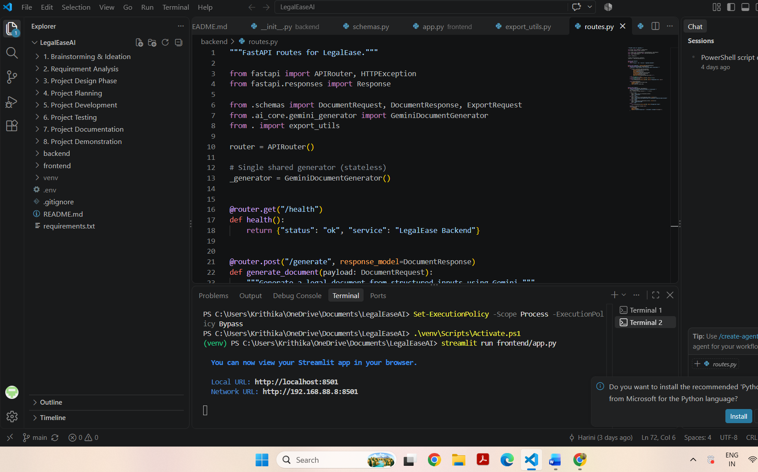

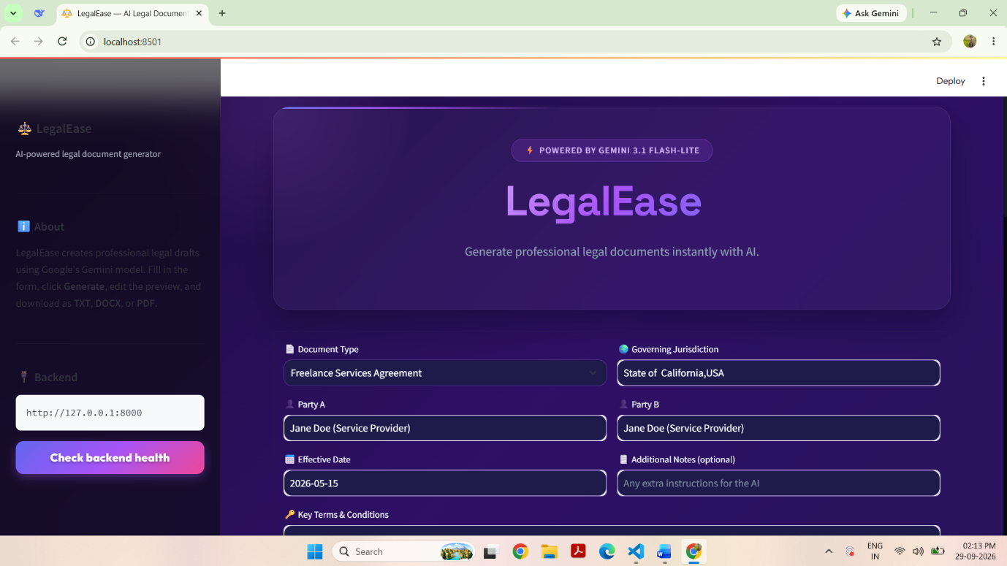

.
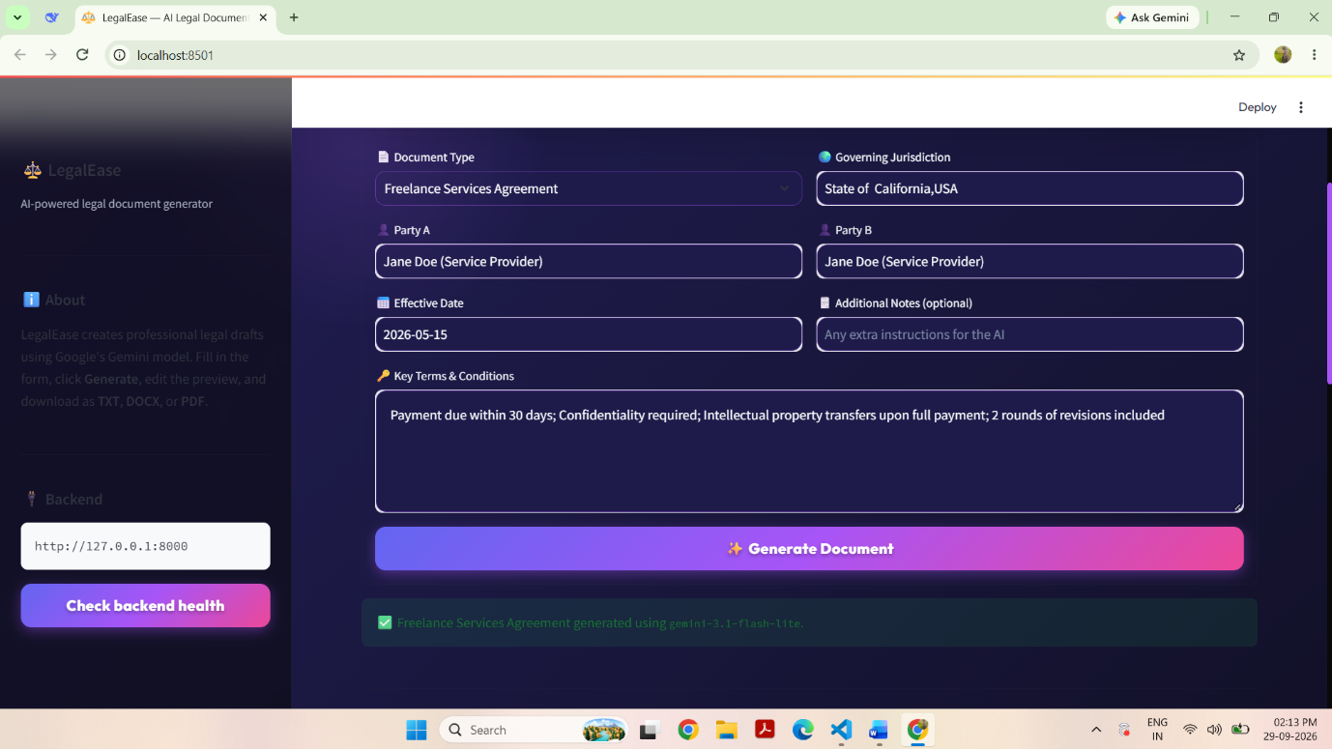

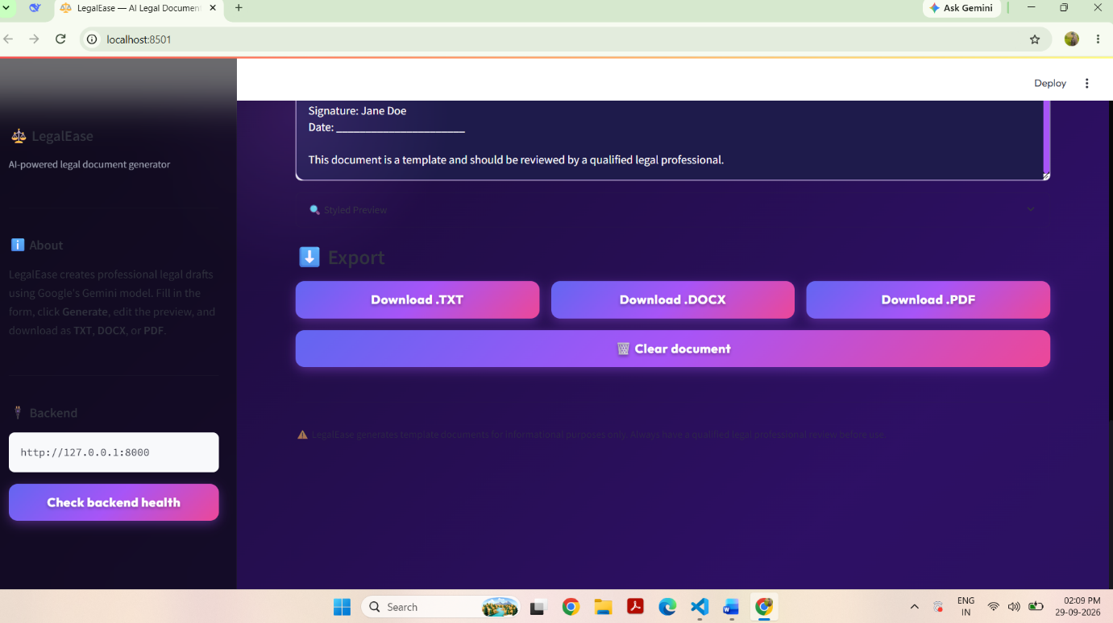

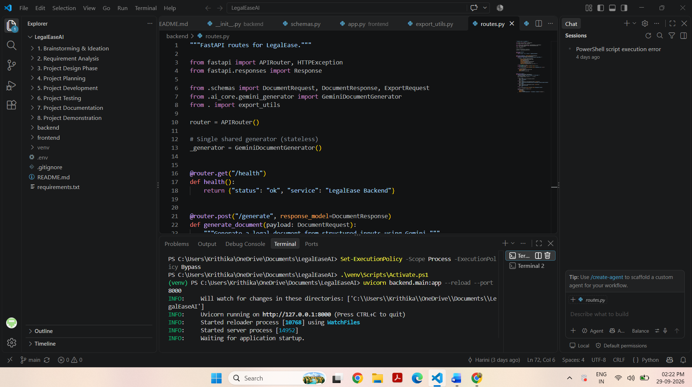

14. ADVANTAGES
- Zero Cost: Completely free to use, eliminating the Rs. 5,000+ legal consultation fee.
- Instant Generation: Creates comprehensive legal documents in under 30 seconds.
- High Customization: Documents are tailored to the specific parties, dates, and terms provided by the user.
- Multi-Format Export: Users can download the document as a PDF, Word doc, or plain text.
- Privacy-Focused: No user data is stored on any external server.
- Professional Structure: AI is prompted to include formal legal sections, numbered clauses, and signature blocks.
- User-Friendly: Simple, intuitive interface requiring no legal expertise to operate.
15. LIMITATIONS
- AI Accuracy: The quality of the document depends on the clarity of the user's input.
- No Digital Signature: The generated documents cannot be digitally signed within the app.
- Internet Dependency: Requires a stable internet connection to communicate with the Gemini API.
- Language: Currently supports only English.
- Not a Substitute for Legal Advice: For highly complex or high-stakes legal matters, professional legal review is still recommended.
16. FUTURE ENHANCEMENT
- Cloud Deployment: Deploy the backend to Render/Railway and the frontend to Streamlit Cloud.
- Multi-Language Support: Add support for Hindi, Tamil, and other regional languages.
- Digital Signature Integration: Integrate DocuSign or similar APIs for e-signatures.
- User Accounts: Allow users to create accounts to save and manage their document history.
- Mobile Application: Develop a dedicated Android/iOS app for easier access on the go.
- Template Library: Add a library of pre-set clauses for common industries.
17. CONCLUSION
LegalEase: AI-Powered Legal Document Generator successfully demonstrates how Generative AI can democratize access to legal documentation. By combining the speed of FastAPI, the simplicity of Streamlit, and the power of Google Gemini, the project delivers a practical, free, and fast solution to a real-world problem.
The system empowers freelancers, small business owners, and individuals to protect their interests without financial barriers. With its robust architecture, privacy-first design, and multi-format export capabilities, LegalEase is a highly effective tool for modern legal document management.
GITHUB LINK: https://github.com/harinipadmavathi1918-cpu/LegalEaseAI
DRIVE LINK: [Your Google Drive Demo Link]

