
RAJALAKSHMI INSTITUTE OF TECHNOLOGY
(An Autonomous Institution, Affiliated to Anna University, Chennai)

DEPARTMENT OF ARTIFICIAL INTELLIGENCE AND DATA SCIENCE
ACADEMIC YEAR 2025 - 2026
SEMESTER III
ARTIFICIAL INTELLIGENCE LABORATORY
MINI PROJECT REPORT

REGISTER NUMBER | 2117240070237
NAME | Ragadharshini Devarajan
PROJECT TITLE | Connect Four Game Using Mini-Max Strategy
DATE OF SUBMISSION
FACULTY IN-CHARGE | Mrs. M. Rubina begam

Signature of Faculty In-charge

INTRODUCTION
Brief overview of Artificial Intelligence concepts
Artificial Intelligence (AI) is the study and engineering of intelligent agents that perceive environments and take actions to maximize chance of success. Game-playing agents are canonical AI examples: they must search through possible future states, evaluate outcomes, and choose actions under uncertainty and adversarial opposition.
Topic introduction & background context
Connect Four is a two-player, turn-based, deterministic board game played on a 7×6 vertical grid. Players alternate dropping discs into columns; discs fill from the bottom up. The objective is to connect four of one’s own discs vertically, horizontally, or diagonally. Because the game is finite, perfect-information, and zero-sum, search algorithms like Minimax are directly applicable.
Why the problem matters
Designing a competent Connect Four agent demonstrates core AI skills: state representation, adversarial search, heuristic evaluation, pruning for efficiency, and trade-offs between optimality and computational cost. It’s an excellent mini project to showcase CO2 (search strategies), CO2 (game playing), CO3 (CSP thinking in state constraints), CO4 (logical decisions), and CO5 (probabilistic notions via optional move ordering / evaluation tuning).
Project aim
Implement a playable Connect Four where the computer uses Minimax with Alpha-Beta pruning and a domain-specific heuristic evaluation function (with depth-limited search) to choose moves. Provide explanation, code (Python), sample outputs, and suggestions for extensions.
PROBLEM STATEMENT
Design and develop an AI agent for the Connect Four game that uses Minimax with Alpha-Beta pruning and a heuristic evaluation function to select near-optimal moves under a depth limit, enabling competitive play against a human player.
GOAL
- Build a functional, playable Connect Four program (console-based) where a human can play vs AI or AI vs AI.
- AI should use Minimax with Alpha-Beta pruning, with a tunable depth limit.
- Provide a heuristic evaluation scoring board states to guide search.
- Demonstrate sample runs and analyze performance (moves/time, win/draw behavior).
- Possibility: show improved play with deeper search and better heuristics.
Expected results: AI plays competitively; with reasonable depth (e.g., depth 5–7) it should beat casual players and avoid simple traps.
THEORETICAL BACKGROUND
Minimax (adversarial search)
Minimax is a recursive search algorithm for two-player zero-sum games. It assumes both players play optimally: the maximizing player chooses moves to maximize utility; the minimizing player chooses moves to minimize utility. The Minimax value of a node is the utility achieved with optimal play from that node.
Time complexity (naive): O(b^d) where b is branching factor (≤7 for Connect Four), d is search depth. Space complexity: O(d) for recursion stack (assuming no memoization).
Alpha-Beta pruning
Alpha-beta pruning optimizes Minimax by eliminating branches that cannot influence the final decision. It keeps two parameters: α (best already explored value along the path to the root for maximizer) and β (best for minimizer). Pruned branches reduce effective branching factor, enabling deeper search for the same time.
Alpha-beta does not change final Minimax result (with perfect move ordering), but improves efficiency. Best-case complexity reduces to O(b^(d/2)) with perfect ordering.
Heuristic evaluation for Connect Four
Because searching to terminal states is expensive, we use a depth-limited search and evaluate non-terminal states with a heuristic function that scores board positions.
Common evaluation ideas:
- Count number of possible 4-disc windows (segments of 4 cells) containing X of AI discs and 0 opponent discs; weight by X (e.g., 3-in-a-row is highly valuable).
- Center column control: center columns are part of more winning lines; reward center occupancy.
- Immediate win/loss detection: game-over states should be returned with high positive/negative infinity-like scores.
A typical heuristic (used here) examines all length-4 windows and assigns scores:
- 4 for AI → big positive (winning)
- 3 + empty → high positive
- 2 + empties → moderate positive
And symmetric negative scores for opponent controlled windows.
Literature survey & alternative algorithms
- Minimax + Alpha-Beta is classical for two-player games (see Russell & Norvig).
- Victor Allis' work analyzed Connect-Four and its solution techniques (search + domain knowledge).
- Alternatives: Monte Carlo Tree Search (MCTS), Reinforcement Learning (self-play), Negamax (a Minimax simplification), and full-depth perfect-solver approaches (solving Connect-Four is possible with endgame databases and retrograde analysis).
Justification for choosing Minimax + Alpha-Beta
- Clear for teaching adversarial search.
- Deterministic and explainable decisions.
- Easy to extend with heuristics and pruning.
- Sufficient for good play with depth-limited search on Connect-Four's branching factor.
ALGORITHM EXPLANATION WITH EXAMPLE
High-level algorithm (Minimax with Alpha-Beta, depth-limited)
- If current board is terminal (win/loss/draw) or depth = 0 → return heuristic(board).
- For each valid move (non-full column):
  - Apply move to create new state.
  - Recursively evaluate using Minimax (switching maximizing/minimizing role), carrying alpha and beta.
  - Undo move.
  - Update best value and alpha/beta; prune when α ≥ β.
- Return best move/value at root.
Example (mini walkthrough)
- Suppose AI (Max) to play on a simplified 4-wide board and depth=3.
- It enumerates legal columns (branches). For each move, simulate opponent responses (Min) and evaluate leaves by heuristic.
- Alpha-beta allows pruning: if the AI finds a move guaranteed to be better than what the opponent can force elsewhere, other branches are skipped.
This reduces redundant search and allows deeper exploration of promising moves.
IMPLEMENTATION AND CODE
# connect4_minimax.py
import math
import random
import time
from copy import deepcopy

ROWS = 6
COLUMNS = 7
PLAYER_PIECE = 1 # Human or Player 1
AI_PIECE = 2 # AI

EMPTY = 0
WINDOW_LENGTH = 4
MAX_DEPTH = 5 # default depth (changeable)

def create_board():
return [[EMPTY for _ in range(COLUMNS)] for _ in range(ROWS)]

def drop_piece(board, row, col, piece):
board[row][col] = piece

def is_valid_location(board, col):
return board[0][col] == EMPTY

def get_next_open_row(board, col):
for r in range(ROWS-1, -1, -1):
if board[r][col] == EMPTY:
return r
return None

def print_board(board):
print("\nBoard:")
for r in range(ROWS):
print('|' + ' '.join(['.' if c == EMPTY else ('X' if c == PLAYER_PIECE else 'O') for c in board[r]]) + '|')
print(' ' + ' '.join(map(str, range(COLUMNS))))

def winning_move(board, piece):
# Check horizontal
for r in range(ROWS):
for c in range(COLUMNS - 3):
if all(board[r][c+i] == piece for i in range(4)):
return True
# Check vertical
for c in range(COLUMNS):
for r in range(ROWS - 3):
if all(board[r+i][c] == piece for i in range(4)):
return True
# Check positively sloped diagonals
for r in range(ROWS - 3):
for c in range(COLUMNS - 3):
if all(board[r+i][c+i] == piece for i in range(4)):
return True
# Check negatively sloped diagonals
for r in range(3, ROWS):
for c in range(COLUMNS - 3):
if all(board[r-i][c+i] == piece for i in range(4)):
return True
return False

def is_terminal_node(board):
return winning_move(board, PLAYER_PIECE) or winning_move(board, AI_PIECE) or len(get_valid_locations(board)) == 0

def evaluate_window(window, piece):
score = 0
opp_piece = PLAYER_PIECE if piece == AI_PIECE else AI_PIECE

if window.count(piece) == 4:
score += 10000
elif window.count(piece) == 3 and window.count(EMPTY) == 1:
score += 100
elif window.count(piece) == 2 and window.count(EMPTY) == 2:
score += 10

if window.count(opp_piece) == 3 and window.count(EMPTY) == 1:
score -= 80
return score

def score_position(board, piece):
score = 0
# Score center column
center_array = [board[r][COLUMNS//2] for r in range(ROWS)]
center_count = center_array.count(piece)
score += center_count * 6

# Score horizontal
for r in range(ROWS):
row_array = [board[r][c] for c in range(COLUMNS)]
for c in range(COLUMNS - 3):
window = row_array[c:c+WINDOW_LENGTH]
score += evaluate_window(window, piece)

# Score vertical
for c in range(COLUMNS):
col_array = [board[r][c] for r in range(ROWS)]
for r in range(ROWS - 3):
window = col_array[r:r+WINDOW_LENGTH]
score += evaluate_window(window, piece)

# Score positive sloped diagonals
for r in range(ROWS - 3):
for c in range(COLUMNS - 3):
window = [board[r+i][c+i] for i in range(WINDOW_LENGTH)]
score += evaluate_window(window, piece)

# Score negative sloped diagonals
for r in range(ROWS - 3):
for c in range(COLUMNS - 3):
window = [board[r+3-i][c+i] for i in range(WINDOW_LENGTH)]
score += evaluate_window(window, piece)

return score

def get_valid_locations(board):
return [c for c in range(COLUMNS) if is_valid_location(board, c)]

def pick_best_move(board, piece):
valid_locations = get_valid_locations(board)
best_score = -math.inf
best_col = random.choice(valid_locations)
for col in valid_locations:
row = get_next_open_row(board, col)
temp_board = deepcopy(board)
drop_piece(temp_board, row, col, piece)
score = score_position(temp_board, piece)
if score > best_score:
best_score = score
best_col = col
return best_col

def minimax(board, depth, alpha, beta, maximizingPlayer):
valid_locations = get_valid_locations(board)
is_terminal = is_terminal_node(board)
if depth == 0 or is_terminal:
if is_terminal:
if winning_move(board, AI_PIECE):
return (None, 100000000000000)
elif winning_move(board, PLAYER_PIECE):
return (None, -10000000000000)
else: # Game over, no more valid moves
return (None, 0)
else: # Depth is zero
return (None, score_position(board, AI_PIECE))
if maximizingPlayer:
value = -math.inf
column = random.choice(valid_locations)
for col in valid_locations:
row = get_next_open_row(board, col)
b_copy = deepcopy(board)
drop_piece(b_copy, row, col, AI_PIECE)
new_score = minimax(b_copy, depth-1, alpha, beta, False)[1]
if new_score > value:
value = new_score
column = col
alpha = max(alpha, value)
if alpha >= beta:
break
return column, value
else:
value = math.inf
column = random.choice(valid_locations)
for col in valid_locations:
row = get_next_open_row(board, col)
b_copy = deepcopy(board)
drop_piece(b_copy, row, col, PLAYER_PIECE)
new_score = minimax(b_copy, depth-1, alpha, beta, True)[1]
if new_score < value:
value = new_score
column = col
beta = min(beta, value)
if alpha >= beta:
break
return column, value

def play_game():
board = create_board()
game_over = False
turn = random.choice([0, 1]) # 0 -> Player first, 1 -> AI first

print("Connect Four: You are 'X' (1). AI is 'O' (2).")
print("Columns are numbered 0 to 6.")
print_board(board)

while not game_over:
if turn == 0:
# Human turn
valid_cols = get_valid_locations(board)
col = None
while True:
try:
col = int(input("Your move (0-6): "))
if col in valid_cols:
break
else:
print("Column full or invalid. Choose from:", valid_cols)
except:
print("Invalid input. Enter column number 0-6.")
row = get_next_open_row(board, col)
drop_piece(board, row, col, PLAYER_PIECE)
if winning_move(board, PLAYER_PIECE):
print_board(board)
print("YOU WIN!")
game_over = True
turn = 1
print_board(board)

else:
# AI turn
start = time.time()
col, minimax_score = minimax(board, MAX_DEPTH, -math.inf, math.inf, True)
end = time.time()
row = get_next_open_row(board, col)
drop_piece(board, row, col, AI_PIECE)
print(f"AI chose column {col} (evaluated in {end-start:.2f}s)")
if winning_move(board, AI_PIECE):
print_board(board)
print("AI WINS!")
game_over = True
turn = 0
print_board(board)

if len(get_valid_locations(board)) == 0 and not game_over:
print("Game is a draw!")
game_over = True

if __name__ == "__main__":
print("Welcome to Connect Four (Console Version)")
print("1: Human vs AI")
print("2: AI vs AI")
mode = input("Choose mode (1/2): ").strip()
if mode == '1':
try:
depth_input = input(f"Enter search depth (recommended 4-6) or press Enter (default {MAX_DEPTH}): ")
if depth_input.strip():
MAX_DEPTH = int(depth_input)
except:
pass
play_game()
else:
# Simple AI vs AI match (demonstration)
board = create_board()
print_board(board)
turn = 0
while True:
if len(get_valid_locations(board)) == 0 or is_terminal_node(board):
print("Game over")
print_board(board)
if winning_move(board, AI_PIECE):
print("AI (O) wins")
elif winning_move(board, PLAYER_PIECE):
print("AI (X) wins")
else:
print("Draw")
break
if turn == 0:
col = pick_best_move(board, PLAYER_PIECE)
row = get_next_open_row(board, col)
drop_piece(board, row, col, PLAYER_PIECE)
turn = 1
print_board(board)
else:
col, _ = minimax(board, MAX_DEPTH, -math.inf, math.inf, True)
row = get_next_open_row(board, col)
drop_piece(board, row, col, AI_PIECE)
turn = 0
print_board(board)

OUTPUT
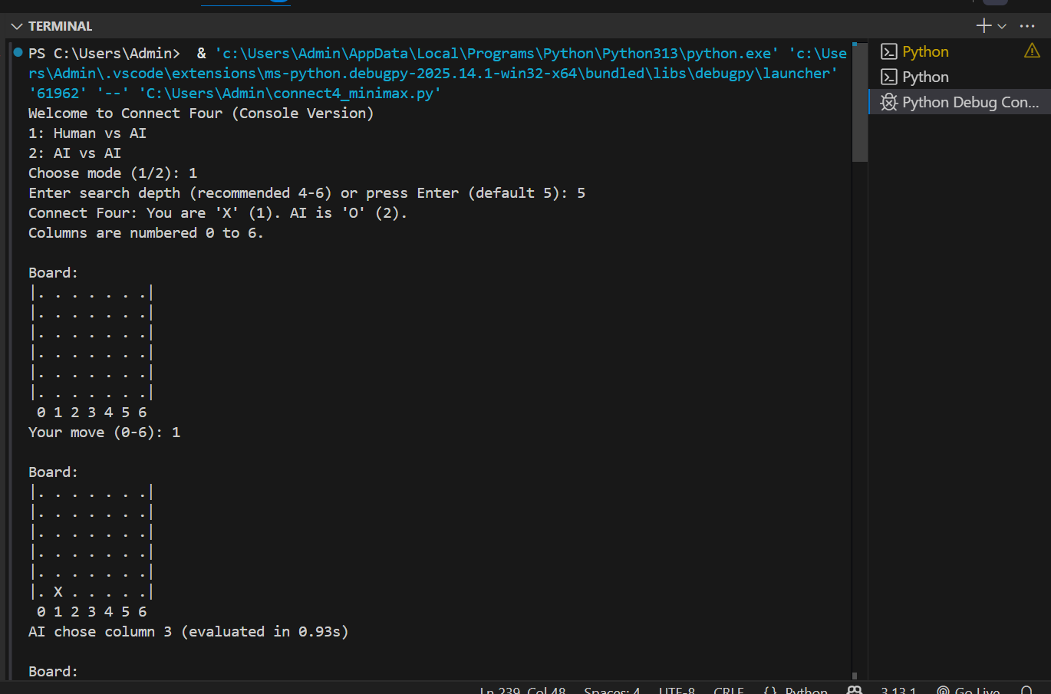
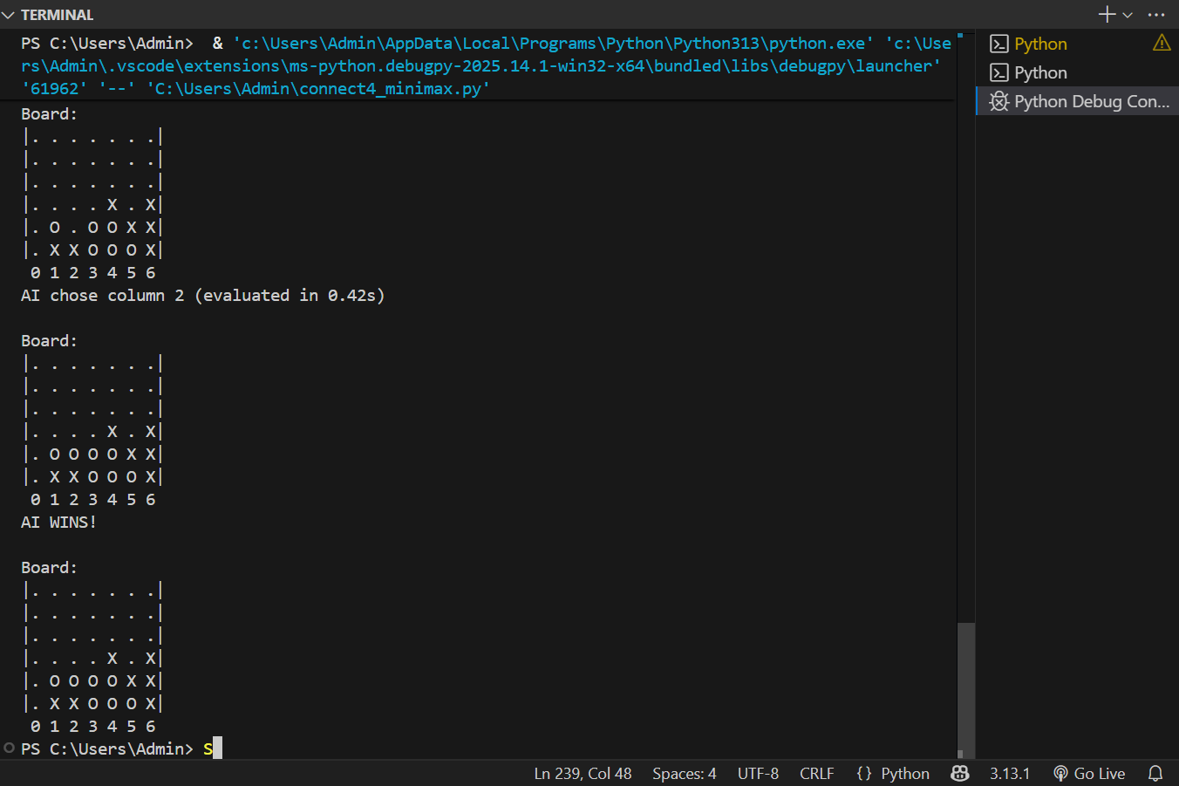
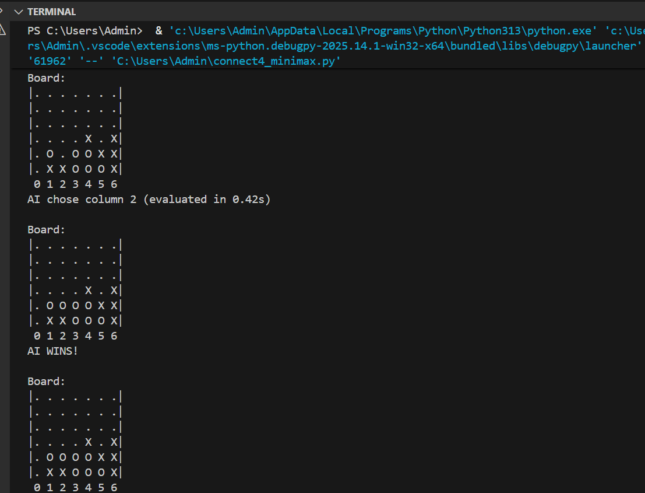
Explanation:
- After human move, the AI searches up to MAX_DEPTH, evaluates positions using the heuristic, and chooses the move with highest minimax score. The console prints chosen column and evaluation time.
RESULTS AND FUTURE ENHANCEMENT
Results / Observations
- With MAX_DEPTH = 4–6, AI plays strongly against casual human players.
- Alpha-Beta pruning significantly reduces evaluated nodes. With simple board copy and Python overhead, deeper searches (depth >7) become slow.
- Heuristic function improves play: center-control and penalizing opponent’s 3-in-a-row reduces immediate threats.
Comparison with other methods
- Plain Minimax (no pruning): Same decisions but much slower; cannot reach the same depth within practical time.
- Negamax: A simplified Minimax with sign inversion; equivalent but cleaner code.
- MCTS: Often better for large branching but needs simulations; can be adapted and may outperform shallow minimax in some setups.
- Bitboard + Perfect Solver: Using bitboard representation and optimized search can solve Connect-Four perfectly (Allis' results). That is more complex to implement but yields perfect play.
Future enhancements
- Move ordering: Explore best moves first (e.g., center, immediate wins) for stronger alpha-beta pruning.
- Iterative deepening: Use iterative deepening with time limits to get best depth within a time budget.
- Transposition table / memoization: Cache evaluated positions to avoid re-evaluating symmetric states.
- Bitboard representation: Replace 2D lists with bitboards for speed and memory efficiency.
- GUI: Implement a graphical UI using Pygame or a web frontend (HTML/JS) to improve presentation.
- Self-play training: Use reinforcement learning or policy networks to learn evaluation functions (Deep RL).
- Perfect play / endgame databases: Implement retrograde analysis for perfect play on smaller subproblems.
Git Hub Link of the project and report
REFERENCES
- Stuart Russell and Peter Norvig, Artificial Intelligence: A Modern Approach, 4th Edition (Pearson). — Chapter on adversarial search and alpha-beta pruning.
- Victor Allis, L. V., A Knowledge-based Approach of Connect-Four (technical report / thesis). — Study of solving Connect Four using search and domain knowledge.
- Wikipedia — “Minimax” and “Alpha–beta pruning” pages. https://en.wikipedia.org/wiki/Minimax_algorithm
- GeeksforGeeks — “Minimax Algorithm” and “Alpha Beta Pruning” tutorials (practical examples and pseudocode). https://www.geeksforgeeks.org/minimax-algorithm-in-game-theory-or-search-algorithms-for-games/
- Towards Data Science — Build a Connect Four AI with Minimax (article showing implementation patterns and heuristics).
- James S. Breese, David Heckerman, Probabilistic Reasoning and the Bayesian approach (for probabilistic comparisons and advanced heuristics). (Optional reading for CO5.)

