
RAJALAKSHMI INSTITUTE OF TECHNOLOGY
(An Autonomous Institution, Affiliated to Anna University, Chennai)

DEPARTMENT OF CSE (ARTIFICIAL INTELLIGENCE AND MACHINE LEARNING)
ACADEMIC YEAR 2025 - 2026
SEMESTER III
ARTIFICIAL INTELLIGENCE LABORATORY
MINI PROJECT REPORT

REGISTER NUMBER | 2117240030040
NAME | S.HARINI
PROJECT TITLE | N-KNIGHT’S TOUR PROBLEM USING BACKTRACKING ALGORITHM
DATE OF SUBMISSION | 28-10-2025
FACULTY IN-CHARGE | Mrs. M. Divya

Signature of Faculty In-charge

INTRODUCTION
Artificial Intelligence (AI) is a branch of computer science that enables machines to think, learn, and make decisions like humans. One of the classic problems in AI and algorithm design is the Knight’s Tour Problem, which demonstrates how AI can be used to solve complex search and optimization problems.
The Knight’s Tour problem is a mathematical puzzle where a knight must visit every square on a chessboard exactly once. It’s an example of a constraint satisfaction problem, commonly used in AI to explore state-space search and backtracking techniques.
This project aims to find a valid path for the knight to tour the entire chessboard using the Backtracking algorithm, an essential problem-solving method in Artificial Intelligence.

PROBLEM STATEMENT
To develop a Python program that solves the Knight’s Tour problem using the backtracking approach, where the knight must move to every cell of an $n×n$chessboard exactly once without revisiting any cell.

GOAL
The goal is to generate a sequence of moves that allows the knight to visit every square on the chessboard exactly once.
If a complete tour exists for a given board size, the program should display the path (board with move numbers). Otherwise, it should show that no solution exists.
This project demonstrates:
- Application of AI search techniques
- Recursive backtracking implementation
- Visualization of step-by-step pathfinding

THEORETICAL BACKGROUND
The Knight’s Tour problem is an AI search problem and is often solved using Backtracking, a type of Depth-First Search (DFS) algorithm.

Backtracking Concept
Backtracking is a problem-solving technique where we explore all possible paths and backtrack (undo the last move) when a path doesn’t lead to a valid solution. It is widely used in AI for solving constraint-based problems like N-Queens, Sudoku, and Knight’s Tour.

Knight’s Tour Problem
The knight moves in an “L” shape: two squares in one direction and one square perpendicular to it. From a given position, it has up to 8 possible moves.
The challenge is to find a path that covers all $n^{2}$squares without repetition.

Literature Survey
- Euler (1759): First studied the Knight’s Tour as a mathematical problem.
- Warnsdorff’s Rule (1823): Proposed a heuristic to minimize dead-ends in the knight’s path.
- Other methods include Brute Force, Heuristic Search, and Genetic Algorithms.

Justification for Choosing Backtracking
Backtracking is chosen because it’s a straightforward and reliable approach for generating all possible move sequences until a valid solution is found. It’s ideal for demonstrating recursion and state-space exploration concepts used in AI.

ALGORITHM EXPLANATION WITH EXAMPLE:

Algorithm Steps:
- Start from the first cell (0, 0) of the board.
- Mark the current cell as visited.
- Try all 8 possible knight moves (in L-shape).
- For each valid move, recursively check if the next move leads to a solution.
- If a move doesn’t lead to a valid path, backtrack (unmark and try another).
- Continue until all squares are visited or no valid move remains.

Example:
For a 5×5 board:
- The knight starts at position (0,0).
- Moves are tried one by one using recursion.
- Once a complete path of 25 moves is found, the solution is printed.
IMPLEMENTATION AND CODE:
Index.html:
<!doctype html>
<html lang="en">
<head>
<meta charset="utf-8" />
<meta name="viewport" content="width=device-width,initial-scale=1" />
<title>Knight's Tour — Minimal Working</title>
<link rel="stylesheet" href="style.css">
</head>
<body>
<div class="app">
<section class="board-area">
<div id="board" class="board" aria-label="Knight board"></div>
</section>
<aside class="panel">
<h2>Knight's Tour — Interactive</h2>
<div class="row">
<label>Board size</label>
<select id="sizeSelect">
<option value="5">5 × 5</option>
<option value="6" selected>6 × 6</option>
<option value="7">7 × 7</option>
<option value="8">8 × 8</option>
</select>
<button id="createBtn">Create</button>
</div>
<div class="row">
<button id="toggleHints">Toggle Hints</button>
<button id="undoBtn">Undo</button>
<button id="resetBtn">Reset</button>
</div>
<div class="row">
<button id="autoBtn">Auto-Solve</button>
<button id="solveAnimBtn">Solve with Animation</button>
</div>
<div id="statusBox" class="status">Status: ready</div>
<div class="counters">
Moves: <span id="moveCount">0</span>
&nbsp;|&nbsp;
Visited: <span id="visitedCount">0</span>/<span id="totalSquares">36</span>
</div>
<hr />
<h3>Learning / Game Ethics</h3>
<p>Play manually first. Use auto-solve only to learn. Be honest and share sources.</p>
</aside>
</div>
<script src="script.js"></script>
</body>
</html>
Style.css:
:root{
--size:60px;
--bg:#f3f6fb;
--card:#fff;
--light:#f9fbff;
--dark:#dceeff;
}
*{box-sizing:border-box}
html,body{height:100%;margin:0;background:var(--bg);font-family:Arial,Helvetica,sans-serif}
.app{display:flex;gap:20px;padding:22px;max-width:1100px;margin:20px auto;align-items:flex-start}
.board-area{flex:1;display:flex;justify-content:center;align-items:center}
.board{
display:grid;
padding:8px;
background:var(--card);
border-radius:12px;
box-shadow:0 6px 18px rgba(20,30,60,0.06);
}
.square{
width:var(--size);height:var(--size);
display:flex;align-items:center;justify-content:center;
position:relative;cursor:pointer;border-radius:8px;
transition:background .12s;
user-select:none;
}
.square.light{background:var(--light)}
.square.dark{background:var(--dark)}
.square .num{position:absolute;left:6px;top:6px;font-size:12px;color:#0b1220}
.square .knight{font-size:18px}
.square.highlight{box-shadow:inset 0 0 0 3px rgba(31,111,235,0.08)}
.panel{width:320px;background:var(--card);padding:16px;border-radius:12px;box-shadow:0 6px 18px rgba(20,30,60,0.06)}
.row{display:flex;gap:8px;margin:8px 0;align-items:center}
.status{margin-top:12px;padding:10px;border-radius:8px;background:#fbfdff;border:1px solid #e6eefc}
.counters{margin-top:10px;font-weight:700}
button{padding:8px 10px;border-radius:8px;border:1px solid #2b6cb0;background:#e7f0ff;color:#0b3a80;cursor:pointer}
button:active{transform:translateY(1px)}
@media (max-width:900px){ .app{flex-direction:column} :root{--size:48px} }

Script.js:
document.addEventListener('DOMContentLoaded', () => {
const boardEl = document.getElementById('board');
const sizeSelect = document.getElementById('sizeSelect');
const createBtn = document.getElementById('createBtn');
const toggleHintsBtn = document.getElementById('toggleHints');
const undoBtn = document.getElementById('undoBtn');
const resetBtn = document.getElementById('resetBtn');
const autoBtn = document.getElementById('autoBtn');
const solveAnimBtn = document.getElementById('solveAnimBtn');
const statusBox = document.getElementById('statusBox');
const moveCountEl = document.getElementById('moveCount');
const visitedCountEl = document.getElementById('visitedCount');
const totalSquares El = document.getElementById('totalSquares');
const MOVES = [[2,1],[1,2],[-1,2],[-2,1],[-2,-1],[-1,-2],[1,-2],[2,-1]];
let N = parseInt(sizeSelect.value, 10) || 6;
let grid = []; // grid[r][c] = { visited, elem, num }
let knight = null; // [r,c]
let history = []; // visited order
let moveIndex = 0;
let hints = true;
let animRunning = false;

function setStatus(s){ statusBox.textContent = 'Status: ' + s; }
function updateCounters(){ moveCountEl.textContent = moveIndex; visitedCountEl.textContent = history.length; totalSquaresEl.textContent = N*N; }
function buildBoard(n){
N = n;
grid = Array.from({length:N}, ()=> Array(N).fill(null));
knight = null; history = []; moveIndex = 0; animRunning = false;
boardEl.innerHTML = '';
const sizePx = Math.max(40, Math.min(80, Math.floor(420 / N)));
document.documentElement.style.setProperty('--size', sizePx + 'px');
boardEl.style.gridTemplateColumns = repeat(${N}, ${sizePx}px);
boardEl.style.width = calc(${sizePx}px * ${N} + 16px);
for(let r=0;r<N;r++){
for(let c=0;c<N;c++){
const sq = document.createElement('div');
sq.className = 'square ' + (((r+c)%2===0)?'light':'dark');
sq.dataset.r = r; sq.dataset.c = c;
const num = document.createElement('div'); num.className = 'num';
sq.appendChild(num);
boardEl.appendChild(sq);
grid[r][c] = { visited:false, elem:sq, num:null, numSpan:num };
}
}
setStatus('click any square to place the knight');
updateCounters();
}
boardEl.addEventListener('click', (ev) => {
if(animRunning) return;
const sq = ev.target.closest('.square');
if(!sq) return;
const r = Number(sq.dataset.r), c = Number(sq.dataset.c);
if(!Number.isFinite(r) || !Number.isFinite(c)) return;
if(!knight){
placeKnight(r,c);
return;
}
const [kr,kc] = knight;
if(isLegalMove(kr,kc,r,c) && !grid[r][c].visited){
moveTo(r,c);
} else {
setStatus('illegal move. click a highlighted square.');
}
});
function isLegalMove(fr,fc,tr,tc){
for(const [dr,dc] of MOVES) if(fr+dr===tr && fc+dc===tc) return true;
return false;
}
function placeKnight(r,c){
knight = [r,c];
grid[r][c].visited = true;
grid[r][c].num = ++moveIndex;
history.push([r,c]);
refreshBoard();
setStatus(knight placed at (${r},${c}));
updateCounters();
}
function moveTo(r,c){
knight = [r,c];
grid[r][c].visited = true;
grid[r][c].num = ++moveIndex;
history.push([r,c]);
refreshBoard();
setStatus(moved to (${r},${c}));
updateCounters();
checkGameState();
}
function refreshBoard(){
for(let r=0;r<N;r++){
for(let c=0;c<N;c++){
const cell = grid[r][c];
const el = cell.elem;
el.classList.remove('highlight');
cell.numSpan.textContent = cell.visited ? cell.num : '';
}
}
if(knight && hints){
const [r,c] = knight;
for(const [dr,dc] of MOVES){
const nr=r+dr, nc=c+dc;
if(nr>=0 && nr<N && nc>=0 && nc<N && !grid[nr][nc].visited){
grid[nr][nc].elem.classList.add('highlight');
}
}
}
}

function undo(){
if(animRunning) return;
if(history.length <= 1){ setStatus('nothing to undo'); return; }
const last = history.pop();
grid[last[0]][last[1]].visited = false;
grid[last[0]][last[1]].num = null;
moveIndex = Math.max(0, moveIndex-1);
const prev = history[history.length-1];
knight = [prev[0], prev[1]];
refreshBoard();
setStatus('undid last move');
updateCounters();
}

function resetBoard(){
if(animRunning) return;
buildBoard(N);
}
function autoSolve(animated=false){
if(!history.length){ setStatus('place knight first'); return; }
setStatus('auto-solve: not implemented in minimal version yet');
}

function hasLegal(){
if(!knight) return false;
const [r,c] = knight;
for(const [dr,dc] of MOVES){
const nr=r+dr, nc=c+dc;
if(nr>=0 && nr<N && nc>=0 && nc<N && !grid[nr][nc].visited) return true;
}
return false;
}
function checkGameState(){
if(history.length === N*N){ setStatus('congratulations — tour complete!'); return; }
if(!hasLegal()){ setStatus('stuck — no legal moves left'); }
}

createBtn.addEventListener('click', ()=> buildBoard(parseInt(sizeSelect.value,10)));
toggleHintsBtn.addEventListener('click', ()=> { hints = !hints; refreshBoard(); setStatus('hints ' + (hints ? 'on' : 'off')); });
undoBtn.addEventListener('click', undo);
resetBtn.addEventListener('click', resetBoard);
autoBtn.addEventListener('click', ()=> autoSolve(false));
solveAnimBtn.addEventListener('click', ()=> autoSolve(true));
sizeSelect.addEventListener('change', ()=> totalSquaresEl.textContent = parseInt(sizeSelect.value,10)**2);
window.addEventListener('keydown', (e)=>{
if(e.key === 'u') undo();
if(e.key === 'r') resetBoard();
if(e.key === 'h'){ hints = !hints; refreshBoard(); setStatus('hints ' + (hints ? 'on' : 'off')); }
});
buildBoard(N
);
});
OUTPUT:
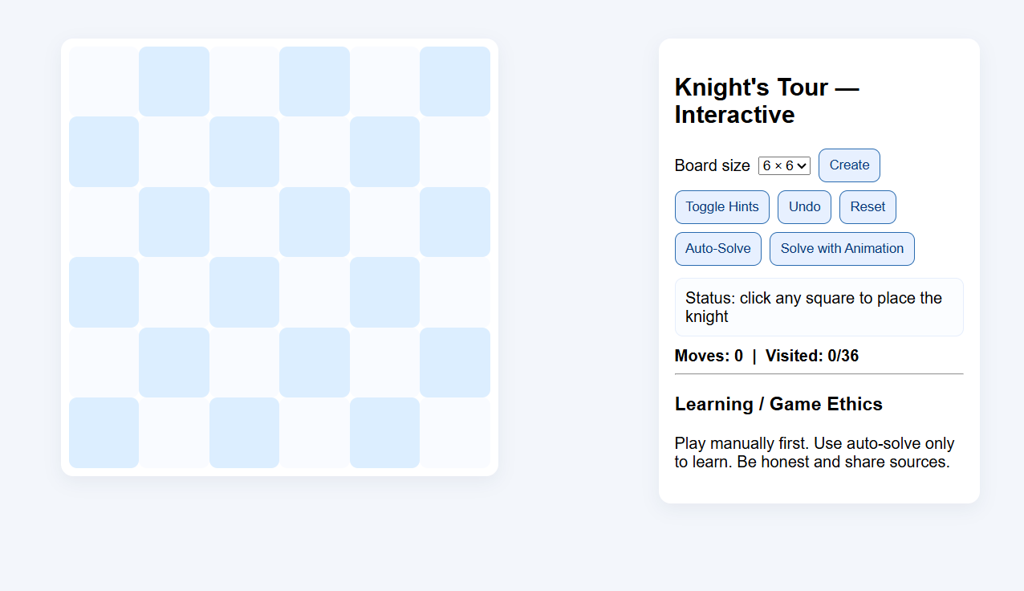
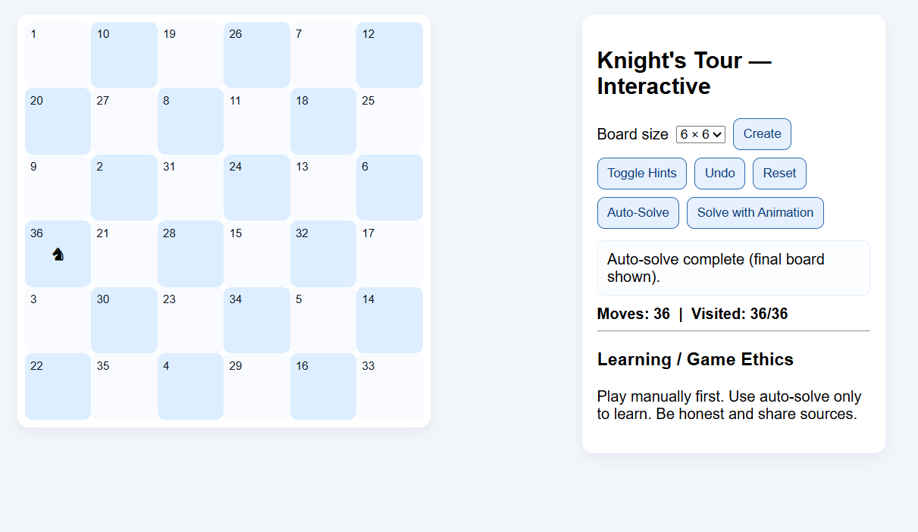

Explanation:
Each number represents the step number of the knight. The knight starts from (0,0) → 0 and visits all 25 squares exactly once.
RESULTS AND FUTURE ENHANCEMENT
RESULTS:
The program successfully finds a valid Knight’s Tour path for smaller boards like 5×5, 6×6, etc., using a pure backtracking approach.
It demonstrates how recursive AI techniques can explore and solve constraint-based problems effectively.
FUTURE ENHANCEMENT:
- Implement Warnsdorff’s heuristic to reduce computation time.
- Develop a GUI visualization to animate knight moves.
- Extend the program to solve generalized N×N chessboards efficiently.
- Explore parallel backtracking or AI optimization algorithms for larger boards.

Git Hub Link of the project and report | https://github.com/harinis240040-byte/N-Knight-problem-solver-.git
REFERENCES:
- Artificial Intelligence: A Modern Approach – Stuart Russell & Peter Norvig.
- GeeksforGeeks – Knight’s Tour Problem using Backtracking (https://www.geeksforgeeks.org)
- TutorialsPoint – Backtracking Algorithms in Python
- Programiz – Recursion and Backtracking in Python
- YouTube: “Knight’s Tour Problem Explained” – Jenny’s Lectures CS/IT

