• OpenAI (GPT-5.5 / GPT-5.5 Instant)
GPT-5.5 was released in late 2025/early 2026. It is described as a frontier agentic model, shifting toward proactive AI agents.
https://developers.openai.com/api/docs/quickstart

• Anthropic (Claude Opus 4.6 / Claude Mythos)
These models were released in early 2026. They are known for high-level reasoning and coding ability. Claude Mythos, released in April 2026, focused on advanced reasoning tasks.
• Google DeepMind (Gemini 3.1 Pro)
Released in Feb 2026, Gemini 3.1 is a multimodal model with improvements in agentic workflows and long-context understanding, including up to 2-hour video analysis.
• Meta (Llama 4)
Llama 4 was launched in April 2026. It is an open-source model with specialized versions such as Llama 4 Scout and Maverick, which offer 10M+ token context windows.
• xAI (Grok-4.20 Beta)
This model was released in early 2026. It offers real-time knowledge integration and provides large context windows (up to 2.0M tokens) for deep analysis.
• DeepSeek (DeepSeek-V3.2 / R1)
DeepSeek continues to release efficient Mixture-of-Experts (MoE) models. Their late 2025/early 2026 updates have maintained high benchmarks at a lower cost.
• Alibaba Cloud / Qwen Team (Qwen 2.5/3)
Qwen 2.5, and later Qwen 3 in April 2026, is an open-weight provider, with models widely regarded for exceptional coding and mathematical capabilities.
• Mistral AI (Mistral Large 2)
Released in late 2025, Mistral Large 2 improved upon reasoning, coding, and mathematical capabilities while aiming to maintain open-weight availability.
• MiniMax (MiniMax M2.7 / M2.8)
This Chinese AI provider is recognized for multimodal capabilities (video/audio) and fast, high-performance LLMs in 2026.
• Moonshot AI (Kimi K2.6 / Kimi K2.5 Thinking)
Known for long-context windows, with their Kimi K2.5/2.6 releases they introduced "thinking" models capable of reasoning, offering strong performance in coding, according to. [1, 2, 3, 4, 5, 6, 7, 8, 9]

OpenAI (GPT-5.5 / GPT-5.5 Instant):
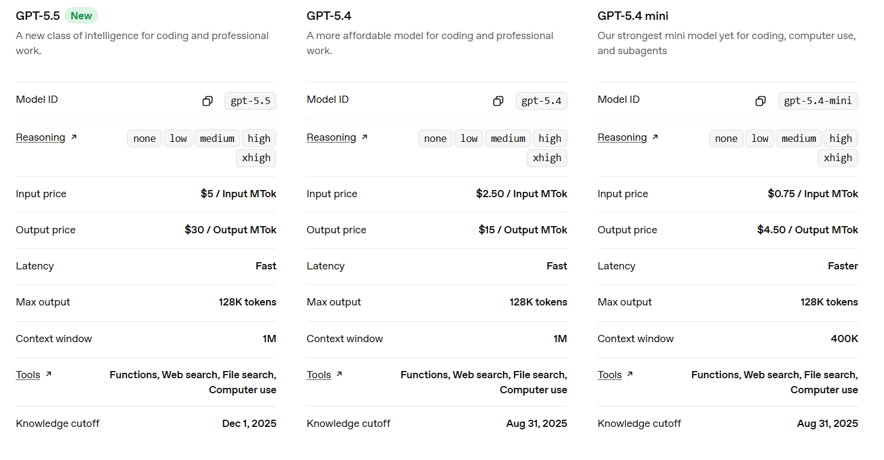

Transformers in Machine Learning
Transformer is a neural network architecture used for various machine learning tasks, especially in natural language processing and computer vision. It focuses on understanding relationships within data to process information more effectively.
- Uses attention mechanisms to capture relationships between inputs
- Processes entire sequences at once instead of step by step
- Improves performance on tasks involving context and dependencies
- Widely used across NLP, vision and other AI applications

Embeddings:
Embeddings are dense, numerical vector representations of data (text, images, audio) that capture semantic meaning and relationships, allowing machine learning models to understand context.
Transformers cannot work with raw words as they need numbers. So, each input token (word or subword) is converted into a vector, called an embedding.
- Both encoder input tokens and decoder input tokens are converted into embeddings.
- These embeddings are trainable, meaning the model learns the best numeric representation for each token.
- The same weight matrix is shared for Encoder embeddings, Decoder embeddings and the final linear layer before softmax
- The embeddings are scaled by model to keep values stable before adding positional encoding.

What are embeddings?
Embeddings are representations of values or objects like text, images, and audio that are designed to be consumed by machine learning models and semantic search algorithms. They translate objects like these into a mathematical form according to the factors or traits each one may or may not have, and the categories they belong to.
Essentially, embeddings enable machine learning models to find similar objects. Given a photo or a document, a machine learning model that uses embeddings could find a similar photo or document. Since embeddings make it possible for computers to understand the relationships between words and other objects, they are foundational for artificial intelligence (AI).
For example, the documents in the upper right of this two-dimensional space may be relevant to each other:

Key Components of the Architecture:
- Tokenization & Embedding: Converts text into numerical vectors that represent meaning.
- Positional Encoding: Informs the model about the order of words since the model processes all tokens at once.
- Encoder/Decoder Structure: Encodes the input data and decodes it to generate output. [1, 2]

vector embeddings
Learn how to turn text into numbers, unlocking use cases like search.
Copy Page
New embedding models
text-embedding-3-small and text-embedding-3-large, our newest and most performant embedding models, are now available. They feature lower costs, higher multilingual performance, and new parameters to control the overall size.
What are embeddings?
OpenAI’s text embeddings measure the relatedness of text strings. Embeddings are commonly used for:
- Search (where results are ranked by relevance to a query string)
- Clustering (where text strings are grouped by similarity)
- Recommendations (where items with related text strings are recommended)
- Anomaly detection (where outliers with little relatedness are identified)
- Diversity measurement (where similarity distributions are analyzed)
- Classification (where text strings are classified by their most similar label)
An embedding is a vector (list) of floating point numbers. The distance between two vectors measures their relatedness. Small distances suggest high relatedness and large distances suggest low relatedness.
Visit our pricing page to learn about embeddings pricing. Requests are billed based on the number of tokens in the input.

