Industrial Internship Report on
“Forecasting of Smart City Traffic Patterns”
Prepared by:
Sri Harini

Executive Summary
This report presents the details of the Industrial Internship provided by Upskill Campus and The IoT Academy in collaboration with the industrial partner UniConverge Technologies Pvt Ltd (UCT).
The internship was focused on solving a real-world problem using Data Science and Machine Learning techniques. The duration of the internship was 6 weeks, during which the complete project including implementation and documentation was completed.
My project titled “Forecasting of Smart City Traffic Patterns” focuses on predicting future traffic flow using historical traffic data. Accurate traffic forecasting helps smart cities reduce congestion, improve traffic signal planning, and support better urban mobility.
This internship provided valuable exposure to industry-level problem solving, data analysis, model building, and performance evaluation. Overall, it was a highly informative and practical learning experience.

TABLE OF CONTENTS
1 Preface 3
2 Introduction 4
2.1 About UniConverge Technologies Pvt Ltd 4
2.2 About upskill Campus 8
2.3 Objective 9
2.4 Reference 9
2.5 Glossary 10
3 Problem Statement 11
4 Existing and Proposed solution 12
5 Proposed Design/ Model 13
5.1 High Level Diagram (if applicable) 13
5.2 Low Level Diagram (if applicable) 13
5.3 Interfaces (if applicable) 13
6 Performance Test 14
6.1 Test Plan/ Test Cases 14
6.2 Test Procedure 14
6.3 Performance Outcome 14
7 My learnings 15
8 Future work scope 16

Preface
This internship report summarizes the work carried out during the six-week industrial internship program. The internship played an important role in bridging the gap between academic learning and industry requirements.
The project focused on forecasting smart city traffic patterns using data-driven approaches. Through this internship, I gained hands-on experience in handling real-world datasets, implementing forecasting models, and analyzing results.
I sincerely thank Upskill Campus, The IoT Academy, and UniConverge Technologies Pvt Ltd for providing this opportunity. I am also grateful to my mentors and coordinators for their guidance and support throughout the internship.
This internship enhanced my technical skills, problem-solving ability, and understanding of real-time applications of Data Science.
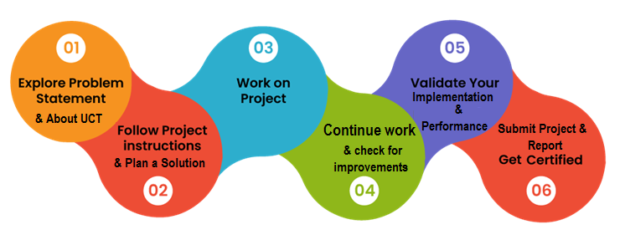

Introduction

About UniConverge Technologies Pvt Ltd
A company established in 2013 and working in Digital Transformation domain and providing Industrial solutions with prime focus on sustainability and RoI.
For developing its products and solutions it is leveraging various Cutting Edge Technologies e.g. Internet of Things (IoT), Cyber Security, Cloud computing (AWS, Azure), Machine Learning, Communication Technologies (4G/5G/LoRaWAN), Java Full Stack, Python, Front end etc.
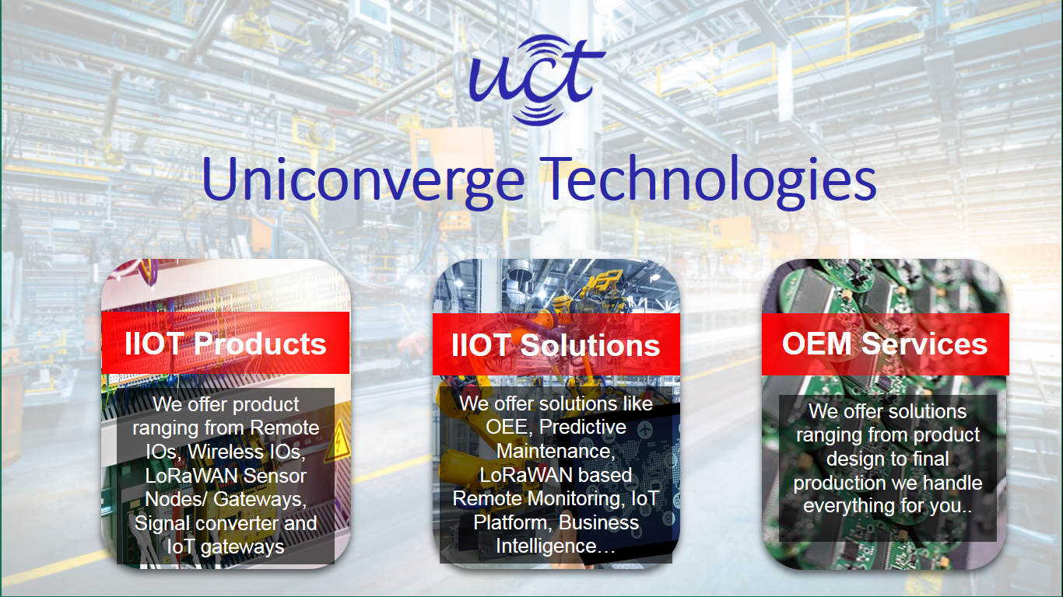
- UCT IoT Platform ()
UCT Insight is an IOT platform designed for quick deployment of IOT applications on the same time providing valuable “insight” for your process/business. It has been built in Java for backend and ReactJS for Front end. It has support for MySQL and various NoSql Databases.
- It enables device connectivity via industry standard IoT protocols - MQTT, CoAP, HTTP, Modbus TCP, OPC UA
- It supports both cloud and on-premises deployments.
It has features to
• Build Your own dashboard
• Analytics and Reporting
• Alert and Notification
• Integration with third party application(Power BI, SAP, ERP)
• Rule Engine

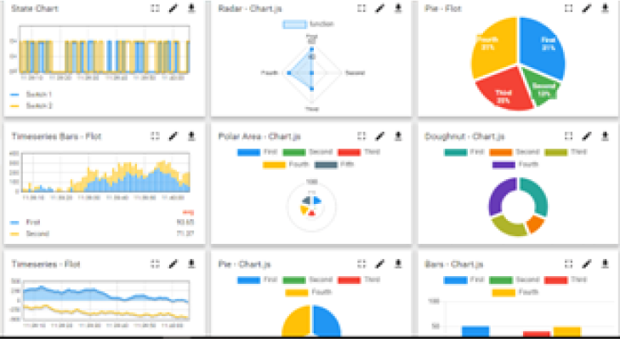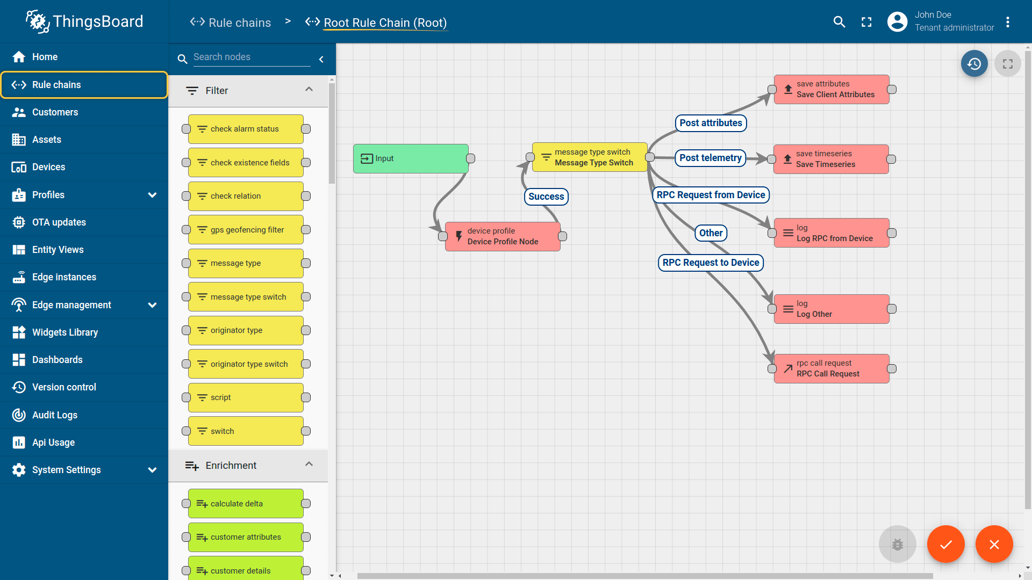

- Smart Factory Platform ()
Factory watch is a platform for smart factory needs.
It provides Users/ Factory
- with a scalable solution for their Production and asset monitoring
- OEE and predictive maintenance solution scaling up to digital twin for your assets.
- to unleased the true potential of the data that their machines are generating and helps to identify the KPIs and also improve them.
- A modular architecture that allows users to choose the service that they what to start and then can scale to more complex solutions as per their demands.
Its unique SaaS model helps users to save time, cost and money.
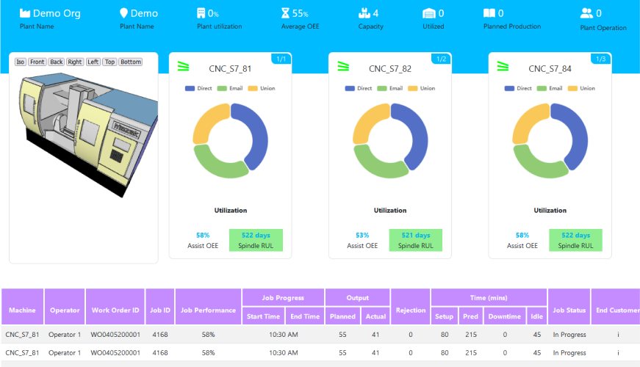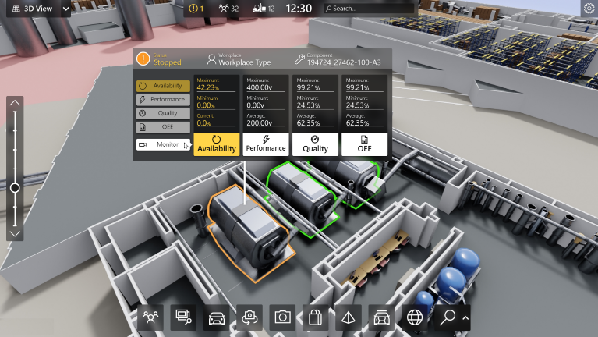

- 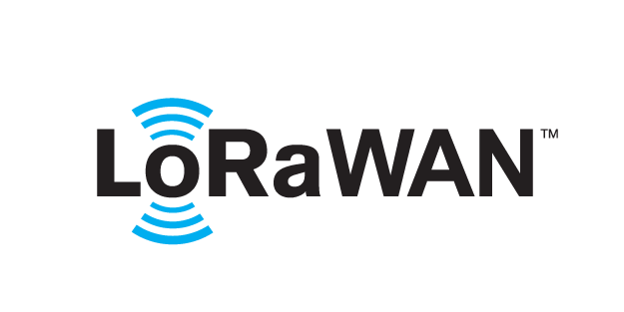 based Solution
UCT is one of the early adopters of LoRAWAN teschnology and providing solution in Agritech, Smart cities, Industrial Monitoring, Smart Street Light, Smart Water/ Gas/ Electricity metering solutions etc.
- Predictive Maintenance
UCT is providing Industrial Machine health monitoring and Predictive maintenance solution leveraging Embedded system, Industrial IoT and Machine Learning Technologies by finding Remaining useful life time of various Machines used in production process.
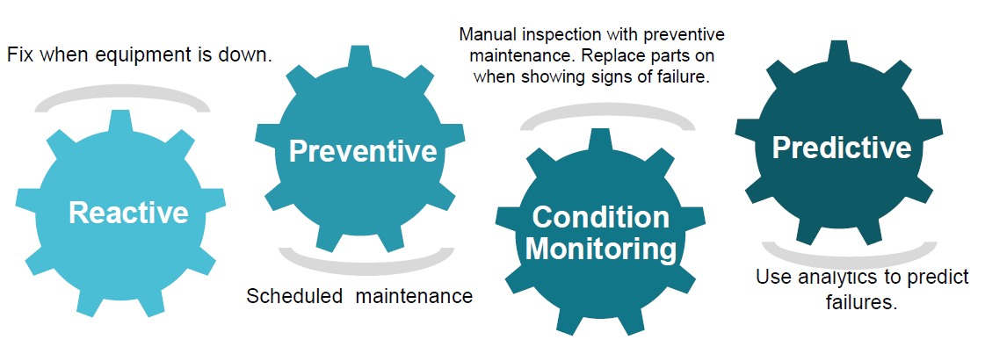

About upskill Campus (USC)
upskill Campus along with The IoT Academy and in association with Uniconverge technologies has facilitated the smooth execution of the complete internship process.
USC is a career development platform that delivers personalized executive coaching in a more affordable, scalable and measurable way.




Seeing need of upskilling in self paced manner along-with additional support services e.g. Internship, projects, interaction with Industry experts, Career growth Services
https://www.upskillcampus.com/
upSkill Campus aiming to upskill 1 million learners in next 5 year

The IoT Academy
The IoT academy is EdTech Division of UCT that is running long executive certification programs in collaboration with EICT Academy, IITK, IITR and IITG in multiple domains.

Objectives of this Internship program
The objective for this internship program was to
☛ get practical experience of working in the industry.
☛ to solve real world problems.
☛ to have improved job prospects.
☛ to have Improved understanding of our field and its applications.
☛ to have Personal growth like better communication and problem solving.

Reference
[1] Time Series Forecasting Concepts
[2] ARIMA and LSTM Documentation
[3] Smart City Traffic Management Studies

Glossary
Terms | Acronym
ARIMA | Auto Regressive Integrated Moving Average
LSTM | Long Short-Term Memory
MAE
  Mean Absolute Error
RMSE | Root Mean Square Error

Problem Statement

Urban areas face increasing traffic congestion due to population growth and vehicle usage. Traditional traffic control methods often fail to predict future traffic conditions effectively.
The problem addressed in this project is forecasting traffic patterns in a smart city environment using historical data. Accurate traffic prediction helps authorities manage congestion, reduce travel time, and improve traffic planning.

Existing and Proposed solution

Existing Solution
- Manual traffic control systems
- Fixed traffic signal timings
- Limited rule-based traffic analysis
- Lack of accurate prediction mechanisms
Proposed Solution
- Use historical traffic data for analysis
- Apply ARIMA for statistical forecasting
- Apply LSTM for learning long-term traffic trends
- Evaluate models using MAE and RMSE
- Select the best-performing model for prediction

Code submission (Github link)

https://github.com/harinisridhar2608-Sri/Upskill-DataScience-Project

Report submission (Github link) :
Forecasting_Smart_City_Traffic_Patterns_SriHarini_USC_UCT.pdf

Proposed Design/ Model

The workflow of the project is as follows:

Data Collection

Data Preprocessing

Exploratory Data Analysis

Model Development (ARIMA and LSTM)

Model Evaluation

Traffic Prediction

This structured approach ensures accurate forecasting and meaningful analysis.

Performance Test

    - Constraints Identified
- Data quality
- Model accuracy
- Overfitting
- Training time
- Performance Metrics Used
- Mean Absolute Error (MAE)
- Root Mean Square Error (RMSE)
- Performance Outcome
- ARIMA performed well for short-term patterns
- LSTM captured long-term trends effectively
- LSTM provided better accuracy overall

My learnings

  - My Learnings
Through this internship, I learned:
- Data preprocessing and feature handling
- Time series forecasting techniques
- ARIMA and LSTM implementation
- Model evaluation and comparison
- Real-world application of Data Science
This internship significantly improved my confidence in applying Machine Learning concepts.

Future work scope

Integration of real-time traffic data
Use of advanced deep learning models
Deployment of models in real-time systems
Integration with IoT-based traffic sensors

