CO1: Assessment Tool 1
Name: S.Durga Harini
Reg. No.: 192325099
Department: AI & ML
Course: MLA 0103 - Artificial Intelligence and Expert System

1.Introduction
Artificial Intelligence (AI) is transforming various industries by enabling machines to perform tasks that traditionally require human intelligence. In educational institutions, AI-powered conversational agents help automate repetitive tasks and improve accessibility to information. Universities receive numerous student queries related to course registration, attendance, examination schedules, timetables, and campus services. Handling these queries manually can lead to delays and increased workload for administrative staff. Therefore, an AI-based Student Support Assistant developed using Dialogflow provides a practical and efficient solution by offering instant, accurate, and round-the-clock support to students.

2. Problem Analysis
The major challenge faced by universities is managing a large volume of student inquiries in a timely manner. Students often require immediate access to academic information, especially during registration periods and examinations. Traditional support systems depend heavily on human intervention, which may not always be available.
Artificial Intelligence addresses this challenge through Natural Language Processing (NLP), Machine Learning, and conversational interfaces. The proposed Student Support Assistant can understand user queries, identify their intentions, and provide relevant responses automatically. This not only reduces administrative workload but also enhances the overall student experience.

3. Agent Design
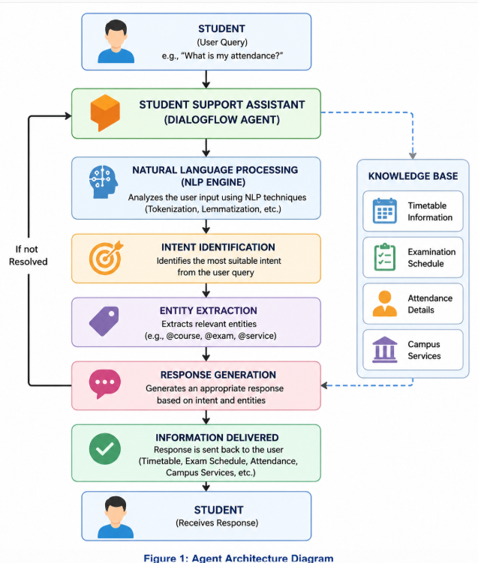

4. Dialogflow Agent Development
Agent Name: StudentSupportAssistant.
Intents: Welcome, Course Registration, Timetable, Examination Schedule, Attendance, Campus Services, Fallback.
Entities: @course, @service, @exam.
Training phrases and responses are configured in Dialogflow 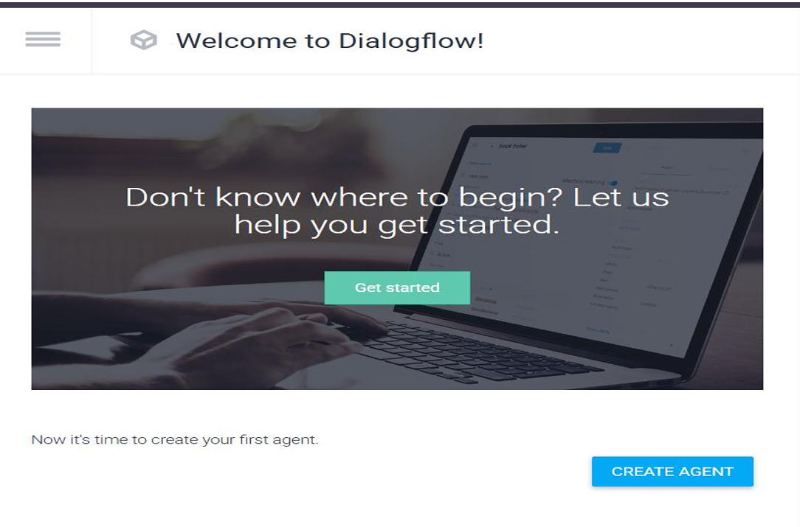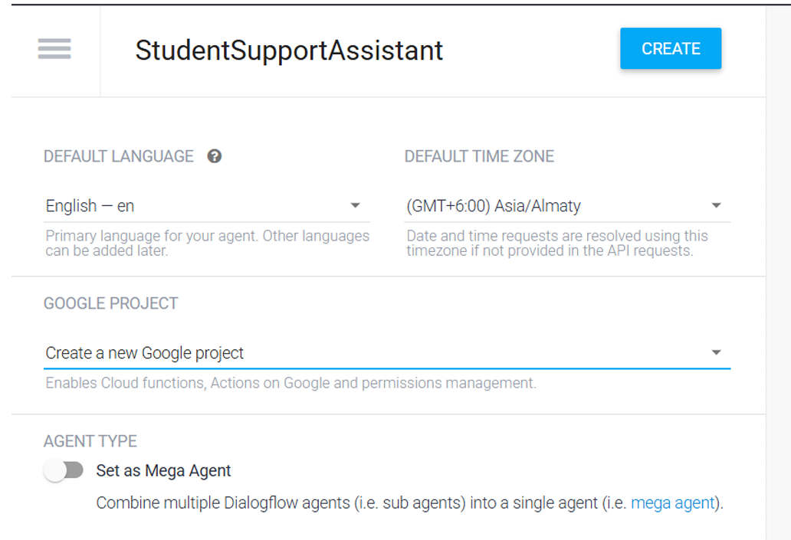
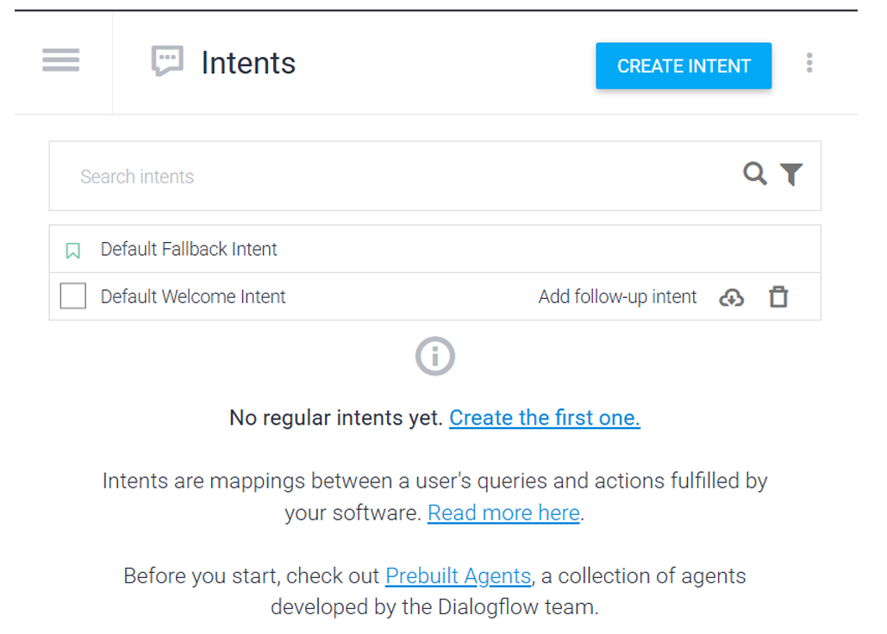
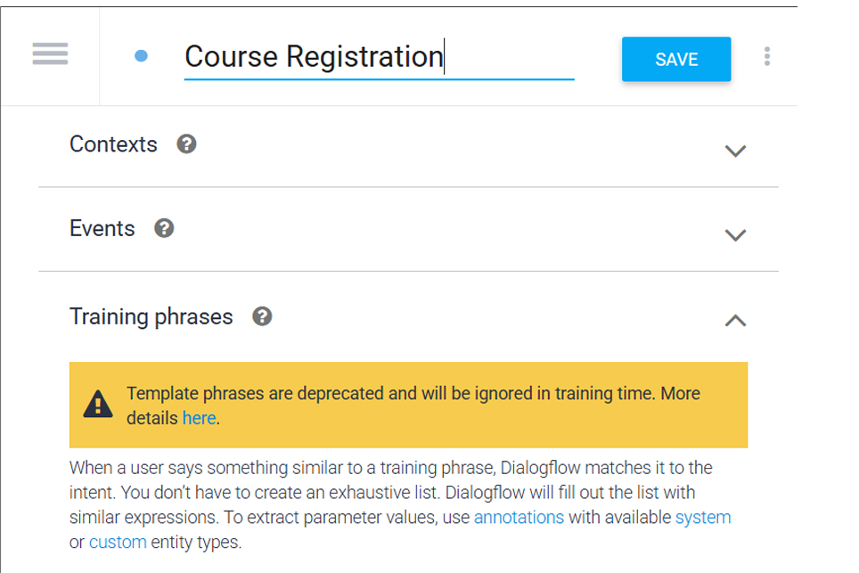

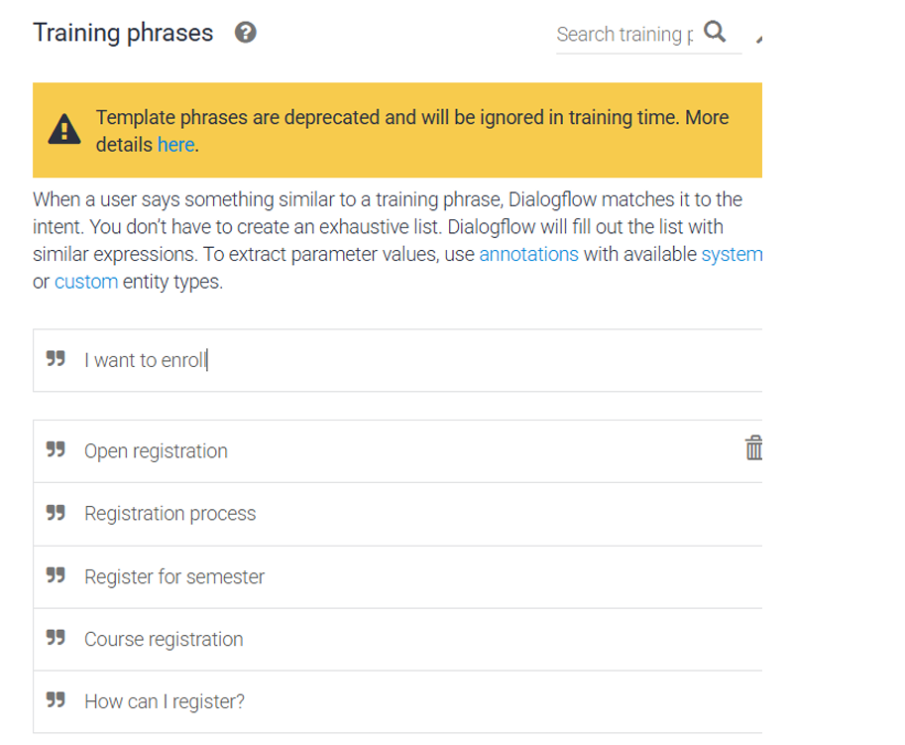

5. Problem Formulation and Conversation Flow
The chatbot interaction can be represented as a problem-solving process in Artificial Intelligence. Initially, the user opens the Student Support Assistant and enters a query. The Dialogflow agent processes the input using Natural Language Processing techniques to identify the user's intent and extract relevant entities. Based on the identified intent, the chatbot generates an appropriate response. The conversation is considered successful when the user receives the required information and confirms that the query has been resolved.

6. Conversation Flow Diagram
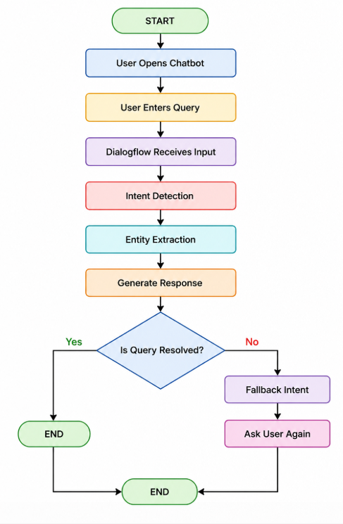

7. Search Strategy Application
Search strategies are an important concept in Artificial Intelligence because they help systems identify the best possible solution from multiple alternatives. In conversational agents, search techniques are used to determine the most appropriate intent and response based on the user's query.
In this project, a heuristic search approach is used to model intent selection within the Dialogflow-based Student Support Assistant. Heuristic search is an informed search technique that uses predefined rules and confidence scores to select the most relevant intent. Unlike uninformed search methods, heuristic search significantly reduces processing time and improves response accuracy.
For example, when a student enters the query, "When are semester examinations?", the chatbot evaluates multiple intents such as Examination Schedule, Timetable, and Course Registration. Based on keyword matching, entity extraction, and confidence scores, the heuristic function identifies the Examination Schedule intent as the most appropriate match and generates the corresponding response.
The heuristic function considers the following parameters:
- Keyword similarity
- Context relevance
- Confidence score
- Entity matching
- Previous conversation context
Breadth First Search (BFS) was also considered for this application. However, BFS explores all possible states level by level, making it less suitable for real-time conversational systems due to increased computational overhead and response time. Therefore, heuristic search was selected because it provides faster, more accurate, and scalable intent selection.
Hence, the implementation of heuristic search enhances the efficiency of the Student Support Assistant by enabling intelligent decision-making and improving the overall user experience.

8. Testing and Evaluation
Test Queries:
1. What is my attendance?
2. Show my timetable.
3. When are exams?
4. Library timings?
5. Tell me a joke?
All valid queries returned expected responses, while unknown queries were handled by the fallback intent.
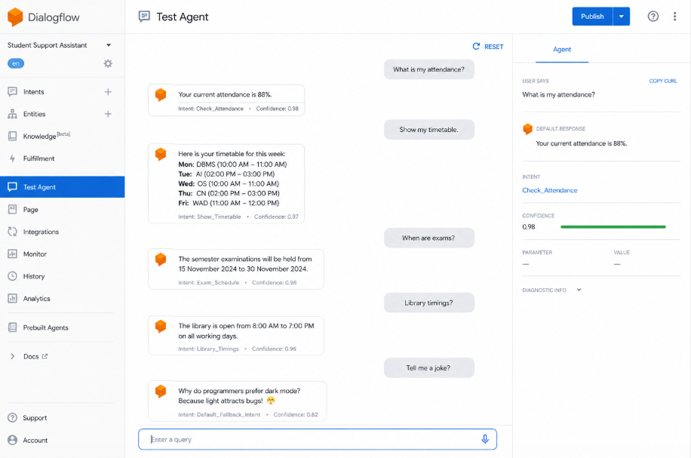

9.Future Enhancements
- Integration with university databases.
- Multilingual support.
- Voice-based interaction.
- WhatsApp and Microsoft Teams integration.
- Sentiment analysis.
- Personalized recommendations.
- Cloud deployment and scalability improvements.

10. Conclusion
The AI-Based Student Support Assistant developed using Dialogflow successfully demonstrates the practical application of Artificial Intelligence, Natural Language Processing, and conversational agent technologies in an educational environment. The chatbot efficiently handles student queries related to attendance, timetables, course registration, examination schedules, and campus services through an intuitive and user-friendly interface.
The implementation of intents, entities, training phrases, and heuristic-based intent selection enables the chatbot to provide accurate and timely responses while minimizing administrative workload. Testing and evaluation results indicate that the system performs reliably and effectively under normal operating conditions.
Overall, the project highlights the significant role of AI in modern educational institutions by improving accessibility to information, enhancing student satisfaction, and increasing operational efficiency. With the addition of future enhancements such as database integration, multilingual capabilities, and voice assistance, the Student Support Assistant has the potential to evolve into a comprehensive intelligent support system for universities and educational organizations.

