HARINITHA K

22ISR011

A **Jenkins Pipeline** is used to **automate the process of building, testing, and deploying software**.

**Step 1: Open Jenkins and Create a New Pipeline**

1. Log in to Jenkins.
2. Click on "New Item"
3. Enter a name for the pipeline

4. Select "Pipeline" as the item type.

5. Click "OK" to proceed.

**Step 2: Configure the Pipeline**

**Step 3: Define the Pipeline Script**

Using Jenkinsfile from SCM

* 1. Select "Pipeline script from SCM".
  2. Choose "Git" and enter the repository URL.
  3. Set the script path to Jenkinsfile.

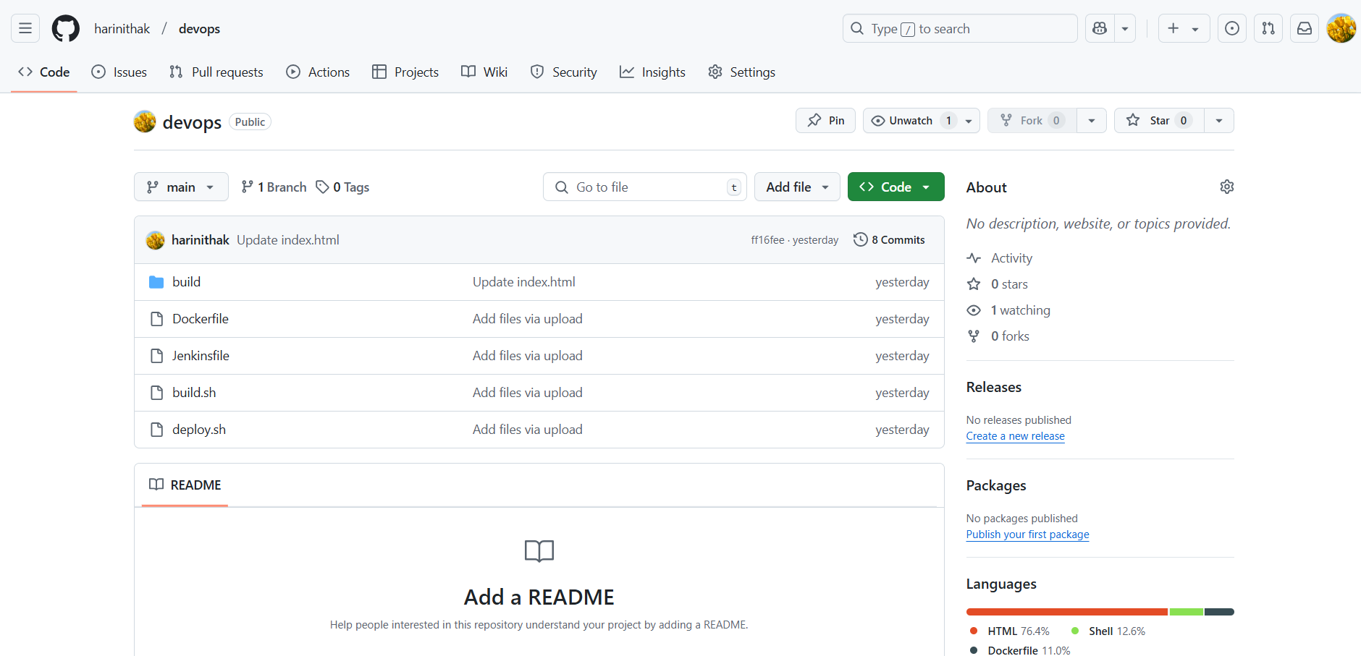

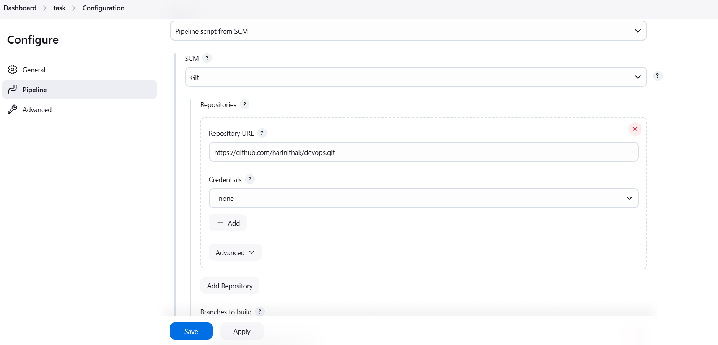

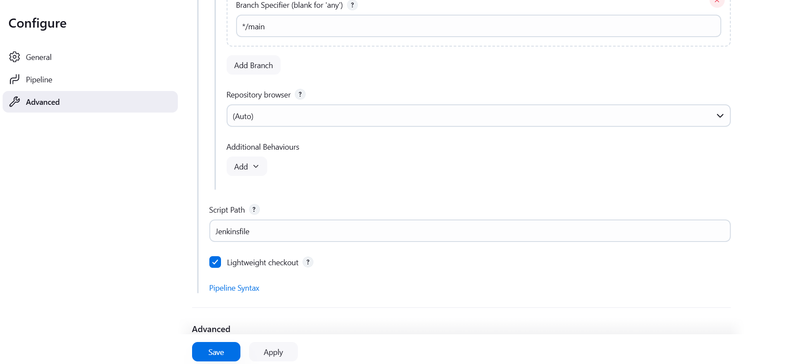

Console Output

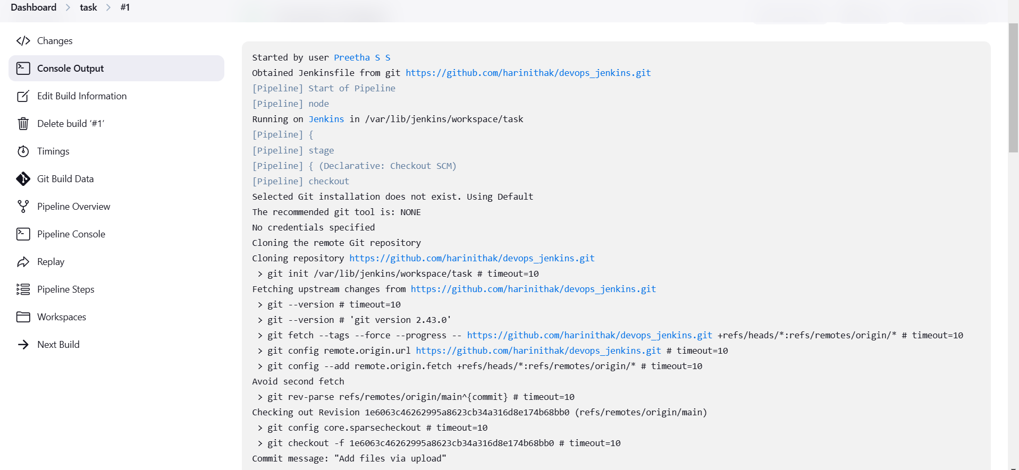

Image pushed into docker hub

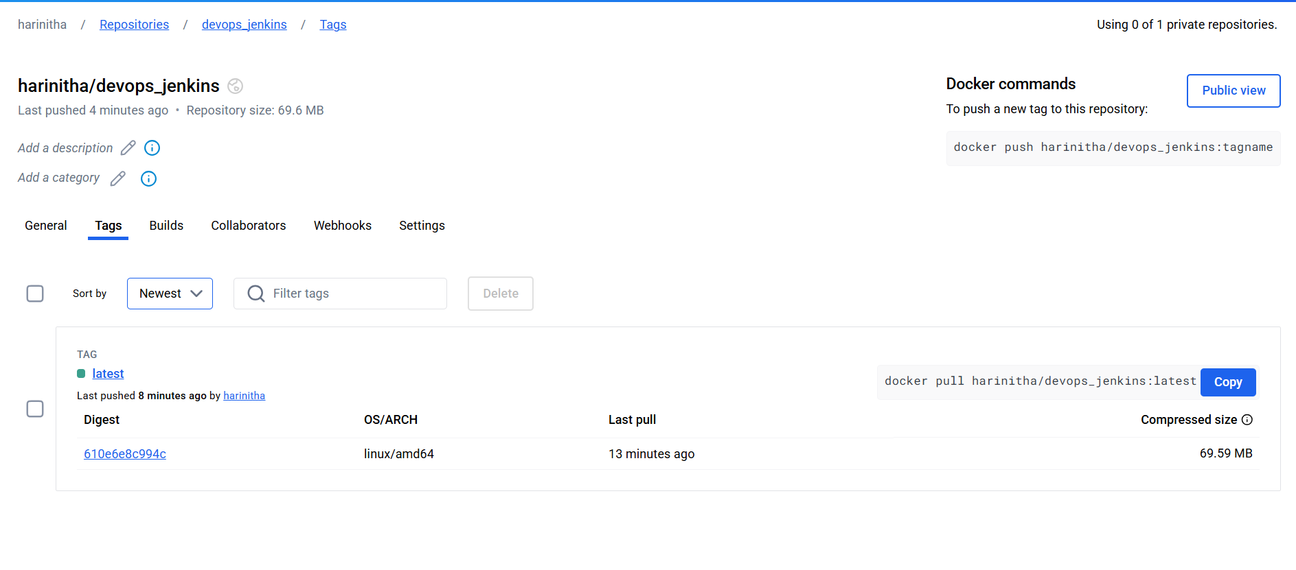

[http://localhost:90](http://localhost:90/)

