PROJECT DOCUMENTATION
EduGenie
Google Gemini 3.8 Flash Powered Learning Assistant

A Generative AI Based Educational Learning Assistant

Project Attribute | Details
Project Name | EduGenie
Application Type | AI-powered educational learning assistant
Backend | Python + FastAPI
Frontend | HTML + CSS + JavaScript
AI Model | Google Gemini 3.8 Flash
Configuration | Environment variables using .env / .env.example
Testing Framework | Pytest + HTTPX
Document Basis | Supplied README, dependency configuration, environment configuration, and project structure

Prepared from the supplied project files

Document Control
Item | Value
Document Type | Software Project Documentation
Project | EduGenie
Version | 1.0
Primary Technology | Python / FastAPI / Google Gemini
Model Configured | gemini-3.8-flash
Application Host | 127.0.0.1
Application Port | 8000

Important Scope Note
This document is generated from the project files supplied in this conversation. The supplied files identify the application, technology stack, features, project structure, configuration values, and dependencies. The actual Python, HTML, CSS, JavaScript, test, and PowerShell source files were not included in this upload, so this document does not invent specific endpoint paths, function implementations, database behavior, or test results that cannot be verified from the supplied materials.

Table of Contents
- 1. Project Overview
- 2. Problem Statement
- 3. Objectives
- 4. Key Features
- 5. System Architecture
- 6. Technology Stack
- 7. Project Structure
- 8. Module and Component Description
- 9. Generative AI / Gemini Integration
- 10. Configuration and Environment Variables
- 11. Installation and Setup
- 12. Application Execution
- 13. Testing Strategy
- 14. Security and Best Practices
- 15. Functional Scenarios
- 16. Error Handling and Reliability
- 17. Limitations
- 18. Future Enhancements
- 19. Conclusion
- Appendix A – Dependency Reference
- Appendix B – Configuration Template

1. Project Overview
EduGenie is an AI-powered educational learning assistant designed to help learners interact with educational content through natural-language prompts. The supplied README describes the application as a combination of Python, FastAPI, HTML, CSS, JavaScript, and Google Gemini 3.8 Flash.
The project is organized as a web application. The backend is represented by an app package, the user interface is stored under templates and static directories, automated API testing is represented under tests, and configuration is controlled through environment variables.

2. Problem Statement
Learners frequently need quick explanations, summaries, practice questions, and guidance while studying. A conversational AI assistant can provide these learning-oriented capabilities through a single web interface, reducing the need to switch between separate educational tools.
EduGenie addresses this requirement by connecting a web interface with a FastAPI backend and a configured Google Gemini generative AI model.

3. Objectives
- Provide an accessible AI-based educational assistant through a web interface.
- Allow learners to ask educational questions using natural language.
- Generate simplified explanations of topics.
- Summarize supplied text or learning material.
- Generate quizzes for practice and revision.
- Provide personalized learning recommendations.
- Keep AI configuration separate from source code through environment variables.
- Provide a Python-based backend suitable for local development and API testing.

4. Key Features
Feature | Purpose
Ask educational questions | Answer learner questions through the AI assistant.
Explain topics | Present educational concepts in an understandable form.
Summarize text | Condense learning material into a shorter form.
Generate quizzes | Create practice questions for revision.
Personalized learning recommendations | Suggest learning directions based on learner needs or prompts.

5. System Architecture
Based on the supplied project structure, the system can be represented at a component level as follows. The diagram describes the documented project organization; detailed request routing and function-level behavior should be confirmed against the source files when those files are supplied.
Layer | Component | Role
Presentation | templates/index.html | Main web interface.
Static UI | static/style.css | Visual styling and layout.
Client Logic | static/app.js | Browser-side JavaScript behavior.
API / Backend | app/main.py | FastAPI application entry point.
Configuration | app/config.py | Application and environment configuration.
Validation | app/schemas.py | Pydantic data schemas.
AI Service | app/gemini_service.py | Gemini-related service layer.
Local AI Option | app/local_explainer.py | Local explainer component indicated by project structure.
Application Services | app/services.py | Additional application service layer.
Testing | tests/test_api.py | API test module.

User → Web UI → FastAPI Backend → Application Services → Gemini 3.8 Flash → Response

6. Technology Stack
Technology | Role in Project
Python | Primary programming language for the backend.
FastAPI | Web framework and API layer.
Uvicorn | ASGI server used to run the FastAPI application.
Jinja2 | Template rendering support.
Pydantic | Data validation and schema management.
Pydantic Settings | Environment/configuration management.
Google GenAI SDK | Integration with Google Gemini models.
python-dotenv | Environment variable loading support.
Pytest | Testing framework.
HTTPX | HTTP client/testing support.
HTML/CSS/JavaScript | Frontend presentation and browser interaction.

7. Project Structure
EduGenie/
├── app/
│ ├── __init__.py
│ ├── main.py
│ ├── config.py
│ ├── schemas.py
│ ├── gemini_service.py
│ ├── local_explainer.py
│ └── services.py
├── templates/
│ └── index.html
├── static/
│ ├── style.css
│ └── app.js
├── tests/
│ └── test_api.py
├── scripts/
│ └── test_api.ps1
├── .vscode/
│ └── settings.json
├── .env
├── .env.example
├── .gitignore
├── requirements.txt
└── README.md
This structure is directly identified by the supplied README. The source files themselves were not included in the current upload, so their internal functions and exact API routes are intentionally not documented as verified facts.

8. Module and Component Description
File / Directory | Documented Responsibility
app/main.py | FastAPI application entry point.
app/config.py | Application configuration.
app/schemas.py | Pydantic request/response schemas.
app/gemini_service.py | Gemini integration service.
app/local_explainer.py | Local explainer component.
app/services.py | Application service layer.
templates/index.html | HTML user interface.
static/style.css | Frontend styling.
static/app.js | Frontend JavaScript.
tests/test_api.py | API test module.
scripts/test_api.ps1 | PowerShell API testing script.
.vscode/settings.json | VS Code project settings.

9. Generative AI / Gemini Integration
The project is configured to use Google Gemini through the Google GenAI Python SDK. The environment configuration identifies the model as 'gemini-3.8-flash' and exposes a thinking-level configuration set to 'medium'.
GEMINI_MODEL=gemini-3.8-flash
GEMINI_THINKING_LEVEL=medium
The Gemini API key is supplied through the GEMINI_API_KEY environment variable. The actual key from the supplied .env file is deliberately excluded from this documentation.
The project also contains configuration for an optional local explainer. The supplied configuration sets USE_LOCAL_EXPLAINER=false and identifies MBZUAI/LaMini-Flan-T5-783M as the configured local model name.

10. Configuration and Environment Variables
Variable | Configured Value / Example | Purpose
GEMINI_API_KEY | YOUR_GEMINI_API_KEY | Authentication credential for Gemini.
GEMINI_MODEL | gemini-3.8-flash | Gemini model selected by the project.
GEMINI_THINKING_LEVEL | medium | Configured Gemini thinking level.
APP_HOST | 127.0.0.1 | Local application host.
APP_PORT | 8000 | Local application port.
USE_LOCAL_EXPLAINER | false | Controls whether the local explainer is enabled.
LOCAL_MODEL_NAME | MBZUAI/LaMini-Flan-T5-783M | Configured local explainer model name.

Environment File Example
GEMINI_API_KEY=YOUR_GEMINI_API_KEY
GEMINI_MODEL=gemini-3.8-flash
GEMINI_THINKING_LEVEL=medium
APP_HOST=127.0.0.1
APP_PORT=8000
USE_LOCAL_EXPLAINER=false
LOCAL_MODEL_NAME=MBZUAI/LaMini-Flan-T5-783M
The supplied .gitignore excludes .env from version control, which is an important protection for secrets.

11. Installation and Setup
- Open the EduGenie project folder in Visual Studio Code.
- Open the integrated terminal.
- Create a Python virtual environment.
- Activate the virtual environment.
- Install the dependencies listed in requirements.txt.
- Create a .env file using .env.example as the template.
- Set a valid Gemini API key in GEMINI_API_KEY.
- Keep the application host and port aligned with the environment configuration.

Virtual Environment – Windows PowerShell
python -m venv .venv
.venv\Scripts\Activate.ps1

Install Dependencies
pip install -r requirements.txt

Create Environment Configuration
Copy-Item .env.example .env
# Then edit .env and replace YOUR_GEMINI_API_KEY with your actual key.
The supplied README explicitly documents creation of a Python virtual environment. The dependency file provides the packages required by the documented stack.

12. Application Execution
The configured application host is 127.0.0.1 and the configured port is 8000. The exact Uvicorn import target should be taken from app/main.py when the source file is available. Because app/main.py was not included in the current upload, this document does not invent a command such as a specific module:variable combination.
# Configuration indicates:
APP_HOST=127.0.0.1
APP_PORT=8000
Once the source files are present, the documented startup command should be verified against the actual FastAPI application object in app/main.py.

13. Testing Strategy
The project structure includes tests/test_api.py and scripts/test_api.ps1. The dependency list includes both pytest and httpx, indicating an API testing approach.
Testing Area | Supplied Evidence | Status in This Document
Automated Python tests | tests/test_api.py | Test module exists; execution result not supplied.
HTTP/API client support | httpx dependency | Configured dependency.
Pytest framework | pytest dependency | Configured dependency.
PowerShell API testing | scripts/test_api.ps1 | Script listed in project structure; source not supplied.
No claim is made that the tests currently pass because the test source and execution output were not included.

14. Security and Best Practices
- Never publish the Gemini API key in source code, README files, screenshots, or public repositories.
- Keep .env out of version control. The supplied .gitignore already contains .env.
- Use .env.example with a placeholder rather than a real credential.
- Regenerate or revoke a credential immediately if it has been exposed publicly.
- Validate incoming data through Pydantic schemas where applicable.
- Keep development and production credentials separate.
- Avoid logging complete authorization credentials or sensitive request content.
Security note: the supplied .env file contains a real-looking credential value. This document does not reproduce it.

15. Functional Scenarios
Scenario | User Action | Expected Application Purpose
Educational Question | User asks a subject-related question. | AI generates an educational response.
Topic Explanation | User requests an explanation of a concept. | AI explains the topic in learner-friendly language.
Text Summary | User supplies text for summarization. | AI returns a concise summary.
Quiz Generation | User requests practice questions. | AI generates a quiz for learning/revision.
Learning Recommendation | User asks what to learn next. | AI provides personalized learning recommendations.

16. Error Handling and Reliability
The supplied project structure contains separate configuration, schema, service, and AI integration modules, which provides a logical separation of concerns. However, the exact exception handling, validation messages, timeouts, retry logic, and fallback behavior cannot be verified without the corresponding source files.
- Configuration errors should be surfaced clearly during application startup.
- Invalid user input should be validated before it reaches the AI service.
- Gemini/API failures should be handled without exposing secrets.
- Network or model failures should return a user-friendly error rather than an unhandled server trace.
- Optional local-explainer behavior should be controlled by the configured feature flag.

17. Limitations
- The supplied upload contains configuration/documentation files but not the implementation source files.
- Exact API endpoints and request/response payloads cannot be verified from the supplied materials.
- Database usage is not documented in the supplied README or requirements file.
- Actual automated test results were not supplied.
- UI screenshots and exact frontend workflows were not supplied.
- Production deployment configuration is not documented in the supplied files.

18. Future Enhancements
- Add authentication and learner profiles.
- Store learning history and quiz performance.
- Add persistent databases for personalized progress.
- Introduce subject-specific learning modes.
- Add richer quiz evaluation and scoring.
- Provide streaming AI responses for better interaction.
- Add rate limiting and production-grade observability.
- Add automated CI testing and deployment.
- Add accessibility improvements and responsive UI testing.
- Provide an administrator dashboard for educational analytics.

19. Conclusion
EduGenie is structured as a lightweight Generative AI educational assistant using FastAPI on the backend and HTML/CSS/JavaScript on the frontend. The supplied project configuration selects Google Gemini 3.8 Flash as the AI model and includes a clear environment-based configuration strategy. The project also includes testing infrastructure and an optional local-explainer configuration.
This documentation reflects the supplied project files and intentionally separates verified project facts from details that would require the missing source files. Supplying the remaining implementation files would allow the documentation to be expanded with exact API endpoints, code-level module explanations, request/response examples, test cases, screenshots, and implementation-specific workflows.

Appendix A – Dependency Reference
Package | Configured Version Range | Purpose
fastapi | >=0.115,<1 | Web/API framework.
uvicorn[standard] | >=0.34,<1 | ASGI server.
jinja2 | >=3.1,<4 | Template rendering.
pydantic | >=2.10,<3 | Data validation.
pydantic-settings | >=2.7,<3 | Settings/configuration management.
google-genai | >=1.30,<2 | Google GenAI SDK.
python-dotenv | >=1.0,<2 | Environment variable loading.
pytest | >=8,<9 | Automated testing.
httpx | >=0.27,<1 | HTTP client/testing support.

Appendix B – Configuration Template
# Gemini
GEMINI_API_KEY=YOUR_GEMINI_API_KEY
GEMINI_MODEL=gemini-3.8-flash
GEMINI_THINKING_LEVEL=medium
# Application
APP_HOST=127.0.0.1
APP_PORT=8000
# Optional local explainer
USE_LOCAL_EXPLAINER=false
LOCAL_MODEL_NAME=MBZUAI/LaMini-Flan-T5-783M

Appendix C – Supplied Source Inventory
Supplied File | Used For
.env | Current environment configuration; secret value intentionally redacted.
.env.example | Safe configuration template.
.gitignore | Repository/security configuration.
README.md | Project overview, features, structure, and setup information.
requirements.txt | Python dependency and version-range reference.

Demo

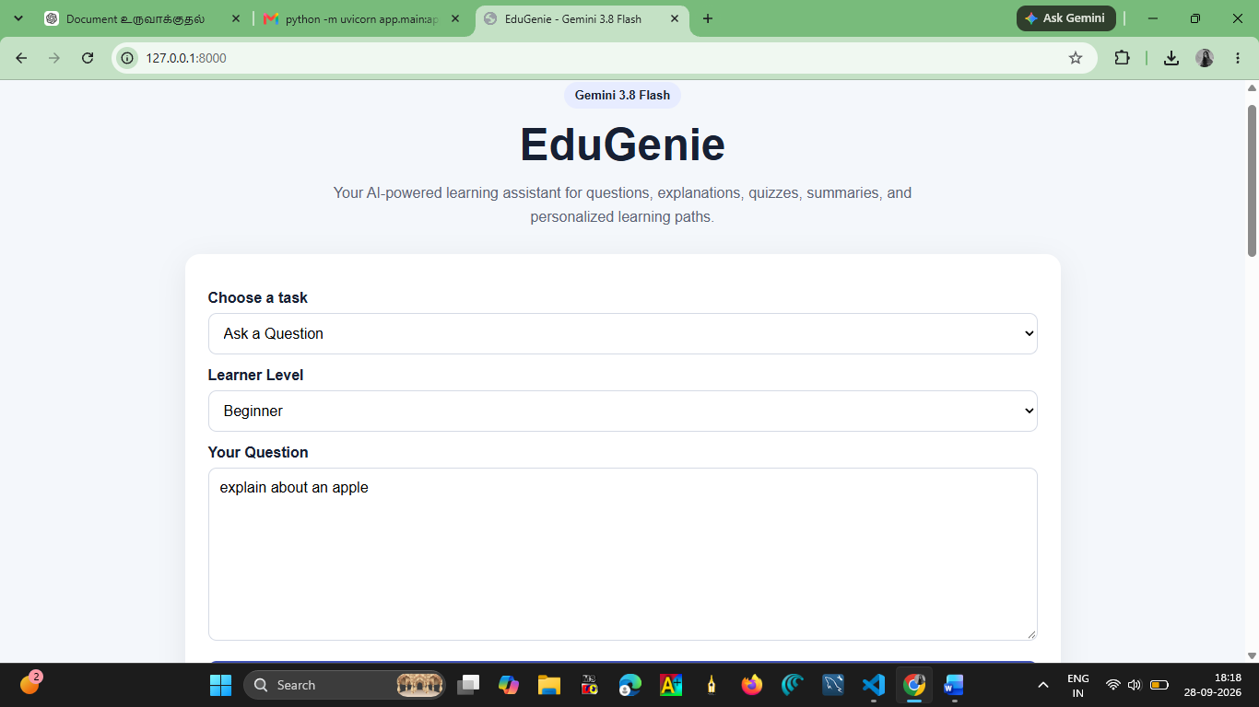
Step 1: we have to enter a question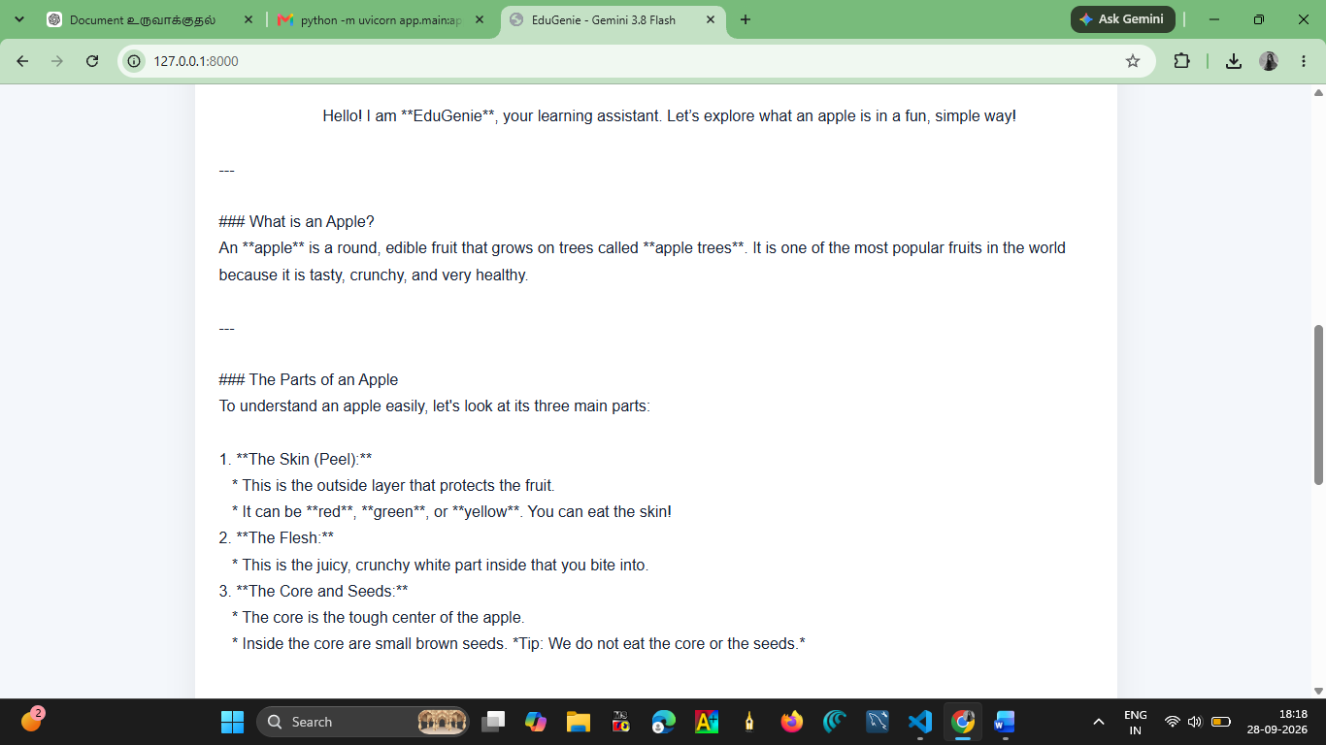
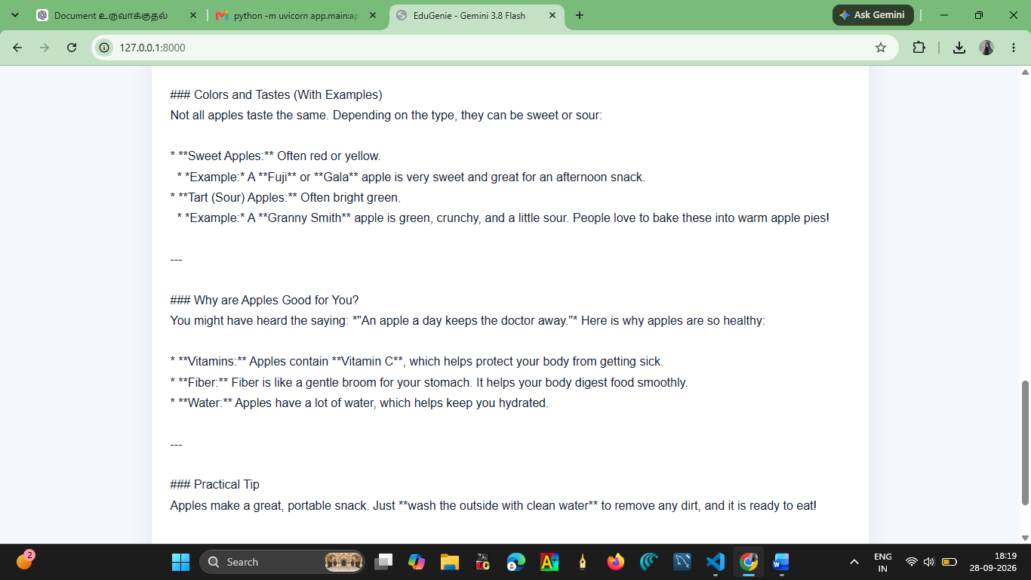
Step 2: give as a answer
We can also create an quiz ,explain a topic,learning recommandations and summarize a text.

End of the document
Thank you!!

