PHASE 5 – PROJECT DEVELOPMENT
Implement Client Script & UI Policy (Incident)

Task 1: Create UI Policy
- Navigate to System UI → UI Policies.
- Click New.
- Enter Name: High Impact Control.
- Select Table: Incident and set Active to true.
- Set condition: Impact is 1 – High.
- Create/configure the Assignment group action as mandatory.
- Set Reverse if false to true.
- Submit the UI Policy.

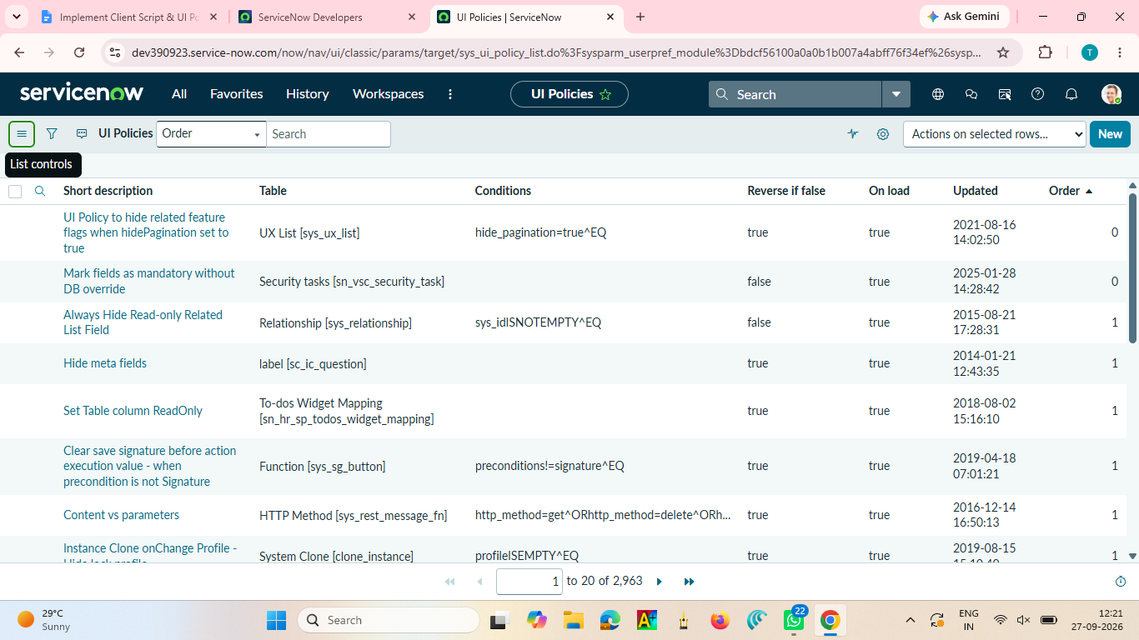

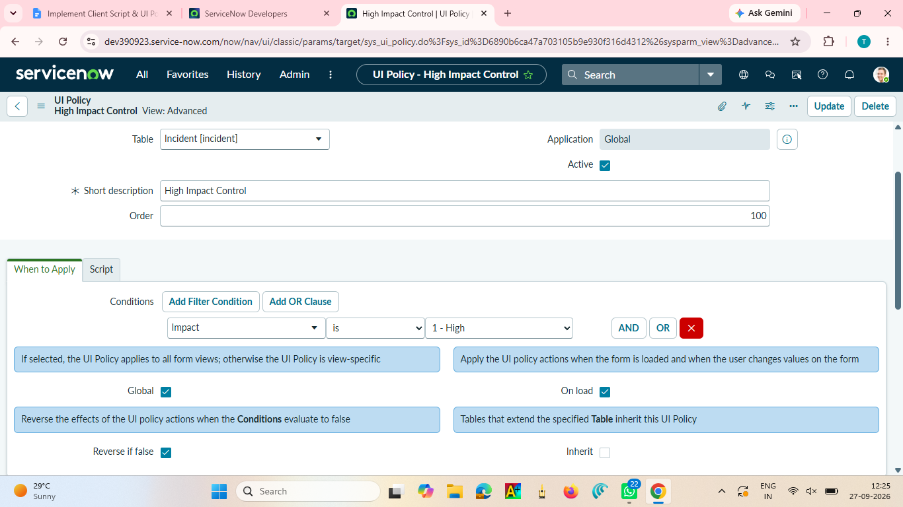

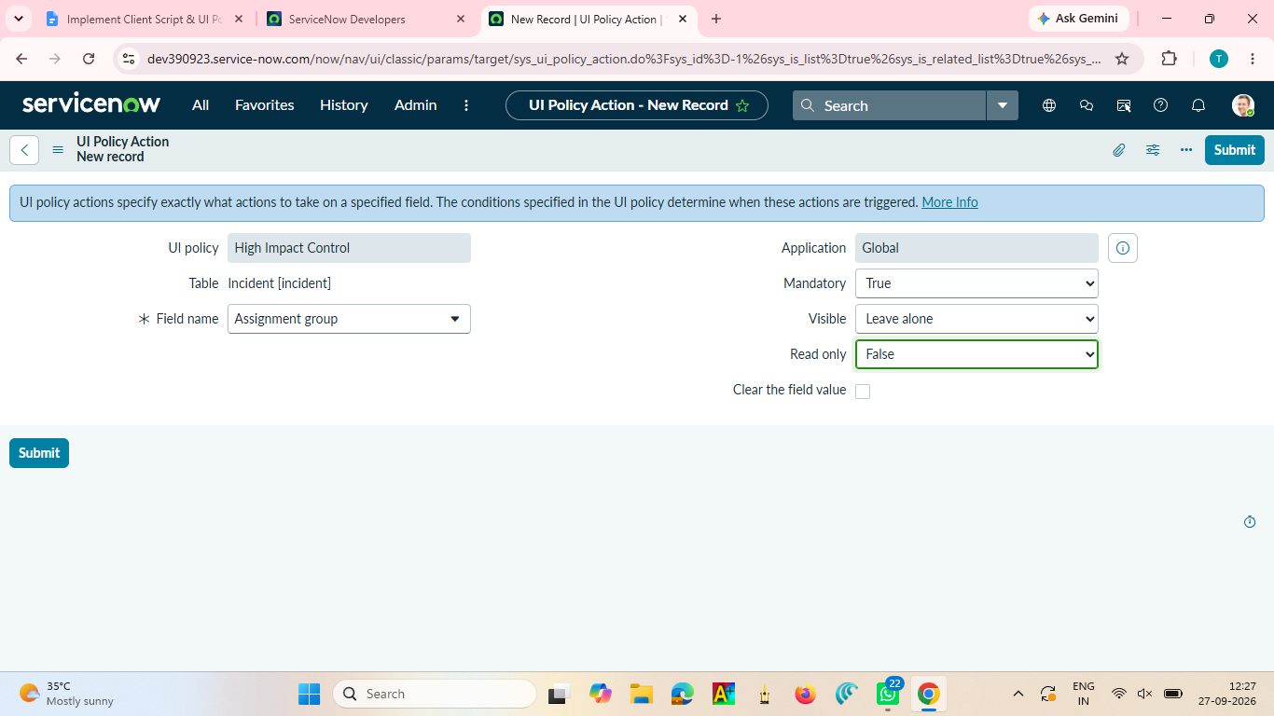

Task 2: Configure Urgency UI Policy Action
- Open High Impact Control.
- Go to the UI Policy Actions related list and click New.
- Select Field name: Urgency.
- Set Read-only to true.
- Leave Visible unchanged.
- Submit.

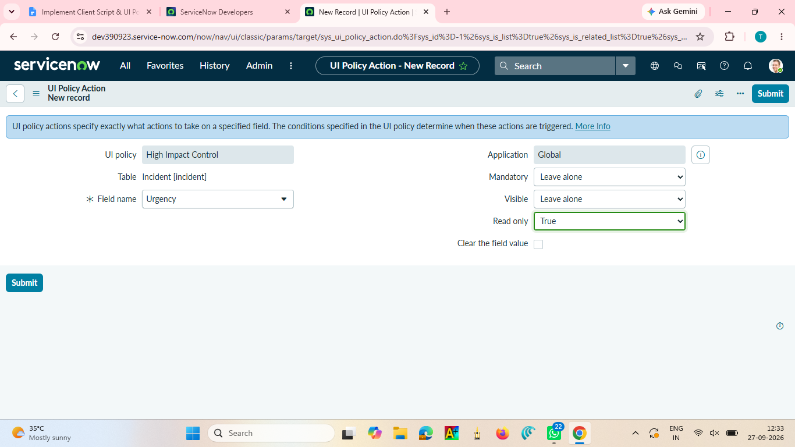

Task 3: Create onChange Client Script
- Name: Auto set urgency for high impact
- Table: Incident
- Type: onChange
- Field name: Impact
- Active: true
Script:
function onChange(control, oldValue, newValue, isLoading) {
if (isLoading || newValue == '') {
return;
}
if (newValue == '1') {
g_form.setValue('urgency', '1');
g_form.addInfoMessage('Urgency set to High for High impact incident.');
}
}

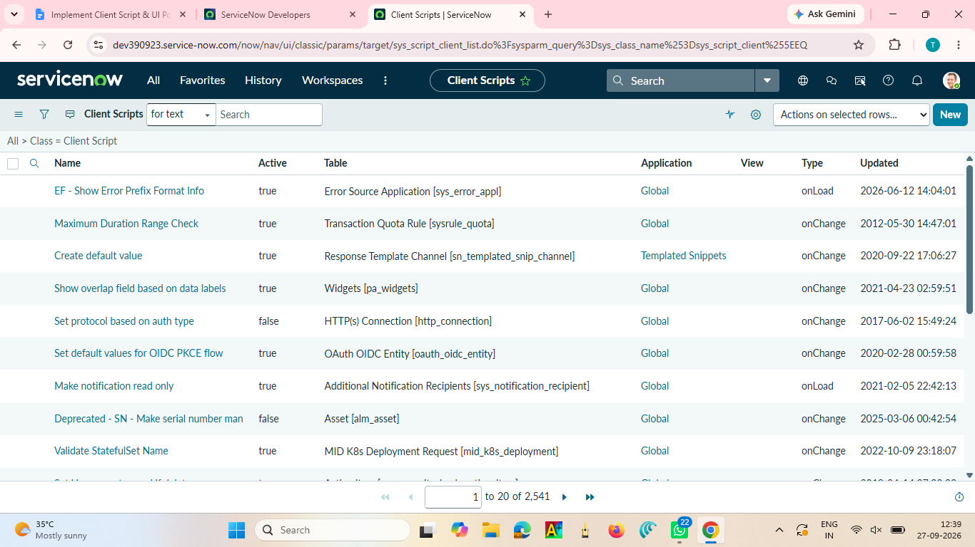

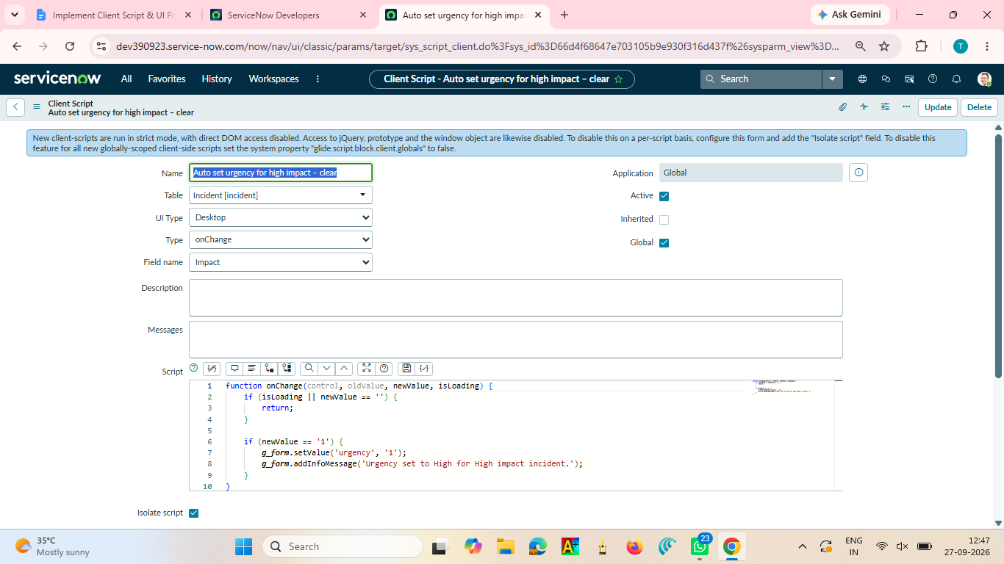

Task 4: Create onSubmit Client Script
- Name: Prevent save if Assigned To missing
- Table: Incident
- Type: onSubmit
- Active: true
Script:
function onSubmit() {
if (g_form.getValue('impact') == '1' &&
g_form.getValue('assigned_to') == '') {
g_form.showErrorBox(
'assigned_to',
'Assigned To is mandatory for High impact incidents.'
);
return false;
}
return true;
}

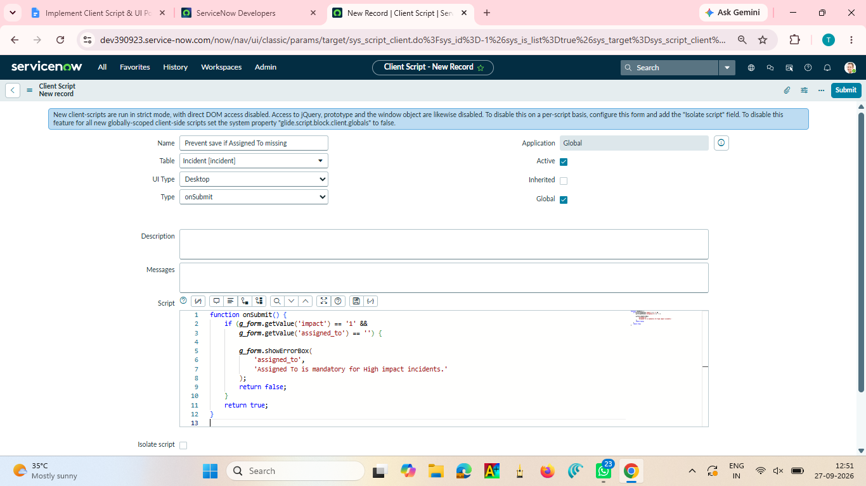

Task 5: Create onCellEdit Client Script
- Name: Prevent state change via list edit
- Table: Incident
- Type: onCellEdit
- Field name: State
- Active: true
Script:
function onCellEdit(sysIDs, table, oldValues, newValue, callback) {
alert('State cannot be updated using list editing. Please open the Incident.');
callback(false);
}

