**PROGRAM:**

#include<iostream.h>

#include<conio.h>

#include<stdio.h>

#include<process.h>

#include<fstream.h>

class product

{

int pno;

char name[50];

float price,qty,tax,dis;

public:

product()

{

pno = 0;

price = 0;

qty = 0;

tax = 0;

dis = 0;

}

void create_product();

void show_product();

int retpno()

{return pno;}

float retprice()

{return price;}

char* retname()

{return (char*)name;}

int retdis()

{return dis;}

int rettax()

{return tax;}

};

void product::create_product()

{

cout<<"\nPlease Enter The Product No. of The Product ";

cin>>pno;

cout<<"\n\nPlease Enter The Name of The Product ";

gets((char*)name);

cout<<"\nPlease Enter The Price of The Product ";

cin>>price;

cout<<"\nPlease Enter The Discount (%) ";

cin>>dis;

tax = 14;

}

void product::show_product()

{

cout<<"\nThe Product No. of The Product : "<<pno;

cout<<"\nThe Name of The Product : ";

puts((char*)name);

cout<<"\nThe Price of The Product : "<<price;

cout<<"\nDiscount : "<<dis;

}

// global declaration for stream object, object

fstream fp;

// function to write in file

void write_product()

{

product pr;

fp.open("Shop.dat",ios::out|ios::app);

pr.create_product();

fp.write((char*)&pr,sizeof(pr));

fp.close();

cout<<"\n\nThe Product Has Been Created ";

getch();

}

// function to read all records from file

void display_all()

{

product pr;

clrscr();

cout<<"\n\n\n\t\tDISPLAY ALL RECORD !!!\n\n";

fp.open("Shop.dat",ios::in);

while(fp.read((char*)&pr,sizeof(pr)))

{

pr.show_product();

cout<<"\n\n====================================\n";

getch();

}

fp.close();

getch();

}

// function to read specific record from file

void display_sp(int n)

{

product pr;

int flag=0;

fp.open("Shop.dat",ios::in);

while(fp.read((char*)&pr,sizeof(product)))

{

if(pr.retpno()==n)

{

clrscr();

pr.show_product();

flag=1;

}

}

fp.close();

if(flag==0)

cout<<"\n\nrecord not exist";

getch();

}

// function to modify record of file

void modify_product()

{

product pr;

int no,found=0;

clrscr();

cout<<"\n\n\tTo Modify ";

cout<<"\n\n\tPlease Enter The Product No. of The Product";

cin>>no;

fp.open("Shop.dat",ios::in|ios::out);

while(fp.read((char*)&pr,sizeof(product)) && found==0)

{

if(pr.retpno()==no)

{

pr.show_product();

cout<<"\nPlease Enter The New Details of Product"<<endl;

pr.create_product();

int pos=-1*sizeof(pr);

fp.seekp(pos,ios::cur);

fp.write((char*)&pr,sizeof(product));

cout<<"\n\n\t Record Updated";

found=1;

}

}

fp.close();

if(found==0)

cout<<"\n\n Record Not Found ";

getch();

}

// function to delete record of file

void delete_product()

{

product pr;

int no;

clrscr();

cout<<"\n\n\n\tDelete Record";

cout<<"\n\nPlease Enter The product no. of The Product You Want To Delete";

cin>>no;

fp.open("Shop.dat",ios::in|ios::out);

fstream fp2;

fp2.open("Temp.dat",ios::out);

fp.seekg(0,ios::beg);

while(fp.read((char*)&pr,sizeof(product)))

{

if(pr.retpno()!=no)

{

fp2.write((char*)&pr,sizeof(product));

}

}

fp2.close();

fp.close();

remove("Shop.dat");

rename("Temp.dat","Shop.dat");

cout<<"\n\n\tRecord Deleted ..";

getch();

}

// function to display all products price list

void menu()

{

product pr;

clrscr();

fp.open("Shop.dat",ios::in);

if(!fp)

{

cout<<"ERROR!!! FILE COULD NOT BE OPEN\n\n\n Go To Admin Menu to create File";

cout<<"\n\n\n Program is closing.. ";

getch();

exit(0);

}

cout<<"\n\n\t\tProduct MENU\n\n";

cout<<"====================================================\n";

cout<<"P.NO.\t\tNAME\t\tPRICE\n";

cout<<"====================================================\n";

while(fp.read((char*)&pr,sizeof(product)))

{

cout<<pr.retpno()<<"\t\t"<<pr.retname()<<"\t\t"<<pr.retprice()<<endl;

}

fp.close();

}

// function to place order and generating bill for Products

void place_order()

{

product pr;

int order_arr[50],quan[50],c=0;

float amt,damt,total=0,tamt;

char ch='Y';

menu();

cout<<"\n============================";

cout<<"\n PLACE YOUR ORDER";

cout<<"\n============================\n";

do{

cout<<"\n\nEnter The Product No. Of The Product : ";

cin>>order_arr[c];

cout<<"\nQuantity in number : ";

cin>>quan[c];

c++;

cout<<"\nDo You Want To Order Another Product ? (y/n)";

cin>>ch;

}while(ch=='y'||ch=='Y');

cout<<"\n\nThank You For Placing The Order";getch();clrscr();

cout<<'/n';

cout<<"\n********************************INVOICE************************\n";

cout<<"\nPr No.\tPr Name\tQuantity\tPrice\tAmount\tAmount after discount\n";

for(int x=0;x<=c;x++)

{

fp.open("Shop.dat",ios::in);

fp.read((char*)&pr,sizeof(product));

while(!fp.eof())

{

if(pr.retpno()==order_arr[x])

{

amt=pr.retprice()*quan[x];

damt=amt-(amt*pr.retdis()/100);

tamt=damt-(damt*pr.rettax()/100);

cout<<'\n'<<order_arr[x]<<'\t'<<pr.retname()<<'\t'<<quan[x]<<"\t\t"<<pr.retprice()<<'\t'<<amt<<"\t\t"<<damt;

total=total+tamt;

}

fp.read((char*)&pr,sizeof(product));

}

fp.close();

}

cout<<"\n\n\t\t\t\t\tTOTAL = "<<total;

getch();

}

//INTRODUCTION

void intro()

{

clrscr();

gotoxy(31,11);

cout<<"SUPER MARKET";

gotoxy(35,14);

cout<<"BILLING";

gotoxy(35,17);

cout<<"PROJECT";

cout<<"\n\nMADE BY : HARINI VENUGOPAL";

cout<<"\n\nCOLLEGE : MEENAKSHI SUNDARARAJAN ENGINEERING COLLEGE";

getch();

}

// ADMINSTRATOR MENU FUNCTION

void admin_menu()

{

clrscr();

char ch2;

cout<<"\n\n\n\tADMIN MENU";

cout<<"\n\n\t1.CREATE PRODUCT";

cout<<"\n\n\t2.DISPLAY ALL PRODUCTS";

cout<<"\n\n\t3.QUERY ";

cout<<"\n\n\t4.MODIFY PRODUCT";

cout<<"\n\n\t5.DELETE PRODUCT";

cout<<"\n\n\t6.VIEW PRODUCT MENU";

cout<<"\n\n\t7.BACK TO MAIN MENU";

cout<<"\n\n\tPlease Enter Your Choice (1-7) ";

ch2=getche();

switch(ch2)

{

case '1': clrscr();

write_product();

break;

case '2': display_all();break;

case '3':

int num;

clrscr();

cout<<"\n\n\tPlease Enter The Product No. ";

cin>>num;

display_sp(num);

break;

case '4': modify_product();break;

case '5': delete_product();break;

case '6': menu();

getch();

case '7': break;

default:cout<<'\a';admin_menu();

}

}

//MAIN FUNCTION

void main()

{

char ch;

intro();

do

{

clrscr();

cout<<"\n\n\n\tMAIN MENU";

cout<<"\n\n\t01. CUSTOMER";

cout<<"\n\n\t02. ADMINISTRATOR";

cout<<"\n\n\t03. EXIT";

cout<<"\n\n\tPlease Select Your Option (1-3) ";

ch=getche();

switch(ch)

{

case '1': clrscr();

place_order();

getch();

break;

case '2': admin_menu();

break;

case '3':exit(0);

default :cout<<'\a';

}

}while(ch!='3');

}

//END

**OUTPUT:**

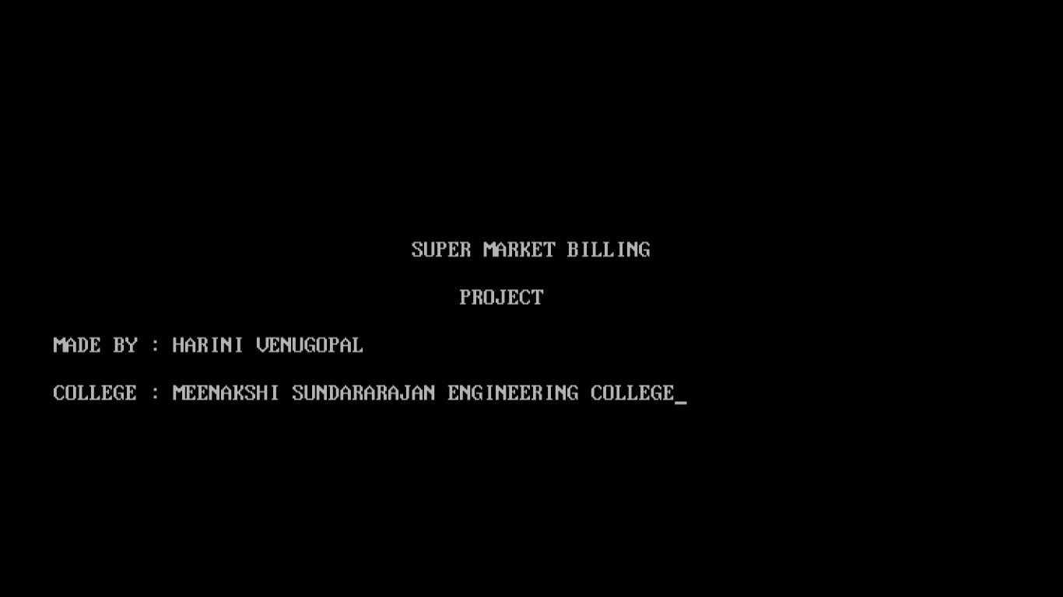

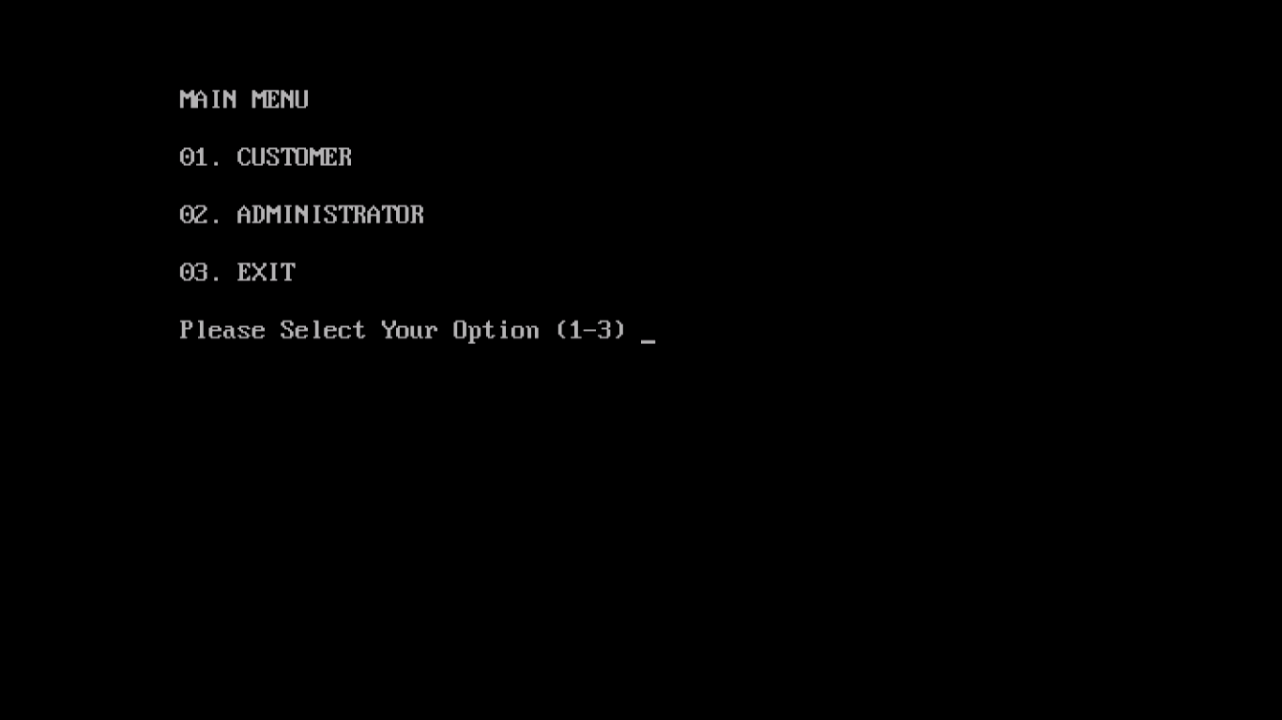

1. **CUSTOMER:**

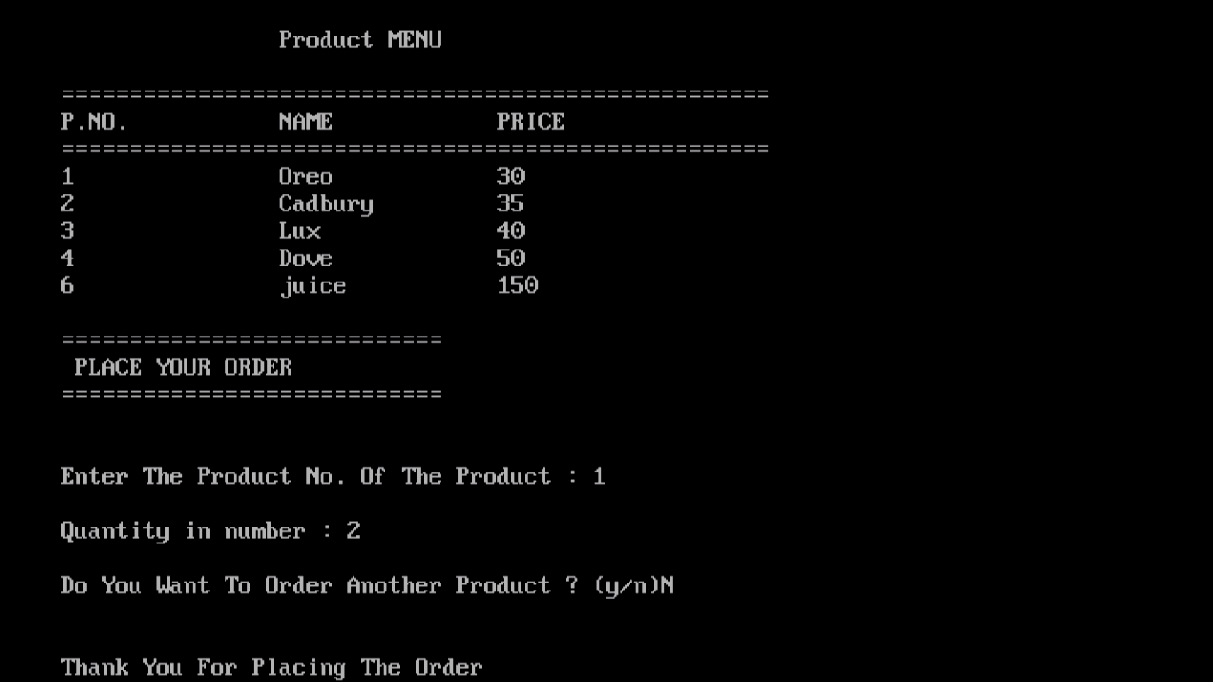

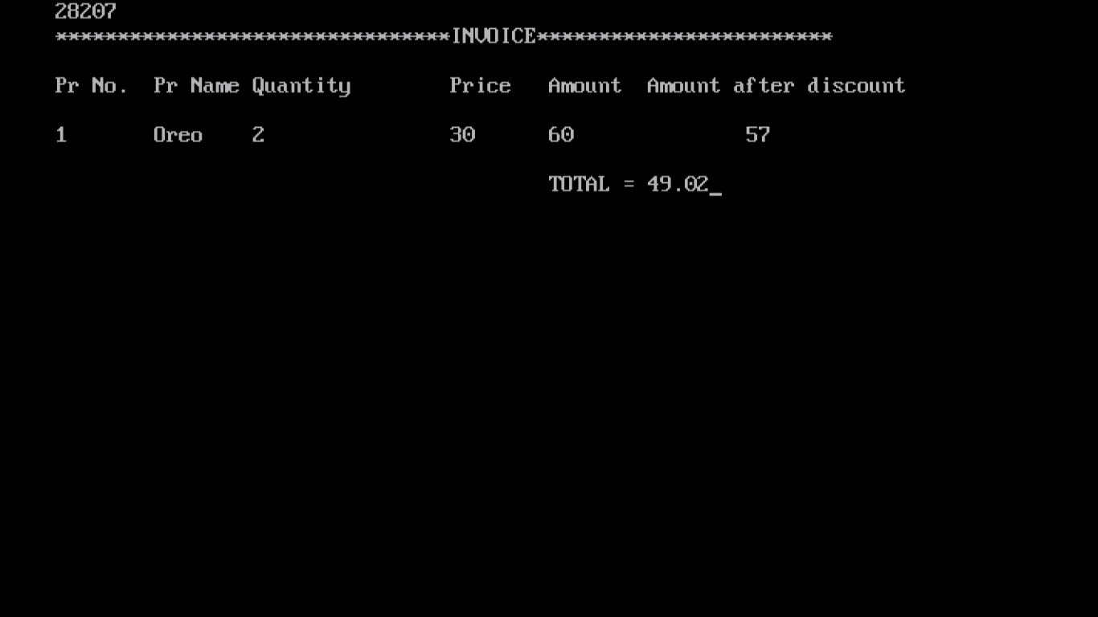

1. **ADMINISTRATOR:**

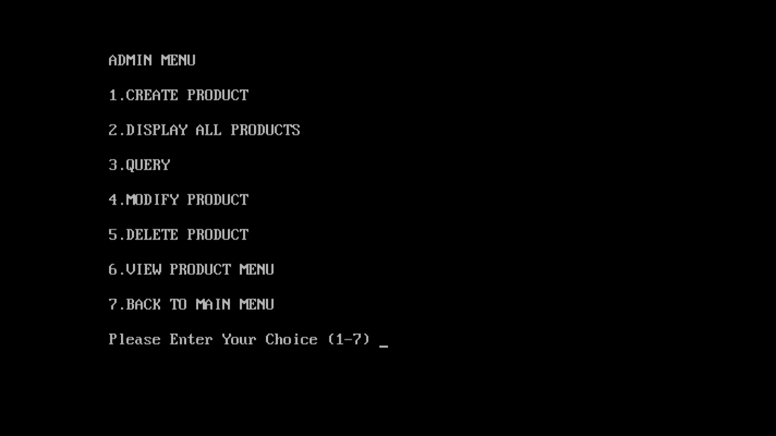

**CREATE PRODUCT:**

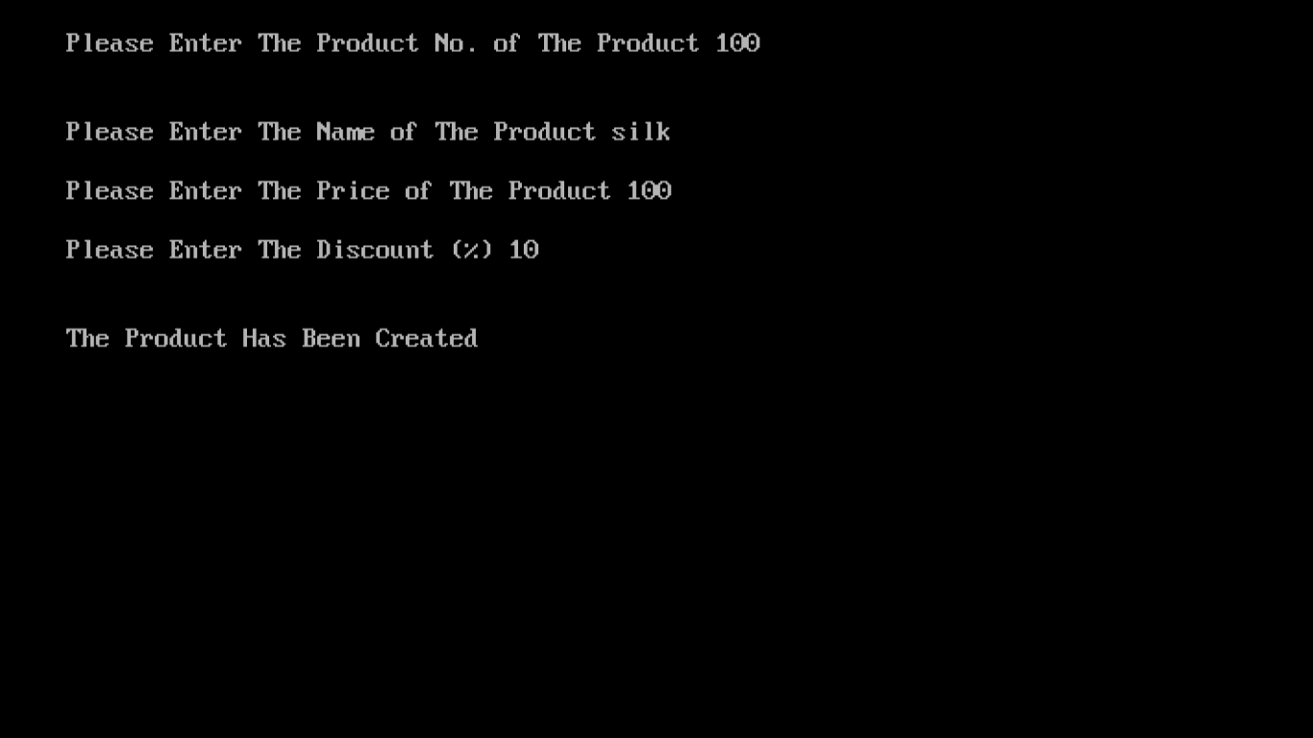

**DISPLAY PRODUCT:**

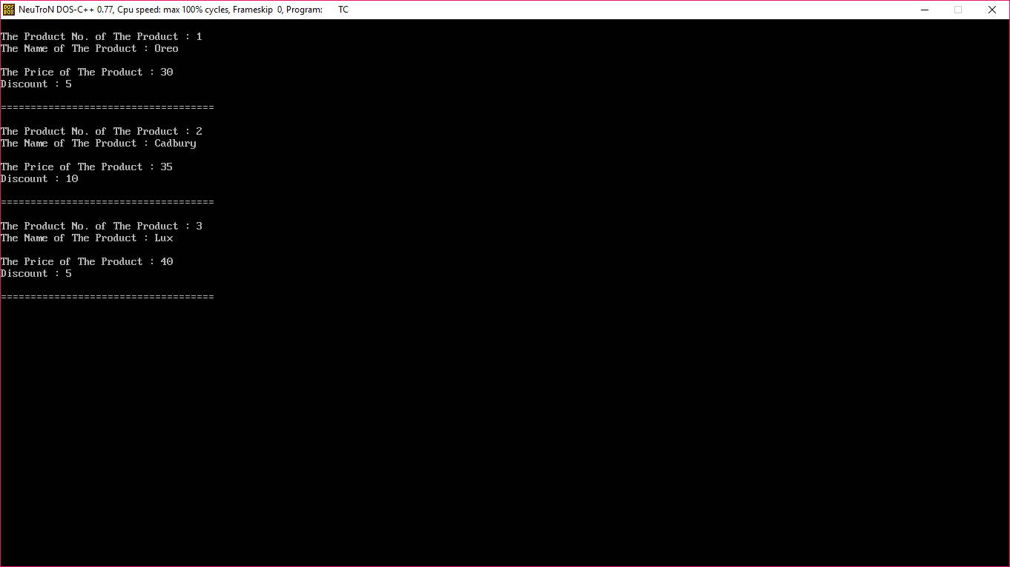

**QUERY:**

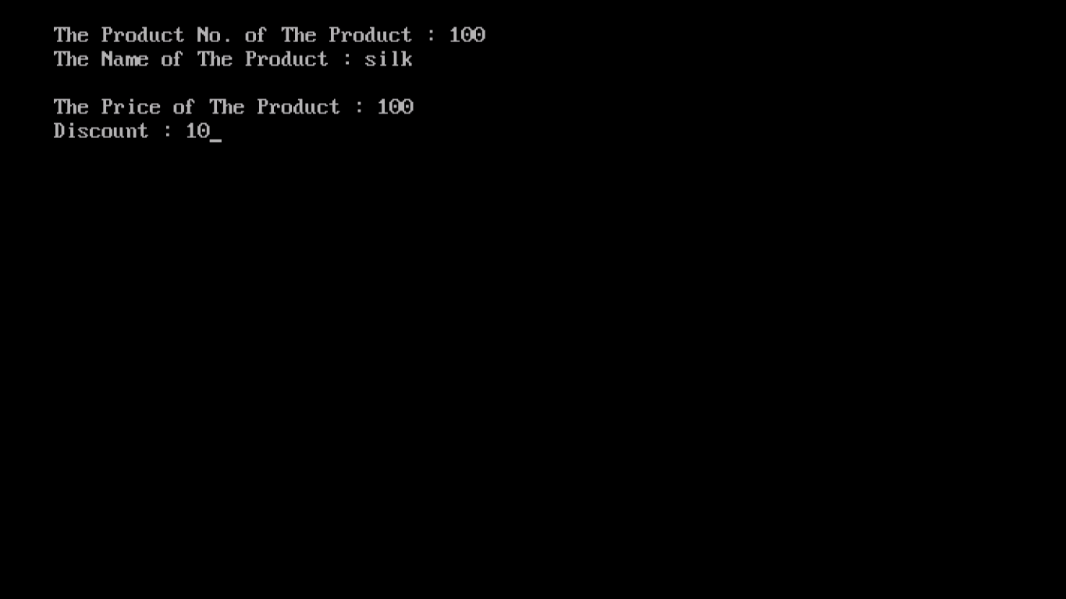

**MODIFY PRODUCT:**

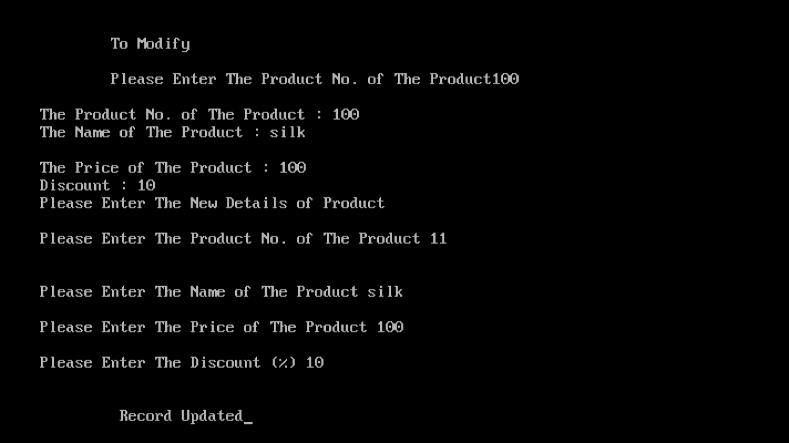

**DELETE PRODUCT:**

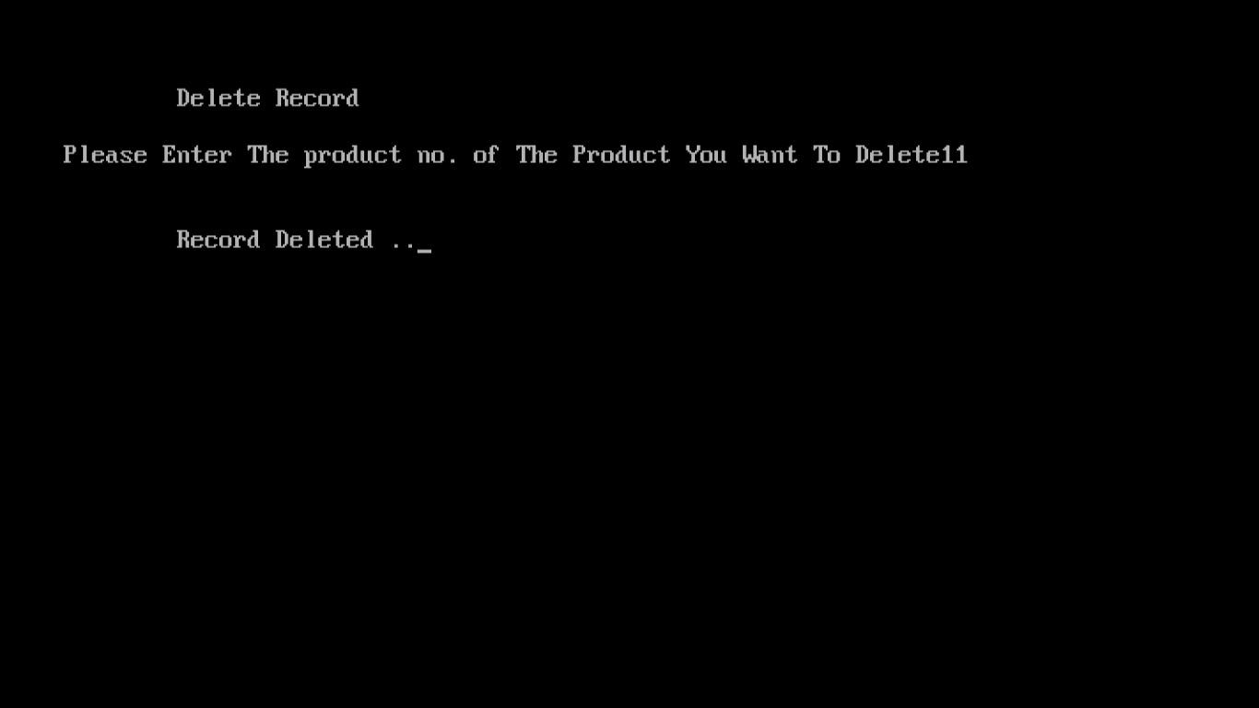

**VIEW PRODUCT MENU:**

