**Joint optimization of preventive maintenance planning and quality control parameter using EWMA chart**

*Project Report Submitted in Partial Fulfilment of the Requirements for the Degree of*

**Bachelor of Technology**

***in***

**Mechanical Engineering**

*Submitted by*

Name of the Student: Harin Raja (1710110134)

# ***Under the Supervision of***

Dr. Divya Shrivastava



Department of Mechanical Engineering School of Engineering

December, 2020

## Candidate Declaration

I declare that this written submission represents my ideas in my own words and where others' ideas or words have been included, I have adequately cited and referenced the original sources. I also declare that I have adhered to all principles of academic honesty and integrity and have not misrepresented or fabricated or falsified any idea/data/fact/source in my submission. I understand that any violation of the above will be cause for disciplinary action by the University and can also evoke penal action from the sources which have thus not been properly cited or from whom proper permission has not been taken when needed.

Name of the Student: Harin Raja R K

Signature and Date: Harin Raja R K, 14/12/2020

## Certificate

It is certified that the work contained in the project reported titled “Joint optimization of preventive maintenance planning and quality control parameter using EWMA chart” by Harin Raja R K (1710110134) has been carried out under my supervision and that this work has not been submitted elsewhere for award of the degree

Signature of the Supervisor

Dr. Divya Shrivastav

Assistant Professor

Mechanical Engineering

School of Engineering

Shiv Nadar University

December, 2020

**Acknowledgement**

In First place, I would like to the thank Shiv Nadar University and the Mechanical Department for giving me such a great opportunity to work on a project and also for providing infrastructure required for the project.

I would like to express my deep and sincere gratitude to my research mentor, Dr. Divya Srhivastava, Assistant Professor, Department of Mechanical Engineering for providing invaluable guidance throughout this project work. Her immense knowledge, motivation and helping nature round the clock have deeply inspired me. It was a great experience and honor to work under her guidance.

I would also like to thank my sister Divya Dharshini for her constant motivation and useful suggestions that helped me further develop this work.

Last but not least, I am extremely grateful to my parents and friends for their constant support and encouragement during the entire course of this wonderful work.

**Table of Contents**

Page

1. Abstract 6

2. Introduction 6

3. Literature Review 7

4. Objectives of Research 8

5. Problem Statement 9

6. Assumptions 9

7. Nomenclature 10

8. Exponentially Weighted Moving Average (EWMA) Chart 12

9. Cost Model Methodology 13

9.1 Cost model for maintenance policies 13

9.2 Cost Model for Process Quality 14

9.2.1 Expected Process Cycle Length 14

9.2.2 Cost Model for Process Failure: 15

9.3 Optimization of expected cost per unit time of system 17

10. Illustrative Example 18

11. Matlab Code 19

12. Simulation Results 24

12.1 Inference 26

13. Sensitivity Analysis 27

13.1 Robustness 28

14. Results and Discussions 29

15.Scope for Future Work 29

16. References 30

**1. Abstract**

The objective of this project is to present an integrated model that can be used to minimize the expected total cost of process failures, inspection, sampling, corrective maintenance/ preventive maintenance (CM/PM) actions by jointly optimizing maintenance and quality control chart parameters for a Exponentially Weighted Moving Average (EWMA)chart. This is of importance, especially in cases where the anticipated shift in process due to machine degradation or external reasons is small.

**2. Introduction**

Performance of a production system depends on breakdown-free operation of equipment and processes. The performance can be improved if these failures can be minimized in a cost effective manner. Maintenance and quality control play an important role in achieving this goal. The conventional ways of determining optimal maintenance and quality control plans have been studied extensively [1, 2].

Experience of practitioners and many studies acknowledge that machines may deteriorate to a less desirable working condition before complete breakdown. This inferior functionality of machine may lead to higher rejection and operating cost, and increased failure rates consequently increased cost of repair/replacement. Despite the clear interdependency between quality control and maintenance policy, industry practices indicate that the quality control and maintenance plans are optimized independent of each other. However, the academic community has shown an increased interest in studying the interdependence of maintenance and process quality in recent years [3–11].

Statistical quality control is vital to monitor the undesirable changes in a process and for measuring, controlling and improving quality. Control charts are an important statistical technique to monitor the quality of the process. The popular charts used for quality analysis are Shewhart charts, Exponentially Weighted Moving Average (EWMA) charts and CUmulative SUM (CUSUM) charts. Though Shewhart charts are highly popular, they are not sensitive to small shifts in process means. And for this reason the EWMA and CUSUM charts are gaining popularity in the present time. Exponentially Weighted Moving Average (EWMA) charts are more effective and flexible in terms of quality analysis, which was first introduced by Robert.

**3 Literature review**

In this section, literature related to the specific issues of integration of maintenance and quality control is presented. Readers interested in literature related to purely maintenance and design of control charts may refer to Duncan (1956), Alexander et al. (1995), Hassan et al. (2000), Sherwin (2000), Wang (2002), Garg and Deshmukh (2006), Schiffauerova and Thomson (2006), and Nenes and Tagaras (2007).

In Lucas and Succuci(1990), the properties of EWMA control schemes have been studied and compared them with CUSUM control schemes. The results show that the properties of EWMA’s are very close to those of CUSUM schemes. The two parameters in the EWMA and CUSUM control schemes are used to average observations over time. This makes them less sensitive to outliers and enables them to detect small shifts more quickly than the standard Shewhart control scheme. Several enhancements to EWMA control schemes were evaluated.

Meanwhile, in M.S. Srivastava(1995), they have shown that EWMA procedure are at least as good as CUSUM procedure in terms of ARLu. Also in this paper they have developed a approximate formula for the control limit L for a given ARL and λ. They also provide a optimal choice of λ as well as the corresponding control limit L and minimum value of ARL1. These approximations are comparable with the results of the discrete time model by Lucas and Succuci(1990).

In Yupaporn Areepong (2015), there was a comparison between EWMA and CUSUM procedures. He suggests that EWMA is superior when the magnitude of shift is small to moderate. This was confirmed by comparing the performance of the EWMA procedure and CUSUM procedure based on ARL for trend exponential AR(1) processes.

Kuo (2006) studied a joint machine maintenance and product quality control problem of finite horizon, discrete time, and markovian deteriorating state for unobservable batch production systems. Linderman et al. (2005) developed a generalised analytical model to determine the optimal policy to coordinate Statistical Process Control (SPC) and planned maintenance to minimise expected total cost. Panagiotidou and Tagaras (2007) developed an economic model for the optimisation of preventive maintenance interval for a production process with two quality states. Panagiotidou and Tagaras (2008) developed an economic model for optimisation of maintenance policy, for both perfect and imperfect maintenance actions, appropriate for a production process (equipment) with two operating states (‘in-control’ state and an ‘out-of-control’) in statistical process control. Chiu and Huang (1996) developed a model that introduces preventive maintenance into the economic design of control charts. They assumed non-uniform distribution for the in-control period with an increasing hazard rate and fixed sampling intervals. In addition, they assumed that a system would become as good as new after preventive maintenance action. Zhou and Zhu (2008) attempted the integration of economic design of control chart and maintenance management, and developed a mathematical model to analyse the cost of the integrated model using the grid-search approach to find the optimal values of policy variables (n, h, L, k) that minimise expected hourly cost. Recently, Panagiotidou and Nenes (2009) proposed a model for the integration of quality and maintenance procedures using Shewhart’s control chart for variables. Wang (2010) has developed three models for the maintenance of the manufacturing system monitored by np control charts with respect to the sampling interval.

The following gaps are observed in the literature on this subject:

(1) Most of the integrated models focus on process quality problems and completely ignore the possibility of an machine failure in terms of machine breakdown or improper functioning of the machine component that result in poor product quality and call for maintenance action.

(2) As mentioned in gap 1, the failure of a machine also includes performance degradation in terms of poor quality leading to rejection of the products being manufactured by the machine. Thus, the cost of corrective maintenance not only includes down-time losses and repair/replacement cost but also may include cost of rejection. This aspect appears to be neglected in most of the maintenance optimization models.

3) Most of integrated models focus on economic design of X bar control char; however EWMA chart becoming much better option available to practitioners because of their superior ability to detect small process shifts

**4 Objectives of research**

The overall objective of the proposed research is to develop an integrated optimized approach for joint consideration of Preventive maintenance plan and quality control chart parameters for an Exponential Weighted Moving Average (EWMA) control chart that can be used to minimize the expected total cost of process failures, inspection, sampling, corrective maintenance/ preventive maintenance (CM/PM) actions. The overall objective is divided into following parts

**Part I**: Detailed literature review to identify the interrelationship between maintenance planning and quality control policy.

**Part II**: Developing solution methodologies.

a) Solutions obtained through independent models of maintenance and quality.

b) Solutions obtained by considering joint optimization of both.

**5 Problem Statement:**

In this study, we consider an integrated model for preventive maintenance and quality control policy. Here we take two failure consequences related to failure of components:

(1) Failure leading to immediate breakdown of the machine (FM1) and

(2) Failure leading to deterioration in the quality of the product due to a shift in process mean (FM2).

We define a failure as an event where the machine either shuts down or produces more rejections than expected. For example, in a grinding machine, if the work head belt is broken, then the machine shuts down completely, which is considered to be caused due to failure mode 1 (FM1). While if the ball screw of the chuck nut is loosened, the grinding may still work but will produce lower quality products, which is considered to be caused owing to failure mode 2 (FM2). Hence it is important to consider these failure modes and costs associated with these failures, which can be defined in maintenance planning decisions.

**6 Assumptions:**

1. A machine produces a single part with a single critical-to-quality (CTQ) characteristic.
2. The distribution of the quality characteristic is normal, and the production process starts in an in-control state with process mean μ0 and standard deviation σ0.
3. The shift in the mean is (μ0 + δ), and the standard deviation (σ0) remains constant. Where the magnitude of the shift is denoted by δ.
4. The time to assignable cause occurs is an exponentially distributed random variable.
5. The process is monitored using an EWMA chart.
6. The failure modes FM1 and FM2 are independent and are on based on a time to failure distribution. The probabilities of FM1 and FM2, be PFM1 and PFM2 respectively. Since these are the only probabilities, PFM1 and PFM2 should add up to 1. These probabilities can be obtained from quality and failure reports provided by maintenance and production line personnel. The reports includes component ID, time of repair, time to failure, action taken, failure mode, and failure cost.
7. Corrective maintenance should be minimal and preventive maintenance is imperfect in nature.
8. Required resources and services are available at the time of failure.
9. The whole system is stopped, at the time of detection and restoration periods. After restoration, the system returns to perfect condition.

**7 Nomenclature**

Nf  Expected number of corrective maintenance

σ0 Process standard deviation

μ0 Process mean

η scale and parameter

β shape parameter

λ1  failure to external reasons

λ2 Failure to machine degradation

L Optimal Value of the control limit or decision boundary

n Sample size

Ƭ Mean elapsed time from the last sample prior to the assignable cause when integrating maintenance and quality policy together

λ control limit chart coefficient or smoothing parameter of the chart

(Rδ)E Probability of nonconforming items produced due to external reasons.

(Rδ)M/C  Probability of nonconforming items produced due to machine failure .

[ETCPUT](M*Q)EWMA Expected total cost per unit time of integrated and quality policy.

ARL2E Average run length due to external reasons when it is in an out-of-control state.

ARL2M/C  Average run length due to machine failure when it is in an out-of-control state.

ARL1  Average run length the system is in-control state.

ARL2  Average run length the system is in an out-of-control state.

CFCPCM  Fixed cost per corrective maintenance.

CFrej Cost of rejection when the process moves to out-of- control.

Creseting  Cost of resetting.

CV Variable cost per sample.

MTTRCM  Meantime to repair for required corrective action.

MTTRCM  Mean time to replacement for required corrective Maintenance of FM2.

Nf  Number of failures of ith component .

R΄ Proportion of non-conforming units.

T1 Expected time to determine the occurrence of an assignable cause.

Tevaluation Evaluation time period available to carry out maintenance work.

Tfalse  Expected time spent searching for a false alarm.

Tresetting  Time to reset the process due to external reason.

TTRcmi  Time to replacement for corrective maintenance of ith component.

TTRpmi  Time to repair for preventive maintenance of ith component.

E[Crejection]M/C Expected cost of rejection due to machine failure.

E[Cfalse] Expected cost for false alarm.

E[Cnon-conforming] Expected cost of non-conforming units when it is in an in-control state.

E[Cprocess] Expected cost of process failure.

E[Cresetting] Expected cost of resetting.

E[Csampling] Expected cost of sampling.

E[TCQ]processfailure  Expected total cost of quality loss due to process failure.

E[Tcycle] Expected process cycle time.

E[Tfalse] Expected time to investigate false alarms.

E[Tin-control] Expected in-control time.

E[Tout-of-control] Expected out-of-control time.

E[CMC] Expected cost of corrective maintenance.

E[PMC] Expected cost of preventive maintenance.

E[TMC] Expected total maintenance cost.

FM1 Failure mode 1.

FM2 Failure mode 2.

h Sample frequency.

**8 Exponentially Weighted Moving Average (EWMA) Chart:**

We use EWMA chart to monitor the process described above. This chart is considered as a good alternative to the CUSUM and other charts by several researchers. EWMA charts are used for detecting small shifts in the process mean. EWMA can detect shifts of 0.5σ0 to 2σ0 much faster than Shewhart charts (i.e., X-bar charts and individual-X charts) with the same sample size.

From the viewpoint of statistical process control, an EWMA control chart is comparable to a CUSUM control chart in its capacity of monitoring a process and detecting the presence of assignable causes that result in changes. However, EWMA forecasts where the average will be in the next period, which makes it easily applicable in industry. In addition, EWMA control charts may be used for auto correlated processes with a slowly drifting mean. Therefore, EWMA is adapted for auto correlated data for identifying similarities between sample observations and time lag between them; other control charts (i.e., CUSUM and Shewhart) assume independence between samples. This makes EWMA a more powerful tool.

The EWMA statistic can be defined as :

Zi= λXi+(1−λ)Zi−1 ,where 0< λ ≤1

Here, λ is the chart parameter, which is estimated beforehand. Initially, the value is set at process mean, i.e. Z0= μ0. Here, Zi refers to the real value of X obtained from sample i.The formula for calculating the Upper Control Limit(UCL), Centre Line(CL) and Lower Control Limit(LCL), are as follows:

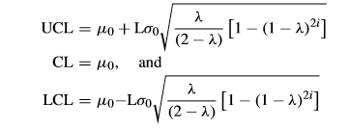

Here, L denotes the decision boundary of the control chart; whose value is also predefined depending on the false alarm rate. The out of control state is reached when the Zi is plotted without specific control limits.

The average run length when the process is in an in-control state is denoted by ARL1 and can be computed using formula from ‘L. Zhang, G. Chen, and P. Castagliola, ‘‘On t and EWMA t charts for monitoring changes in the process mean” ’. It is computed as follows:

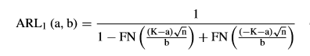

In this formula, FN(.) is a cummilative distribution function of the standard normal distribution, and K=3/(n^0.5), which points to the false alarm rate of 0.0027 or an in-control ARL1=370.

The average run length ARL2 can be obtained from Srivastava and Wu, which minimizes ARL2 for the given ARL1 and the proposed value of λ. This formula is a very good approximate that is produced by Markov Chain approach. The formula is as follows

C:\Users\Harin\Desktop\OUR\a1.PNG

C:\Users\Harin\Desktop\OUR\a3.PNG

Where,

C:\Users\Harin\Desktop\OUR\a4.PNGc* is an optimal constant value that minimizes ARL2. The width of the control limit is approximated as:

**9 Cost Model Methodology:**

**9.1 Cost model for maintenance policies**

The preventive and corrective maintenance costs requires the following information:

1. Time required to implement maintenance actions and also time related with logistic delay of the material.
2. Previous data on probability of equipment failure
3. Cost of materials, labour and cost associated with downtime
4. Equipment restoration degree and restoration factor.

The corrective maintenance of the machine includes down time costs for repairing and restoring the machine during the given time period and cost of labour and materials required. It can be expressed as:

C:\Users\Harin\Desktop\OUR\new3\CodeCogsEqn.gif

The preventive maintenance of the machine includes the costs due to the costs of required labour and materials. It can be expressed as:

C:\Users\Harin\Desktop\OUR\new3\CodeCogsEqn (2).gif

The total cost involved with process manufacturing depends on preventive maintenance costs[PMC] and corrective maintenance costs[CMC]. The expected total cost is calculated as:

C:\Users\Harin\Desktop\OUR\new3\CodeCogsEqn (1).gif

**9.2 Cost Model for Process Quality:**

The total expected cost for quality loss due to process quality failure depends on the expected process cycle length and expected cost of process failure.

**9.2.1 Expected Process Cycle Length**

The total process cycle length consists of In-Control time and Out-Of-Control time. In In-Control time, the expected number of false alarms during the process time is given by S/ARL1. The In-Control time is assumed to be a negative exponential distribution with mean 1/ λ and includes the time to failure and the expected time to investigate the false alarm as given above. Hence, the expected time of an assignable cause, during the in control length can be expressed as:

C:\Users\Harin\Downloads\CodeCogsEqn (3).gif

The Out-Of-Control time includes the following. The time between the occurrence of an assignable cause and the next sample and can be expressed as:

C:\Users\Harin\Desktop\OUR\new3\CodeCogsEqn (4).gif

The expected time to an out of control state, *T*=H/2. For a sample size of n units, the time required to analyze the sample and the chart is given by C:\Users\Harin\Desktop\OUR\new3\CodeCogsEqn (5).gif . And the time to investigate the assignable cause is given by T. The expected time to restore the process if it moves out of control due to machine degradation or external is given by:

C:\Users\Harin\Desktop\OUR\new3\CodeCogsEqn (6).gif

The expected process time is expressed as the sum of the expected In-Control and expected Out-of-Control times.

C:\Users\Harin\Desktop\OUR\new3\CodeCogsEqn (7).gif

**9.2.2 Cost Model for Process Failure:**

The expected process costs includes cost due to defective products, sampling, downtime, cause analysis, and restoring the system.

Cost associated with false alarms consists of the cost of analysis of the false alarm. Let Cfalse be the cost per unit time for investigating the false alarm. Thus, the expected cost for a false alarm can be expressed as follows:

C:\Users\Harin\Downloads\CodeCogsEqn (14).gif

The expected cost per cycle for sampling is the sum of fixed cost per sample and variable cost per job and can be expressed as:

C:\Users\Harin\Downloads\CodeCogsEqn (9).gif

The expected cost of non-confirming units when the process is in control is given by:

C:\Users\Harin\Downloads\CodeCogsEqn (4).gif

The expected cost for finding and resetting the assignable cause due to external reasons, and downtime if process ceases functioning and for finding and resetting the process can be calculated as follows:

C:\Users\Harin\Downloads\CodeCogsEqn (5).gif

The rejection of products can be either due to machine failure or external reasons, when the machine is in out-of-control state. The cost of rejection due to machine failure can be given by:

C:\Users\Harin\Downloads\CodeCogsEqn (7).gif

Whereas, the cost of rejection when the process due to external reasons is

C:\Users\Harin\Downloads\CodeCogsEqn (8).gif

The expected cost of corrective maintenance action due to failure mode FM2, includes the cost of lost production, labour cost and fixed cost per corrective maintenance during the time to repair. The total cost for finding and repairing the assignable cause due to machine failure is given by

C:\Users\Harin\Downloads\CodeCogsEqn (10).gif

The expected cost of process failure corresponds to the sum of expected costs while operating the process corresponding to in-control and out-control cycles. The sum of the above equations give the expected cost of process failure per cycle and is given as:

C:\Users\Harin\Downloads\CodeCogsEqn (11).gif

In this work, it is assumed that the process failure is repetitive in nature. It means that the expected cycle length is fixed. If there are process failure cycles in a given evaluation period, the expected cost of process failure quality for the evaluation period is given by:

C:\Users\Harin\Downloads\CodeCogsEqn (12).gif

**9.3 Optimization of expected cost per unit time of system:**

The sum of all the costs above mentioned divided by the evaluation time period, gives us the expected total cost per unit time of the system. The economic objective is to minimize by choosing the optimal value of the decision variables. It can be expressed as:

C:\Users\Harin\Downloads\CodeCogsEqn (13).gif

The model is solved to get those optimal values of n, h, tPM, Land λ

Objective function:

Subject to:

n, h, tPM, L, λ $≥$ 0

n min nm n max

h min  hm h max

t PM min tPM m tPM max

L min Lm L max

λ min λm λ max

**10 Illustrative Example:**

Consider a Multi- component Operating Machine, where the machine operates two shifts of 12 hours and works 6 days a week and produces a 10 m high CLP with process mean of 5m, and standard deviation of 0.01. The magnitude of shift owing to external reasons is 1 and due to machine is 0.6. Machine failure is assumed to follow a two parameter Weibull distribution with η=1000 and β=2.5 as the characteristic life and shape parameter, respectively. The input parameter is as follows:

|  |  |
| --- | --- |
| **Parameter** | **Value** |
| **δE** | **1.00** |
| **δM/c** | **0.60** |
| **Tfalse (h)** | **0.50** |
| **T1 (h)** | **0.50** |
| **Tresetting (h)** | **1.00** |
| **Ts (h)** | **0.33** |
| **Cfrej (sr/job)** | **400.00** |
| **Cfalse (sr/h)** | **5.00** |
| **LC (sr/h)** | **12.50** |
| **Clp (sr/h)** | **8.33** |
| **Cf (sr)** | **50.00** |
| **PR (job/h)** | **19** |
| **TTRcm (h)** | **12** |
| **TTR pm (h)** | **7** |
| **Cv( (sr/job)** | **5.00** |
| **Cresetting (sr/h)** | **5.50** |

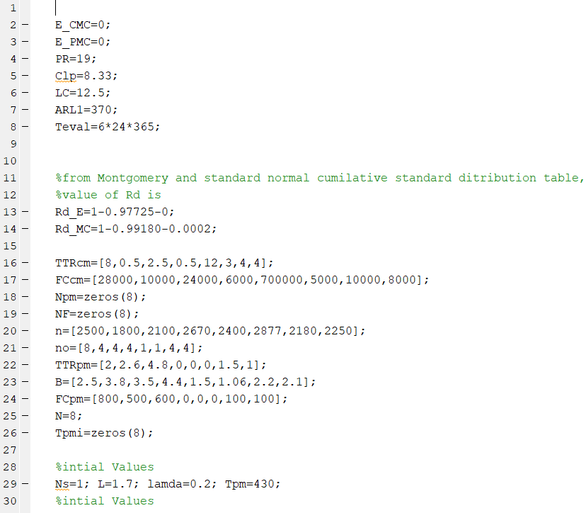**11 Matlab Code:**

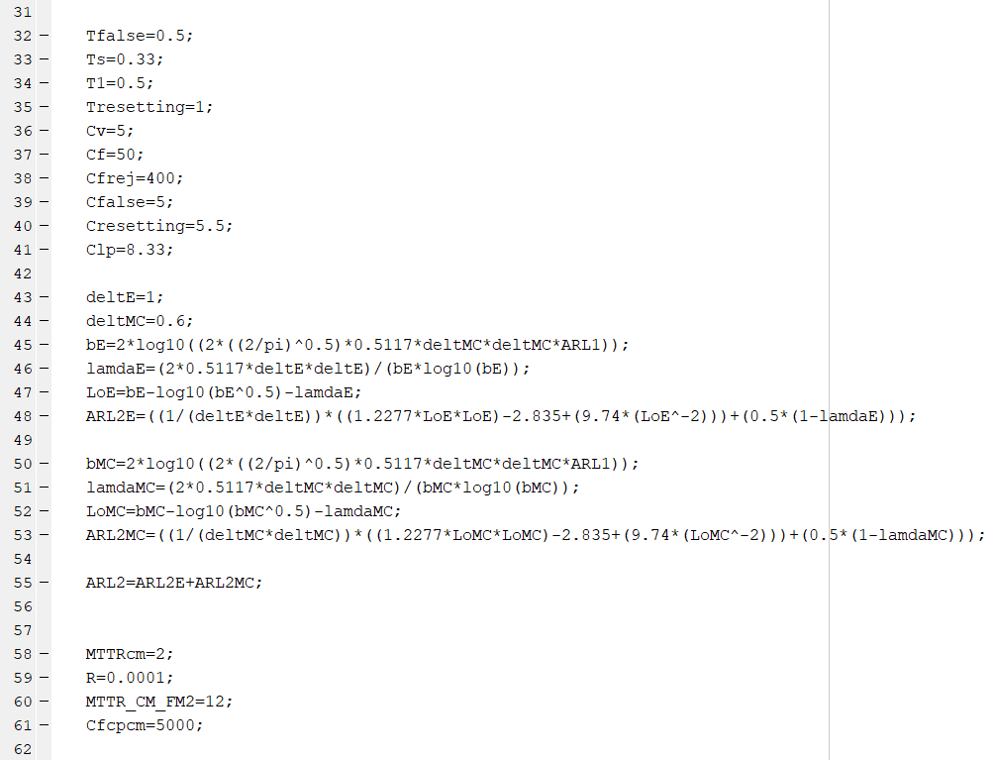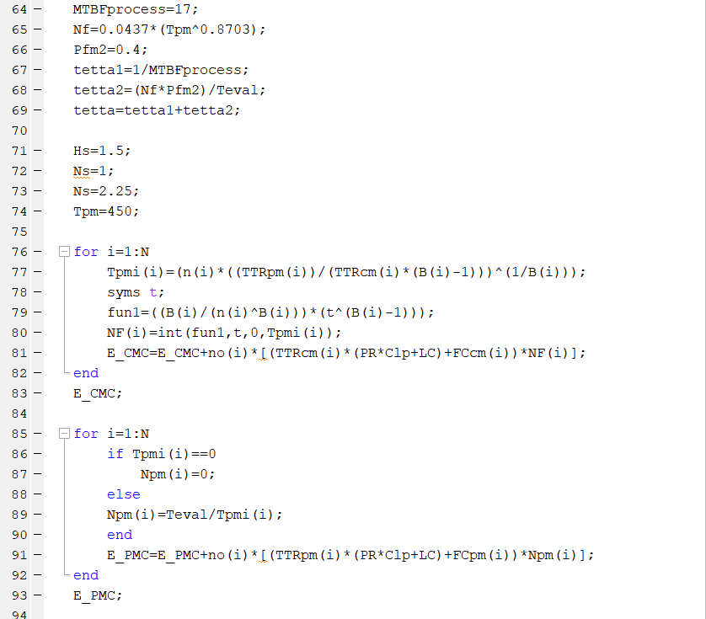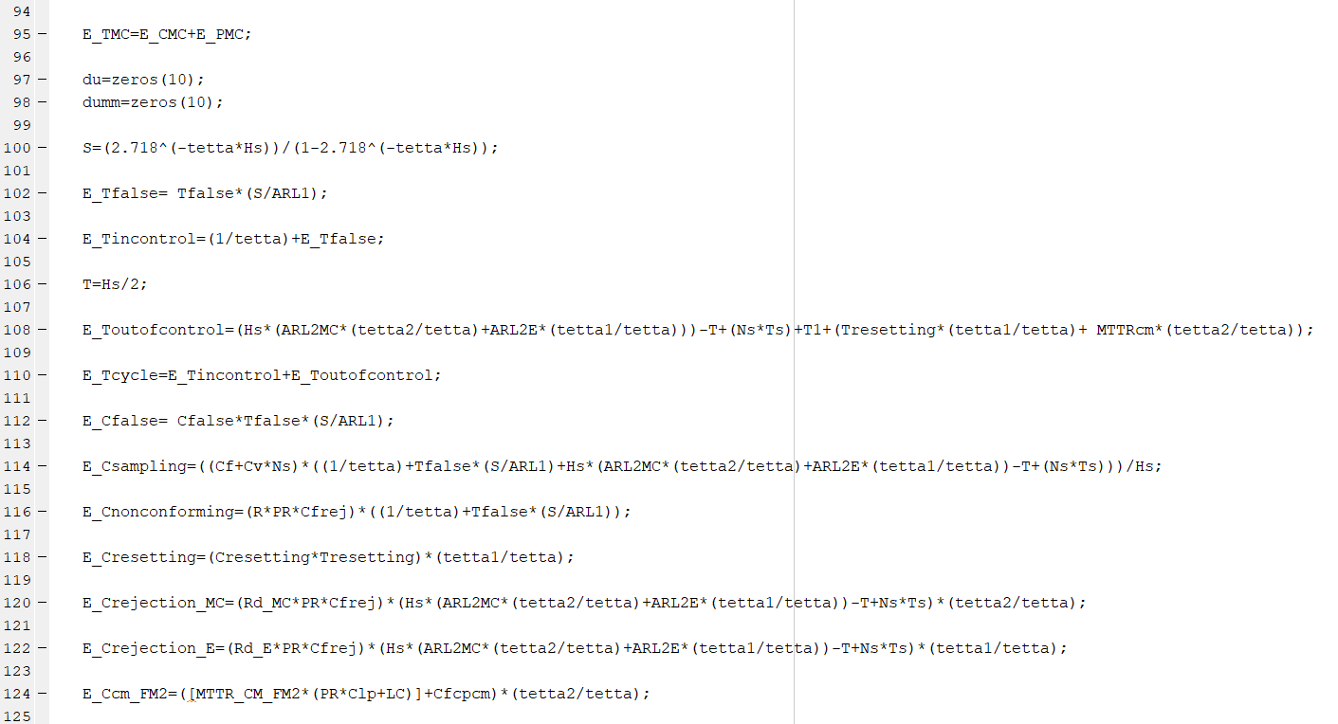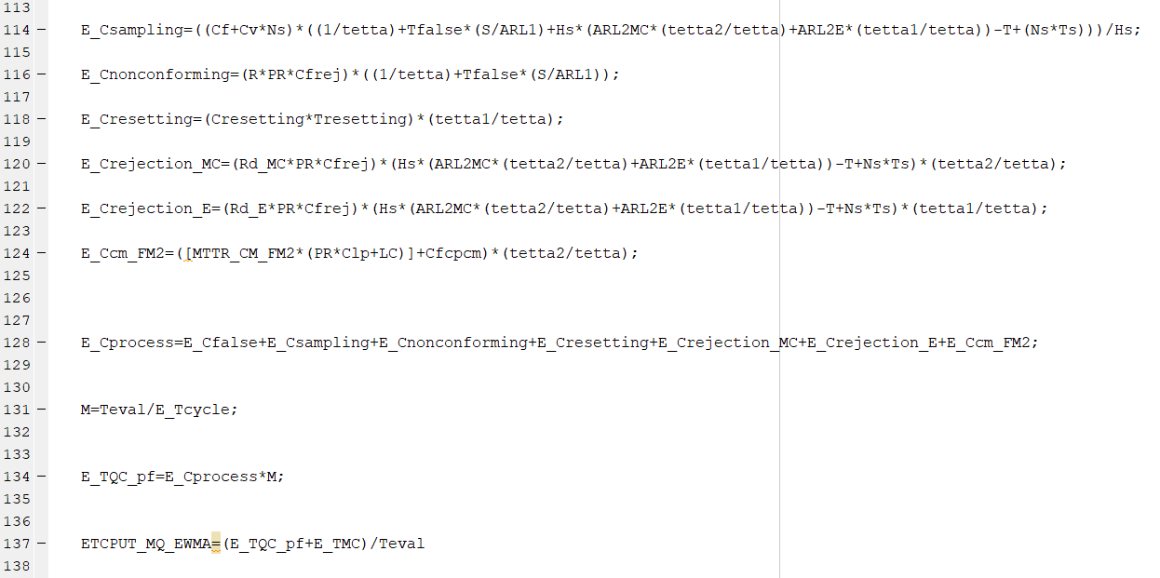

**12 Simulation Results:**

**Figure 12.a: Number of Samples (Ns) vs ETCPUT(M*Q)EWMA**

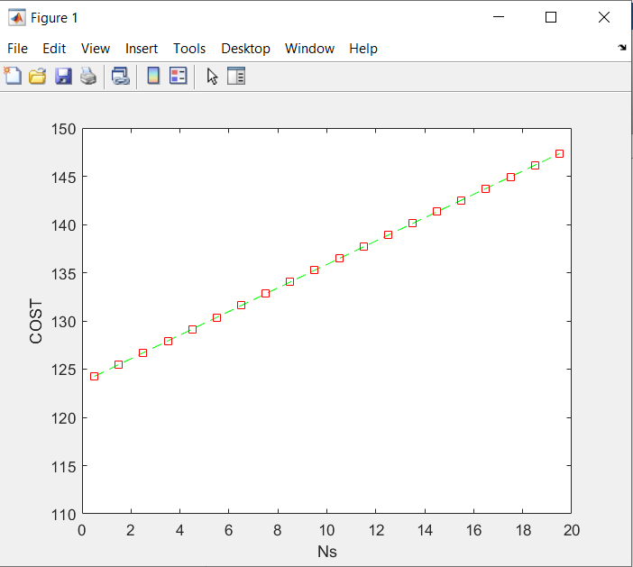

**Figure 12.b: Sample Frequency (Hs) vs ETCPUT(M*Q)EWMA**

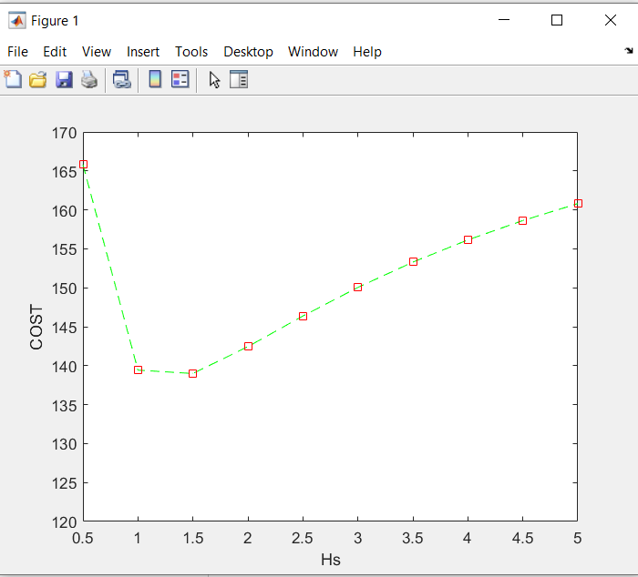

**Figure 12.c: Control Limit Width (L) vs ETCPUT(M*Q)EWMA**

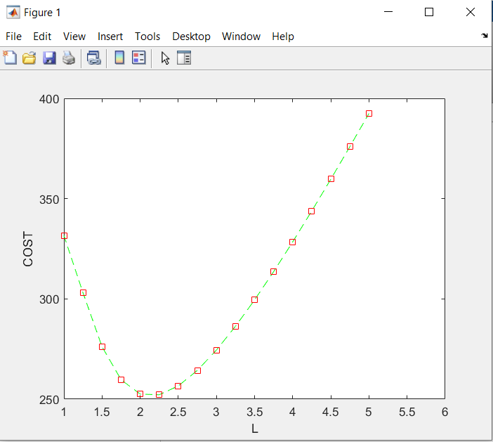

**Figure 12.d: Preventive Maintenance Interval (Tpm) vs ETCPUT(M*Q)EWMA**

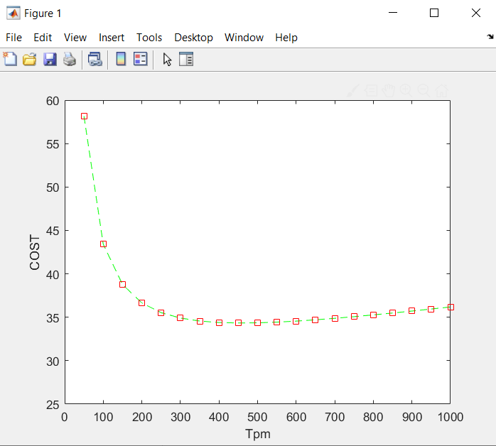

**12.1 Inference:**

From the above results it was inferred that the total cost incurred by the machine was minimal at particular values of the decision variables. From Figure 11.a, we observe that as the number of samples increase the total cost increases as well. The values of Ns was found optimal at Ns= 1. So it is observed that the number of samples taken is 1 for every 1.5 hrs which is inferred from figure 11.b, the curve of sample frequency vs cost.

It is important to find the optimum values of the decision parameters of the control chart to find the optimum upper and lower control limits. Thus, Figure 11.c displays the impact of changing the control limit width (L) on the expected total cost. It is observed that the optimum values of L are in the range of 2-2.25. Figure 11.d illustrates the effect of the preventive maintenance interval (TPM ) on the proposed expected total cost; the optimum range of TPM is 400 to 450 h.

In this study, the EWMA chart is implemented with parameters L = 2.25 and different values of λ between 0 and 1. By using pilot runs, it was observed that the chart was effective at detecting small shifts in the process mean at L = 2.25 and λ = 0.2.

The integrated model of maintenance and quality parameter was found to be optimal at the above mentioned values and the minimized cost was **(ETCPUT(M*Q)EWMA)** equal to 143.98.

**13. Sensitivity Analysis:**

An important practical issue in the application of the economic design approach is the estimation of the required model parameters. Since the process and cost parameters cannot always be estimated with accuracy, it is important to know the effect that poor estimates may have on the quality of integrated maintenance planning and control chart model design. To investigate this issue, a systematic sensitivity analysis was conducted on some of the cost and process parameters. The sensitivity analysis was performed with the illustrative example.

In table 12.1, the basic variables are changed from the basic value (input values) to different levels. Level 1 refers to a change in the input parameter by -10% of it original value, Level 1 refers to a change in the input parameter by +10% of it original value and Level 3 refers to a change in the input parameter by -+20% of it original value. The simulated cost (ETCPUT(M*Q)EWMA) of the machine is given corresponding to the change in different values in the same table. The sensitivity of the model with respect to the input parameters can be seen.

Table 12.1: Sensitivity of the basic variables and influence range of [ETCPUT]((M∗Q)_EWMA)

|  |  |  |  |  |  |  |  |  |  |
| --- | --- | --- | --- | --- | --- | --- | --- | --- | --- |
| Parameter | Basic Level | Level 1 (-10%) | Level 2 (+10%) | Level 3 (+20%) | ETCPUT(M*Q)EWMA | | | | |
| Basic Level | Level 1 | Level 2 | Level 3 | Range |
| δe | 1.00 | 0.90 | 1.10 | 1.20 | 143.98 | 155.17 | 133.37 | 123.42 | 123.42-155.17 |
| δm/c | 0.60 | 0.54 | 0.66 | 0.72 | 143.98 | 138.07 | 148.98 | 153.25 | 138.07-153.25 |
| Tfalse | 0.50 | 0.45 | 0.55 | 0.60 | 143.98 | 143.99 | 143.98 | 143.98 | 143.98-143.99 |
| T1 | 0.50 | 0.45 | 0.55 | 0.60 | 143.98 | 144.15 | 143.81 | 143.64 | 143.64-144.15 |
| Tresetting | 1.00 | 0.90 | 1.10 | 1.20 | 143.98 | 144.31 | 143.66 | 143.33 | 143.33-144.31 |
| Ts | 0.33 | 0.30 | 0.36 | 0.40 | 143.98 | 143.81 | 144.16 | 144.34 | 143.81-144.34 |
| Cfrej | 400.00 | 360.00 | 440.00 | 480.00 | 143.98 | 135.36 | 152.60 | 161.22 | 135.36-161.22 |
| Cfalse | 5.00 | 4.50 | 5.50 | 6.00 | 143.98 | 143.99 | 143.99 | 143.99 | 143.98-143.99 |
| LC | 12.50 | 11.25 | 13.75 | 15.00 | 143.98 | 143.94 | 144.03 | 144.08 | 143.94-144.08 |
| Clp | 8.33 | 7.50 | 9.16 | 10.00 | 143.98 | 143.40 | 144.57 | 145.16 | 143.40-145.16 |
| Cf | 50.00 | 45.00 | 55.00 | 60.00 | 143.98 | 140.79 | 147.18 | 150.38 | 140.79-150.38 |
| Cv | 5.00 | 4.50 | 5.50 | 6.00 | 143.98 | 143.26 | 144.70 | 145.43 | 143.26-145.43 |
| Cresetting | 5.50 | 4.95 | 6.05 | 6.60 | 143.98 | 143.97 | 144.00 | 144.02 | 143.97-144.02 |

**13.1. Robustness:**

The robustness of the model is analysed by calculating the percentage difference in the cost incurred by changing the input values to different values one at a time. By doing this, we are able to see how robust the model is with respect to changes occurred to the input variables. This changes may account to the errors caused in machine, human or maybe due to machine degradation or component failure, etc.

In table 13.1, the robustness of the model is calculated and shown. From the table it is inferred that δe and Cfrej show higher variation in the cost incurred. Hence even a minute changes caused will have a adverse impact in the total caused incurred, and hence this values must be monitored and kept as constant as possible. The values δm/c and Cf are moderately robust and must be monitored to a certain extent to keep the cost under control. The rest of the values doesn’t seem to show much of a impact on the total cost incurred and doesn’t need much of monitoring.

Table 12.2: Robustness wrt the basic variables

|  |  |  |  |  |  |  |  |
| --- | --- | --- | --- | --- | --- | --- | --- |
| Parameter | Basic Level | Level 1 (-10%) | Level 2 (+10%) | Level 3 (+20%) | % Change in Cost | | |
| Level 1 | Level 2 | Level 3 |
| δe | 1.00 | 0.90 | 1.10 | 1.20 | 7.77% | -7.37% | -14.28% |
| δm/c | 0.60 | 0.54 | 0.66 | 0.72 | -4.10% | 3.47% | 6.44% |
| Tfalse | 0.50 | 0.45 | 0.55 | 0.60 | 0.01% | 0.00% | 0.00% |
| T1 | 0.50 | 0.45 | 0.55 | 0.60 | 0.12% | -0.12% | -0.24% |
| Tresetting | 1.00 | 0.90 | 1.10 | 1.20 | 0.23% | -0.22% | -0.45% |
| Ts | 0.33 | 0.30 | 0.36 | 0.40 | -0.12% | 0.13% | 0.25% |
| Cfrej | 400.00 | 360.00 | 440.00 | 480.00 | -5.99% | 5.99% | 11.97% |
| Cfalse | 5.00 | 4.50 | 5.50 | 6.00 | 0.01% | 0.01% | 0.01% |
| LC | 12.50 | 11.25 | 13.75 | 15.00 | -0.03% | 0.03% | 0.07% |
| Clp | 8.33 | 7.50 | 9.16 | 10.00 | -0.40% | 0.41% | 0.82% |
| Cf | 50.00 | 45.00 | 55.00 | 60.00 | -2.22% | 2.22% | 4.45% |
| Cv | 5.00 | 4.50 | 5.50 | 6.00 | -0.50% | 0.50% | 1.00% |
| Cresetting | 5.50 | 4.95 | 6.05 | 6.60 | -0.01% | 0.01% | 0.03% |

**14 Results and Discussion**

An integrated model for joint maintenance actions and process quality control for optimizing the cost has been proposed in this work. The proposed methodology had given the optimum values of the decision parameters, i.e. n, h, tPM, L and λ.

**Optimal Values:**

|  |  |
| --- | --- |
| Parameter | Optimal Value |
| Ns | 1 |
| Hs | 1.5 |
| Tpm | 450 |
| L | 4.5 |
| λ | 0.2 |

This model will help a wide range of manufacturing companies to implement a system that would take care of these parameters, and would decrease the cost involved in maintaining the machine. Further, it also helps in planning and implementing the PM interval required to improve the production yield and performance while minimizing downtime.

**15 Scope for Future Work**

The future work that can happen with the present proposed model can include integration of Maintenance planning and quality control for joint monitoring of process mean and variance using EWMA charts.

**16 References:**

1. Garg A, Deshmukh SG (2006) Maintenance management: literature review and directions. J Qual Maint Eng 12(3):205–238

2. Montgomery DC (1980), The economic design of control charts: a review and literature survey. J Qual Technol 12(2):75–87

3. Pandey D, Kulkarni MS, Vrat P (2010) Joint consideration of production scheduling, maintenance and quality policies: a review and conceptual framework. Int J Adv Oper Manag 2(1/2):1–24

4. Linderman K, McKone-Sweet KE, Anderson JC (2005), An integrated systems approach to process control and maintenance. Eur J Oper Res 164:324–340

5. Cassady CR, Bowden RO, Liew L, Pohl EA (2000) Combining preventive maintenance and statistical process control: a preliminary investigation. IIE Trans 32:471–478

6. Panagiotidou S, Tagaras G (2008) Evaluation of maintenance policies for equipment subject to quality shifts and failures. Int J Prod Res 46(20):5761–5779

7. ZhouWH, Zhu GL (2008) Economic design of integrated model of control chart and maintenance management. Math Comput Model 47(11–12):1389–1395

8. WangW(2011)Maintenance models based on the np control charts with respect to the sampling interval. J Oper Res Soc 62:124–133

9. Taguchi G, Elsayed EA, Hsiang T (1989) Quality engineering in production systems. McGraw-Hill, New York

10. Pandey D, Kulkarni MS, Vrat P (2011) A methodology for joint optimization for maintenance planning, process quality and production scheduling. J Comput Ind Eng 61(4):1098–1106

11. Pandey D, Kulkarni MS, Vrat P (2012) A methodology for simultaneous optimization of design parameters for the preventive maintenance and quality policy incorporating Taguchi loss function. Int J Prod Res 50(7):2030–2045

12.Lucas and Saccuci (1990), Exponentially Weighted Moving Average Control Schemes: Properties and Enhancements

13.M.S. Srivastava(1995), Evaluation of optimum weights and average run lengths in EWMA control schemes

14. Yupaporn Areepong (2012), Explicit formulas of average run length for a moving average control chart for monitoring the number of defective products

15.Teh Sin Yin (2015), A Study on the S2-EWMA Chart for Monitoring the Process Variance based on the MRL Performance.

16.DoğanA.Serel (2008), Economic design of EWMA control charts based on loss function

Chapter 11, Markov chains.

17. Douglas C. Montgomery, Introduction to Statistical Quality Control.

18. Yupaporn Areepong (2012), Statistical design of EWMA chart for MA(Q) based on ARL .

19. Wang, W., 2010. Maintenance models based on the np control charts with respect to the sampling interval. Journal of the Operational Research Society, doi:10.1057/jors.(2009).165.

20. Kuo, Y., 2006. Optimal adaptive control policy for joint machine maintenance and product quality control. European Journal of Operational Research, 171, 586–597.

21. Farahani, A., Tohidi, H., Integrated optimization of quality and maintenance: A literature review, Computers & Industrial Engineering (2020)

21. Adel Al-Shayea., 2019. New integrated model for maintenance planning and quality control policy for Multi-Component system using EWMA chart.

22. Pandey D, Kulkarni MS, Vrat P (2015), Integrated design of preventive maintenance and quality control policy parameters with CUSUM chart.