Graphene Composites LLP

About us…
- Product Range
- Process Range
- Why FRP
- Industries being catered to…
- Applications of FRP
- ISO Certification.
- Contract Manufacturing – Concept and Process and Why us ?
- Contact us.

You Define, We Deliver.

: About us :
Established in 2017, Graphene Composites LLP is a fast growing manufacturer of Composites (Fiber Reinforced Plastics – FRP) in India aiming at catering the global markets.

“You (our customer) just define your product requirement and rest leave it to us…. we will deliver the product !” Our completely integrated business process includes - Product Design, Product Development, Serial Production, Quality Control, and perfect logistics. Entire chain of business is managed by 150 experienced professionals, which enhances our understanding of customer’s requirements and fulfill them precisely.

With an aim at catering the global market, Graphene has organically grown into a trustworthy Composite manufacturer with 95% of our products getting exported to American and European market and the volume keeps growing steadily. We emphasize on offering consistent quality delivered in assured timeline.

Founders of Graphene Composites, brings in decades of global business experience, knowledge of product, relevant presence in industry and commercial insights which helps in driving the growth, both by expanding the existing volume, diversifying into new products/process and strategic business alliances. It is often that, our customers / suppliers gets quickly converted into our business partners which helps bring mutual growth.

Located in the “Composites Hub of India” – we have a green field state-of-the-art manufacturing facility spanning across 400,000 Sqft area, at Savli, Vadodara (Gujarat). The location offers us cumulative advantage of abundant skilled manpower, availability of key raw materials, just 150 km away from Seaport and well connected by road/rail/airports etc.

We aim to establish ourselves as the most reliable Indian manufacturer of FRP products in the world.

Product :

- PULTRUDED PROFILES :

We have 20 Pultrusion lines running 24x7 producing all kinds of Profiles primarily used in Cooling Tower application and many speciality applications. Our fabrication department is fully equipped to offer all kinds of fabrication required in Pultruded profiles. You just give us drawings and we will fabricate it for you with utmost precision. This is an added advantage for our global customers who are aiming at sourcing “Ready-to-use” products for their far away project sites.

Each piece of our profile, passes through 3 stage quality inspection which makes it full proof system hence our global customers can be at ease. Tailor-made packing aimed at both adequate protection for our product and traceability for ease of handling at the time of its use, is made inhouse by our own team.

We manufacture - All sizes of ANGLES, C-CHANNELS, FLATS, H-BEAM, I-BEAM, ROUND PIPES, SQUARE PIPES …. and many more specific shapes required by customer.

2. Customised Moulding (Infusion / Hand Lay up/ Vaccume Bagging )

Many industries across the world regularly requires FRP products with very specific design as per their own shapes and dimensions. All these regular requirements are catered by our Customised Molding Dept. Its focused primarily on Wind Sector and our prime product is Necelle Cover.

We have state of the art production facility to manufacture Necelle Covers and we aim to cater to the global requirements of the same.

You have design / Concept / Idea or Expectation about any of your FRP product requirement – Share with us and we will offer you get the exact product delivered…..We offer complete solution.

Based on detailed requirement of our customer, our Engineering and Design team can design the product, Tooling team makes the mold, Production takes care of Producing the product and QC Team ensures that our customer gets delivery of a perfect product in all respects.

At our manufacturing facility, we can offer all possible options of manufacturing processes to choose from. Infusion, Hand Layup, Vacuum Bagging etc.

Though relatively young manufacturer, we have been one of the fastest growing supplier to Wind Industry leaders in India. With supplies of small parts for Turbine, our focus is to be THE manufacturer of Nacelle Cover in Indian Wind industry and also aiming at the Global market.

- Molded (FRP) Grating :

Grating is one of the most common Composites products, used across the world in almost all large sized Industries as Platform, Structural parts, Weather Resistant Cover, Walk ways etc. Grating can be commonly described as Composite product with Uniform mesh and height, available with different combinations of Fiberglass and Resins customized to meet specific requirements.

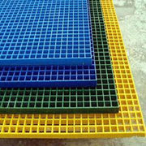

We offer wide varieties of combinations in Grating.

Some of the most common variants are based on :

- Mesh Size and Height.
- Resin and Color.
- Surface.
- Full Panel/Customized Size.

- Mesh Size and Heigth :

We offer the two most common Mesh sizes :

38 mm x 38 mm and Height 38 mm
38 mm x 38 mm and Height 25 mm.

- Resin and Color :

Primarily, Polyester Resin and Vinyl Ester Resins are used in manufacturing Molded Grating.

Color : A full spectrum of color option can be offered.

- Surface :

We offer four different variants of Surface of the grating :

- Meniscus (Concave Surface)
- Gritted
- Flat Surface
- Surface Plate with pattern (Usually Chequered Plate).

Contract Manufacturing

When it comes to have complete reliability of sourcing a product directly from manufacturer, on consistent basis with transparent commercials - Contract Manufacturing is the way to go.

Graphene has mastered the art of Contract Manufacturing. We offer unique combinations of “Complete transparency, Reliable manufacturing, Multi-stage quality checks, Traceability, Agreed shipments/dispatches” in short – We deliver precisely as per our commitment”

We are committed to exploring and expanding our cooperation with our global business partners, with our focus on long term Contract Manufacturing arrangements.

Do let us know in case you have any requirement……

and

4. Full Panel / Cutomised Size

Full Size : 1220 mm x 3660 mm

Customised Size :

We also offer, Cutomised Sizes as per the specific requirement of customers. In case of standard Sizes with repeated use; we provide, ready-to-use kits with specific dimensions as per the requirements.

2b. Application Areas :

Some of the common applications of Grating that one finds are as listed below :

- Cooling Towers Chemicals/Oil and Gas Plants,
- Water and waste water Pulp & Paper
- Pharmaceuticals Telecommunication
- Recreational Areas Decking
- Food and Beverages Power and Utilities
- Transportation Architectural,
- Offshore projects General Manufacturing

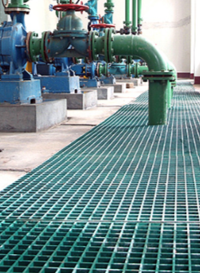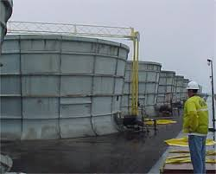

Quality :

We have well laid out Quality Policy which is strictly adhered to, at every stage of process :

- All raw material suppliers undergoes a stringent quality evaluation and approval process. Hence, only approved supplier of raw material is preferred.

- Well defined blend of raw materials is used with extreme precision.

- A unique in the industry – “Automated Control Systems” has been deployed, which ensures scientifically calculated parameters during the production.

- Skilled Manpower, gives the ultimate “quality touch” to the process.

2c. Advantages of FRP Grating vs conventional Steel Plates usages :
Fiber Reinforced Plastic (FRP) Grating is having several key advantages over conventional steel grating are

- Lightweight,
- Corrosion Resistance,
- Slip Resistance,
- Flexibility and Ergonomic,
- Lower Maintenance,
- Better impact properties,
- Higher strength-to-weight ratio (Strength)
- Electrical and Thermal Non-conductivity,
- Longer product life span.
- Maintenance Free
- Easy installation and dismantling etc….

Solar Industry ……

Molded Grating is most commonly used as walk ways in large scale Solar Plants. The well accepted Size in Solar Industry is panle with 300 mm width, however the same can be customized.

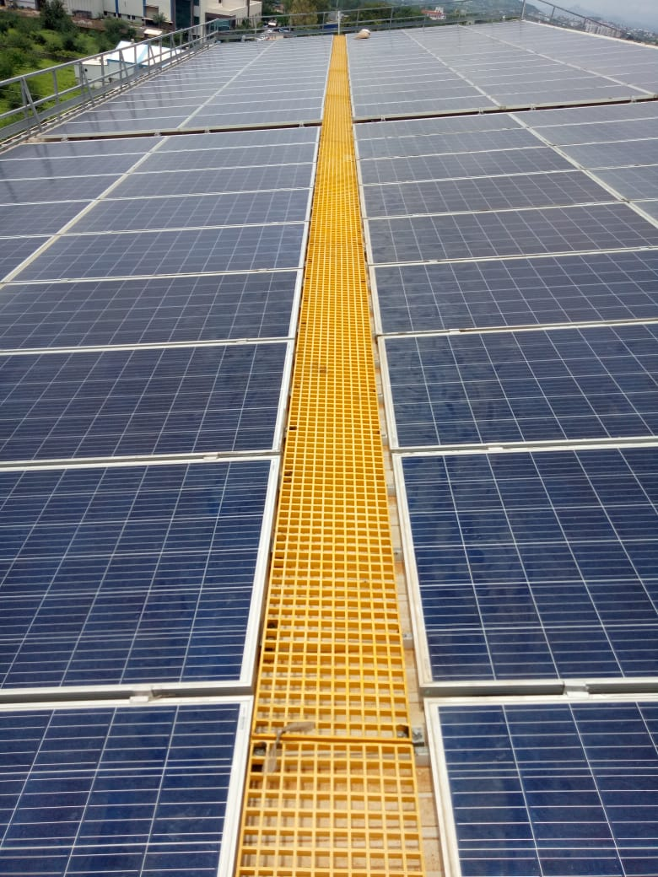
Third Party Inspection :

Manufacturing Address :
Opp Baroda Dairy, Savli-Jarod Road, Savli - Vadodara Rd, Gothda, Vadodara, Gujarat 391770
Tel : 9662677211
Email : sanjay@graphenecomposites.in

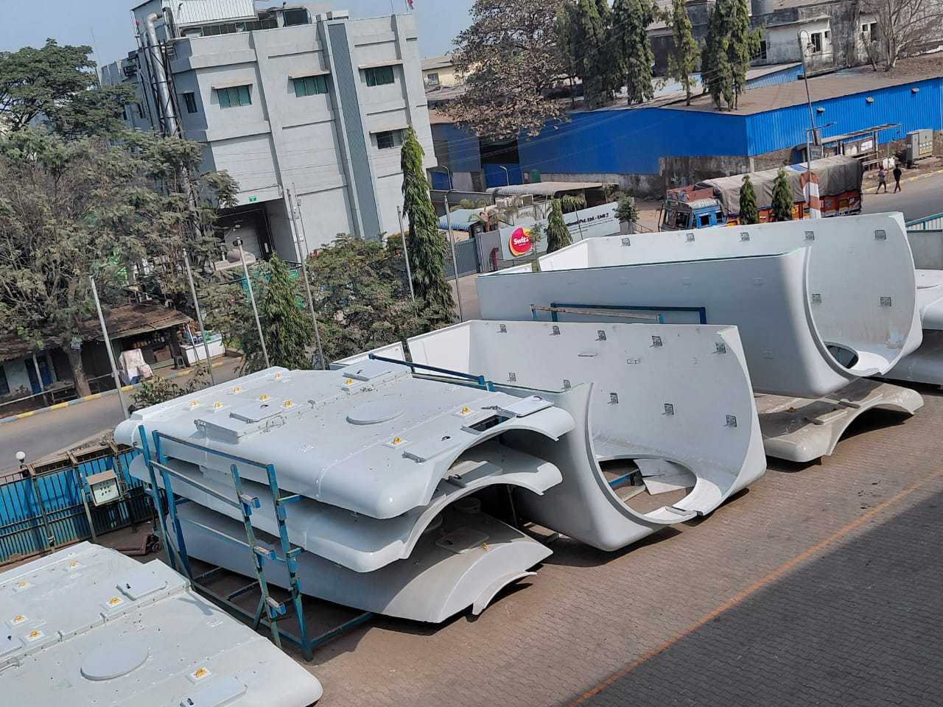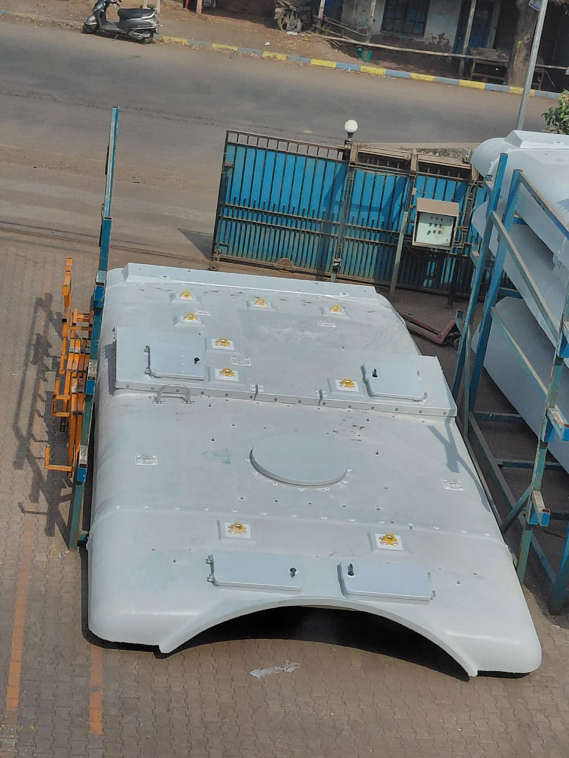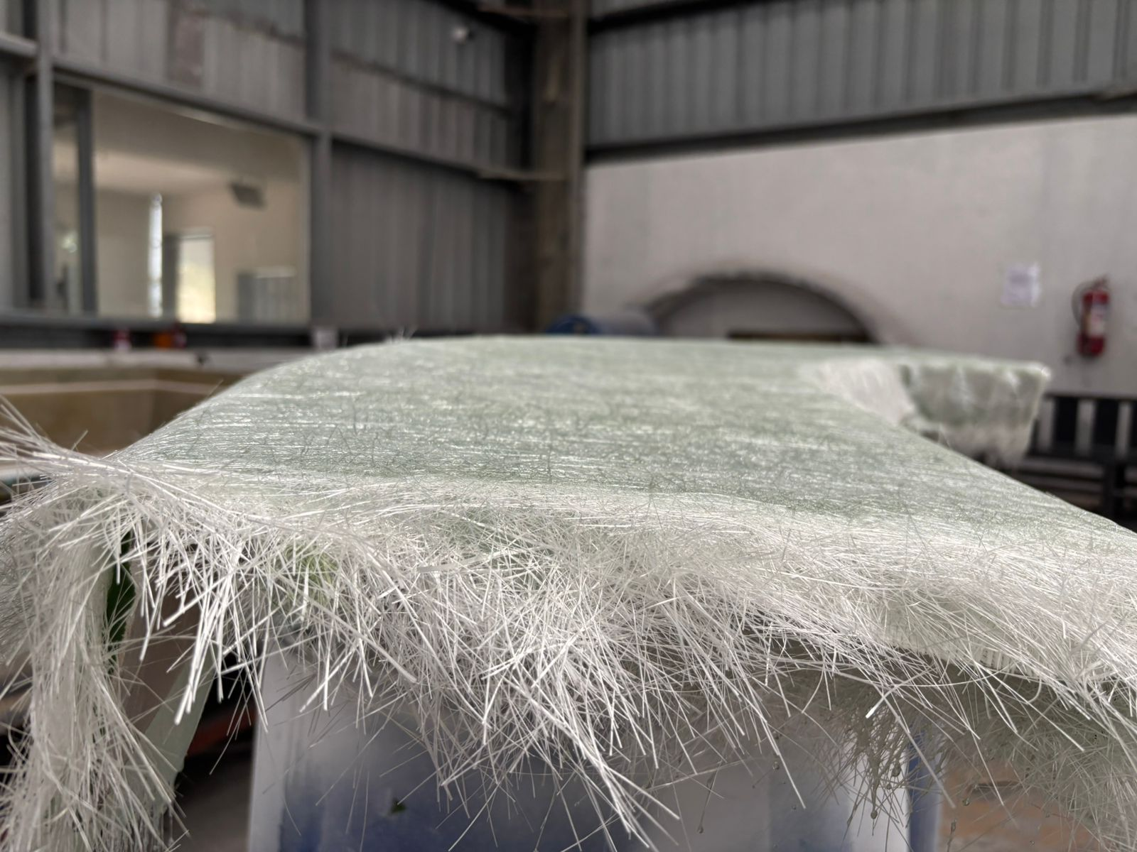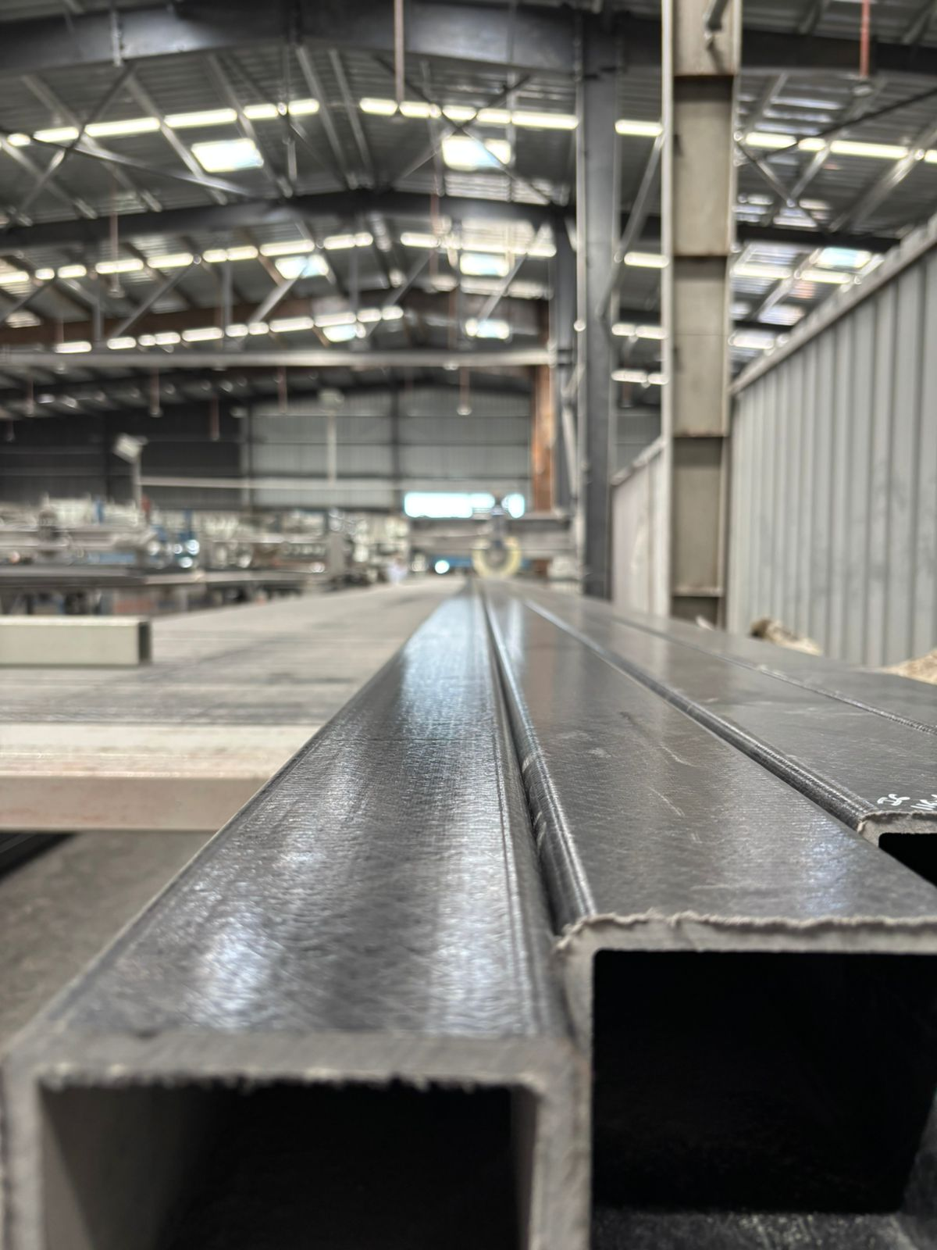

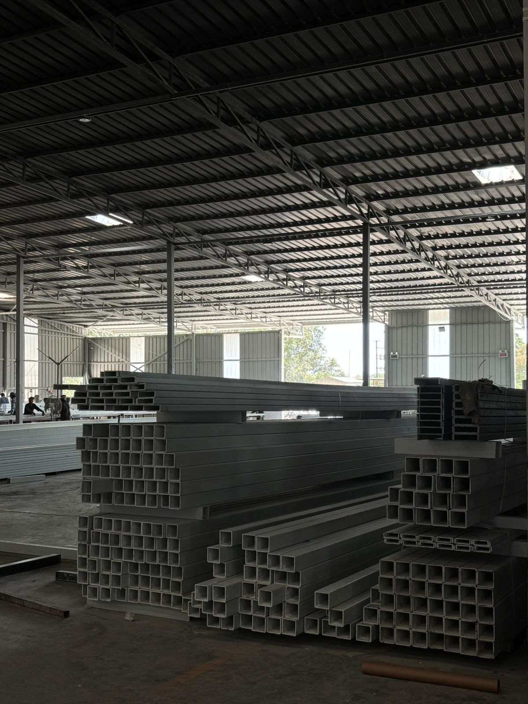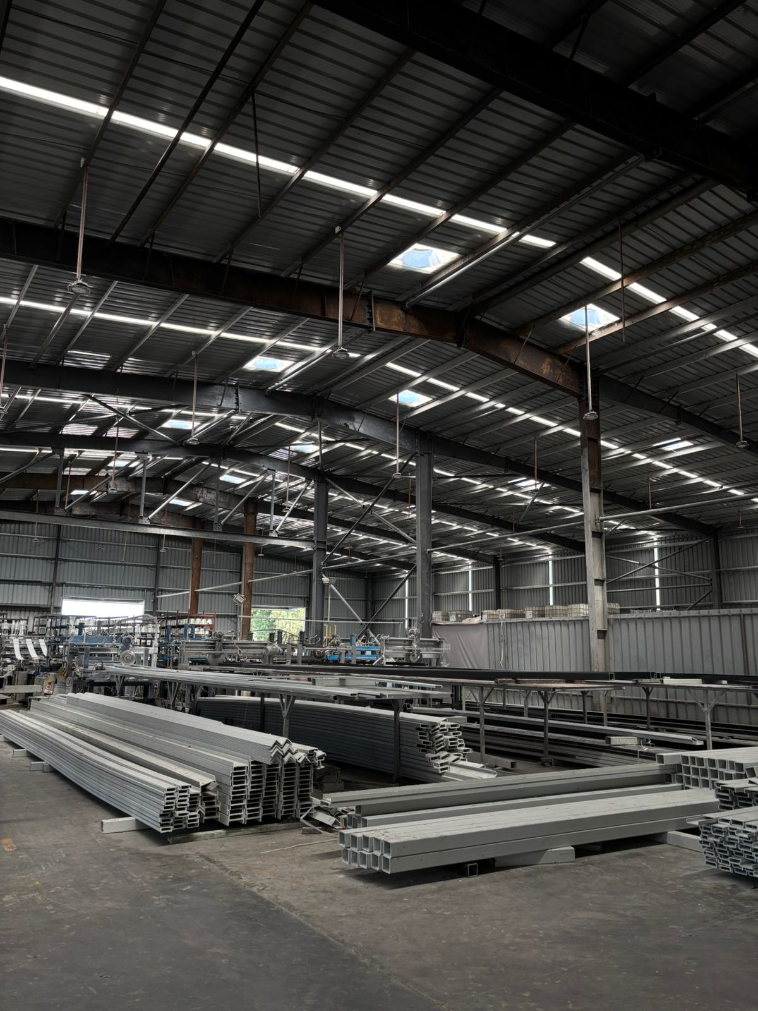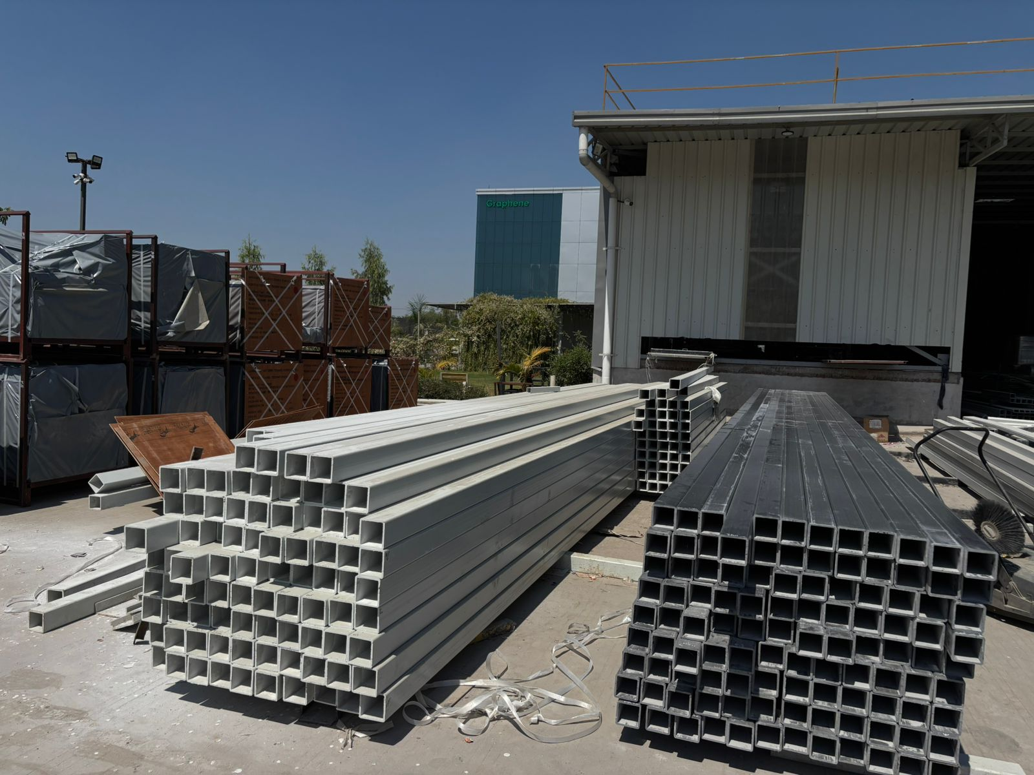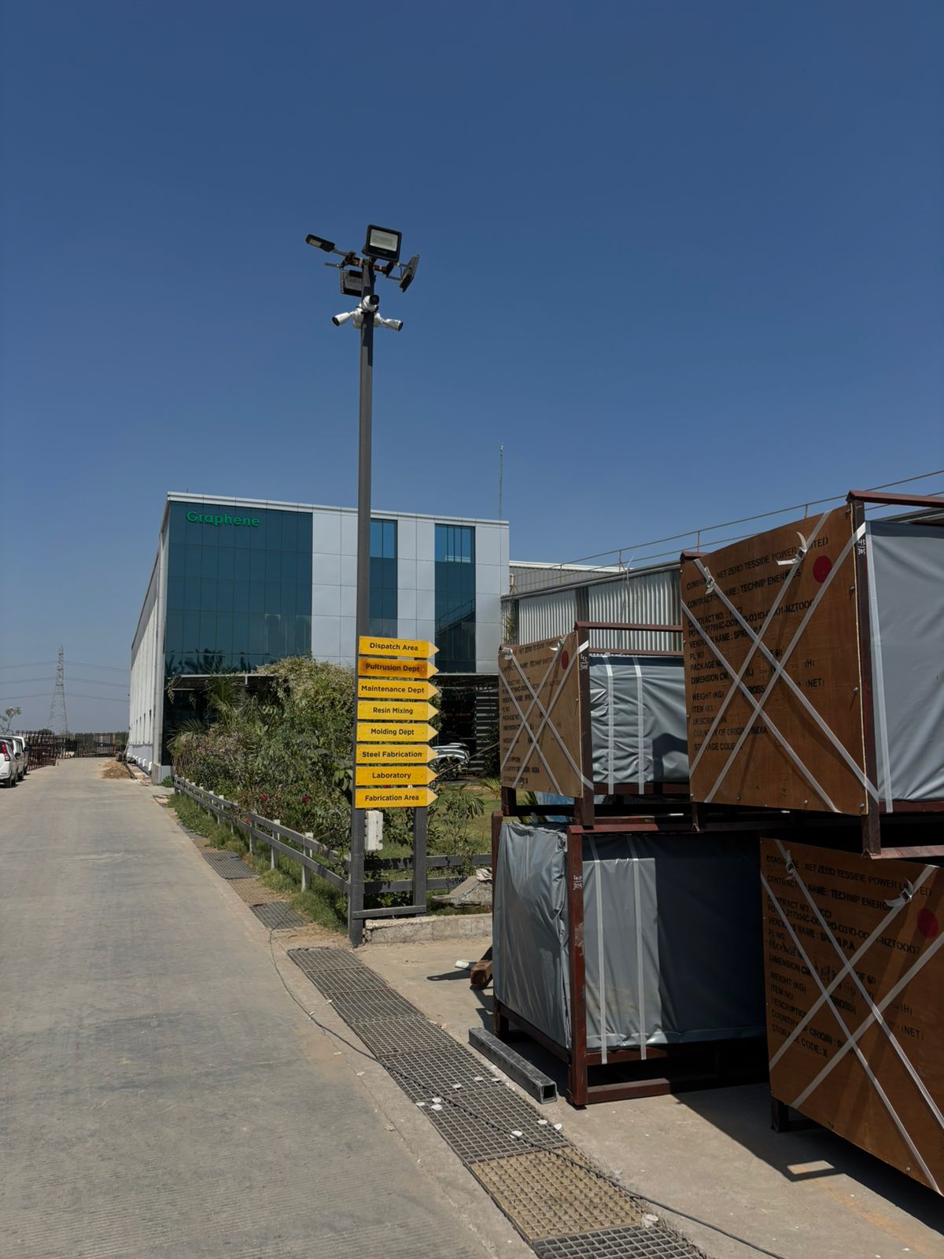

IS FIBERGLASS GRATING BETTER THAN STEEL?
For many, steel is the grating material of choice due to its low upfront costs. But does it really offer the best value? Is there another material that is better than steel? In many aspects, fiberglass grating is superior to steel. Read on to find out more about how fiberglass compares to steel.

Strength
In terms of strength, fiberglass grating is comparable to steel. Pultruded fiberglass grating does offer improved strength, but it is not suitable for every application. Although fiberglass grating is rigid, it is a more flexible material than steel. This flexibility gives it a higher impact resistance compared to steel. While an impact might damage or dent steel, an impact of similar strength on fiberglass grating will not cause any damage.

Safety
In the workplace, safety is of the utmost importance. Fiberglass is a safer material than steel in several key aspects. First, the material is non-skid, meaning it is designed to prevent sliding or skidding. Furthermore, it can be textured to increase traction. Steel, being a metal, is much more likely to cause slipping or skidding in damp conditions.
Fiberglass grating is also safer than steel in that it does not conduct electricity. The fact that steel readily conducts electricity can be a major hazard for workers.
The flexible property of fiberglass also gives it another advantage over steel; it is softer underfoot. The rigidness of steel can cause foot and back problems for workers, especially those that must stand for long periods of time. Fiberglass is easier on the feet and can decrease worker fatigue and increase productivity.

Durability
The biggest advantage that fiberglass has over steel is its durability. This is especially true in chemical or aquatic applications. Fiberglass is far more resistant to rust and corrosion when compared to steel. This means that steel grating will have to be replaced more often than fiberglass, leading to increased costs. Even in harsher conditions, fiberglass has proven to last for decades.

Cost
As far as costs, steel is less expensive upfront. However, that is only considering the cost of material and not installation. Because of its heavy weight, the installation of steel grating is costly. A structural steel foreman, special equipment, operators and welders need to be calculated into the costs.
Fiberglass, being a lightweight material, is easier to work with. Therefore, installation requires less manpower and equipment. The installation costs of fiberglass grating can be less than half of steel. Not to mention, fiberglass is virtually maintenance free. On the other hand, steel may have to be repainted as part of regular maintenance, adding to its long-term cost. In the end, fiberglass is often the better investment.

Relinea's range of structural grating products possess many benefits over traditional materials. Workplace safety is vital in all places of work, but fibreglass structural flooring products excel in industries such as Water/Wastewater Treatment Plants, Railway Maintenance, Service Risers, Rooftop Access Walkways and many more.The performance benefits possessed include but are not limited to:
- Anti-slip fibreglass grating that meets all health & safety and DDA requirements.
- Structural grp grating that is as strong as steel, yet up to 60% lighter
- Minimal maintenance over a 50 year life cycle - outlasting traditional steel grating thus lowering

