Project documentation

Last updated Thursday, December 09, 2021

**TRACKING THE PERFORMANCE OF VOLUNTEERS AND CHILDREN ACROSS DIFFERENT SHELTER HOMES**

Contents

Introduction 1

Description of partnering organization and their needs 1

Description of audience 2

Story/exploration experience for the audience 2

Visual encoding choices 2

Data provenance 2

Data dictionary 2

Data transformation and cleaning 4

Calculations 4

## Introduction

Creating Visualizations to understand the overall trend has become crucial in every industry, non-profit and service organizations as a means of supporting data driven decision making. Dashboards can help boards and people working for nonprofits get a handle on large amounts of data and see the significance of the data quickly. Dashboards can also be shared with donors and grant makers to help familiarize them with a nonprofit’s impact, scope of programs, or finances.

## Description of partnering organization and their needs

Make a Difference is a non-profit organization that works for children in shelter homes to build a community around them, who want to contribute to help build long-term solutions towards ensuring equitable outcomes. The organization supports children in over 35 shelters across India and has a volunteer base of around 3200 people across the country. Volunteers go to shelters on a weekly basis to ensure support for children not only in terms of academics but also try to inculcate life skills.

The current challenge is to monitor and evaluate operational health parameters such as attendance percentage of volunteers, volunteer dropouts, child attendance %, and the progress of children over the course of time through interactions with volunteers, fellow children, and training. Constant monitoring would help flag potential challenges to ensure operational quality and consistency. Secondly, shelter managers interact with children on a weekly basis and get qualitative data from the children to enable the feedback of operations through a project called the voice of the child.

## Description of audience

The intended audiences are the shelter managers and the shelter authorities. The shelter managers are the people who work for the organization, go on weekly visits to the shelter to manage operations. The shelter authorities are the people who run the shelters and are the primary guardians of the children.

## Story/exploration experience for the audience

I would like to tell the story to the audience (shelter managers) about the volunteers and children who are critical with low participation in the quarter August – November 2021. The audience would be able to see the total number of children in the respective shelters, Below this would be the student ids of students who are participating poorly in the class. This will help the audience to get a sense of children who needs extra care and attention. Volunteers take a survey from the children every month to get to know their mental and physical wellbeing through a set a questions framed by psychiatric and health experts. The answers will be analyzed by domain experts and the results would be given with the following actionables.

1. Inform – which means the children passed the test confirming that they are in a good mental state.
2. Caution - The children have passed the test with few concerns. They need to be checked in frequently.
3. Escalation – The student is in a poor mental state and failed the test. Immediate counselling is required.

With these parameters, the shelter authorities would be able to prioritize care to the needy and take appropriate measures.

The next part of the dashboard represents the no of volunteers, the volunteers who are absent frequently with their names. With this result, the shelter authorities would be able to talk to the volunteers about the issues they face and provide help. This is crucial because the students should be affected of the volunteer’s absence, Hence after talking to volunteers, the shelter authorities will decide if they have to assign a different volunteer to the class. The slope chart would be helpful in identifying which shelter has most number of dropouts and take actions to reduce the attrition rate. The bar chart talks about the feedback given by children with regards to the organization’s performance in being helpful to them. This feedback will enable the shelter authorities to plan training programs for shelters lacking excellence. This order of exploration will help the audience get a clear perspective of the trends and will ease comparison of different data points. There are also different filters where the audience can delve deeper by also looking at specific shelters.

## 

## Visual encoding choices

## Using filters for different shelters associated with the cities, BANs for a number of volunteers and children with respect to each shelter in the city, bar charts to capture volunteer dropouts over the period will be a good start to monitor the performance of volunteers and children. This can be used to know at which point the volunteer wants to quit due to some reasons. Again, bar chart can be used to track the attendance volunteers. A card can be used to display the information regarding actionables. Slope chrats can be used to find which shelters have the highest volunteer dropouts. This information can be used to improve the strategies to reduce attrition rates. This dashboard has been made simple so that the audience would find it easy to navigate through the dashboard.

## Data provenance

The data was collected by the shelter managers who go to the shelter every week to monitor the sessions happening. The data was recorded in a common google sheet where all the shelter managers update the progress every week. There were a lot of qualitative data present on the sheets where people enter comments, to-do lists and other updates they have from each shelter. These data were all compiled into a sql database by the data team in the organization. CSV files were provided to me. All the unnecessary columns out of scope of this dashboard were removed.

Point of contact – Akshay Chawda ([akshay.chawda@makeadiff.in](mailto:akshay.chawda@makeadiff.in))

## Data dictionary

The data includes different tables with child data, volunteer data, the feedback given by the children and volunteer drop-outs.

**CHILD DATA:**

|  |  |  |
| --- | --- | --- |
| Field name | Data type | Definition |
| Shelter Name | String | Name of the Shelter |
| Child Name | String | Name of the Child |
| Aug’21 | Number | Number of Classes Present in Aug Attendance |
| Sep’21 | Number | Number of Classes Present in Sep Attendance |
| Oct’21 | Number | Number of Classes Present in Oct Attendance |
| Nov’21 | Number | Number of Classes Present in Nov Attendance |

**VOLUNTEER DATA:**

|  |  |  |
| --- | --- | --- |
| Field name | Data type | Definition |
| Shelter Name | String | Name of the Shelter |
| Volunteer Name | String | Name of the Volunteer |
| Aug’21 | Number | Number of Classes Present in Aug Attendance |
| Sep’21 | Number | Number of Classes Present in Sep Attendance |
| Oct’21 | Number | Number of Classes Present in Oct Attendance |
| Nov’21 | Number | Number of Classes Present in Nov Attendance |

**CHILD FEEDBACK:**

|  |  |  |
| --- | --- | --- |
| Field name | Data type | Definition |
| Student ID | String | Child ID |
| Feed Back | String | Children gave feedback through a google form which outputs results based on the total score. The results include “Excellent”,”Very good”, ”Good”, ”Not Satisfied”, ”Poor” |

**CHILD SURVEY RESULTS:**

|  |  |  |
| --- | --- | --- |
| Field name | Data type | Definition |
| Student ID | String | Child ID |
| Actionable | String | Caution, inform, Escalation |

## Data transformation and cleaning

There were some missing values in the data such as children’s scores, attendance. Scores are something that cannot be replaced by mean, median or mode (which is a common technique to replace missing values) as it can give inaccurate conclusions about the performance of the child. Hence those rows were replaced with 0. The attendance values were also replaced with 0.

The data was present on a monthly basis for 4 months from August – November 2021. According to the requirement from the organization to track monthly progress, all the values were combined to find month-wise aggregates.

## Calculations

Percentage of the attendance was found using calculated field to help shelter managers understand the monthly performance of volunteers and children per shelter so that they will be able to talk to those specific persons having low attendance to understand the issues they’re facing. This will help maintain the impact of the program and address the issues periodically.

A parameter and a set was created to find the top n volunteers with low participation.

Sample Diagram of the Dashboard:

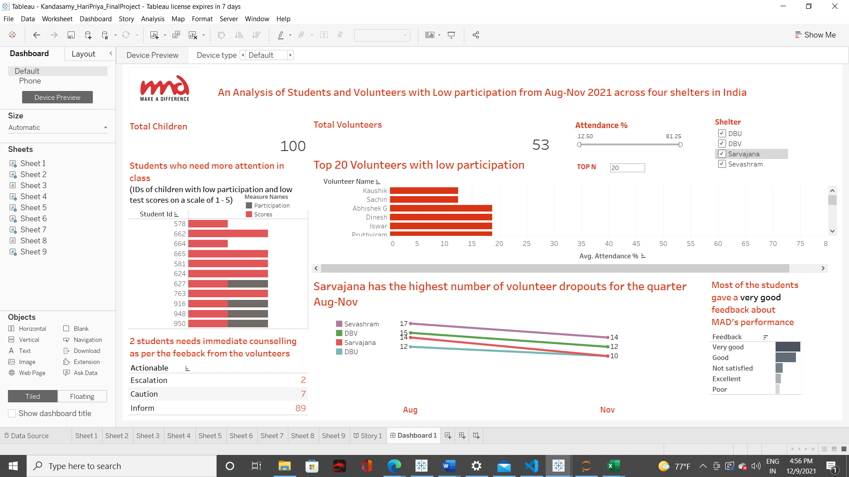

Link to the Dashboard:

[Kandasamy_HariPriya_FinalProject: Dashboard 1 - Tableau Online](https://prod-useast-a.online.tableau.com/#/site/inf385tdatastorytelling/views/Kandasamy_HariPriya_FinalProject/Dashboard1?:iid=2)

Link to the final presentation:

[Datastorytelling_presentation - Google Drive](https://drive.google.com/drive/u/6/folders/13efpy2YqwmHUqv9POL6NDlY7NGA66ZrY)