**TIME SERIES ANALYSIS OF INDUSTRIAL PRODUCTION**

**ABSTRACT:**

Industrial Production refers to the output of the industry establishments and covers sectors such as mining, manufacturing and public utilities (electricity, water and gas). This indicator is measured in an index based on a reference period that expresses change in volume of production output. This project deals with the Index of Industrial Production (Base: 1993-94=100) at two digit industry level indices . The industrial products involved are: food production, chemical, petroleum, mining, manufacturing, electricity , general.

The motive of this project is to analyse the industrial production data using time series analysis and draw inference. The dataset is collected from Open Government Data Platform India. The primary objective is to study the effects of trend on Index of Industrial Production (IIP) in India to predict the future production and also to forecast the variable of interest based on the past values of variable by using Auto Regressive Model.

Keywords: Index of Industrial production, Auto Regressive model, trend, time series analysis

**INTRODUCTION:**

**“The country that is more developed industrially, shows to the less developed the image of its own future.”**

**-Karl Marx**

Industrialization contributes to the growth of Economy, in turn it helps in developing a nation. During the last 20 years, globalization has drastically changed the industrial world. Industrial sector contributes 29.02% to the Indian Economy which is lower than the world’s average of 30.5%. Industrial production is the measure of output industrial sector that includes manufacturing, mining and utilities. The inflation rate of industrial production influences the economic development as the country is rich in natural resources and commercial crops.

The share of industries to GDP is 17% which goes upto 27% when contribution of mining, electricity and gas is included.

**OBJECTIVE:**

Index of industrial production is the most important and widely analyzed high frequency indicator, which is a crucial variable in forecasting process of short term evolution of GDP.

The motive of the study is to predict the future of industrial production by using timeseries analysis as we are bound to be aware of important trends to improve the government policies.

**DATA :**

The data has been collected from the Open government data platform India. The study deals with IIP of base year (1993-94) at 2 digit industry indices from 1994-2011 and IIP of base year (2011-12) from 2012-2016. Index of Industrial production (IIP) –available monthly ,with the least time lag – is one of the most widely used leading indicators of Industrial production for short term economic analysis because of its strong relationship with economic fluctuations in rest of economy. The raw data was compiled by shifting the base year from 2011 to 1994 for the IIP from 2012-2016 and the analysis are done.

**METHODOLOGY :**

1. Trend is used to monitor the movement of changes occurring over the index of industrial production. Different types of trend equations like linear, quadratic, cubic and fourth degree were computed. When it comes to forecasting, polynomial trends tend to be quite stormy and there is a probability that the graph will bend in the wrong direction, since the flexibility depends on the degree of polynomial. Hence linear trend is the easiest way to understand the dynamics. It helps in understanding the growth and also specifies the speed of the changes. The best fit is found by using the r^2 value which should be closer to 1. An upward trend is observed by using the trend equation y = a*X +b.

2.BUILDING A TREND LINE:

A trend line is an important tool in technical analysis of time series data. An uptrend line has a positive slope and it acts as a support and indicate that the production increases year by year



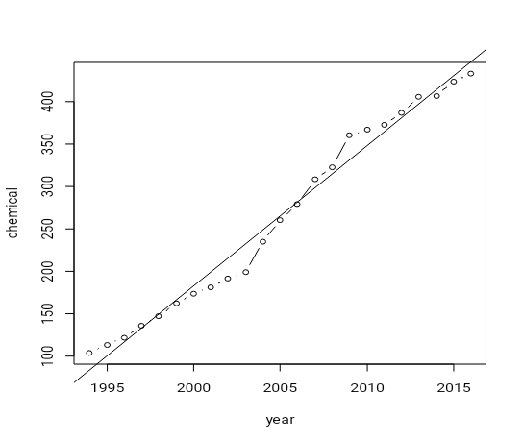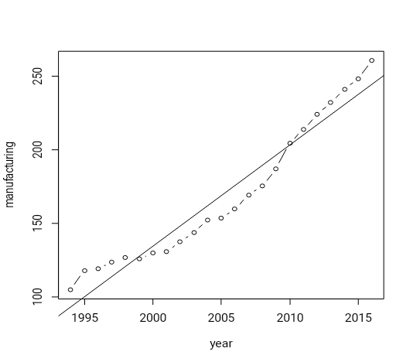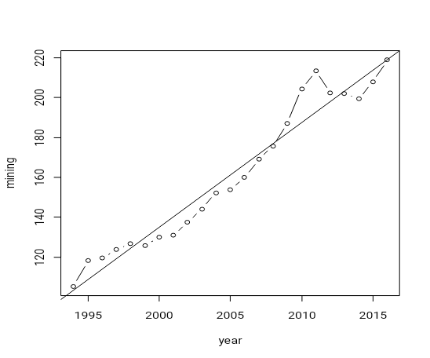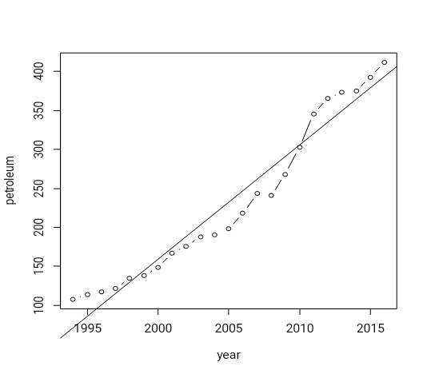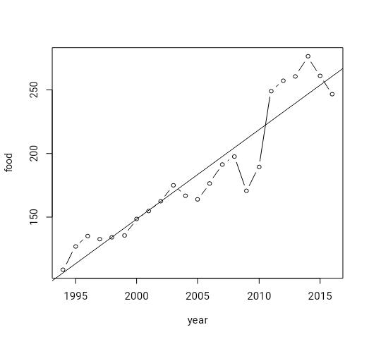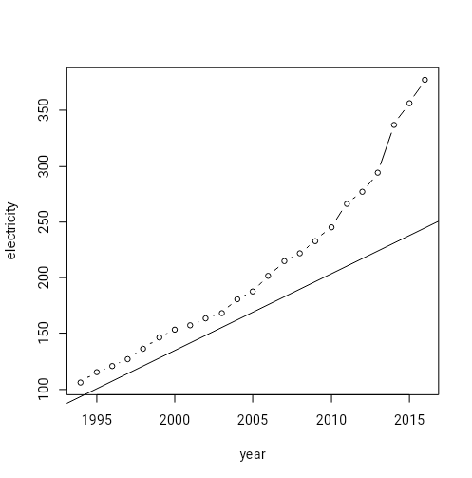

3.MODEL SELECTION :

The classical regression is insufficient for explaining all the dynamics of timeseries . The introduction of correlation as a phenomena that may be generated through Lagged linear relations leads to Auto regressive model(AR). Auto regression models are based on the idea that forecasting of current values can be explained as a function of past values.

Y=a+ b1 y(t-1) + b2 y(t-2) +b3 y(t-3) +. . . .

By identifying the suitable order of AR model by using the p value, the prediction analysis is done.

FINDINGS:

1. By trend analysis, Inflation is found to be positively co-related with IIP.
2. The linear trend was found to be the best fit in all cases.
3. The IIP was predicted for the years 2017,2018,2019,2020 with respect to the base year 2011 by using autoregressive model and it is tabulated below

|  |  |  |  |  |  |  |  |
| --- | --- | --- | --- | --- | --- | --- | --- |
| **YEAR** | **FOOD PRODUCTS** | **CHEMICAL** | **PETROLEUM** | **MINING** | **MANUFACTURING** | **ELECTRICITY** | **GENERAL** |
| 2017 | 104.7361 | 119.9117 | 124.9251 | 104.81 | 127.7703 | 151.8318 | 126.52227 |
| 2018 | 111.9848 | 122.7558 | 130.9299 | 107.11 | 133.9967 | 162.9428 | 132.4449 |
| 2019 | 113.1648 | 126.2546 | 137.12 | 109.41 | 140.6007 | 175.01 | 138.5075 |
| 2020 | 112.6991 | 129.568 | 143.501 | 111.71 | 147.6052 | 188.1129 | 144.7315 |

INFERENCE:

With the base year as 2011, the indices of the industries is expected to rise by the following percentage in the year 2020.

->manufacturing – 47.6%

->mining-11.71%

->electricity-88.11%

->food-12.69%

->chemical-29.56%

->petroleum-43.5%

Conclusion:

India is expected to become the fifth largest manufacturing country in the world. The general index of the industrial production is expected to increase by 44.73% in the year 2020

WHAT HAS BEEN DONE?

1.Make in India Initiative

2.project monitoring cell for stalled infrastructure and industrial projects.

3.opened up economy broadly to competition

4.reduced reservations for small scale industries

WHAT SHOULD BE DONE?

1.increasing automation and robotics can increase output

2.Focusing on making the product design and engineering processes more efficient.

References:

1.Wikipedia-Index of industrial production

2.How to improve India’s industrial statistics-R.Nagaraj

3.IOSR Journal of Mathematics e-ISSN:2278-5728,p-ISSN:2319-765X.Volume12 issue 3 (May-Jun 2016) [www.iosrjournals.org](http://www.iosrjournals.org)

4.IIP growth- [www.economictimes.com/IIP-growth/news](http://www.economictimes.com/IIP-growth/news)

5. [www.statistictimes.com](http://www.statistictimes.com) -Sector wise contribution of GDP