1. Design a Data Warehouse for IPL Cricket Tournament (Asked in Flipkart Interview for Senior Data Engineer role).

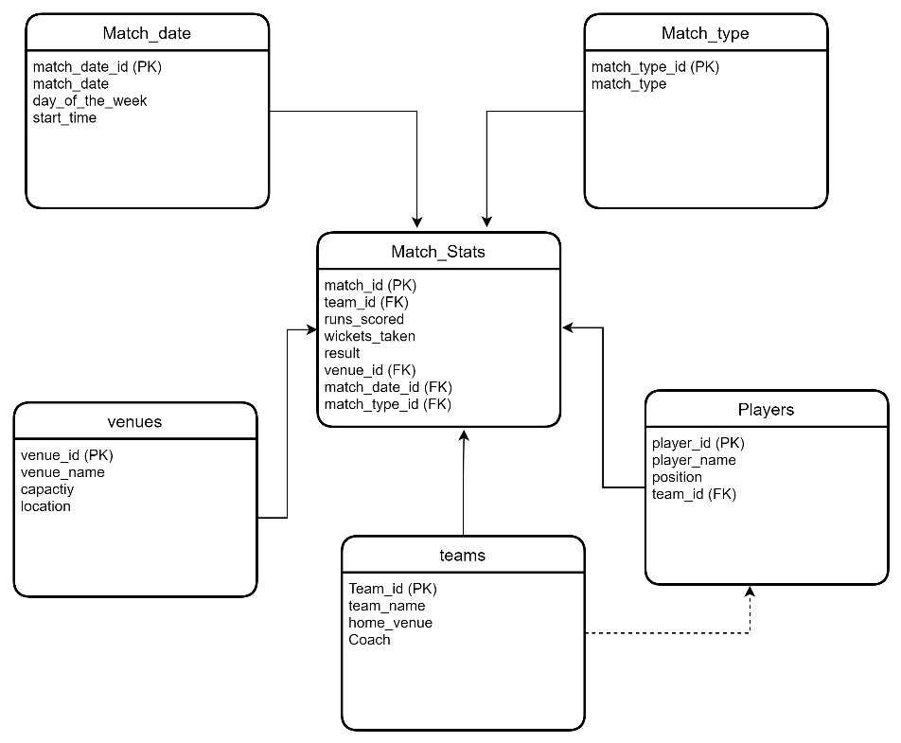

**-> Total runs scored by each team in a given season:**

SELECT t.team_name, SUM(f.runs_scored) as total_runs

FROM teams t

JOIN match_facts f ON t.team_id = f.team_id

GROUP BY t.team_name

**-> Average runs scored by each player in a given season:**

SELECT p.player_name, AVG(f.runs_scored) as avg_runs

FROM players p

JOIN match_facts f ON p.player_id = f.player_id

GROUP BY p.player_name