UNIFIED DIAGNOSTIC LABORATORY
+ BLOOD BANK + BILLING SAAS
Business Requirements | Product Requirements | System Design | Database Design | Implementation Plan
Product principle
One login. One application. One patient record. Pathology, billing, reporting and blood bank are modules inside the same workspace. Many users and many computers can work simultaneously on the same tenant data.

Item | Detail
Document version | 1.0
Prepared for | Unified Lab Pathology + Blood Bank SaaS product
Date | 08 October 2026
Primary deployment | Cloud, offline-first desktop, on-prem/local server, hybrid
Target market | Diagnostic labs, pathology centres, blood banks, hospitals with in-house labs, collection centres
Primary client surfaces | Web, Windows desktop, mobile apps, analyzer connector
Architecture goal | Lightweight, modular, multi-tenant, role-based, auditable, offline-capable
Compliance posture | Designed to support accreditation and regulatory controls; final compliance requires validation, SOPs and implementation against applicable standards/guidelines.

1. Executive Summary
This document defines the requirements and implementation blueprint for a unified diagnostic laboratory platform combining pathology laboratory operations, patient registration, billing, referral management, report generation, blood bank management, inventory, analyzer integration, role-based access control, subscriptions, licensing and offline-first operation.
The product is deliberately designed as one application rather than separate pathology, billing and blood-bank products. A diagnostic centre can enable all modules or only the modules it needs. Reception desks can use the same system from multiple computers, while technicians, pathologists, accountants and blood-bank staff can work simultaneously on the same shared data.
The platform must support cloud SaaS, Windows desktop, mobile and local/offline deployments. In offline mode, the installation continues operating against local data and synchronizes with the cloud when connectivity returns. Annual offline licensing is supported; access should transition to a controlled renewal state after expiry without silently deleting or corrupting clinical data.

2. Product Vision
Build a clean, fast and configurable Laboratory Information and Operations Platform that is simple enough for a reception user but deep enough for a diagnostic centre with multiple departments, branches, analyzers and blood-bank workflows.
Design principle | Requirement
Unified workspace | One login, one application shell, common navigation and shared patient identity across pathology, billing and blood bank.
Configurable | Modules, screens, fields, permissions, report templates, pricing, discounts and referral rules can be configured per tenant/branch.
Concurrent | Multiple staff members and computers can perform different or similar tasks at the same time with transaction-safe writes and live queue updates.
Offline-first | Core operations continue without internet in supported offline deployments. Sync is explicit, encrypted and conflict-aware.
Auditable | Clinical result changes, report amendments, approvals, billing overrides, stock actions and administrative changes have audit records.
Lightweight | Fast initial load, lazy-loaded modules, compact APIs, background jobs and optimized queries.
Integration-ready | Analyzer connectors, HL7/FHIR adapters, messaging, storage and payment integrations use adapter interfaces rather than hard-coded vendor logic.

3. Scope and Product Boundaries

3.1 In scope
- Multi-tenant SaaS and single-organization deployments.
- One unified app shell with modules for pathology, billing, blood bank, referrals, reports, inventory, users, RBAC and administration.
- Multi-user and multi-PC simultaneous operation.
- Patient registration, search, order management, sample lifecycle, result management and report delivery.
- Blood donor and blood component management, inventory, testing, cross-matching and issue/return/discard workflows.
- Billing, GST configuration, discounts, payments, refunds, credits, pricing and referral commissions.
- 100+ starter report templates plus a reusable custom report designer.
- Analyzer integrations through configurable connectors and mapping rules.
- Web application, Windows desktop application, mobile apps and analyzer connector/service.
- Cloud storage, local storage, scheduled backup and import/export.
- Annual SaaS/offline licensing and feature/module entitlements.
- RBAC with granular actions, role assignment, branch and department scope.

3.2 Out of scope for the initial platform
- Full hospital EHR/HMIS replacement including nursing, OT, radiology PACS and pharmacy unless later added as separate modules.
- Device-specific analyzer drivers that are not technically documented by the analyzer vendor. These should be implemented as connector adapters after protocol verification.
- Guaranteeing accreditation or regulatory certification by software alone. The software should provide controls and evidence; the operating organization remains responsible for SOPs, staff competence, validation and accreditation requirements.
- Automated medical diagnosis. The application may calculate, flag or format results, but clinical interpretation remains under authorized personnel.

4. Users, Personas and Work Environments
Persona | Primary tasks | Typical device
Organization Admin | Tenant settings, users, roles, branches, pricing, modules, reports, license | Web/Desktop
Receptionist | Patient registration, order, billing, payment, barcode, print report | Desktop/Web
Billing Executive | Invoices, discounts, payments, refunds, ledger, daily closing | Desktop/Web
Lab Technician | Sample receive/collect/process, result entry, QC-related tasks | Desktop/Web/Mobile
Pathologist | Result review, verification, approval, digital signature, amendments | Desktop/Web/Tablet
Blood Bank Technician | Donor, screening, collection, component processing, stock and issue | Desktop/Web/Mobile
Blood Bank Manager | Approval, inventory controls, expiry, wastage and regulatory reports | Web/Desktop
Referral Manager | Doctor/hospital/lab relationships and commission settlement | Web/Desktop
Accountant | Ledger, collections, refunds, reconciliation and reports | Web/Desktop
Collection Centre User | Patient registration, sample collection, dispatch and receipt tracking | Web/Mobile
Super Admin | SaaS plans, tenants, support, feature flags, templates, licenses and system health | Web

Key operating model
A pathology centre may have four reception computers and four different reception users. Each user can have the same Receptionist role and work simultaneously on registration, billing, report printing and sample workflows. The permission model controls actions; the computer does not define the role.

5. Functional Architecture
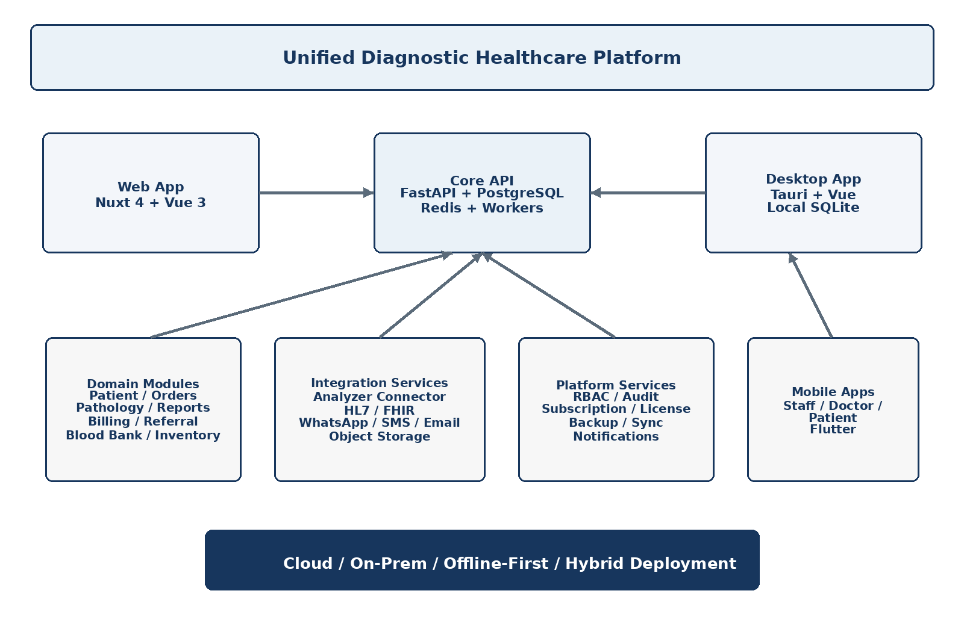
Figure 1. Unified application architecture

5.1 Core application modules
# | Module | Primary scope
1 | Platform Administration | Tenant, branches, modules, settings, branding, subscription, licenses, feature flags, audit and backup.
2 | Identity and RBAC | Authentication, sessions, roles, permissions, branch scope, department scope, data scope, overrides.
3 | Patient Management | Registration, UHID, demographics, addresses, identifiers, history, documents, consent and duplicate detection.
4 | Pathology / LIMS | Test master, profiles, packages, orders, samples, barcodes, worklists, results, validation, approval and report release.
5 | Billing | Rate lists, invoices, discounts, GST configuration, payments, refunds, credits, receipts, cash closure and reconciliation.
6 | Referral Management | Doctors, hospitals, external labs, referral contracts, discount rules, commission rules, ledger and settlement.
7 | Reporting | Report designer, template library, versioning, QR verification, signatures, delivery and report history.
8 | Blood Bank | Donors, screening, donation, components, testing, quarantine/release, stock, cross-match, issue, return, discard and adverse events.
9 | Inventory | Reagents, consumables, blood components, lot/batch, expiry, min/max stock, purchase/issue/adjustment and alerts.
10 | Analyzer Integration | Connector service, ASTM/HL7/TCP/serial/file input, mapping, raw messages, result import, error queue.
11 | Notifications | Email, SMS, WhatsApp, push, templates, queues, delivery tracking and retry.
12 | Analytics | Operational dashboards, TAT, revenue, test volumes, stock, referral, user activity and quality indicators.
13 | Import/Export | CSV/XLSX/JSON/PDF exports, bulk imports, mapping, validation, dry run and rollback where feasible.
14 | Sync and Offline | Local database, change queue, sync engine, device registration, conflict handling and status dashboards.

6. Unified UI/UX Requirements
The application should look and behave as one product. Users should not feel that pathology, billing and blood bank are separate systems. The left navigation, header, global search, patient drawer, notification center, shortcuts and action patterns should remain consistent across modules.

6.1 Recommended global navigation
Dashboard
Patients
Orders & Samples
Pathology
Reports
Billing
Referral Partners
Blood Bank
Inventory
Doctors / Hospitals / Labs
Templates
Analytics
Imports & Exports
Administration
Top bar: Global Search | Notifications | Branch | User Profile

6.2 Configurable home dashboard
- Widgets are permission-aware and module-aware. If Blood Bank is disabled, blood-bank widgets are not shown.
- Admin can configure default widgets per role.
- Users can pin frequent actions: New Patient, New Order, Collect Sample, Quick Billing, Print Report, Blood Issue.
- Operational queues should be visible without navigating through multiple screens.
- Global patient search should return patient, UHID, mobile, order, invoice, report and sample references where permitted.

7. RBAC, Roles and Permission Model
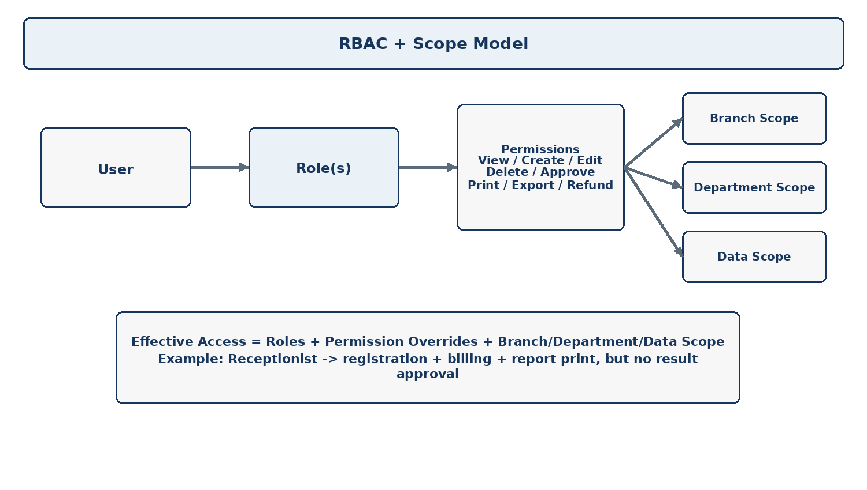
Figure 2. Role, permission and scope model
Permissions must be granular. A single manage toggle is insufficient for a healthcare application because viewing, editing, approving, refunding, printing and exporting can have different risk levels.

7.1 Permission naming standard
<module>.<resource>.<action>
Examples:
patient.patient.create
patient.patient.view
billing.invoice.create
billing.invoice.discount
billing.invoice.refund
lab.result.enter
lab.result.verify
lab.result.approve
report.report.amend
blood.stock.issue
blood.stock.discard
admin.user.manage

7.2 Role structure
Role | Typical access
Super Admin | SaaS-wide administration; no tenant clinical access unless explicitly granted for support.
Organization Admin | Tenant-wide configuration, users, roles, modules, pricing, templates and reports.
Lab Admin | Pathology and laboratory configuration and operational oversight.
Receptionist | Patient registration, order, billing, payment, barcode, report view/print.
Billing Executive | Invoices, payments, discounts within assigned limits, refunds if permitted.
Lab Technician | Samples, worklists, result entry and technical operations.
Pathologist | Result review, report approval, signature, amendment and critical-result workflow.
Blood Bank Technician | Donor, donation, component, test, stock and cross-match operations.
Blood Bank Manager | Approval, stock controls, wastage, regulatory reporting and oversight.
Accountant | Financial reports, settlement, reconciliation, ledger and audit views.
Custom Role | Any configurable combination of permissions, branch scope and department scope.

7.3 Multiple roles per user
A user may have more than one role. The effective permission set is the union of assigned role permissions, subject to explicit deny/override policy. The system must store why an elevated permission exists and log sensitive actions.

7.4 Scope controls
Scope | Examples
Organization | All branches in one tenant
Branch | Noida branch only
Department | Hematology + Biochemistry
Resource owner | Records created by the user, where required
Data class | Clinical, billing, blood-bank or administrative
Action limit | Discount up to 10%; refund up to configured amount

8. Business Requirements
ID | Area | Requirement
BR-001 | Unified operations | Pathology, billing and blood bank must be available from one login and application shell.
BR-002 | Multi-user | Multiple users can work simultaneously on the same tenant and branch.
BR-003 | Multi-PC | Multiple computers in reception, lab and blood bank can operate concurrently against shared data.
BR-004 | Configurable modules | Tenant admin can enable/disable modules and selected features.
BR-005 | Annual licensing | Offline installations can be licensed for a fixed period and renewed annually.
BR-006 | Cloud subscription | Cloud deployments support subscription plans, entitlements and usage limits.
BR-007 | Offline continuity | Supported offline deployments continue core operations when internet is unavailable.
BR-008 | Sync | Changes made offline are queued and synchronized with the cloud when connectivity returns.
BR-009 | Patient identity | One patient identity is shared across orders, billing, reports and blood-bank records.
BR-010 | Configurable pricing | Rates, packages, corporate rates, referral rates and discounts are configurable.
BR-011 | Referral accounting | Doctor/hospital/lab referral commission and patient discount rules are calculated automatically.
BR-012 | Report customization | Users with permission can choose and configure report templates; final approval is controlled.
BR-013 | Analyzer import | Analyzer results can be imported automatically where protocol support is available.
BR-014 | Audit | Sensitive changes have immutable or tamper-evident audit records.
BR-015 | Import/export | Data can be imported/exported with validation, logs and permissions.
BR-016 | Backup | Tenant and installation backup/restore workflows are available.
BR-017 | Notifications | Report-ready and operational alerts can be delivered through configured channels.
BR-018 | Integration | API and interoperability adapters support external systems without changing the core domain model.

9. End-to-End Pathology Workflow
Patient Search / New Patient
-> Registration / Duplicate Check
-> Referral Source
-> Test / Profile / Package Selection
-> Pricing + Discount Rule
-> Invoice + Payment
-> Sample Collection
-> Barcode Print
-> Sample Receive / Accession
-> Analyzer / Manual Result
-> Result Validation
-> Abnormal / Critical Flag
-> Technical Verification
-> Pathologist Review / Approval
-> Report Render + Signature + QR
-> Print / Download / WhatsApp / SMS / Email
-> Amendment workflow if required

9.1 Patient registration requirements
- Patient number/UHID generation with configurable prefix and branch scope.
- Duplicate detection using configurable matching rules such as mobile, name + DOB, external identifier and other tenant-defined criteria.
- Ability to register a patient without forcing every optional field.
- ABHA field/linking should be treated as an integration/identity feature and must follow the current ABDM implementation and consent requirements at the time of production deployment.
- Patient merge must be restricted, audited and reversible through a controlled workflow where feasible.

9.2 Sample lifecycle
ORDERED -> COLLECTED -> BARCODED -> RECEIVED -> ACCEPTED
|
-> REJECTED (reason required)
RECEIVED -> IN PROCESS -> RESULT ENTERED -> VERIFIED -> RELEASED

10. Test Master and Result Engine
Tests are not just display names. Each test must be a structured definition that can drive ordering, billing, specimen handling, analyzer mapping, result entry, reference ranges and reporting.
Field | Purpose
test_code | Unique stable internal code
display_name | Human-readable test name
department_id | Hematology, Biochemistry, Serology, etc.
specimen_type | Blood, serum, plasma, urine, swab, etc.
container_type | Tube/container definition
method | Method/assay
unit | Result unit
decimal_precision | Display precision
reference_range | Age/sex/condition-specific range
critical_low / high | Critical thresholds
calculation_formula | Derived value calculation
analyzer_code | Machine mapping identifier
loinc_code / local_code | Interoperability or local coding field
turnaround_time | Operational TAT
active_from / active_to | Versioned validity
report_group | Placement in report template

10.1 Profiles and packages
- Test profile groups multiple analytes for ordering and reporting.
- Package can bundle tests with commercial pricing, optional discount and referral rules.
- An individual test may appear in multiple profiles/packages without duplicating the underlying test definition.
- Package price should not destroy line-level auditability; invoice lines should preserve the final allocated amounts.

11. Blood Bank Module
The Blood Bank module shares patient, user, audit, billing, inventory and reporting infrastructure with the rest of the platform but maintains its own domain state machine and stricter authorization rules.

11.1 Donor workflow
Donor Registration
-> Identity / History
-> Screening Questionnaire
-> Eligibility Decision
-> Donation
-> Component Processing
-> TTI / Required Testing
-> Quarantine
-> Release / Reject / Discard
-> Inventory

11.2 Inventory states
COLLECTED -> TESTING -> QUARANTINED -> RELEASED -> RESERVED -> ISSUED
|
-> EXPIRED / DISCARDED
ISSUED -> RETURNED (only under approved rules)
Capability | Requirements
Donor | Registration, history, questionnaire, deferral, repeat donor tracking
Donation | Donation event, collection details, component generation
Testing | Blood group, TTI/infectious screening fields, quality checks, verification
Components | RBC, plasma, platelets, cryoprecipitate and configurable components
Barcode | Configurable labels; support for required local or ISBT-style encoding where implemented and validated
Stock | Real-time availability, location, blood group, component, lot, expiry
Cross-match | Compatibility workflow, patient/sample linkage, test results and approval
Issue | Request, reservation, issue, return, discard and traceability
Alerts | Low stock, expiring units, pending testing, quarantine and exceptions
Reporting | Regulatory and operational reports with configurable formats

External blood-bank ecosystem note
The e-RaktKosh platform describes donor management, blood grouping, TTI screening, component preparation, centralized inventory, alerts and statutory reporting. The product should therefore model these as first-class domain concepts and keep an integration boundary for current government workflows rather than assuming a static API contract.

12. Billing, Discount and Referral Commission Engine
Billing must work from the same patient/order context as pathology. A receptionist should be able to register a patient, select tests, choose a referral source, apply an eligible discount, collect payment and print the receipt without moving to another application.

12.1 Pricing resolution order
Base Test Price
-> Branch Rate / Tenant Rate
-> Package / Profile Rule
-> Corporate / Contract Rate (if applicable)
-> Referral Discount Rule
-> Manual Discount (if permitted)
-> Taxes / GST configuration
-> Final Invoice Amount

12.2 Referral rule model
Rule field | Example
partner_type | Doctor / Hospital / Lab / Collection Centre / Corporate
partner_id | Dr. X
scope | All tests / Department / Test / Package
effective_from | 2026-10-01
effective_to | Optional
patient_discount_pct | 5%
commission_pct | 10%
commission_fixed | Optional
priority | Higher priority wins if multiple rules match
approval_required | Yes/No
status | Active/Inactive

12.3 Financial rules
- Invoice totals must be deterministic and reproducible from stored line/rule snapshots.
- Discount and commission rules used at invoice time must be preserved with the invoice; later rule changes must not rewrite history.
- Refunds and cancellations must generate accounting/audit events rather than deleting invoices.
- Commission settlement should use a ledger model, not just a summary field on the doctor record.
- Authorization thresholds should support amount-based approval for discounts and refunds.

13. Report Engine and Custom Report Designer
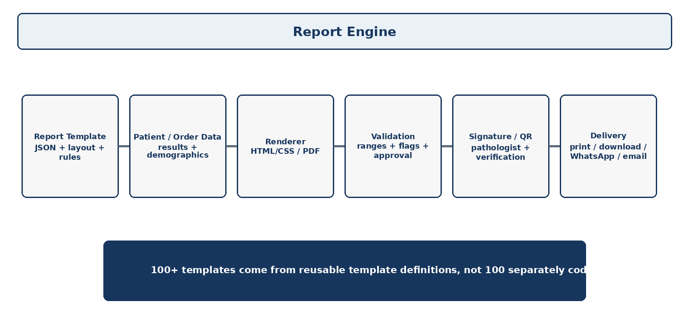
Figure 3. Report generation pipeline
The system should ship with 100+ starter templates, but these templates should be definitions stored in the database/object store rather than 100 hard-coded screens. The same renderer should support preview, PDF generation and print output.

13.1 Report designer components
- Header, footer, logo and organization branding.
- Patient demographics block.
- Doctor/referral source block.
- Test/result table with reference range and flags.
- Grouped sections and profiles.
- Conditional visibility rules.
- Charts, histograms and image blocks where clinically appropriate.
- Barcode and QR verification blocks.
- Digital signature and authorization block.
- Page numbering, print margins and paper size.
- Watermark and status such as DRAFT/FINAL/CORRECTED.
- Multi-language labels and custom static text.
- Template versioning with publish/rollback capability.

13.2 Sample template model
{
"template_id": "CBC-A4-001",
"version": 3,
"page": {"size": "A4", "orientation": "portrait"},
"blocks": [
{"type": "patient", "x": 24, "y": 38, "w": 540, "h": 62},
{"type": "result_table", "source": "CBC", "x": 24, "y": 120, "w": 540, "h": 360},
{"type": "qr", "source": "report_verification", "x": 480, "y": 700}
],
"footer": {"show_page_number": true}
}

14. Analyzer Integration Architecture
Analyzer
|
+-- Serial / TCP / ASTM / HL7 / File Drop
|
v
Analyzer Connector Service
|-- Device Health
|-- Raw Message Capture
|-- Parser
|-- Mapping Engine
|-- Patient/Sample Matching
|-- Validation
+-- Error / Retry Queue
|
v
Result Import API
|
v
Result Store -> Verification -> Report

14.1 Connector requirements
- Connector runs close to the analyzer, typically on a Windows PC/local server.
- No analyzer should need to expose inbound ports directly to the public internet.
- Each analyzer has a configurable protocol and mapping profile.
- Raw messages are retained for troubleshooting according to retention policy.
- Patient/sample matching must be deterministic; uncertain matches go to an exception queue instead of silently attaching results.
- Imported results are distinguishable from manually entered results in audit history.
- Connection status, last message, last success, queue depth and error count are visible to authorized users.

15. Offline-First and Hybrid Deployment
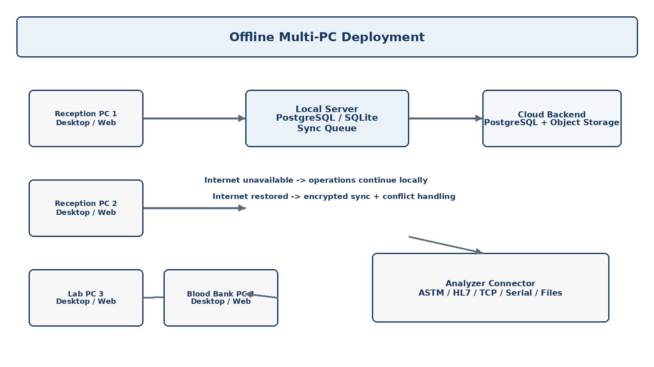
Figure 4. Offline multi-PC topology
For an offline diagnostic centre with multiple computers, a shared local server is preferable to giving each PC an independent database. The local server becomes the authoritative local source for the site, while cloud synchronization occurs when connectivity is restored.

15.1 Offline operating modes
Mode | Description
Cloud | All clients connect to central cloud services; recommended for normal SaaS deployments.
Local / Offline | Local server and local database provide continuity without internet.
Hybrid | Local operations continue during outages, then sync selected changes to cloud.
On-prem | Organization runs application services in its own environment; licensing and update policy remain managed by vendor.
Desktop standalone | Single-PC demo or very small installation; limited collaboration compared with local-server deployment.

15.2 Sync data model
Every syncable record should contain at minimum:
id
tenant_id
branch_id
created_at
updated_at
deleted_at
version
origin_device_id
sync_status
server_version
Change Queue:
local_change -> pending -> sent -> acknowledged -> applied
-> conflict -> resolved

15.3 Conflict policy
- Never silently overwrite clinical results or blood-bank inventory with last-write-wins.
- Use server-side transactional checks for stock, payment and result approval.
- Patient demographics may use field-level merge in low-risk fields, but merge decisions should be logged.
- For clinical result conflicts, stop synchronization of the conflicting record and present a controlled resolution workflow to an authorized user.
- All conflict decisions create audit events.

16. SaaS Subscription and Offline License System
The commercial model separates subscription/entitlement data from clinical operations. A customer can purchase a cloud plan, an offline annual license or a hybrid plan with selected modules and limits.
Entity | Key fields
Plan | plan_code, name, billing_cycle, included_modules, user_limit, branch_limit, storage_limit
Subscription | tenant_id, plan_id, start_at, end_at, status, payment_reference, auto_renew
License | license_key, tenant_id, deployment_mode, issued_at, expires_at, features, limits, status
Device | device_id, tenant_id, branch_id, fingerprint, last_seen_at, license_status
Entitlement | tenant_id, module_code, enabled_from, enabled_to, limits
Renewal | previous_license, new_license, extension_days, payment_reference, actor

Expiry behavior
Do not delete data at expiry. The product should enter a controlled state such as renewal-required or restricted operational mode defined by contract. Read-only access and export/backup options should be planned so records remain recoverable. Exact grace-period and lock rules should be a commercial/legal decision.

17. Storage, Backup, Import and Export

17.1 File storage
- Object storage should hold reports, logos, signatures and attachments; database stores metadata and secure object references.
- Storage adapter interface should support cloud object storage and local filesystem storage.
- Files should have tenant isolation, checksums, size limits and retention metadata.
- Access should use short-lived signed URLs or server-mediated streaming rather than exposing permanent public file URLs.

17.2 Import/export
Data set | Formats | Rules
Patients | CSV/XLSX/JSON | Preview, field mapping, duplicate detection, validation
Tests | CSV/XLSX/JSON | Codes unique, units/ranges validated
Rates | CSV/XLSX | Effective dates and duplicate rule checks
Doctors/partners | CSV/XLSX | Partner type and identifiers required
Opening stock | CSV/XLSX | Batch/lot/expiry/quantity and unit rules
Reports | PDF/ZIP | Metadata linked to patient/report IDs where import is supported
Backup | Encrypted archive | Versioned backup and restore validation

18. Integration Strategy
Integration | Approach
ABDM / ABHA | Adapter layer; use current official implementation guides, consent flows and credentials. Store external identifiers separately from internal patient ID.
HL7 / FHIR | Interoperability gateway with canonical internal model. Map Patient, ServiceRequest/DiagnosticReport/Observation and related resources as applicable.
Analyzer | Local connector using device protocol adapters.
WhatsApp/SMS/Email | Notification provider adapters with templates and delivery status.
Payment gateway | Billing adapter; payment callbacks recorded as immutable payment events.
Storage | S3-compatible/local storage adapter.
External HIMS/EMR | API/webhook/HL7/FHIR connectors with tenant-specific configuration.

19. Technical System Architecture

19.1 Recommended technology stack
Layer | Technology | Why
Web | Nuxt 4 + Vue 3 + TypeScript | Fast unified app shell, strong component ecosystem, SSR/SPA flexibility
UI | Tailwind CSS + headless component primitives | Consistent design system and small reusable UI units
State | Pinia + query/cache layer | Predictable client state and server data caching
Backend | FastAPI + Python | Strong API productivity, validation, async support and integration libraries
Database | PostgreSQL 16+ target | Transactions, JSONB where needed, indexing, mature tooling
Cache / queue | Redis | Cache, rate limiting, ephemeral state and background job queues
Background jobs | Celery/ARQ or equivalent | Notifications, report generation, imports, sync and other asynchronous work
Desktop | Tauri + Vue | Lower footprint than Electron in many deployments; Windows-first packaging
Mobile | Flutter | Single codebase for Android/iOS, suitable for scanning and field workflows
Local DB | SQLite for client cache/local operation; PostgreSQL for multi-PC local server | Simple single-PC storage plus stronger local multi-user server option
Reports | HTML/CSS renderer + PDF engine | One template model for preview and PDF
Object storage | S3-compatible abstraction | Cloud/local storage portability
Containers | Docker | Repeatable deployments, testing and local development
Reverse proxy | Nginx/Caddy/managed ingress | TLS termination and routing
Monitoring | OpenTelemetry + Prometheus/Grafana + error tracking | Traceability across API, workers and connectors
CI/CD | GitHub Actions/GitLab CI | Tests, lint, builds, migrations and deployment automation

19.2 Service boundaries
API Gateway / Web App
|
+-- Identity & RBAC
+-- Patient Service
+-- Lab Service
+-- Billing Service
+-- Referral Service
+-- Blood Bank Service
+-- Report Service
+-- Inventory Service
+-- Notification Service
+-- Integration Service
+-- Sync Service
+-- Admin / License Service
Initial implementation may be a modular monolith. Extract services only after load, ownership or deployment constraints justify it.
Architecture recommendation
Start as a modular monolith with clear domain boundaries and background workers. Do not start with 12 independent microservices. This keeps development and debugging manageable while preserving a path to service extraction later.

20. Database Design
The database must be relational-first. Clinical, billing and inventory workflows need transactions, constraints and consistent relationships. JSONB is useful for flexible configuration, report layout definitions and integration payloads, but core clinical and financial facts should remain strongly structured.

20.1 Database naming conventions
- Lowercase snake_case for table and column names.
- Singular conceptual names for major resources are acceptable; use one convention consistently.
- UUID/ULID identifiers for externally exposed records; numeric surrogate keys may be used internally if carefully isolated.
- Every tenant-owned table must include tenant_id unless the table is provably global.
- Dates use timestamptz in UTC at rest; display converts to organization timezone.
- Use created_at, updated_at; soft deletion only where business history requires it.
- Immutable clinical/financial events should be append-only where possible.

20.2 Core entity relationship map
TENANT
├── BRANCH
│ ├── USERS / ROLES / PERMISSIONS
│ ├── PATIENTS
│ │ ├── ORDERS -> ORDER_ITEMS -> TESTS
│ │ ├── SAMPLES -> SAMPLE_EVENTS
│ │ ├── RESULTS -> RESULT_VALUES
│ │ └── REPORTS -> REPORT_VERSIONS
│ ├── INVOICES -> PAYMENTS
│ ├── REFERRAL_PARTNERS -> RULES -> LEDGER
│ └── BLOOD BANK
│ ├── DONORS -> DONATIONS
│ ├── COMPONENTS / UNITS
│ ├── TESTS / CROSS_MATCH
│ └── ISSUES / RETURNS / DISPOSALS

20.3 Identity and tenancy tables
Table | Key columns / purpose
tenants | id, legal_name, display_name, status, timezone, country, settings_json
branches | id, tenant_id, name, code, address, timezone, status
departments | id, tenant_id, branch_id, name, type, status
users | id, tenant_id, username/email, password_hash, status, last_login_at
roles | id, tenant_id, name, description, is_system, status
permissions | id, code, module, resource, action, risk_level
role_permissions | role_id, permission_id, allow
user_roles | user_id, role_id, branch_scope_json, department_scope_json
user_permission_overrides | user_id, permission_id, allow, reason, expires_at
user_sessions | id, user_id, device_id, refresh_token_hash, issued_at, expires_at, revoked_at
devices | id, tenant_id, branch_id, device_type, fingerprint, app_version, last_seen_at
api_keys | id, tenant_id, name, key_hash, scopes, expires_at, status
audit_logs | id, tenant_id, actor_id, action, entity_type, entity_id, before_json, after_json, ip, created_at

20.4 Patient tables
Table | Key columns / purpose
patients | id, tenant_id, patient_no, first_name, last_name, dob, sex, mobile, email, status
patient_identifiers | id, patient_id, type, value, issuer, is_primary
patient_addresses | id, patient_id, type, address fields
patient_contacts | id, patient_id, contact_name, relationship, phone
patient_consents | id, patient_id, consent_type, status, captured_at, source
patient_documents | id, patient_id, document_type, object_key, checksum
patient_external_ids | id, patient_id, system, external_id, metadata_json
patient_merges | id, tenant_id, survivor_patient_id, merged_patient_id, reason, actor_id
patient_notes | id, patient_id, note_type, body, author_id

20.5 Test and configuration tables
Table | Key columns / purpose
lab_departments | id, tenant_id, code, name, status
specimen_types | id, tenant_id, code, name, handling
container_types | id, tenant_id, code, name, specimen_compatibility
tests | id, tenant_id, code, name, department_id, specimen_type_id, unit, method, status
test_parameters | id, test_id, code, name, datatype, unit, sort_order
test_reference_ranges | id, test_parameter_id, sex, age_min, age_max, low, high, critical_low, critical_high
test_calculations | id, test_id, formula, variables_json, version
test_profiles | id, tenant_id, code, name, department_id
profile_items | profile_id, test_id, sort_order
test_packages | id, tenant_id, code, name, price, status
package_items | package_id, test_id, quantity, sort_order
test_analyzer_mappings | id, analyzer_id, test_id, analyzer_code, parameter_code

20.6 Orders, samples and results tables
Table | Key columns / purpose
orders | id, tenant_id, branch_id, patient_id, order_no, status, referral_partner_id, ordered_at
order_items | id, order_id, test_id, profile_id/package_id, price, discount, tax, status
samples | id, order_id, patient_id, barcode, specimen_type_id, collected_at, received_at, status
sample_events | id, sample_id, event_type, event_at, actor_id, notes
worklists | id, tenant_id, department_id, worklist_date, status
worklist_items | worklist_id, sample_id, test_id, assigned_to, status
results | id, order_item_id, result_status, verification_status, entered_by, verified_by, approved_by
result_values | id, result_id, parameter_id, value_text, value_numeric, flag, unit, reference_snapshot_json
result_amendments | id, result_id, old_value_json, new_value_json, reason, actor_id
critical_notifications | id, result_id, threshold_type, recipient, notified_at, acknowledgment_status

20.7 Reporting tables
Table | Key columns / purpose
report_templates | id, tenant_id, code, name, report_type, status, current_version_id
report_template_versions | id, template_id, version_no, definition_json, schema_version, published_at, published_by
reports | id, tenant_id, patient_id, order_id, report_no, status, template_version_id, final_at
report_files | id, report_id, object_key, checksum, mime_type, generated_at
report_signatures | id, report_id, signer_user_id, signature_type, signed_at, signature_hash
report_delivery_events | id, report_id, channel, destination_hash, status, provider_message_id, sent_at
report_amendments | id, report_id, reason, previous_version_id, new_version_id, actor_id

20.8 Billing tables
Table | Key columns / purpose
rate_lists | id, tenant_id, branch_id, name, effective_from, effective_to, status
rate_list_items | rate_list_id, test_id/package_id, price
invoices | id, tenant_id, branch_id, patient_id, invoice_no, subtotal, discount, tax, total, status
invoice_items | id, invoice_id, order_item_id, item_type, gross, discount, tax, net, rule_snapshot_json
payments | id, invoice_id, payment_no, method, amount, status, provider_reference
refunds | id, payment_id, amount, reason, approved_by
cash_sessions | id, branch_id, user_id, opened_at, opening_cash, closed_at, closing_cash
cash_transactions | id, cash_session_id, invoice/payment/refund, amount, type
discount_rules | id, tenant_id, scope_json, discount_type, value, priority, effective dates
financial_adjustments | id, invoice_id, type, amount, reason, actor_id

20.9 Referral tables
Table | Key columns / purpose
referral_partners | id, tenant_id, partner_type, name, registration_no, status
referral_rules | id, partner_id, scope_json, discount_pct, commission_pct, fixed_commission, priority
referral_ledger | id, partner_id, invoice_id, amount, type, status, settlement_id
referral_settlements | id, partner_id, period_start, period_end, amount, status, approved_by
referral_contacts | id, partner_id, name, phone, email

20.10 Blood bank tables
Table | Key columns / purpose
donors | id, tenant_id, donor_no, name, dob, sex, blood_group, contact, status
donor_screenings | id, donor_id, questionnaire_version, eligibility, deferral_reason, screened_by
donor_deferrals | id, donor_id, start_at, end_at, reason, status
donations | id, donor_id, donation_no, collected_at, collection_site, status
blood_units | id, donation_id, unit_no, component_type_id, blood_group, volume, expiry_at, status
blood_components | id, code, name, storage_temp, shelf_life
blood_unit_tests | id, blood_unit_id, test_code, result, status, verified_by
blood_quarantine | id, blood_unit_id, reason, start_at, released_at
crossmatches | id, patient_id, sample_id, blood_unit_id, result, verified_by
blood_requests | id, tenant_id, patient_id, requester, urgency, status
blood_issues | id, blood_request_id, blood_unit_id, issued_at, issued_by
blood_returns | id, blood_issue_id, returned_at, reason, disposition
blood_disposals | id, blood_unit_id, disposed_at, reason, approved_by
adverse_events | id, patient_id, blood_issue_id, event_type, severity, reported_at

20.11 Inventory tables
Table | Key columns / purpose
inventory_items | id, tenant_id, item_type, code, name, unit, reorder_level
inventory_lots | id, item_id, lot_no, expiry_at, quantity, location_id
inventory_transactions | id, lot_id, transaction_type, quantity, source_ref, actor_id
inventory_locations | id, branch_id, name, type
inventory_alerts | id, lot_id/item_id, alert_type, status, created_at

20.12 Integration/sync tables
Table | Key columns / purpose
analyzers | id, tenant_id, branch_id, name, protocol, host, port, status
analyzer_connections | id, analyzer_id, connected_at, disconnected_at, status
analyzer_messages | id, analyzer_id, direction, message_type, raw_payload, received_at
analyzer_errors | id, analyzer_id, message_id, error_code, details, status
integration_endpoints | id, tenant_id, type, base_url, credential_ref, status
webhook_subscriptions | id, tenant_id, event_type, endpoint, secret_ref, status
sync_events | id, tenant_id, device_id, entity_type, entity_id, operation, payload_hash, status
sync_conflicts | id, sync_event_id, entity_type, entity_id, conflict_type, resolution, resolved_by
background_jobs | id, tenant_id, job_type, payload_json, status, attempts, run_at

20.13 Critical indexes and constraints
- Unique: (tenant_id, patient_no), (tenant_id, invoice_no), (tenant_id, order_no), (tenant_id, report_no).
- Index patient search on normalized mobile, patient_no, identifier values and name search strategy.
- Composite indexes for operational queues: (tenant_id, branch_id, status, updated_at).
- Blood stock indexes on (branch_id, blood_group, component_type_id, status, expiry_at).
- Result lookup indexes on order_item_id and verification/approval status.
- Use database constraints for non-negative financial amounts, valid quantity ranges and unique external identifiers.
- All foreign keys must have deliberate delete behavior. Do not cascade-delete clinical history by default.

21. API Design
/api/v1/auth/*
/api/v1/tenants/*
/api/v1/users/*
/api/v1/roles/*
/api/v1/patients/*
/api/v1/orders/*
/api/v1/samples/*
/api/v1/tests/*
/api/v1/results/*
/api/v1/reports/*
/api/v1/billing/*
/api/v1/referrals/*
/api/v1/blood-bank/*
/api/v1/inventory/*
/api/v1/analyzers/*
/api/v1/sync/*
/api/v1/imports/*
/api/v1/exports/*
/api/v1/admin/*

21.1 API rules
- All tenant-scoped APIs derive tenant_id from authenticated context, never from an untrusted frontend field alone.
- Authorization is evaluated server-side for every protected endpoint.
- Use idempotency keys for payment callbacks, sync replay and other operations that may be retried.
- Paginate all large collections; never return unbounded patient/result lists.
- Use cursor pagination for high-volume activity or transaction feeds.
- API error format should include code, message, field errors and correlation ID.
- Long-running exports, PDF batches and imports run as background jobs.

22. Security and Privacy Requirements
Area | Requirement
Authentication | Strong password policy, MFA option for administrators, secure session/refresh tokens, device/session revocation.
Authorization | Server-side RBAC; branch and department scope enforced in every query path.
Encryption | TLS in transit; encrypted storage and backups; secret manager for integration credentials.
Audit | Sensitive actions logged with actor, time, entity, reason and before/after metadata when appropriate.
Clinical changes | Result/report amendments require reason and preserve previous version.
File access | Private by default, signed/temporary access, tenant isolation.
Exports | Export permission is explicit and should be logged; bulk export may require elevated approval.
Payments | Do not store payment card credentials; use provider tokens/references.
Secrets | Never store analyzer passwords, API keys or signing credentials in source code.
Data retention | Configurable per tenant and applicable legal/clinical policy; retention changes audited.
Support access | Support impersonation should be time-limited, explicit, logged and preferably read-only by default.

23. Non-Functional Requirements
Category | Target / design goal
Page load | Common screens should feel interactive quickly; critical list pages should avoid blocking on large datasets.
API p95 | Target under 500 ms for ordinary CRUD/query endpoints under expected load; heavier operations are asynchronous.
Concurrency | Support at least 50-100 simultaneous active users per tenant as initial target; architecture should scale beyond this.
Availability | Cloud target 99.9% service availability, excluding planned maintenance, subject to chosen infrastructure.
Offline | Core workflows available during network outage for supported deployments.
Data integrity | ACID transactions for invoices, payments, stock movement and result approval.
Scalability | Horizontal API/worker scaling; read replicas introduced when justified by load.
Observability | Logs, metrics, traces, error tracking, audit logs and connector health.
Accessibility | Keyboard-friendly forms, labels, contrast and responsive layouts.
Internationalization | English first; architecture ready for Hindi and other languages.

24. Backup, Disaster Recovery and Business Continuity
Control | Recommended policy
Database backup | Automated daily full + point-in-time recovery/WAL where infrastructure supports it.
Object storage | Versioning + backup/replication according to plan.
Offline backup | Encrypted local backup to selectable location.
Restore testing | Regular restore verification; backup is not considered valid until restore is tested.
RPO | Cloud target example: 15-60 minutes depending on plan and cost.
RTO | Cloud target example: 1-4 hours for standard plans.
Audit retention | Separate audit retention from operational record deletion policies.

25. QA and Validation Strategy
Layer | Tests
Unit | Pricing calculations, permission resolution, reference ranges, commission calculation, state transitions
API | CRUD, authorization, validation, tenancy isolation, idempotency
Integration | Analyzer parsing, message mapping, report renderer, notifications, payment callbacks
Database | Constraints, migrations, query performance, rollback behavior
UI | Registration, billing, result entry, report approval, responsive behavior
Offline | Create/update while offline, reconnect, sync order, conflict cases, duplicate prevention
Security | Tenant isolation, privilege escalation, session revocation, export restrictions
Performance | Concurrent reception usage, report batch generation, analyzer bursts, large patient searches
Recovery | Backup restore, corrupted queue, partial sync recovery
UAT | Real workflow validation with reception, technician, pathologist, blood-bank and accountant users

25.1 Must-pass scenarios
- Four reception users register and bill different patients simultaneously without data mix-up.
- Two users attempt to modify the same sensitive result; authorization and version checks prevent silent overwrite.
- A sample is rejected with a reason and cannot be released as if it were accepted.
- A report is amended after release and previous version remains accessible to authorized users.
- A referral discount and commission are applied according to the active rule and preserved on the invoice.
- Blood stock issue and return correctly update available quantity and audit history.
- Internet is disconnected during active operations; supported offline workflows continue and later synchronize.
- Analyzer sends a result; system maps it to the correct sample and test, or routes it to exception queue if matching is uncertain.
- Tenant A cannot access Tenant B data using any direct identifier or API request.
- Expired offline license does not erase local data and follows the configured renewal policy.

26. Implementation Roadmap
A realistic commercial implementation is better delivered in controlled releases. A reference plan below assumes a small-to-mid sized product team and existing engineering competence; actual dates should be re-estimated after detailed workflow workshops and analyzer/API validation.
Phase | Name | Deliverables | Reference duration
Phase 0 | Discovery & architecture | Requirements workshops, UX flows, roles, deployment modes, regulatory gap analysis, domain model, prototype | 2-3 weeks
Phase 1 | Platform foundation | Tenancy, auth, RBAC, branches, users, audit, settings, design system, CI/CD | 4-6 weeks
Phase 2 | Pathology core | Patients, tests, orders, samples, barcodes, result entry, verification | 6-8 weeks
Phase 3 | Billing + referrals | Rates, invoices, payments, discount engine, referral commission ledger | 4-6 weeks
Phase 4 | Report engine | Template schema, renderer, designer, QR, signatures, starter templates | 6-8 weeks
Phase 5 | Analyzer integration | Connector service, protocol adapters, mapping, exception queues | 4-8 weeks depending on devices
Phase 6 | Blood bank | Donor, screening, components, stock, cross-match, issue/return/discard | 8-12 weeks
Phase 7 | Offline/hybrid | Local server, sync engine, conflict handling, offline license | 6-10 weeks
Phase 8 | Mobile | Staff/doctor/patient workflows, barcode/scan features | 6-10 weeks
Phase 9 | Hardening | Performance, security, backups, UAT, migration tools, release readiness | 4-6 weeks

Release strategy
Release pathology + billing + reports first. Add blood bank after the core domain and audit model are proven. Offline and analyzer integration can run in parallel once the transactional APIs and data model stabilize.

27. Suggested Engineering Team
Role | Count | Primary responsibility
Product/Business Analyst | 1 | Workflow, requirements, acceptance criteria, stakeholder coordination
Tech Lead / Architect | 1 | Domain boundaries, data model, security, integrations, technical decisions
Backend Engineers | 2-3 | FastAPI, PostgreSQL, RBAC, billing, blood bank, sync
Frontend Engineer | 2 | Nuxt/Vue, design system, complex workflows
Desktop/Integration Engineer | 1 | Tauri, analyzer connector, local deployment, device communication
Mobile Engineer | 1 | Flutter staff/doctor/patient apps
QA Engineers | 2 | Manual + automation, device/integration testing, regression
DevOps/SRE | 0.5-1 | CI/CD, observability, backups, environments, security hardening
Domain SME(s) | Part-time | Laboratory, pathology, blood-bank and compliance workflow validation

28. Environments, DevOps and Release Management
Development
|
Feature branch -> Pull Request -> Unit/API tests -> Lint/type checks
|
Staging
-> Migration test
-> Integration tests
-> UAT
|
Production
-> Migration backup
-> Deploy
-> Smoke tests
-> Monitoring
- Use database migrations (Alembic) and never alter production schema manually except emergency procedures.
- Every production release is traceable to a git commit and migration version.
- Feature flags allow modules/features to be rolled out selectively.
- Desktop and analyzer connector releases should have explicit version compatibility with backend API versions.
- Keep staging data synthetic or de-identified; do not casually copy real patient data into development environments.

29. MVP Acceptance Criteria
Area | MVP must demonstrate
Unified UX | Single login and application shell exposes enabled modules.
Reception | At least four simultaneous users can register, bill, collect samples and print reports.
Patient | One patient identity connects order, sample, result, report and invoice.
RBAC | Create custom role and assign granular permissions; unauthorized actions are rejected server-side.
Pathology | Order -> sample -> result -> verification -> report workflow works end-to-end.
Billing | Rates, discount, payment, receipt, refund and audit trail work.
Referral | Doctor/hospital/lab referral can automatically apply configured discount and commission.
Reports | At least starter templates plus template versioning and QR verification work.
Analyzer | At least one documented analyzer protocol is integrated end-to-end in a controlled environment.
Offline | Local deployment works during internet outage and synchronizes after reconnection.
Security | Cross-tenant access tests fail closed; logs are generated for sensitive actions.
Backup | A backup can be restored to a test environment successfully.

30. Key Risks and Mitigations
Risk | Mitigation
Trying to build everything at once | Use modular releases and a strict MVP boundary.
Offline sync complexity | Start with local-server multi-PC mode before fully independent client databases; build a versioned change log early.
Analyzer variability | Use connector adapters and require a device test plan for each model/protocol.
Report template complexity | Define a stable template schema and renderer before building 100+ templates.
Regulatory assumptions | Keep compliance controls configurable and validate with current official guidance and the customer laboratory SOPs.
Performance regressions | Use indexes, pagination, async jobs and performance budgets from the beginning.
Permission sprawl | Use stable permission naming, risk levels, module groups and role templates.
Data corruption on sync | Transactions, idempotency, conflict queues and restore tooling; never silent last-write-wins for clinical/stock facts.
Data migration quality | Provide dry-run imports, error reports, mapping templates and reconciliation counts.

31. Future Expansion Roadmap
- Collection-centre network with sample dispatch/receipt tracking.
- Home sample collection and phlebotomist mobile workflow.
- Patient portal with report history and secure report verification.
- Advanced QC, lot/reagent management and equipment maintenance.
- AI-assisted document extraction or operational summarization, with human review and strict privacy controls.
- Enterprise data warehouse and cross-branch analytics.
- Additional interoperability implementation guides and national/regional health networks.
- PACS/radiology integration and broader HIMS integration as separate bounded modules.

32. Appendix A - Starter Permission Catalog
Module | Action | Example code
Patient | view | patient.view
Patient | create | patient.create
Patient | edit | patient.edit
Patient | merge | patient.merge
Patient | export | patient.export
Patient | documents.view | patient.documents.view
Patient | documents.manage | patient.documents.manage
Order | view | order.view
Order | create | order.create
Order | edit | order.edit
Order | cancel | order.cancel
Order | print | order.print
Sample | view | sample.view
Sample | collect | sample.collect
Sample | receive | sample.receive
Sample | reject | sample.reject
Sample | recollect | sample.recollect
Sample | print_barcode | sample.print_barcode
Result | view | result.view
Result | enter | result.enter
Result | edit | result.edit
Result | verify | result.verify
Result | approve | result.approve
Result | amend | result.amend
Result | export | result.export
Report | view | report.view
Report | generate | report.generate
Report | print | report.print
Report | download | report.download
Report | send | report.send
Report | amend | report.amend
Report | template.view | report.template.view
Report | template.manage | report.template.manage
Billing | view | billing.view
Billing | create | billing.create
Billing | edit | billing.edit
Billing | discount | billing.discount
Billing | payment | billing.payment
Billing | refund | billing.refund
Billing | cancel | billing.cancel
Billing | print | billing.print
Billing | export | billing.export
Billing | close_day | billing.close_day
Referral | partner.view | referral.partner.view
Referral | partner.manage | referral.partner.manage
Referral | rule.view | referral.rule.view
Referral | rule.manage | referral.rule.manage
Referral | ledger.view | referral.ledger.view
Referral | settlement.manage | referral.settlement.manage
BloodBank | donor.view | bloodbank.donor.view
BloodBank | donor.manage | bloodbank.donor.manage
BloodBank | screening.manage | bloodbank.screening.manage
BloodBank | donation.manage | bloodbank.donation.manage
BloodBank | stock.view | bloodbank.stock.view
BloodBank | stock.manage | bloodbank.stock.manage
BloodBank | crossmatch.manage | bloodbank.crossmatch.manage
BloodBank | issue | bloodbank.issue
BloodBank | return | bloodbank.return
BloodBank | discard | bloodbank.discard
BloodBank | adverse_event.manage | bloodbank.adverse_event.manage
Inventory | view | inventory.view
Inventory | create | inventory.create
Inventory | adjust | inventory.adjust
Inventory | issue | inventory.issue
Inventory | purchase | inventory.purchase
Inventory | expiry.manage | inventory.expiry.manage
Users/Roles | user.view | users/roles.user.view
Users/Roles | user.manage | users/roles.user.manage
Users/Roles | role.view | users/roles.role.view
Users/Roles | role.manage | users/roles.role.manage
Users/Roles | session.revoke | users/roles.session.revoke
Administration | tenant.manage | administration.tenant.manage
Administration | branch.manage | administration.branch.manage
Administration | settings.manage | administration.settings.manage
Administration | module.manage | administration.module.manage
Administration | license.manage | administration.license.manage
Administration | backup.manage | administration.backup.manage
Administration | audit.view | administration.audit.view
Administration | integration.manage | administration.integration.manage
Import/Export | import.execute | import/export.import.execute
Import/Export | export.execute | import/export.export.execute
Import/Export | export.bulk | import/export.export.bulk
Analytics | dashboard.view | analytics.dashboard.view
Analytics | finance.view | analytics.finance.view
Analytics | lab.view | analytics.lab.view
Analytics | bloodbank.view | analytics.bloodbank.view

33. Appendix B - Sample Role Matrix
Role | Patients | Samples/Results | Reports | Billing | Blood Bank | Admin | Notes
Receptionist | P/C/E | P/C/E | View/Print | Create/Payment | No | No | View
Billing Executive | View | View | View/Print | Full within limits | No | No | Finance
Lab Technician | View | Sample/Result | View | View | No | No | Technical
Pathologist | View | View | Verify/Approve | View | No | No | Clinical approval
Blood Bank Technician | View | View | View | View | Full | View stock | Blood bank
Blood Bank Manager | View | View | View | View | Full + approve | Full | Blood bank admin
Organization Admin | Full | Full | Full | Full | Configurable | Full | Tenant admin

34. Appendix C - Data Migration Plan
- Inventory existing source data and identify authoritative masters.
- Create mapping sheets for patients, tests, doctors, rates, opening balances and historical reports.
- Normalize and deduplicate patients before import where possible.
- Load master data first, then patients, then transactional history in dependency order.
- Run dry-run import and generate an error file with row-level issues.
- Reconcile counts and financial totals with source system.
- Freeze source migration window only for final cutover; preserve source backup.
- Run post-cutover verification and keep rollback plan until sign-off.

35. Appendix D - Example API Contracts
POST /api/v1/orders
Authorization: Bearer <token>
Idempotency-Key: <uuid>
{
"patient_id": "PATIENT-ID",
"branch_id": "BRANCH-ID",
"items": [
{"test_id": "CBC", "quantity": 1}
],
"referral_partner_id": "DOC-ID"
}
Response:
{
"order_id": "ORD-ID",
"order_no": "ORD-2026-001025",
"status": "ordered"
}
POST /api/v1/results/{result_id}/approve
{
"reason": "Reviewed against analyzer output"
}
Server checks:
1. User permission
2. Result state
3. Version / optimistic lock
4. Required fields and flags
5. Audit event
6. Signature policy
7. Report release eligibility

36. Reference Sources and Standards to Validate During Implementation
The product should use current official documents and implementation guides during detailed design. The references below are starting points rather than a legal/compliance certification checklist.
Ref | Source | URL
R1 | NABL FAQ - accreditation and ISO 15189 application/maintenance context | https://nabl-india.org/faq/
R2 | NABL 112A - Specific Criteria for Accreditation of Medical Laboratories, Issue 01, 18-Dec-2024 | https://nabl-india.org/nabl/file_download1.php?filename=202412180304-NABL-112-A-doc.pdf
R3 | e-RaktKosh - centralized blood bank management overview | https://eraktkosh.mohfw.gov.in/BLDAHIMS/bloodbank/about.cnt
R4 | e-RaktKosh portal - blood availability and blood centre services | https://eraktkosh.mohfw.gov.in/eraktkoshPortal/
R5 | ABDM official material - ABHA, HFR/HPR and digital health ecosystem overview | https://abdm.gov.in/strapicms/uploads/ABDM_STANDEE_24aabea939.pdf
R6 | HL7 FHIR specification directory | https://hl7.org/fhir/directory.html

Implementation note: healthcare interoperability and government integration requirements change. Before production, confirm the current ABDM implementation guides, credentials, consent flows, applicable blood-bank reporting requirements, current NABL criteria, and any organization-specific accreditation scope.

37. Final Product Definition
Target state
The finished product is a single configurable diagnostic platform: one login, one patient identity, one application shell, one billing engine, one report engine, shared RBAC, shared audit, shared inventory and optional blood-bank capabilities. It runs in cloud, local/offline and hybrid modes; supports web, Windows and mobile clients; connects to analyzers; and exposes controlled integration APIs.

The most important implementation decision is to keep clinical, financial, inventory and identity data as transactional domain models under one tenant boundary, while treating the desktop client, report designer, analyzer connector and mobile apps as clients/adapters over that model. This keeps the product configurable and maintainable as the number of tests, templates, branches, users and integrations grows.

