Architecture

Credit Card Default Prediction

Hariom Patil
Danish Khan

Revision Number – 1.0

Last Date of Revision – 15-05-2023

Liabaries Requirment

Flask==2.0.1
Flask-Cors==3.0.10
Jinja2==3.0.1
numpy==1.19.5
pandas==1.1.5
scikit-learn==0.24.2
sklearn==0.0
seaborn==0.0

warning=0.0

ARCHITECTURE

Contents

Abstract |  |  |  |  |  |  |  |  |  |  |  |  |  |  | 4
Introduction |  |  |  |  |  |  |  |  |  |  |  |  |  |  | 4
 | Why this Architecture Design documentation? |  |  |  |  |  |  |  |  |  |  |  |  |  |  |  | 4
1 Architecture |  |  |  |  |  |  |  |  |  |  |  |  |  |  | 4
2 Architecture design |  |  |  |  |  |  |  |  |  |  |  |  |  |  | 5
 | 2.1 Data gathering from main source |  |  |  |  |  |  |  |  |  |  |  |  |  | 5
 | 2.2 Data description |  |  |  |  |  |  |  |  |  |  |  |  |  | 5
 | 2.3 Data pre-processing |  |  |  |  |  |  |  |  |  |  |  |  |  |  | 5
 | 2.4 Modelling |  |  |  |  |  |  |  |  |  |  |  |  |  |  |  | 6
 | 2.5 UI integration |  |  |  |  |  |  |  |  |  |  |  |  |  | 6
 | 2.6 Data from user |  |  |  |  |  |  |  |  |  |  |  |  |  | 6
 | 2.7 Data validation |  |  |  |  |  |  |  |  |  |  |  |  |  | 6
 | 2.8 Rendering the results |  |  |  |  |  |  |  |  |  |  |  |  |  | 6
 | 2.9 Deployment

ARCHITECTURE

Abstract

Credit card default prediction is a critical task in the financial industry, aiming to identify potential defaulters and mitigate risks associated with unpaid credit card debts. This study presents a comprehensive analysis of credit card default prediction using advanced machine learning techniques. The research encompasses exploratory data analysis, data cleaning, feature engineering, and model training. The Random Forest algorithm, with hyperparameter tuning, is employed to develop an accurate prediction model. Evaluation metrics such as F1 Score are utilized to assess the model's performance. The study also acknowledges the collaboration of team members and expresses gratitude to mentors for their guidance and support. The findings of this research contribute to enhancing the understanding of credit card default prediction and provide valuable insights for risk management and decision-making in the financial sector.

Introduction

Why this Architecture Design documentation?

The main objective of the Architecture design documentation is to provide the internal logic understanding of the flight fare prediction code. The Architecture design documentation is designed in such a way that the programmer can directly code after reading each module description in the documentation.

1 Architecture
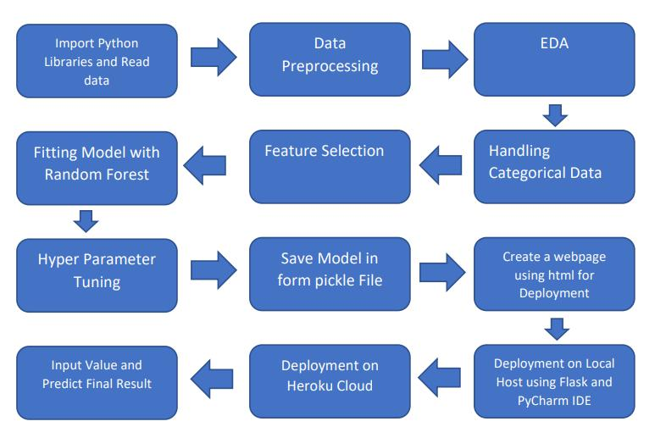

ARCHITECTURE

2 Architecture design

This project is to create an interface for the user to predict if the person would default on credit card next month, in addition to this, in need of getting the real time project experience we are importing the gathered data into our own database and then start the project from the scratch.

2.1 Data gathering from main source

The data for the current project is being gathered from Kaggle dataset, the link to the data is:

https://www.kaggle.com/datasets/uciml/default-of-credit-card-clients-dataset
2.2 Data description

There are about 30k+ records of credit card default with 25 columns consisting of information like payment balance, payment of September to April etc

2.5 Data pre-processing

Steps performed in pre-processing are:

- Data set is divided in 70:30 ratio for train and test respectively.
- ID column was dropped as its unnecessary for our modeling.
- We have also dropped columns ‘PAY_2’. ‘PAY_3’, ‘PAY_4’, ‘Pay_5’, ‘PAY_6’, ‘BILL_AMT2’, ‘BILL_AMT3’, ‘BILL_AMT4’, ‘BILL_AMT5’, ‘BILL_AMT6’ as they possess multi-collinearity with columns ‘PAY_0’ and ‘BILL_AMT0’ respectively
- The attribute name 'default.payment.next.month’ was coverted to ‘Payment_default’ for naming convenience.
- Pay_0:No consumption of credit card=-2,Pay duly(paid on time)=-1,payment delay for one mouth=1, payment delay for two months=2,payment delay for nine months and above=-9.
No Null values in dataset

2.6 Modelling

The pre-processed data is then visualized and all the required insights are being drawn. Although from the drawn insights, the data is randomly spread but still modelling is performed with different machine learning algorithms to make sure we cover all the possibilities. And finally, as expected random forest regression performed well and further hyperparameter tuning is done to increase the model’s accuracy.

2.7 UI integration

Both CSS and HTML files are being created and are being integrated with the created machine learning model. All the required files are then integrated to the app.py file and tested locally. Note: We have not make the CSS and HTML File.

2.8 Data from user

The data from the user is retrieved from the created HTML web page.

2.9 Data validation

The data provided by the user is then being processed by app.py file and validated. The validated data is then sent for the prediction.

2.10 Rendering the results

The data sent for the prediction is then rendered to the web page.

2.11 Deployment

The tested model is then deployed to NETLIFY. So, users can access the project from any internet devices.

ScreenShot of the App Interface

