**Team Name:** The Jedi Triforce

**Members Present:**

* Hari Poorna Kumar Kalahasti
* Megha Hole
* Mary Deepika Basani
* Pavani Seshadri

**CRC card**

|  |  |
| --- | --- |
| **Class Name :** Orders | |
| **Class Description :**  This plays a crucial role managing the ordering process with e-commerce app. It also represents a specific order placed by user for or more products | **Associated Use cases:**   * Checkout * View order history * Track Order shipping * Cancel Order |
| **Responsibilities:**   * Store order details * Allow user to view order history. * Record order history for users. * Enable the user to cancel order. * Handle order related notifications like order confirmation. | **Collaborators**   * Collaborated with the user class to associate order. * Product class to represent items within in the order. * Payment gateway to represent items within the order. * Email service for sending emails. |

**Class diagram**

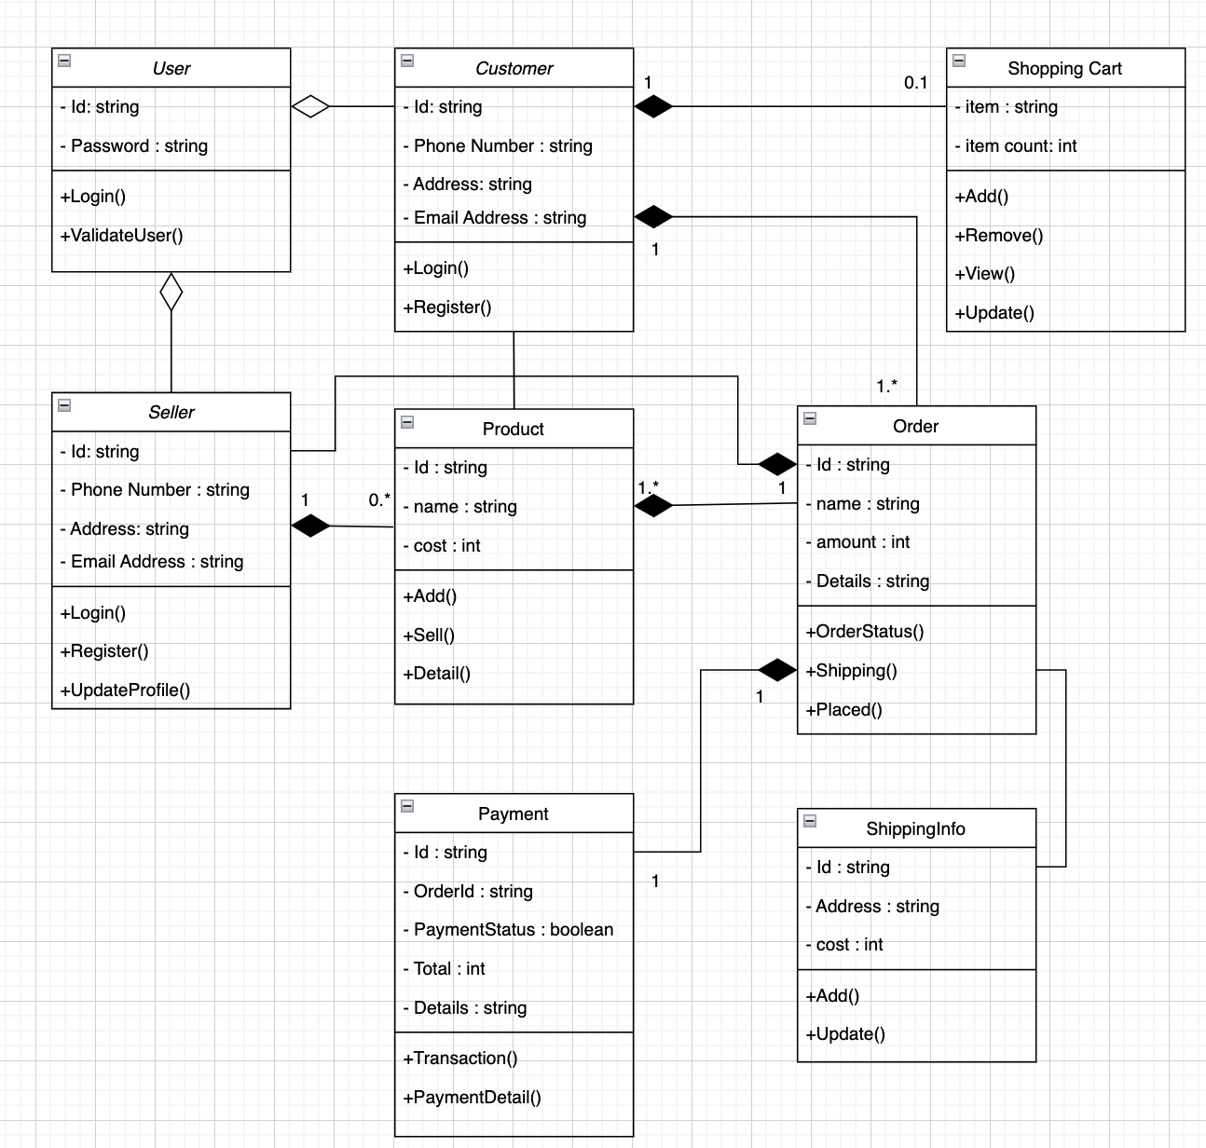

**Object diagram**

