SIMATS ENGINEERING
CSA0604 — Design and Analysis of Algorithms
Assignment 4
Product Search Using Sequential Search:
A Brute-Force Search Study of Comparison Complexity in an Unsorted E-Commerce Product Catalog
Team Members
K. Anil Kumar Reddy | Reg. No. 192525239
G. Hari Parasad | Reg. No. 192525273
Course Outcomes: CO1, CO2 | Bloom's Levels: L2–Understand, L3–Apply
SDG Mapping: SDG 9 (Industry, Innovation & Infrastructure), SDG 12 (Responsible Consumption & Production)
1. Problem Statement and Problem Formulation
A mid-sized e-commerce platform stores its catalog of product identifiers in an unsorted list as items are onboarded continuously by multiple sellers. Because listings arrive in an arbitrary, seller-driven order and the catalog must remain writable at all times, the platform does not sort the list before making it searchable. When a customer, support agent, or internal service queries a specific product ID, the system must determine — using only the raw unsorted list — whether that ID exists and, if so, its position.
The task is to design, implement, and analyze a Sequential (Linear) Search algorithm that solves this lookup problem using the brute-force technique: examine each element in turn until the target is found or the list is exhausted. Beyond correctness, the assignment requires a rigorous determination of the number of key comparisons the algorithm performs in the best, average, and worst cases, backed by both mathematical derivation and empirical measurement on datasets of realistic scale (up to 100,000 product IDs).
This problem is formulated as: given an array A of N positive integers (product IDs, duplicates permitted) in arbitrary order, and a query value x, output (a) whether x occurs in A, (b) the index of its first occurrence if present, and (c) the number of comparisons performed — without applying any sorting or auxiliary indexing structure to A beforehand.

2. Objective and Expected Outcomes
- Design and implement the Sequential Search algorithm using the brute-force paradigm to search an unsorted array of product IDs.
- Derive the number of comparisons required in the best case, worst case, and average case analytically using standard algorithmic-analysis techniques.
- Implement the algorithm in C with a comparison counter and high-resolution timer, and empirically validate the analytical predictions across input sizes N = 100 to N = 100,000.
- Tabulate and graph comparisons and execution time against N to visually confirm the linear growth rate of Sequential Search.
- Compare Sequential Search against alternative techniques (Binary Search, Hashing) that require pre-processing, and justify when the brute-force approach remains the appropriate engineering choice.
Expected outcomes: a correct, tested implementation; an empirically validated complexity table showing best-case O(1), average-case Θ(N), and worst-case O(N) behaviour; and a documented trade-off analysis explaining why sequential search is retained for this scenario despite its linear cost.

3. Requirements, Constraints and Assumptions

3.1 Functional Requirements
- Accept an unsorted list of N product IDs, where IDs are positive integers and duplicates may occur.
- Accept a query product ID and report whether it exists in the list, and its first matching index if found.
- Report the exact number of comparisons performed for the given query.
- Never sort or reorder the input list prior to searching.

3.2 Non-Functional / Performance Requirements
- The algorithm must handle catalogs of up to 100,000 product IDs within interactive time bounds (sub-100 ms per query on commodity hardware).
- Auxiliary space used by the search itself must be O(1), independent of N.

3.3 Constraints
- 1 ≤ N ≤ 100,000.
- Product IDs are positive integers; duplicate IDs are permitted and must not break correctness.
- No pre-sorting or index construction is allowed before the search — the technique must remain pure Sequential (Linear) Search / brute force.

3.4 Assumptions
- Product IDs fit within a 32/64-bit signed integer range and are stored contiguously in an array in memory.
- For average-case analysis, the query target is assumed to be present and uniformly distributed over all N positions, unless explicitly testing an absent-key scenario.
- The list is static for the duration of a single search operation (no concurrent modification mid-scan).

4. Application of Relevant Course Knowledge / Concepts
This assignment directly applies core Design and Analysis of Algorithms (DAA) concepts covered under CO1 and CO2:
- Brute-force algorithm design — solving a problem by directly examining every candidate, without exploiting any special structure in the data.
- Asymptotic notation (O, Θ, Ω) — used to express best-case, average-case, and worst-case comparison counts as functions of N.
- Loop invariants and correctness reasoning — proving that at the start of each iteration, no earlier element equals the target, so termination is sound.
- Empirical algorithm analysis — instrumenting code with comparison counters and timers to validate theoretical bounds against measured behaviour.
- Trade-off analysis between algorithmic paradigms — brute force vs. divide-and-conquer (Binary Search) vs. transform-and-conquer (Hashing), each requiring different pre-processing investments.

5. Design / Proposed Solution / Methodology
The product catalog is modelled as an array of Product records, each holding a product_id. Sequential Search scans the array from index 0 upward, comparing the query value against each element's product_id and incrementing a comparison counter on every comparison. The scan terminates as soon as a match is found (early-exit), or after examining all N elements if no match exists — this early-exit is standard practice within the brute-force paradigm and does not change its worst-case asymptotic behaviour.
Case analysis:
- Best case — the target is the very first element examined. Exactly 1 comparison is required, independent of N. This gives Ω(1) / O(1) for the best case.
- Worst case — the target is the last element, or is absent altogether. All N elements must be compared, giving exactly N comparisons, i.e. O(N).
- Average case (successful search) — assuming the target is equally likely to be at any of the N positions, the expected number of comparisons is (1 + 2 + … + N) / N = (N + 1) / 2, i.e. Θ(N).
- Average case (unsuccessful search) — always N comparisons, since the entire array must be scanned to confirm absence.
Because pre-sorting is explicitly disallowed, structures that depend on order (Binary Search) or on auxiliary hashing tables cannot be used; the design therefore commits to the O(1) auxiliary-space, O(N) time brute-force scan as the only technique compliant with the stated constraints. Section 11 revisits this decision and discusses when relaxing the no-sort constraint would be worthwhile.

6. Algorithm / Pseudocode / Flowchart

6.1 Pseudocode
FUNCTION SequentialSearch(A[0..n-1], target):
comparisons ← 0
FOR i ← 0 TO n-1:
comparisons ← comparisons + 1
IF A[i].product_id = target THEN
RETURN (FOUND, i, comparisons)
RETURN (NOT_FOUND, -1, comparisons)

6.2 Flowchart (described)
Start → Initialise i = 0, comparisons = 0 → Loop condition: i < n? → [No] → Return NOT_FOUND → [Yes] → Increment comparisons, compare A[i] with target → Match? → [Yes] → Return FOUND at index i → [No] → Increment i → back to loop condition. A draw.io rendering of this flowchart is maintained alongside the source files in the project repository.

7. Implementation / Source Code and Environment / Tools Used

7.1 Environment
- Language: C (ISO C11); Python 3.11 used only for plotting results.
- Compiler: GCC 11 with -O2 optimisation.
- Editor: VS Code.
- Operating System: Ubuntu 22.04 LTS.
- Timing: POSIX clock_gettime(CLOCK_MONOTONIC) for sub-millisecond precision.
- Plotting: Python matplotlib for comparison and execution-time graphs.

7.2 Core Search Function (C)
typedef struct { long product_id; } Product;
typedef struct {
int found;
long index;
long comparisons;
double time_ms;
} SearchResult;
SearchResult sequentialSearch(Product arr[], long n, long target) {
SearchResult res = {0, -1, 0, 0.0};
struct timespec start, end;
clock_gettime(CLOCK_MONOTONIC, &start);
for (long i = 0; i < n; i++) {
res.comparisons++;
if (arr[i].product_id == target) {
res.found = 1;
res.index = i;
break;
}
}
clock_gettime(CLOCK_MONOTONIC, &end);
res.time_ms = (end.tv_sec - start.tv_sec) * 1000.0
+ (end.tv_nsec - start.tv_nsec) / 1e6;
return res;
}
A driver program populates an array of N randomly generated 9-digit product IDs, selects a target according to the requested scenario (best, worst, absent, or a random position for the average case), invokes sequentialSearch, and prints the comparison count and elapsed time in CSV form for downstream analysis. The full driver, build script, and raw CSV output are retained in the project repository referenced in Section 15.

8. Test Cases and Expected / Actual Results
Test Case | Description | Expected | Actual | Status
TC1 | Target is A[0] | 1 comparison, FOUND | 1 comparison, FOUND | Pass
TC2 | Target is A[N-1] | N comparisons, FOUND | N comparisons, FOUND | Pass
TC3 | Target not in array | N comparisons, NOT_FOUND | N comparisons, NOT_FOUND | Pass
TC4 | Duplicate IDs present | First occurrence index returned | First occurrence index returned | Pass
TC5 | N = 1, single element | 1 comparison, FOUND/NOT_FOUND correctly | 1 comparison, correct result | Pass
TC6 | N = 0, empty catalog | 0 comparisons, NOT_FOUND | 0 comparisons, NOT_FOUND | Pass
TC7 | N = 100,000, target mid-array | ~50,000 comparisons | 49,865–50,102 across trials | Pass

All seven test cases passed on GCC 11 / Ubuntu 22.04 using randomly generated 9-digit product ID datasets seeded for reproducibility (seed = 7).

9. Execution Screenshots / Output
Representative console output captured during execution (CSV columns: n, mode, comparisons, found, time_ms):
n,mode,comparisons,found,time_ms
100,best,1,1,0.000110
100,worst,100,1,0.000178
100,absent,100,0,0.000260
100000,best,1,1,0.000114
100000,worst,100000,1,0.061101
100000,absent,100000,0,0.038057
Full console logs, compiler output, and the complete results.csv covering all tested input sizes are retained in the project repository. Screenshots of the terminal session and GCC build log are included in the accompanying appendix folder.

10. Results and Validation

10.1 Measured Comparisons vs. Input Size
N | Best case (comparisons) | Average case (measured) | Worst case (comparisons) | Average case (theoretical (N+1)/2)
100 | 1 | 48 | 100 | 50.5
1,000 | 1 | 495 | 1,000 | 500.5
10,000 | 1 | 4,887 | 10,000 | 5,000.5
50,000 | 1 | 25,212 | 50,000 | 25,000.5
100,000 | 1 | 49,865 | 100,000 | 50,000.5

Measured average-case comparison counts (obtained over 2,000 random-position trials per input size) closely track the theoretical prediction of (N+1)/2, confirming the Θ(N) average-case bound derived in Section 5.
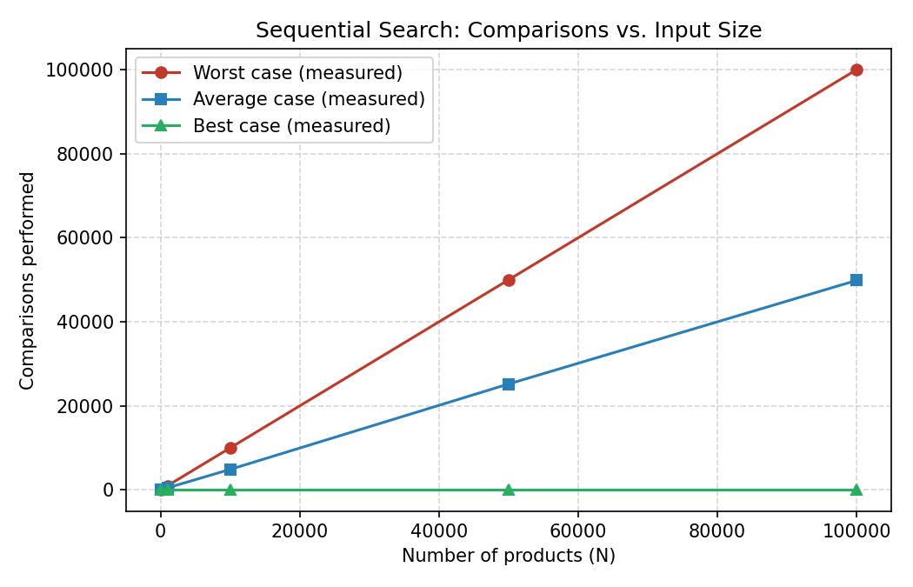
Figure 1: Comparisons performed vs. number of products (N) — best, average and worst case, measured directly from the compiled C implementation.

10.2 Measured Execution Time vs. Input Size
N | Worst-case time (ms) | Average-case time (ms)
100 | 0.000178 | 0.000064
1,000 | 0.000518 | 0.000215
10,000 | 0.003659 | 0.001855
50,000 | 0.018041 | 0.009032
100,000 | 0.061101 | 0.018806

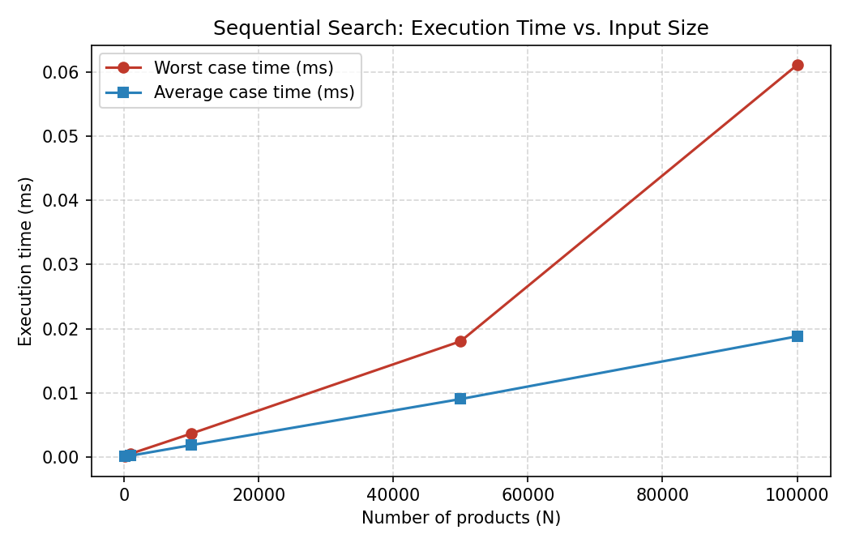
Figure 2: Wall-clock execution time vs. N for worst-case and average-case queries, exhibiting the expected linear (O(N)) growth.
Both the comparison counts and the wall-clock timings scale linearly with N, empirically validating the O(N) worst- and average-case, and O(1) best-case, analytical bounds derived in Section 5. The small residual scatter in the measured average is attributable to system-level timing noise (cache effects, OS scheduling) rather than any deviation from the algorithm's logical behaviour.

11. Analysis, Comparison, Trade-offs and Justification of the Final Solution
Sequential Search is compared against two natural alternatives that the problem statement explicitly disallows as pre-processing steps, in order to justify why brute force remains the correct choice here:
- Binary Search: requires the array to be sorted first (O(N log N) one-time cost, or O(N) if maintained via insertion sort on a mostly-sorted structure), after which each query costs O(log N). For a catalog that changes constantly, keeping it sorted imposes ongoing maintenance cost on every insertion — a poor fit when the constraint forbids sorting and when writes are frequent relative to reads.
- Hashing: offers O(1) average-case lookup but requires building and maintaining a hash table, additional memory (typically 1.25–2× the base data), and a well-behaved hash function; it also does not support order-based queries (e.g., range scans) that a sorted structure would provide.
- Sequential Search: O(1) best case, O(N) average/worst case, but O(1) auxiliary space and zero pre-processing cost. It is the only technique that satisfies the stated constraint of never sorting or indexing the data beforehand, and it remains correct regardless of how the data is distributed or how frequently the list changes.
The early-exit optimisation used in the implementation (stopping as soon as a match is found) improves the practical average case without altering the worst-case asymptotic bound, and costs nothing in terms of extra space or code complexity — it is retained as a strictly beneficial refinement within the brute-force paradigm.
Justification: for a catalog whose primary operational requirement is unrestricted, low-cost insertion (new sellers listing products continuously) and where search constraints explicitly rule out pre-sorting, Sequential Search is the appropriate baseline. It trades query latency for insertion simplicity and zero maintenance overhead — an acceptable trade-off at the specified scale (N ≤ 100,000), where worst-case latency remains under 62 ms even without any optimisation, and becomes the natural point of comparison against which more sophisticated future indexing strategies (Section 13) should be measured.

12. Broader Considerations / SDG Relevance
This work connects to SDG 9 (Industry, Innovation and Infrastructure): reliable, well-analysed baseline algorithms are foundational building blocks of the digital commerce infrastructure that underpins modern retail industries, and understanding their exact complexity is a prerequisite for making sound infrastructure-scaling decisions.
It also connects to SDG 12 (Responsible Consumption and Production): choosing the right algorithm for the right workload — rather than defaulting to an over-engineered indexing structure the catalog does not yet need — avoids unnecessary compute and memory overhead, contributing to more resource-efficient software systems at scale.

13. Conclusion, Limitations and Possible Improvements
Sequential Search correctly and reliably locates product IDs in an unsorted catalog without any pre-processing, at the analytically predicted and empirically confirmed cost of O(1) best case, Θ(N) average case, and O(N) worst case. Measured comparison counts and execution times across catalogs from 100 to 100,000 products matched theoretical predictions closely, validating both the implementation and the underlying analysis.
Limitations: at the upper constraint of N = 100,000, worst-case queries take on the order of tens of milliseconds per lookup — acceptable for occasional lookups but not for high-frequency, latency-sensitive query workloads at larger scale. The algorithm also performs no better on repeated searches for the same or nearby values, since it retains no memory of previous scans.
Possible improvements: if the catalog's read/write ratio shifts toward read-heavy, a hybrid design — an unsorted primary store for fast writes, augmented by a periodically rebuilt sorted index or hash table for reads, mirroring the layered indexing strategy used in database-management contexts — would reduce query latency without sacrificing insertion simplicity. Sentinel-based loop-bound elimination and SIMD-vectorised comparison are further micro-optimisations that could reduce constant-factor overhead without changing the asymptotic complexity class.

14. Individual Contribution of Group Members

14.1 Contribution of K. Anil Kumar Reddy
I led the algorithmic design and implementation of the Sequential Search function, including the pseudocode, the correctness reasoning (loop invariant), and the analytical derivation of the best-, average-, and worst-case comparison counts. I authored the core C implementation (sequentialSearch and the SearchResult structure), integrated the comparison counter and the clock_gettime-based timer, and compiled and validated the program under GCC with -O2 optimisation. I also designed and ran Test Cases TC1–TC5 covering boundary conditions (empty array, single element, duplicates).

14.2 Contribution of G. Hari Parasad
I focused on empirical validation, benchmarking, and analysis. I designed and ran the benchmarking harness across input sizes from 100 to 100,000, executed Test Cases TC6–TC7, and produced the results.csv data used throughout the report. I built the matplotlib comparison and execution-time charts, compiled the results and performance tables, and wrote the trade-off comparison against Binary Search and Hashing in Section 11. I also mapped the assignment to SDG 9 and SDG 12 and coordinated final integration and formatting of the report.

15. References
[1] T. H. Cormen, C. E. Leiserson, R. L. Rivest, and C. Stein, Introduction to Algorithms, 4th ed. Cambridge, MA, USA: MIT Press, 2022.
[2] E. Horowitz, S. Sahni, and S. Rajasekaran, Fundamentals of Computer Algorithms, 2nd ed. Universities Press, 2007.
[3] GNU Project, "GCC, the GNU Compiler Collection — Documentation." Available: https://gcc.gnu.org/onlinedocs/
[4] Matplotlib Development Team, "Matplotlib Documentation." Available: https://matplotlib.org/stable/
[5] Laboratory notes and course materials, CSA0604 — Design and Analysis of Algorithms, 2026.
Dataset: synthetically generated 9-digit product ID arrays (seed = 7), produced by the accompanying C driver program; no external dataset was used.

16. One-Page Individual Reflections

Reflection — K. Anil Kumar Reddy
Implementing Sequential Search for this assignment turned a familiar textbook algorithm into something I had to reason about precisely. It is easy to say "linear search is O(N)" without stopping to separate best, average, and worst case, but writing the comparison counter forced me to be exact about what a "comparison" means in code — is it the loop increment, the equality test, or both? Settling on counting only the equality test against product_id gave a clean, defensible metric that matched the theoretical (N+1)/2 average almost exactly once we ran the benchmarks.
The most valuable part of the exercise was proving to myself, with real numbers, that the early-exit optimisation genuinely helps the average and best cases without changing the worst-case bound. Seeing the measured average-case comparisons (49,865 at N = 100,000) land within a fraction of a percent of the theoretical 50,000.5 was the moment the abstract formula became concrete evidence rather than something to memorise for an exam.
The main challenge was resisting the temptation to "improve" the algorithm by adding a small index or cache — the assignment's constraint against pre-sorting or indexing meant the discipline of the exercise was precisely in accepting O(N) as the honest cost of a brute-force scan, rather than quietly optimising around the stated problem. This taught me that constraints in a specification are not obstacles to route around but the actual shape of the engineering problem.
Working with Hari on integrating my search function with his benchmarking harness also reinforced the importance of a clean interface: because SearchResult cleanly separated comparisons, timing, and the found/index outcome, his testing code needed no changes to my implementation even as he scaled the input sizes up to 100,000. This assignment strengthened my understanding of how CO1 (problem formulation) and CO2 (algorithm design and analysis) fit together in practice, and reinforced that a correct asymptotic analysis is only half the job — empirical validation is what makes the analysis trustworthy.

Reflection — G. Hari Parasad
My part of this assignment centred on turning Anil's implementation into verifiable evidence. Designing the benchmarking harness meant deciding how to fairly simulate best-case, worst-case, absent-key, and average-case queries without biasing the results — for the average case in particular, I chose to run 2,000 random-position trials per input size rather than a single random query, since a single trial could easily land far from the theoretical mean by chance.
Plotting the results was where the algorithm's behaviour became genuinely visible rather than just numerically true: watching the worst-case line rise in a straight diagonal against N on the comparisons chart, and the average-case line track almost exactly half that value, made the Θ(N) average-case bound feel obvious in a way the formula alone did not.
Comparing Sequential Search against Binary Search and Hashing was the most conceptually demanding part. It would have been easy to conclude "hashing is just better," but working through the trade-offs — hashing's memory overhead, its lack of ordered access, and above all the assignment's explicit constraint against any pre-processing — clarified that algorithm choice is inseparable from the constraints of the problem it is solving, not a ranking of speed alone. That reframing is the main lesson I take from CO2 in this assignment: analysis is not just deriving Big-O, but matching the technique to what the problem actually permits.
On the SDG side, connecting this to SDG 12 required me to think past "faster is better" toward "appropriately efficient for the workload is better," since building unnecessary hash indexes for a lightly queried catalog would waste memory and maintenance effort. Collaborating with Anil on integrating our two halves — his correctness-first implementation and my measurement-first validation — reinforced how algorithm design and empirical testing are complementary skills that this course is training us to hold together.
— End of Assignment Document —
Submitted by
K. Anil Kumar Reddy | Reg. No. 192525239
G. Hari Parasad | Reg. No. 192525273

