# Innovative Solution: SMART PUBLIC RESTROOMS

# 

# Introduction:

# Smart public restrooms represent an innovative and forward-thinking approach to enhancing the user experience in shared facilities. In a world increasingly characterized by connectivity and automation, the application of cutting-edge technology to public restrooms offers numerous benefits, from improved hygiene and resource conservation to increased convenience and accessibility. These smart restrooms leverage a range of technologies, such as sensors, mobile apps, and data analytics, to create a more efficient and user-friendly environment. This introduction will explore some of the most impactful technologies that can be deployed in smart public restrooms, showcasing how they contribute to a cleaner, more convenient, and more environmentally sustainable restroom experience for all.

# Problem Statement

Public restrooms are an essential but often overlooked aspect of urban infrastructure. They are frequently plagued by issues of hygiene, maintenance, and user convenience, creating challenges for both patrons and facility managers. Traditional restrooms are often wasteful in terms of water and energy use, and maintaining cleanliness is a persistent challenge. Furthermore, accessibility and user convenience are areas that require significant improvement. In light of these challenges, there is a pressing need for innovative solutions that harness the power of modern technology to transform public restrooms into smarter, more efficient, and user-friendly spaces. This problem statement aims to address the shortcomings of conventional public restrooms and explore the potential of smart restroom technologies to alleviate these issues.

# Solution Overview:

# Sensor-Based Hygiene and Maintenance:

# Implement sensor technology for faucets, soap dispensers, and hand dryers to reduce the need for physical contact and promote hygiene. Automatic flush toilets and occupancy sensors can also be used to maintain cleanliness and improve user experience.

# Digital Availability Monitoring: Utilize QR codes, mobile apps, and occupancy sensors to provide real-time information about restroom availability. Users can check the status and even reserve a spot, reducing wait times and increasing convenience.

# Real-Time Monitoring and Alerts: Install sensors that monitor restroom conditions, such as usage and cleanliness. These sensors can automatically alert cleaning staff when maintenance or cleaning is needed, ensuring a consistently clean and well-maintained restroom.

# Energy and Resource Efficiency: Implement energy-efficient lighting with motion sensors to reduce electricity consumption. Water and energy usage can be optimized through smart technologies, lowering operational costs and reducing environmental impact.

# User Feedback and Engagement: Develop a feedback system that allows users to provide input on restroom conditions. This information can help facility managers improve the restroom experience and address issues promptly. Additionally, provide interactive and informative digital displays for user engagement.

# Accessibility and Inclusivity: Ensure that smart public restrooms are designed with inclusivity in mind. Features such as accessible stalls, audio guidance, and smartphone apps for accessibility can make the restroom experience more accommodating to individuals with disabilities.

# Implementation Plan for Smart Public Restrooms:

# Phase 1: Needs Assessment and Planning

# Identify Locations: Determine the specific public restroom locations where smart technologies will be implemented. Consider high-traffic areas and facilities with the most significant usage.

# Define Objectives: Clearly outline the goals of implementing smart restroom technology, such as improved hygiene, reduced resource consumption, and enhanced user experience.

# Budget and Resources: Allocate the necessary budget and resources for technology acquisition, installation, and ongoing maintenance.

# Phase 2: Technology Selection and Procurement

# Select Smart Technologies: Research and choose the appropriate sensor-based fixtures, occupancy monitoring systems, digital displays, and other technologies based on the identified objectives and budget.

# Vendor Selection: Identify reputable vendors or suppliers for the chosen technologies. Consider factors like reliability, support, and cost-effectiveness.

# Contract Negotiation: Negotiate contracts with vendors, including service agreements, warranties, and technical support.

# Phase 3: Installation and Integration

# Physical Installation: Deploy the selected technologies in the identified public restrooms. Ensure proper installation and calibration of sensors and fixtures.

# Integration and Connectivity: Set up a centralized control system that connects all the restroom technologies. This system should allow for real-time monitoring and control of restroom conditions.

# Phase 4: Testing and Quality Assurance

# Functional Testing: Conduct thorough testing of all smart restroom components to ensure they function as intended. Address any issues or malfunctions promptly.

# User Testing: Involve users in the testing phase to gather feedback and make necessary adjustments to improve user experience.

# Phase 5: Training and Maintenance

# Staff Training: Train maintenance staff on how to use and maintain the smart technologies. Ensure they are proficient in responding to alerts and troubleshooting.

# Maintenance Plan: Develop a comprehensive maintenance plan that includes routine inspections, cleaning, and proactive technology maintenance.

# Phase 6: User Education and Engagement

# User Education: Educate restroom users about the new smart features through signage and promotional materials. Encourage them to use available apps or QR codes for availability information.

# Feedback Mechanism: Establish a system for users to provide feedback on their experience and report any issues.

# Phase 7: Data Analysis and Optimization

# Data Collection: Collect data from sensors and user feedback mechanisms to analyze restroom usage patterns and issues.

# Optimization: Use the data to optimize cleaning schedules, resource usage, and user engagement. Continuously look for ways to improve the restroom experience.

# Phase 8: Expansion and Scaling

# Evaluate Success: Assess the success and impact of smart restrooms in initial locations. Consider user feedback and operational data.

# Scale Up: Expand the implementation to additional public restroom locations as budget and resources allow. Use lessons learned from initial deployments to streamline the process.

# Phase 9: Monitoring and Ongoing Maintenance

# Continuous Monitoring: Continuously monitor the performance of the smart restroom technologies, responding to alerts and making improvements as needed.

# Regular Updates: Stay updated with advancements in smart restroom technology and consider periodic updates or upgrades to maintain effectiveness.

# By following this implementation plan, you can transform traditional public restrooms into smart, user-friendly, and efficient facilities that cater to the needs of a diverse public while promoting hygiene and sustainability.

# Design:

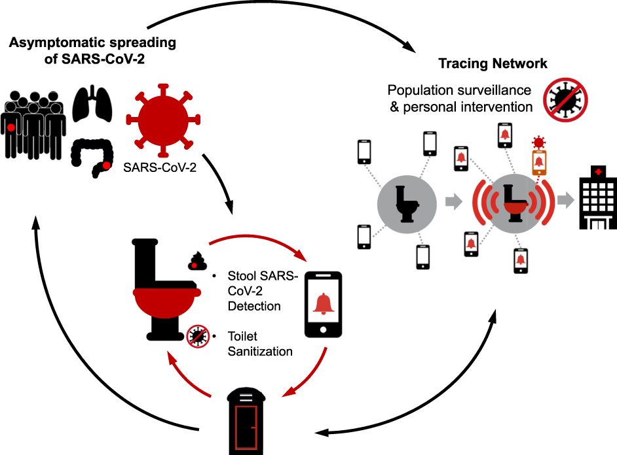

# Benefits:

# 1)    Improved Hygiene:

# Automated features, like touchless faucets, soap dispensers, and flush systems, reduce the risk of spreading germs and enhance overall cleanliness.

# 2)    Enhanced Accessibility:

# Features like smart signage, voice assistance, and accessible design can cater to a broader range of users, including those with disabilities.

# 3)    Water and Energy Efficiency:

# Smart restrooms can incorporate sensors and timers to reduce water and energy wastage, contributing to environmental sustainability.

# 4)    Real-time Maintenance:

# Sensors and monitoring systems can provide real-time data on restroom usage, helping authorities allocate resources efficiently and ensure maintenance is performed promptly

# 5)    Enhanced User Experience:

# Smart public restrooms can offer features like mobile apps for finding the nearest facility, ratings and reviews, and even entertainment options, improving user satisfaction.

# 6)    Smart Waste Management:

# Automated waste compactors and sensors can optimize waste collection schedules, reducing costs and environmental impact.

# 7)    Emergency Features:

# In cases of emergencies, such as medical incidents or security concerns, smart restrooms can have features like emergency buttons or communication systems for immediate assistance.

# Conclusion:

# In conclusion, smart public restrooms hold significant promise for enhancing public hygiene and convenience while reducing environmental impact. Their potential benefits, such as improved sanitation, accessibility, sustainability, and data-driven insights, make them a valuable addition to urban infrastructure. Overcoming challenges, including cost and privacy concerns, will be essential, but the growing adoption of smart technology in public facilities suggests a future where smart public restrooms become integral to modern cities, significantly improving the overall restroom experience for all.