NOVAINVEST
Portfolio Dashboard
Client Application Guide

Prepared for:
Valued Client

Date: June 18, 2026
Version: 1.0

Table of Contents

1. How to Run the Application

Prerequisites
Docker Desktop | Version 24+ — must be running before you start
Port 80 | Must be free on your machine (the app binds to port 80)
Port 3000 | Used by the NestJS API (also exposed for direct API access)
Git | To clone the repository (or unzip the project folder)

Option A — Production Mode (Recommended)
Everything runs inside a single Docker container — Nginx, NestJS, MongoDB, and Redis are all managed automatically.

1 | Open a terminal and navigate to the project folder
2 | Run: docker compose up --build
3 | Wait for all services to start (first build takes ~2-3 minutes; subsequent starts are instant)
4 | Open your browser and go to: http://localhost

URLs & Ports
Service | URL | Port
Frontend (Angular SPA) | http://localhost | 80
Backend API (NestJS) | http://localhost/api/ | 80 → proxied to 3000
API — direct access | http://localhost:3000 | 3000
MongoDB (internal) | 127.0.0.1:27017 | 27017 (container only)
Redis (internal) | 127.0.0.1:6379 | 6379 (container only)

Background / Detached Mode
To run the app in the background (so the terminal stays free), use: docker compose up -d --build
To stop it later: docker compose down

Option B — Local Development Mode (No Docker for app code)
Runs MongoDB and Redis in Docker, but the backend and frontend are started locally with hot-reload. Use this when actively developing.

Step 1 — Start databases | docker compose -f docker-compose.dev.yml up -d
Step 2 — Start backend | cd backend → npm install → npm run start:dev → http://localhost:3000
Step 3 — Start frontend | cd frontend → npm install → npm start → http://localhost:4200
Step 4 — Run unit tests | cd frontend → npm run test (runs all 33 unit tests with Vitest)

What's Inside the Single Container
Process | Role
Nginx :80 | Serves the Angular SPA for / and reverse-proxies /api/ requests to NestJS on port 3000
NestJS :3000 | REST API — handles authentication, portfolio CRUD, and chart data computation
MongoDB :27017 | Persistent database — data survives container restarts via the mongo-data Docker volume
Redis :6379 | Cache layer — stores computed chart data to avoid redundant database queries
Supervisord | Process manager — starts MongoDB first, then Redis, then NestJS (with auto-retry), then Nginx

Environment Variables (Optional)
The app ships with safe default values for evaluation. For production deployments, override these before running:

JWT_SECRET | Secret key used to sign access tokens (default: change_me_in_production)
JWT_REFRESH_SECRET | Secret key used to sign refresh tokens (default: change_me_refresh_in_production)

Either set them inline: JWT_SECRET=mysecret JWT_REFRESH_SECRET=myrefresh docker compose up --build
Or create a .env file in the project root with the two keys above.

Rate Limiting
The API allows a maximum of 200 requests per minute per client. If the limit is exceeded, the server returns HTTP 429 Too Many Requests and the frontend displays a friendly toast message asking the user to wait.

2. Login Page

URL: localhost/login
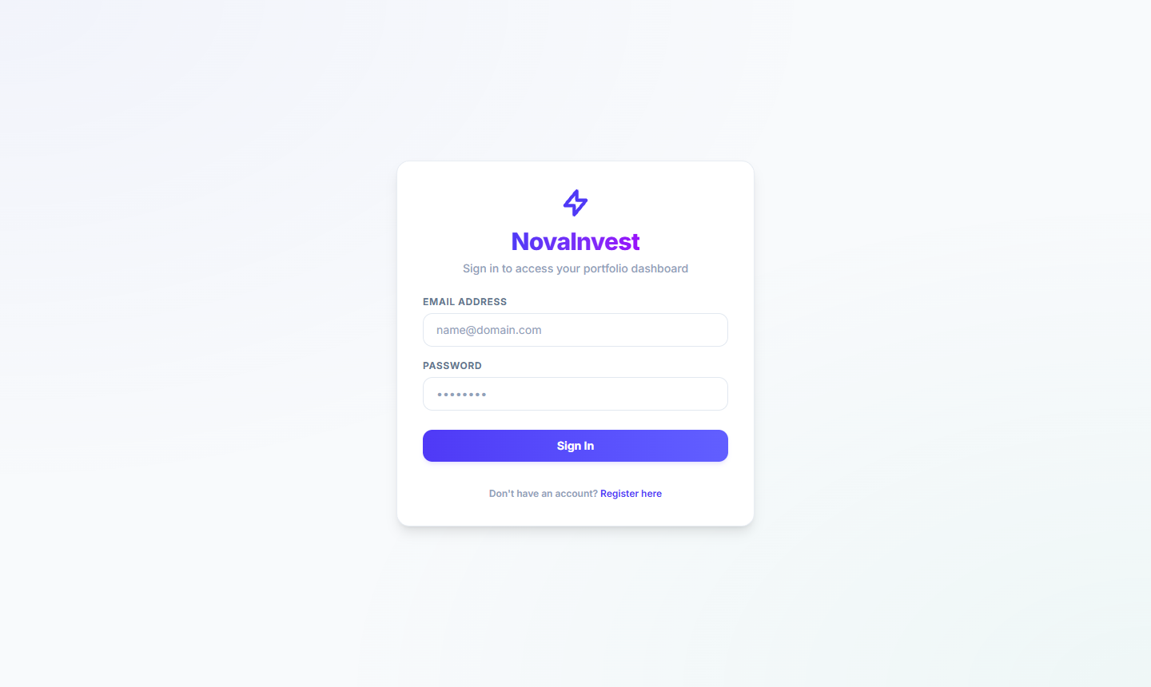

Overview
The Login Page is the secure entry point to the NovaInvest Portfolio Dashboard. It presents a clean, minimal authentication form under the NovaInvest brand identity, giving users a professional and trustworthy first impression.

Page Components
Brand Logo | Purple lightning bolt icon with the NovaInvest wordmark in brand purple
Tagline | "Sign in to access your portfolio dashboard"
Email Field | Text input labelled EMAIL ADDRESS — accepts user email credentials
Password Field | Masked text input labelled PASSWORD — hides characters for security
Sign In Button | Full-width purple CTA button that authenticates the user
Register Link | "Don't have an account? Register here" — navigates to registration

Security Features
- Password field masks all characters by default
- JWT token-based authentication with automatic refresh policy
- Session tokens are never exposed in the URL
- Redirects unauthenticated users back to this page automatically

Test Credentials
Email: a@gmail.com | Password: 12341234

User Flow
Enter email address → Enter password → Click Sign In → Redirected to Portfolio Overview dashboard.

3. Portfolio Overview

URL: localhost/dashboard/home-portfolio
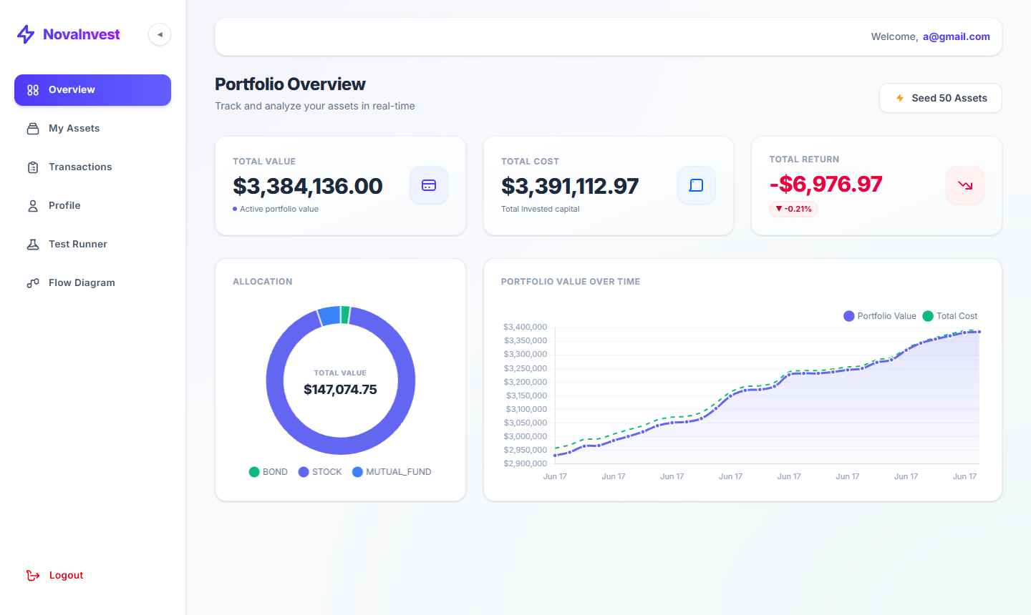

Overview
The Portfolio Overview is the main dashboard home screen. It provides a real-time snapshot of the user's entire investment portfolio — total value, cost basis, and returns — alongside visual charts for allocation breakdown and historical performance.

Key Metric Cards
TOTAL VALUE | TOTAL COST | TOTAL RETURN
$3,384,136.00 | $3,391,112.97 | -$6,976.97
Active portfolio value | Total invested capital | -0.21% return

Charts & Visualisations
Allocation Chart | Donut chart displaying portfolio split by asset class: BOND, STOCK, MUTUAL_FUND
Portfolio Value Chart | Line chart plotting Portfolio Value vs Total Cost over time (Jun 17 date range)

Seeding Sample Data — Seed 50 Assets
To populate the dashboard with realistic test data, click the '⚡ Seed 50 Assets' button in the top-right corner of the Portfolio Overview page. This instantly creates 50 diversified assets (stocks, bonds, and mutual funds) with randomised quantities and pricing, so every chart and table fills with live-looking data immediately. Ideal for demonstrations and first-time setup.

Sidebar Navigation
- Overview (current — highlighted in purple)
- My Assets — manage individual holdings
- Transactions — view buy/sell history
- Profile — account settings
- Test Runner — internal QA tool
- Flow Diagram — architecture view
- Logout — ends the user session

4. Asset Management

URL: localhost/dashboard/assets
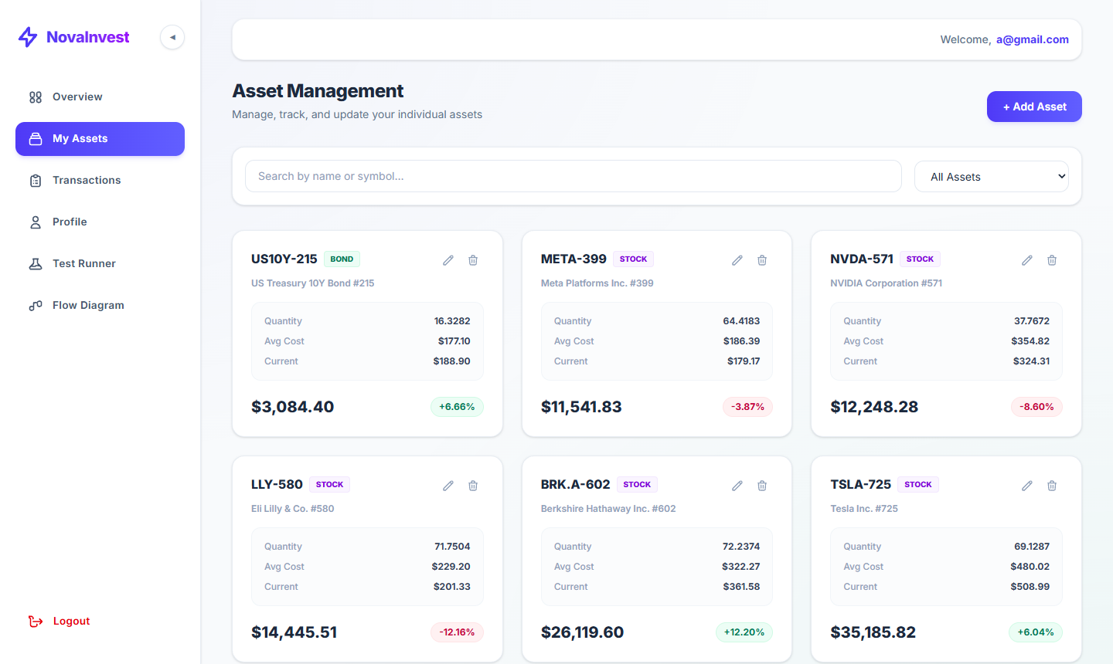

Overview
The Asset Management page allows users to view, search, add, edit, and delete individual investment holdings. Each asset card displays its symbol, type, quantity, average cost, current price, total value, and percentage return.

Page Controls
Search Bar | Full-width search to filter assets by name or ticker symbol
Filter Dropdown | "All Assets" dropdown to filter by asset class (BOND, STOCK, MUTUAL_FUND)
+ Add Asset | Purple button in the top-right to add a new investment holding
Edit Icon | Pencil icon on each card — opens an edit form for that asset
Delete Icon | Trash icon on each card — removes the asset after confirmation

Sample Assets Visible
Symbol | Type | Qty | Avg Cost | Current | Return
US10Y-215 | BOND | 16.3282 | $177.10 | $188.90 | +6.66%
META-399 | STOCK | 64.4183 | $186.39 | $179.17 | -3.87%
NVDA-571 | STOCK | 37.7672 | $354.82 | $324.31 | -8.60%
LLY-580 | STOCK | 71.7504 | $229.20 | $201.33 | (below)

Asset Card Layout
Each card shows: Symbol + Type badge at top | Quantity, Avg Cost, Current price in the body | Total Value (bold) + colour-coded return % at the bottom.

5. Transaction Activity

URL: localhost/dashboard/transactions
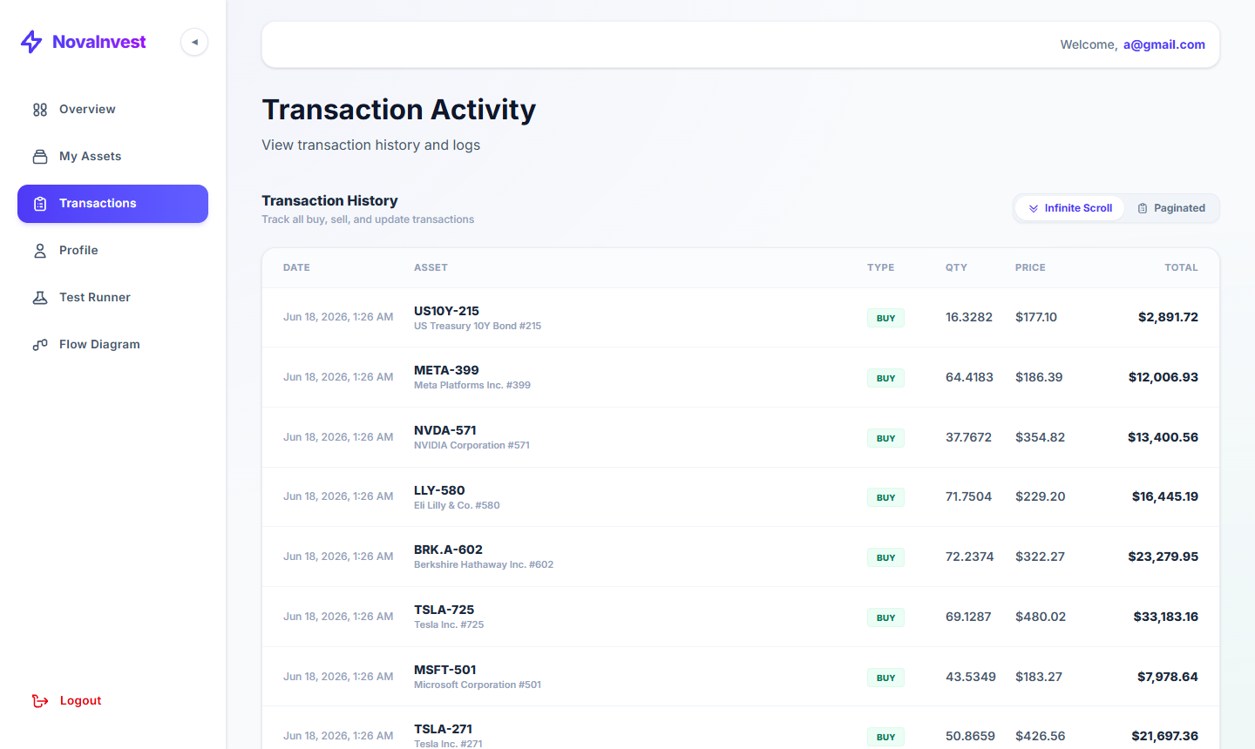

Overview
The Transaction Activity page provides a complete, chronological ledger of every buy, sell, and update event in the portfolio. Users can choose between two view modes and see a detailed breakdown per trade.

View Modes
Infinite Scroll | Transactions load continuously as the user scrolls down the page (selected by default)
Paginated | Transactions are split into pages for easier navigation

Transaction Table Columns
DATE | ASSET | TYPE | QTY | PRICE
Jun 18, 2026, 1:26 AM | US10Y-215 / US Treasury 10Y Bond #215 | BUY | 16.3282 | $177.10
Jun 18, 2026, 1:26 AM | META-399 / Meta Platforms Inc. #399 | BUY | 64.4183 | $186.39
Jun 18, 2026, 1:26 AM | NVDA-571 / NVIDIA Corporation #571 | BUY | 37.7672 | $354.82
Jun 18, 2026, 1:26 AM | LLY-580 / Eli Lilly & Co. #580 | BUY | 71.7504 | $229.20

Key Features
- Every portfolio transaction is recorded automatically on asset creation or update
- BUY type is shown with a green badge for clear visual identification
- TOTAL column shows the gross value of each trade (qty × price)
- Timestamp precision to the minute for full audit trail

6. User Profile

URL: localhost/dashboard/profile
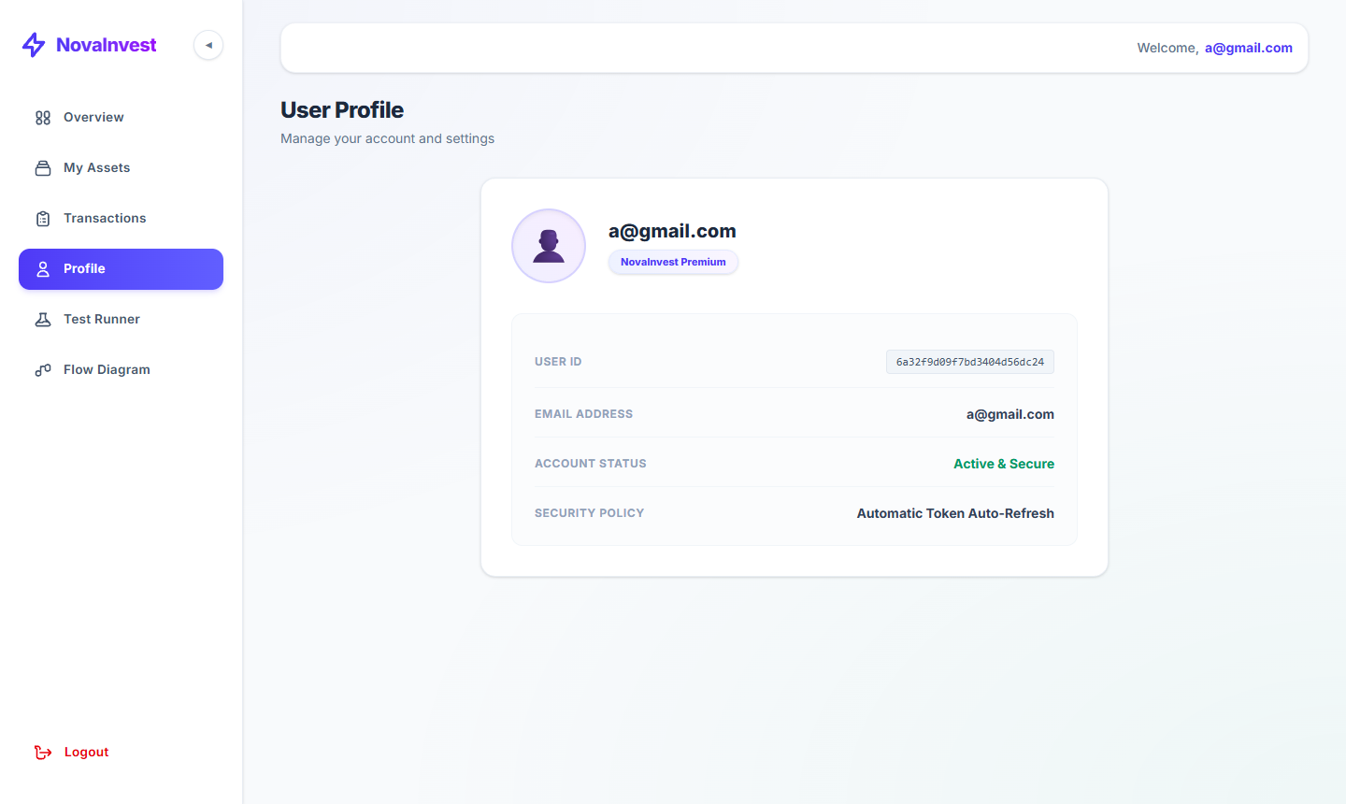

Overview
The User Profile page displays the authenticated user's account details, subscription tier, security status, and active security policy. It is a read-only summary of the account configuration.

Profile Information
Email Address | a@gmail.com
Account Tier | NovaInvest Premium
User ID | 6a32f9d09f7bd3404d56dc24 (MongoDB ObjectId)
Account Status | Active & Secure
Security Policy | Automatic Token Auto-Refresh

Account Tier — NovaInvest Premium
The Premium tier unlocks full portfolio features including unlimited asset tracking, real-time pricing, transaction history, and advanced analytics. The badge is displayed prominently under the user avatar.

Security Policy — Automatic Token Auto-Refresh
- JWT access tokens are refreshed automatically in the background
- Users are never interrupted with forced re-login during an active session
- Refresh tokens are rotated on each use to prevent replay attacks
- All authentication state is stored server-side with no sensitive data in local storage

7. System Test Runner

URL: localhost/dashboard/tests
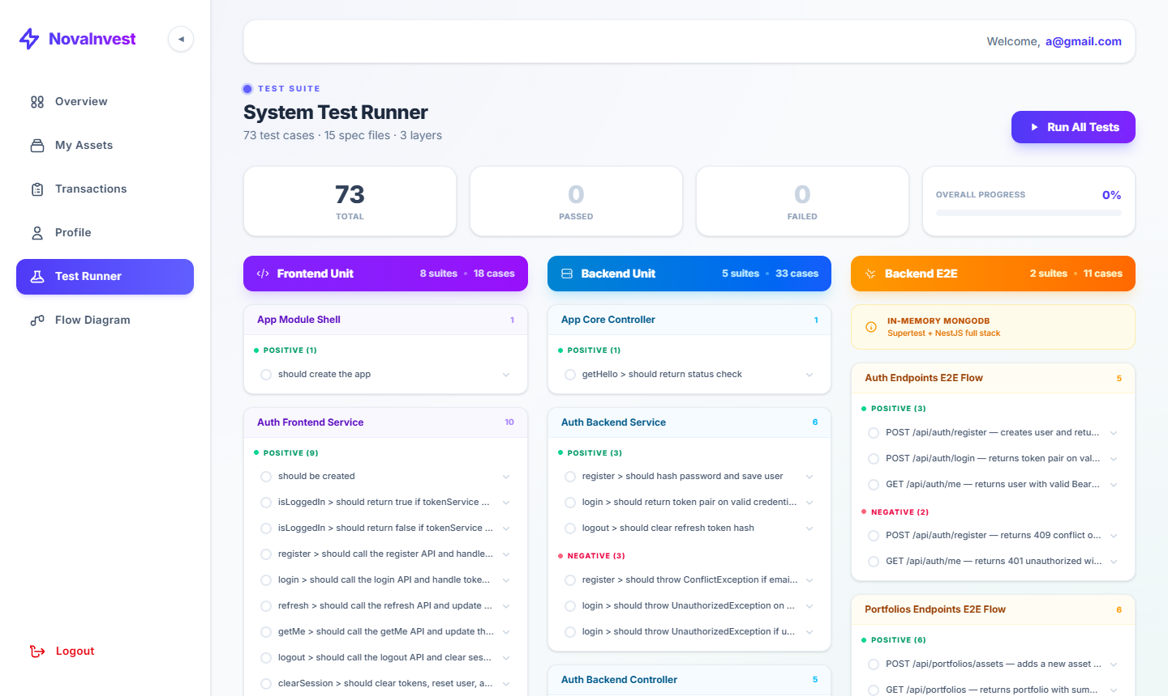

Overview
The System Test Runner is a built-in quality-assurance dashboard that lets you execute and inspect every automated test in the application — directly from the browser. It covers three layers of testing: Frontend Unit, Backend Unit, and Backend E2E, with 73 test cases across 15 spec files.

Test Suite Summary
Layer | Suites | Cases | Colour
Frontend Unit | 8 suites | 18 cases | Purple
Backend Unit | 5 suites | 33 cases | Blue
Backend E2E | 2 suites | 11 cases | Amber
TOTAL | 15 spec files | 73 cases

Running Tests
Run All Tests | Click the '▶ Run All Tests' button (top-right) to execute all 73 cases in one go
Run Single Test | Expand any test suite card and click the checkbox next to an individual case to run it alone
Live Progress | A progress bar and PASSED / FAILED counters update in real time as tests execute
Overall Progress | Percentage indicator shows how many of the 73 tests have completed

Test Case Tabs — Per Test Detail
Each individual test case expands to reveal four tabs:

Tab | What it shows
Overview | High-level description of the test — what it checks and the expected outcome
Fixtures | Test data and mock objects used to set up the test environment before the assertion runs
Test Code | The actual assertion snippet (Arrange → Act → Assert pattern) shown with syntax highlighting
Live Logs | Real-time console output streamed while the test is executing — useful for debugging failures

Test Result Badges
- POSITIVE — test cases expected to pass (green badge)
- NEGATIVE — test cases that validate error/rejection scenarios (red badge)
- Each suite card shows a count of positive and negative cases at a glance

E2E Test Suites
Auth Endpoints E2E Flow | 5 cases — register, login, token validation, 409 conflict, 401 unauthorised
Portfolios Endpoints E2E Flow | 6 cases — add asset, fetch portfolio, filter by type, and more
In-Memory MongoDB | Supertest + NestJS full stack — no external database required for E2E

8. Flow Diagram

URL: localhost/dashboard/flow-diagram
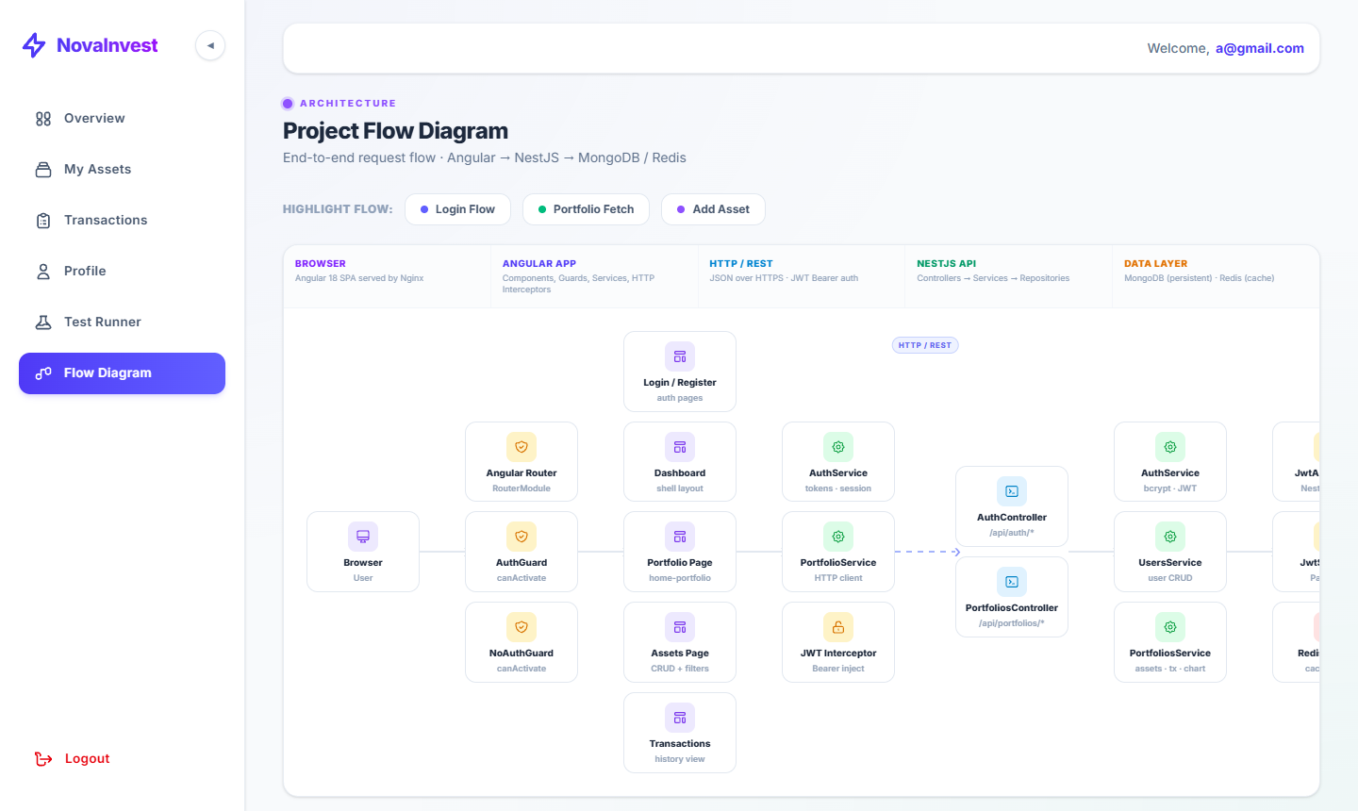

Overview
The Flow Diagram page is an interactive architecture visualiser. It maps every component in the system across five layers and lets you highlight exactly how data travels during three key user flows: Login, Portfolio Fetch, and Add Asset.

Architecture Layers
Layer | Components & Responsibilities
Browser | Angular 18 SPA served by Nginx — the user-facing interface
Angular App | Components, Route Guards (AuthGuard / NoAuthGuard), Services, HTTP Interceptors
HTTP / REST | JSON over HTTPS with JWT Bearer authentication — connects frontend to backend
NestJS API | Controllers → Services → Repositories pattern; JwtAuthGuard, JwtStrategy
Data Layer | MongoDB (persistent storage) + Redis (cache layer for chart data)

Highlighted Flows
Login Flow | Browser → AuthGuard → Login/Register page → AuthService → AuthController → UsersService → MongoDB
Portfolio Fetch | Browser → AuthGuard → Portfolio Page → PortfolioService (HTTP client + JWT Interceptor) → PortfoliosController → PortfoliosService → MongoDB + Redis cache
Add Asset | Browser → Assets Page → PortfolioService → PortfoliosController → PortfoliosService → MongoDB

How to Use the Flow Diagram
- Click 'Login Flow', 'Portfolio Fetch', or 'Add Asset' at the top to highlight the relevant path
- Active components appear in full colour; inactive ones are greyed out
- The description bar below the tabs narrates the exact data journey in plain English
- Arrows between nodes show direction of calls — dashed arrows indicate async / cache paths

Portfolio Fetch — Detailed Flow
Dashboard loads → PortfolioService sends GET /api/portfolios with JWT → JwtAuthGuard validates token → PortfoliosService queries MongoDB for assets and computes summary → Redis cache serves chart data if available.

9. Summary

NovaInvest is a full-stack investment portfolio dashboard built for individuals who want a professional, real-time view of their assets. All seven screens work together to provide a seamless experience:

Screen | Purpose
1. How to Run | Docker setup, ports, env vars, dev mode, and rate limiting
2. Login | Secure JWT authentication gateway
3. Portfolio Overview | Real-time portfolio value, cost, return + charts. Use 'Seed 50 Assets' to populate with sample data.
4. Asset Management | CRUD operations on individual investment holdings
5. Transactions | Full audit trail of all buy/sell/update events
6. User Profile | Account details, Premium tier, and security policy
7. Test Runner | 73 automated tests across 3 layers — run all or one-by-one with live logs
8. Flow Diagram | Interactive architecture map showing Login, Portfolio Fetch, and Add Asset flows

The application is containerised with Docker and runs entirely on localhost — no cloud dependency required for evaluation. To start the app: docker compose up -d

For further questions or a live demo, please contact the development team.

