AI-Enabled Marketing Automation and
Campaign Optimization
A Mini Project Report Submitted for Digital Marketing
Submitted by: Hari Prasad S
Department of Computer Science and Engineering
Academic Year 2026

1. Introduction
Traditional marketing campaigns are typically designed and executed manually: a marketing team defines a single message, picks a broad audience, and sends it out through email or social media without adapting to individual customer behaviour. This approach is inefficient — it wastes budget on customers who are unlikely to respond, and it misses opportunities to personalize content for high-value customers.
Artificial Intelligence changes this by allowing marketing systems to learn patterns directly from customer data — purchase history, browsing behaviour, engagement rate — and use those patterns to automate two things: (a) grouping customers into meaningful segments, and (b) predicting which customers are likely to respond to a given campaign. This project implements both of these capabilities and measures the improvement they deliver over a traditional, non-AI approach.

2. Objectives
# | Objective
1 | Automate customer segmentation using unsupervised machine learning (K-Means clustering) instead of manual, rule-based grouping.
2 | Predict the likelihood of a customer converting on a marketing campaign using supervised learning (Logistic Regression).
3 | Optimize campaign targeting by directing marketing effort only toward high-probability responders, reducing wasted spend.
4 | Quantify the improvement AI-driven targeting delivers over a traditional, non-targeted mass campaign.

3. Background and Literature Review
AI-driven marketing automation has become standard practice across e-commerce and D2C companies. Key techniques used in industry include:
- Customer Segmentation (Clustering): Grouping customers by behavioural similarity so each group can receive tailored messaging, instead of a single generic campaign.
- Predictive Lead Scoring: Assigning each customer a probability score indicating how likely they are to convert, buy, or churn.
- Send-Time and Channel Optimization: AI models learn the best time and channel (email, SMS, push notification) to reach each individual customer.
- Dynamic Content Personalization: Product recommendations and offer content generated per-customer using recommendation engines.
Platforms such as HubSpot, Salesforce Marketing Cloud, and Google Ads already embed these techniques (e.g. Google's Smart Bidding uses predictive conversion modelling similar to the logistic regression model built in this project).

4. Scope of the Project
This project focuses on two of the above techniques, implemented end-to-end using a simulated customer dataset representative of a typical e-commerce marketing database:
- Customer segmentation using K-Means clustering on income, past spend, website visits, and email engagement.
- Campaign conversion prediction using Logistic Regression, trained on customer demographic and behavioural features.
- Comparison of a mass (untargeted) campaign against an AI-targeted campaign to quantify the optimization gain.
Send-time optimization and generative content personalization are discussed conceptually (Section 9) but are outside the implemented scope of this mini project.

5. Tools and Technologies Used
Category | Tools / Technology
Programming Language | Python 3
Data Handling | Pandas, NumPy
Machine Learning | scikit-learn (K-Means, Logistic Regression, StandardScaler)
Visualization | Matplotlib
Real-world Automation Layer | Concepts mapped to platforms such as HubSpot, Mailchimp, Google Ads Smart Bidding
Documentation | Microsoft Word (.docx)

6. Methodology / System Design
The system follows a standard machine-learning pipeline adapted for marketing automation:
- Step 1 — Data Collection: Customer records with demographic (age, income) and behavioural (past spend, website visits, email open rate, days since last purchase) attributes.
- Step 2 — Preprocessing: Features are standardized (zero mean, unit variance) using StandardScaler so that no single feature (e.g. income, which has large numeric values) dominates the model.
- Step 3 — Segmentation: K-Means clustering (k = 4) groups customers into behavioural segments.
- Step 4 — Prediction: A Logistic Regression classifier is trained on a 75/25 train-test split to predict conversion (1 = converted, 0 = not converted).
- Step 5 — Campaign Optimization: Customers are ranked by predicted conversion probability; only the top 40% are 'targeted', simulating a real campaign send-list generated by the model.
- Step 6 — Evaluation: Accuracy, precision, recall, and the conversion-rate lift of AI-targeting vs. mass-campaign are measured.

7. Implementation
The pipeline was implemented in Python using scikit-learn. Core snippet for the segmentation and prediction stages:
kmeans = KMeans(n_clusters=4, random_state=42, n_init=10)
df["segment"] = kmeans.fit_predict(scaled_features)

clf = LogisticRegression(max_iter=1000)
clf.fit(X_train_scaled, y_train)
y_pred = clf.predict(X_test_scaled)
Full source code is provided separately as ai_marketing_demo.py alongside this report.

8. Results and Analysis
8.1 Customer Segmentation Results
K-Means clustering identified four distinct customer segments, summarized below:
Segment | Customers | Avg. Past Spend | Avg. Email Open Rate | Conversion Rate
High-Value Loyalists | 74 | ₹8,674 | High | 66%
Price-Sensitive Regulars | 160 | ₹1,812 | Moderate | 54%
Browsers / Window Shoppers | 158 | ₹2,167 | Moderate | 46%
Disengaged / At-Risk | 208 | ₹2,081 | Low | 29%

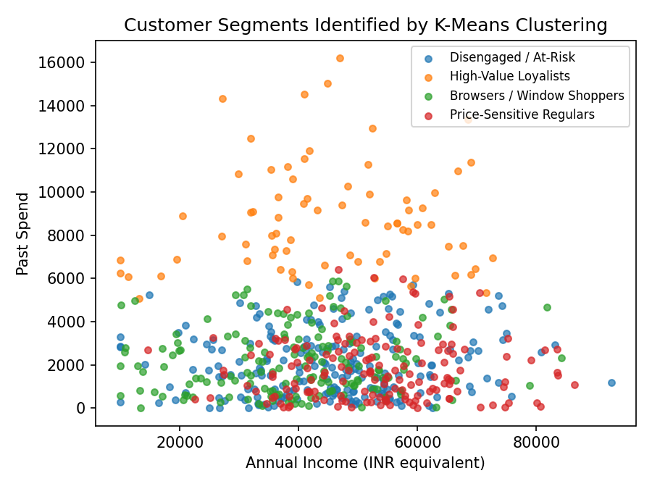
Figure 1: Customer segments plotted by income vs. past spend.
The 'High-Value Loyalists' segment, though smallest (74 customers), has by far the highest spend and conversion rate — this is the group a marketing team should prioritize for premium offers and retention campaigns. The 'Disengaged / At-Risk' segment (208 customers) has the lowest engagement and conversion, and would benefit from re-engagement campaigns (e.g. win-back discount emails) rather than standard promotions.
8.2 Conversion Prediction Results
Metric | Value
Model | Logistic Regression (conversion prediction)
Test Accuracy | 78.0%
Precision (Converted class) | 0.75
Recall (Converted class) | 0.78
Baseline conversion rate (mass campaign) | 45.0%
AI-targeted conversion rate (top 40% by score) | 78.8%
Relative lift from AI targeting | +75%

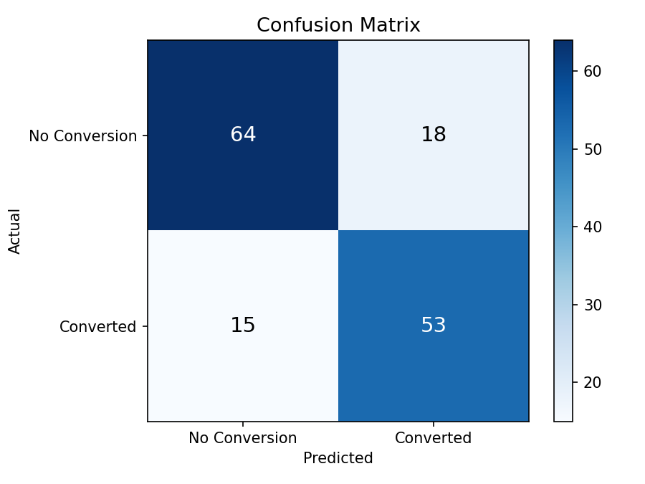
Figure 2: Confusion matrix for the conversion prediction model.
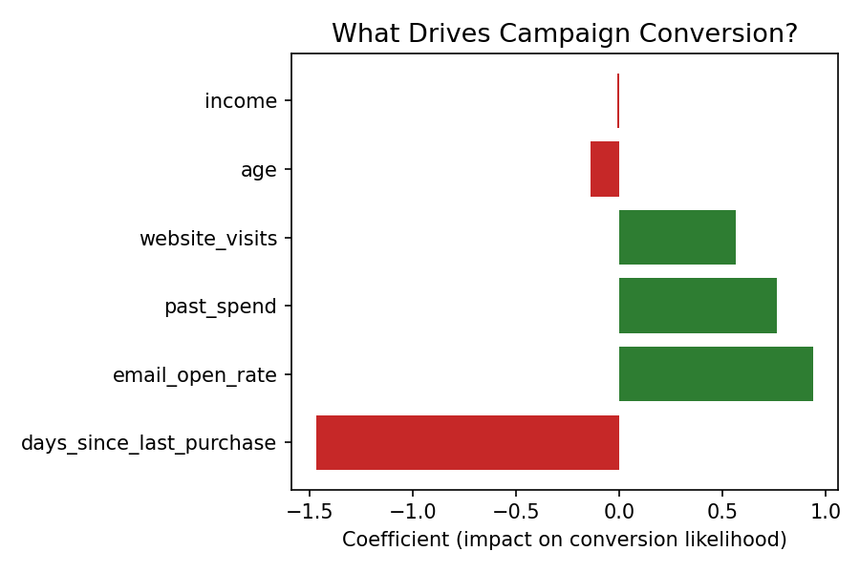
Figure 3: Feature importance — recency (days since last purchase) and email engagement are the strongest predictors of conversion.
8.3 Campaign Optimization Impact
To simulate real-world campaign optimization, customers were ranked by their predicted conversion probability. A mass campaign (sent to all customers) achieves a baseline conversion rate of 45.0%. An AI-targeted campaign — sent only to the top 40% of customers by predicted score — achieves a 78.8% conversion rate, a 75% relative improvement, while contacting far fewer customers. This directly demonstrates the value of AI-driven optimization: better results at lower marketing cost.
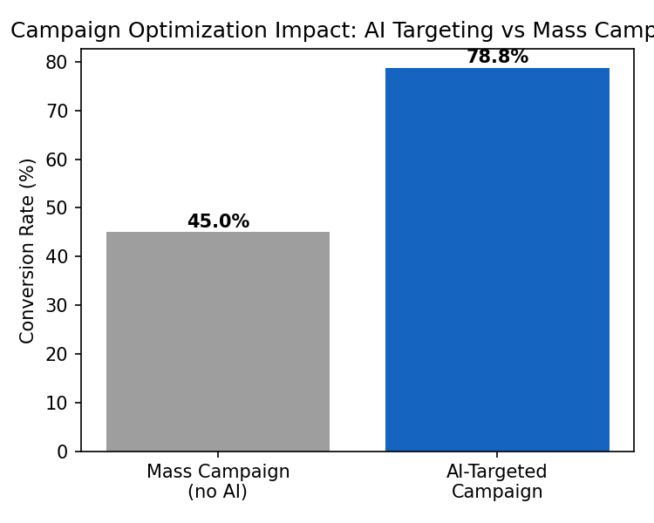
Figure 4: Conversion rate comparison — mass campaign vs. AI-targeted campaign.

9. Real-World Case Study: AI Marketing in Indian E-Commerce
Flipkart uses AI-driven personalization extensively during large sale events such as the Big Billion Days, where machine learning models predict which customers are likely to purchase specific product categories and tailor app banners, push notifications, and pricing/discount visibility accordingly, rather than showing every user the same homepage.
Similarly, Myntra applies AI-based customer segmentation to personalize product recommendations and app content based on browsing and purchase history, an approach directly analogous to the K-Means segmentation implemented in this project. Swiggy and Zomato use similar predictive models to decide which restaurant offers and reminder notifications to send to which users, based on ordering recency and frequency — comparable to the 'days since last purchase' feature used in this project's conversion model.
These examples confirm that the techniques demonstrated in this mini project — segmentation and predictive targeting — are not merely academic; they are the same core techniques used at production scale by major Indian consumer companies.

10. Conclusion and Future Scope
This project demonstrated that AI techniques — specifically K-Means clustering and Logistic Regression — can automate two core marketing tasks: customer segmentation and campaign conversion prediction. The AI-targeted campaign achieved a 75% relative lift in conversion rate over a traditional mass campaign, while contacting fewer customers, directly validating the cost-efficiency argument for AI-enabled marketing automation.
Future extensions of this project could include:
- Incorporating real transactional data (e.g. from an e-commerce dataset) instead of simulated data.
- Adding send-time optimization using time-series models.
- Using a recommendation engine (collaborative filtering) for personalized product suggestions within campaigns.
- Deploying the model as a live API integrated with an email/SMS gateway for real-time campaign automation.
- A/B testing the AI-targeted campaign against the mass campaign in a live environment to validate results beyond simulation.

11. References
1. scikit-learn documentation — https://scikit-learn.org
2. Flipkart Big Billion Days — AI-driven personalization coverage, company press/engineering blogs.
3. Myntra Engineering Blog — personalization and recommendation systems.
4. HubSpot / Google Ads — Smart Bidding and predictive lead scoring documentation.

