INTERIM PROGRESS REPORT (IPR)
Arrhythmia Recognition Using Neural Networks:
A Comparative Study of MLP, 1D-CNN and LSTM Architectures
Reporting Period: Weeks 1 – 9
Student Name: Hariprasad Murugesan
Student ID: 24135993
Course: MSc Data Science and Analytics
Module: 7COM1039-0509-2025 — Advanced Computer Science Masters Project
Supervisor: Neeli Khalid
Institution: University of Hertfordshire

Table of Contents
Table of Contents 1
Chapter I — Introduction & Overview 1
1.1 Background 1
1.2 Problem Statement 1
1.3 Research Aim 1
1.4 Research Objectives 1
1.5 Research Questions 1
1.6 Project Scope 1
1.7 Proposed Practical Investigation 1
1.8 Methodology Overview 1
1.9 Tools and Technologies 1
1.10 Expected Deliverables 1
1.11 Ethical, Legal, Professional and Social Issues 1
Chapter II — Progress to Date 1
2.1 Literature Review Progress 1
2.2 Dataset Collection and Preparation 1
2.3 Exploratory Data Analysis 1
2.4 Feature Engineering 1
2.5 Machine Learning Model Development 1
2.6 Deep Learning Model Development 1
2.7 Prototype / Demonstration Design Progress 1
2.8 Preliminary Results 1
2.9 Problems Encountered 1
2.10 Evidence of Work Completed 1
Chapter III — Planned Work 1
3.1 Remaining Tasks 1
3.2 Project Timeline 1
3.3 Evaluation Plan 1
3.4 Success Criteria 1
3.5 Risk Management and Contingency Planning 1
Bibliography 1
Appendices 1
Appendix A: 12-Week Project Gantt Chart 1
Appendix B: Preprocessing Validation Figures 1
Appendix C: Key Code Listings 1

Chapter I — Introduction & Overview

1.1 Background
Cardiovascular disease is the single largest cause of death worldwide, and the World Health Organisation puts the annual figure at roughly 17.9 million people. A good share of those deaths involves cardiac arrhythmias, which are disturbances in the heart’s electrical rhythm that range from completely benign to immediately life-threatening. The electrocardiogram (ECG) is still the standard non-invasive way of recording this electrical activity, and automating the classification of individual heartbeats has been an active research problem for decades because it promises faster and more consistent screening than manual reading.
Three problems keep resurfacing in the literature, and they are the ones this project is built around. Real ECG recordings are noisy: they pick up muscle movement, poor electrode contact, and mains interference. The benchmark datasets, MIT-BIH above all, are overwhelmingly made up of normal beats, so a model can post a high overall accuracy while barely recognising the rarer arrhythmia types that actually matter clinically. And several beat categories look similar enough on the waveform that even carefully trained models confuse them. My project sits inside that space and asks how three different neural network designs (an MLP, a 1D-CNN, and an LSTM) cope with the same noise, the same imbalance, and the same overlap.

1.2 Problem Statement
Most published work tests a single architecture on its own, under its own preprocessing, its own train/test split, and its own choice of metric. That makes it very hard to compare one paper against another, because an apparent improvement could just as easily come from the setup as from the model. A second and subtler issue is patient-level data leakage. If beats from the same patient end up in both the training and test sets, the model can quietly learn to recognise that individual’s signal rather than the arrhythmia itself, and the reported accuracy is inflated in a way that will not survive contact with a new patient.
The problem I am addressing is the absence of a fair, same-conditions comparison between a feature-engineered MLP and two architectures that learn straight from the raw signal (1D-CNN and LSTM), all evaluated on MIT-BIH with strict patient-level separation and a single consistent strategy for class imbalance.

1.3 Research Aim
The aim is to evaluate and compare three neural network architectures (MLP, 1D-CNN, and LSTM) for automated cardiac arrhythmia detection on the MIT-BIH Arrhythmia Database, through one reproducible preprocessing and evaluation pipeline, in order to establish which architecture best handles the noise, class imbalance, and overlapping decision boundaries that characterise real ECG data.

1.4 Research Objectives
- Review the literature on traditional machine learning and deep learning approaches to arrhythmia recognition and identify their limitations on real-world ECG.
- Acquire and preprocess ECG data from the MIT-BIH Arrhythmia Database, including signal filtering, R-peak detection, and beat segmentation.
- Engineer multi-domain feature representations (time, frequency, and wavelet) as the input for the MLP baseline.
- Implement and tune the MLP, 1D-CNN, and LSTM models for multi-class beat classification.
- Evaluate each model using sensitivity, specificity, macro-F1, AUC-ROC, and Cohen’s Kappa under patient-wise cross-validation.
- Assess how SMOTE affects minority-class recognition on the feature-based path.
- Carry out error analysis to surface the dominant misclassification patterns.
- Draw evidence-based conclusions on which architecture is best suited to scalable, patient-independent screening.

1.5 Research Questions
- What arrhythmia recognition techniques already exist, and what are their main limitations when they meet real-world ECG data?
- How do MLP, 1D-CNN, and LSTM architectures compare when classifying MIT-BIH beats under identical, leakage-free conditions?
- How much does SMOTE improve per-class sensitivity on the minority arrhythmia classes for the feature-based path?
- How much does the feature representation, whether time, frequency, or wavelet, affect performance compared with feeding the raw sequence directly to the deep models?

1.6 Project Scope
The project covers the full pipeline for beat classification on MIT-BIH: parsing the raw signal and annotation files, denoising and segmenting the signal around each detected beat, mapping beats onto the five AAMI EC57 classes (N, S, V, F, Q) and training along with evaluating the three architectures under matched conditions. The comparison includes the effect of SMOTE on the feature path and a Wilcoxon signed-rank test to check whether the differences between models are real or just fold-to-fold variance.
It does not extend to real-time or embedded deployment, to full 12-lead analysis, or to clinical validation on new patients. Those are sensible directions for later, but they sit outside what one person can do well inside a 12-week module.

1.7 Proposed Practical Investigation
The practical work is organised as one reproducible Python pipeline rather than three separate scripts, and fairness is enforced right at the segmentation stage. Every beat is cut into the same fixed window (250 ms before and 400 ms after the R-peak, which is 234 samples at 360 Hz) and standardised with a per-beat Z-score. That shared window is the common foundation from which every input representation is derived, so no architecture ever sees more of the signal than another.
From that window the pipeline splits into two input paths. The engineered-feature path computes time-domain statistics, frequency-domain features, and Daubechies-4 wavelet energies from each beat and concatenates them into a compact 12-dimensional vector; this is the MLP’s input. The raw-sequence path hands the 234-sample voltage trace straight to the 1D-CNN and the LSTM, with no hand-crafted features, so those models learn their own representations. Because both paths start from the same normalised window, any performance gap reflects architectural capacity rather than an information advantage.

1.8 Methodology Overview
Dataset and preprocessing. The data source is the MIT-BIH Arrhythmia Database, 48 half-hour recordings from 47 subjects, accessed through PhysioNet. Each record is read in WFDB format and its beats mapped to the five AAMI EC57 classes. Signals are denoised with a zero-phase 0.5–40 Hz Butterworth band-pass, R-peaks are located with the GQRS detector, and each beat is segmented into the shared 234-sample window and Z-scored.
Splitting by patient. The data is partitioned at the record level, not the beat level. Every fold holds out complete patients, so no beat from a held-out patient ever appears in training. This is deliberately more conservative than a random beat-wise split, which would let a model exploit an individual’s signal identity — the leakage that inflates accuracy by several points in the published work. A patient-wise estimate is the one that matters for real deployment.
Handling imbalance. The strategy differs by path, on purpose. On the MLP’s feature vectors, SMOTE is applied inside each training fold only, after the split, because interpolating between scalar feature vectors produces plausible minority-class points. For the raw-sequence models, SMOTE is not used: averaging two raw ECG waveforms sample-by-sample can create physiologically impossible morphologies, so class-weighted cross-entropy is used instead.
Optimisation and evaluation. All three models are tuned with a grouped inner cross-validation search on macro-F1, then evaluated with a ten-fold patient-wise loop. I report per-class sensitivity and specificity (with particular attention to V and to the rare F class), macro-F1, AUC-ROC, and Cohen’s Kappa, and I use a paired Wilcoxon signed-rank test at α = 0.05 on the per-fold macro-F1 to decide whether the architectures actually differ.

1.9 Tools and Technologies
The implementation uses Python 3.10 with NumPy and SciPy for numerical work, WFDB for reading the MIT-BIH records, PyWavelets for the wavelet features, scikit-learn for the MLP baseline and the evaluation metrics, and imbalanced-learn for SMOTE. The 1D-CNN and LSTM are built in TensorFlow/Keras and trained on an NVIDIA RTX 4060 laptop GPU through WSL2 Ubuntu. Matplotlib and Seaborn handle the signal, distribution, and results plots. Literature has come through IEEE Xplore, PubMed, and ScienceDirect via the university library.

1.10 Expected Deliverables
- A reproducible Python codebase covering the whole pipeline, from raw signal to model evaluation, released on GitHub under an open-source licence.
- A like-for-like comparison of the feature-engineered MLP against the representation-learning 1D-CNN and LSTM.
- Evidence-based conclusions on which architecture best handles noise, imbalance, and class overlap on MIT-BIH.
- A browser-based demonstration application that presents the trained models’ results interactively (planned; see Section 2.7).
- A completed dissertation covering methodology, results, error analysis, and documented code.

1.11 Ethical, Legal, Professional and Social Issues
MIT-BIH is a public, de-identified dataset distributed through PhysioNet under an open licence, so the project does not recruit participants or collect new patient data. It contains no identifiable information and falls outside the UK GDPR definition of personal data, so no ethics approval beyond the standard secondary-data declaration is needed. On the professional side, the code will be released on GitHub with the dataset cited under PhysioNet’s terms, and every result will be framed as a research comparison between architectures rather than as a validated diagnostic tool, so there is no risk of implying the models are ready for clinical use.

Chapter II — Progress to Date

2.1 Literature Review Progress
The literature review is complete. Over the first few weeks I worked through around ten sources spanning the classical machine-learning era and the recent deep-learning work, and I settled the direction of the project on the back of it. The recurring gap is that most studies test one architecture at a time, under their own preprocessing and split, and only a minority control for patient-level leakage. That gap is exactly what the four research questions target. The table below summarises the sources that shaped the design most directly.
Study | Approach / Architecture | Dataset | Key contribution | Limitation / gap
Kiranyaz et al. (2016) | Patient-specific 1D-CNN on raw beats | MIT-BIH | Showed a compact 1D-CNN can classify beats in near real time. | Patient-specific setup does not test generalisation to unseen patients.
Hannun et al. (2019) | 34-layer deep CNN | Single-lead, large private set | Cardiologist-level rhythm detection at scale. | Needs a very large labelled set; not reproducible on MIT-BIH.
Jahan et al. (2025) | CNN-LSTM-attention hybrid | MIT-BIH | Attention improves minority-class recall. | Single architecture; split and leakage control unclear.
Sun et al. (2024) | CNN-LSTM-SE | MIT-BIH | Squeeze-excitation sharpens feature channels. | No like-for-like baseline; imbalance handling light.
Thota et al. (2025) | Lightweight CNN-attention-BiLSTM | Standard + wearable ECG | Small model works on wearable signals. | Reports overall accuracy; per-class detail thin.
Mirdan (2025) | Deep attention model | MIT-BIH | Attention-based gains on beat classification. | Imbalance and patient-wise split not fully addressed.
Shahnawaz et al. (2026) | Augmentation + optimal feature set | MIT-BIH | Data augmentation lifts minority classes. | Feature/augmentation focus, no architecture comparison.
Jaya Prakash et al. (2025) | Systematic review | Multiple | Confirms imbalance is the main open problem. | Confirms, rather than resolves, the gap.
Table 2.1 — Core literature: what each source contributes and where it leaves a gap. The shared weakness, single-architecture testing without leakage control, is what this project sets out to close.
Reading across the table, two things stand out. The first is that the field has largely moved from hand-crafted features towards representation learning: the older strand (Kiranyaz et al., 2016; de Chazal et al., 2004) leans on engineered inputs, while almost everything from 2024 onward stacks convolutional and recurrent layers, usually with an attention mechanism added on top. The second is that this shift has not been tested fairly. Very few of the recent papers pin down whether their reported gains come from the architecture or from a more forgiving experimental setup, and fewer still report per-class numbers for the rare classes where the clinical value actually sits. The systematic review (Jaya Prakash et al., 2025) says as much: imbalance, not architecture, is the real bottleneck. That is the reasoning behind keeping a feature-engineered MLP in the comparison rather than dropping it as old-fashioned. If a cheap baseline holds up against a raw-signal CNN under honest conditions, that is worth knowing, and none of the surveyed papers set up the experiment to find out.

2.2 Dataset Collection and Preparation
This stage is finished. All 48 MIT-BIH records were downloaded and verified through the wfdb package, with the 360 Hz sampling rate and two-channel layout (MLII and V5) confirmed on record 100. I started with a handful of records to prove the loading worked end to end before committing to the full set, which saved time when a couple of records needed their annotation files handled slightly differently.

2.3 Exploratory Data Analysis
EDA is complete. Mapping every record’s raw annotation symbols onto the five AAMI classes gives 109,454 labelled beats, and the class split is as lopsided as the literature warned: N dominates at 82.8%, and the clinically important F class is barely there at 0.7%. This is the imbalance that motivates the SMOTE and class-weighting choices, so it is worth seeing plainly.
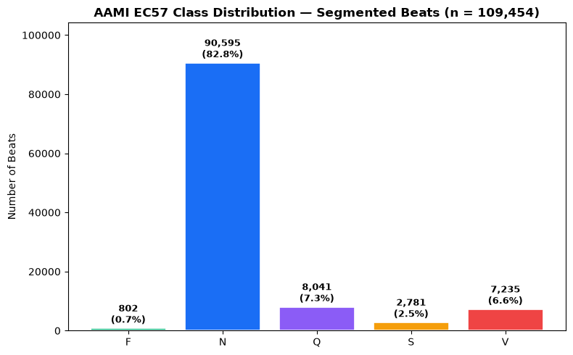
Figure 2.1 — Beat counts per AAMI class across the full dataset. N accounts for over four in five beats; F is under one in a hundred.
Signal quality was checked with a before/after comparison of the raw trace against the 0.5–40 Hz zero-phase Butterworth output, and R-peak detection was validated against the expert annotations on record 100 (2,272 detected against 2,273 true beats, giving a sensitivity of 0.9996 and a positive predictive value of 1.0000). Both figures are in Appendix B.

2.4 Feature Engineering
Feature engineering for the MLP baseline is complete. Each beat is segmented into the shared 234-sample window and reduced to a 12-dimensional vector across three domains: five time-domain statistics (mean, standard deviation, skewness, kurtosis, RMS), two frequency-domain features (dominant frequency and spectral energy from the FFT), and five Daubechies-4 wavelet sub-band energies at level 4. A patient-wise GroupKFold split was implemented first, with zero patient overlap confirmed between folds, and SMOTE is applied to the training fold only so the balancing never leaks into evaluation. I trialled PCA on the feature set but dropped it: at twelve dimensions there is little to gain, and standardisation with a fold-fitted StandardScaler proved the cleaner choice.
The effect of SMOTE on the training fold is worth seeing directly. Before balancing, the minority classes are almost invisible next to N; after balancing, each class is brought up to the majority count so the MLP sees roughly equal numbers during training (Figure 2.1b). This only ever happens inside the training fold — the held-out fold keeps its natural, imbalanced distribution, so the evaluation still reflects real-world proportions.
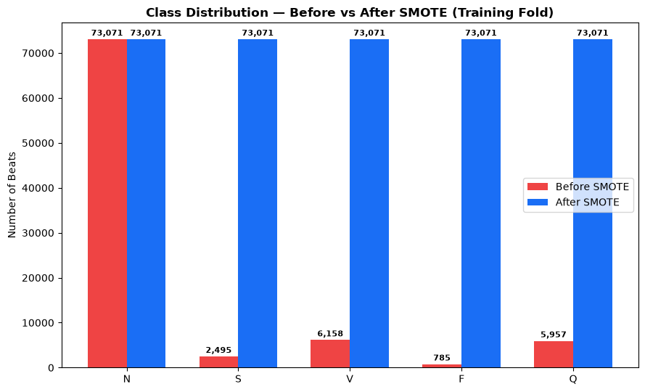
Figure 2.1b — Training-fold class counts before and after SMOTE. Balancing is applied only to the training data; the test fold is left untouched to keep the evaluation honest.

2.5 Machine Learning Model Development
The MLP baseline is implemented and has completed a first cross-validation run. It takes the standardised 12-feature vector, uses two hidden layers with dropout, and trains on the SMOTE-balanced feature set with a sparse categorical loss. This is a working model producing preliminary numbers (Section 2.8), not a finished one — the systematic fine-tuning of its width, depth, and regularisation is still to come.

2.6 Deep Learning Model Development
The 1D-CNN and the LSTM are both implemented and have each completed a first cross-validation run on the raw 234-sample sequences with class-weighted loss. The CNN uses two convolution-and-pooling blocks into a small dense head; the LSTM uses a single recurrent layer into a dense head. As with the MLP, these are first working versions: they run end to end and give preliminary results, but their hyperparameters have not yet been searched properly.

2.7 Prototype / Demonstration Design Progress
I have designed the demonstration application but not yet built it. The plan is a single-page browser dashboard that shows an example ECG trace, lets the viewer pick a beat morphology and see how the model classifies it, and lays out the final per-class results once the evaluation is done. Keeping it browser-based and driven by the saved results means the demo will not need a live model running at demonstration time. At this point it is a design outline and a set of decisions about layout and content; the implementation is scheduled alongside the final evaluation.

2.8 Preliminary Results
These are first-pass numbers from the initial cross-validation runs, before any real fine-tuning, so I am treating them as a sanity check on the pipeline rather than as the project’s findings. On macro-F1 the MLP and the CNN come out almost level, with the LSTM trailing. That the cheap twelve-feature MLP is holding its own against a raw-signal CNN is already the most interesting thing the pipeline has shown, and it is the sort of result the full evaluation needs to confirm or overturn.
Model | Macro-F1 (mean ± sd) | Macro AUC-ROC | Status
MLP (12 features + SMOTE) | 0.328 ± 0.099 | 0.763 | Preliminary
1D-CNN (raw sequence) | 0.327 ± 0.100 | 0.760 | Preliminary
LSTM (raw sequence) | 0.269 ± 0.049 | 0.671 | Preliminary
Table 2.2 — Preliminary macro-averaged results from the first cross-validation runs. Numbers are expected to move once fine-tuning and the full ten-fold evaluation are in place.
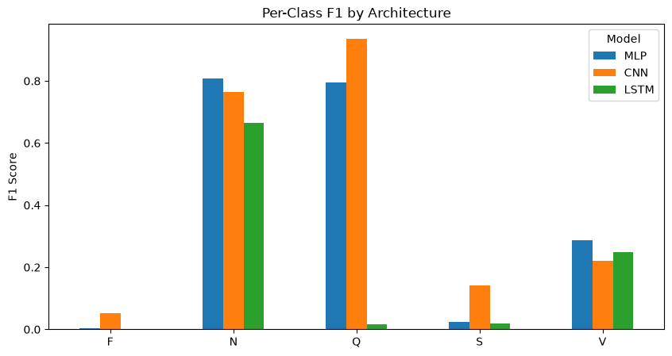
Figure 2.2 — Per-class F1 on a representative fold. Every model leans on N and V and struggles on S and F, which is the imbalance problem showing through.
Looking at where the errors fall is more informative than the headline score at this stage. The preliminary confusion matrix for the CNN on a held-out fold (Figure 2.3) shows the pattern I expected from the class distribution: the model is confident on N and V, but a large slice of true N beats leak into V, and the two smallest classes, S and F, are mostly absorbed into their nearest neighbours. This is not a tuning problem so much as a data problem, and it is exactly what the error-analysis phase is meant to quantify properly once the models are fine-tuned. I am flagging it now because it already tells me the interesting question is not “which model wins” but “how far can any of them get on the rare classes given how little F data exists.”
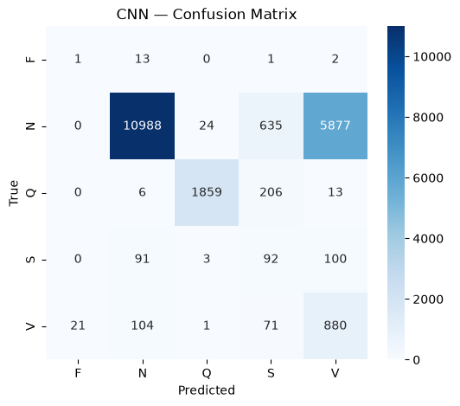
Figure 2.3 — Preliminary confusion matrix for the 1D-CNN on a held-out fold (row-normalised). The heavy N-to-V leakage and the near-total loss of F are visible off the diagonal.

2.9 Problems Encountered
Most of the real work in the last few weeks has been debugging rather than modelling, and a few problems are worth recording. The first was an execution-order bug: run out of order, the notebook quietly reused a stale split, so I consolidated the clean-and-split logic into a single ordered step that rebuilds everything in dependency order. The second was the AAMI label ordering. scikit-learn’s encoder sorts the class names alphabetically, which did not match the clinical order I had assumed, so early plots attached colours to the wrong class until I started reading the class order back from the encoder. The third was SMOTE failing on the sparsest folds, where a minority class had too few samples for the default neighbour count; capping the neighbours at the available count fixed it.
Three more were subtler and cost more time. When some records turned out to carry non-beat annotation symbols (the +, ~, and | markers), a handful of beats came through with no valid class label and crashed both the encoder and SMOTE; I added an explicit validity mask that drops them at source before anything downstream sees them. Keras then threw a dtype error during training because the string labels were reaching the loss function unencoded, which I traced to a missing transform step and fixed by encoding once, up front, with the same fitted encoder used everywhere else. Finally, the AUC-ROC calculation warned and returned nonsense on folds where a rare class was absent from the test set; I now compute AUC only over the classes actually present in a fold and average with a NaN-aware mean. None of these were conceptually hard, but each one was quietly corrupting results until it was found, which is exactly why they are worth flagging in a progress report rather than hiding.

2.10 Evidence of Work Completed
- Finalised literature review with the comparison table above and a complete reference list.
- Downloaded and verified the full MIT-BIH database (48 records, 360 Hz, two leads).
- Implemented zero-phase Butterworth filtering and GQRS R-peak detection, validated at 0.9996 sensitivity on record 100.
- Mapped annotations to the five AAMI classes across the full set, giving 109,454 beats and confirming the 82.8% N imbalance.
- Implemented patient-wise GroupKFold splits with zero patient overlap verified.
- Engineered the 12-dimensional feature vector and applied SMOTE to the training fold only.
- Implemented all three models (MLP, 1D-CNN, LSTM) and completed a first cross-validation run producing preliminary results.
- Set up GPU training through WSL2 and a checkpointed run so long jobs can resume.

Chapter III — Planned Work

3.1 Remaining Tasks
The pipeline is built and the models run, so the remaining work is about turning preliminary numbers into defensible findings and packaging the project up. The main items are:
- Fine-tune all three architectures properly, using a grouped inner cross-validation search over width, depth, dropout, and learning rate, rather than relying on the first working configuration (Phase 5).
- Run the full comparative evaluation: the complete ten-fold patient-wise loop with per-class sensitivity and specificity, macro-F1, AUC-ROC, Cohen’s Kappa, confusion matrices, and the paired Wilcoxon signed-rank test (Phase 5).
- Carry out the error analysis, focusing on the dominant confusions and the near-total loss of the rare F class (Phase 6).
- Build the browser-based demonstration application described in Section 2.7, driven by the saved final results (Phase 6).
- Write up the dissertation (methodology, results, error analysis, and documented code) and prepare the GitHub release. This has not started yet (Phase 7).

3.2 Project Timeline
The table summarises the remaining phases; the full 12-week Gantt chart is Appendix A.
Phase | Weeks | Key tasks
Phase 6 | 9–11 | Fine-Tuning, Error analysis and the browser-based demonstration application.
Phase 7 | 11–12 | Dissertation write-up and GitHub code release.

3.3 Evaluation Plan
Each model will be assessed with the ten-fold patient-wise loop already in the code, so class proportions stay consistent across folds while patient separation is respected. For every fold I will record per-class sensitivity and specificity, especially for the minority S, V, F, and Q classes, alongside macro-F1, AUC-ROC, Cohen’s Kappa, and confusion matrices. To compare the three architectures, and to compare performance with and without SMOTE, I will run a paired Wilcoxon signed-rank test at α = 0.05 on the per-fold macro-F1, with Holm correction across the three pairwise comparisons so the multiple testing does not manufacture significance.

3.4 Success Criteria
I will consider the project successful if it delivers a clean, leakage-free comparison of the three architectures on MIT-BIH, with per-class results and a statistical test that lets me say honestly whether they differ; a measured account of what SMOTE does to minority-class recall on the feature path; an error analysis that explains where the ceiling comes from; and a reproducible codebase plus a working demonstration. A particular class of success would be an honest negative result, for instance finding no significant gap between the models, reported as such rather than dressed up, since that is still a useful finding for anyone choosing an architecture.

3.5 Risk Management and Contingency Planning
Risk | Likelihood / Impact | Mitigation / contingency
Fine-tuning runs take longer than planned on the deep models. | Medium / Medium | Keep the search grids small and grouped; reuse the checkpointed GPU run so long jobs resume instead of restarting.
Minority classes (F, S) stay near-unlearnable after tuning. | Medium / Medium | Report the limit honestly, lean on SMOTE and class weighting, and frame F as a data-scarcity result rather than a model failure.
Demonstration application slips against the write-up. | Low / Low | The demo is driven by saved results, so it does not depend on a live model and can be built in parallel with the write-up.
Dissertation write-up compresses at the end. | Medium / High | Start drafting methodology and results sections as soon as the evaluation is stable, not after it.

Bibliography
- Shahnawaz, M., Kumawat, N., Singh, T., Satakshi and Kumar, M. (2026) 'An augmented ECG data-based classification for arrhythmia using optimal feature set', Health Information Science and Systems, 14(1). https://doi.org/10.1007/s13755-026-00440-3.
- Jahan, I., Parsub, W.R., Islam, M.S., Rimi, R.A., Mosharof, F. and Reza, A.W. (2025) 'Enhancing cardiac arrhythmia detection: deep learning-based CNN-LSTM-attention framework for digitized ECG classification', in Bhattacharya, A., Dutta, S., Yang, X.-S. and Goon, S. (eds) Innovations in Data Analytics — ICIDA 2024. Lecture Notes in Networks and Systems, vol. 1408. Singapore: Springer, pp. 245–258. https://doi.org/10.1007/978-981-96-6297-5_19.
- Jaya Prakash, A., Nasreddine Belkacem, A., Elfadel, I.M., Jelinek, H.F. and Atef, M. (2025) 'Advances in machine and deep learning for ECG beat classification: a systematic review', Frontiers in Digital Health, 7, art. 1649923. https://doi.org/10.3389/fdgth.2025.1649923.
- Mirdan, A.S. (2025) 'A deep attention-based model on MIT-BIH', Journal of Al-Qadisiyah for Computer Science and Mathematics, 17(2), pp. 29–47. Available at: https://jqcsm.qu.edu.iq/index.php/journalcm/article/view/2175 (Accessed: 12 July 2026).
- Thota, V., Prajapati, H., Joshi, Y. and Rathi, S. (2025) 'A lightweight CNN-attention-BiLSTM architecture for multi-class arrhythmia classification on standard and wearable ECGs', arXiv. Available at: https://arxiv.org/abs/2511.08650 (Accessed: 12 July 2026).
- PhysioNet (2024) MIT-BIH Arrhythmia Database. Available at: https://physionet.org/content/mitdb/1.0.0/ (Accessed: 12 July 2026).
- Sun, A., Hong, W., Li, J. and Mao, J. (2024) 'An arrhythmia classification model based on a CNN-LSTM-SE algorithm', Sensors, 24(19), art. 6306. https://doi.org/10.3390/s24196306.
- World Heart Federation (2023) World Heart Report 2023: Confronting the World's Number One Killer. Geneva: World Heart Federation. Available at: https://world-heart-federation.org/wp-content/uploads/World-Heart-Report-2023.pdf (Accessed: 12 July 2026).
- Rahman, A.U., Asif, R.N., Sultan, K., Alsaif, S.A., Abbas, S., Khan, M.A. and Mosavi, A. (2022) 'ECG classification for detecting ECG arrhythmia empowered with deep learning approaches', Computational Intelligence and Neuroscience, 2022(1), art. 6852845. https://doi.org/10.1155/2022/6852845.
- Hannun, A.Y., Rajpurkar, P., Haghpanahi, M., Tison, G.H., Bourn, C., Turakhia, M.P. and Ng, A.Y. (2019) 'Cardiologist-level arrhythmia detection and classification in ambulatory electrocardiograms using a deep neural network', Nature Medicine, 25(1), pp. 65–69. https://doi.org/10.1038/s41591-018-0268-3.
- Quan, W., Chen, Z., Gao, J. and Hu, X. (2018) 'Comparative study of CNN and LSTM based attention neural networks for aspect-level opinion mining', in 2018 IEEE International Conference on Big Data (Big Data). IEEE, pp. 2141–2150. https://doi.org/10.1109/BigData.2018.8622153.
- Kiranyaz, S., Ince, T. and Gabbouj, M. (2016) 'Real-time patient-specific ECG classification by 1-D convolutional neural networks', IEEE Transactions on Biomedical Engineering, 63(3), pp. 664–675. https://doi.org/10.1109/TBME.2015.2468589.
- de Chazal, P., O'Dwyer, M. and Reilly, R.B. (2004) 'Automatic classification of heartbeats using ECG morphology and heartbeat interval features', IEEE Transactions on Biomedical Engineering, 51(7), pp. 1196–1206. https://doi.org/10.1109/TBME.2004.827359.
- Moody, G.B. and Mark, R.G. (2001) 'The impact of the MIT-BIH Arrhythmia Database', IEEE Engineering in Medicine and Biology Magazine, 20(3), pp. 45–50. https://doi.org/10.1109/51.932724.

Appendices

Appendix A: 12-Week Project Gantt Chart
The plan runs across Phases 1–7, from the literature review through to the dissertation write-up and code release. Completed phases are shaded green and planned phases blue.
Phase / Task | W1 | W2 | W3 | W4 | W5 | W6 | W7 | W8 | W9 | W10 | W11 | W12
Phase 1 — Literature Review & Proposal Finalisation
Phase 2 — Dataset Acquisition & Pre-processing
Phase 3 — Feature Engineering & Formatting
Phase 4 — Architecture Implementation & Tuning
Phase 5 — Comparative Evaluation & Imbalance Analysis
Phase 6 — Error Analysis & Interpretation
Phase 7 — Dissertation Write-up & Code Release
■ Completed ■ Planned

Appendix B: Preprocessing Validation Figures
These figures support the dataset and EDA sections. The first shows the raw ECG against the zero-phase Butterworth-filtered signal; the second shows GQRS R-peak detection against the expert annotations on record 100.
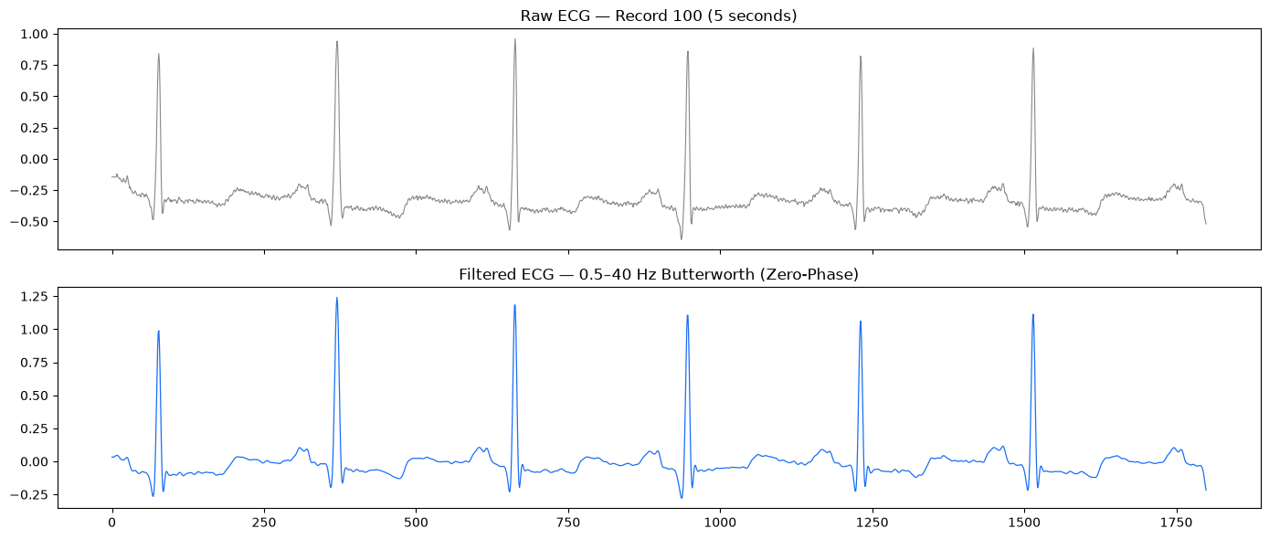
Figure B.1 — Raw versus 0.5–40 Hz zero-phase Butterworth-filtered ECG. Baseline wander and high-frequency noise are removed without shifting the QRS in time.
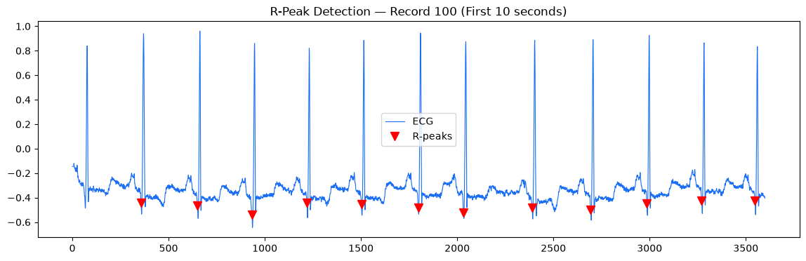
Figure B.2 — GQRS R-peak detection on record 100: 2,272 detected against 2,273 true beats (Se = 0.9996, PPV = 1.0000).

Appendix C: Key Code Listings
The two functions below are the core of the shared preprocessing path and are what guarantees the three architectures receive comparable inputs. The first cuts every beat into the same fixed window and drops incomplete or non-beat annotations; the second turns each beat window into the 12-dimensional feature vector used by the MLP.

C.1 Beat segmentation into the shared 234-sample window
def segment_beats(signal, r_peaks, labels, fs=360, pre_ms=250, post_ms=400):
pre = int(pre_ms / 1000 * fs)
post = int(post_ms / 1000 * fs)
beats, beat_labels = [], []
for peak, label in zip(r_peaks, labels):
if label is None:
continue # skip non-beat annotations (+, ~, |, x, etc.)
start, end = peak - pre, peak + post
if start < 0 or end > len(signal):
continue # skip incomplete beats at signal edges
beats.append(signal[start:end])
beat_labels.append(label)
return np.array(beats), np.array(beat_labels)

C.2 Multi-domain feature extraction (time, frequency, wavelet)
from scipy.stats import skew, kurtosis
import pywt
import pandas as pd

def extract_features(beat, fs=360):
feats = {}
# 1. Time-domain
feats['mean'] = np.mean(beat)
feats['std'] = np.std(beat)
feats['skew'] = skew(beat)
feats['kurtosis'] = kurtosis(beat)
feats['rms'] = np.sqrt(np.mean(beat**2))

# 2. Frequency-domain
fft_vals = np.abs(np.fft.rfft(beat))
feats['dominant_freq'] = np.argmax(fft_vals)
feats['spectral_energy'] = np.sum(fft_vals**2)

# 3. Wavelet-domain (db4, level 4)
coeffs = pywt.wavedec(beat, 'db4', level=4)
for i, c in enumerate(coeffs):
feats[f'wavelet_energy_L{i}'] = np.sum(c**2)

return feats

feature_dicts = [extract_features(b) for b in beats]
feature_df = pd.DataFrame(feature_dicts)
print(feature_df.shape)
print(feature_df.head())

