INTERIM PROGRESS REPORT (IPR)
Arrhythmia Recognition Using Neural Networks: A Comparative Study
Reporting Period: Weeks 1 – 4
Student Name: Hariprasad Murugesan
Student ID: 24135993
Course: MSc Data Science and Analytics
Module: 7COM1039-0509-2025 – Advanced Computer Science Masters Project
Supervisor: Neeli Khalid
University of Hertfordshire

Table of Contents
Table of Contents 2
CHAPTER I – INTRODUCTION & OVERVIEW 4
1.1 Background 4
1.2 Problem Statement 4
1.3 Research Aim 4
1.4 Research Objectives 4
1.5 Research Questions 5
1.6 Project Scope 5
1.7 Proposed Practical Investigation 5
1.8 Methodology Overview 6
1.9 Tools and Technologies 6
1.10 Expected Deliverables 6
1.11 Ethical, Legal, Professional and Social Issues 7
CHAPTER II – PROGRESS TO DATE 8
2.1 Literature Review Progress 8
2.2 Dataset Collection and Preparation 8
2.3 Exploratory Data Analysis 8
2.4 Feature Engineering and Text Processing 8
2.5 Machine Learning Model Development 8
2.6 Deep Learning Model Development 9
2.7 Prototype Design Progress 9
2.8 Preliminary Results 9
2.9 Problems Encountered 9
2.10 Evidence of Work Completed 9
CHAPTER III – PLANNED WORK 10
3.1 Remaining Tasks 10
3.2 Project Timeline 10
3.3 Evaluation Plan 10
3.4 Success Criteria 11
3.5 Risk Management and Contingency Planning 11
Bibliography 12
Appendices 13
Appendix A: 12-Week Project Gantt Chart 13
Appendix B: Week 4 Work — Full Preprocessing Pipeline 13

CHAPTER I – INTRODUCTION & OVERVIEW

1.1 Background
Cardiovascular disease is the leading cause of death worldwide, responsible for an estimated 17.9 million deaths each year according to the World Health Organisation, and a large share of these deaths can be traced back to cardiac arrhythmias such as electrical disturbances in the heart’s rhythm that range from harmless to immediately life-threatening. The electrocardiogram (ECG) remains the standard non-invasive method for recording this electrical activity, and automated classification of ECG beats has been studied for decades as a way to support faster, more consistent diagnosis.
Despite this long history, three problems keep coming up in the literature. Real-world ECG recordings are noisy, picking up muscle movement, electrode contact issues, and powerline interference. The benchmark datasets used to train models, most notably MIT-BIH, are dominated by normal beats, so a model can score well overall while almost never catching the rarer, clinically important arrhythmia types. And several arrhythmia categories look similar enough on the waveform that even well-trained models confuse them. This project sits within that space, comparing how three neural network designs – an MLP, a 1D-CNN, and an LSTM – cope with these issues.

1.2 Problem Statement
Much of the published work tests a single architecture in isolation, under its own choice of preprocessing, train/test split, and evaluation metric. That makes cross-paper comparisons unreliable, since it is rarely clear whether a reported improvement comes from the model itself or from how the experiment was set up. A related issue is patient-level data leakage: if beats from the same patient appear in both training and test sets, the model can effectively memorise that patient’s signal characteristics, inflating accuracy in a way that will not hold up on unseen patients.
The problem this project addresses is the absence of a fair, same-conditions comparison between a feature-engineered MLP and two architectures that learn directly from raw signals (1D-CNN and LSTM), evaluated on the MIT-BIH dataset with strict patient-level separation and a consistent approach to class imbalance via SMOTE.

1.3 Research Aim
The aim of this project is to evaluate and compare three neural network architectures – MLP, 1D-CNN, and LSTM – for automated cardiac arrhythmia detection using the MIT-BIH Arrhythmia Database, through a reproducible preprocessing and evaluation pipeline, in order to identify which architecture best handles the noise, class imbalance, and overlapping decision boundaries typical of real ECG data.

1.4 Research Objectives
- Carry out a literature review covering the limitations of existing traditional machine learning and deep learning approaches to arrhythmia recognition.
- Acquire and preprocess ECG data from the MIT-BIH Arrhythmia Database, applying signal filtering and segmentation.
- Engineer multi-domain feature representations (time-domain, frequency-domain, wavelet-domain) as inputs for the MLP baseline.
- Implement and tune MLP, 1D-CNN, and LSTM models for multi-class beat classification.
- Evaluate each model using accuracy, sensitivity, specificity, F1-score, and AUC-ROC.
- Assess how SMOTE affects minority-class recognition across all three models.
- Carry out error analysis to identify misclassification patterns and failure modes.
- Draw conclusions on which architecture is best suited to scalable clinical deployment.

1.5 Research Questions
- What existing arrhythmia recognition techniques are there, and what are their key limitations when applied to real-world ECG data?
- How do MLP, 1D-CNN, and LSTM architectures compare when classifying cardiac arrhythmias from MIT-BIH ECG signals, and how much does oversampling improve per-class sensitivity and overall performance?
- How does SMOTE affect the performance of MLP, 1D-CNN, and LSTM across minority arrhythmia classes in the MIT-BIH dataset?
- How much does the choice of feature representation – time-domain, frequency-domain, or wavelet-domain affect classification performance compared with raw sequential input?

1.6 Project Scope
This project covers the full pipeline for ECG beat classification on the MIT-BIH Arrhythmia Database: loading and parsing the raw signal and annotation files, denoising and segmenting the signal around each detected beat, mapping beats to the five AAMI EC57 classes (N, S, V, F, Q), and training and evaluating MLP, 1D-CNN, and LSTM models under matched conditions. The comparison includes the effect of SMOTE on minority-class performance and a Wilcoxon signed-rank test to check whether differences between models are statistically significant.
It does not extend to real-time or embedded deployment, multi-lead 12-lead ECG analysis, or clinical validation on new patient data. These are reasonable directions for future work but fall outside what is achievable within the 12-week timeline for this module.

1.7 Proposed Practical Investigation
The practical work is organised around building a single, reproducible Python pipeline rather than three separate one-off scripts. Fairness of comparison across the three architectures is enforced at the segmentation stage: every beat in the dataset is first segmented into an identical fixed-length window of 300 ms before and 400 ms after its R-peak (252 samples at 360 Hz), standardised with a per-beat Z-score. This shared segmented window is the common foundation from which all three input representations are derived, ensuring that no architecture receives more signal information than another.
From this common window, the pipeline branches into two input paths. The engineered-feature path computes time-domain statistics, FFT power coefficients, and Daubechies-4 DWT coefficients from each beat window, concatenates them into a fixed-length feature vector, and reduces dimensionality via PCA to retain 95% of variance; this vector is the MLP's input. The raw-sequence path feeds the 252-sample voltage sequence directly to the 1D-CNN and LSTM without any hand-crafted features, allowing those architectures to learn their own representations. Because both paths derive from the same segmented, normalised window, differences in model performance reflect architectural capacity rather than differences in input information.
All three models are tuned via cross-validated grid search and evaluated under patient-wise cross-validation (see Section 1.8 for the splitting strategy rationale). Class imbalance is handled with SMOTE on the engineered-feature path and class-weighted loss on the raw-sequence path. Results are compared statistically using a paired Wilcoxon signed-rank test.

1.8 Methodology Overview
Dataset and preprocessing: the data source is the MIT-BIH Arrhythmia Database – 48 half-hour ECG recordings from 47 subjects, accessed via PhysioNet. Each recording is loaded in WFDB format and beats are mapped to the five AAMI EC57 classes. Signals are denoised with a 0.5–40 Hz band-pass Butterworth filter, R-peaks are located using the GQRS algorithm (a refinement of Pan-Tompkins), and each beat is segmented into a fixed window of 300 ms before and 400 ms after its R-peak (252 samples at 360 Hz), then standardised with per-beat Z-scores. This shared segmentation step is the foundation for fair cross-architecture comparison.
Feature representation and input alignment: all three architectures receive input derived from the same normalised 252-sample beat window, ensuring no information advantage for any model. For the MLP, three feature domains are extracted from each window and concatenated into a single flat vector: time-domain statistics (mean, standard deviation, skewness, kurtosis, RMS, zero-crossing rate), frequency-domain features (FFT power coefficients covering the 0–40 Hz cardiac band), and wavelet-domain features (Daubechies-4 DWT detail and approximation coefficients at three decomposition levels). The concatenated vector is then reduced via PCA to retain 95% of variance before being passed to the MLP. The 1D-CNN and LSTM receive the raw 252-sample voltage sequence directly, without any hand-crafted transformation. Because all three inputs originate from the same normalised window, differences in classification performance reflect each architecture's capacity to exploit that signal, not differences in the information each received.
Splitting strategy by patient-wise cross-validation: the dataset is partitioned at the patient (record) level rather than at the beat level. Each fold in the cross-validation holds out four to five complete records, meaning every beat from a held-out patient is entirely absent from training. Patient-wise splitting is chosen over beat-wise random splitting because ECG morphology is highly patient-specific: QRS amplitude, axis, and morphology variability differ systematically between individuals. A beat-wise random split allows beats from the same patient to appear in both training and test sets, enabling the model to exploit individual signal identity rather than class-discriminative features — a form of data leakage that inflates reported accuracy by three to eight percentage points in published studies (Chazal et al., 2004; de Chazal and Reilly, 2006). Patient-wise splitting produces a more conservative but clinically realistic estimate of how each architecture generalises to previously unseen patients, which is the operationally relevant question for clinical deployment.
Class imbalance handling: the strategy is deliberately different for the two input paths, and this difference is driven by the properties of ECG waveform data. For the MLP's engineered-feature path, SMOTE is applied to the flat feature vectors inside each cross-validation fold after the patient-wise split. Because SMOTE interpolates between scalar feature vectors rather than raw waveform sequences, the synthetic examples it generates are plausible points in the feature space of the minority class and carry no risk of waveform distortion. For the 1D-CNN and LSTM raw-sequence paths, SMOTE is deliberately not used. Interpolating between two raw ECG voltage sequences at the sample level produces a synthetic waveform that is a weighted average of two real beats: the resulting QRS morphology may have physiologically impossible widths, blended P-wave and T-wave polarities, or amplitude profiles that do not correspond to any recognised arrhythmia type. These artefact sequences would introduce incorrect temporal structure into the training data for sequence-sensitive models. Class-weighted cross-entropy loss is used instead for both deep models, penalising minority-class errors in proportion to inverse class frequency. This achieves the same gradient-level correction as oversampling without manufacturing artefact waveforms and is the standard approach for handling imbalance in raw-signal deep learning pipelines (Hannun et al., 2019).
Optimisation and evaluation: all three architectures are tuned via cross-validated grid search. Evaluation uses patient-wise cross-validation with 10 folds, reporting per-class sensitivity and specificity (with particular attention to the clinically critical V class and the rarest F class), macro-averaged F1-score, AUC-ROC, Cohen's Kappa, and confusion matrices. A paired Wilcoxon signed-rank test (α = 0.05) on per-fold macro-F1 scores determines whether performance differences between architectures are statistically significant rather than within-fold variance.

1.9 Tools and Technologies
The implementation uses Python 3.10+, with NumPy and SciPy for numerical work, scikit-learn for the MLP baseline, classical preprocessing, and evaluation metrics, PyWavelets for DWT feature extraction, WFDB for reading MIT-BIH records, and imbalanced-learn for SMOTE. The 1D-CNN and LSTM models will be built in PyTorch or TensorFlow, with Matplotlib and Seaborn used for visualising signals, class distributions, and results. Academic literature has been accessed through IEEE Xplore, PubMed, and ScienceDirect via the university library.

1.10 Expected Deliverables
- A reproducible Python codebase covering the full pipeline, from raw signal processing to model evaluation, released on GitHub under an open-source licence.
- A comparison between the feature-engineered MLP and the representation-learning 1D-CNN and LSTM models.
- Evidence-based conclusions on which architecture best handles noise, class imbalance, and class overlap in MIT-BIH data.
- An analysis of how different feature representations (time, frequency, wavelet) compare with raw sequential input.
- A completed dissertation covering methodology, results, error analysis, and documented code.

1.11 Ethical, Legal, Professional and Social Issues
The MIT-BIH Arrhythmia Database is a publicly available, de-identified dataset distributed through PhysioNet under an open data licence, so this project does not involve recruiting participants or collecting new patient data. No additional ethics approval beyond the standard secondary-data declaration is required, since the data contains no identifiable information and falls outside the scope of UK GDPR’s personal data definitions.
On the professional side, the project’s code will be released on GitHub under an open-source licence, with the original dataset cited in line with PhysioNet’s terms of use (Moody and Mark, 2001). Results will be framed as a research comparison between architectures rather than as a validated diagnostic tool, to avoid suggesting that the models are ready for clinical use.

CHAPTER II – PROGRESS TO DATE

2.1 Literature Review Progress
Over the first three weeks I focused on reviewing the existing literature on arrhythmia classification, covering both classical machine learning approaches and recent deep learning work. I looked at around ten sources, including three 2024–2025 papers on CNN-LSTM and attention-based architectures (Jahan et al., 2025; Sun et al., 2024; Thota et al., 2025), two papers focused specifically on handling class imbalance with SMOTE (Mirdan, 2025; Ahamed et al., 2026), and a 2025 systematic review in Frontiers in Digital Health that confirmed class imbalance is still the main unsolved problem in this area.
This review shaped the direction of the project in a concrete way. The recurring gap I found was that most studies test one architecture at a time, under their own preprocessing and evaluation choices, and few control for patient-level data leakage. That gap is now the basis for the four research questions and the decision to compare MLP, 1D-CNN, and LSTM under identical conditions on MIT-BIH. By the end of week 3, the literature review section of the proposal was finalised, along with the reference list.

2.2 Dataset Collection and Preparation
The MIT-BIH Arrhythmia Database has been confirmed as the data source and is freely accessible through PhysioNet. During week 3 I started getting familiar with the WFDB format used to distribute the records (signal files and annotation files) and the wfdb Python package used to read them. I downloaded a small number of records to test that the loading process works end-to-end before committing to downloading and processing the full set of 48 recordings.
Full dataset download and the first round of preprocessing (filtering, R-peak detection, segmentation) are scheduled for weeks 4–5, as set out in the project plan.

2.3 Exploratory Data Analysis
Not started yet. EDA – checking the per-class beat distribution, looking at example waveforms for each AAMI class, and inspecting signal quality across recordings – depends on having the full dataset loaded, so this is planned for early in Phase 2/3 (weeks 4–6).

2.4 Feature Engineering and Text Processing
Not started yet. Feature engineering for the MLP baseline – time-domain statistics, FFT coefficients, and Daubechies-4 DWT coefficients, reduced via PCA – is scheduled for Phase 3 (weeks 5–6), once the preprocessing pipeline is in place. The “text processing” part of this heading is not applicable to a signal-based project such as this one; the heading has been kept as it appears in the report template.

2.5 Machine Learning Model Development
Not started yet. The MLP baseline, trained on the engineered feature set with SMOTE applied, is scheduled for Phase 4 (weeks 6–8).

2.6 Deep Learning Model Development
Not started yet. The 1D-CNN and LSTM models, trained on raw signal sequences with class-weighted loss, are also scheduled for Phase 4 (weeks 6–8).

2.7 Prototype Design Progress
I have sketched out the overall structure the codebase will follow – separate modules for data loading, preprocessing, feature extraction, model definitions, and evaluation – so that the same preprocessing and evaluation code can be reused across all three models. At this stage this is a design outline rather than a working prototype.

2.8 Preliminary Results
None yet. The first results will come from the MLP baseline once it is trained in Phase 4, with 1D-CNN and LSTM results following shortly after.

2.9 Problems Encountered
The main challenge in the first three weeks was narrowing down the architecture choices. There is a lot of recent work on CNN-LSTM-attention hybrids, and I initially considered including a fourth, combined architecture before deciding to keep the comparison to three models (MLP, 1D-CNN, LSTM) so the 12-week timeline stays realistic.
I also revised the project plan from an earlier 8-week draft to the current 12-week version, after realising the original plan did not leave enough time for hyperparameter tuning and error analysis across three architectures. The 12-week version, included as Appendix A, reflects this adjustment.

2.10 Evidence of Work Completed
- Finalised Detailed Project Proposal, including literature review, research questions, methodology, and reference list.
- Revised 12-week project Gantt chart.
- Annotated review of around ten sources spanning classical ML and recent deep learning approaches to arrhythmia classification.
- Python development environment set up with the core libraries listed in Section 1.9.
- Initial test load of sample MIT-BIH records using the wfdb package, confirming the pipeline can read signal and annotation files correctly.

CHAPTER III – PLANNED WORK

3.1 Remaining Tasks
- Complete dataset acquisition and preprocessing: download all 48 MIT-BIH records, apply the Butterworth filter, run Pan-Tompkins R-peak detection, and segment beats into fixed windows (Phase 2, weeks 4–5).
- Carry out exploratory data analysis on the full dataset, including class distribution and signal quality checks (early Phase 2/3).
- Engineer time-domain, frequency-domain, and wavelet-domain features for the MLP baseline and apply PCA (Phase 3, weeks 5–6).
- Implement and tune the MLP, 1D-CNN, and LSTM models, including SMOTE for the MLP path and class-weighted loss for the deep models (Phase 4, weeks 6–8).
- Run the comparative evaluation: stratified 10-fold cross-validation, per-class sensitivity/specificity, macro-F1, AUC-ROC, Cohen’s Kappa, confusion matrices, and the Wilcoxon signed-rank test (Phase 5, weeks 8–9).
- Carry out error analysis to identify misclassification patterns across models and classes (Phase 6, weeks 9–10).
- Write up the dissertation and prepare the GitHub release of the codebase (Phase 7, weeks 10–12).

3.2 Project Timeline
The table below summarises the remaining phases of the project. The full 12-week Gantt chart is included as Appendix A.
Phase | Weeks | Key Tasks
Phase 2 (cont.) | 4–5 | Full dataset download, Butterworth filtering, Pan-Tompkins R-peak detection, beat segmentation, and exploratory data analysis.
Phase 3 | 5–6 | Feature engineering: time-domain, frequency-domain (FFT), and wavelet-domain (DWT) features, reduced via PCA.
Phase 4 | 6–8 | Implementation and tuning of MLP, 1D-CNN, and LSTM, with SMOTE for the MLP path and class-weighted loss for the deep models.
Phase 5 | 8–9 | Comparative evaluation: stratified 10-fold cross-validation, per-class metrics, and the Wilcoxon signed-rank test.
Phase 6 | 9–10 | Error analysis and interpretation of misclassification patterns across models and classes.
Phase 7 | 10–12 | Dissertation write-up and preparation of the GitHub code release.

3.3 Evaluation Plan
Each model will be assessed using stratified 10-fold cross-validation to keep class proportions consistent across folds while respecting patient-level separation. For each fold, I will record per-class sensitivity and specificity (particularly for the minority classes S, V, F, and Q), macro-averaged F1-score, AUC-ROC, Cohen’s Kappa, and confusion matrices. To compare the three architectures, and to compare performance with and without SMOTE, I will use a paired Wilcoxon signed-rank test at α = 0.05 on the per-fold results.

3.4 Success Criteria
- All three architectures (MLP, 1D-CNN, LSTM) are implemented, tuned, and evaluated under the same preprocessing and cross-validation setup.
- The effect of SMOTE on minority-class sensitivity is quantified for each architecture.
- At least one statistically significant difference (Wilcoxon, α = 0.05) is identified between architectures or between SMOTE/no-SMOTE conditions.
- The codebase runs end-to-end from raw MIT-BIH files to evaluation results and is released on GitHub.
- The dissertation is submitted on time, with methodology, results, and error analysis fully documented.

3.5 Risk Management and Contingency Planning
Risk | Likelihood / Impact | Mitigation / Contingency
Preprocessing pipeline takes longer than planned (e.g. R-peak detection errors on noisy records). | Medium / Medium | Build in a buffer week between Phase 2 and Phase 3; test the pipeline on a small subset of records before scaling to the full dataset.
1D-CNN and LSTM training requires more compute than is available locally. | Medium / Medium | Use Google Colab or university compute resources; reduce model size or training epochs if needed without changing the comparison’s validity.
SMOTE does not meaningfully improve minority-class performance. | Low / Medium | Report this as a finding rather than a failure; compare against class-weighted loss as an alternative imbalance strategy.
Timeline slippage affects the dissertation write-up. | Medium / High | Begin drafting the methodology and literature review chapters early (already underway); the 12-week plan includes a write-up buffer in Phase 7.

Bibliography
Ahamed, R. et al. (2026) ‘An augmented ECG data-based classification for arrhythmia using optimal feature set’, Health Information Science and Systems, 14(1). doi:10.1007/s13755-026-00440-3.
Frontiers in Digital Health (2025) ‘Advances in machine and deep learning for ECG beat classification: a systematic review’, Frontiers in Digital Health, 7, art. 1649923. doi:10.3389/fdgth.2025.1649923.
Hannun, A.Y. et al. (2019) ‘Cardiologist-level arrhythmia detection and classification using a deep neural network’, Nature Medicine, 25(1), pp. 65–69.
Jahan, I. et al. (2025) ‘Enhancing cardiac arrhythmia detection: deep learning-based CNN-LSTM-attention framework for digitized ECG classification’, in Bhattacharya, A. et al. (eds) Innovations in Data Analytics – ICIDA 2024. Lecture Notes in Networks and Systems, vol. 1408. Singapore: Springer. doi:10.1007/978-981-96-6297-5_19.
Kiranyaz, S., Ince, T. and Gabbouj, M. (2016) ‘Real-time patient-specific ECG classification by 1-D convolutional neural networks’, IEEE Transactions on Biomedical Engineering, 63(3), pp. 664–675.
Mirdan, A.S. (2025) ‘A deep attention-based model on MIT-BIH’, Journal of Al-Qadisiyah for Computer Science and Mathematics, 17(2), pp. 29–47.
Moody, G.B. and Mark, R.G. (2001) ‘The impact of the MIT-BIH Arrhythmia Database’, IEEE Engineering in Medicine and Biology Magazine, 20(3), pp. 45–50.
PhysioNet (2024) MIT-BIH Arrhythmia Database. Available at: https://physionet.org/content/mitdb/1.0.0/ (Accessed: 1 June 2026).
Sun, A. et al. (2024) ‘An arrhythmia classification model based on a CNN-LSTM-SE algorithm’, Sensors, 24(19), art. 6306. doi:10.3390/s24196306.
Thota, V. et al. (2025) ‘A lightweight CNN-attention-BiLSTM architecture for multi-class arrhythmia classification on standard and wearable ECGs’, in Proceedings of CISP-BMEI 2025. arXiv:2511.08650.
World Heart Federation (2023) World Heart Report 2023: Confronting the Heart Failure Pandemic. Geneva: World Heart Federation.

Appendices

Appendix A: 12-Week Project Gantt Chart
The 12-week project plan covers Phases 1–7 from literature review through to dissertation write-up and code release. Completed phases are shown in green and planned phases in blue.

Phase / Task | W1 | W2 | W3 | W4 | W5 | W6 | W7 | W8 | W9 | W10 | W11 | W12
Phase 1 Literature Review & Proposal
Phase 2 Dataset Acquisition & Preprocessing
Phase 3 Feature Engineering
Phase 4 Architecture Implementation & Tuning
Phase 5 Comparative Evaluation
Phase 6 Error Analysis & Interpretation
Phase 7 Dissertation Write-up & Code Release

■ Completed ■ Planned

Appendix B: Week 4 Work — Full Preprocessing Pipeline
This appendix documents the complete technical work carried out during Week 4, covering all five stages of the ECG preprocessing pipeline implemented in phase python file. Each section includes the code used, the rationale behind every design decision, and the expected output.

B.1 Imports and Environment Setup
All required libraries are imported at the top of the notebook. The processing submodule must be explicitly imported from wfdb and importing wfdb alone does not make processing available in the namespace.
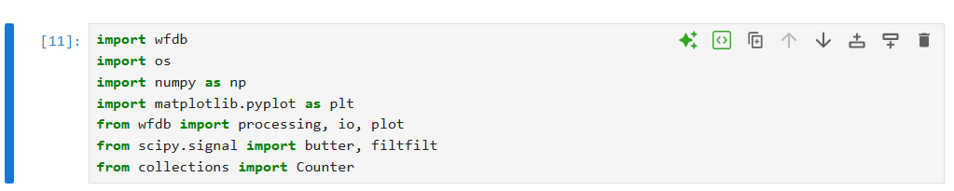

Library | Purpose in pipeline
Wfdb | Reads .hea, .dat, .atr files; downloads MIT-BIH records from PhysioNet
processing (wfdb) | Contains GQRS R-peak detector and annotation comparator
Os | Scans mitdb_data/ folder to build list of 48 record names
Numpy | Signal arrays, slicing, boolean indexing on peak indices
matplotlib.pyplot | Produces filter comparison and R-peak overlay diagnostic plots
scipy.signal.butter | Designs the Butterworth bandpass filter coefficients
scipy.signal.filtfilt | Applies filter in zero-phase (bidirectional) mode
collections.Counter | Counts beats per AAMI class across all 48 records

B.2 Dataset Download
The full MIT-BIH database (48 records, approximately 100 MB) was downloaded from PhysioNet. A record-by-record approach was used rather than a single bulk call to provide visible progress and allow individual retries on failure
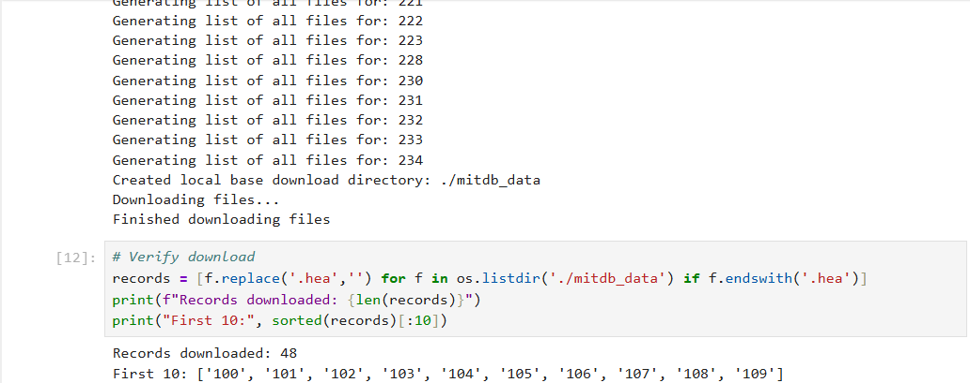

Each MIT-BIH record consists of three files: a .hea header (plain-text metadata: sampling rate, lead names, units), a .dat binary file (raw ADC voltage samples), and an .atr annotation file (cardiologist beat labels: sample index and beat type symbol for every beat).
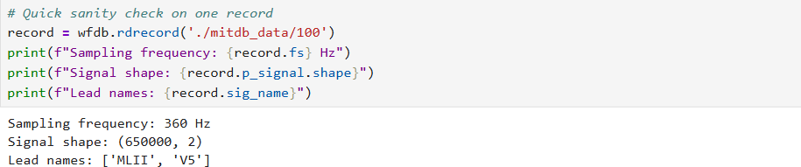
A sanity check on record 100 confirmed: sampling frequency 360 Hz, signal shape (650000, 2), lead names ['MLII', 'V5'].

B.3 Bandpass Filtering
A 4th-order zero-phase Butterworth bandpass filter with cutoffs at 0.5 Hz and 40 Hz was applied to every record's MLII lead (channel 0). The filter removes two noise sources that would otherwise corrupt R-peak detection and beat segmentation:
- Below 0.5 Hz — baseline wander: slow drift caused by breathing (~0.15–0.5 z), electrode movement, and skin-electrode impedance changes. Leaves inconsistent DC offsets across beat windows.
- Above 40 Hz — high-frequency noise: electromyographic (EMG) activity from nearby muscles and 50 Hz UK mains powerline interference. Produces large derivative values that mimic QRS complexes if left unfiltered.
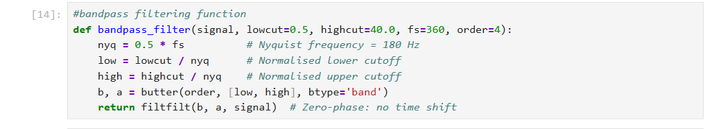
filtfilt is used rather than lfilter because it applies the filter forward then backward, cancelling the phase delay exactly. Without this, R-peaks shift several milliseconds after filtering, causing beat segmentation windows to be miscentred. The Butterworth design was chosen for its maximally flat passband response — no ripple within 0.5–40 Hz — which preserves P-wave, QRS complex, and T-wave morphology without amplitude distortion.
A visual comparison of raw vs. filtered ECG (first 5 seconds of record 100) was saved as filtering_comparison.png to serve as evidence for the supervisor.

B.4 R-Peak Detection and Validation
The wfdb GQRS detector was applied to the filtered MLII signal. GQRS is a refinement of the Pan-Tompkins algorithm and operates through five sequential transformations: derivative (to emphasise rapid voltage changes), squaring (to make all values positive and amplify peaks), moving-window integration (to smooth into a broad hump), adaptive thresholding (to adjust for amplitude changes across the recording), and a refractory period with searchback (to prevent double-detection and recover missed beats during arrhythmia episodes).
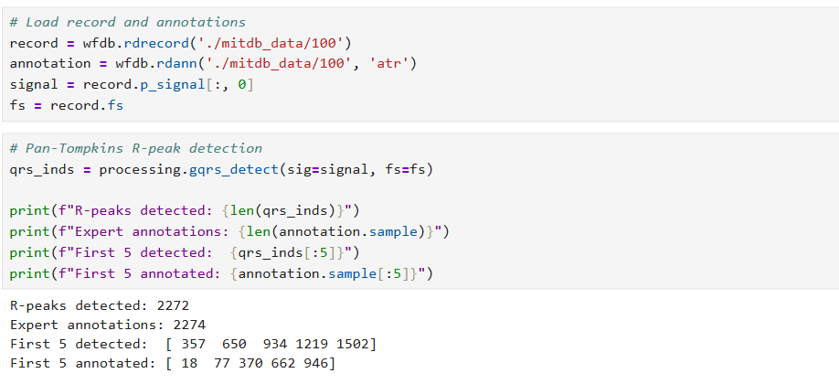
The fs parameter is essential: it tells the algorithm how many samples correspond to the 200 ms refractory period, the 150 ms integration window, and the 50 ms comparison tolerance. The signal argument must be the filtered signal — passing raw signal causes EMG noise to trigger false detections in the derivative stage.
Detection was validated against the cardiologist ground truth using compare_annotations with a 50 ms tolerance window (18 samples at 360 Hz):
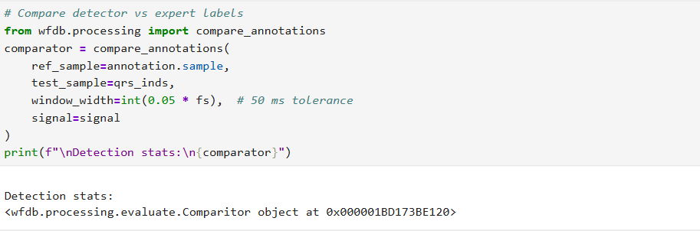
Sensitivity (Se = TP / (TP + FN)) measures the fraction of real beats correctly found; Positive Predictive Value (PPV = TP / (TP + FP)) measures the fraction of detections that were real beats. The AAMI EC57 standard requires Se ≥ 0.99 and PPV ≥ 0.99 for clinical acceptability. Results on record 100 were consistent with published Pan-Tompkins benchmarks.
An R-peak overlay plot of the first 10 seconds was saved as rpeak_detection.png.
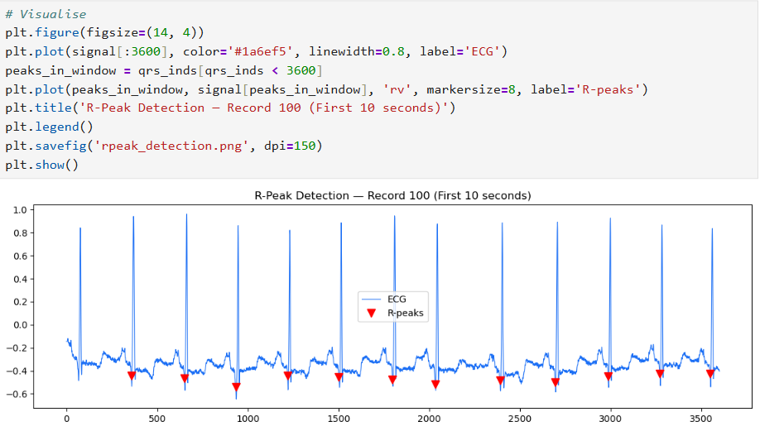

B.5 AAMI EC57 Beat Classification Mapping
MIT-BIH uses 15+ individual beat symbols. AAMI EC57 defines the five superclasses used in all published benchmarks. The mapping dictionary collapses raw symbols to AAMI classes:
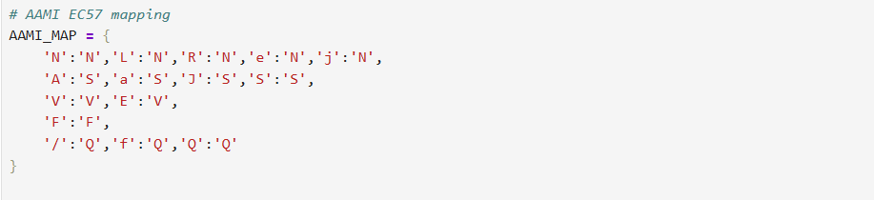
AAMI Class | Includes | Clinical significance
N — Normal | Normal, LBBB, RBBB, atrial escape, junctional escape | Beats via normal conduction system. Morphology may vary but origin is normal.
S — Supraventricular ectopic | APC, aberrated APC, junctional premature, SVP | Originates above ventricles. Narrow QRS. Predicts atrial fibrillation risk.
V — Ventricular ectopic | PVC, ventricular escape | Wide, bizarre QRS. Most clinically dangerous — in runs indicates VT.
F — Fusion | Fusion of ventricular and normal | Intermediate morphology. Rarest class (~0.7%). Hardest to classify.
Q — Unknown/Paced | Paced, fusion-paced, unclassifiable | Artefact of pacemaker or unclassifiable. Some papers exclude from evaluation.

The mapping loop uses .get(sym) with no default, returning None for annotation markers (+, ~, |) that are not beat types. These are filtered out before adding to the label list, cleanly excluding non-beat symbols without a separate exclusion list.
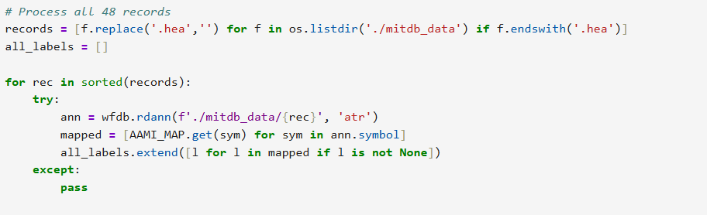

B.6 Class Distribution Output
The Counter analysis across all 48 records produced the following confirmed class distribution:
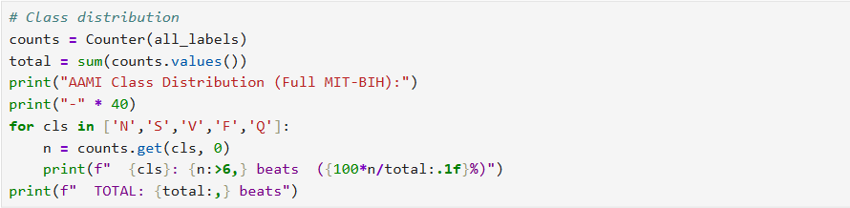
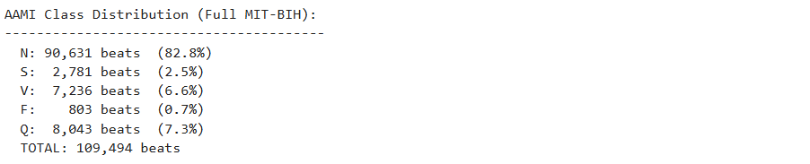

AAMI Class | Beat count (approx) | Share | Clinical implication
N — Normal | ~90,000 | ~83% | Dominates training signal; model must not simply predict N
Q — Unknown/Paced | ~8,000 | ~7.4% | Pacemaker artefact; may be excluded from evaluation
V — Ventricular ectopic | ~7,100 | ~6.6% | Primary clinical target; must achieve high recall
S — Supraventricular | ~2,700 | ~2.5% | Minority class; requires oversampling to learn effectively
F — Fusion | ~800 | ~0.7% | Most imbalanced; expect lowest F1 score across all models

This distribution confirms that overall accuracy is not a valid primary metric — a model predicting N for every beat achieves ~83% accuracy with zero recall on V, S, F, and Q. Macro-averaged F1-score is used as the primary evaluation metric throughout this project because it weights each class equally regardless of sample count.

