**Myers Briggs Personality Prediction Model**

**Project 3 – University of Texas, Austin – Data Analytics Bootcamp, 2019 - 2020**

**Group Members:**

**David Altuve – The Campaigner | Ekta Sharma – The Logistician | Kat Jansen – The Virtuoso**

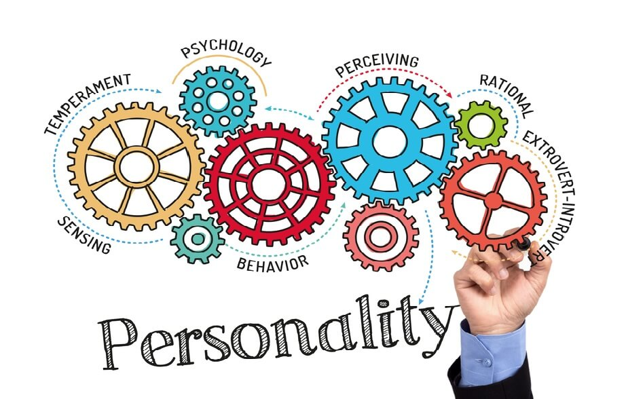

The purpose of this project is to predict personality types as one of the sixteen categories of Myers Briggs personality types (MBTI) based on the correlation between people's writing styles and their psychological personalities. The MBTI sorts individuals into one of the sixteen broad personalities based on the level of extroversion or introversion, sensing or intuition, thinking or feeling, and judging or perceiving.

The goal is to find a correlation between people’s post on social media and their personality type. We believe that social media gives people the platform to express themselves freely and openly and hence those posts can be an indicator of their personality type.

We aim to use a big dataset to train and test various classification models based entirely on the writing samples.

**We acknowledge the fact that all personality types are equal.**

