**PUBLIC TRANSPORT OPTIMIZATION**

**Introduction:**

The project involves integrating IoT sensors into public transportation vehicles to monitor ridership, track locations, and predict arrival times. The goal is to provide real-time transit information to the public through a public platform, enhancing the efficiency and quality of public transportation services. This project includes defining objectives, designing the IoT sensor system, developing the real-time transit information platform, and integrating them using IoT technology and Python.

**Design Thinking:**

|  |
| --- |
| * Project Objectives: Define objectives such as real-time transit information, arrival time prediction, ridership monitoring, and enhanced public transportation services. * IoT Sensor Design: Plan the deployment of IoT sensors (e.g., GPS, passenger counters) in public transportation vehicles. * Real-Time Transit Information Platform: Design a web-based platform to display realtime transit information to passengers * Integration Approach: Determine how IoT sensors will send data to the real-time transit information platform. |
|  |

**Hardware Components:**

1.Radar sensors

2.IR Sensors

3.Active Infrarred Sensors

4.On-board Diagnosis System

5.Telematics Systems

**Software Components:**

1.Git Application

2.Visual Studio Code

3.Programming Launguage(Python)

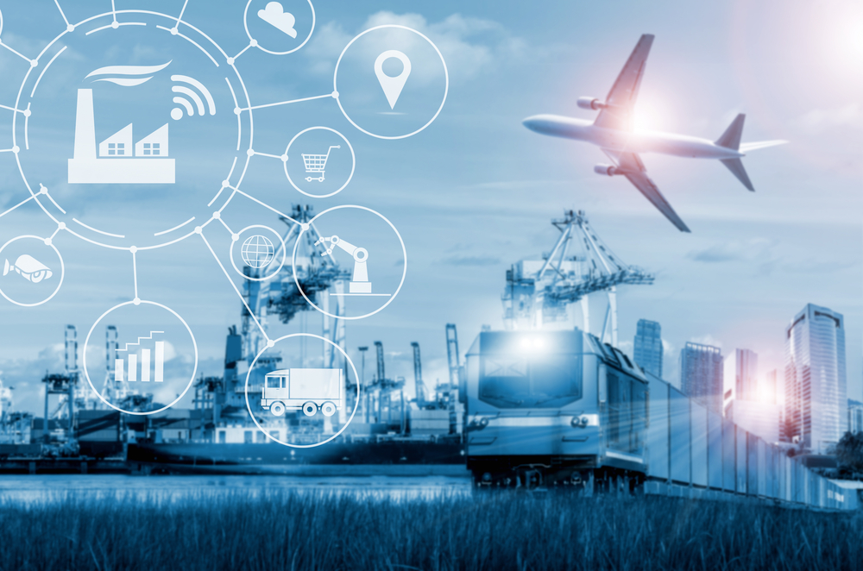

**Need for Public Transport Optimization:**

In cities with smart public transport, people waiting at a bus stop know their bus will be on time because they get alerts about estimated arrival times. They may or may not know that their city’s department of transportation automatically deploys more buses when necessary, staggers arrival times to avoid “bus bunching,” and keeps buses on the go by continuously analyzing sensor data and proactively fixing things before they take a bus out of service.Some U.S. cities are also using IoT to optimize their transportation routes, enhance roadway safety and reduce infrastructure costs. With more and more Internet of Things (IoT) devices entering the market daily, it’s getting easier and easier to capture interesting data from the sensors and control systems involved with running a modern city. Low Energy Bluetooth (LEB) devices, GPS, near-field communication, mobile apps, streaming apps — data comes from everywhere today, and cities are generating data at a rapidly increasing rate. [**Smart cities**](https://solace.com/blog/smart-city-data-management/) use this data to enhance the quality of life for their citizens, and there’s no better example than when you apply a “smart city” mindset to public transportation systems.

**Conclusion:**

By optimizing your public transport systems you can help citizens get where they’re going more quickly by reducing congestion on roadways and intelligently allocating and routing buses to areas with more travelers. That means locals, visitors and workers spend less time in transit and more time enjoying your city, successfully completing errands or getting to and from work.

Project Submitted by,

Name : P.Hari Prasath

Email id :hariprasath0520gmail.com

Nan Mudhalvan id :au713921106017

College Code :7139