Exp 5 - Obj 1
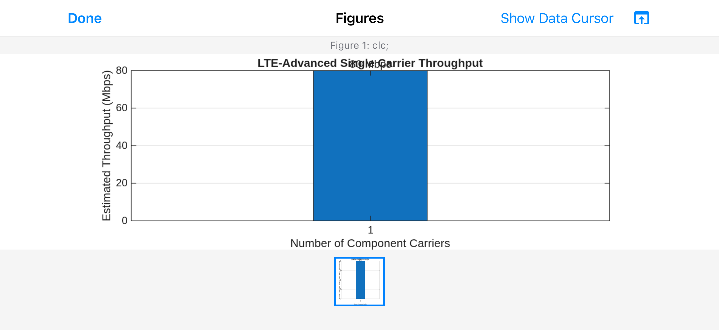
clc;
clear;
close all;

% Experiment 5 - Objective 1: Single Component Carrier Throughput
BW1 = 20; % Component carrier bandwidth (MHz)
SE = 4; % Spectral efficiency (bits/s/Hz)
Ncc = 1; % Number of component carriers

BWagg = BW1 * Ncc;
Throughput = BWagg * SE;

disp('Single Component Carrier');
disp(['Bandwidth = ', num2str(BWagg), ' MHz']);
disp(['Estimated Throughput = ', num2str(Throughput), ' Mbps']);

figure;
bar(Ncc, Throughput);
grid on;
xlabel('Number of Component Carriers');
ylabel('Estimated Throughput (Mbps)');
title('LTE-Advanced Single Carrier Throughput');
text(Ncc, Throughput, [num2str(Throughput), ' Mbps'], ...
'HorizontalAlignment', 'center', 'VerticalAlignment', 'bottom');

Exp 5 - Obj 2
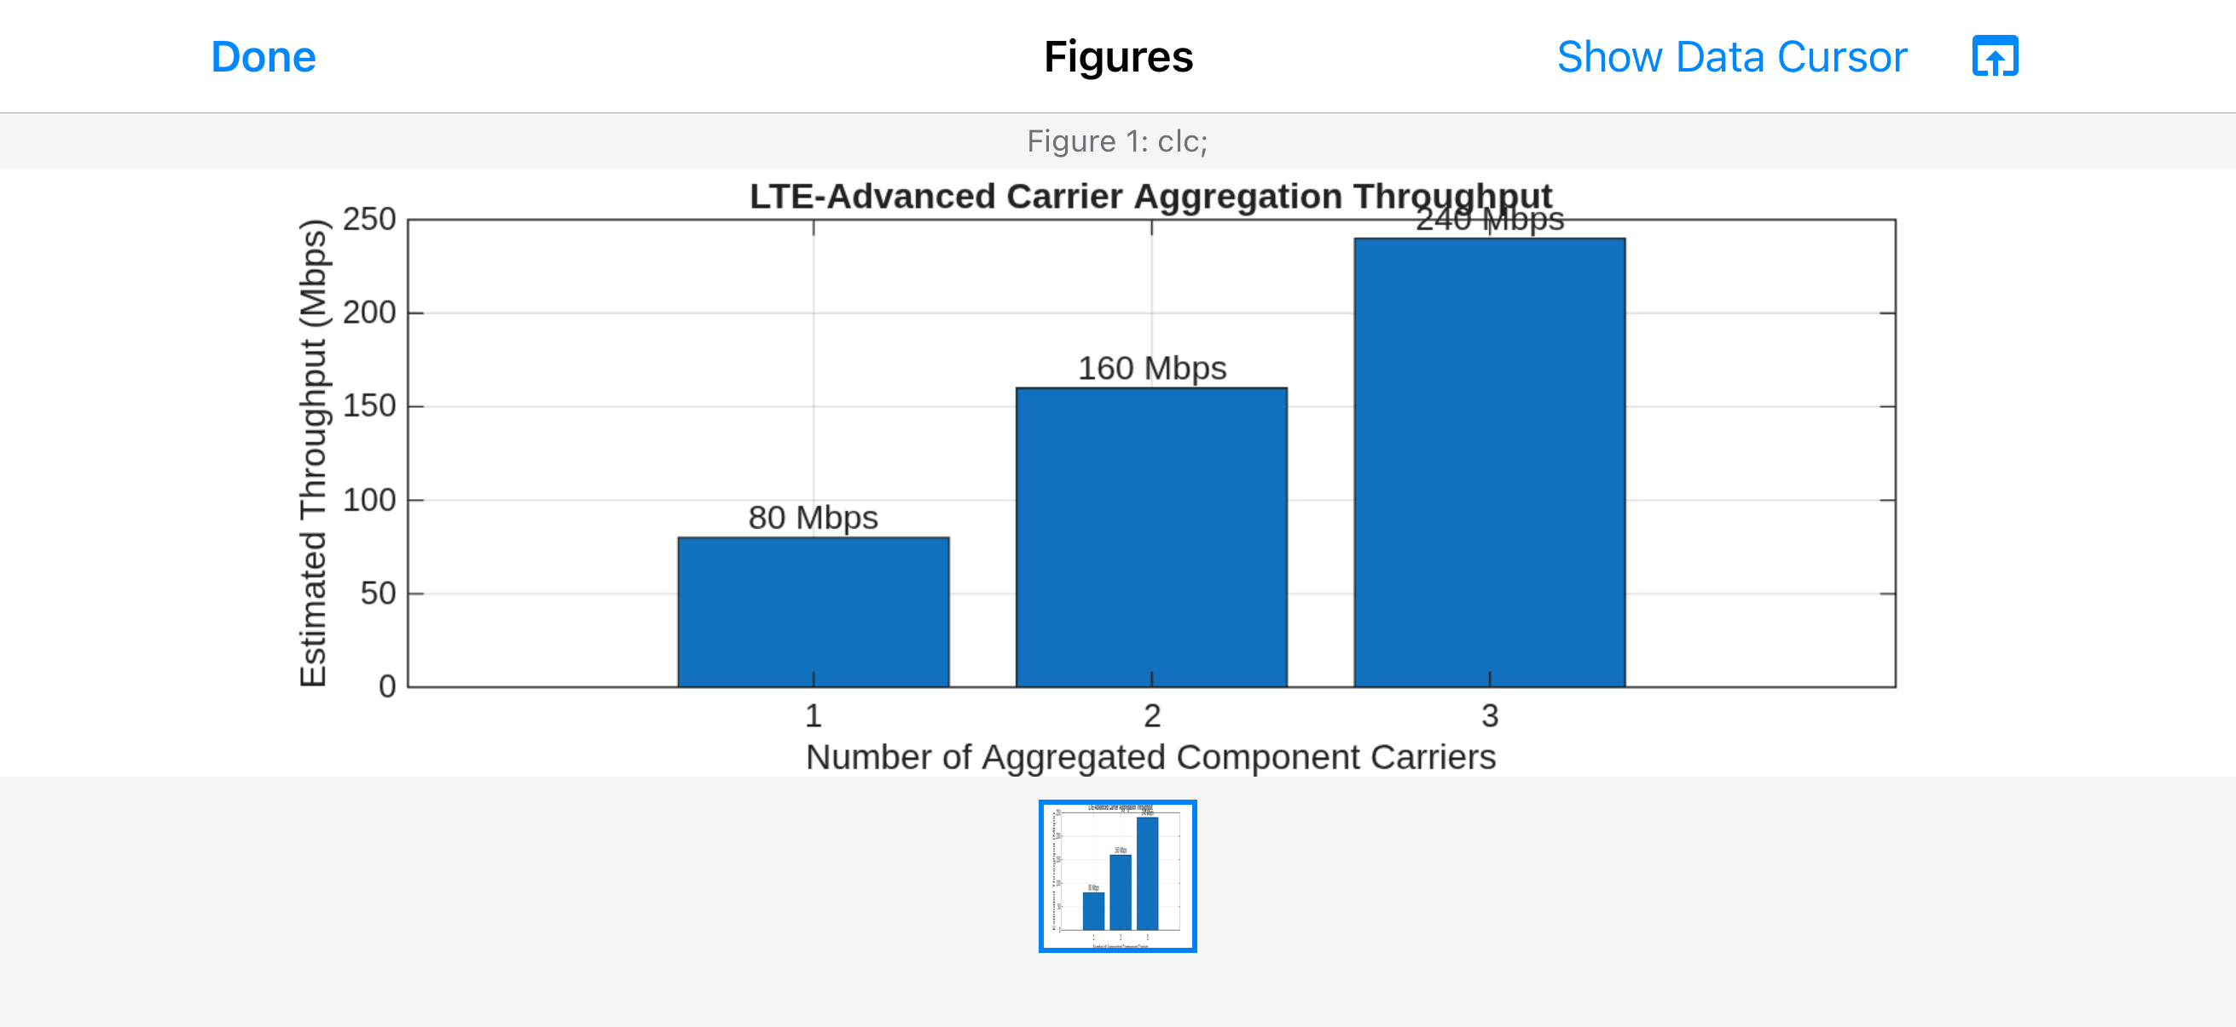
clc;
clear;
close all;

% Experiment 5 - Objective 2: Carrier Aggregation Throughput
BWcc = 20; % Bandwidth per component carrier (MHz)
SE = 4; % Spectral efficiency (bits/s/Hz)
CC = [1 2 3]; % Number of component carriers

BWagg = BWcc .* CC;
Throughput = BWagg .* SE;

figure;
bar(CC, Throughput);
grid on;
xlabel('Number of Aggregated Component Carriers');
ylabel('Estimated Throughput (Mbps)');
title('LTE-Advanced Carrier Aggregation Throughput');
xticks(CC);
for k = 1:length(CC)
text(CC(k), Throughput(k), [num2str(Throughput(k)), ' Mbps'], ...
'HorizontalAlignment', 'center', 'VerticalAlignment', 'bottom');
end

Exp 5 - Obj 3
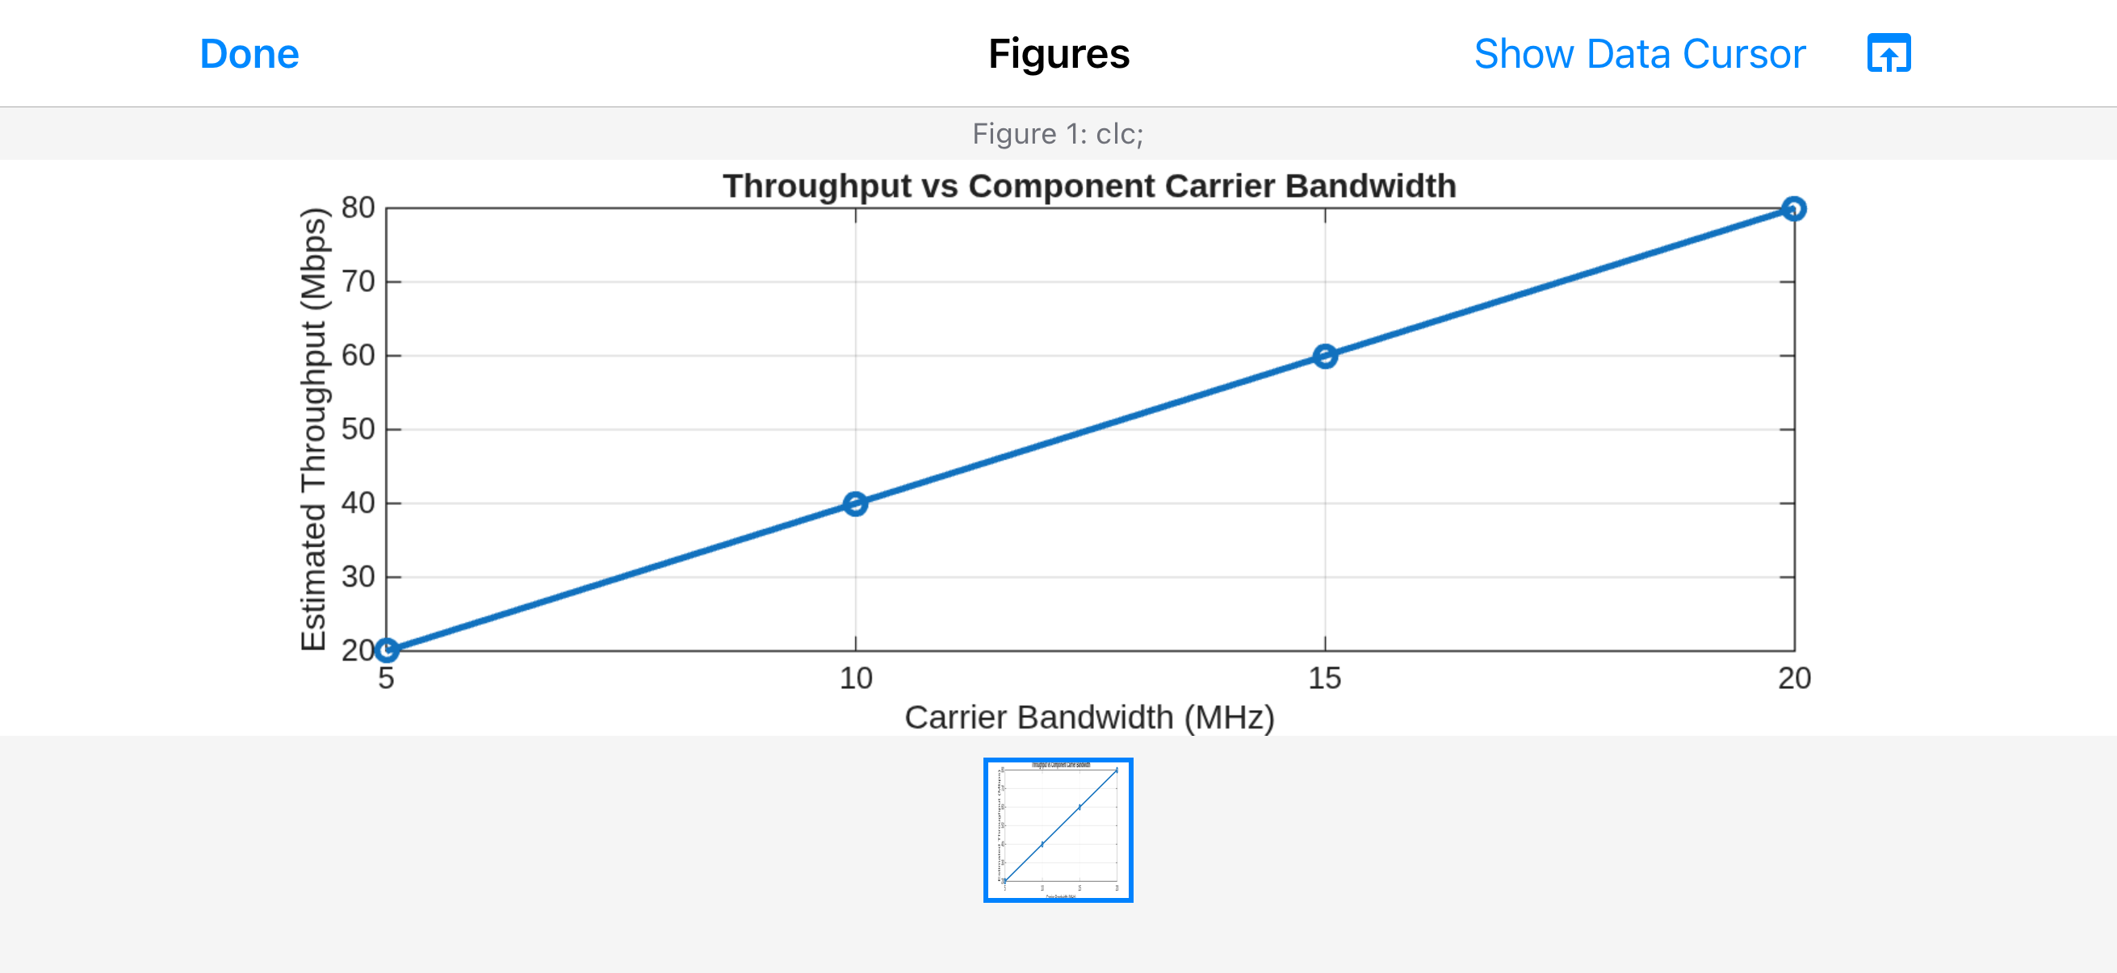
clc;
clear;
close all;

% Experiment 5 - Objective 3: Throughput vs Carrier Bandwidth
BW = [5 10 15 20]; % Carrier bandwidth (MHz)
SE = 4; % Spectral efficiency (bits/s/Hz)
Throughput = BW .* SE;

figure;
plot(BW, Throughput, 'o-', 'LineWidth', 2);
grid on;
xlabel('Carrier Bandwidth (MHz)');
ylabel('Estimated Throughput (Mbps)');
title('Throughput vs Component Carrier Bandwidth');
xticks(BW);

Exp 6 - Obj 1
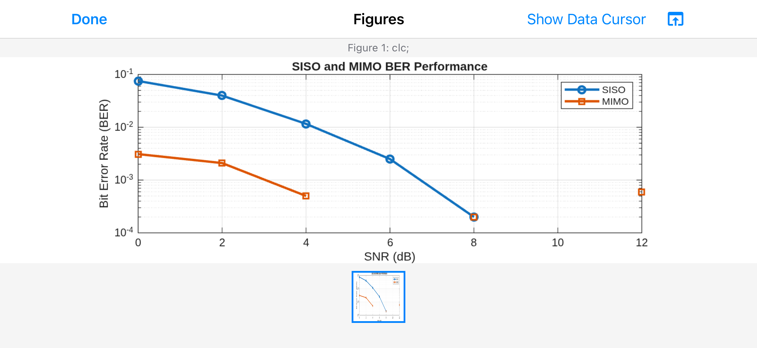
clc;
clear;
close all;

% Experiment 7 - Objective 1: SISO and Simplified MIMO BER
SNRdB = 0:2:12;
N = 1e5;
bits = randi([0 1], N, 1);
tx = 2*bits - 1; % BPSK symbols

BER_SISO = zeros(size(SNRdB));
BER_MIMO = zeros(size(SNRdB));

for k = 1:length(SNRdB)
snrLin = 10^(SNRdB(k)/10);
noiseStd = sqrt(1/(2*snrLin));

% SISO BPSK transmission
noise = noiseStd * randn(N,1);
rx = tx + noise;
BER_SISO(k) = mean((rx >= 0) ~= bits);

% Simplified diversity model for comparison
noise2 = noiseStd * randn(N,1);
rx2 = tx + noise2;
combined = (rx + rx2)/2;
BER_MIMO(k) = mean((combined >= 0) ~= bits);
end

figure;
semilogy(SNRdB, max(BER_SISO,1/N), 'o-', 'LineWidth', 2);
hold on;
semilogy(SNRdB, max(BER_MIMO,1/N), 's-', 'LineWidth', 2);
grid on;
xlabel('SNR (dB)');
ylabel('Bit Error Rate (BER)');
title('SISO and Simplified Diversity BER Performance');
legend('SISO', 'Simplified Diversity', 'Location', 'best');

Exp 6 - Obj 2
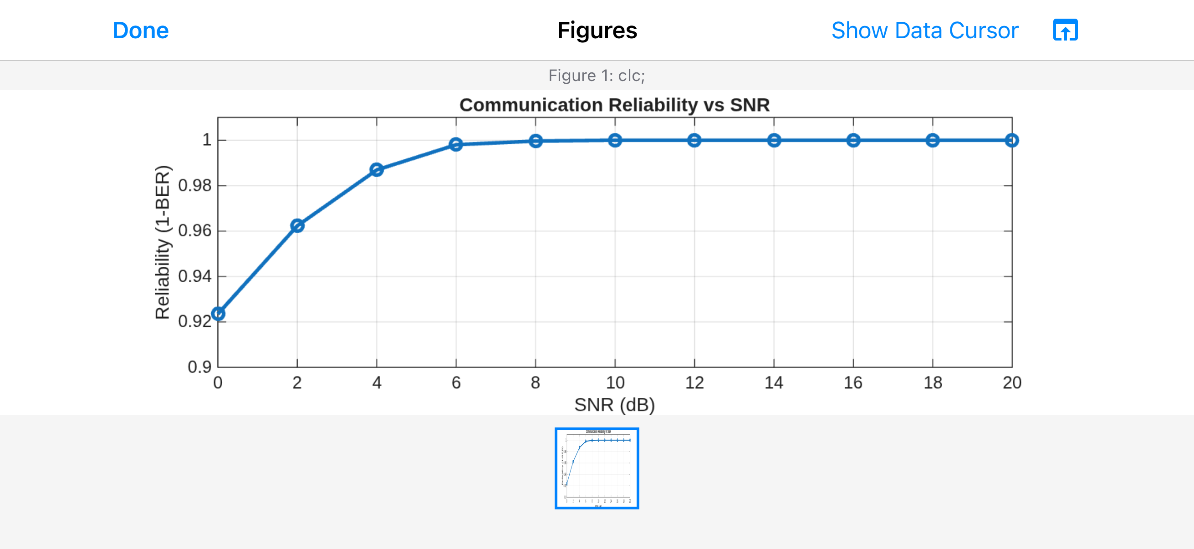
clc;
clear;
close all;

% Experiment 7 - Objective 2: Communication Reliability vs SNR
SNRdB = 0:2:20;
N = 1e5;
bits = randi([0 1], N, 1);
tx = 2*bits - 1;
BER = zeros(size(SNRdB));

for k = 1:length(SNRdB)
snrLin = 10^(SNRdB(k)/10);
noiseStd = sqrt(1/(2*snrLin));
rx = tx + noiseStd * randn(N,1);
detected = rx >= 0;
BER(k) = mean(detected ~= bits);
end

reliability = 1 - BER;

figure;
plot(SNRdB, reliability, 'o-', 'LineWidth', 2);
grid on;
xlabel('SNR (dB)');
ylabel('Reliability (1 - BER)');
title('Communication Reliability vs SNR');
ylim([0.9 1.005]);

Exp 6 - Obj 3
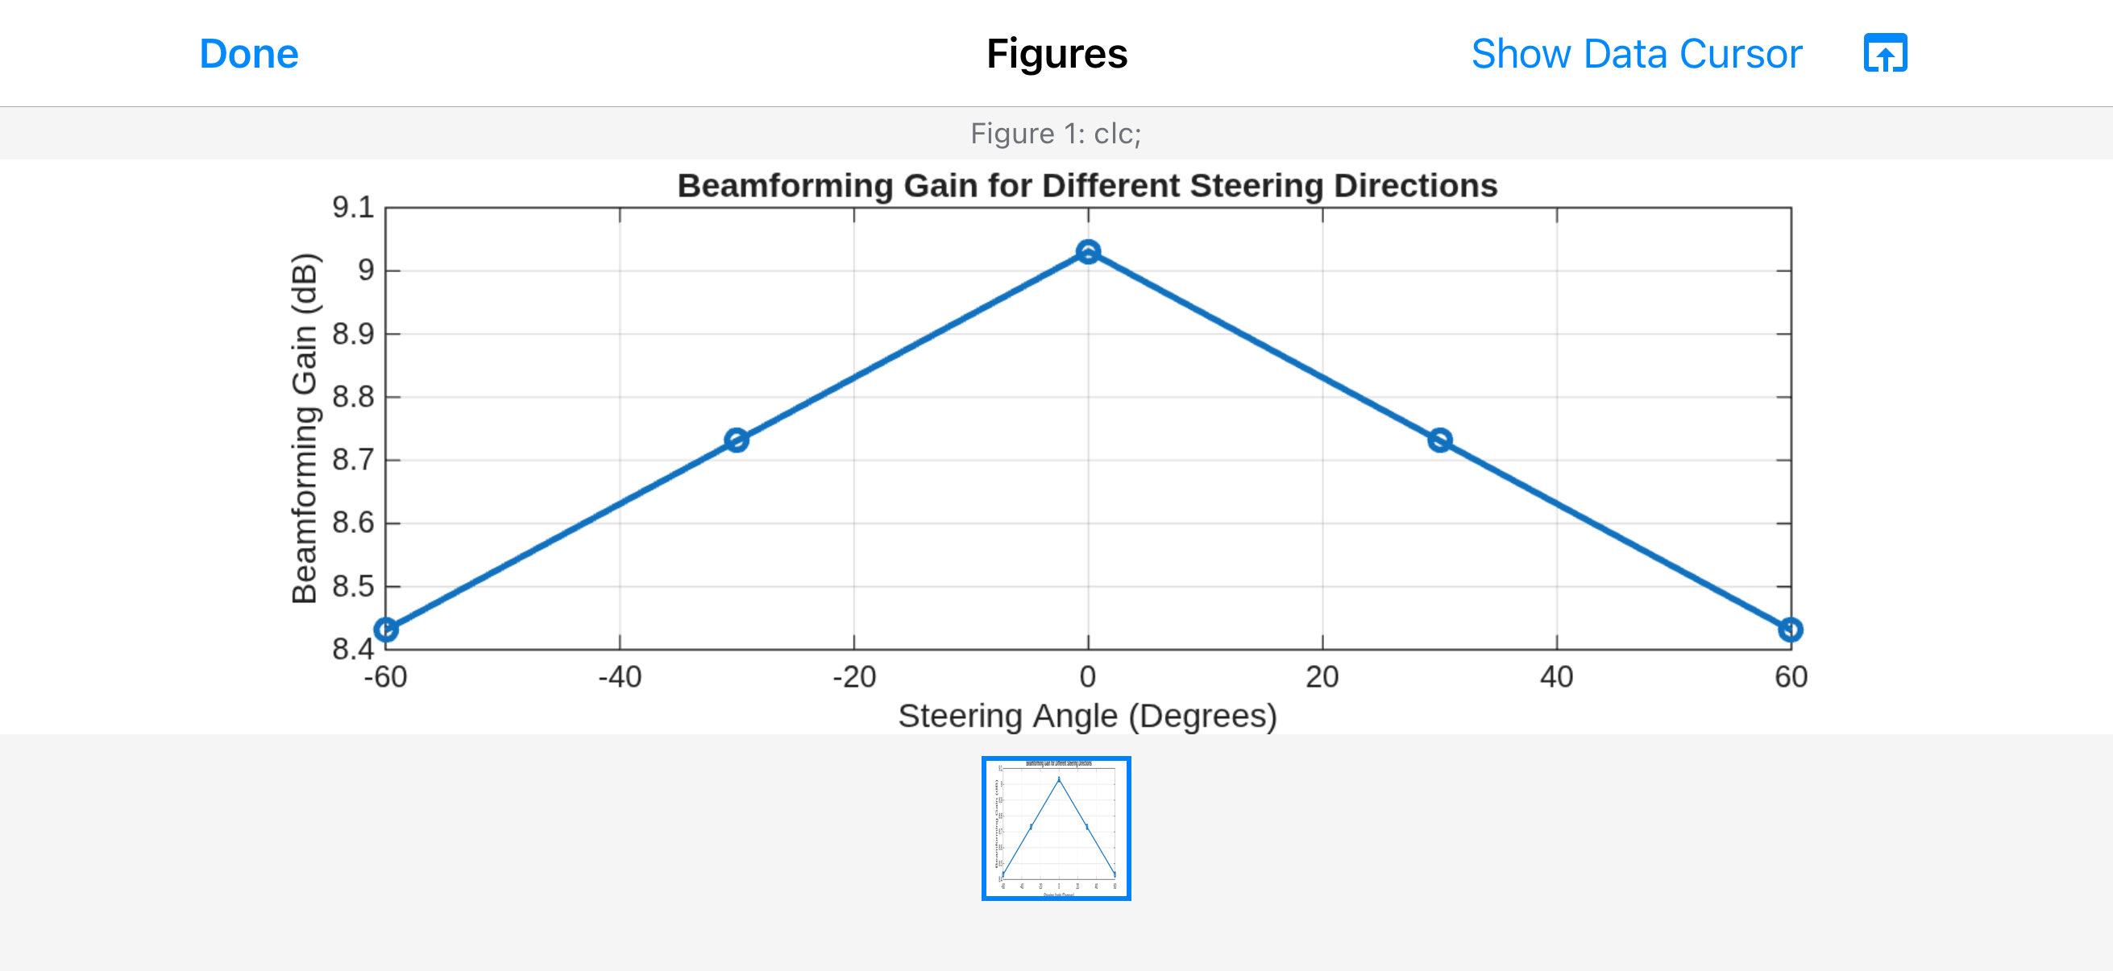
clc;
clear;
close all;

% Experiment 7 - Objective 3: Simplified Beamforming Gain
N = 8; % Number of antenna elements
steer = [-60 -30 0 30 60]; % Steering angles (degrees)
gain = 10*log10(N) - 0.01*abs(steer);

figure;
plot(steer, gain, 'o-', 'LineWidth', 2);
grid on;
xlabel('Steering Angle (Degrees)');
ylabel('Beamforming Gain (dB)');
title('Beamforming Gain for Different Steering Directions');
xticks(steer);

Exp 7 - Obj 1
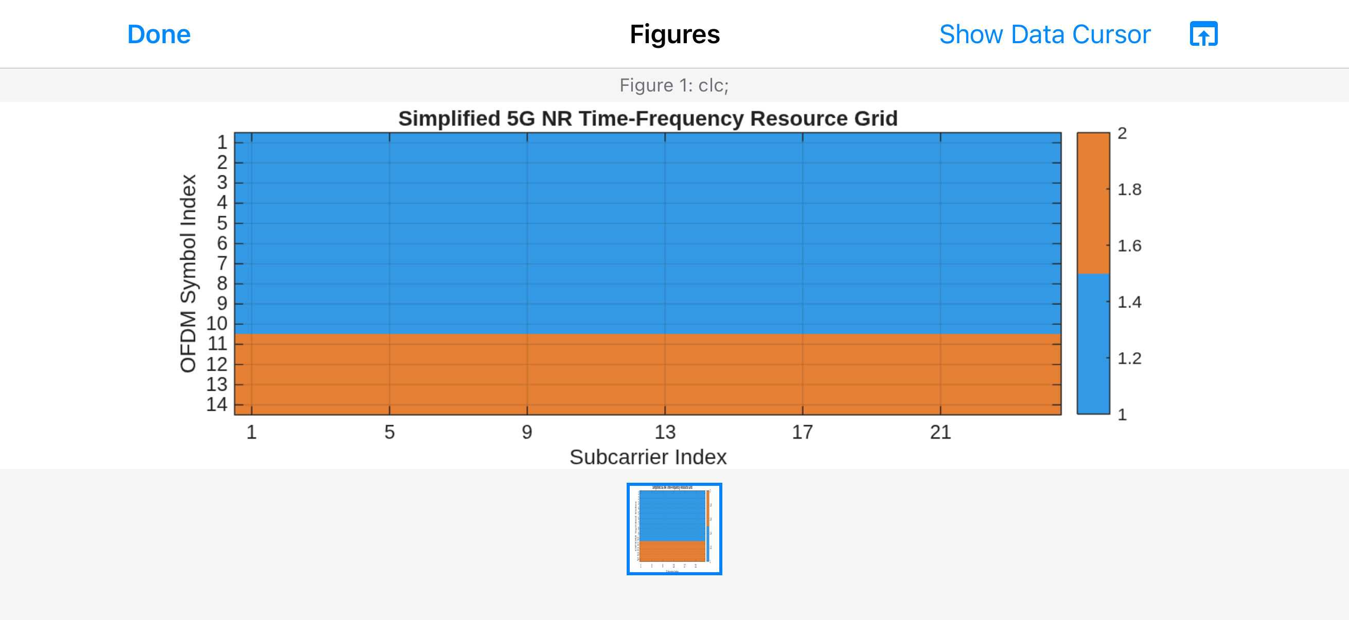
clc;
clear;
close all;

% Experiment 9 - Objective 1: Simplified 5G NR Time-Frequency Grid
Nsc = 24; % Number of subcarriers
Nsym = 14; % Number of OFDM symbols
gridData = ones(Nsym, Nsc);

% Symbols 1-10: Downlink; symbols 11-14: Uplink
gridData(11:14, :) = 2;

figure;
imagesc(1:Nsc, 1:Nsym, gridData);
set(gca, 'YDir', 'normal');
xlabel('Subcarrier Index');
ylabel('OFDM Symbol Index');
title('Simplified 5G NR Time-Frequency Resource Grid');
colormap([0.2 0.6 0.9; 0.9 0.5 0.2]);
caxis([1 2]);
cb = colorbar;
cb.Ticks = [1 2];
cb.TickLabels = {'Downlink', 'Uplink'};
xticks([1 5 9 13 17 21 24]);
yticks(1:Nsym);

Exp 7 - Obj 2
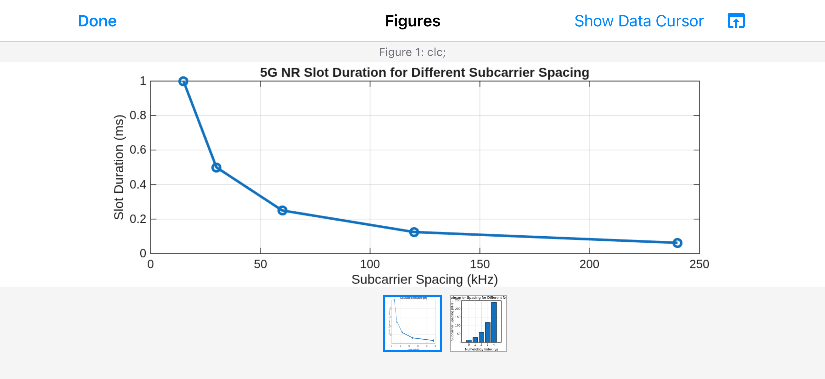
clc;
clear;
close all;

% Experiment 9 - Objective 2: 5G NR Numerology and Slot Duration
scs = [15 30 60 120 240]; % Subcarrier spacing (kHz)
mu = 0:4; % Numerology index
slot = 1 ./ (2.^mu); % Slot duration (ms)

figure;
plot(scs, slot, 'o-', 'LineWidth', 2);
grid on;
xlabel('Subcarrier Spacing (kHz)');
ylabel('Slot Duration (ms)');
title('5G NR Slot Duration for Different Subcarrier Spacing');
xticks(scs);

figure;
bar(mu, scs);
grid on;
xlabel('Numerology Index (\mu)');
ylabel('Subcarrier Spacing (kHz)');
title('5G NR Subcarrier Spacing for Different Numerologies');
xticks(mu);

Exp 7 - Obj 3
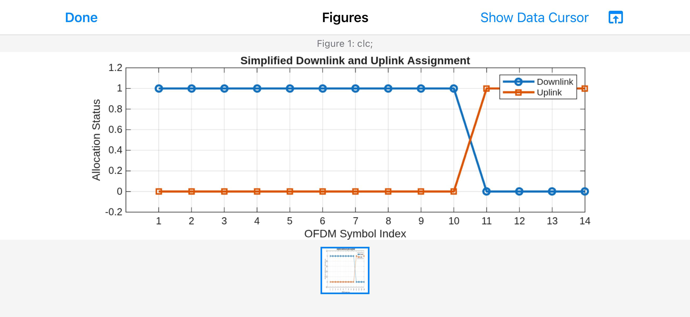
clc;
clear;
close all;

% Experiment 9 - Objective 3: Downlink and Uplink Assignment
symbols = 1:14;
DL = [ones(1,10) zeros(1,4)];
UL = [zeros(1,10) ones(1,4)];

figure;
plot(symbols, DL, 'o-', 'LineWidth', 2);
hold on;
plot(symbols, UL, 's-', 'LineWidth', 2);
grid on;
xlabel('OFDM Symbol Index');
ylabel('Allocation Status');
title('Simplified Downlink and Uplink Assignment');
legend('Downlink', 'Uplink', 'Location', 'best');
xticks(symbols);
ylim([-0.2 1.2]);

