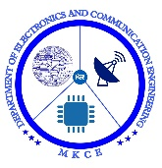

##### ACCIDENT ALERT LOCATION TRACKING SYSTEM USING GPS AND GSM

##### MICRONTROLLERS AND INTERFACING PROJECT REPORT

###### ***Submitted by***

###### **HARI PRASATH R**

##### 

**BACHELOR OF ENGINEERING**

In

**DEPARTMENT OF ELECTRONICS AND COMMUNICATION ENGINEERING**

**M.KUMARASAMY COLLEGE OF ENGINEERING**

(Autonomous)

**KARUR – 639 113**

**MAY 2025**

**BONAFIDE CERTIFICATE**

Certified that thisreport **“ACCIDENT ALERT LOCATION TRACKING SYSTEM USING GPS AND GSM”** is the Bonafide work of “**DINESH S (927623BEC049), GOBIKRISHNAN A (927623BEC055), GOKUL K (927623BEC056), HARI PRASATH (927623BEC063)”** who carried out the project work under my supervision in the academic year 2024 - 2025 **EVEN**.

**SIGNATURE SIGNATURE**

**Dr.A.KAVITHA, B.E., M.E., Ph.D., Dr.E.DINESH B.E., M.E., Ph.D.,**

**HEAD OF THE DEPARTMENT, SUPERVISOR,**

Professor, Associate Professor,

Department of Electronics and Department of Electronics and Communication Engineering, Communication Engineering,

M.Kumarasamy College of Engineering, M.Kumarasamy College of Engineering, Thalavapalayam, Thalavapalayam,

Karur-639113. Karur-639113.

This project report has been submitted for the **ECB1223 – Microcontrollers and interfacing** viva voceexaminationheld at M. Kumarasamy College of Engineering, Karur on _______________________.

**INTERNAL EXAMINER**

**INSTITUTION VISION AND MISSION**

**Vision**

To emerge as a leader among the top institutions in the field of technical education.

**Mission**

**M1:** Produce smart technocrats with empirical knowledge who can surmount the global challenges.

**M2:** Create a diverse, fully -engaged, learner -centric campus environment to provide quality education to the students.

**M3:** Maintain mutually beneficial partnerships with our alumni, industry and professional associations

**DEPARTMENT VISION, MISSION, PEO, PO AND PSO**

**Vision**

To empower the Electronics and Communication Engineering students with emerging technologies, professionalism, innovative research and social responsibility.

**Mission**

**M1:** Attain the academic excellence through innovative teaching learning process, research areas & laboratories and Consultancy projects.

**M2:** Inculcate the students in problem solving and lifelong learning ability.

**M3:** Provide entrepreneurial skills and leadership qualities.

**M4:** Render the technical knowledge and skills of faculty members.

**Program Educational Objectives**

**PEO1:** **Core Competence:** Graduates will have a successful career in academia or industry associated with Electronics and Communication Engineering

**PEO2:** **Professionalism:** Graduates will provide feasible solutions for the challenging problems through comprehensive research and innovation in the allied areas of Electronics and Communication Engineering.

**PEO3:** **Lifelong Learning:** Graduates will contribute to the social needs through lifelong learning, practicing professional ethics and leadership quality

**Program Outcomes**

**PO 1: Engineering knowledge:** Apply the knowledge of mathematics, science, engineering fundamentals, and an engineering specialization to the solution of complex engineering problems.

**PO 2: Problem analysis:** Identify, formulate, review research literature, and analyze complex engineering problems reaching substantiated conclusions using first principles of mathematics, natural sciences, and engineering sciences.

**PO 3: Design/development of solutions:** Design solutions for complex engineering problems and design system components or processes that meet the specified needs with appropriate consideration for the public health and safety, and the cultural, societal, and environmental considerations.

**PO 4: Conduct investigations of complex problems:** Use research-based knowledge and research methods including design of experiments, analysis and interpretation of data, and synthesis of the information to provide valid conclusions.

**PO 5: Modern tool usage:** Create, select, and apply appropriate techniques, resources, and modern engineering and IT tools including prediction and modeling to complex engineering activities with an understanding of the limitations.

**PO 6: The engineer and society:** Apply reasoning informed by the contextual knowledge to assess societal, health, safety, legal and cultural issues and the consequent responsibilities relevant to the professional engineering practice.

**PO 7: Environment and sustainability:** Understand the impact of the professional engineering solutions in societal and environmental contexts, and demonstrate the knowledge of, and need for sustainable development.

**PO 8: Ethics:** Apply ethical principles and commit to professional ethics and responsibilities and norms of the engineering practice.

**PO 9: Individual and team work:** Function effectively as an individual, and as a member or leader in diverse teams, and in multidisciplinary settings.

**PO 10: Communication:** Communicate effectively on complex engineering activities with the engineering community and with society at large, such as, being able to comprehend and write effective reports and design documentation, make effective presentations, and give and receive clear instructions.

**PO 11: Project management and finance:** Demonstrate knowledge and understanding of the engineering and management principles and apply these to one’s own work, as a member and leader in a team, to manage projects and in multidisciplinary environments.

**PO 12: Life-long learning:** Recognize the need for, and have the preparation and ability to engage in independent and life-long learning in the broadest context of technological change.

**Program Specific Outcomes**

**PSO1:** Applying knowledge in various areas, like Electronics, Communications, Signal processing, VLSI, Embedded systems etc., in the design and implementation of Engineering application.

**PSO2:** Able to solve complex problems in Electronics and Communication Engineering with analytical and managerial skills either independently or in team using latest hardware and software tools to fulfil the industrial expectations.

|  |  |
| --- | --- |
| **Abstract** | **Matching with POs, PSOs** |
| The Accident Alert and Location Tracking System detects accidents using a vibration sensor and sends the vehicle’s GPS location via SMS and call through a GSM module. It helps provide quick emergency response by alerting family, ambulance, and hospitals. | **PO1, PO2, PO3, PO4, PO5, PO6, PO7, PO8, PO9, PO10, PO11, PO12, PSO1, PSO2** |

**ACKNOWLEDGEMENT**

We gratefully remember our beloved Founder Chairman, (Late) Thiru. M. Kumarasamy, whose vision and legacy laid the foundation for our education and inspired us to successfully complete this project.

We extend our sincere thanks to Dr. K. Ramakrishnan, Chairman, and Mr. K. R. Charun Kumar, Joint Secretary, for providing excellent infrastructure and continuous support throughout our academic journey.

We are privileged to extend our heartfelt thanks to our respected Principal, Dr. B. S. Murugan, B.Tech., M.Tech., Ph.D., for providing us with a conducive environment and constant encouragement to pursue this project work.

We sincerely thank Dr. A. Kavitha, B.E., M.E., Ph.D., Professor and Head, Department of Electronics and Communication Engineering, for her continuous support, valuable guidance, and motivation throughout the course of this project.

Our special thanks and deep sense of appreciation go to our Project Supervisor, Dr.E.Dinesh M.E., Ph.D., Associate Professor, Department of Electronics and Communication Engineering, for his exceptional guidance, continuous supervision, constructive suggestions, and unwavering support, all of which have been instrumental in the successful execution of this project.

We would also like to acknowledge our Class Advisor, Dr.K.Karthikeyan, M.E., Ph.D., Associate Professor, Department of Electronics and Communication Engineering, and our Project Coordinator, Dr.K.Sivanandam, M.E., Ph.D., Associate Professor, Department of Electronics Engineering (VLSI Design and Technology), for their constant encouragement and coordination that contributed to the smooth progress and completion of our project work.

We gratefully thank all the faculty members of the Department of Electronics and Communication Engineering for their timely assistance, valuable insights, and constant support during various phases of the project.

Finally, we extend our profound gratitude to our parents and friends for their encouragement, moral support, and motivation, without which the successful completion of this project would not have been possible.

**ABSTRACT**

The Accident Alert and Location Tracking System is a safety project designed to help save lives during road accidents by using GSM and GPS technology. The system uses an Arduino board connected to a vibration sensor, a GPS module, and a GSM module. When an accident happens, the vibration sensor detects the shock and immediately activates a buzzer to alert people nearby. At the same time, the GPS module collects the exact location of the vehicle in the form of latitude and longitude. This location is then sent through SMS to emergency contacts, including a family member, an ambulance service, and a nearby hospital, using the GSM module. The message also includes a Google Maps link to help rescuers quickly find the accident spot. In addition to sending messages, the system also makes automatic phone calls to ensure faster response. A reset button is provided to restart the system after the situation is handled. This system is low-cost, easy to build, and highly effective in reducing the time it takes to respond to road accidents, making it suitable for vehicles like cars, bikes, and buses to improve road safety.

**TABLE OF CONTENTS**

|  |  |  |  |
| --- | --- | --- | --- |
| **CHAPTER No.** | **CONTENTS** | | **PAGE No.** |
|  | **INSTITUTION VISION AND MISSION** | | III |
|  | **DEPARTMENT VISION AND MISSION** | | IV |
|  | **DEPARTMENT PEOS, POS AND PSOS** | | IV |
|  | **ABSTRACT** | | IX |
|  | **LIST OF FIGURES** | | XII |
|  | **LIST OF ABBREVIATIONS** | | XIII |
| **1** | **INTRODUCTION** | | **1** |
|  | 1.1 | OBJECTIVE | 1 |
|  | 1.2 | PROBLEM STATEMENT | 1 |
|  | 1.3 | SCOPE OF THE PROJECT | 2 |
|  | 1.4 | SIGNIFICANCE | 3 |
| **2** | **LITERATURE SURVEY** | | **4** |
|  | 2.1 | OVERVIEW OF EXISTING ACCIDENT ALLERT SYSTEMS | 4 |
|  | 2.2 | GPS TECHNOLOGY FOR ACCIDENT DETECTION AND LOCALIZATION | 4 |
|  | 2.3 | GSM TECHNOLOGY FOR EMERGENCY ALERTING | 5 |
|  | 2.4 | INTEGRATION CHALLENGES AND BEST PRACTICES | 5 |
| **3** | **EXISTING SYSTEM`** | | **7** |
|  | 3.1 | IOT BASED ACCIDENT DETECTION AND VEHICLE TRACKING SYSTEM USING GPS AND GSM MODULE | 7 |
|  | 3.2 | DESIGN & DEVELOPMENT OF ARDUINO BASED VEHICLE ACCIDENT ALERT SYSTEM USING GPS, GSM MODULE, DISTANCE & FORCE SENSOR | 7 |
|  | 3.3 | VEHICLE ACCIDENT ALERT SYSTEM BUILT USING ARDUINO, GPS, AND A GSM MODULE | 8 |
| **4** | **PROPOSED SYSTEM** | | **9** |
|  | 4.1 BLOCK DIAGRAM | | 10 |
|  | 4.2 BLOCK DIAGRAM DESCRIPTION | | 10 |
| **5** | **METHODOLOGY** | | 12 |
|  | 5.1 SCHEMATIC DIAGRAM | | 13 |
|  | 5.2 WORKING | | 14 |
|  | 5.3 COMPONENTS AND DESCRIPTION | | 14 |
|  | 5.3.1 ARDUINO UNO R3 | | 15 |
|  | 5.3.2 GSM (800L) | | 16 |
|  | 5.3.3 GPS (NEO 6M) | | 17 |
|  | 5.3.4 VIBRATION SENSOR | | 18 |
|  | 5.3.5 BUZZER | | 19 |
|  | 5.3.6 PUSH BUTTON | | 20 |
| **6** | **RESULT AND DISSCISSION** | | **21** |
|  | 6.1 RESULTS | | 21 |
|  | 6.2 DISCUSSION | | 22 |
| **7** | **CONCLUSION AND FUTURE WORK** | | 23 |
|  | 7.1 CONCLUSION | | 24 |
|  | 7.2 FUTURE WORK | | 25 |
|  | **REFERENCES** | | 26 |

**LIST OF FIGURES**

|  |  |  |
| --- | --- | --- |
| **FIGURE NO.** | **TITLE** | **PAGE NO.** |
| 4.1 | BLOCK DIAGRAM | 9 |
| 5.1 | SCHEMATIC DIAGRAM | 13 |
| 5.2 | ARDUINO UNO R3 | 15 |
| 5.3 | GSM (800L) | 16 |
| 5.4 | GPS (NEO 6M) | 17 |
| 5.5 | VIBRATION SENSOR | 18 |
| 5.6 | BUZZER | 19 |
| 5.7 | PUSH BUTTON | 20 |
| 6.1 | OUTCOME | 21 |
| 6.2 | SMS MESSAGE | 22 |
| .3 | CALL | 22 |
|  |  |  |

**LIST OF ABBREVIATIONS**

|  |  |  |
| --- | --- | --- |
| **ACRONYM** |  | **ABBREVIATION** |
| **GSM** | | - | Global System For Mobile Communication |
| **GPS** | | - | Global Positioning System |
| **IOT** | | - | Internet of Things |

CHAPTER 1  
INTRODUCTION

In recent years, the number of road accidents has been increasing significantly, posing serious threats to human life. Quick emergency response and accurate location tracking are critical for minimizing fatalities and injuries. Traditional emergency systems often lack automatic detection and real-time communication, causing delays in assistance. This project aims to overcome those limitations by developing an Arduino-based Accident Alert and Location Tracking System. By integrating a vibration sensor, GPS module, and GSM module, the system can detect an accident, identify the precise location, and automatically alert emergency contacts through SMS and phone calls.

1.1 Objective

* To design a low-cost, real-time accident detection system using Arduino.
* To detect vehicle collisions using a vibration sensor.
* To fetch and process live GPS coordinates during an accident.
* To send automatic SMS alerts with location details to family, hospital, and ambulance services.
* To initiate emergency phone calls for immediate assistance.
* To provide a manual reset option in case of false alarms.

**1.2 Problem Statement**

In many cases of road accidents, delay in emergency response leads to severe injuries and loss of life. The primary causes of these delays include:

* Lack of immediate accident detection
* Absence of real-time location tracking
* No automated alert system for emergency contacts and hospitals

To address these issues, an Accident Alert and Location Tracking System using GPS and GSM can be implemented. This system will detect accidents using sensors, retrieve the accident location via GPS, and send instant alerts through SMS and phone calls to family members, nearby hospitals, and ambulance services. Additionally, it will provide an option to update emergency contact numbers easily for improved flexibility.

This system will ensure quick response times, potentially saving lives by reducing delays in medical assistance.

**1.3 Scope of the Project**

This project aims to build a compact and cost-effective accident detection and alert system for vehicles using Arduino. It uses a vibration sensor to detect collisions, a GPS module to fetch the real-time location, and a GSM module to send SMS alerts and make emergency calls to pre-defined contacts. Designed to enhance road safety, the system is suitable for motorcycles, cars, and other vehicles. It also includes a manual reset button to prevent false alerts. The system is scalable and can be further improved with mobile app integration or cloud-based tracking in the future.

**Key Points:**

* Detects accidents using a vibration sensor.
* Sends real-time GPS location via SMS.
* Makes emergency calls to family and ambulance services.
* Includes manual reset to cancel false alerts.
* Suitable for bikes, cars, and small transport vehicles.
* Can be upgraded with advanced features like app control or cloud tracking.

**1.4 Significance**

* Provides immediate accident detection and alert system for enhanced road safety.
* Sends real-time GPS location to emergency contacts, reducing response time.
* Helps in saving lives by enabling quicker medical assistance.
* Useful in remote or rural areas with limited access to emergency services.
* Low-cost and easy to implement in bikes, cars, and other vehicles.
* Minimizes human dependency for alerting help after an accident.
* Supports manual reset to prevent false alarms.
* Can be a valuable addition to smart vehicle safety systems.

**CHAPTER 2**

**LITERATURE SURVEY**

**2.1 Overview of Existing Accident Allert Systems**

Current accident alert systems are mostly integrated into modern vehicles or smartphone apps. They use sensors, GPS, and mobile networks to detect crashes and alert emergency services. Examples include the eCall system in Europe, OnStar by General Motors, and mobile apps like Google Personal Safety. However, these systems are often costly, internet-dependent, and not suitable for two-wheelers or older vehicles.

* **E Call (Europe)** – Auto emergency alert in new cars.
* **OnStar** – Crash detection and roadside help in premium vehicles.
* **Google Safety App** – Smartphone-based crash alerts.
* **Limitations** – Expensive, internet-dependent, not ideal for bikes or rural use.

**2.2 GPS Technology for Accident Detection and Localization**

Modern GPS modules (e.g. u-blox NEO-6M) sample position, speed, and heading at regular intervals, enabling a microcontroller to spot sudden decelerations or off-axis movements that indicate a crash. Upon impact detection, the system tags the last valid coordinates—often accurate to 2–5 meters in open skies—and holds them for transmission. Power and signal constraints (urban canyons, foliage) mean designers must balance update rate, TTFF, and sometimes fuse IMU data to maintain reliability.

* Continuous 1 Hz (or higher) sampling of lat/long, speed, heading
* Trade-off: higher update rates vs. battery draw
* Accuracy degraded by multipath and obstructions
* TTFF (cold vs. hot start) impacts response time
* Optional fusion with accelerometer/gyro for dead reckoning

**2.3 GSM Technology for Emergency Alerting**

GSM modems such as SIM800L use AT commands to send SMS or place calls over the cellular network, delivering accident alerts to predefined contacts. After crash detection, the microcontroller instructs the GSM module to compose a message with descriptive text plus GPS coordinates, typically dispatching within seconds. Network coverage, startup current (up to 2 A), and SIM registration times are critical design considerations to ensure timely, reliable alerts.

* AT-command interface for SMS and voice calls
* Peak transmission current: ~1.5–2 A
* Network dependency: coverage gaps can delay alerts
* SIM registration / attach time factors into latency
* Message formatting: coordinate precision and human-readable text

**2.4 Integration Challenges and Best Practices**

Coordinating GPS and GSM subsystems demands precise synchronization, robust data validation, and security measures to prevent false or incomplete alerts. Systems should withhold GSM transmission until a valid GPS fix (≥4 satellites) is confirmed, and apply sanity checks (e.g. speed thresholds) and smoothing filters to reject spurious readings. For privacy and resilience, advanced deployments may encrypt data channels (MQTT over LTE) or incorporate fallback radios (NB-IoT, LoRa) in weak-coverage areas.

* Block transmission until “fix locked” status
* Sanity checks: reject impossible speeds or jumps
* Smoothing filters to mitigate GPS noise
* Encryption layers to protect location data
* Fallback communication protocols for coverage gaps

**CHAPTER 3**

**EXISTING SYSTEM**

**3.1 IOT Based Accident Detection and Vehicle Tracking System Using GPS and GSM Module**

In the paper titled *“*IoT Based Accident Detection and Vehicle Tracking System Using GPS and GSM Module*”*, the authors propose a system that utilizes the Internet of Things (IoT) for real-time vehicle accident detection and location tracking. The core idea revolves around integrating a vibration sensor with an Arduino microcontroller to detect collisions. Upon detection, the system uses a GPS module to obtain the vehicle’s current location and a GSM module to send this information via SMS to predefined emergency contacts. Additionally, the data is uploaded to an IoT platform for remote access and monitoring. This solution is particularly effective in reducing the time it takes for emergency services to respond to accidents, especially in remote or highway areas. The paper emphasizes the importance of real-time tracking and automation in improving road safety and emergency responsiveness.

**3.2 Design & Development of Arduino Based Vehicle Accident Alert System Using GPS, GSM Module, Distance & Force Sensor**

The paper *“*Design & Development of Arduino Based Vehicle Accident Alert System Using GPS, GSM Module, Distance & Force Sensor*”* presents an advanced approach to accident detection by using a combination of force and distance sensors for improved accuracy. The system is built on an Arduino platform and employs a force-sensitive resistor (FSR) to measure impact severity and an ultrasonic sensor to monitor the proximity of objects, potentially providing data before an accident occurs. In the event of a crash, the GPS module captures the vehicle’s coordinates, and the GSM module sends these details via SMS to emergency contacts. A small LCD is used to display system status in real-time. The multi-sensor approach makes this system more reliable and precise in detecting true accidents, thereby reducing false alerts. This paper highlights both reactive and preventive measures, contributing to enhanced vehicle safety systems.

**3.3 Vehicle Accident Alert System Built Using Arduino, GPS, And A GSM**

**Module**

In the Zenodo-published paper titled “Vehicle Accident Alert System Built Using Arduino, GPS, And A GSM Module*”*, the author develops a low-cost, beginner-friendly system designed to detect vehicle accidents and send alerts via SMS. The system is constructed using an Arduino Uno, an accelerometer to detect sudden shocks or movement (suggesting an accident), a GPS module to determine the vehicle’s location, and a GSM module to transmit the alert message. The main advantage of this design is its simplicity and affordability, making it suitable for educational purposes and small-scale deployments. While it lacks advanced features like IoT integration or preventive detection, the project effectively demonstrates how basic components can be combined to build a working accident alert system. The paper serves as a foundational prototype that can be expanded with additional sensors and technologies for real-world use.

**CHAPTER 4**

**PROPOSED SYSTEM**

The proposed system introduces a simple traffic simulation system that leverages real-time data to optimize traffic signal operations. By integrating vehicle proximity and density sensors, the system dynamically adjusts signal timings based on actual traffic conditions at intersections. Unlike traditional fixed-cycle systems, which operate on pre-set durations, this system uses sensors to monitor the presence and density of vehicles, feeding the data into a dynamic timer adjustment algorithm. The algorithm processes the collected data to determine the optimal duration for each signal phase, reducing idle times and improving traffic flow efficiency.

The system comprises several components, including sensors for data collection, a control unit for data analysis, a dynamic timer adjustment mechanism, and a feedback loop to ensure continuous updates based on changing traffic conditions. This adaptive approach reduces unnecessary waiting times, minimizes fuel consumption, and enhances road safety by ensuring smoother transitions between signals. Additionally, the modular design of the system allows for future scalability, such as integrating AI for traffic pattern prediction and enabling vehicle-to-infrastructure communication for smarter interactions between vehicles and signals. This innovative solution is suitable for both urban and suburban areas, addressing the inefficiencies of existing systems while paving the way for more sustainable and responsive traffic management.

**4.1 Block Diagram**

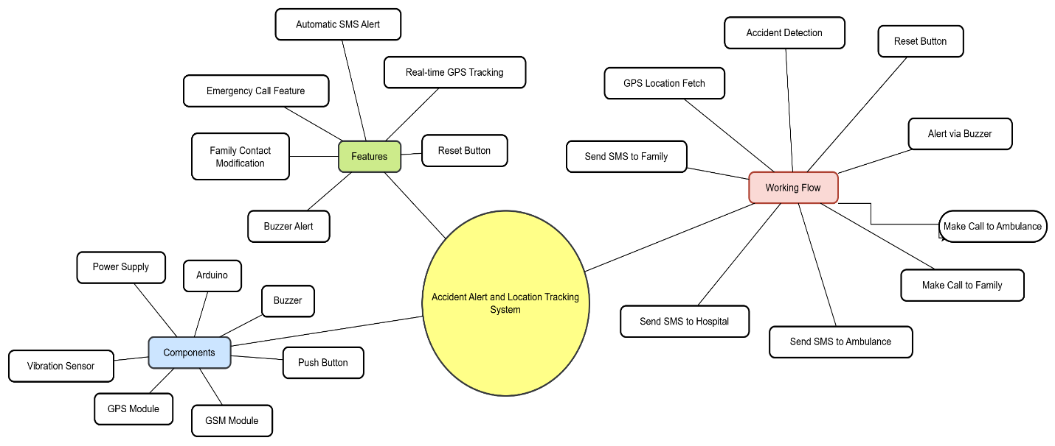

**Fig 4.1 Block Diagram**

**4.2 Block Diagram Description**

* The system leverages hardware components like an **Arduino microcontroller**, a **vibration sensor** for accident detection, a **GPS module** for real-time location tracking, and a **GSM module** for communication.
* Key features include **automatic SMS alerts** to family members, hospitals, and ambulance services, as well as **emergency calls** to both ambulances and pre-set family contacts.
* Additionally, the system provides **rest-time GPS tracking** for continuous monitoring and an **audible buzzer alert** for immediate notifications.
* A **reset button** allows users to clear alerts or restart the system.
* The workflow demonstrates a structured sequence: upon detecting an accident (via the vibration sensor), the system fetches GPS coordinates, triggers the buzzer, and initiates calls and SMS notifications to emergency contacts.
* This setup ensures rapid response and enhanced safety, making it suitable for vehicles or personal safety applications.

**CHAPTER 5**

**METHODOLOGY**

The development of the Accident Alert and Location Tracking System follows a clear and organized process to ensure quick accident detection and emergency response. It starts with identifying the problem—delays in emergency help after accidents. The system is designed to reduce response time by automatically detecting accidents and sending alerts. In the design phase, important parts are chosen: an Arduino microcontroller, a vibration sensor to detect impact, a GPS module to get the location, and a GSM module to send messages and make calls.

In the hardware setup, all these parts are connected. The vibration sensor detects shocks, the GPS and GSM modules use Software Serial to communicate, and a buzzer and reset button are added for alerts and control. In the software part, the system keeps checking the vibration sensor. If a strong impact is detected, the buzzer sounds and the system enters “accident mode.” The GPS gets the location, and if it fails, a default location is used. The GSM module then sends SMS alerts to emergency contacts (like family, ambulance, and hospital) and also makes automatic calls. A reset button lets the user stop the alert once help arrives.

Testing includes checking sensor accuracy, GPS location tracking, and GSM messaging. Real-world tests are done to make sure the system works properly. Finally, the system is installed in the vehicle, with focus on saving power and handling errors if GPS or GSM fails. The goal is to create a reliable system that sends fast and accurate accident alerts, helping emergency teams respond quickly and potentially save lives.

**5.1 Schematic Diagram**

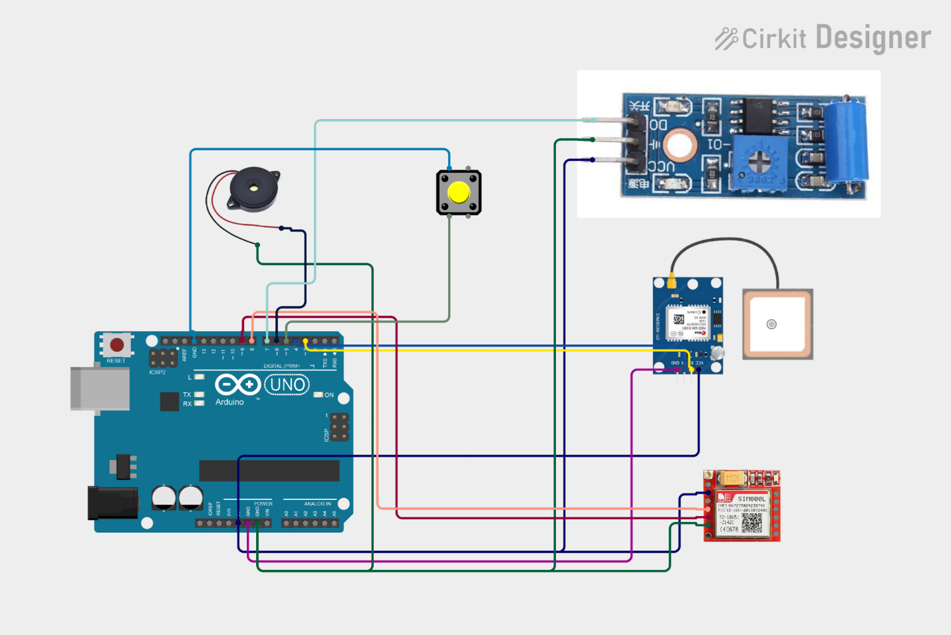

**Fig 5.1 Schematic Diagram**

**5.2 Working**

**1. Accident Detection**

* A vibration sensor is used to detect sudden jerks or impacts that may indicate a vehicle accident.
* When the sensor triggers, it sends a signal to the Arduino UNO.

**2. Local Alert Activation**

* The Arduino responds by activating a buzzer, which alerts people nearby about the possible accident.

**3. Location Tracking**

* The Arduino communicates with the GPS module to fetch the current latitude and longitude.
* These coordinates are formatted into a Google Maps link for easy tracking.

**4. Emergency Communication**

* The GSM module sends an SMS alert to predefined contacts:
  + Family Member
  + Ambulance
  + Hospital
* The SMS contains the accident alert and GPS location

**5. Auto Calling**

* After sending the SMS, the system makes automatic phone calls to:
  + Family
  + Ambulance

**6. System Reset**

* A push button is available to manually reset the system after an alert or in case of a false detection.

**7. Full Automation**

* The entire system works autonomously, requiring no user input once an accident is detected—ideal for real-time emergency response.

**5.3 Components and Description**

**5.3.1 Arduino Uno R3**

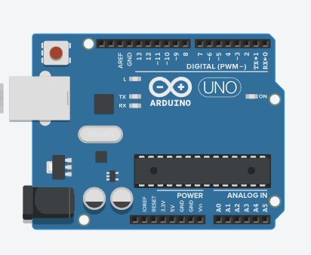

**Fig 5.2 Arduino Uno R3**

1. **Description:**  
    Arduino UNO is a microcontroller board based on the ATmega328P. It has 14 digital input/output pins, 6 analog inputs, a USB connection, a power jack, and an ICSP header. It is programmed using the Arduino IDE and is capable of reading data from sensors and controlling modules based on programmed logic.
2. **Role:**  
    Arduino acts as the **brain** of the system. It constantly monitors inputs from the **vibration sensor** and **reset button**. When an accident is detected through the vibration sensor, it collects **GPS location data**, triggers the **buzzer**, and sends **SMS alerts and calls** using the GSM module. It coordinates all operations, ensuring that alerts are sent only when required and includes GPS data in messages for quick response.

**5.3.2 GSM (800L)**

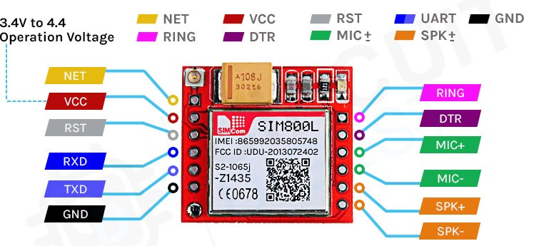 **Fig 5.3 GSM (800L)**

1. **Description:**

SIM800L is a quad-band GSM/GPRS module that supports voice calls, SMS, and internet data transfer. It communicates with the Arduino via serial communication (TX/RX pins). It operates on 3.7–4.2V and uses an external SIM card to connect to mobile networks.

1. **Role:**  
    The GSM module is the communication interface of the system. When the Arduino detects an accident, it sends SMS alerts to predefined numbers like family, hospital, and ambulance with a Google Maps link to the location. It also makes automated phone calls to draw attention. This module ensures remote communication in emergency situations, even in areas without internet, using basic mobile network functionality.

**5.3.3 GPS (Neo 6M)**

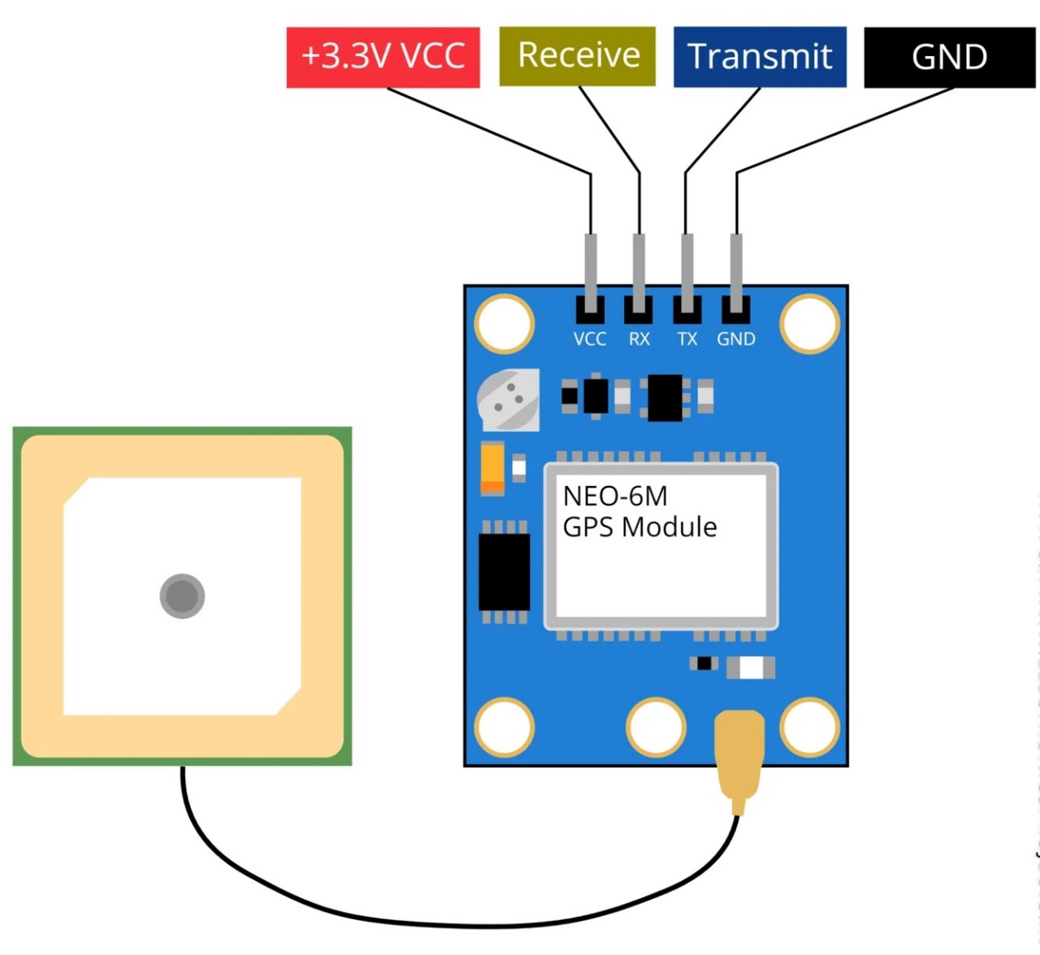

**Fig 5.4 GPS (Neo 6M)**

1. **Description:**  
    Neo-6M is a GPS receiver module that uses satellite signals to determine the device's geographic location (latitude and longitude). It communicates with the Arduino via serial protocol and includes a ceramic antenna for better signal reception.
2. **Role:**  
    The GPS module is used for **real-time location tracking**. When the Arduino receives an accident trigger, it collects the current GPS coordinates and converts them into a Google Maps link. This link is sent through the GSM module to emergency contacts. It helps **rescuers quickly locate** the accident site without needing further instructions or calls.

**5.3.4 VIBRATION SENSOR**

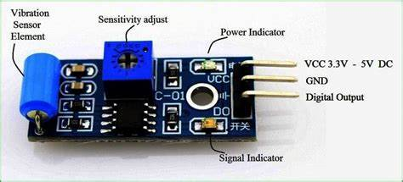

**Fig 5.5 VIBRATION SENSOR**

1. **Description:** This sensor detects mechanical vibrations or shocks. It generally contains a spring or metal contact that closes the circuit when sudden movement is detected. It gives digital output (HIGH/LOW) depending on vibration intensity.
2. **Role:** The vibration sensor is the **accident detection mechanism**. When a strong vibration (such as a crash or fall) occurs, it sends a signal to the Arduino indicating an impact. This is treated as a potential accident and triggers the alert process. It is essential for **automated detection** without any human input.

**5.3.5 BUZZER**

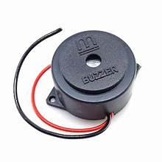**Fig 5.6 Buzzer**

1. **Description:**

A buzzer is an electronic audio signaling device that emits sound when powered. It can be controlled by microcontrollers and used as an alarm or notification system.

1. **Role**

The buzzer provides an immediate audio alert when an accident is detected. It helps attract the attention of nearby people, letting them know that an emergency has occurred. It also alerts the person involved in the accident (if conscious) that the system is working and help is being notified.

**5.3.6 PUSH BUTTON**

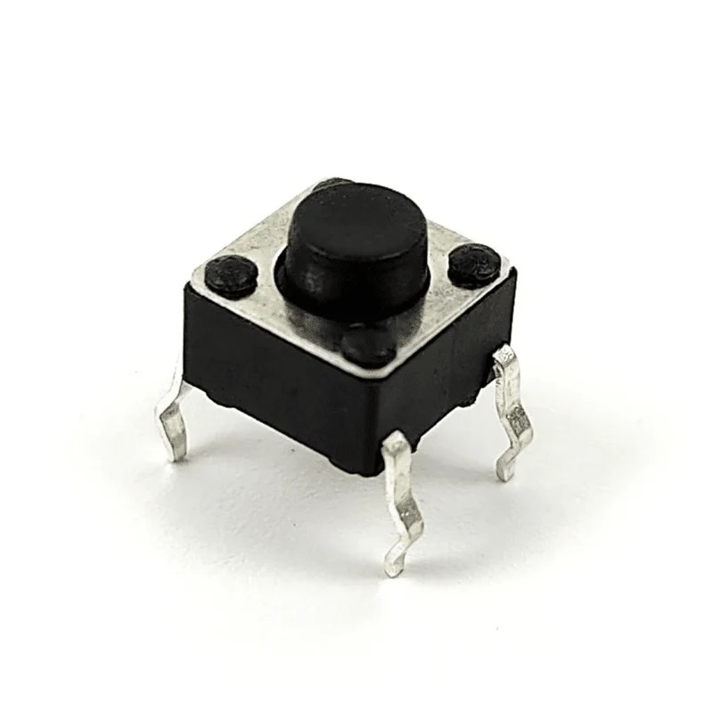

**Fig 5.7 Push button**

* 1. **Description:**

A push button is a basic switch mechanism that completes or interrupts an electrical circuit when pressed. In this project, it is wired to a digital pin on the Arduino and uses internal pull-up resistance.

* 1. **Role**

The push button acts as a **manual reset** option. If the vibration sensor falsely triggers the system (due to potholes or bumps), the user can press the button to stop the alert process. It resets the Arduino's accident flag and prevents unnecessary messages or calls. This gives users **manual control** in non-accident scenarios.

**CHAPTER 6**

**RESULTS AND DISCUSSION**

**6.1 Results**

The implemented system successfully detects accidental vibrations using a vibration sensor and triggers an automated emergency response. Upon detecting an accident, the Arduino processes the data, activates a buzzer, and immediately fetches the GPS coordinates from the Neo-6M GPS module. These coordinates are then embedded in a Google Maps link and sent as an SMS to pre-configured contacts (family, ambulance, and hospital) using the GSM SIM800L module. Additionally, automated phone calls are made to the emergency contacts for added attention. A reset button allows the user to cancel alerts in case of false triggers. The system has demonstrated real-time responsiveness, location accuracy, and effective communication under various test conditions.

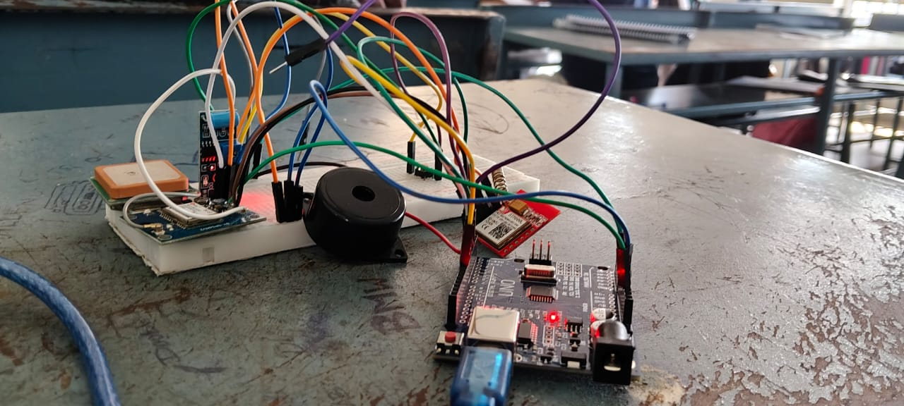

**Fig 6.1 Outcome**

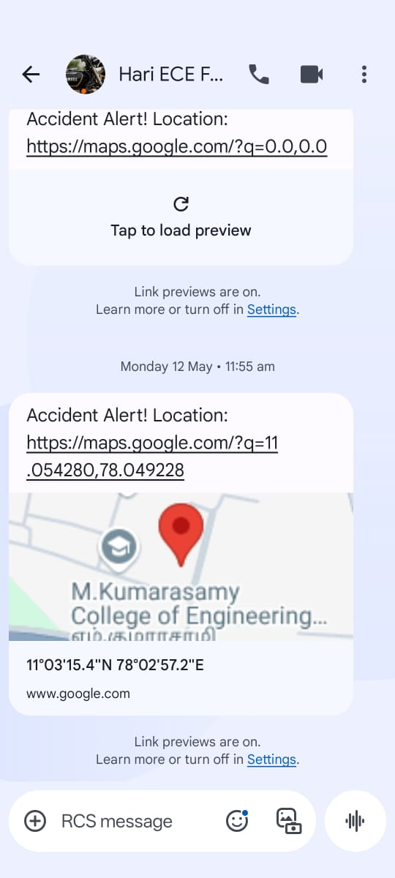

**Fig 6.2 SMS Message**

When an accident is detected, the system sends an automatic SMS to the registered family members, ambulance, and hospital. The message includes a Google Maps link with the exact accident location, allowing quick identification and response. This ensures that even in areas with poor internet, the alert reaches important contacts reliably. The family number can be easily updated in the code.

**Fig 6.3 Phone Call**

After sending the SMS, the system makes automatic phone calls to the family, ambulance, and hospital to ensure urgent notification. Each number is called briefly and then disconnected automatically. This voice alert ensures someone is alerted even if the SMS is missed, providing an extra layer of emergency communication.

**6.2 Discussion**

This system provides a **low-cost, efficient, and reliable** solution for accident detection and emergency communication, especially in remote or rural areas where immediate medical help is not always accessible. The use of vibration sensing ensures that the system can work autonomously, without human interaction during an emergency. GPS integration adds the vital feature of **location accuracy**, while GSM ensures **connectivity without the need for internet**. One of the key strengths of this system is its **simplicity in design and usability**, making it easy to install in vehicles or wearable devices. However, the system can be further improved by integrating advanced sensors (e.g., accelerometers for higher accuracy), a rechargeable power source, or IoT-based live tracking. False alarms due to minor vibrations can also be refined using threshold tuning or machine learning models. In conclusion, the project demonstrates a practical implementation of microcontroller-based accident alert systems and offers great potential for saving lives by **reducing response time in critical situations**.

**CHAPTER 7**

**CONCLUSION AND FUTURE WORK**

**7.1 Conclusion**

The proposed accident alert and location tracking system provides a reliable, real-time solution for detecting accidents and notifying emergency contacts with the exact GPS location. By integrating a vibration sensor, GPS module (Neo 6M), and GSM module (SIM800L), the system ensures immediate alert generation and communication. The Arduino Uno acts as the central controller, managing sensor inputs and coordinating message delivery. The buzzer serves as an on-site alert, while the reset button prevents false alarms. Overall, the project offers a **cost-effective, easy-to-deploy safety mechanism** suitable for vehicles, especially in areas with limited access to emergency infrastructure.

**7.2 Future Work**

1. **Integration with Mobile App:** A dedicated smartphone app can be developed to display live tracking, accident history, and allow dynamic contact updates.
2. **IoT & Cloud Storage:** Data can be uploaded to a cloud platform for real-time monitoring, data analysis, and remote access by hospitals or emergency services.
3. **Advanced Sensors:** Use of accelerometers and gyroscopes (like MPU6050) can improve accident detection accuracy and reduce false positives.
4. **Power Optimization:** Incorporating a rechargeable battery with solar charging or vehicle power integration can make the system more sustainable.
5. **Voice Feedback or Recording:** Adding a voice module can help capture the victim’s condition or surroundings and transmit it via GSM.
6. **Automatic Vehicle Locking/Control:** Future versions can integrate with vehicle systems to automatically slow or stop the vehicle post-accident.

**REFERENCES**

1. Ahay Khattar, Pratim Sarkar, J. Selvin Paul Peter,” IOT Based Accident Detection and Vehicle Tracking System Using GPS and GSM Module”, International Journal of Advanced Science and Technology, Vol. 29, No. 06 (2020)
2. Suhas Sanap, Vedant Patil, Harshal Buchake, Dr. Jeet Patil,” Design & Development of Arduino Based Vehicle Accident Alert System Using GPS, GSM Module, Distance & Force Sensor”, International Journal of Engineering Research & Technology (IJERT), Vol. 13, Issue 04 (April 2024).
3. Valiyev Muhammadali,” Vehicle Accident Alert System Built Using Arduino, Gps, And A Gsm Module”, Zenodo (2023).
4. Patil, A. A., & Patil, M. P. (2016) Vehicle Accident Detection and Reporting System using GPS and GSM Technology International Journal of Engineering Research and General Science, 4(3), 282–285.
5. Kamble, A., Pawar, S., & Bhagat, V. (2015), Accident Detection and Alert System International Journal of Computer Applications, 123(16), 34–36.
6. Rajeshwari, S., Santhosh Kumar, D., & Patil, J. P. (2014), Accident Detection and Ambulance Rescue System International Journal of Scientific & Engineering Research, 5(9), 645–649.
7. Nagaraju, G., & Vijaya Lakshmi, R. (2018) GPS and GSM Based Vehicle Accident Detection System, International Journal of Advanced Research in Electrical, Electronics and Instrumentation Engineering, 7(2), 1169–1175.