CO-3 AT-2
5.During frequency response testing, the output voltage decreases rapidly above the designed operating frequency, resulting in a much smaller bandwidth than expected. Analyze the circuit and identify whether the reduction is caused by component variation, improper coupling, or transistor parasitic effects. Recommend suitable corrective measures to restore the desired bandwidth
CIRCUIT:

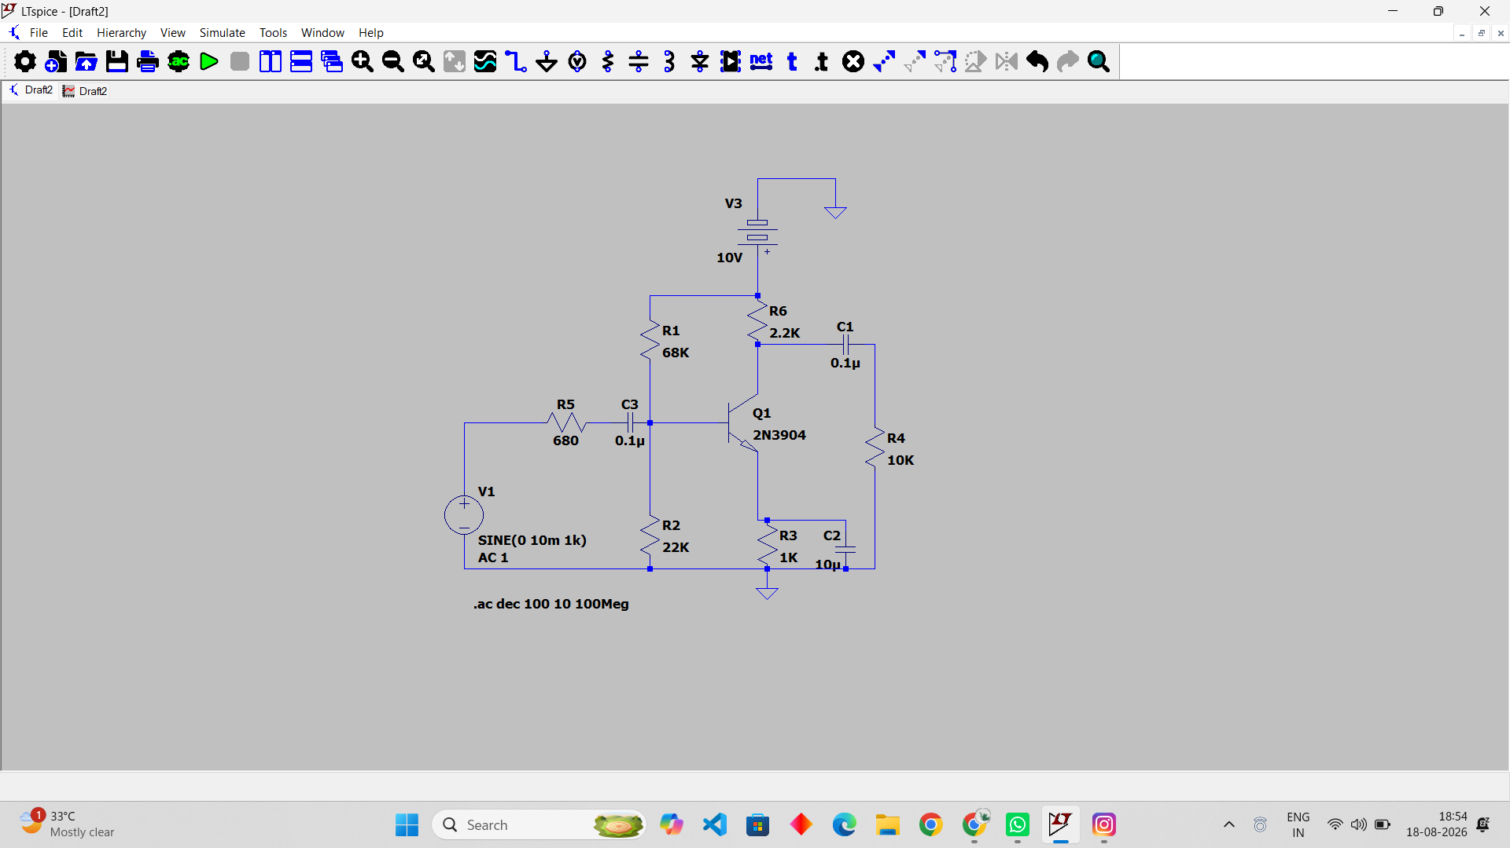

OUTPUT:

