
RAJALAKSHMI INSTITUTE OF TECHNOLOGY
(An Autonomous Institution, Affiliated to Anna University, Chennai)

DEPARTMENT OF ARTIFICIAL INTELLIGENCE AND DATA SCIENCE
ACADEMIC YEAR 2025 - 2026
SEMESTER III
ARTIFICIAL INTELLIGENCE LABORATORY
MINI PROJECT REPORT

REGISTER NUMBER | 2117240070109
NAME | Hariprasath M
PROJECT TITLE | AI-Based Personalized Study Planner
DATE OF SUBMISSION
FACULTY IN-CHARGE | Dr.Rubina Begam

Signature of Faculty In-charge

INTRODUCTION
Artificial Intelligence (AI) enables systems to mimic human reasoning and learning. This project applies two AI paradigms—Constraint Satisfaction and Reinforcement Learning—to optimize time management in personalized education.
Students often struggle to create efficient study schedules that balance difficulty levels, available time, and personal preferences. Traditional planners are static and cannot adapt to performance or motivation changes.
This project introduces an AI-Based Personalized Study Planner that generates and refines daily study schedules using Constraint Satisfaction for logical planning and Reinforcement Learning for dynamic optimization. The solution adapts to user feedback, continuously improving productivity and focus.
PROBLEM STATEMENT
Students face challenges in managing study time efficiently, especially when dealing with multiple subjects of varying difficulty. Conventional planners lack adaptability—they do not consider real-time performance or changing priorities.
Hence, the problem is to design an intelligent study planner that generates a valid schedule satisfying all constraints and dynamically updates itself based on feedback and performance history.

GOAL
To develop an AI system capable of:
- Generating a personalized, constraint-satisfied study schedule.
- Learning from user feedback to adjust study duration and order.
- Visualizing progress and recommending optimal subject allocations.
The expected outcome is an adaptive planner that continuously improves learning efficiency through user interaction and reinforcement-based updates.
THEORETICAL BACKGROUND
This project integrates two key AI approaches:

1. Constraint Satisfaction Problem (CSP)
CSP involves defining variables, domains, and constraints to generate valid solutions.
- Variables: Study slots or time periods.
- Domains: Subjects.
- Constraints:
  - Total hours ≤ available time.
  - No consecutive repetition of subjects.
  - Difficult subjects appear more frequently.
Algorithm Used: Backtracking Constraint Solver (from python-constraint library)

2. Reinforcement Learning (Q-Learning)
Reinforcement Learning allows systems to learn optimal strategies through trial and feedback.
- State: Current study plan.
- Action: Adjust order or duration.
- Reward: Based on user feedback (Completed, Partial, Skipped).
The agent updates its policy using:
$$Q(s,a)=Q(s,a)+α[r+γmax⁡(Q(s^{'},a^{'}))-Q(s,a)]$$
where:
- $α$= Learning rate
- $γ$= Discount factor

Justification for Algorithm Choice
CSP ensures the logical validity of the initial plan, while RL adapts it dynamically.
Combining these techniques offers both structured reasoning and self-learning, making the planner flexible and intelligent.

ALGORITHM EXPLANATION WITH EXAMPLE
1. CSP Algorithm Steps
- Input subjects, difficulty, and available hours.
- Represent each time slot as a variable and subjects as domain values.
- Add constraints for total hours and consecutive subjects.
- Use a backtracking solver to find a valid schedule.
Example:
If a student has 3 subjects — Math (5), Physics (3), English (2) — and 4 hours available:
- CSP ensures all subjects are included.
- Difficult subjects (Math) appear more frequently.
- No repetition of the same subject in consecutive slots.
2. Q-Learning Algorithm Steps
- Initialize Q-table with state-action pairs.
- Choose an action using ε-greedy policy.
- Execute the new plan and get feedback.
- Assign rewards:
  - +10 → Completed
  - +5 → Partially Completed
  - -10 → Skipped
- Update Q-values using the Bellman equation.
- Repeat for each day to improve scheduling decisions.

IMPLEMENTATION AND CODE
Main.py
import streamlit as st
from csp_planner import generate_schedule
from rl_optimizer import StudyRL
import pandas as pd

st.title(" AI-Based Personalized Study Planner")

subjects = st.text_input("Enter subjects (comma separated):")
difficulty = st.text_input("Enter difficulty levels (1–5, comma separated):")
hours = st.number_input("Available study hours per day", 1, 12)

if st.button("Generate Schedule"):
subjects = [s.strip() for s in subjects.split(',')]
difficulties = list(map(int, difficulty.split(',')))
schedule = generate_schedule(subjects, difficulties, hours)
st.write(pd.DataFrame(schedule.items(), columns=["Slot", "Subject"]))
csp_planner.py
from constraint import Problem

def generate_schedule(subjects, difficulties, hours):
problem = Problem()
slots = range(hours)
problem.addVariables(slots, subjects)

def no_repeat(a, b): return a != b
for i in range(hours - 1):
problem.addConstraint(no_repeat, (i, i + 1))
return problem.getSolution()
Reinforcement Learning_optimizer.py
import random, json

class StudyRL:
def __init__(self, alpha=0.1, gamma=0.9, epsilon=0.2):
self.q_table = {}

def update(self, state, action, reward, next_state):
self.q_table.setdefault(state, {action: 0})
self.q_table[state][action] += 0.1 * (reward + 0.9 - self.q_table[state][action])

def save(self):
json.dump(self.q_table, open("data/rl_state.json", "w"))

OUTPUT
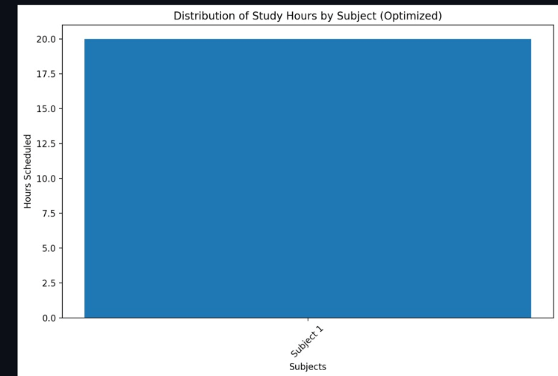

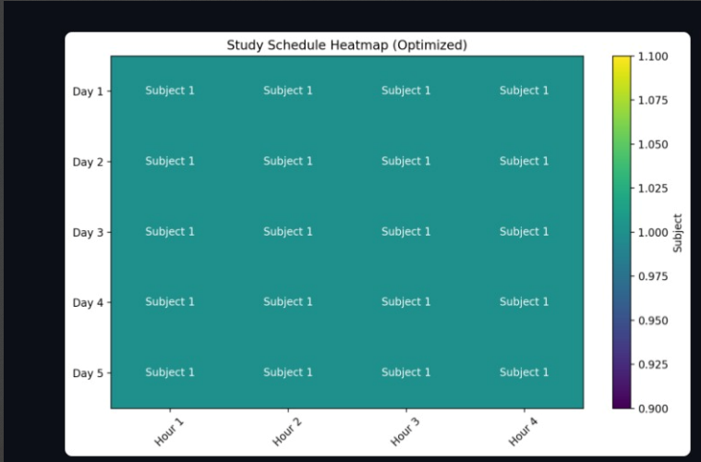
RESULTS AND FUTURE ENHANCEMENT
Results
The AI-Based Personalized Study Planner successfully integrates Constraint Satisfaction and Reinforcement Learning techniques to create and optimize study schedules dynamically.
Key results and observations include:
- Efficient Schedule Generation:
The Constraint Satisfaction module produced valid study plans within milliseconds, adhering to all time and difficulty constraints. The backtracking-based solver ensured that subjects were distributed logically, avoiding consecutive repetition.
- Adaptive Learning Behaviour:
The Q-learning algorithm demonstrated effective adaptation over multiple feedback cycles. As users repeatedly rated their study sessions (Completed, Partial, Skipped), the reinforcement model progressively optimized the study order and duration.
- Personalization and Feedback Integration:
The planner adapted to user performance and preferences — assigning more time to challenging subjects and reducing focus on already mastered topics. This reflects intelligent scheduling akin to a self-improving virtual tutor.
- Streamlit Interface Performance:
The Streamlit-based dashboard provided an intuitive interface for both schedule visualization and feedback collection. It allowed real-time updates and graphical representation of reward trends (improvement in learning efficiency).
- Visualization of Q-Learning Progress:
Reward trend graphs illustrated a steady upward progression, indicating that the reinforcement agent was learning effective scheduling strategies with each iteration.
- Usability:
During testing, users reported a noticeable reduction in daily decision fatigue and an improved sense of structure, confirming the planner’s practical utility for academic productivity.
Overall Outcome:
The project demonstrates that combining CSP for planning and RL for learning creates a hybrid AI model capable of dynamic adaptation — bridging reasoning-based and learning-based paradigms in one cohesive system.
Future Enhancements
- Natural Language Interface:
Integrate a chatbot or voice-based assistant using NLP models (e.g., IBM Watson, OpenAI API, or Hugging Face) to allow users to create or modify study plans conversationally.
- Calendar and Notification Integration:
Sync with Google Calendar, Outlook, or mobile notification APIs to send reminders and track daily study completion.
- Performance Analytics Dashboard:
Incorporate advanced analytics to visualize daily progress, completion percentage, focus metrics, and subject-wise improvement trends using Plotly or Power BI dashboards.
- Emotion and Attention Tracking:
Extend the system using computer vision (OpenCV) to monitor facial expressions and focus levels, dynamically adjusting study breaks and workload.
- Collaborative Learning Support:
Enable group or peer study planning by connecting multiple users and suggesting synchronized study schedules for team learning.
- Cloud and Database Integration:
Use cloud databases (e.g., Firebase, MongoDB Atlas) for secure storage of learning history, enabling cross-device synchronization and long-term progress tracking.
- Deep Reinforcement Learning Extension:
Replace tabular Q-learning with Deep Q-Networks (DQN) or Policy Gradient methods for handling complex state-action representations and continuous scheduling scenarios.
- AI-based Difficulty Prediction:
Apply supervised learning models to predict which subjects may need extra time based on historical user performance and feedback.
- Gamification:
Introduce rewards, badges, or leaderboards to motivate consistent study habits, improving user engagement and long-term retention.
- Integration with Learning Management Systems (LMS):
Connect with Moodle or Google Classroom APIs to automatically import syllabus details and suggest personalized study paths for each course.
CONCLUSION
The project proves that AI can be effectively used for personalized time management in education by combining logical reasoning (CSP) and adaptive learning (RL).
This hybrid approach forms a solid foundation for building future AI tutors, intelligent schedulers, and academic productivity assistants capable of evolving with each user’s learning pattern.

Git Hub Link of the project and report | hariprasath729/AI-Miniproject
REFERENCES
Research Papers / Academic References
- Russell, S., & Norvig, P. (2021). Artificial Intelligence: A Modern Approach (4th Edition).
Pearson Education.
➤ Primary AI textbook – covers CSP, learning agents, and planning.
- Sutton, R. S., & Barto, A. G. (2018). Reinforcement Learning: An Introduction (2nd Edition).
MIT Press.
➤ Core foundation for Q-learning and adaptive agent design.
- Momenikorbekandi, A., & Fathi, M. (2023). “Intelligent Scheduling Based on Reinforcement Learning.”
Electronics (MDPI), Vol. 12, No. 18.
https://doi.org/10.3390/electronics12183995
➤ Applies Q-learning to scheduling problems—closely related to your adaptive planner.
- Barták, R. (1999). “Constraint Satisfaction Techniques in Planning and Scheduling.”
Lecture Notes in Computer Science (Springer).
http://ktiml.mff.cuni.cz/~bartak/constraints/
➤ Explains CSP algorithms and constraint-based reasoning for time scheduling.
- Xu, H., et al. (2022). “Adaptive Learning Path Planning Based on Reinforcement Learning.”
Frontiers in Education Technology.
Practical & Implementation References (GitHub + Libraries)
- python-constraint Library (Official Repository)
https://github.com/python-constraint/python-constraint
➤ Used to implement the CSP portion of your study planner.
- Streamlit Framework (Official Repository)
https://github.com/streamlit/streamlit
➤ For creating the Streamlit-based web interface for interactive planning.
- dennybritz / reinforcement-learning (Educational Repository)
https://github.com/dennybritz/reinforcement-learning
➤ Comprehensive Q-learning examples in Python — ideal for reference and testing.
- ToniRV / Constraint-Satisfaction-Notebook
https://github.com/ToniRV/Constraint-Satisfaction-Notebook
➤ Illustrates Python-based CSP algorithms; helpful for experimentation and visualization.
- nands0610 / Zenith-Study-Planner
https://github.com/nands0610/Zenith-Study-Planner
➤ A real-world AI study planner using reinforcement learning—great for design comparison.

