NORTHWIND TRADERS
Business Insight Report
Name: [Your name]
Dep: [Your department]
Reg: [Your register number]

1. Introduction

Northwind Traders Dataset
Northwind Traders is a sample company that imports and exports speciality foods. The Power BI file (DATASET_3.pbix) links seven tables: orders, order details, products, categories, customers, employees and shippers. Between 4 July 2013 and 4 May 2015 it records 809 orders from 91 customers in 21 countries, covering 77 products in 8 categories, handled by 8 employees and delivered through 3 shippers. Total sales over this period come to about $1.27 million.

Purpose of the Dashboard
The dashboard brings orders, quantities, freight, customers, categories and employees together on one page. Year, country and category slicers let a viewer filter every visual at once instead of working through separate spreadsheets.

Purpose of this Business Insight Report
This report explains what each KPI and chart shows, compares results across categories, months, regions and employees, and turns those findings into practical recommendations for management.

2. Dashboard Overview
[Paste your Power BI screenshot here: full Interactive Sales Dashboard page]

Key Components
- Five KPI cards: Total Orders, Total Quantity Sold, Total Freight, Average Freight and Number of Customers.
- Line chart of Total Orders by order date (monthly trend).
- Bar chart of Total Orders by employee.
- Column chart of Total Sales by product category.

Interactive Filters Available
- Order date: limits all visuals to a chosen year or period.
- Country: shows the dashboard for one customer country.
- Category name: limits all visuals to one product category.

3. KPI Analysis
KPI | Value | Interpretation
Total Orders | 809 | Steady order flow across roughly 22 months, so sales do not depend on a few big deals.
Total Quantity Sold | 51,317 units | About 63 units per order, which points to bulk buying by business customers.
Total Freight | $63,955.02 | Shipping is a real cost on every order and needs active control.
Average Freight | $79.05 | A benchmark: countries or shippers well above it should be checked first.
Number of Customers | 91 (89 ordered) | Customers are spread over 21 countries, but a few large accounts still matter a lot.

Total Sales, calculated as unit price × quantity × (1 − discount), is $1,265,793, which means the average order is worth roughly $1,565.

4. Product Category Performance Analysis
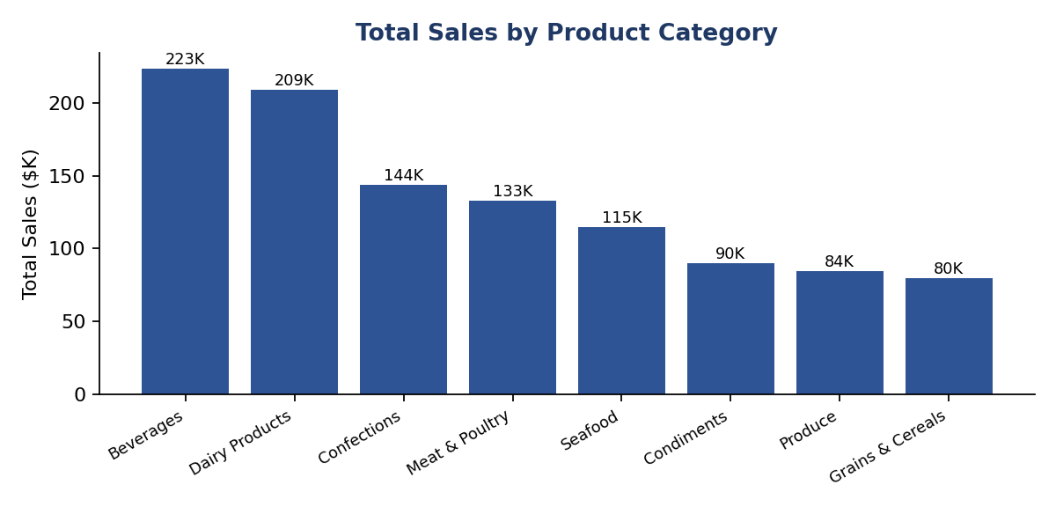
Figure 1: Total Sales by Product Category
[Paste your Power BI screenshot here: your Power BI Sales by Product Category chart (optional replacement for Figure 1)]
- Highest-selling category: Beverages with $223,349 (about 20.7% of sales).
- Lowest-selling category: Grains & Cereals with $79,607 (about 7.4%).
- Relative differences: Beverages sells about 2.8 times as much as Grains & Cereals. Beverages and Dairy Products ($208,789) are close to each other and well ahead of Confections ($143,661). The top three categories bring in about 53% of sales, and the bottom three (Condiments, Produce, Grains & Cereals) only about 24%.
- Important observations: Two categories lead clearly, followed by a steady decline, so no single category carries the whole business.

Key Insight
Beverages and Dairy Products are the core revenue drivers, so supply, stock and promotion for them should come first. Grains & Cereals, Produce and Condiments are the weakest and are the best candidates for a pricing or assortment review.

5. Monthly Order Trend Analysis
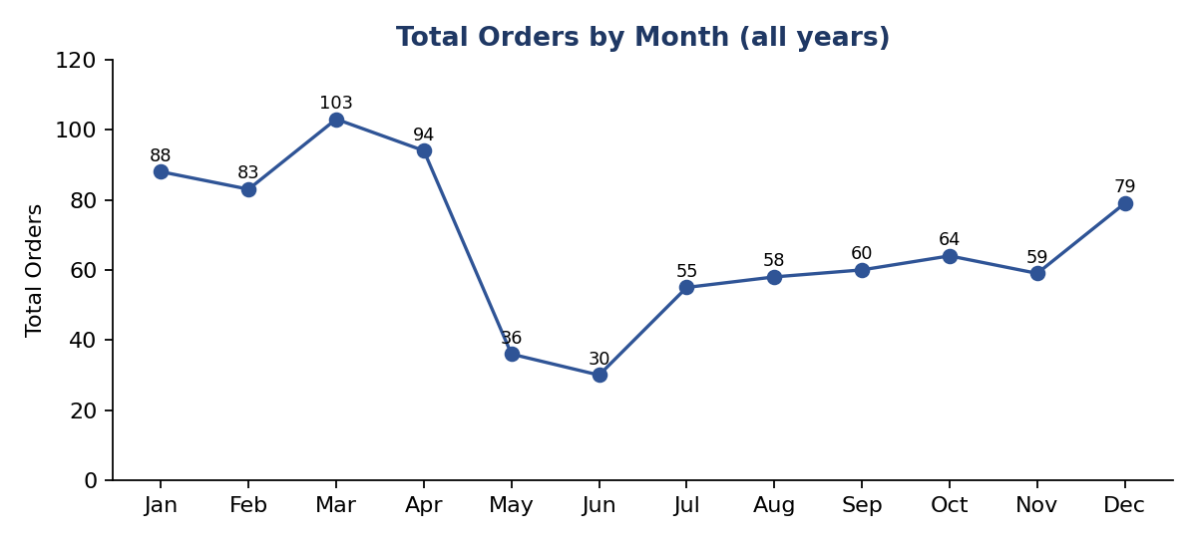
Figure 2: Total Orders by Month (all years combined)
- Highest-order month: March with 103 orders.
- Lowest-order month: June with 30 orders.
- Overall pattern: Orders are strong from January to April (83 to 103 a month), fall sharply in May and June, then recover slowly from July (55) to a late rise in December (79).
- Major fluctuations: The fall from 94 orders in April to 36 in May and 30 in June is the biggest swing, a drop of about 68% from April to June.

Key Insight
Part of the May and June dip comes from the data itself: the records start in July 2013 and stop on 4 May 2015, so May and June have far fewer years of data than other months. Even so, the first quarter looks like the busiest period, so staffing, stock build-up and promotions should be planned around it. By year, there were 152 orders in 2013 (half a year), 408 in 2014 and 249 in 2015 (four months).

6. Regional / Filter-Based Analysis
The Region slicer was applied for Germany, USA and Brazil to see how the dashboard changes. Germany and USA are the two largest markets, and Brazil is the third largest.
[Paste your Power BI screenshot here: dashboard filtered for Germany, USA and Brazil (one screenshot each)]
Region | Major Observation | Business Insight
Germany | 120 orders, 11 customers, 7,835 units, average freight $92.63. Dairy Products leads ($42,117), ahead of Beverages ($33,986). Busiest month April. | Germany is the biggest market and prefers Dairy over Beverages, so it needs its own category focus.
USA | 119 orders, 13 customers, 8,476 units, total freight $13,730, average freight $115.38. Beverages leads ($49,430), then Meat & Poultry ($39,513). | USA shipping costs 46% more per order than the $79.05 average and should be reviewed.
Brazil | 81 orders, 9 customers, average freight only $58.18. Beverages is far ahead ($34,335 against Dairy at $13,901). | Brazil is a Beverages-driven market with low shipping cost, a good place to grow.

Discussion
- KPI changes: Orders, quantity, freight and customers shrink to the selected country's share, while average freight moves up or down with distance and order size.
- Category changes: The top category differs by market: Dairy Products in Germany, Beverages in the USA and Brazil.
- Monthly changes: Germany peaks in April (18 orders), the USA in September (14) and Brazil in January (11), so seasonality is not the same everywhere.
- Employee changes: Margaret Peacock leads in Germany (25 orders) and Brazil (20), while Janet Leverling leads in the USA (21).

7. Employee Performance Analysis
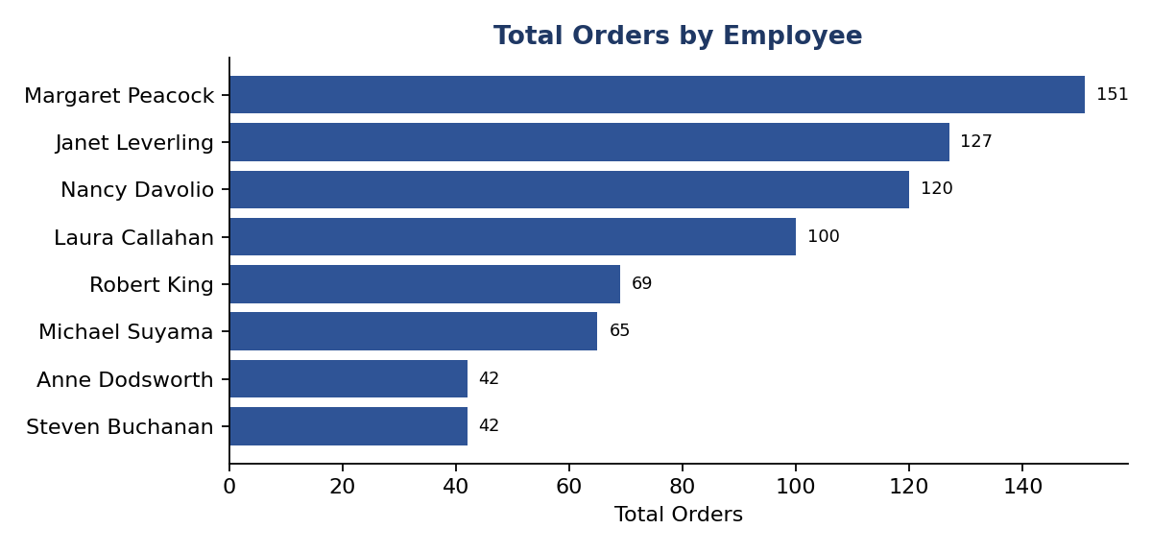
Figure 3: Total Orders by Employee
- Highest-performing employee: Margaret Peacock with 151 orders.
- Lowest-performing employees: Anne Dodsworth and Steven Buchanan, both with 42 orders.
- Difference between employees: Margaret handled about 3.6 times as many orders as the lowest two. The top four employees (Margaret Peacock, Janet Leverling, Nancy Davolio and Laura Callahan) handled 498 of 809 orders, about 62%.
- Changes after applying filters: The leader changes with the country filter: Janet Leverling overtakes Margaret in the USA.

Key Insight
Order handling is concentrated in a few people and partly follows regional relationships. The way top performers manage their key accounts could be shared with the lower-volume employees.

8. Business Insights

Insight 1
Observation: Beverages ($223,349) and Dairy Products ($208,789) together make up about 40% of sales, while the weakest category, Grains & Cereals, adds only $79,607.
Insight: Sales rely on two strong categories. Protecting their supply and promotion matters most, and the weak categories need a reason to stay in the same shelf space.

Insight 2
Observation: Germany and the USA place 239 of 809 orders (about 30%) from only 2 of 21 countries. USA freight averages $115.38, and Austria is even higher at $185.62 across 38 orders.
Insight: Sales are concentrated in a few markets, and some of them are expensive to serve. Freight terms should be checked before pushing growth there.

Insight 3
Observation: Shipper average freight differs: United Package $87.48 (315 orders), Federal Shipping $81.78 (249) and Speedy Express $65.45 (245).
Insight: The cheapest shipper is also carrying the fewest orders, so moving more high-freight shipments to Speedy Express could cut logistics cost.

9. Business Recommendations
- Product planning: Secure supply of Beverages and Dairy Products, and test bundles or price changes for Grains & Cereals, Produce and Condiments.
- Logistics: Renegotiate or reassign shippers for the USA and Austria, where freight per order is far above the $79.05 average.
- Seasonality: Build stock and staffing for January to April, and use the quiet mid-year months for promotions.
- Sales team: Pair low-volume employees with top performers and let regional leaders (Margaret Peacock in Germany and Brazil, Janet Leverling in the USA) share their account-handling methods.
- Market development: Study the smaller markets that show strong category preferences, and adjust the product mix to each.

10. Conclusion
The dashboard shows a healthy, bulk-order business built on Beverages and Dairy Products, with sales concentrated in a few countries and employees. The main chances to improve are lowering freight cost in expensive markets, planning around the busy first quarter and lifting the weakest categories and employees.

