TECHNICAL DESIGN DOCUMENT
HFLMS Load Balancing
& Hosting Architecture
Current issue, current deployment, and proposed hosting scale-out options
System | HFLMS
Document type | Technical Design Document
Version | 1.0
Date | 22 October 2026
Status | Proposed options for review
Prepared from the supplied Confluence HTML macro and server inventory.

Contents / Index
Select a section title to jump to that part of the document.
01 | Purpose and scope
02 | Current issue and findings
03 | Current architecture
04 | Proposed architecture - Option 1: four hostings
05 | Proposed architecture - Option 2: six hostings using the SMS host
06 | Option comparison
07 | Deployment and validation considerations
08 | Assumptions and constraints
Navigation: Index entries are internal links. Page numbers are provided in the footer.

1. Purpose and scope
This document describes the reported HFLMS load-balancing issue, records the supplied current server topology, and presents two hosting-distribution options. It is intended to support technical review and option selection.
The proposals increase the number and distribution of IIS hosting instances. They do not establish that Citrix can use HTTP 503 response codes as a health-check or routing criterion, and they do not claim a confirmed root cause for the interruptions.
In scope | Not defined by the supplied information
Current issue and observed findings | A confirmed root cause for the HTTP 503 responses
Server names, IP addresses, and current connections | Detailed Citrix monitor configuration or change commands
Two hosting scale-out alternatives | Capacity sizing, licensing, or application performance results

2. Current issue and findings
HFLMS is behind a Citrix load balancer. When an application request receives HTTP 503 Service Unavailable, the request is not being routed away from the unhealthy application server. The reported Citrix limitation is that the available configuration cannot route based on the application response code.
Incident | Observed duration | Operational note
First interruption | 8 minutes | A forced IIS restart was required.
Second interruption | 2 minutes | Service recovered after the reported interruption.

Resource finding: RAM and worker-process utilization were reported as normal and below their thresholds during the incidents.

Design constraint: Increasing hosting instances may distribute application capacity differently, but does not change Citrix response-code health-check behavior.

3. Current architecture
Two IIS application servers provide two existing application hostings on HTTP port 80. The Citrix virtual IP distributes application requests to the IIS tier. Application and notification-role servers connect to the database server.
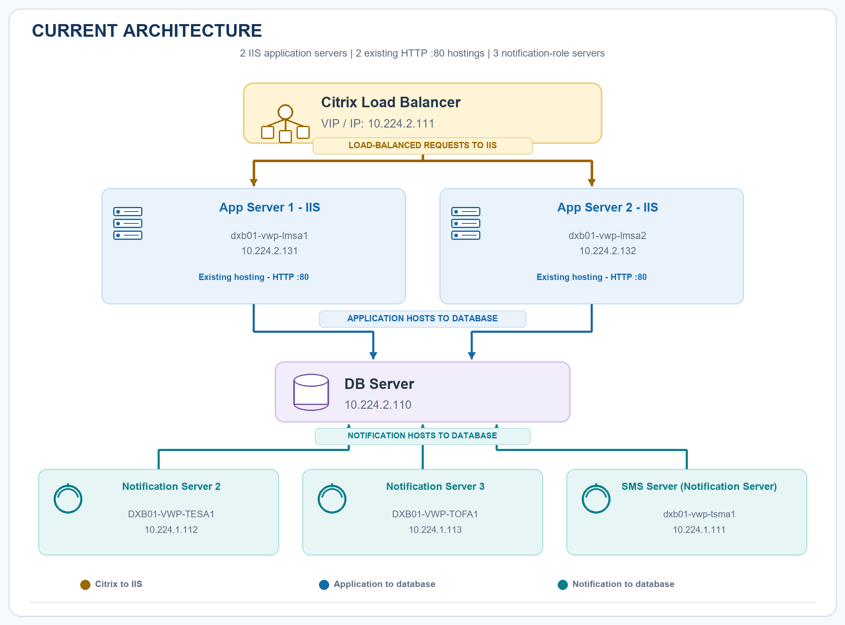
Figure 1. Current HFLMS logical deployment and supplied server inventory.
Role | Hostname | IP address / endpoint
Citrix Load Balancer | VIP | 10.224.2.111
App Server 1 - IIS, hosting :80 | dxb01-vwp-lmsa1 | 10.224.2.131
App Server 2 - IIS, hosting :80 | dxb01-vwp-lmsa2 | 10.224.2.132
Notification Server 2 | DXB01-VWP-TESA1 | 10.224.1.112
Notification Server 3 | DXB01-VWP-TOFA1 | 10.224.1.113
SMS Server (Notification Server) | dxb01-vwp-tsma1 | 10.224.1.111
DB Server | Hostname not supplied | 10.224.2.110

4. Proposed architecture - Option 1: four hostings
Retain App Server 1 and App Server 2. Keep the existing HTTP :80 hosting on each server and add a new HTTP :81 hosting on each. Configure Citrix to distribute traffic across the four intended IIS hosting endpoints, subject to supported load-balancer configuration.
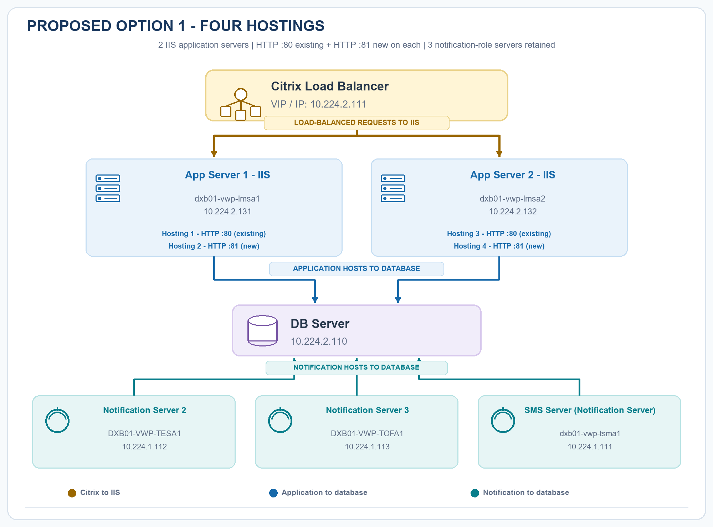
Figure 2. Option 1 - four IIS hosting instances on the two existing application servers.
- Application endpoints: 10.224.2.131:80, 10.224.2.131:81, 10.224.2.132:80, and 10.224.2.132:81.
- Keep Notification Server 2, Notification Server 3, and the SMS Server (Notification Server) in their current roles.
- Application and notification servers continue to connect to DB Server 10.224.2.110.
- No new physical server is proposed; the second hosting on each application server is new.

5. Proposed architecture - Option 2: six hostings using the SMS host
Retain the two current IIS application servers and repurpose the underutilized SMS host as App Server 3. Configure two hosting endpoints per application server (HTTP :80 available/existing and HTTP :81 new), for six hostings across three servers. The SMS host leaves its notification role; Notification Server 2 and Notification Server 3 remain connected to the database.
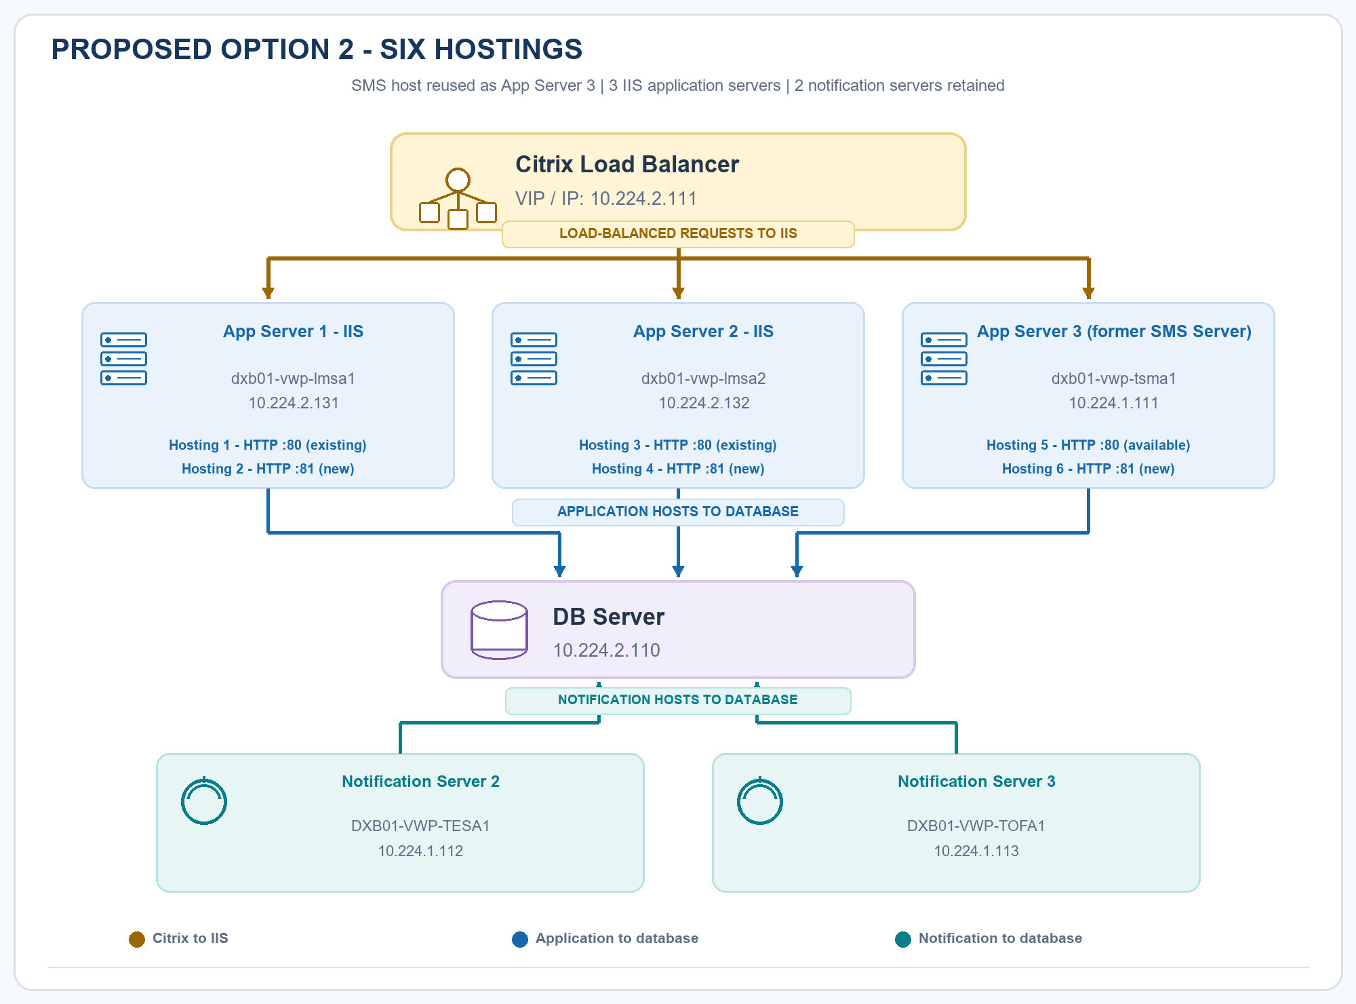
Figure 3. Option 2 - reuse the existing SMS host as App Server 3; no new physical node is added.
- App Server 3 uses dxb01-vwp-tsma1 at 10.224.1.111, the former SMS server.
- The six intended hosting endpoints are ports 80 and 81 on each of App Server 1, App Server 2, and App Server 3.
- Notification Server 2 (10.224.1.112) and Notification Server 3 (10.224.1.113) remain notification-role nodes.
- Validate that the former SMS host can support IIS and the HFLMS workload before selecting this option.

6. Option comparison
Decision point | Option 1 | Option 2
Application servers | 2 existing servers | 3; SMS host reused as App Server 3
Total IIS hostings | 4 (2 per app server) | 6 (2 per app server)
Hosting ports per app server | 80 existing + 81 new | 80 available/existing + 81 new
Notification-role servers | 3 retained, including SMS host | 2 retained; SMS host repurposed
New physical hardware | None proposed | None proposed
Citrix VIP | 10.224.2.111 | 10.224.2.111
Primary trade-off | More hostings on the current application tier | More hosting distribution; validate role migration and host readiness

Selection: The supplied information does not designate a preferred option. Selection should follow operational readiness, application compatibility, and capacity validation.

7. Note
- The SMS server is currently underutilized. Hence, Option 2 proposes repurpose it as an application server.

8. Assumptions and constraints
- Server names and IP addresses are reproduced from the supplied architecture; the database hostname was not provided.
- HTTP :80 is the existing/available hosting port, and HTTP :81 is the proposed new hosting port on each application server.
- Option 2 reuses the existing SMS host; no new physical node is added. The SMS host leaves the notification role, leaving Notification Server 2 and Notification Server 3.
- Application servers and notification servers connect to DB Server 10.224.2.110.
- The reported Citrix limitation remains a constraint for both options; topology changes alone are not a verified fix for HTTP 503 health-based routing.
- RAM and worker-process utilization were reported normal; this does not establish that all other application or resource conditions were normal.
End of document: This design captures the current state and two alternatives for review. Final implementation details and option approval remain subject to infrastructure and application-owner validation.

