TECHNICAL DESIGN DOCUMENT
EIDA Integration
Services & Architecture
Dubai Islamic Bank | Emirates ID Authority

DOCUMENT OVERVIEW
Design description for the DIB custom EIDA services exposed to consumer channels, including device registration, identity-card data and status checks, biometric verification, device identification, and integration architecture.
Document attribute | Description
Purpose | Technical design reference for EIDA integration services and channel consumers
Source | Prepare-TechnicalDesignDocument.txt and supplied architecture diagrams
Audience | Application, channel, IT support, Information Security, and integration teams

Contents
1. Introduction
1.1 Purpose of this document
1.2 Requirement overview
1.2.1 ICA interfaces
1.3 Scope
1.4 Definitions and acronyms
1.5 Prerequisites and dependencies
2. Requirement details
2.1 Interface details
2.1.1 Register (PC) device
2.1.2 Read public data
2.1.3 Check ID card validity
2.1.4 Biometric verification
2.1.5 Get device ID
2.2 ICA API interaction sequence
3. Systems involved
4. Supported platforms
5. Technology
6. Application architecture
7. Network topology
8. Open and closed issues
8.1 Open issues / 8.2 Closed issues
9. Change log

1. Introduction

1.1 Purpose of this document
This technical design document describes the services exposed by EIDA through the DIB custom integration. Consumer channels can use these services in accordance with DIB business requirements.

1.2 Requirement overview
Based on the SDK supplied by EIDA, services for public-data retrieval, Emirates ID card-status checking, and biometric verification are developed and exposed to consumer channels.

1.2.1 ICA interfaces
The following functions are provided by the DIB custom application for channels such as Flex Branch, FinnOne, ATM, CDM, and mobile applications to support customer authentication:
- Register device (PC)
- Read public data
- Check ID card validity
- Get finger choices
- Verify biometric
- Get device ID

1.3 Scope
In response to central-bank regulatory requirements, DIB integrates with ICA to check Emirates ID card validity and perform biometric verification. This supports customer authenticity checks during customer or account opening, finance applications, cash withdrawals, and cash deposits.

1.4 Definitions and acronyms
Acronym | Definition
DIB | Dubai Islamic Bank
ICA | Federal Authority for Identity and Citizenship
EIDA | Emirates Identification Authority
SDK | Software Development Kit
DLL | Dynamic-link library

1.5 Prerequisites and dependencies
- The biometric device and its drivers must be installed on the client PC.
- Device registration must be completed by IT Support with assistance from Information Security (IS), which owns the registration credentials.
- IT Support uses the separate installation SOP supplied for the release.

2. Requirement details
DIB uses in-process integration with ICA so that the SDK and DLL can be used from web clients and mobile channels; the source design identifies in-process mode as the mode that supports mobile integration. The DIB custom application encapsulates the EIDA SDK and DLLs into a single DLL registered on the client side.

2.1 Interface details

2.1.1 Register (PC) device
Purpose: one-time registration of a machine or mobile device with EIDA. Method documented in EidServices.dll: registerDevice(). EidaServices.html is distributed with the release bundle for IT Support to perform registration during client setup.
Registration requires the EIDA user ID, encrypted EIDA password, and machine MAC address. IS enters the credentials in ServiceConfiguration.txt on the client PC; the EIDA DLL identifies the MAC address at runtime. After registration succeeds, remove the user ID and password from ServiceConfiguration.txt or delete the file.
The method invokes the corresponding EIDA DLL method and passes the details to the VG gateway. Successful registration returns a device ID:
<EidaServices>
<error><ecode>0</ecode><errordescription>success</errordescription><eidamsg>null</eidamsg></error>
<deviceID>[registered device identifier]</deviceID>
</EidaServices>
Registration diagnostics: C:\EmiratesIDConfig\DebugLogsRegister.txt (the source also varies capitalization of - logs - ; Windows paths are case-insensitive). For EIDA service logs, consult the log_directory property in C:\EmiratesIDConfig\config_ap.

2.1.2 Read public data
Method: getPublicData() in EIDServices.dll. Channels call this service to retrieve public data stored on an Emirates ID card. The response is XML; ResponseStatus - Success - indicates successful retrieval. Attributes:
# | Attribute | Description | Format / remarks
1 | IdNumber | Unique card-holder identification number | 784YYYYnnnnnnnC: birth year, unique number, check digit
2 | CardNumber | Unique card number
3 | IDType | ID type | ID: citizen; IR: resident; IL: GCC
4 | IssueDate | Card issue date | DD/MM/YYYY
5 | ExpiryDate | Card expiry date | DD/MM/YYYY
6 | TitleArabic | Title in Arabic | See Toolkit References document
7 | FullNameArabic | Full name in Arabic | Citizen/resident name components per card data
8 | TitleEnglish | Title in English | See Toolkit References document
9 | FullNameEnglish | Full name in English | Citizen/resident name components per card data
10 | Gender | Gender | M: male; F: female; other values may be returned
11 | NationalityArabic | Nationality in Arabic | See Toolkit References document
12 | NationalityEnglish | Nationality in English | See Toolkit References document
13 | NationalityCode | Nationality code | See Toolkit References document
14 | DateOfBirth | Date of birth | DD/MM/YYYY
15 | PlaceOfBirthArabic | Place of birth in Arabic
16 | PlaceOfBirthEnglish | Place of birth in English

For citizens, the full name may combine first, father, grandfather, great-grandfather, family, tribe, and clan names. For residents, it may combine first, second, third, last, family, tribe, and clan names. Consult Toolkit References for title and nationality values. For troubleshooting, use the log_directory property in C:\EmiratesIDConfig\config_ap.

2.1.3 Check ID card validity
Method: checkCardStatus() in EIDServices.dll. ICA verifies the card status and the response is returned to the channel. ecode 0 means valid; any other value means the card is not in a valid state.
Successful response example:
<EidaServices>
<error><ecode>0</ecode><errordescription>Valid</errordescription></error>
<CardStatusDetails>
<CardNumber>000023207</CardNumber>
<RequestID>[sample token omitted]</RequestID>
<IDNumber>784198050605132</IDNumber>
<CardStatusRefID>[sample token omitted]</CardStatusRefID>
<ResponseStatus>SUCCESS</ResponseStatus>
</CardStatusDetails>
</EidaServices>
Expired-card response example:
<EidaServices>
<error><ecode>1</ecode><errordescription>Emirates ID Card is expired</errordescription>
<Message>Emirates ID Card is expired</Message></error>
<CardStatusRefID>[sample token omitted]</CardStatusRefID>
<CardStatusDetails></CardStatusDetails>
</EidaServices>
ICA status | Meaning / handling
Valid | Genuine, registered with VG, not expired or revoked.
Not Registered | Genuine but not yet registered with VG.
Expired | Genuine and registered with VG, but past expiry. Service provider decides whether to proceed.
Revoked | Reported lost or stolen. Do not proceed with service delivery to the person presenting the card.

ICA recommends that channels persistently store the response and map it to CardStatusRefID for future reference. EIDA service logs are located using log_directory in C:\EmiratesIDConfig\config_ap.

2.1.4 Biometric verification
Biometric verification uses two methods: Get Finger Choices followed by Verify Biometric.

2.1.4.1 Get finger choices
Method as documented: boimetricVerifyGetFingers(). This composite service checks card status first and retrieves finger choices from ICA only if the card is valid. Two choices are returned for channel display. Web channels may use a list; mobile, ATM, and CDM channels may display finger images.
Reference identifier | Finger name
0 | Validation against both reference identifiers stored in the card
3 | NO_MEANING
5 | RIGHT_THUMB
9 | RIGHT_INDEX
13 | RIGHT_MIDDLE
17 | RIGHT_RING
15 | RIGHT_LITTLE
6 | LEFT_THUMB
10 | LEFT_INDEX
14 | LEFT_MIDDLE
18 | LEFT_RING
22 | LEFT_LITTLE

Successful response example:
<EidaServices>
<error><ecode>0</ecode><errordescription>success</errordescription></error>
<FingerDetails>
<Finger><FingerIndex>0</FingerIndex><FingerDetail>RIGHT_THUMB</FingerDetail></Finger>
<Finger><FingerIndex>1</FingerIndex><FingerDetail>LEFT_THUMB</FingerDetail></Finger>
<RequestID>[sample token omitted]</RequestID>
<CardStatusRefID>[sample token omitted]</CardStatusRefID>
</FingerDetails>
</EidaServices>
- ecode 0 indicates successful retrieval of finger choices.
- Persist CardStatusRefID, which identifies the card-status check.
- Retain RequestID and pass it to biometric verification.
- Pass the selected FingerIndex to biometric verification.
- Persist the response according to ICA guidelines.

2.1.4.2 Verify biometric
Method as documented: boimetricVerifyFinger(String fingerIndex, String requestID). The channel passes the selected FingerIndex and RequestID from Get Finger Choices. EIDA DLL initializes the device (turning on its light), captures the customer fingerprint, and sends biometric data to ICA.
Success response:
<EidaServices>
<error><ecode>0</ecode><errordescription>success</errordescription><eidamsg></eidamsg></error>
<FingerVerification><FingerIndex>0</FingerIndex><FingerDetail></FingerDetail></FingerVerification>
<RequestID>[sample token omitted]</RequestID>
</EidaServices>
Failed match response:
<EidaServices>
<error><ecode>2</ecode><errordescription>low score match</errordescription></error>
<FingerVerification><FingerIndex>0</FingerIndex><FingerDetail></FingerDetail></FingerVerification>
<RequestID>[sample token omitted]</RequestID>
</EidaServices>
Channels should persist the response according to ICA guidelines. For troubleshooting, consult EIDA service logs via log_directory in C:\EmiratesIDConfig\config_ap on the client PC.

2.1.5 Get device ID
Method: getDeviceID(). This alternative avoids requiring a biometric device and card to be inserted during registration. The DLL retrieves the machine MAC address and encrypts it using EIDA DLL logic.
- The channel invokes Get Device ID; the DLL returns an encrypted machine/device identifier.
- The channel invokes the SOA service with that identifier and a unique reference number generated by the channel.
- Store both input parameters at the channel for future analysis.
Success response:
<EidaServices>
<error><ecode>0</ecode><errordescription>success</errordescription></error>
<DeviceDetails><DeviceID>[encrypted device identifier]</DeviceID></DeviceDetails>
</EidaServices>
Failure response:
<EidaServices>
<error><ecode>2</ecode><errordescription>General Error</errordescription>
<Message>Internal issue when getting device ID, pls. try again</Message></error>
<FingerDetails><FingerIndex></FingerIndex><FingerDetail></FingerDetail><RequestID></RequestID></FingerDetails>
</EidaServices>
Channels should persist the response according to ICA guidelines. For troubleshooting, consult EIDA service logs via log_directory in C:\EmiratesIDConfig\config_ap.

2.2 ICA API interaction sequence
When a custom DLL method is invoked, the EIDA Toolkit uses the following common sequence. The table describes the Read Public Data flow.
# | Toolkit API | Description
1 | Initialize | Establishes Toolkit context with integration mode (in-process or agent) and application configuration. Called once per application.
2 | ListReaders | Lists connected smart-card and fingerprint readers; only supported devices are listed.
3 | Connect | Connects to a selected reader and returns a handle for subsequent Toolkit calls. Repeat when a card is inserted or a reader is reconnected.
4 | ReadPublicData | Invokes the service using the connected-device handle. A Request ID is required.
5 | Disconnect | Disconnects the card after services complete so it can be safely removed.
6 | Cleanup | Called once, such as at shutdown, to reset Toolkit context and related state.

3. Systems involved
# | System | Role | Data / transport | Comments
1 | Core banking branch | Consumer | DLL method
2 | DIB Custom (EIDA) DLL | Producer | Direct binding / SDK
3 | EIDA SDK | Producer | HTTPS
4 | DIB EIDA Proxy | Producer / Consumer | HTTPS / reverse proxy
5 | ICA | Producer | HTTPS

4. Supported platforms
The Toolkit was tested on the combinations listed below. Other versions may function but are not officially tested or supported. Confirm current vendor support before deployment.
Platform | Documented versions
Windows | Windows 7, 8, 10
Windows Server | 2008, 2012
Linux | Ubuntu 15.10 Desktop; RHEL 7
Mac OS X | 10.10, 10.11, 10.12
Android | 4.4 to 7
iOS | 8, 9, 10
Browser | Internet Explorer 10

5. Technology
Technology | Version / detail
Eclipse Java EE IDE | 4.7.3
Java | 8

6. Application architecture
EIDA Integration Solution Architecture - branch and loan applications connect through the NLB and Apache proxy servers to ICA.
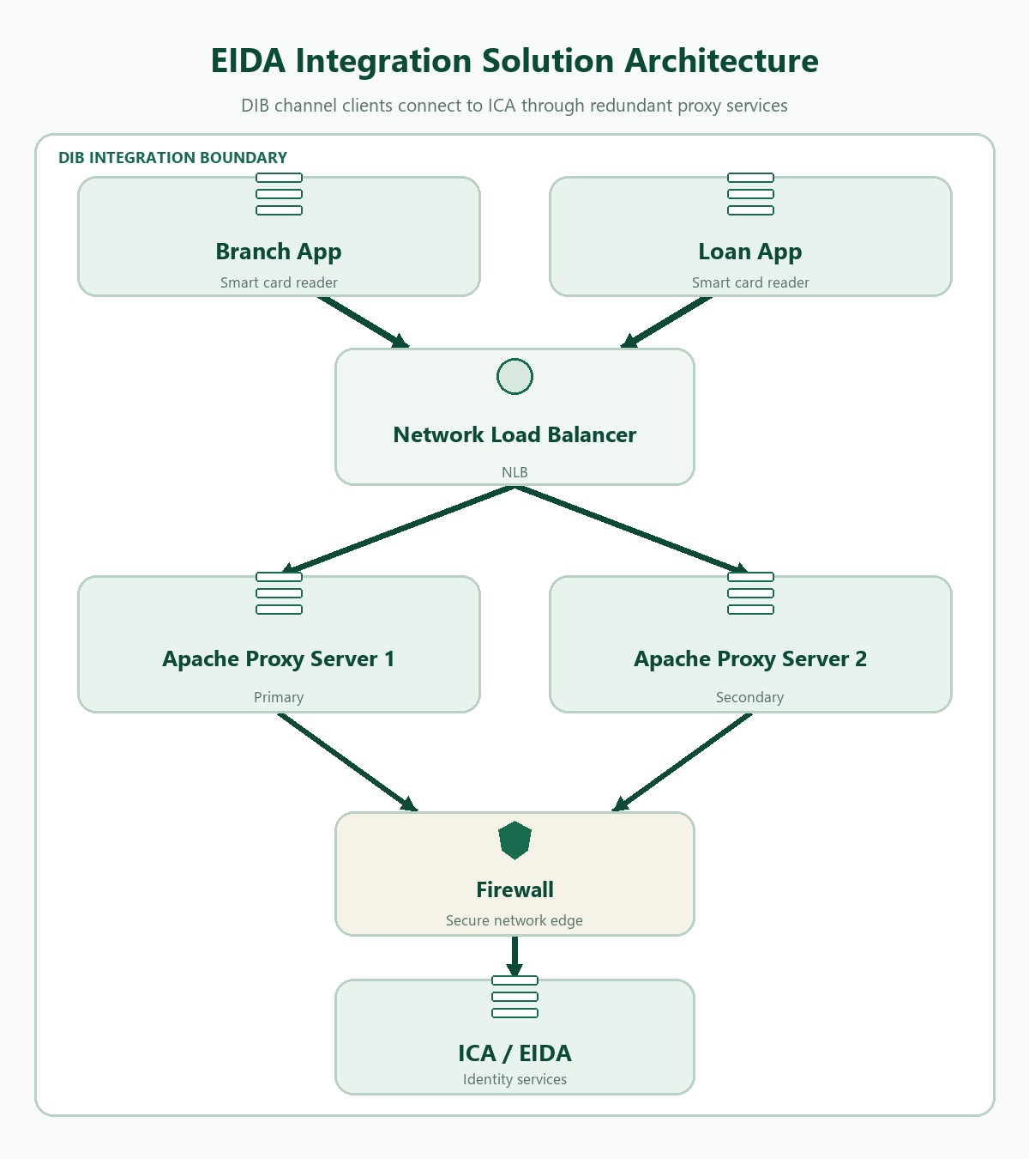
EIDA Integration Solution Architecture - branch and loan applications connect through the NLB and Apache proxy servers to ICA.

7. Network topology
Connectivity diagram for Emirates ID Authority - primary and disaster-recovery connectivity, DIB servers, MPLS links, and branch access.
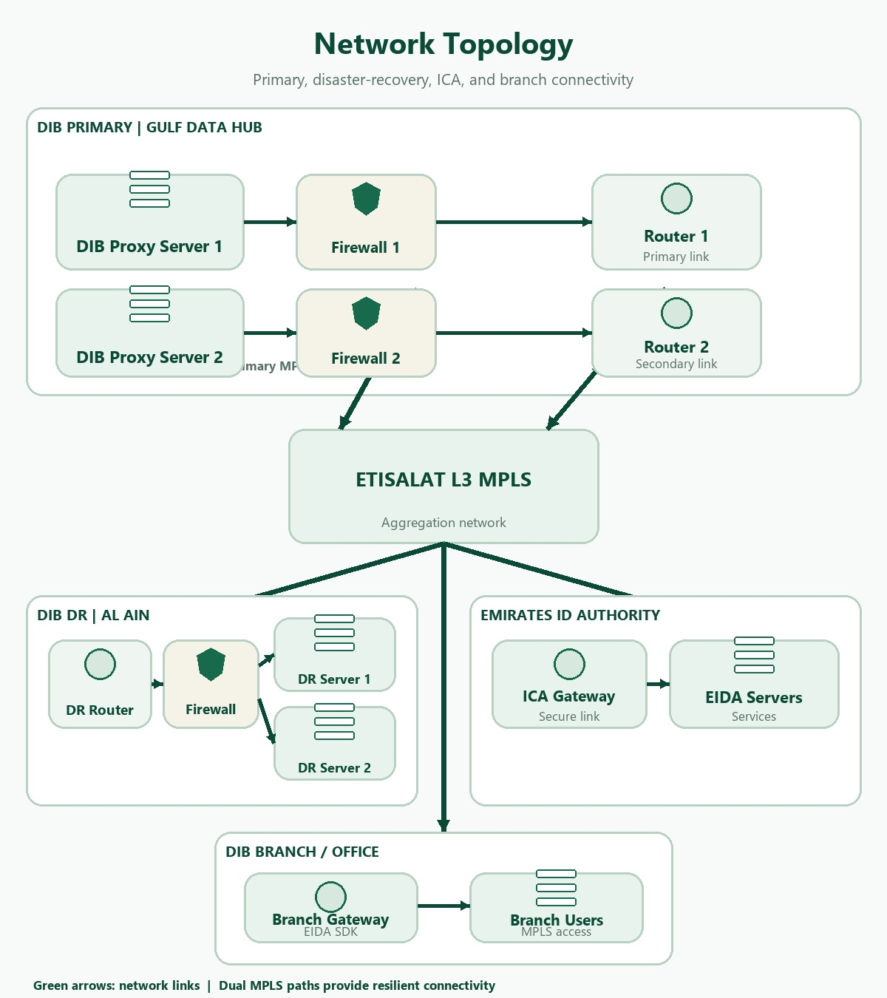
Connectivity diagram for Emirates ID Authority - primary and disaster-recovery connectivity, DIB servers, MPLS links, and branch access.

8. Open and closed issues
Maintain these registers even when a Configuration Management tool is used. No issue records were provided in the source material.

8.1 Open issues
ID | Issue | Resolution | Responsibility | Target date | Impact date

8.2 Closed issues
ID | Issue | Resolution | Responsibility | Target date | Impact date

9. Change log
Maintain this table even when a Configuration Management tool is used. No change entries were provided in the source material.
Version | Date | Change description | Author / owner

