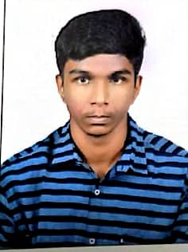 JEFFI DONAL D

MANNARGUDI-614001.

https://www.linkedin.com/in/jeffi-donal-847556253

Enthusiastic software engineer with a strong affinity for coding and a passion for crafting efficient solutions. Committed to continuous learning and eager to collaborate within dynamic team settings to drive impactful outcomes.

# EDUCATION

## SRI KRISHNA COLLEGE OF ENGINEERING AND TECHNOLOGY ,

COIMBATORE B.E ELECTRONICS AND COMMUNICATION ENGINEERING CGPA: 8.14

CLASS XII – 94.0% | SSLC CLASS X – 93.2%

# TECHNICAL SKILLS

PROGRAMMING LANGUAGES: C, C++, Java, Python, Javascript, HTML, CSS, SQL ,Data Structures,Analysis of algorithms



CERTIFICATIONS



Soft Skills -



NPTEL



Stress MManmmanageManaagr-



Ethics un Engineering Practices -



NPTEL



Cloud Computing, Deep Learning, Generative AI, Backend Development