Cards.css

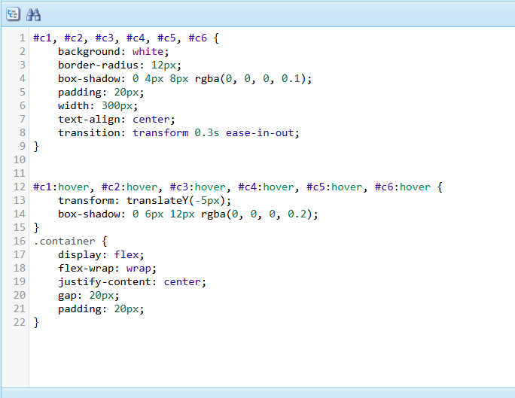

Template style.css

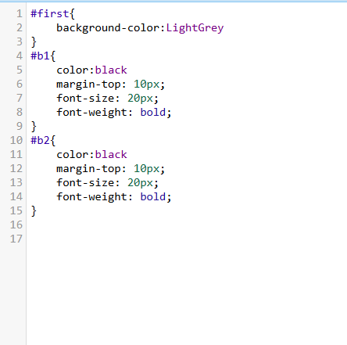

Contact.css

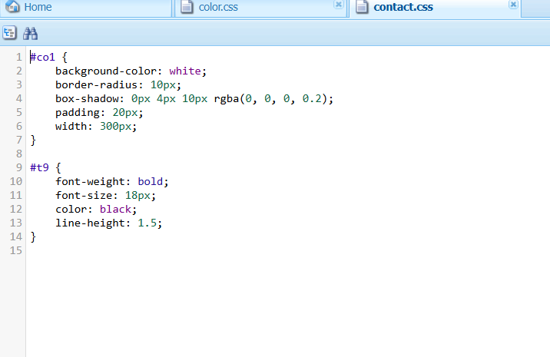

Main.css

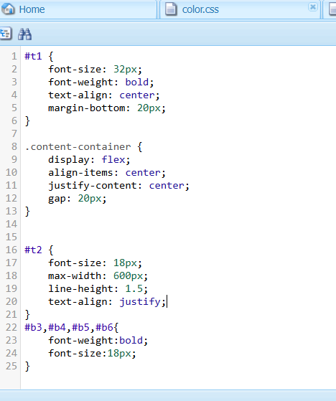

Bookcomponent.html

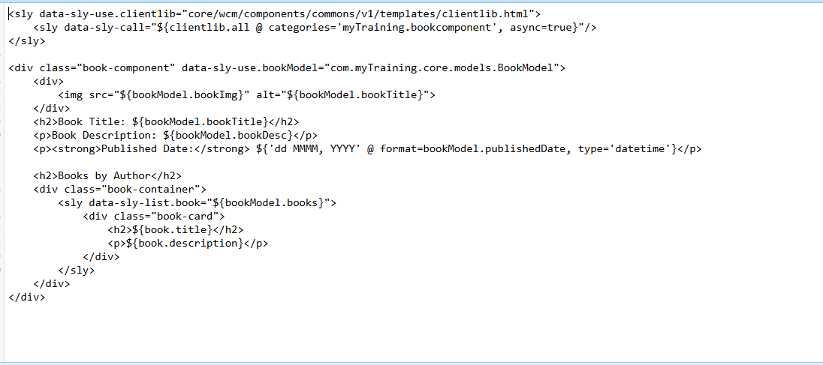

Bookcomponent.html(inline css,js)

<div class="book-component">

<h2>Books</h2>

<div class="book-container"></div>

</div>

<style>

.book-component {

text-align: center;

}

.book-container {

display: grid;

grid-template-columns: repeat(3, 1fr); /\* 3 columns \*/

gap: 20px;

justify-content: center;

padding: 20px;

}

.card {

border: 1px solid #ddd;

border-radius: 5px;

padding: 15px;

box-shadow: 0px 4px 6px rgba(0, 0, 0, 0.1);

background-color: #fff;

text-align: center;

overflow: hidden;

}

.card img {

width: 100%;

height: 200px;

object-fit: cover;

border-radius: 5px;

}

.card h3 {

font-size: 18px;

margin: 10px 0;

}

.card p {

font-size: 14px;

color: #555;

}

@media (max-width: 768px) {

.book-container {

grid-template-columns: repeat(2, 1fr); /\* 2 columns on smaller screens \*/

}

}

@media (max-width: 480px) {

.book-container {

grid-template-columns: repeat(1, 1fr); /\* 1 column on very small screens \*/

}

}

</style>

<script>

async function fetchBooks() {

try {

const response = await fetch('/bin/training/searchpages'); // Fetch JSON from servlet

const data = await response.json();

return data.results || [];

} catch (error) {

console.error('Error fetching books:', error);

return [];

}

}

async function renderBooks() {

const container = document.querySelector('.book-container');

const data = await fetchBooks();

if (!data.length) {

container.innerHTML = "<p>No books found.</p>";

return;

}

// Display books with images

data.forEach((book) => {

const card = document.createElement('div');

card.classList.add('card');

const img = document.createElement('img');

img.src = book.image; // Load image from JSON

img.alt = book.title;

const title = document.createElement('h3');

title.textContent = book.title;

const description = document.createElement('p');

description.textContent = book.description || "No description available";

card.appendChild(img);

card.appendChild(title);

card.appendChild(description);

container.appendChild(card);

});

}

renderBooks();

</script>