1. **Aim: Write a program to implement Naïve Bayesian classification**

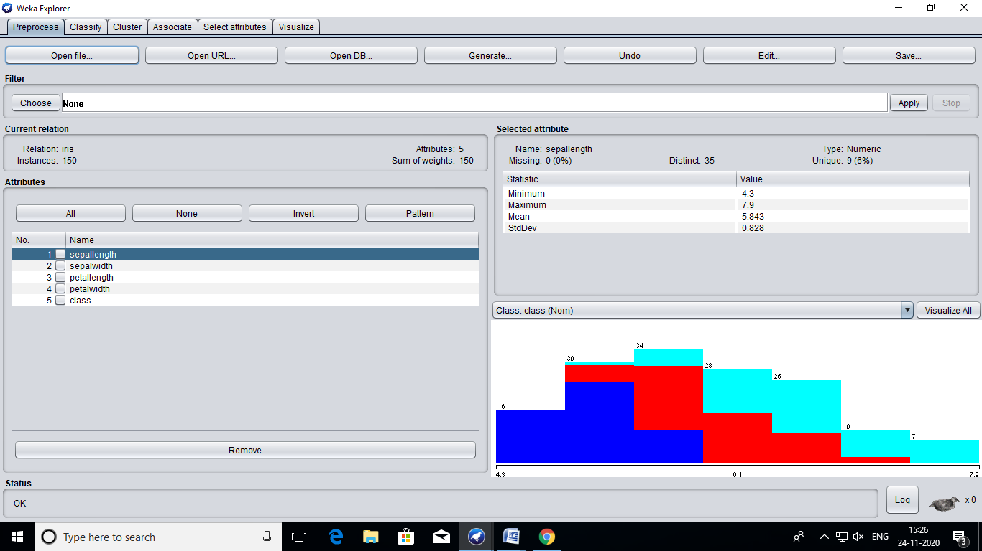

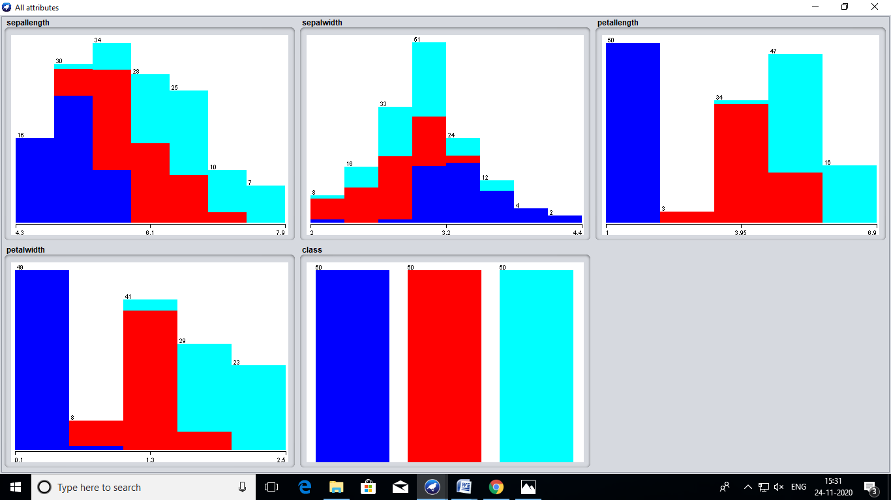

**=== Run information ===**

**Scheme: weka.classifiers.bayes.NaiveBayes**

**Relation: iris**

**Instances: 150**

**Attributes: 5**

**sepallength**

**sepalwidth**

**petallength**

**petalwidth**

**class**

**Test mode: 10-fold cross-validation**

**=== Classifier model (full training set) ===**

**Naive Bayes Classifier**

**Class**

**Attribute Iris-setosa Iris-versicolor Iris-virginica**

**(0.33) (0.33) (0.33)**

**===============================================================**

**sepallength**

**mean 4.9913 5.9379 6.5795**

**std. dev. 0.355 0.5042 0.6353**

**weight sum 50 50 50**

**precision 0.1059 0.1059 0.1059**

**sepalwidth**

**mean 3.4015 2.7687 2.9629**

**std. dev. 0.3925 0.3038 0.3088**

**weight sum 50 50 50**

**precision 0.1091 0.1091 0.1091**

**petallength**

**mean 1.4694 4.2452 5.5516**

**std. dev. 0.1782 0.4712 0.5529**

**weight sum 50 50 50**

**precision 0.1405 0.1405 0.1405**

**petalwidth**

**mean 0.2743 1.3097 2.0343**

**std. dev. 0.1096 0.1915 0.2646**

**weight sum 50 50 50**

**precision 0.1143 0.1143 0.1143**

**Time taken to build model: 0 seconds**

**=== Stratified cross-validation ===**

**=== Summary ===**

**Correctly Classified Instances 144 96 %**

**Incorrectly Classified Instances 6 4 %**

**Kappa statistic 0.94**

**Mean absolute error 0.0342**

**Root mean squared error 0.155**

**Relative absolute error 7.6997 %**

**Root relative squared error 32.8794 %**

**Total Number of Instances 150**

**=== Detailed Accuracy By Class ===**

**TP Rate FP Rate Precision Recall F-Measure MCC ROC Area PRC Area Class**

**1.000 0.000 1.000 1.000 1.000 1.000 1.000 1.000 Iris-setosa**

**0.960 0.040 0.923 0.960 0.941 0.911 0.992 0.983 Iris-versicolor**

**0.920 0.020 0.958 0.920 0.939 0.910 0.992 0.986 Iris-virginica**

**Weighted Avg. 0.960 0.020 0.960 0.960 0.960 0.940 0.994 0.989**

**=== Confusion Matrix ===**

**a b c <-- classified as**

**50 0 0 | a = Iris-setosa**

**0 48 2 | b = Iris-versicolor**

**0 4 46 | c = Iris-virginica**